Swarm structure ads

Vehicle attribute note

1. 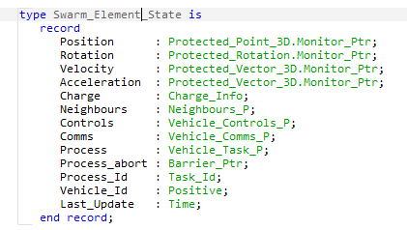..

Vehicle communication note

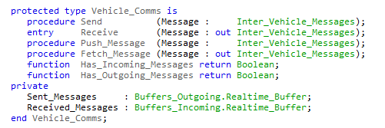

Vehicle control note

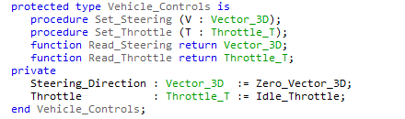

Vehicle charge info

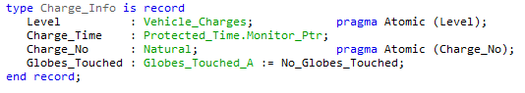

Swarm structure base ads

Energy Globe structure

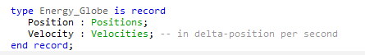

Energy Globes array structure



Throttle and charge value

