**Set up a VPC with an Internet gateway, create a public subnet, a private subnet make a route table connecting the Internet gateway and the subnets, and launch a Linux EC2 instance by using the above vpc and public subnet.**

**Set up a VPC with an Internet gateway, create a public subnet, a private subnet**

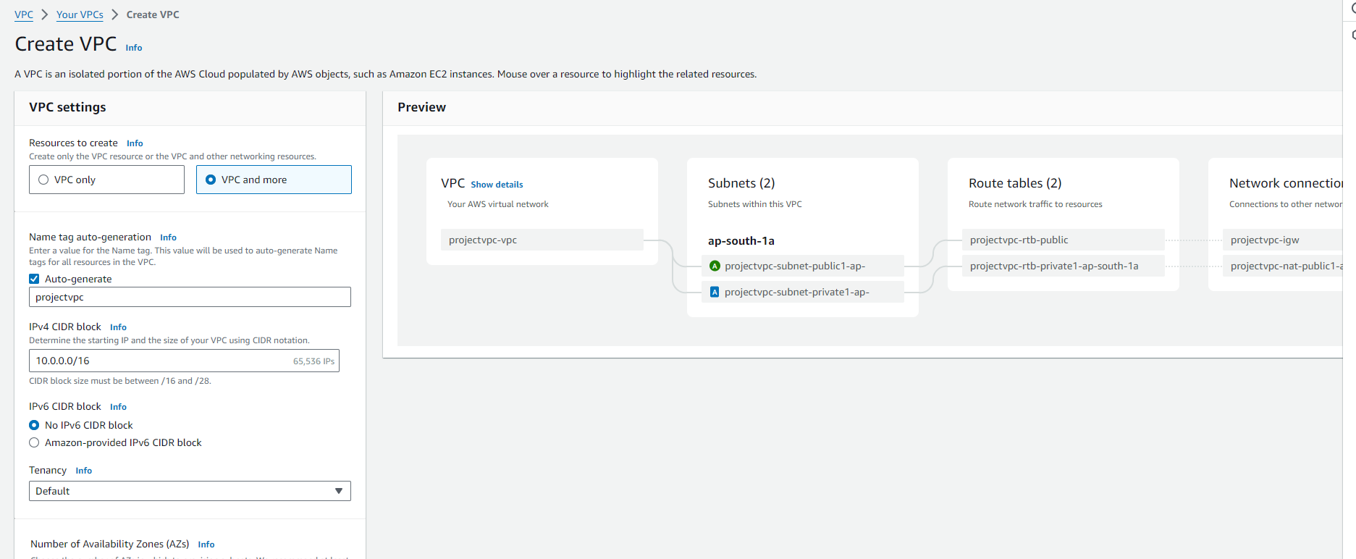

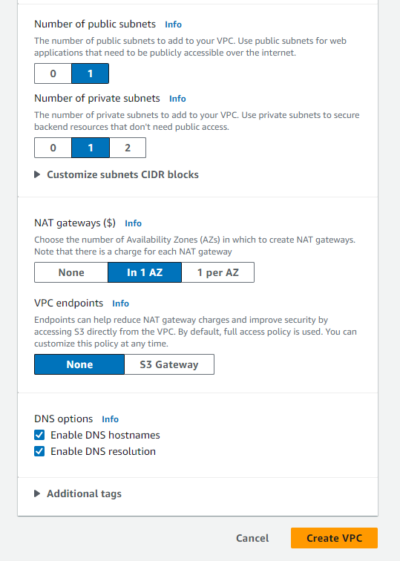 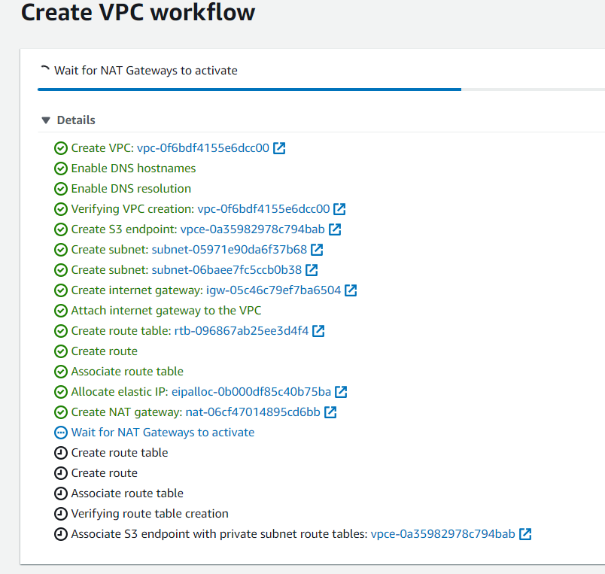

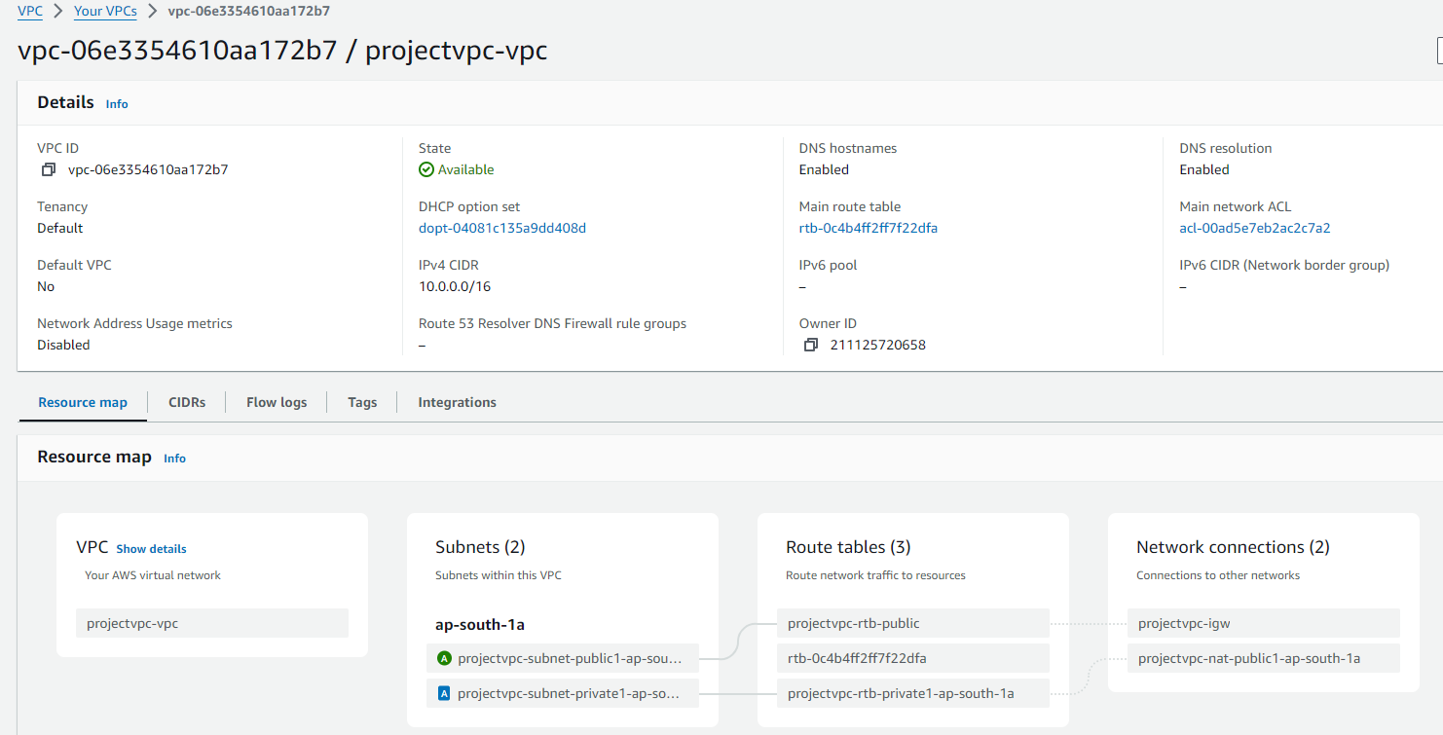

**Now create a route table:**

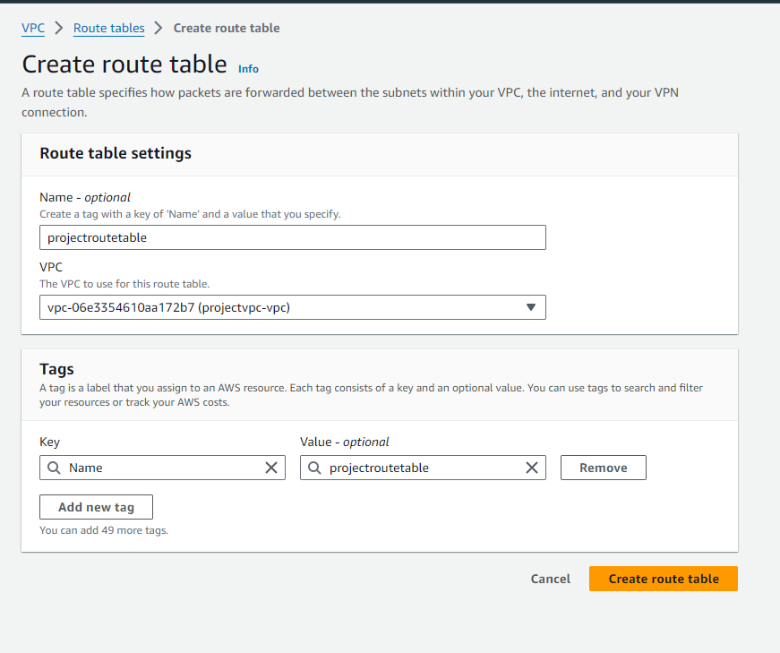

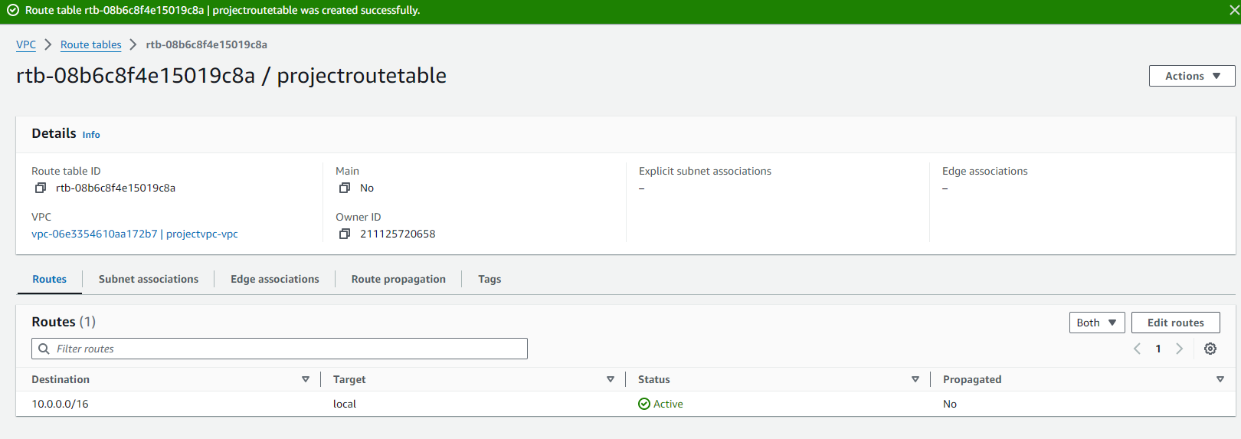

**Associate Route Table with subnet:**

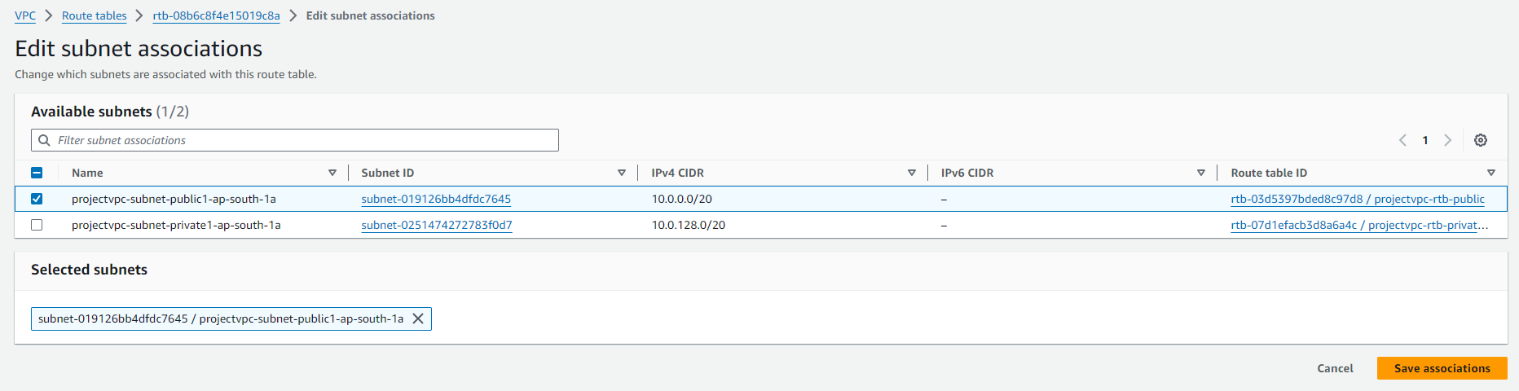

**Internet Gateway:**

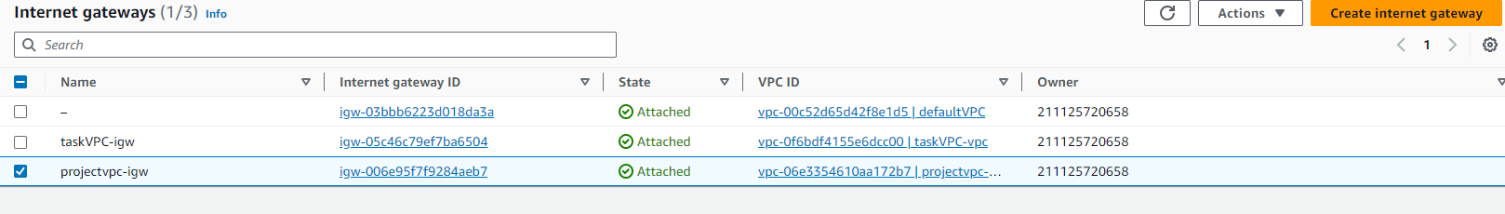

**Subnets:**

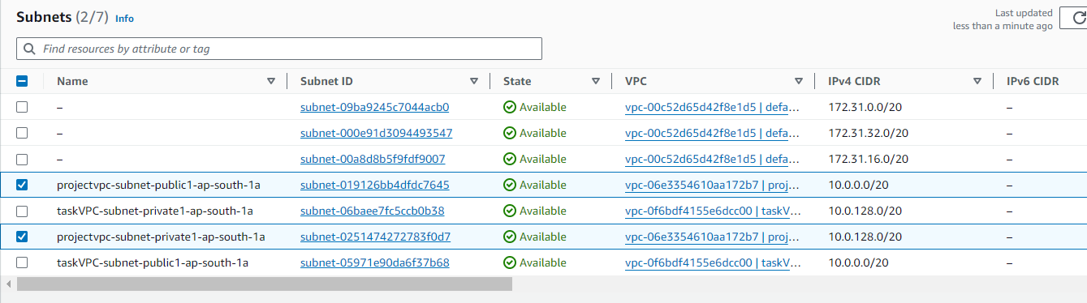

**Launch a instance with the code given in usedata** 