Library System – Documentation

ABDALSALAM E.ALZAQZOUQ 222000008
Abdelrahman ismail 231000276
Abdelrahman hasan 231001730
Ahmed Hegazii 222000112

GITHUB LINK : https://github.com/SinonHacke/Library-System-V1.git

1. Project Overview
This project is a Python-based desktop application built using the Tkinter GUI framework. It consists of three independent systems combined in one repository:
- Attendance Management System
- Library Management System
- To-Do List Application
The project demonstrates Object-Oriented Programming (OOP), event-driven programming, basic authentication, CRUD operations, and data persistence using JSON files.

2. Technologies Used
- Programming Language: Python 3
- GUI Framework: Tkinter
- Storage:
• In-Memory Dictionaries
• JSON File (todo_data.json)
- Architecture Style: MVC-like (Model – View – Controller)

3. Project Structure
Library-System-V1/
Attendance_System.py
Library_Sysytem.py
Todo_App.py
todo_data.json

4. Attendance Management System
The Attendance System allows users to register, log in, mark their attendance daily, and view attendance statistics.
Main Features:
- User registration and login
- Attendance status selection (Present, Absent, Excused)
- One attendance record per day restriction
- Bonus system for consistent attendance
Main Class:
- AttendanceApp
Data Model:
Each user has attendance statistics stored in memory, including counts for each status, a bonus flag, and the last attendance date.

5. Library Management System
The Library Management System manages books and users and allows borrowing and returning books.
Backend Class:
- LibraryBackend
Stored Data:
- Books: ID, title, author, status (available / borrowed)
- Users: ID, name, borrowed books list
Core Functions:
- Add and list books
- Add and list users
- Borrow and return books
GUI Class:
- LibraryApp

6. To-Do List Application
The To-Do List application allows users to manage daily tasks with persistent storage.
Features:
- User authentication
- Add, list, delete tasks
- Toggle task completion status
- Persistent storage using JSON
Backend Class:
- TodoListBackend
GUI Class:
- TodoApp_Gui

7. Diagrams Used in the Project
UML Class Diagram:
- Represents the structure of classes such as AttendanceApp, LibraryBackend, LibraryApp, TodoListBackend, and TodoApp_Gui.
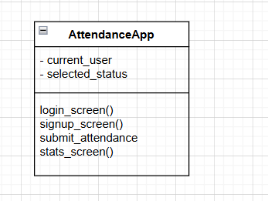

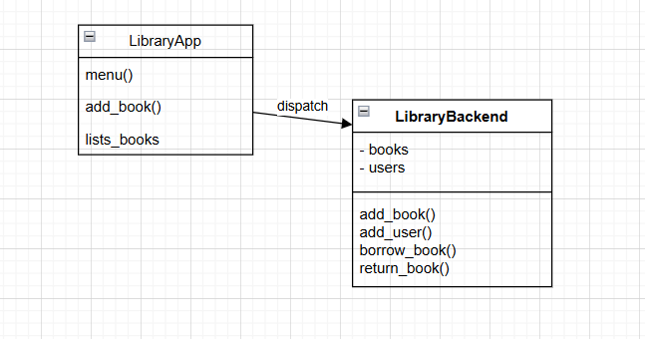

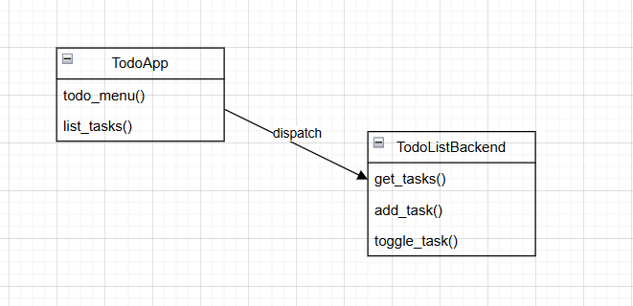

The project clearly follows a class-based structure, making UML Class Diagrams the most appropriate representation.

8. Architecture Style
The project follows an MVC-like architecture:
- Model: Backend classes handling data logic
- View: Tkinter GUI components
- Controller: GUI methods that interact with backend logic
The application is event-driven, responding to user actions such as button clicks and input dialogs.

9. Strengths and Improvements
Strengths:
- Clean separation between GUI and logic
- Beginner-friendly structure
- Demonstrates real-world application concepts
Suggested Improvements:
- Password hashing for better security
- Use a database instead of in-memory storage
- Combine all systems into a single main dashboard
- Add UML diagram files to the repository

10. Conclusion
This project is well-suited for academic purposes and beginner-level software engineering demonstrations. It effectively showcases GUI programming, OOP concepts, and basic system design principles.

