Project Report: Multi-System Application
Introduction
This report presents a desktop-based application integrating three subsystems: To-Do List, Library Management, and Attendance Tracking. The system is developed using Python and Tkinter, providing a graphical interface for user interaction and local data management using JSON files or in-memory storage.
The purpose of the project is to demonstrate modular system design, user account management, and task or data tracking across different systems.
System Overview
The application consists of three main systems:
- To-Do List Management System
- Library Management System
- Attendance Tracking System
Each system operates independently but shares common login functionality and interface style for consistency.

Library Management System
Overview:
- Manages books and library users.
- Allows adding books, listing books, adding users, listing users, borrowing and returning books.
- Data is stored in-memory for simplicity.
Key Components:
- LibraryBackend: Manages books, users, and borrow/return logic.
- LibraryApp: GUI that interacts with the backend.
Flow:
- User logs in.
- Selects Library System from main menu.
- Performs actions such as adding books/users or borrowing/returning books.
- Backend updates data and GUI displays the results.
Diagram Placement:
- Use Case, Sequence, and UML diagrams specific to Library System can be shown here.
- 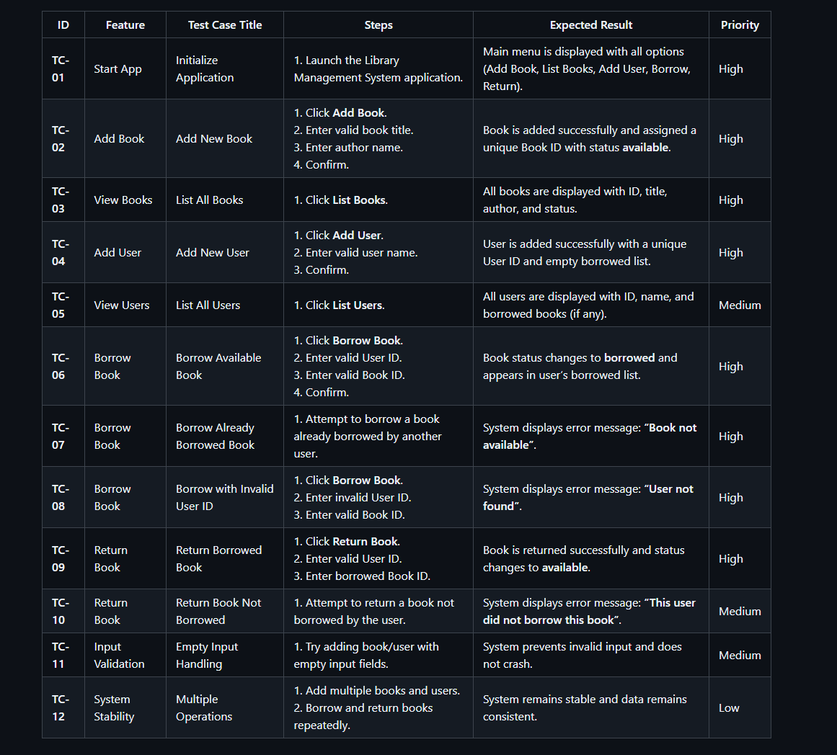

To-Do List Management System
Overview:
- Allows users to manage personal tasks.
- Supports adding new tasks, viewing existing tasks, marking tasks as done, and deleting tasks.
- Data is stored persistently in a JSON file (todo_data.json).
Key Components:
- TodoListBackend: Handles data operations like adding, toggling, deleting tasks.
- TodoApp_Gui: Provides GUI for task management, login, and sign-up.
Flow:
- User logs in or signs up.
- Main To-Do menu appears.
- User performs task operations.
- Backend updates data, GUI shows results.
Diagram Placement:
- Use Case, Sequence, and UML diagrams specific to To-Do can be shown here.
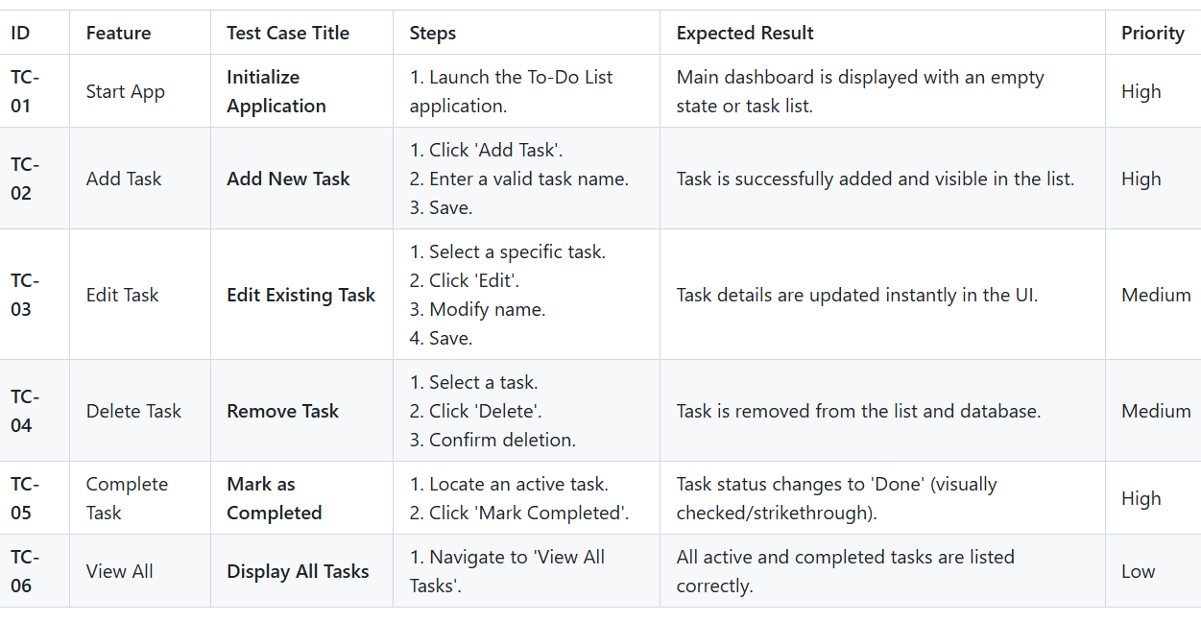

Attendance Tracking System
Overview:
- Tracks attendance for users.
- Users can mark attendance as Present, Absent, or Excused.
- Calculates bonus eligibility based on attendance.
- Data is stored in-memory.
Key Components:
- AttendanceApp: Manages GUI and user interactions.
- ATTENDANCE dictionary: Stores attendance statistics for each user.
Flow:
- User logs in.
- Attendance options are displayed (Present, Absent, Excused).
- User selects status and submits.
- System updates statistics and calculates bonuses.
Diagram Placement:
- Use Case, Sequence, and UML diagrams specific to Attendance System can be shown here.

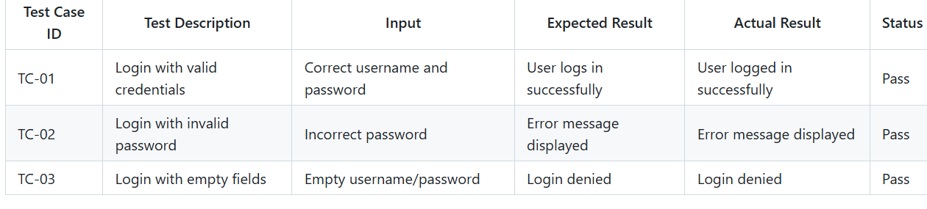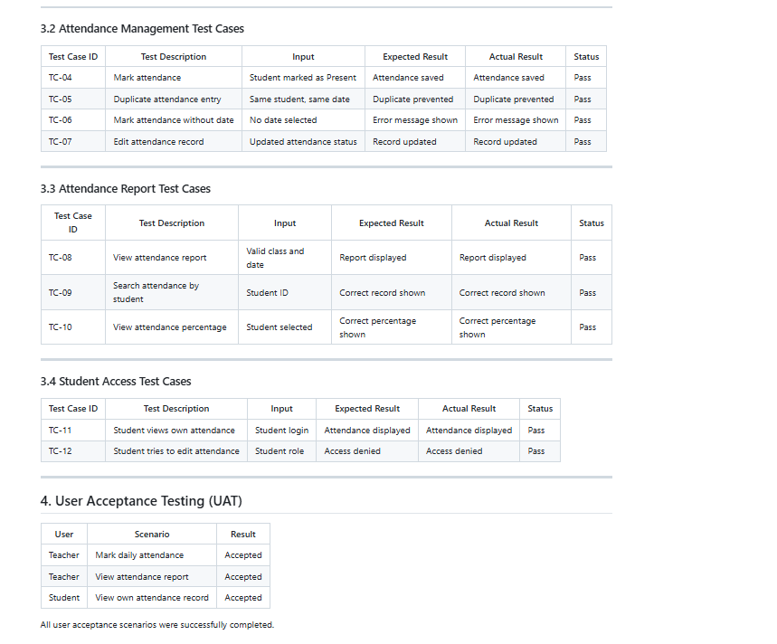

6. Use Case Diagram
Placement: After system descriptions.
Explanation:
- Illustrates what each user can do in each subsystem.
- Shows login, sign-up, task management, library operations, and attendance marking.
Figure: 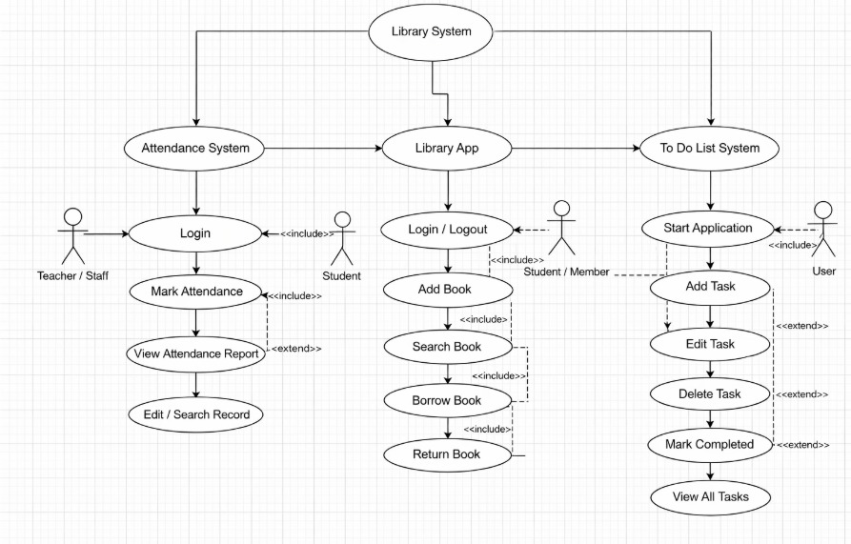

7. Sequence Diagram
Placement: After Use Case Diagram.
Explanation:
- Shows step-by-step flow for interactions between the user, GUI, and backend.
- Helps understand the operation sequence in each system.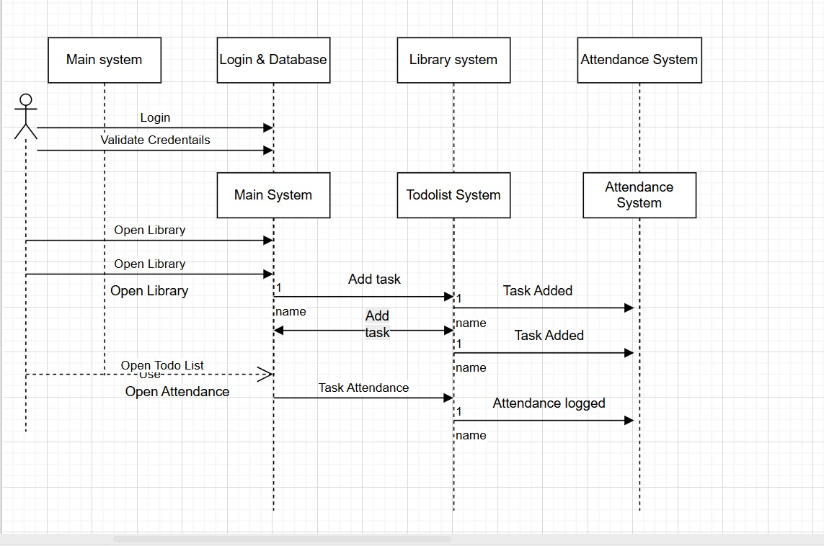
8. UML Diagram
Placement: After Sequence Diagram, before Main Function Explanation.
Explanation:
- Displays class structure and relationships.
- Main classes per system:
- To-Do: Todo App Gui & Todo List Backend
- Library: Library App & Library Backend
- Attendance: Attendance App
- Shows how GUI interacts with backend and how data is managed.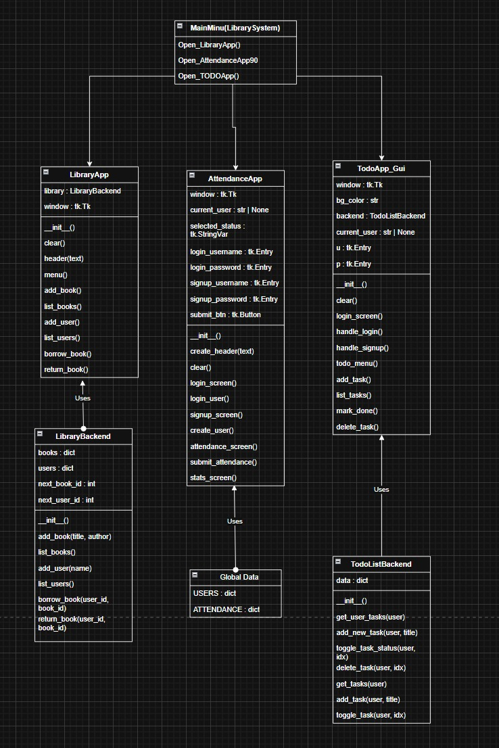

Main Function Explanation
- Initializes the application.
- Creates the main window and starts the GUI event loop.
- Launches selected subsystem after successful login

Functional Requirements
- User account creation and login.
- Task management (To-Do).
- Book and user management (Library).
- Borrowing and returning books (Library).
- Attendance marking and bonus calculation (Attendance).
- Logout functionality.

Non-Functional Requirements
- User-friendly interface.
- Local data storage (JSON files for To-Do and Users).
- Fast response and reliable behavior.
- Modular design for easy maintenance and extension.

Tools and Technologies
- Python programming language.
- Tkinter for GUI.
- JSON for data storage.
- In-memory structures for Library and Attendance.
- Development in Visual Studio Code or PyCharm.

Conclusion
The multi-system application integrates To-Do List, Library Management, and Attendance Tracking. Each system provides clear functionality and user interaction. Diagrams (Use Case, Sequence, UML) provide visual understanding of the system flow, interactions, and class relationships. The project demonstrates modular design, data handling, and GUI development, providing a solid foundation for future enhancements.
Scrum Board – Multi-System Project (Simple Version)
Project Name: Multi-System Management
Sprint Goal: Unified system including login, system selection, and data management for all subsystems.

Backlog / Tasks
ID | Feature / Task | Description
1 | Main Menu | Window for selecting system (Attendance, Library, Todo List)
2 | User Login & Sign-Up | Login and account creation for all systems
3 | Attendance System | Track user attendance and show stats and bonus
4 | Library System | Manage books and users, borrow and return books
5 | Todo List System | Add/Delete/Toggle tasks
6 | Data Saving | Save all system data in JSON files
7 | GUI Design | Unified colors, fonts, and buttons across all windows
8 | Error Handling | Handle invalid input or missing files
9 | Integration | Connect all systems with the main menu
10 | Testing | Ensure all features work correctly

Issues / Bugs
ID | Issue | Notes
1 | Incorrect login | Shows error message
2 | Duplicate user registration | Shows error message
3 | Multiple attendance entries per day | Prevents double entry
4 | Borrowing non-existent or unavailable book | Validates data in Library system
5 | Invalid task number in Todo List | Shows error message
6 | Running a non-existent system from menu | Shows error message
7 | Missing data files | Automatically creates new files

