Vitaly Kurnosenko
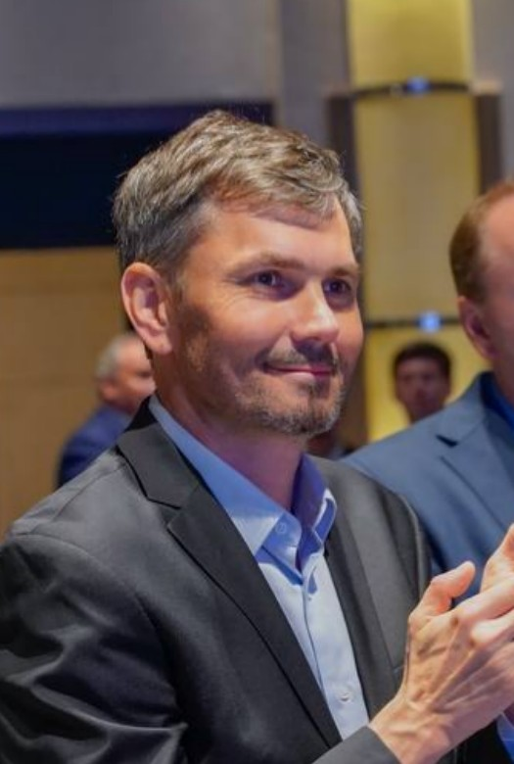
Senior AI / LLM Engineer | Python · Agentic Workflows · RAG · Production APIs
Phone: +86 15601694273
Email: vitaliy@sinoptics.ai
Telegram: @vitaly_kur
Languages: English — B2; Russian — native; Chinese — HSK 4

Professional Summary
Senior AI / LLM Engineer with 20+ years in software engineering and 4+ years building production data and ML systems. Design and operate scalable, low-latency AI services in Python: LLM orchestration, multi-agent workflows, RAG, real-time APIs, and cloud-native deployment on AWS and GCP.
Recent focus: architecting agentic automation platforms that unify multi-channel inputs (Telegram, WeChat, email, web, API/webhooks), run reasoning pipelines, and return reliable structured outputs for business workflows. Strong ownership mindset — comfortable across architecture, backend services, MLOps, and production operations in fast-moving environments.

Core Skills
Area | Technologies and practices
AI / LLM | LLM orchestration, prompt engineering, structured output (JSON Schema), streaming inference patterns, multi-agent systems, tool calling, LLM-as-judge
Agent frameworks | Dify, n8n, LangChain-compatible orchestration patterns, MCP integrations, orchestrator → domain agents → aggregator architectures
RAG | Vector indexes, semantic + metadata chunking, hybrid retrieval, reranking, KB freshness, faithfulness / groundedness checks
Python backends | FastAPI, Celery, async workers, REST APIs, type hints, production debugging, microservices
ML in production | Feature pipelines, real-time scoring, SageMaker, A/B and shadow deployment, model routing, quality monitoring
Data & messaging | PostgreSQL, MongoDB, Redis, BigQuery, SQS/SNS, event-driven architectures, SQL + NoSQL data design
Cloud & MLOps | AWS (Lambda, SageMaker, EC2, ECR, SQS/SNS, Secrets Manager), GCP (GKE, BigQuery, GCS), Docker, Kubernetes (K3S, GKE), GitHub Actions, CodeBuild
Observability | Structured logging, pipeline alerting, Prometheus/Grafana (Helm), fault tolerance, retries, audit logs

Professional Experience
Senior AI / LLM Engineer — Sinoptics AI
October 2025 — July 2026
AI platform for intelligent document processing and agentic business automation. End-to-end ownership from multi-channel ingestion to production-grade AI services and structured outputs.
LLM orchestration and agentic workflows:
- Architected a multi-agent processing pipeline: ingestion (Telegram, WeChat, email, web, API) → OCR / Vision LLM → LLM structuring → orchestrator → domain agents (Finance, Accounting, Legal, Logistics) → aggregated validation / compliance / risk report.
- Built a production Dify workflow (24 nodes, 34 edges): PDF/image intake → OCR / PDF parsing → LLM field extraction → external verification → 5 parallel domain agents → final report; webhook-triggered, fault-tolerant execution.
- Orchestrated n8n workflows and multi-agent architectures with RBAC, audit logs, retry logic, and error handling for long-running AI tasks.
- Designed reasoning and task-automation pipelines for real-world business workflows: supplier due diligence, invoice validation, compliance checks, and proactive exception surfacing.
RAG and knowledge systems:
- Built a RAG system on Dify for corporate knowledge bases: metadata-aware chunking, vector indexes, retrieval context for agents, versioning and freshness controls.
- Implemented structured LLM output via JSON Schema and constrained prompting; post-processing, validation, and human-in-the-loop review.
Production APIs and infrastructure:
- Deployed on-premise LLM platform (Dify v1.10): Docker Compose, PostgreSQL, nginx, TLS.
- Migrated FastAPI + Celery + Redis services to K3S on AWS EC2; hybrid CI/CD (GitHub Actions → CodeCommit → CodeBuild → ECR → kubectl), secrets in AWS Secrets Manager.
- Integrated external APIs and web sources for enrichment and verification in agent tool chains.
Stack: Python, FastAPI, Dify, n8n, OpenAI-compatible LLM APIs, OCR / Vision AI, RAG, PostgreSQL, Redis, Docker, K3S/Kubernetes, AWS, Yandex Cloud.
ML Engineer / Data Engineer — Yofi Inc. (USA)
February 2022 — October 2025 · remote
Anti-fraud and customer-intelligence platform for Shopify enterprise merchants (Lululemon and others). Built and operated real-time ML services and data infrastructure at scale.
- Developed production ML pipelines: bot detection, abuse scoring, behavioral feature engineering, real-time scoring via AWS SageMaker and Lambda.
- Built ML gateway and safe model rollout: SNS/SQS-triggered Python services, model routing, shadow predictions in MongoDB, A/B testing without production risk.
- Delivered FastAPI prediction services for behavioral telemetry and real-time risk assessment.
- Operated data plane over 1B+ events (GCS, BigQuery, Hudi/Delta); Spark jobs on Kubernetes for training data preparation.
- Implemented monitoring, data quality gates, and automated pipeline testing to reduce production incidents and model drift impact.
- Integrated multi-source data (Shopify, Klaviyo, Moonsense) via Airbyte connectors and webhook pipelines.
Stack: Python, SQL, PySpark, FastAPI, AWS SageMaker, Lambda, SQS/SNS, MongoDB, Neo4j, Redis, BigQuery, Airflow, dbt, Docker, Kubernetes (GKE).
Head of IT and Finance — Engineering Solutions LLC
March 2013 — December 2017 · Moscow
- Led IT infrastructure and financial systems; ERP implementation, reporting automation, cross-functional delivery under business constraints.
Head of IT Department — New Engineering Solution
April 2003 — February 2013 · Moscow
- Owned corporate ERP, IT infrastructure, and reporting systems; early data discipline and process automation.

Selected Projects
- Multi-channel agent orchestration — unified Telegram / WeChat / email / API inputs into a single intelligent workflow with parallel domain agents and structured final reports.
- Supplier due diligence workflow — OCR + LLM extraction + external verification + multi-agent analysis for compliance and risk assessment.
- OCR forms pipeline — template-based extraction from scanned trade and logistics documents with validation and post-processing.
- Real-time ML routing — production gateway for model selection, shadow deployment, and A/B rollout in a high-volume e-commerce environment.

Education
- Southern Federal University — PhD, Mathematical Sciences *(1994 — 2003)*
- RPANEPA (RANEPA) — MBA, Information Technology *(2005 — 2007)*

Certifications
- Certified Accountant Practitioner (CAP) — IFRS financial reporting, management accounting

Additional
- Comfortable in remote, async, cross-functional teams; strong product and ownership mindset in startup-paced environments.
- PhD-level foundation in mathematical modeling and statistical reasoning — useful for evaluation design and production AI reliability.
- Ready to discuss: agentic orchestration, RAG architecture, real-time Python APIs, ML production rollout, structured LLM output, and observability for AI systems.

