Shaikh J Ahmed
2. URL to STUDENT WEB SITE
https://cis-linux2.temple.edu/tomcat11/fa26_3308_tup53806/
3. user_role TABLE DESIGN
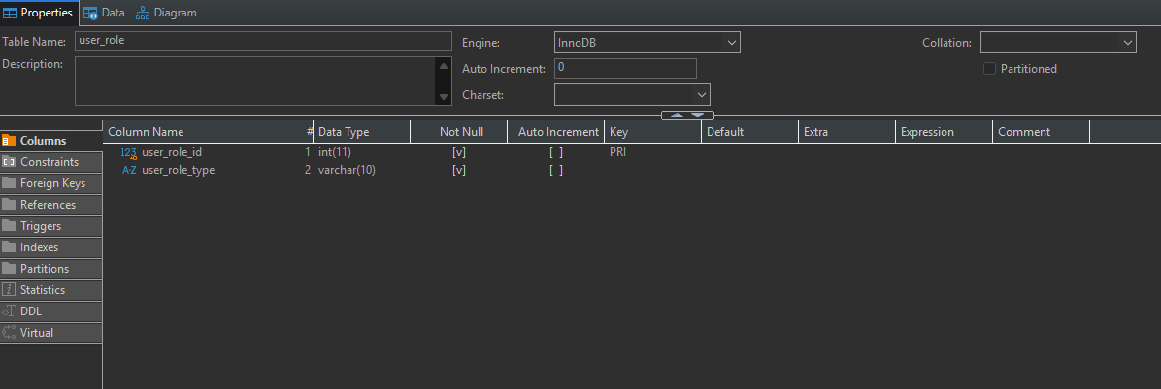
4. web_user TABLE DESIGN and FOREIGN KEY
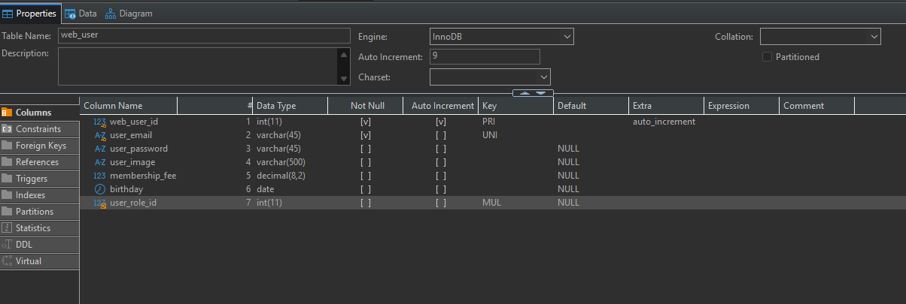
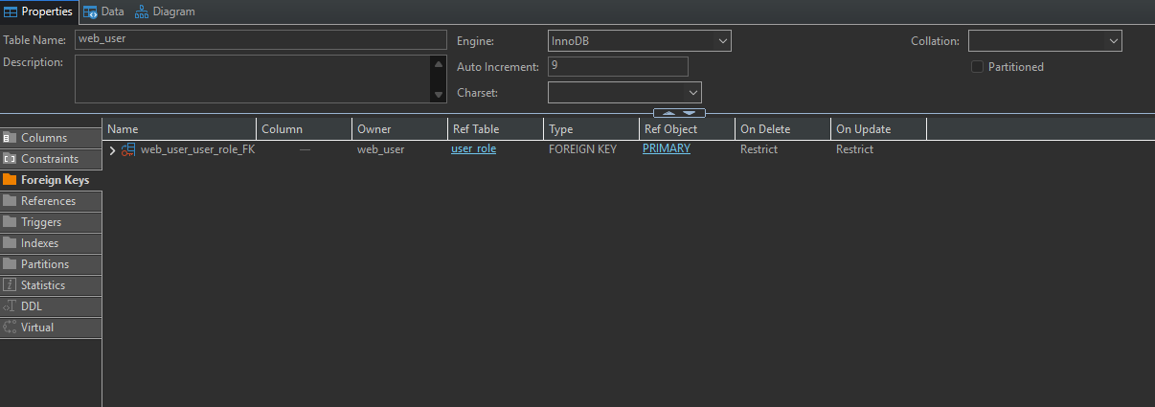
5. DATA ENTRY ERRORS
a) Error: Duplicate user_role PK
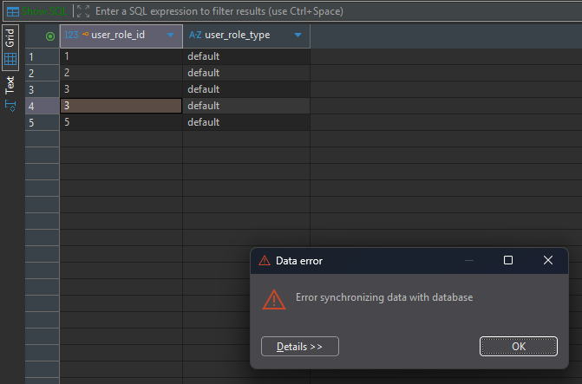
b) Error: Invalid user_role FK in web_user record
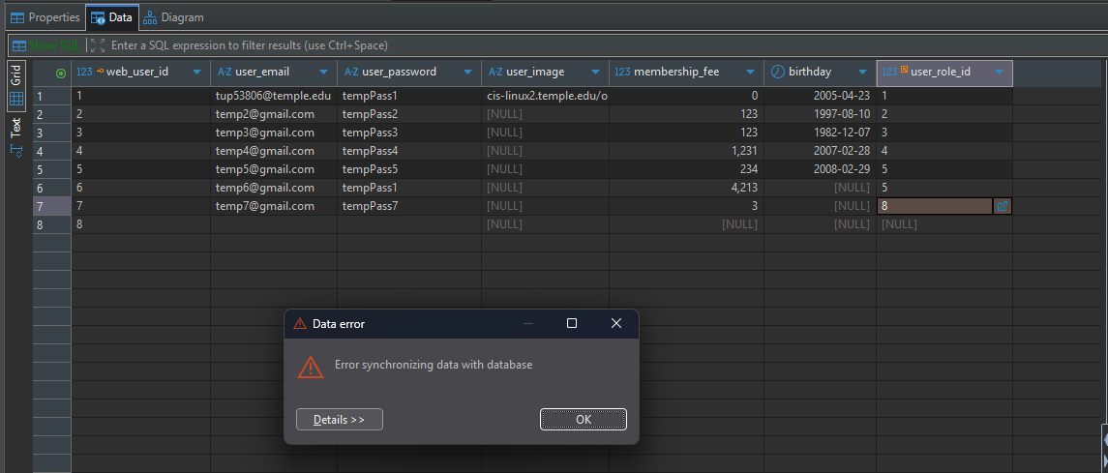
c) Error: Cannot delete a user_role record that’s referenced by a web _user record
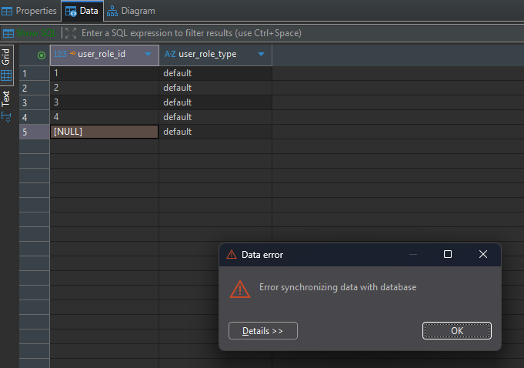
6. SELECT STATEMENTS
a) USER_ROLE: all rows, all columns, sorted by user_role_id.
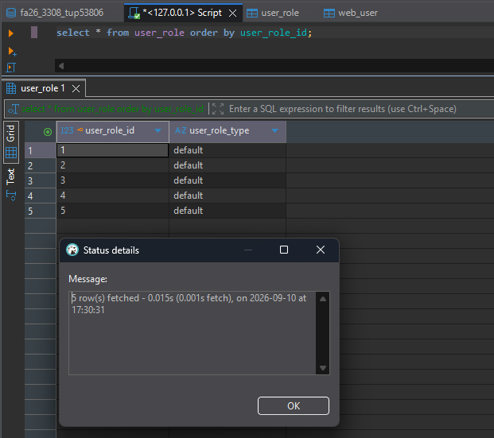
b) WEB_USER: all rows, all columns, sorted by web_user_id.
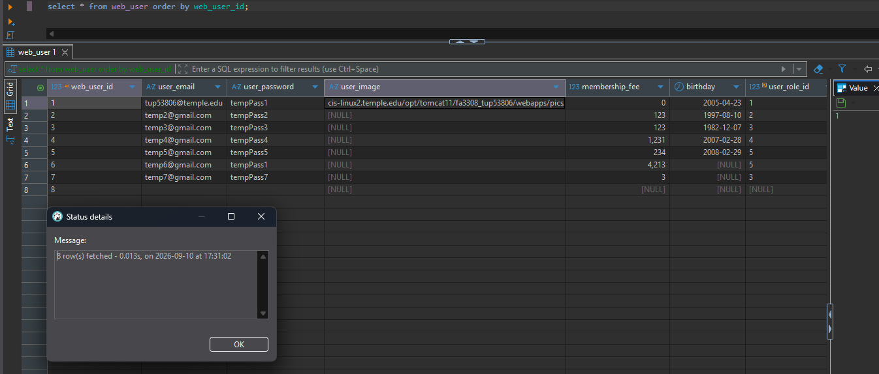
c) WEB_USER JOINED WITH USER_ROLE: all rows, certain columns, sorted.
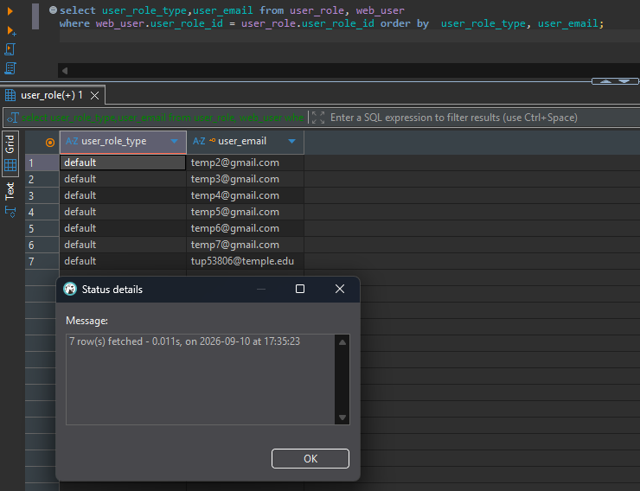

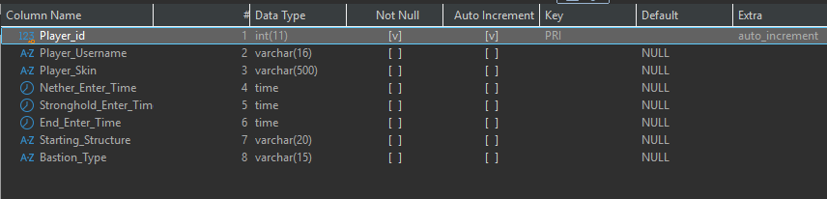
Other Table

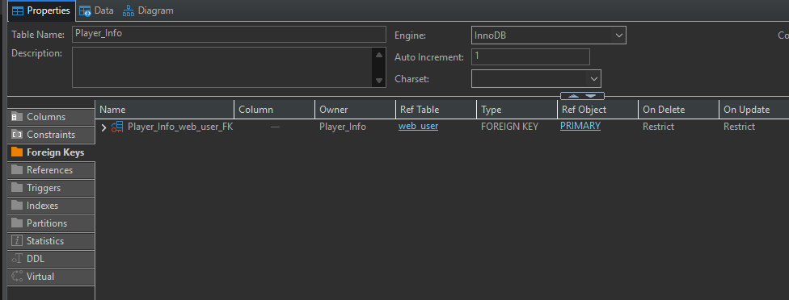
Foreign Key

Invalid FK from “other” to web_user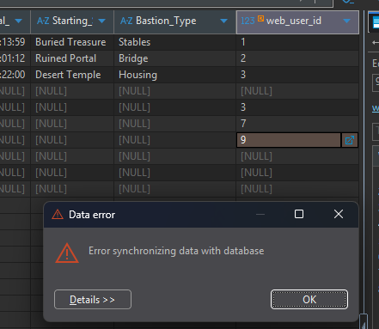
Error - cannot delete a referenced web_user record
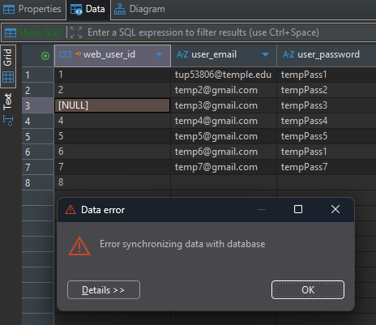
Select * from Player_Info t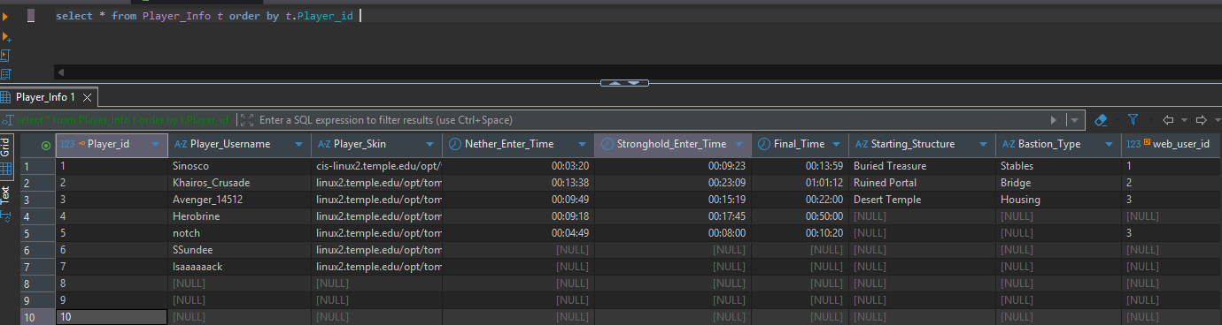
“other” table joined with web_user (all rows)
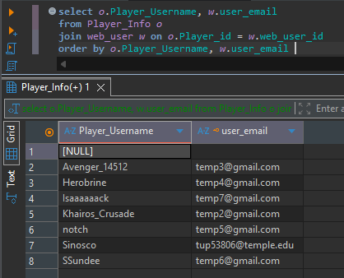
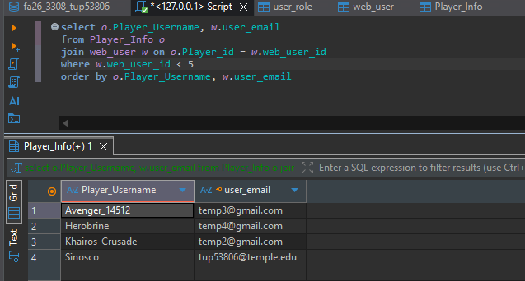
“other” table joined with web_user (but just some rows)

