PROJECT REPORT ON

Healthcare Analytics Using Big Data

Subject Name: Big Data Analytics Subject Code: BDA601
Submitted By: Submitted To:
Sinchana Ms. Surbhi
1AY23CD055

Table of Contents:
Task 1:- Big Data in Daily Life – Dashboard(Power BI)
Topic | Page No:
1.About the Project | 3-5
2.About the Tools and Technologies Used | 6-7
- Detailed Description of My Contribution  - What is Done and How it is Done  - Code Explanation | 8-9
4.Implementation Code | 10
5.Results | 11-12
6.Conclusion | 13
Figures:  - : Transformed Data  - : Dashboard | 12-13

TASK 2: BI vs Big Data – Role Play 14-15
TASK 3: Architecture Design Challenge 15-16
TASK 4: Analytics & Tool Match 17
Bonus Challenge 17-18

- ABOUT THE PROJECT :

1.1 Background of Healthcare Analytics Using Big Data

Modern hospitals generate enormous volumes of healthcare data every second.
Sources of healthcare data include:
• Electronic Health Records (EHR)
• Laboratory reports
• Medical imaging (X-rays, MRI, CT scans)
• Wearable health devices
• ICU monitoring systems
• Pharmacy and billing systems
In large hospitals:
• Thousands of patient records are generated daily
• Continuous real-time monitoring data flows from ICU machines
• Gigabytes of medical imaging data are stored daily
Traditional systems cannot efficiently process this massive and complex data.
This is where Big Data Analytics becomes essential.

Big Data in Healthcare Analytics– The 5V Model
- Volume
Healthcare generates massive datasets:
• Patient medical histories
• Diagnostic images
• Insurance and billing records

➢ Velocity
Healthcare data is generated rapidly:
• Real-time heart rate monitoring
• ICU live updates
• Emergency admission logs

➢ Variety
Healthcare data formats:
• Structured (Patient ID, Age, Test Results)
• Semi-structured (JSON health logs)
• Unstructured (X-ray images, prescriptions, doctor notes)

➢ Veracity
Data may contain:
• Missing test values
• Incorrect patient entries
• Duplicate records
Data cleaning ensures reliable diagnosis and reporting.

➢ Value
Healthcare analytics helps:
• Predict disease outbreaks
• Identify high-risk patients
• Optimize hospital resources
• Improve treatment outcomes
Big Data converts raw medical data into life-saving insights.

Why Traditional BI Fails in Cybersecurity

Traditional BI tools like Excel and SQL databases:
- Cannot process medical imaging
- Cannot handle real-time ICU streaming data
- Limited scalability
- Designed mainly for structured tabular data
- Suitable for reporting, not predictive healthcare
Healthcare requires:
• Real-time monitoring
• Distributed storage
• Predictive analytics
• AI-based disease detection
Hence, Big Data technologies are required.

- ABOUT TOOLS & TECHNOLOGIES (DETAILED)

  - Power BI – Business Intelligence Layer
Power BI is used to create hospital dashboards.
In Healthcare:
• Displays patient admission trends
• Shows disease distribution
• Visualizes recovery rates
• Compares department performance
Power BI helps hospital administrators understand data visually.

  - Apache Hadoop – Distributed Storage
Hadoop is used for storing massive healthcare data.
Key Components:
• HDFS – Distributed storage
• MapReduce – Batch processing
• YARN – Resource management
Advantages:
• Stores large patient datasets
• Fault-tolerant
• Highly scalable

Apache Spark – Real-Time Processing Apache
Spark enables fast in-memory processing.
In Healthcare
•Detects abnormal heart rate instantly
• Predicts disease risk
• Performs machine learning on patient history
Spark processes medical data much faster than traditional systems.

NoSQL Databases – Flexible Storage

MongoDB – Flexible Storage
MongoDB stores semi-structured health records.
Advantages:
• Schema flexibility
• Handles JSON data
• Horizontally scalable
Healthcare data varies in format; NoSQL supports this variation.

- DETAILED DESCRIPTION OF CONTRIBUTION

What is Done and How it is Done?

Data Understanding
Each patient record contains:
• Patient ID
• Age
• Gender
• Diagnosis
• Admission Date
• Discharge Date
• Treatment Cost
• Recovery Status
Each row represents one patient case.

Data Preprocessing
Data cleaning includes:
• Removing null medical values
• Removing duplicate records
• Standardizing cost format
• Handling missing diagnosis entries

Analytical Logic Applied
The dashboard focuses on:
• Total Patients
• Recovery Rate %
• Average Treatment Cost

Code Explanation

Total Patients

TotalPatients = COUNTROWS(Healthcare_Data)

Recovered Patients

RecoveredPatients =
CALCULATE(
COUNTROWS(Healthcare_Data),
Healthcare_Data[Recovery_Status] = "Recovered"

)

Recovery %

Recovery% =
DIVIDE([RecoveredPatients], [TotalPatients]) * 100

Average Treatment Cost

AvgCost =
AVERAGE(Healthcare_Data[Treatment_Cost])

IMPLEMENTATION OF CODE

  - Overview of Implementation
In this project:
- Healthcare dataset imported into Power BI
- Data cleaned
- DAX measures created
- Interactive dashboard built

  - Data Import and Preparation
• KPI Cards → Total Patients, Recovery %, Avg Cost
• Line Chart → Monthly Admissions
• Bar Chart → Department-wise Patients
• Pie Chart → Disease Distribution
• Slicers → Gender, Date, Department
All visuals are interactive and dynamically filter based on user selection.

4.3 Summary of Implementation
The Healthcare Analytics dashboard was developed by importing the dataset into Power BI and performing data cleaning and transformation. Key columns such as admission date, department, treatment cost, and recovery status were verified and formatted correctly. DAX measures including Total Patients, Recovery %, and Average Cost were created to analyze hospital performance.
Interactive visuals such as KPI cards, line charts, bar charts, pie charts, and slicers were added. The final dashboard dynamically updates based on user selections, enabling efficient and data-driven healthcare analysis.

RESULTS ANALYSIS

Overall Patient Overview

The KPI indicators display Total Patients, Recovery Percentage, and Average Treatment Cost. Total Patients shows hospital workload during the selected period. Recovery % indicates treatment effectiveness and overall healthcare quality. Average Cost helps understand financial performance. Together, these metrics provide a quick summary of hospital efficiency and patient outcomes.
  - Monthly Admission Trend

The line chart shows how patient admissions change over time. It helps identify peak months and seasonal patterns. Higher admissions during certain months may indicate seasonal diseases or outbreaks. This analysis helps hospitals plan staff schedules, manage bed capacity, and ensure proper medical supplies.

Department-wise Analysis

The bar chart presents patient distribution across departments. Some departments may consistently more cases, indicating higher demand. This insight helps management allocate doctors, nurses, and equipment efficiently. It also supports better infrastructure planning and workload balancing across departments.

Trend-Based Insights

The pie chart highlights the most common diseases treated. It helps identify major health issues affecting patients. Understanding disease patterns supports preventive healthcare programs, awareness campaigns, and resource allocation for frequently occurring conditions.

Cost Analysis

Average treatment cost varies across departments and diseases. This analysis helps identify high-cost treatments and financial trends.

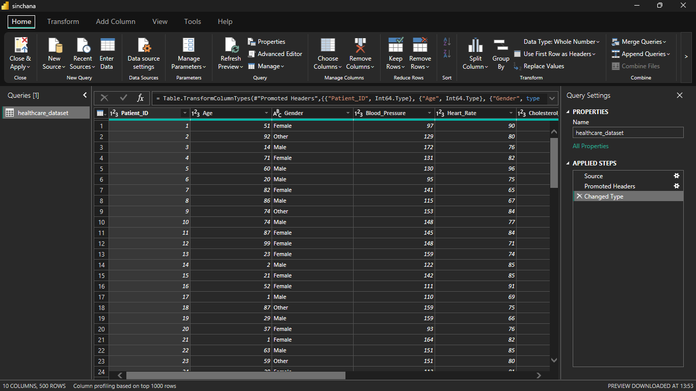
Figure1.1: Transformed Data used for visualizations

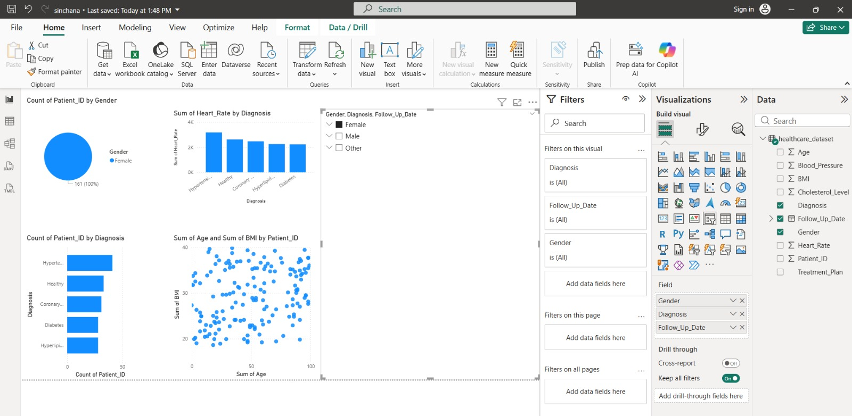

Figure 1.2: Interactive Dashboard using Power BI visualization tool

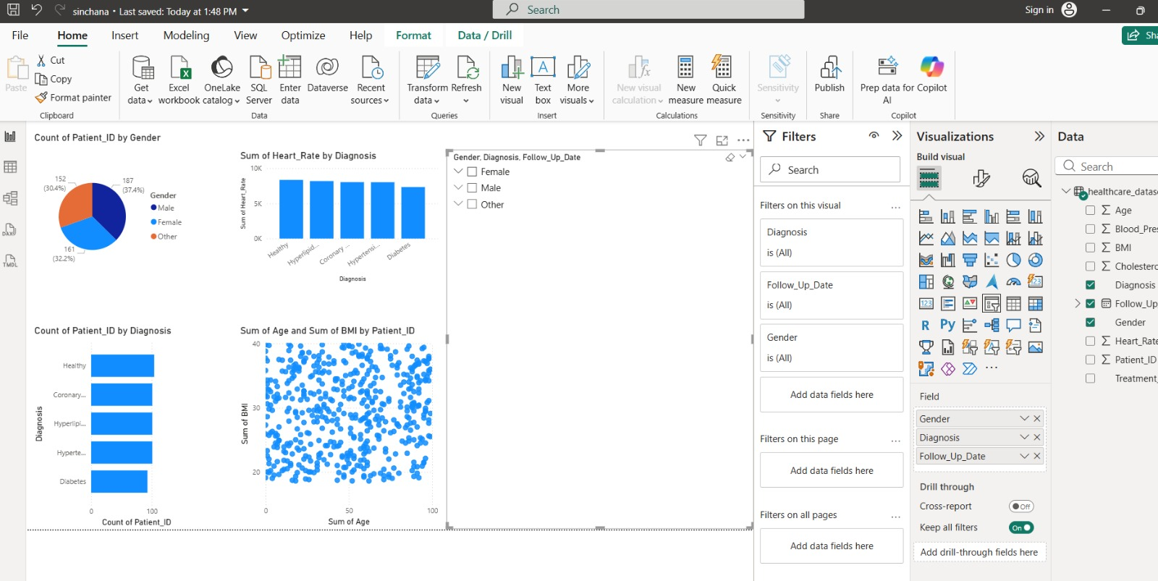

Figure 1.3: Interactive Dashboard using Power BI visualization tool

Data Set Used: https://www.kaggle.com/datasets/sanlavisingh/healthcare-dataset-csv-32-13-kb

Conclusion:

The Healthcare Analytics system demonstrates how Big Data technologies improve hospital decision-making.
By using Power BI for visualization and Big Data tools like Hadoop and Spark for storage and processing, large healthcare datasets were transformed into meaningful insights.
The dashboard helps:
• Monitor patient trends
• Improve recovery outcomes
• Optimize hospital resources
• Support data-driven medical decisions
This project successfully showcases the application of Big Data Analytics in Healthcare Management.

TASK 2: BI vs Big Data – Role Play

Scenario: A hospital administration office. Manager is frustrated, looking at fragmented patient readmission reports. Consultant is leaning against the desk, holding a tablet showing a live data stream.
Manager: I’ve been running these SQL queries for three hours. I can see who came back to the ER within 30 days, but I can’t tell why it keeps happening. My Excel dashboard just shows me the "what," not the "how."
Consultant: That’s the classic wall of Traditional BI. You’re looking at structured billing codes and discharge dates. But the "why" is buried in the 80% of data your SQL database can’t touch—doctor’s handwritten notes, pathology images, and even patient heart-rate telemetry.
Manager: We collect that stuff, but it stays in separate silos. SQL can’t join a cardiac waveform with a PDF of a nurse’s note.
Consultant: Exactly. That’s the first limitation. Traditional BI is like trying to diagnose a patient using only their ID card. Big Data in healthcare evolved because we realized that "unstructured" noise—like genomic data or live vitals—is where the real life-saving insights are.
Manager: So, Big Data is just "more" medical records?
Consultant: Not just more—it’s the Three Vs in a clinical context: Volume (terabytes of MRI images), Velocity (streaming data from ICU monitors), and Variety (social determinants of health, wearable data, and lab results).
Manager: Okay, but if my SQL server chokes on a few thousand rows of billing data, how does Big Data handle a million MRI scans?
Consultant: We use Hadoop. Think of it as a "team of specialists." Instead of one massive computer trying to analyze every scan in the hospital, Hadoop breaks the data into chunks and distributes it across a cluster of servers. They process the data in parallel and give you the result in seconds.
Manager: That sounds like a "distributed brain."
Consultant: Precisely. It’s cost-effective because you don't need a multi-million dollar mainframe; you just add more standard servers as your patient data grows.
Manager: Fine, Hadoop stores the images. But clinical data is messy—different doctors use different terms for the same cough. How do I query that "mess"?
Consultant: That’s the NoSQL advantage. SQL is like a rigid pill-dispenser; everything must fit perfectly. NoSQL is a flexible medical kit. You can store "document-style" data—like an entire patient history with varying formats—without breaking the system every time a new medical code is invented.
Manager: I’m a manager, not a data scientist. How does this improve patient outcomes?
Consultant: Right now, your BI tells you a patient died or was readmitted. With Big Data, we move to Predictive Analytics. We can feed live data from a bedside monitor into an algorithm that spots the tiny patterns of sepsis six hours before a human can see the symptoms.
Manager: Six hours? That’s the difference between a recovery and a tragedy.
Consultant: Exactly. It’s the difference between reading an autopsy report and performing a preventative check-up.
Manager: So, my SQL skills aren't useless?
Consultant: Not at all. You still need SQL for the "Clean Room" data—accounting and inventory. But for the "Emergency Room" data? You need Big Data.
Manager: Alright. I’m tired of looking at "what happened." Let’s see "what’s coming." Where do we start?
Consultant: Let’s pick one high-risk ward and build a small Hadoop-based data lake to ingest their live vitals.

TASK 3: Architecture Design Challenge

High Data Volume
- Massive patient records
- Large medical imaging files
- Distributed storage required.

High Data Velocity

Real-time ICU monitoring

Emergency data streaming

Low latency required.

Data Variety and Integration

Structured (lab reports)

Semi-structured (health logs)

Unstructured (X-rays)

Security and Privacy

• Patient data must be encrypted
• HIPAA-like compliance
• Role-based access control

TASK 4: Analytics & Tool Match

Business Question | Analytics Type | Tool Used
What happened? | Descriptive Analytics | Power BI
Why did it happen? | Diagnostic Analytics | Power BI (Drill-down Reports)
What will happen next? | Predictive Analytics | Spark ML
What action should be taken? | Prescriptive Analytics | AI-based Clinical Decision Systems

Bonus Challenge
“Explain Big Data to a 10-year-old”
Big Data is a huge amount of information that is collected every day from different places. It is much bigger than the data you can write in a notebook. Because it is so big, normal computers cannot handle it easily, so special computers are used to study it.
Imagine an ice cream shop. Every time someone buys ice cream, the shop writes down:
- Which flavor was bought
- How much it cost
- Whether it was hot or cold outside
Now imagine this happens every day, for many months, with thousands of customers.
Soon, the shop will have thousands and thousands of records. That huge collection of information is called Big Data.
Now, computers study this big information and find patterns, like:
- Chocolate sells more in summer
- More people buy ice cream in the evening
- Rainy days have fewer customers
Using this, the shop owner can:
- Make more chocolate ice cream in summer
- Plan better for busy days
So, Big Data is not just a lot of information — it is information that helps us learn patterns and make better decisions.
In simple words, Big Data is a giant collection of information that computers use to learn patterns and help people make smarter choices.

