**Assignment 4**

Group project (team of 2-3 people)

**Task 1.**

In this task use STL containers, algorithms and templated classes

Create struct or a class **Course**, which contains following attributes:

1. Name of the course
2. Number of students enrolled
3. Lecturer

Create multiple **Activities**:

1. class ACM with following attributes:
   1. Topic of the day
   2. Location – a **map** containing City as a key and an address as a value
   3. Number of presentations
2. Class IEEE with following attributes:
   1. Conference name
   2. Conference location
   3. Topics of the presentations – a **set** that contains topic names

Create a **templated** class **Student**, which contains following attributes:

1. Name of the student
2. ID (8 digit number)
3. Age
4. **Course** that student takes in the current semester
5. **Activities** – must be set by template for each Student object. Each student has only one activity

Overload stream insertion and stream extraction operators to insert data to the class as well as print it into the screen:

* std::cout << student_object – must print the table containing student information to the screen

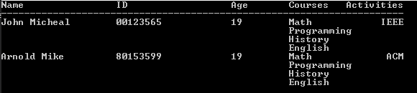

* std::cin >> student_object – must provide console interface to enter all data about student into the program (Name, ID, Age, Courses, Activites)

Do the same operator overloading for every other class.

Task 2.

Overload necessary operators to use your classes with following STL algorithms:

1. std::count()
2. std::find()
3. std::for_each()
4. std::count_if()

Demonstrate your code by creating a table of 6 students and applying each function as well as each overloaded operators for each of the classes

=====

1. Bonus: work with git and upload files to Github, have at least 3 commits. Provide link (+2%)
2. Penalty: similarity >70% (-100%)
3. Penalty: group_size <=1 (-15%)
4. Penalty: group_size >=3 (-40%)
5. Penalty: late submission (-5% for each hour)