Ilya Buglakov

**Task 02 report**

Running second subtask from console

Here are described the steps to launch second subtask from terminal using javac compiler.

1. First we need to launch command line (further cmd) in directory with source code of subtask02 application. In my file system it’s “d:\Repositories\epamJavaWeb\IlyaBuglakov\task02javac\

subtask02reverseargs\src\”.

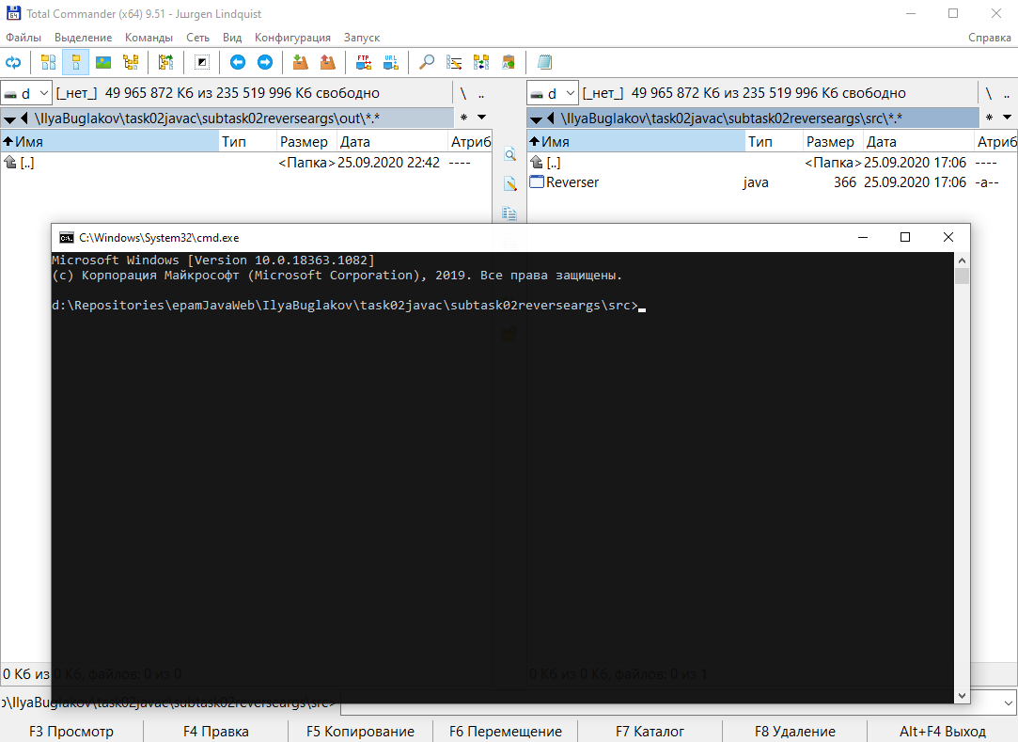

1. Now we need to compile source code. For this it is enough to execute “javac” program and pass as an argument the name of source code file – “Reverser.java”. Also we should use “-d” argument, to specify the compiler output location. In my case the path is “../out/”. Compiliation was successful.

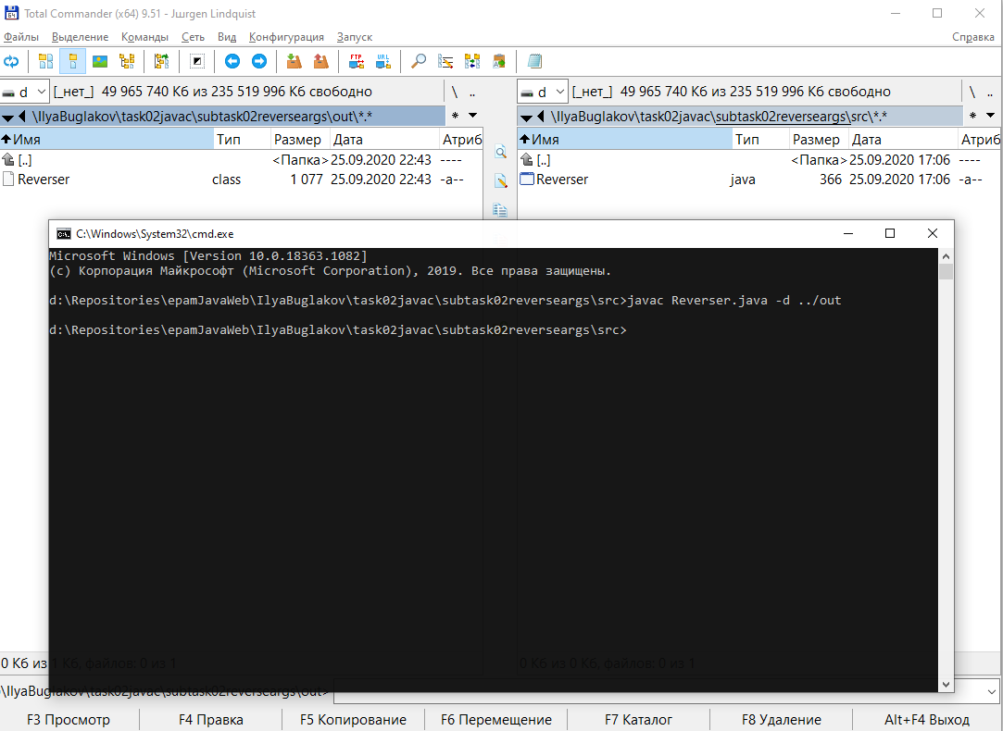

1. Now all we need to launch an application, is to go to the directory with compiled class and to run it. To move between directories, we can use “cd” command.

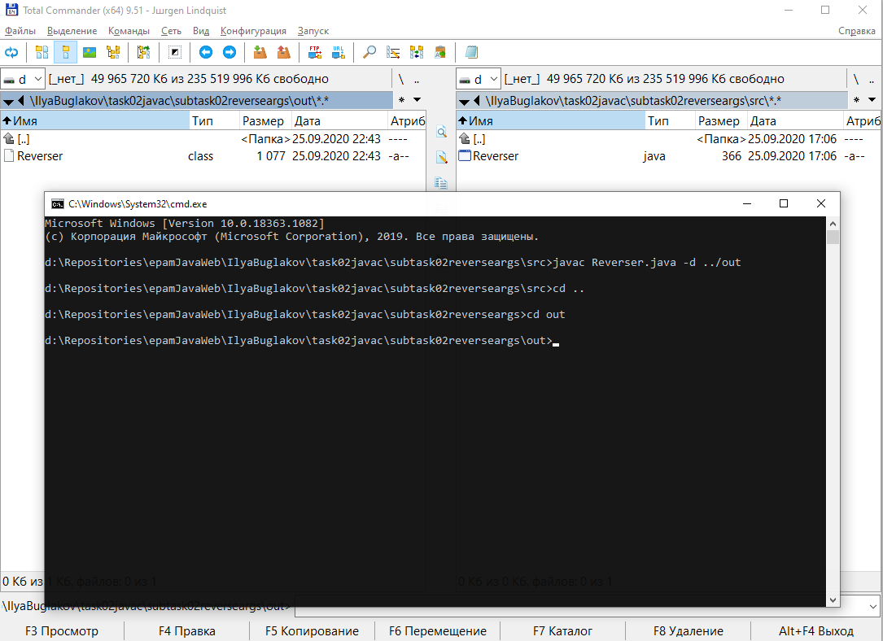

To check if here any files we can use “dir” command.

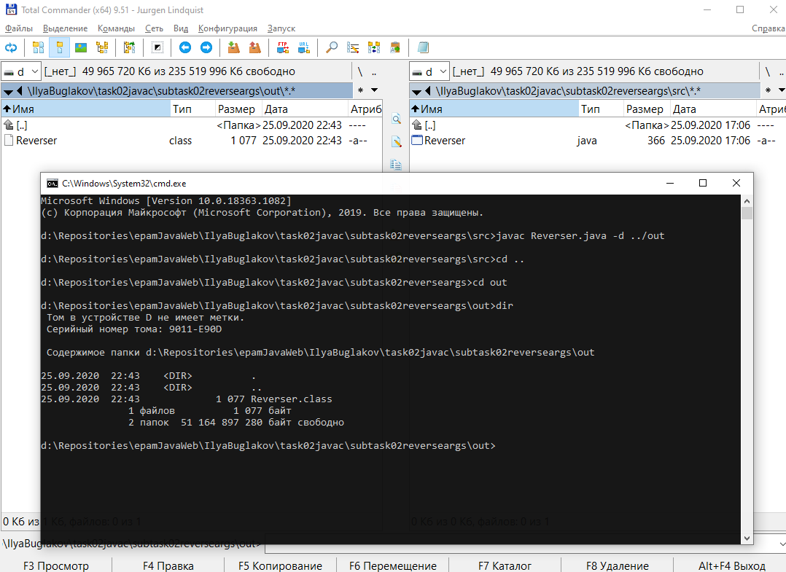

Now we can see here new file – “Reverser.class”.

All we now need is to use “java” application and run this .class file. Of course, passing the correct arguments.

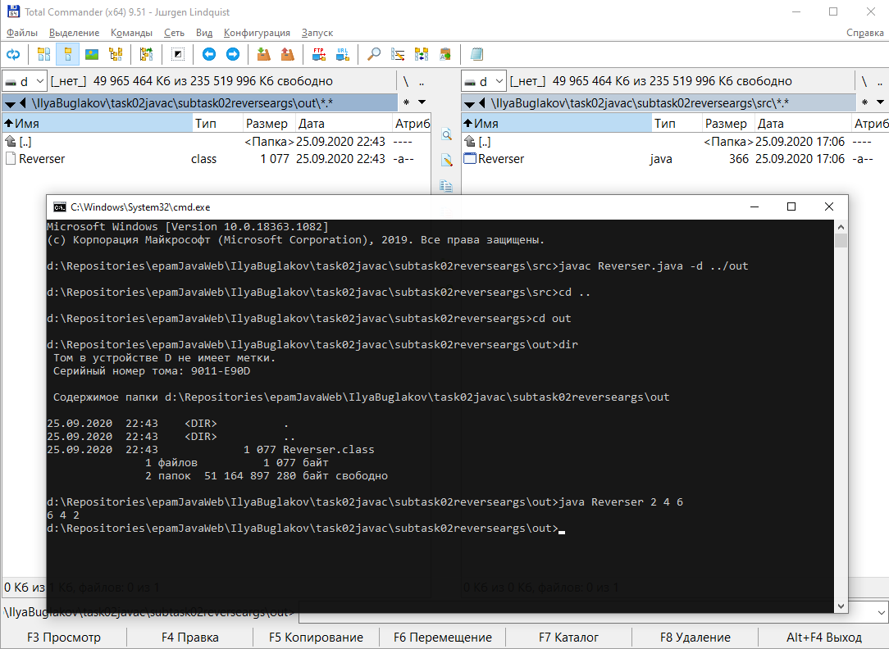

1. Here is the source code of this program

