Abstract

The modern high-speed development of society makes people face much stress, which can damage their mental or physical health. Stress has become an important social issue, and knowing our stress levels allows us an opportunity to relax or take a break at the right time. With current methods of checking stress relying on subjective questionnaires and other methods requiring specific equipment, noninvasive pupillometry with the widely available ubiquitous smartphone offers a scalable, cost-effective, and continuous stress monitoring method. Psychological stress can affect parasympathetic activity, reducing heart rate variability and increasing pupil. Heart rate variability and pupil changes can measure the activity of the autonomic nervous system and can show stress levels. This study will investigate smartphones' ability to capture psychological stress's effects on pupil size and assess the feasibility of mobile phone-monitored pupil index as a physiological indicator of stress level, using traditional heart rate variability as a validation test.

This study explored the changes in pupil size and HRV in response to mental stress. There were two experiments, the first with 18 people and the second with 17. The experimental results show that they are highly correlated probably because they are controlled by similar brain activity, and phones is able to detect this pupil change.

Acknowledgements

I would sincerely thank Prof. Leanne Chan, my supervisor. Prof. Chan's advice has been tremendously helpful throughout the whole FYP project. Without Professor Chan's professional guidance and criticism at every stage, this project would not have been successful.

Additionally, I sincerely thank every one of the volunteers for their participation in this study. Without their participation, I could not have gathered data for hypothesis testing and subsequent validation. I appreciate each participant's time and contributions, and I acknowledge that their cooperation in taking time out of their hectic schedules was essential.

Contents
Abstract i
Acknowledgements ii
Use of Generative AI (GenAI) Tools iii
Contents iv
List of Figures vi
List of Tables vii
1. Introduction 1
1.1 Background 1
1.2 Problem Statements 3
1.3 Objectives 4
2. Literature Review 5
2.1 Relationship between heart rate and stress level 5
2.2 Relationship between pupil size and stress level 6
2.3 Stress inducing methods 7
2.4 Pupil light reflex evoked by screen 8
2. Methodology 9
2.1 Prerequisites 9
2.2 Experimental Design 13
2.3 Experimental environment requirements 16
2.4 Subjects 17
2.5 Research ethics 17
2.6 Statistical analysis 17
3. Results and discussion 24
3.1 Results of Experiment on the effect of screen on pupil size 24
3.1 Discussion of Experiment on the effect of screen on pupil 25
3.3Result on the Influence of Different Stress Levels on Heart Rate Variability in the first experiment 26
3.4 Discussion on the Influence of Different Stress Levels on Heart Rate Variability in the first experiment 27
3.5 Result on the Influence of Different Stress Levels on Pupil Size in the first experiment 28
3.6 Discussion on the Influence of Different Stress Levels on Pupil Size in the first experiment 29
3.7 Result on the Interdependence of Pupil Size and Heart Rate Changes in Stress-Induced Conditions 30
3.8 Discussion of Interdependence of Pupil Size and Heart Rate Changes in Stress-Induced Conditions 31
3.10 ANOVA Result of HRV in Second Experiment 33
3.11 Discussion on ANOVA Result of HRV in Second Experiment 34
3.12 ANOVA Result of Ratio in Second Experiment 34
3.13 Discussion on ANOVA Result of Ratio in Second Experiment 35
3.14 Result on Post-hoc analyses in HRV 36
3.13 Discussion on Post-hoc analyses in HRV 38
3.15 Discussion on Post-hoc analyses in Pupil Size 40
3.16 Result on Analysing the Interdependence of Pupil Size and Heart Rate Changes in Stress-Induced Conditions 41
3.16 Discussion on McNemar's test 44
3.17 Limitation 44
4.Conclusion 45
4.1Project outcomes 45
4.2Future work 45

List of Figures
Figure 1 | The mobile phone used in this experiment | P.9
Figure 2 | Scosche Rhythm 24 | P.10
Figure 3 | optical heart rate sensor | P.10
Figure 4 | IDetect startup interface | P.11
Figure 5 | Screenshots during testing | P.11
Figure 6 | Test Results | P.11
Figure 7 | Detection start interface | P.12
Figure 8 | Screenshots during testing | P.12
Figure 9 | Test Results | P.12
Figure 10 | Flow diagram of the experiment of the effect of Screen Luminance on Pupil Size | P.13
Figure 11 | Flow diagram of first experiment procedure | P.14
Figure 12 | Flow diagram of second experiment procedure | P.15
Figure 13 | Experiment Setup | P.16
Figure 14 | Sign test results of Screen Effects(Screen Effects) | P.24
Figure 15 | Wilcoxon signed rank test(Screen Effects) | P.24
Figure 16 | Sign Test (HRV) on experiment one | P.26
Figure 17 | Wilcoxon signed rank (HRV) on experiment one | P.26
Figure 18 | Sign Test (Pupil Size) on experiment one | P.28
Figure 19 | Wilcoxon signed rank(Pupil Size) on experiment one | P.28
Figure 20 | McNemar's test on experiment one | P.30
Figure 21 | ANOVA Result of HRV in Second Experiment | P.33
Figure 22 | Violin Plot with Boxplot for HRV | P.33
Figure 23 | ANOVA Result of Ratio in Second Experiment | P.34
Figure 24 | Violin Plot with Boxplot for | P.35
Figure 25 | Bar Plot of HRV Result | P.36
Figure 26 | Bar Plot of Pupil Size Result | P.38

List of Tables
Table 1 | Contingency table on experiment one | P.30
Table 2 | Sing Test Result(HRV) | P.36
Table 3 | Wilcoxon rank sum test Result(HRV) | P.37
Table 4 | Sing Test Result(Pupil Size) | P.39
Table 5 | Wilcoxon rank sum test Result(HRV) | P.40
Table 6 | R1 vs R2 Contingency Table | P.41
Table 7 | R1 vs Level1 Contingency Table | P.41
Table 8 | R1 vs Level15 Contingency Table | P.41
Table 9 | R2 vs Level1 Contingency Table | P.42
Table 10 | R2 vs Level15 Contingency Table | P.42
Table 11 | McNemar's test Result | P.43

1. Introduction

1.1 Background
Hong Kong is a well-developed international financial center with a high economic income for its citizens. However, the bustling urban lifestyle imposes pressure on its residents. It has become customary for people in Hong Kong to work excessive hours. A survey among employees in Hong Kong revealed that the average weekly working hours stood at a staggering 49.6 hours; compared with other developed regions, it was very high. The report also states that 82% of respondents feel stressed about their work environment [1].

On the other hand, Hong Kong's consumer price index is also significantly higher than other developed regions; the citizens living there must face high expenses for housing, food, transportation, and other necessities. With both lengthy work time and high living costs, Hong Kong people have been facing relatively high pressure in their daily lives for an extended period.

Experiencing stress over time will affect our physical and mental health. It can cause ailments consisting of melancholy and anxiety, affecting our mental fitness. Stress will activate the body's sympathetic apprehensive gadget and become overactive, resulting in abnormal physical, psychological, and behavioral situations [2]. The accumulation of stress has been related to a boom in tension and despair. Overstress can even affect our physical health, such as leading to headaches or cardiovascular disease. Hence, it is vital to perceive strain and find time for relaxation to shield our health.

The Hospital Authority's Mental Health Review Report [3] provided an estimate of the percentage of Hong Kong's population with mental health illnesses as 13% or around 886,000 people. The mental disorder in Hong Kong may be greater than the present reported rates. So, we need a convenient and effective way to track mental health.

However, contemporary stress testing depends mainly on subjective questionnaires and a shortage of non-stop monitoring. Recently, pupillary metrics and Heart Rate Variability (HRV) have emerged as candidate biomarkers for objectively comparing strain levels [4]. Commonly used physiological signs consist of adjustments in coronary heart fee, blood pressure, pores, and skin conductance. Although these methods are feasible for reporting stress responses objectively, they need a specialized device and cannot be used for daily monitoring. The smartphone's front camera can be a handy physiological indicator with potential.

Previous studies have revealed that changes in pupil size can reflect an individual's psychological stress levels. Hess and Polt [5] found that variations in pupil size while performing simple multiplication problems can directly measure the level of cognitive effort. The pupillary response reflects not only the presence of mental activity but also demonstrates that cognitive demand is closely linked to the problem's difficulty, with pupil diameter increasing as the problem becomes more challenging. Pedrotti et al. [6] demonstrated that pupil diameter signal discriminates well for stress detection. Unlike other physiological stress indicators, the pupil diameter can be measured unobtrusively [6].

Smartphones are widespread in Hong Kong, with over 97% of citizens at least owning one as of 2023[7]. The widespread adoption of smartphones provides excellent potential for leveraging built-in cameras to monitor pupillary metrics conveniently. Recent smartphone models contain high-resolution front-facing cameras and dedicated processors optimized for computer vision tasks. By installing a pupillometry app, smartphones can capture changes in pupil diameter triggered by emotional arousal and cognitive workload.
Compared to other devices, smartphone-based pupillometry permits More cost-effective and more convenient daily tracking of everyday activities. The excessive penetration of smartphones in Hong Kong gives a unique potential for scaling up this pressure screening technique locally.
This project aims to determine whether or not the ratio of pupil length and iris length detected through telephone cameras can function as the correct physiological indicator.

1.2 Problem Statements

Much literature proposes that persistent stress can affect an indicator of an individual's physical health and mental health, causing adverse effects. However, current methods of stress evaluation are primarily based on subjective self-reports, including questionnaires, while other objective methods require specific instruments, including brainwave testing. Recently, pupil size measurements have received increased interest as a physiological stress biomarker due to their non-invasive and fast-changing nature. However, many studies have confirmed the link between pupillary changes and stress levels. However, they also use specific instruments, such as eye-tracking instruments. The public does not have this device at home and would like to find out if other simple devices can detect this change.

The project induced different levels of cognitive load to control participants' stress levels precisely. At the same time, physiological data such as pupil changes and heart rate variability were also collected. By revealing the inner connection between pupil response, heart rate changes, and stress states, this study provides a new technological approach for continuously assessing stress in clinical and non-clinical settings. The results are expected to expand the use of smartphones as stress assessment tools. It will bring new monitoring methods for stress management.

1.3 Objectives
Current stress assessment methods depend basically on subjective self-reporting, Such as questionnaires. The other objective methods, such as heart rate variability and brain wave monitoring, require unique equipment. This study aims to validate whether pupil statistics captured via a smartphone camera can provide an accurate and objective physiological indicator of stress. It is hoped that it can be used as a daily detecting method.

This research will collect pupil indicators (pupil-iris ratio) and Heart Rate Variability for the period of a cognitive load assignment. I assume that pupil parameters are correlated significantly with perceived stress and use heart rate variability as a validation metric.

Compared to other biomarkers, such as HRV and EEG, which require specialized equipment, pupillometry through ubiquitous smartphones can be used as a cost-effective and convenient method for continuous stress monitoring.

In conclusion, this study aimed to validate the feasibility of using pupillary changes detected by smartphones as a biomarker.

2. Literature Review

2.1 Relationship between heart rate and stress level

Many studies have also shown a significant relationship between stress levels and heart rate. When a person is under high levels of stress, the autonomic nervous system (ANS) will be activated, which leads to biological responses such as vasoconstriction, increased blood pressure, muscle tension, and changes in heart rate (HR) and heart rate variability (HRV)[8]. As the physiological response to stress causes a decrease in the heart rate variability

The heart price will increase in the presence of an acute stressor, but HR can also become aware of lengthy periods of mental strain. According to Järvelin-Pasanen et al. [9], a systematic review integrating increased workplace stress was associated with reduced heart rate variability. Compared to the low work stress group, the workers with a high effort-low reward imbalance represent the high work stress group; they had higher blood pressure during the day and a 6.8 bpm higher heart rate [10]. Chronic stress also affects the heart rate variability.

The study by Carvalho et al. found that critical care nurses had a significant decrease in heart rate variability (HRV) parameters after a 6-hour work shift, and most of these nurses were classified as having medium to high occupational stress levels [11]. This shows that HRV can detect pressure. Continuously monitoring HRV makes it possible to know where you are in terms of stress level.

In summary, many studies have indicated that heart rate variability has a relationship with stress, whether acute or chronic.

2.2 Relationship between pupil size and stress level
Studies have shown that increasing cognitive load results in more significant pupil dilation than simple tasks, indicating that cognitive activation inhibits parasympathetic outflow [12]. Pupil dilation has been demonstrated to correspond to exposure to experimental stressors, and pupil diameter is a sensitive indicator of the perception of acute stress responses. Although most studies examine pupillary changes under experimental conditions, sustained pupil dilation would also be observed under real-life chronic stress. This is because when a person is long-term in stressful, his nervous system is also chronically activated.

Neuroscience research has revealed a tight correlation between the activity of the LC-NE system and pupillary dilation [13]. This system is critical in regulating emotion and attention and is related to stress responses in all individuals. Different physical indicators, such as psychological and physiological factors. It may also cause pupil dilation or constriction, making pupil size become a potential indicator of mental states such as stress and mood.

As reported by Afer et al [14], "VR tasks were implemented to induce stress, while simultaneously measuring and evaluating users' pupil diameters and pulse rates based on self-reported stress levels. The results showed a statistically significant correlation between self-reported stress and users' pupil dilation and pulse rates."

Yamanaka showed that as time pressure increased (with shorter time limits), subjects' LF/HF ratio (low frequency/high frequency ratio, reflecting sympathetic and parasympathetic nervous activity) and pupil diameter significantly increased [9]. This reflects the fact that acute pressure can be detected by the diameter of the pupil.

P. F. Lee and L. K. Shan argued that the changes in pupil diameter are closely related to mental stress and changes in autonomic nervous system activity, suggesting that measuring pupil diameter has the potential to become a convenient method for assessing mental stress [15]. They was able to control the pressure level by varying the degree of difficulty and concluded that the pupil size increases with the pressure level.

In summary, substantial evidence indicates that acute and chronic stressors can cause pupil dilation due to the activation of the LC-NE system. Pupillometry is a promising method for objectively measuring absolute environmental stress levels. Further study of how individual variation in pupillary reactivity relates to stress outcomes may uncover new applications for stress management.

2.3 Stress inducing methods

Cognitive load is the amount of capacity the brain approaches while acting a challenge. High cognitive load can cause a lack of working memory capability, which can negatively affect challenge overall performance, leading to stress. Galy et al. [16]suggested that task difficulty directly affects cognitive load, such that time pressure could activate a neurological system response, which would have a cascading effect on stress. They explained that time pressure involves a conflict between the designated completion time for a task and the actual time required, eliciting strong emotional reactions.

Dedovic and colleagues [17] manipulated cognitive load levels through experimental challenge designs to exceed individuals' abilities and impose time constraints. Their research shows that failure on a challenge blended with a loss of perceived control, particularly when evaluated through others, successfully induces stress. The latest research has precisely leveraged gaming environments to control and range stress levels. Yelamanchili et al.[18] showed Tetris' efficacy in eliciting specific person states like tension and immersion. Specifically, placing more significant difficulties in Tetris led to drastically extra anxiety among players.

Overall, the literature above suggests that challenge demands that surpass working memory capability or elicit negative emotions, consisting of time stress or out of control, can increase cognitive load and result in stress. Controlled gaming environments additionally provide possibilities to evaluate stressful states systematically.

2.4 Pupil light reflex evoked by screen

The pupil responds to light, which is an automatic response by the nervous system. Ellis [19] suggested that the pupil would vary in different light conditions; in bright situations, the response would shrink and dilate in reaction to dark situations.

Research done by Santos et al. [20] compares the changes in pupil size to different reading methods, such as smartphones, computers, tablets, and print material. They found that when digital gadgets are used, there is a considerable decrease in pupil length compared to print material. The brighter light emitted from digital displays triggers decreased pupil size compared to reading print material.

Overall, Pupils unconsciously constrict and dilate in response to reflections of light in response to surrounding brightness levels. In addition, when exposed to the screen of an electronic device with enhanced brightness, it will also result in a smaller pupil size.

2. Methodology

2.1 Prerequisites
2.1.1Hardware

Smart Phone (Android Operating System)

Requirement:

- Android 10.0 or above (google Pixel 4 used in this experiment)

- Requires a front lens of 8 million pixels or above.
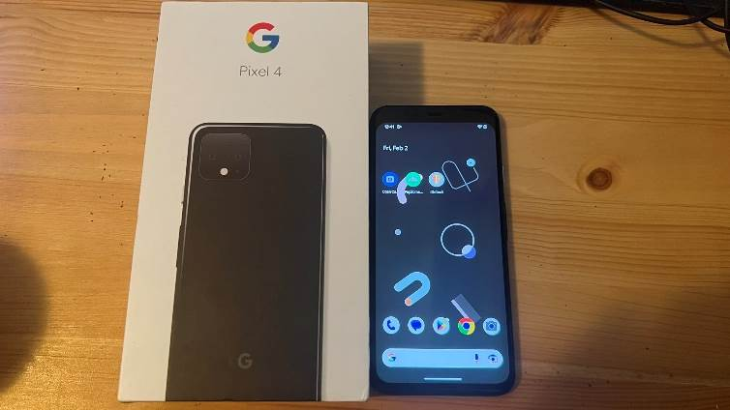

Figure 1-The mobile phone used in this experiment
Mobile Phone Holder
The mobile phone holder is used to hold the mobile phone securely. Its adjustable metal structure allows free adjustment of both the angle and distance. This makes it possible to position the phone at the optimal angle to capture clear-eye images for analysis. The holder provides stable support while allowing flexible positioning of the phone's camera directly in front of the user's eyes. This ensures high-quality images can be captured efficiently for accurate iris recognition and gauges pupils' size ratios through changes over time.

Armband-Scosche Rhythm 24
The Scosche Rhythm 24 is a heart rate-monitoring sports watch that allows wearers to monitor their heart rate and exercise intensity through its built-in optical heart rate sensor. It can connect to various applications via Bluetooth to display heart rate data on the user's smartphone. This study used it to collect heart rate variability (HRV) data by connecting to the Elite HRV application to record beat-to-beat heart rate over time for HRV analysis.

Reece et al. [21] found that the Scosche Rhythm 24 armband displayed acceptable agreement across all conditions tested, as evidenced by mean bias within ±1 bpm, MAPE <5% for all conditions, satisfying the CTA standards for returning valid heart rate measures during rest, lifestyle activity, walking, jogging, and cycling. Provide possibilities to evaluate stressful states systematically.

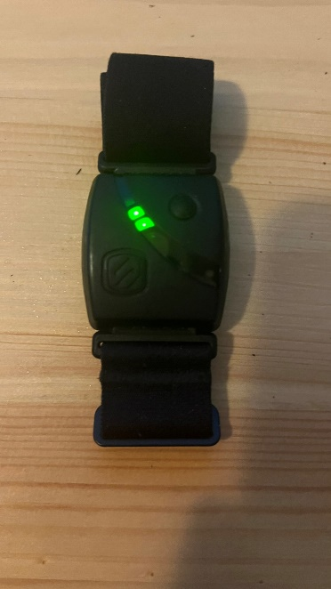 | 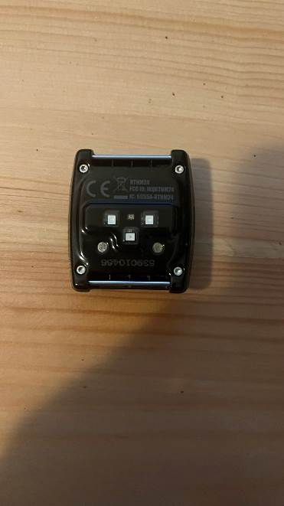
Figure 2 - Scosche Rhythm 24 | Figure 3 - optical heart rate sensor

2.1.2 Software
IDetect

A former graduate developed this eye-tracking program. It utilizes YOLO5, a state-of-the-art object detection model. In low-light environments, it can accurately identify pupils and irises.
This software calculates the ratio between pupil and iris diameters from data collected over a five-minute or one-minute period. In this study, this application was used to monitor pupil changes at different levels of stress.

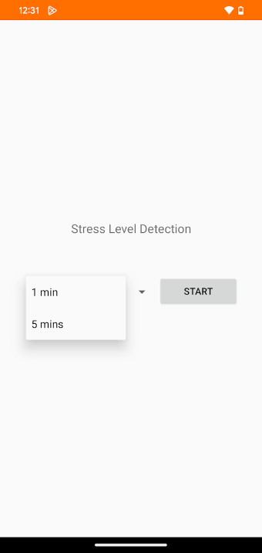 | 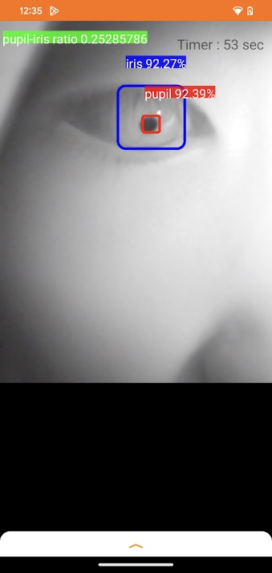 | 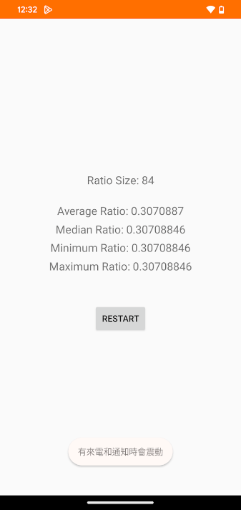
Figure 4- IDetect startup interface | Figure 5 - Screenshots during testing | Figure 6 - Test Results

Eite HRV

Elite HRV is a smartphone app that measures heart rate variability (HRV) by connecting to different detection heart rate devices via Bluetooth; it records the changes in heart rate over a while and provides HRV metrics.

Research has shown that Elite HRV provides valid HRV measurements that correlate with electrocardiogram readings, the gold standard method. A gold standard electrocardiogram is a reliable traditional method. Moya-Ramon et al. [22] found that the Elite HRV smartphone application demonstrated high validity and reliability compared to ECG, as evidenced by no significant differences in supine and seated positions and good reliability between tests. This application will be used to collect HRV data in this experiment.

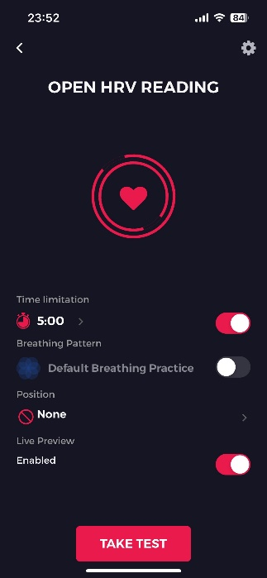 | 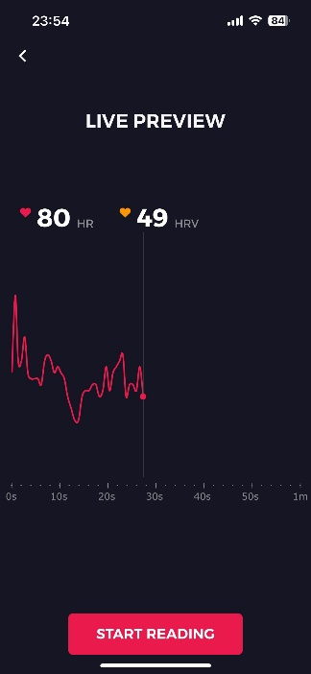 | 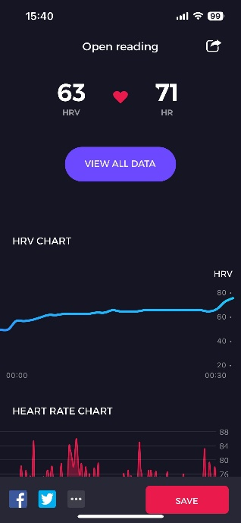
Figure 7- Detection start interface | Figure 8 - Screenshots during testing | Figure 9 - Test Results

2.2 Experimental Design

Pre-study -Effect of Screen Luminance on Pupil Size
This experiment aims to analyze whether light exposure from the screen could cause bias in the experimental data.

Procedure:

- Record the pupil ratio of participants in an environment with a screen.
- Record the pupil ratio of participants in an environment without a screen.
- Conduct a significance analysis to determine if the screen affects pupil ratio measurements.
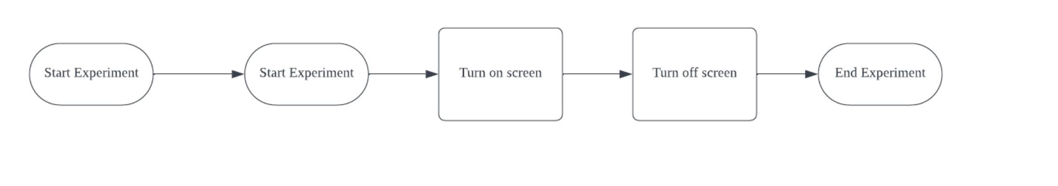
Figure 10- Flow diagram of the experiment of the effect of Screen Luminance on Pupil Size

Validating Physiological Indicators as Stress Markers
This study aims to collect participants' heart rate and pupil ratio and correlate them with the corresponding stress levels to analyze whether pupil ratio can serve as a reliable indicator of stress level. Previous research by Yelamanchili et al. [18] showed that Tetris can elicit different user states, such as anxiety and immersion. Specifically, setting higher difficulties in Tetris resulted in significantly more anxiety reported by players. This experiment will use Tetris as a method to control stress.
In the current study, level one of the game will represent a normal stress state, while a high level will represent a relatively higher stress state than physiological measures. I conducted two Stress level experiments. I summarized the issues with the first experiment in the second experiment, which had a more comprehensive setup.
First Experiment Procedure:
- Participants randomly play the Tetris game for 5 minutes at an easy or difficult level.
- Use a front-facing phone camera and an app to record and calculate the ratio of pupil to iris.
- Simultaneously, a wristband was used to record heart rate variability data.
- Take a 5-minute break.
- Participants play the Tetris game for 5 minutes at the opposite level (easy or difficult) from Step 1.
- Repeat Steps 2 and 3 to record data.
- Analyze the relationship between pupil-to-iris ratio and heart rate variability and establish correlations with stress levels.
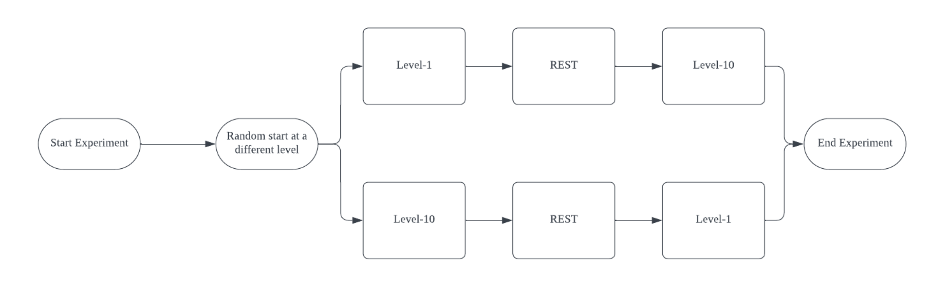
Figure 11- Flow diagram of first experiment procedure

Second Experiment Procedure:
- Repeat Steps 1-6 from the first experiment.
- Before starting, record resting pupil-to-iris ratio and heart rate data for analysis as baseline data.
- Allow participants to wear glasses to reduce stress and difficulty due to vision impairment.
- Wear the wristband on the hand not operating the computer to avoid interference with heart rate variability readings.
- Analyze the data and establish correlations between the measured indicators and stress levels.
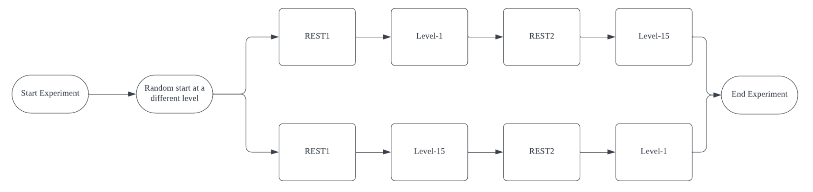
Figure 12- Flow diagram of second experiment procedure

2.3 Experimental environment requirements
During first experiment, the participants were not allowed to wear eyeglasses. Nearsighted participants may need to view the screen from a closer distance. For the second experiment, participants are allowed to wear glasses.

Participants will need to complete the testing in a dimly lit room to help minimize the effects of pupil light response on the measurements. A darker environment may also allow the phone app to be more accurate in its readings since there will be less noise in the images collected.

The experiment will take place in an identical or similar classroom. The room mainly used for this study is Y5-302 to ensure testing occurs in a controlled environment.
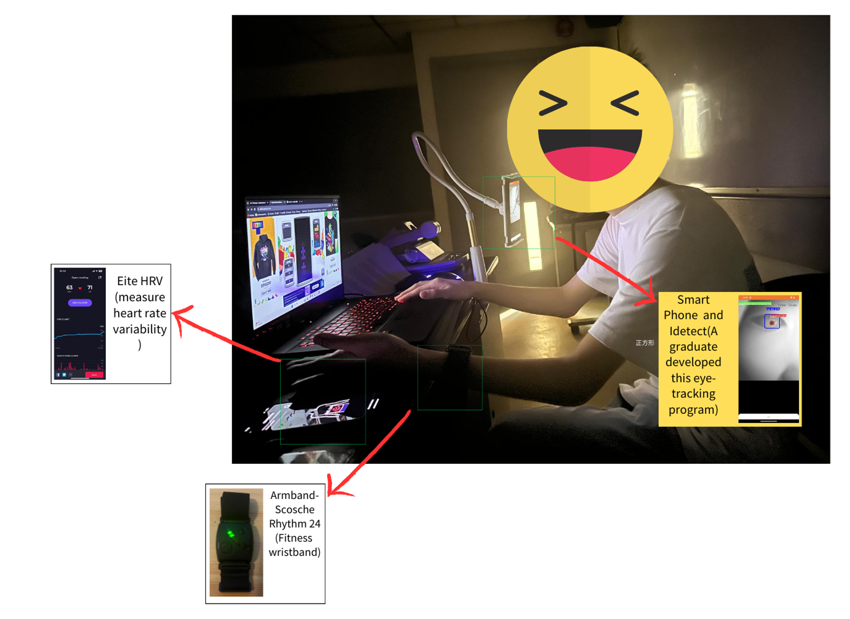
Figure 13- Experiment Setup

2.4 Subjects
For the first experiment, eighteen college students participated in the study; among them, ten had normal vision, and eight wore glasses. Seventeen college students participated in the second experiment. Six of the subjects participated in an experiment to analyze the effect of the screen on pupil measurements.

2.5 Research ethics
Before experimentation, all volunteers were informed about the study's purpose, procedures, and requirements. They were asked to sign a consent form to confirm their voluntary participation and understanding of the experimental conditions. Participants' face areas were videotaped throughout the experiment. These video recordings helped ensure the study results' accuracy and completeness.

2.6 Statistical analysis
This project mainly uses R programming language to analyze data. R language is a free software programming language mainly used for statistical analysis, graphics, and data exploration. To analyze the data, record it in an Excel file and import it into R. It has a rich database that can conveniently do different hypothesis tests to analyze data.

Effect of Screen Luminance on Pupil Size

- Assessing the Significance of Screen Effects on Pupil Size
Due to the small sample size and the lack of assumptions regarding the normality of the pupil size data distributions, two non-parametric tests were considered:

The sign test is appropriate for analyzing the signs (positive or negative) of the differences between paired observations without making assumptions about the underlying distribution.

The Wilcoxon signed-rank test is suitable for comparing two related or paired samples by analyzing the ranks of the differences between observations.

Null Hypothesis (H0): The distributions of pupil size with and without screen influence are the same.

Alternative Hypothesis (H1): The distributions of pupil size with and without screen influence are different.

Validating Physiological Indicators as Stress Markers
First Experiment

- Analyzing the Influence of Different Stress Levels on HRV
Due to the relatively small sample size obtained in this study, non-parametric statistical tests were deemed appropriate for analyzing the effect of stress levels on HRV. Non-parametric tests do not rely on assumptions of normality in the data distribution, making them suitable for small sample sizes. Specifically, the Wilcoxon signed-rank test was used to compare the median pupil sizes between the two stress level conditions (high and low stress) for paired samples. Additionally, to provide further insight into the differences in pupil size between the two stress levels, a sign test was conducted. The sign test is a non-parametric test that analyzes the signs (positive or negative) of the differences between paired observations, without making assumptions about the underlying distribution.

Hypotheses:

Wilcoxon Signed-Rank Test:

H0: The median pupil size under high stress conditions = the median pupil size under low stress conditions.
H1: The median pupil size under high stress conditions ≠ the median pupil size under low stress conditions.

Sign Test:

H0: The central location of the paired differences in pupil size between high and low stress conditions = 0.
H1: The central location of the paired differences in pupil size between high and low stress conditions ≠ 0.

- Analyzing the Influence of Different Stress Levels on Pupil Size
Similarly to the analysis above based on data non-normality, apply the appropriate statistical test Wilcoxon signed-rank test, and sign test to analyze the effect of stress levels on pupil size.
Hypotheses:

Wilcoxon Signed-Rank Test:
H0: The median pupil size under stress conditions ≤ the median pupil size under normal conditions.
H1: The median pupil size under stress conditions > the median pupil size under normal conditions.

Sign Test:
H0: The central location of the paired differences in pupil size between stress and normal conditions = 0.
H1: The central location of the paired differences in pupil size between stress and normal conditions ≠ 0.

3.Analyzing the Interdependence of Pupil Size and Heart Rate Changes in Stress-Induced Conditions
Contingency table

Creating a 2x2 contingency table that shows the frequency of combinations of HRV and pupil size changes. The rows of the contingency table represent the binary classification of HRV, while the columns represent the binary classification of pupil size.
McNemar's test

McNemar's test is a statistical test for comparing two related data, usually applied to data on binary variables from the same set of physical examination samples under different conditions or at different points in time. It tests whether there is a significant difference between the two measurements.
Hypotheses:

Null hypothesis (H0): There is no significant difference between pupil size changes and heart rate changes under different stress levels.

Alternative hypothesis (H1): There is a significant difference between pupil size changes and heart rate changes under different stress levels.

Second Experimental
The participants undergo two gaming conditions:
G1: Easy level (Normal state)
G2: Difficult level (Stress state)
A baseline measurement (R1) is taken before starting, and the two gaming conditions have a break (R2).

1.One-Way ANOVA

One-Way Analysis of Variance (One-Way ANOVA) is a statistical method used to compare the means of three or more independent sample groups to determine if there are any statistically significant differences between them. It tests the influence of a single independent variable (factor) on a continuous dependent variable.

Repeated measures of one-way ANOVA were used to test whether the main effect of difficulty levels on the ratio or HRV was significant.

If a significant main effect is observed, post hoc multiple comparisons using sign tests and the Wilcoxon signed-rank test are used to determine which specific difficulty levels differ significantly.

2. Post-hoc analyses

If the ANOVA results showed a significant main effect of difficulty level, post-hoc analyses were needed to compare further and identify significant differences between specific difficulty level pairs.

Sign and rank-sum tests were conducted as post-hoc analyses to investigate whether there were significant differences in pupil ratio and HRV measures between the various difficulty level conditions (R1, R2, Level 1, Level 15).

Hypotheses:

For the sign tests:
Null Hypothesis (H0): The proportion of positive differences between the two conditions is 0.5
Alternative Hypothesis (H1): The proportion of positive differences between the two conditions is not equal to 0.5

For the Wilcoxon rank-sum test:
Null Hypothesis (H0): The distributions of the two conditions are the same.
Alternative Hypothesis (H1): The distributions of the two conditions are different.

3.Analyzing the Interdependence of Pupil Size and Heart Rate Changes in Stress-Induced Conditions

Contingency table

Creating a 2x2 contingency table that shows the frequency of combinations of heart rate variability (HRV) and pupil size changes. The rows of the contingency table represent the binary classification of HRV, while the columns represent the binary classification of pupil size changes.

This contingency table can clearly show whether the two physiological indicators, HRV, and pupil size, have a consistent pattern of change (diagonal elements) or an inconsistent change (off-diagonal elements) under a given stress level.

McNemar's test

McNemar's test is a non-parametric statistical test used to analyze paired dichotomous categorical variables

Hypotheses:

Hypotheses Null hypothesis (H0): There is no significant difference between pupil size changes and heart rate changes under different stress levels.

Alternative hypothesis (H1): There is a significant difference between pupil size changes and heart rate changes under different stress levels.

3. Results and discussion

3.1 Results of Experiment on the effect of screen on pupil size
Sign test
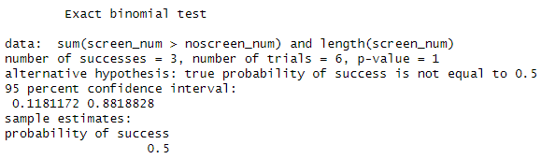
Figure 14- Sign test results of Screen Effects(Screen Effects)

Figure 14 shows the sign test (exact binomial test) result no evidence to reject the null hypothesis of probability of difference = 0.5 (p-value = 1). The 95% confidence interval (0.118, 0.882) for the probability of success is very wide.

Wilcoxon signed rank test
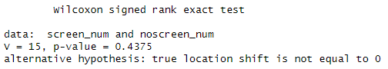
Figure 15- Wilcoxon signed rank test(Screen Effects)
The Wilcoxon signed rank test showed in Figure 15 did not find a statistically significant difference between the Pupil size with or without screen vectors (p-value = 0.4375 >0.05). The high p-value indicates the data is consistent with the null hypothesis of difference.

3.1 Discussion of Experiment on the effect of screen on pupil

This experiment aimed to study how screen light affects human pupil size during the procedure, analyzed pupil size data from 6 participants under the dimmest screen light setting. Neither the signed test (p=1) nor the Wilcoxon signed rank test (p=0.4375) indicated a statistically significant difference between the two pairs. Overall, the data did not provide enough evidence to reject the null hypothesis of no difference.

In conclusion, the screen light in the experiment set to a minimum intensity level did not significantly affect pupil constriction. This is likely because the light intensity was too low to influence how the pupil regulates itself notably. Therefore, screen light can be ruled out as a potential confounding factor in future experiments studying how stress level affects pupil size.

3.3Result on the Influence of Different Stress Levels on Heart Rate Variability in the first experiment
Sign Test
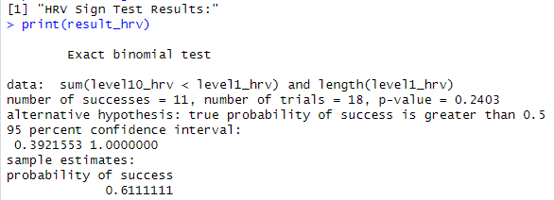
Figure 16- Sign Test (HRV) on experiment one
The exact binomial test showed in Figure 15- that in 18 trials, the HRV of Level 15 difficulty was less than the HRV of Level 1 difficulty 11 times. However, the non-significant p-value of 0.2403 lacks evidence to support the hypothesis that level 15 would significantly reduce heart rate variability.
Wilcoxon Signed Rank Test
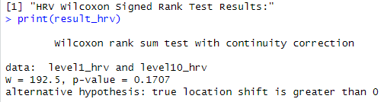
Figure 17- Wilcoxon Signed Rank Test(HRV) on experiment one
The Wilcoxon signed-rank test showed in Figure 17 with continuity correction compared HRV values at level 1 and level 15. The p-value of 0.1707 is more significant than the typical 0.05 significance level. Therefore, there may not be enough evidence to prove that HRV values are significantly higher at level 15 compared to level 1 difficulty.

3.4 Discussion on the Influence of Different Stress Levels on Heart Rate Variability in the first experiment
Based on the sign test and Wilcoxon signed rank test results, there was no evidence of a significant difference in heart rate variability (HRV) between levels 1 and 15 of difficulty. Possible reasons for the lack of a significant difference in HRV between the two difficulty levels are as follows:
1. In this experiment, a Tetris level of 10 May needs challenging individuals with speedy reactions, including those who often play computer games. They could have kept up with the game tempo without experiencing significant stress. While stress induces sympathetic arousal, mainly to lower coronary heart price variability, the game's difficulty would not have been sufficiently stimulating to activate the sympathetic nervous system and consequently reduce heart rate variability.

2. The wristband, the heart rate tracking device worn by individuals, might have been placed on their dominant hand, which becomes the hand used to control the Tetris game. This could have introduced measurement mistakes because of the physical motion of the hand, which may be hidden, masking any differences in HRV between the difficulty levels.

3. Individual differences in how humans address stress would have contributed to the need for sizable HRV differences between the two difficulty levels. Some people may experience more incredible stress in situations of equal difficulty, while others can better control their stress response. This led to variability in the HRV measurements.

Overall, the statistical tests failed to detect a significant impact of difficulty level on heart rate variability in this study.

3.5 Result on the Influence of Different Stress Levels on Pupil Size in the first experiment
Sign Test
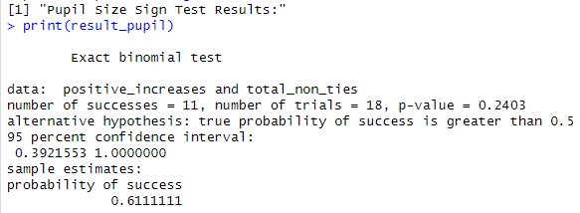
Figure 18- Sign test Rank Test(Pupil Size) on experiment one
The output shows in Figure 18 the results of an sign test , which tests if the proportion of positive outcomes is significantly greater than 0.5. The test is based on 11 positive outcomes out of 18 total non-tied trials. The p-value of 0.2403 indicates insufficient evidence to conclude that the true proportion of positive outcomes is greater than 0.5.
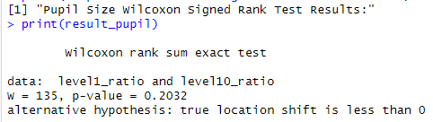
Figure 19- Wilcoxon Signed Rank Test(HRV) on experiment one
The output shows in Figure 19 the Wilcoxon Signed Rank Test results comparing pupil size ratios between level 1 and level 15. The test statistic (W = 135) and p-value of 0.2032 suggest insufficient evidence to conclude that the pupil size ratios are significantly smaller at level 15 compared to level 1.

3.6 Discussion on the Influence of Different Stress Levels on Pupil Size in the first experiment
This experiment aims to find the stress levels and how they affect people's physical responses. It looked at changes in pupil size at different task levels. However, the statistical analysis results did not show evidence that the task level significantly affected pupil size. Possible reasons why there were no significant changes in pupil size:

- In this experiment, the complex level of Tetris is set to Level 10 to let the participant feel stressed. This study may not have been challenging enough for this game level to cause sizable pupil dilation. Therefore, the difficulty level 10 in Tetris might have yet to reach that stress level.
- Some individuals need to wear glasses. This may also have encouraged the measurement results. The first part of the experiment required participants to temporarily remove their glasses to help with eye imaging and avoid reflection. Removing glasses may also have affected their pupil length measurements because the display screen can be blurry for a few individuals. Therefore, it would have interfered with the experimental results.

Although this experiment did not find significant changes in pupil size, the results may have been influenced by the task difficulty setting and the experimental procedure.

3.7 Result on the Interdependence of Pupil Size and Heart Rate Changes in Stress-Induced Conditions
Contingency table
 | Pupil Size
HRV | Decrease | Increase
Decrease | 6 | 6
Increase | 1 | 5
Table 1- Contingency table on experiment one
McNemar's test
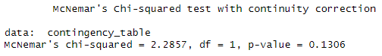
Figure 20- McNemar's test on experiment one
The McNemar's test results shown in Figure 18 did not find a sizable difference inside the range of individuals who showed changes in their heart rate variability (HRV) and pupil size. The p-value of 0.1306 is higher than 0.05, which means we cannot reject the null hypothesis. This suggests that no significant relationship exists between heart rate variability and changes in pupil length.

3.8 Discussion of Interdependence of Pupil Size and Heart Rate Changes in Stress-Induced Conditions
The association between HRV changes (increase/decrease) and pupil size changes (increase/decrease) using the chi-square test, but the results showed no significant association between them (p = 0.39). In this study, I could not confirm that the decrease in heart rate due to stress would similarly lead to an increase in pupil size. From a theoretical perspective, heart rate variability (HRV) and pupil size are regulated by similar physiological mechanisms. HRV is influenced by the autonomic nervous system, particularly the balance between sympathetic and parasympathetic activity, while pupil size is controlled by the dilator and sphincter muscles of the iris, which are innervated by the autonomic nervous system but through different pathways. The experimental process may need to be improved.

3.9Modifications to the Experimental Procedure
Modify the experiment as viable based on previously determined possibilities. This is to improve the study design and statistics collection:

- Allowed the participants to wear glasses during the experiment. The original procedure required removing glasses temporarily during the eye-tracking measurement phase. It may affect the pupil size reading due to wearing and removing glasses. Since the experiment occurred in a dim environment, there were only a few reflections. Therefore, the reflection on the glasses will not affect the image results, and clear images can still be captured. So, participants were allowed to keep their glasses on. It could minimize changes in pupil measurements caused by taking glasses on and off.

- Participants need to wear the wristband which is a heart rate monitoring device on their non-dominant hand. This is the hand they do not use for computer operation. In the previous experiment, wearing the device on the dominant hand may have caused motion artifacts from hand movements during keyboard use. It could have affected accurate heart rate variability (HRV) measurement. Moving the device to the non-dominant hand reduces this potential interference.

- During the experiment, Increase the difficulty of the Tetris game from level 10 to level 15. Level 10 may not have been challenging enough for some well-practiced participants, like those with a lot of computer gaming experience. It may have failed to cause a noticeable stress response. The increased falling speed at level 15 is expected to be more challenging for most participants. It should better activate the sympathetic nervous system and impact physiological markers like heart rate variability (HRV) and pupil size.

- Besides recording HRV and pupil size during relaxed and high-difficulty conditions, more data points were collected: a) Baseline heart rate and pupil data when participants entered the class as a reference. b) Intermediate data between the two difficulty levels is used to observe how physiological indicators change over time. Collecting these additional data enables a more comprehensive evaluation of how game difficulty impacts physiological responses and supports more in-depth statistical analyses.

These modifications to the experimental procedure aim to enhance the experimental design by controlling ability confounding factors, increasing the stress of the experimental stimulus, and obtaining a more comprehensive dataset.

3.10 ANOVA Result of HRV in Second Experiment
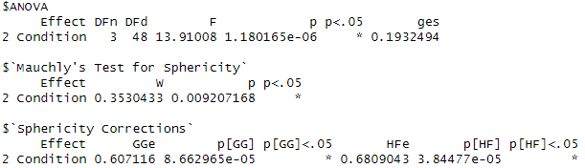
Figure 21- ANOVA Result of HRV in Second Experiment
The results of the one-way analysis of variance (ANOVA) reveal a statistically significant effect of the different conditions on the participants' heart rate variability (HRV) (F(3,48) = 13.91, p = 1.180165e-06). This extremely small p-value (less than 0.001) suggests that under the null hypothesis (the means of HRV are equal across conditions), the probability of observing such a significant difference between groups is extremely low. Consequently, we reject the null hypothesis and conclude that there is at least one pair of conditions between which the means of HRV differ significantly from a statistical standpoint.
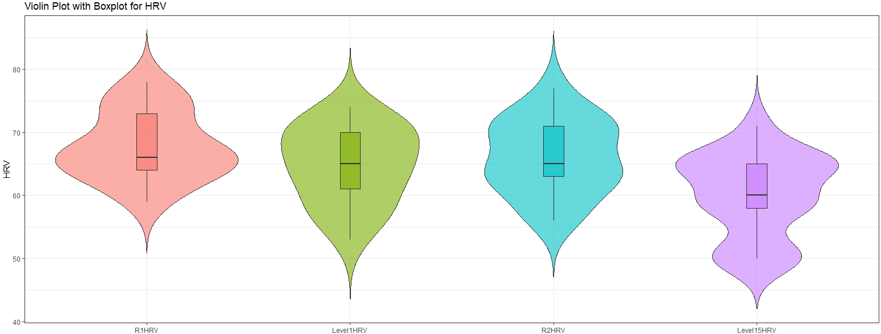
Figure 22- Violin Plot with Boxplot for HRV

According to the violin plot, it can be observed that the distribution of HRV values in the Level 15 group is different from the other groups. Firstly, the median line of Level 15 is noticeably lower than the other groups, indicating that the overall HRV values in this group tend to be lower. Second, the shape of Level 15 is more concentrated in the lower value range than the other groups.

3.11 Discussion on ANOVA Result of HRV in Second Experiment
This may reflect the enhanced stress response and sympathetic activation induced by the challenging Level 15 Tetris game, which resulted in a decrease in HRV. In contrast, the baseline, break, and Level 1 conditions showed higher levels of overall HRV, indicating a more relaxed state.
The results align with expectations that increasing game difficulty could affect HRV. However, extra analyses are required to determine which pair of groups is statistically significant.

3.12 ANOVA Result of Ratio in Second Experiment
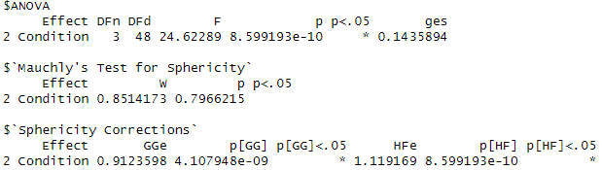
Figure 23- ANOVA Result of Ratio in Second Experiment
In the one-way ANOVA results, the p-value is 8.599193e-10, which is much smaller than the significance level of 0.05,which is that there is at least one pair of group in pupil /iris ratio means that are significantly different between different conditions.
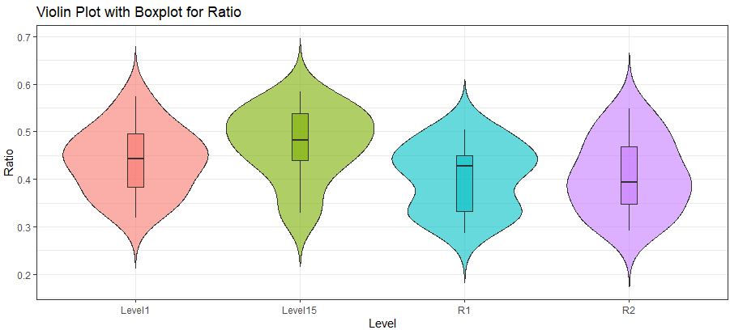
Figure 24- Violin Plot with Boxplot for Ratio
In this violin plot, it can be observed that the violin part of the Level 15 group is wider in the higher value range compared to the other groups, which means there are more data points in the higher value range. Moreover, the median of the Level 15 group is slightly higher than the other groups.

3.13 Discussion on ANOVA Result of Ratio in Second Experiment
As the Tetris game difficulty increases to the highest level (stage 15), participants may experience more sympathetic nervous system activation, resulting in larger pupil size.
In comparison, the baseline, break, and level 1 conditions show off pupil/iris ratio distributions greater focused inside the lower value range. This sample shows that during these lower-difficulty conditions, participants were more relaxed and had smaller pupil sizes. Similarly, statistical significance requires extra tests.

3.14 Result on Post-hoc analyses in HRV
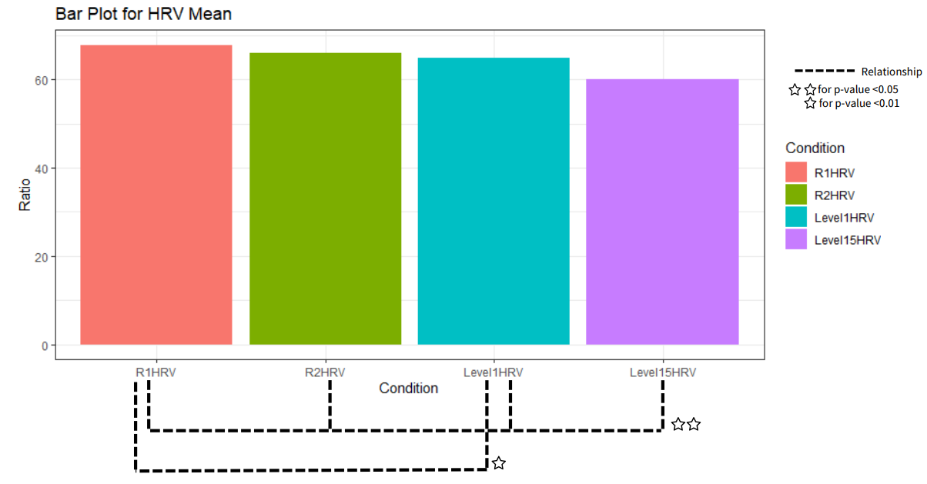
Figure 25-Bar Plot of HRV Result
Pair of Group | P-value
R1 vs R2 | 0.8479003906
R1 vs Level1 | 0.0425415039
R1 vs Level15 | 0.0005493164
R2 vs Level1 | 0.3591308594
R2 vs Level15 | 0.0005493164
Level1 vs Level15 | 0.0005493164
Table 2- Sing Test Result(HRV)

The p-values in Table 2 show statistically significant differences (p<0.05) when comparing the baseline, break, and Level 1 conditions (R1, R2) to the Level 15 difficulty level. R1 vs Level1also had a p-value of 0.0425415039, this difference could be considered significant but not so strong. On the other hand, R1 vs R2 and R2 vs. Level1 had non-significant p-values above 0.05, suggesting no mean differences between these group pairs.

Pair of Group | P-value
R1 vs R2 | 0.324942692
R1 vs Level1 | 0.214075225
R1 vs Level15 | 0.002080901
R2 vs Level1 | 0.653205736
R2 vs Level15 | 0.036539389
Level1 vs Level15 | 0.066852941
Table 3-Wilcoxon rank sum test Result(HRV)
The only statistically significant difference (p<0.05) was between R1 (baseline), R2(break), and Level15 (High difficulty). All other pairwise comparisons had non-significant p-values above 0.1. Level 1 vs Level 15 (p=0.066852941) may be a weak relationship.

3.13 Discussion on Post-hoc analyses in HRV
The finding that HRV was significantly lower in the Level 15 high-difficulty condition compared to baseline (R1) ,R2(break)and lower difficulty levels provides validation for using pupil response to measure cognitive load/stress. Lower HRV during the very challenging Level 15 game aligns with the expected decrease in HRV under stressful circumstances due to increased sympathetic nervous system activation. The HRV data serves as an essential benchmark, verifying that pupil dilation tracked sympathetic arousal levels as predicted based on known effects of stress on HRV.
Overall, The HRV results confirm that pupil response reflected processing demands appropriately across the difficulty levels in this experimental paradigm.
3.14 Result on Post-hoc analyses in Pupil Size

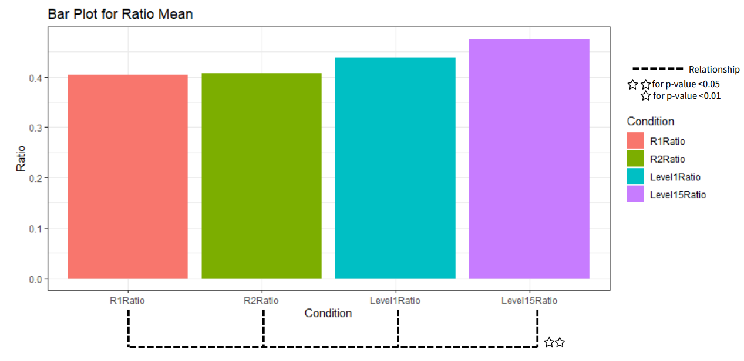
Figure 26- Bar Plot of Pupil Size Result

Pair of Group | P-value
R1 vs R2 | 1.00000000000
R1 vs Level1 | 0.28692626953
R1 vs Level15 | 0.00054931641
R2 vs Level1 | 0.66461181641
R2 vs Level15 | 0.00003051758
Level1 vs Level15 | 0.02545166016
Table 4-Sing Test Result(Pupil Size)

Level 15 (high difficulty) showed significantly larger pupil sizes compared to baseline (R1), break (R2), and Level 1, with very small p-values <0.05. There were no significant pupil size differences between the resting baselines (R1 vs R2) or between baselines and Level 1 (p-values > 0.05). In summary, pupil sizes were markedly increased only in the most difficult Level15 condition relative to lower difficulty levels and baselines, validating pupillometry as a measure of cognitive load.

Pair of Group | P-value
R1 vs R2 | 1.00000000000
R1 vs Level1 | 0.205379737
R1 vs Level15 | 0.005393566
R2 vs Level1 | 0.305725370
R2 vs Level15 | 0.014494915
Level1 vs Level15 | 0.113922226
Table 5-Wilcoxon rank sum test Result (Pupil Size)
Pupil size distributions differed significantly only when comparing the highest difficulty Level15 to the resting baselines R1 (p=0.005393566) and R2 (p=0.014494915).
However, there were not statistically or weak significant distributional differences involving the lower Level1 difficulty compared to Level15 (p-values ≈0.1).

3.15 Discussion on Post-hoc analyses in Pupil Size
Compared to resting baselines, the significant increase in pupil size distributions only during the highly demanding Level15 condition aligns with expected pupillary responses to stress. The lack of pupil size changes in lower difficulty levels validates that measurable pupillary dilation is isolated to stressful states. This pattern demonstrates the sensitivity of smartphone camera-based pupillometry for detecting cognitive load changes, especially in highly demanding situations compared to resting states.

3.16 Result on Analysing the Interdependence of Pupil Size and Heart Rate Changes in Stress-Induced Conditions

R1 vs R2 Contingency Table
 | Pupil Size
HRV | Decrease | Increase
Decrease | 4 | 4
Increase | 5 | 4
Table 6- R1 vs R2 Contingency Table

R1 vs Level1 Contingency Table
 | Pupil Size
HRV | Decrease | Increase
Decrease | 2 | 2
Increase | 10 | 3
Table 7- R1 vs Level15 Contingency Table

R1 vs Level15 Contingency Table
 | Pupil Size
HRV | Decrease | Increase
Decrease | 15 | 1
Increase | 1 | 0
Table 8- R1 vs Level15 Contingency Table

R2 vs Level1 Contingency Table
 | Pupil Size
HRV | Decrease | Increase
Decrease | 2 | 5
Increase | 9 | 0
Table 9- R2 vs Level1 Contingency Table

R2 vs Level15 Contingency Table
 | Pupil Size
HRV | Decrease | Increase
Decrease | 1 | 0
Increase | 16 | 0
Table 10- R2 vs Level15 Contingency Table

Pair of Group | P-value
R1 vs R2 | 1
R1 vs Level1 | 0.04331
R1 vs Level15 | 0.0003006
R2 vs Level1 | 0.4227
R2 vs Level15 | McNemar's test cannot be performed because there are only 1X2 rows.
Level1 vs Level15 | 0.001946
Table 11- McNemar's test Result

The McNemar's Test showed no significant difference between R1 and R2 (p = 1), meaning participants' responses stayed the same at these two points. However, there were significant differences between R1 and Level1 (p = 0.04331) and between R1 and Level15 (p = 0.0003006). This means that participants' responses changed significantly under these conditions. The difference between R1 and Level15 was very significant, with a p-value much lower than the usual cut-off of 0.05.
There was no significant difference between R2 and Level 1 (p = 0.4227). The McNemar's Test could not be done between R2 and Level15 because of the 1x2 table. However, the available data shows a trend that should be investigated further.
Finally, there was a significant difference between Level 1 and Level 15 (p = 0.001946), showing that participants' responses changed significantly between these two conditions.

3.16 Discussion on McNemar's test
The P-value and various trends show that participants' responses under the level 15 difficulty of Tetris were statistically different from other groups. This could be because the same parasympathetic nervous system controls both pupil size and heart rate variability. Therefore, when stress causes a decrease in heart rate variability, the pupil size may dilate.

The significant difference between R1 and level 1 might be due to an error caused by insufficient sample size in the experiment. This can be further investigated by expanding the sample size to determine the reason behind this difference.

3.17 Limitation
The study was conducted in a controlled environment. The lights in the classroom were turned off, the computer screen was dimmed to minimize the effect of light on the pupils, and a specific cell phone model was used. Therefore, the following limitations may exist in the actual application:

- In practice, other light influences in the environment can make the pupil larger or smaller; for example, in a bright environment, the pupil will shrink. This change in pupil size due to light may be mixed with the effects of mental stress and obscure the change.
- Different brands of phone cameras differ a lot in details, lens quality, and how they process images. Moreover, since the phone processor needs to be used for image segmentation and ratio calculation, the processor's speed also affects the actual application.

4.Conclusion

4.1Project outcomes

This study found that pupil size and heart rate variability (HRV) are adequate indicators of stress levels. The high resolution of modern smartphone cameras can accurately segment and detect changes in pupil diameter. It has been confirmed that smartphones can be used as a convenient, non-invasive, and continuous daily stress monitoring device.

Overall, the feasibility of using smartphone pupillometry to detect stress was demonstrated compared to traditional HRV measurements. I hope that this method can be consistently applied as a device to detect stress.

4.2Future work

The following are research directions that can be improved in the future:

1. Increase the sample size: There needs to be more than the current sample size to do a parametric test assuming normal distribution, which can limit the generalizability and statistical power of the study. Therefore, increasing the sample size will allow stabilized statistical analysis and other advanced statistical methods.

2. Advanced machine learning technology: It can be utilized to achieve continuous stress monitoring in daily life. These models can utilize pupil data collected from smartphone cameras to analyze each individual's unique pupil response patterns related to stress in different environments. It can be applied in various scenarios, such as workplace stress assessment and student stress level monitoring. By assessing an individual's stress level, the system can remind them to take a break or relax. This approach prevents potential mental health problems due to excessive stress.
References:

[1] R. Welford, "Work life balance in Hong Kong: Survey results", The University of Hong Kong and CSR Asia, 2008.

[2] H.-G. Kim, E.-J. Cheon, D.-S. Bai, Y. H. Lee, and B.-H. Koo, "Stress and Heart Rate Variability: A Meta-Analysis and Review of the Literature," Psychiatry Investigation, vol. 15, no. 3, pp. 235–245, Mar. 2018, doi: 10.30773/pi.2017.08.17

[3] Hospital Authority, "Mental health review report," 2017.

[4]K. Yamanaka and M. Kawakami, "Convenient Evaluation of Mental Stress With Pupil Diameter," International Journal of Occupational Safety and Ergonomics, vol. 15, no. 4, pp. 447-450, 2009, doi: 10.1080/10803548.2009.11076824.

[5]E. H. Hess and J. M. Polt, "Pupil Size in Relation to Mental Activity during Simple Problem-Solving," Science, vol. 143, no. 3611, pp. 1190-1192, Mar. 1964, doi: 10.1126/science.143.3611.1190.

[6] M. Pedrotti, M. A. Mirzaei, A. Tedesco, J.-R. Chardonnet, F. Mérienne, S. Benedetto, and T. Baccino, "Automatic Stress Classification With Pupil Diameter Analysis", International Journal of Human–Computer Interaction, vol. 30, no. 3, pp. 220-236, 2014, doi: 10.1080/10447318.2013.848320.

[7] Census and Statistics Department, Hong Kong Special Administrative Region, "Thematic Household Survey Report No. 77," 2023.

[8] J. Taelman, S. Vandeput, A. Spaepen, and S. Van Huffel, "Influence of Mental Stress on Heart Rate and Heart Rate Variability," in 4th European Conference of the International Federation for Medical and Biological Engineering, Berlin, Heidelberg, 2009, pp. 1366–1369. [Online]. Available: https://doi.org/10.1007/978-3-540-89208-3_324

[9]S. Järvelin-Pasanen, S. Sinikallio, and M. P. Tarvainen, "Heart rate variability and occupational stress—systematic review," Ind. Health, vol. 56, no. 6, pp. 500–511, 2018.

[10] T. G. Vrijkotte, L. J. Doornen, and E. J. de Geus, "Effects of work stress on ambulatory blood pressure, heart rate, and heart rate variability," Hypertension, vol. 35, no. 4, pp. 880–886, 2000.

[11] S. P. Carvalho et al., "Stress Level of Critical Care Nurses: Evaluation by Heart Rate Variability," Biomed. J. Sci. Tech. Res., vol. 4, no. 3, pp. 3984-3991, May 2018, Accessed: Apr. 12, 2024. [Online]. Available: https://biomedres.us/pdfs/BJSTR.MS.ID.001068.pdf

[12] S. R. Steinhauer, G. J. Siegle, R. Condray, and M. Pless, "Sympathetic and parasympathetic innervation of pupillary dilation during sustained processing," Int. J. Psychophysiol., vol. 52, no. 1, pp. 77–86, 2004, doi: 10.1016/j.ijpsycho.2003.12.005.

[13] B. Laeng, S. Sirois, and G. Gredebäck, "Pupillometry: A Window to the Preconscious?," Perspect. Psychol. Sci., vol. 7, no. 1, pp. 18–27, Jan. 2012, doi: 10.1177/1745691611427305.

[14] N. Afer et al., "Stress generation and non-intrusive measurement in virtual environments using eye tracking," Original Research, Open Access, vol. 11, pp. 5977–5989, 2020.

[15] P. F. Lee and L. K. Shan, "A preliminary study on pupil size changes detection on mental stress with mental stressor," Biomedical Engineering: Applications, Basis and Communications, vol. 29, no. 2, p. 1750011, 2017.

[16] E. Galy, M. Cariou, and C. Mélan, "What is the relationship between mental workload factors and cognitive load types?," Int. J. Psychophysiol., vol. 83, no. 3, pp. 269–275, Mar. 2012, doi: 10.1016/j.ijpsycho.2011.09.023.

[17] K. Dedovic et al., "The Montreal Imaging Stress Task: using functional imaging to investigate the effects of perceiving and processing psychosocial stress in the human brain," J. Psychiatry Neurosci., vol. 30, no. 5, pp. 319–325, Sep. 2005.

[18] T. Yelamanchili, F. F. H. Nah, K. L. Siau, and L. Chen, "Neural Correlates of User Experience in Gaming," 2017.

[19] C. J. Ellis, "The pupillary light reflex in normal subjects," Br. J. Ophthalmol., vol. 65, no. 11, pp. 754–759, Nov. 1981, doi: 10.1136/bjo.65.11.754.

[20] A. M. Miranda, E. J. Nunes-Pereira, K. Baskaran, and A. F. Macedo, "Eye movements, convergence distance and pupil-size when reading from smartphone, computer, print and tablet," Scand. J. Optom. Vis. Sci., vol. 11, no. 1, pp. 1–5, Jul. 2018, doi: 10.5384/sjovs.vol11i1p1-5.

[21] J. D. Reece, J. A. Bunn, M. Choi, and J. W. Navalta, "Assessing Heart Rate Using Consumer Technology Association Standards," Technologies, vol. 9, no. 3, p. 46, Jun. 2021, doi: 10.3390/technologies9030046.

[22] M. Moya-Ramon, M. Mateo-March, I. Peña-González, M. Zabala, and A. Javaloyes, "Validity and reliability of different smartphones applications to measure HRV during short and ultra-short measurements in elite athletes," Computer Methods Programs Biomed., vol. 217, p. 106696, 2022.

