Data Understanding
This section explores the Building Data Genome Project 2 (BDG2) dataset to uncover its core structure and time-dependent behaviour, to quantify central tendency and spread, and to identify skewness and relationships between variables. BDG2 contains hourly meter readings for 1,636 non-residential buildings on 19 sites in North America and Europe for 2016–2017, together with building metadata and hourly weather observations for each site.
Unless stated otherwise, the examples use the Robin site (University College London), which has 52 buildings with electricity meters and 15 with hot water meters. The relationship between electricity and temperature is also compared for four similar college buildings in different climates (Ottawa, Cardiff, Austin and Tempe), and heating demand is analysed across all 623 heating meters in the dataset. The raw data are shown without cleaning, so that data quality issues remain visible.
The most striking extreme value in each figure is explained in a separate box. Each extreme is classified as one of four types, because the type decides how it should be handled:
- Measurement error: the meter recorded something that did not happen. It should be removed or corrected before modelling.
- Real effect: something actually happened, such as a storm or a heatwave. It should be kept.
- Method artefact: the value is created by how the figure or calculation is made, not by the data.
- Dataset structure: the value follows from how the dataset is assembled or recorded.

Dataset structure
Not every variable is available for every building. Figure 1 shows, for each site, the share of buildings that have data in each metadata field and meter. A meter counts as present when at least 50 % of its hourly values are recorded. Only floor area, primary space usage and electricity are close to universal. The other fields depend strongly on the site and country. Heating type is recorded only for the UK sites. Steam and chilled water meters are found almost only in the USA and Canada. Gas is metered only in the UK, Ireland and on two US sites. Energy Star score and site/source EUI exist only for the Hog site. As a result, no building has all fields. Every analysis must therefore select sites based on the variables it requires, and results that rely on site-specific fields cannot be generalised to the whole dataset.
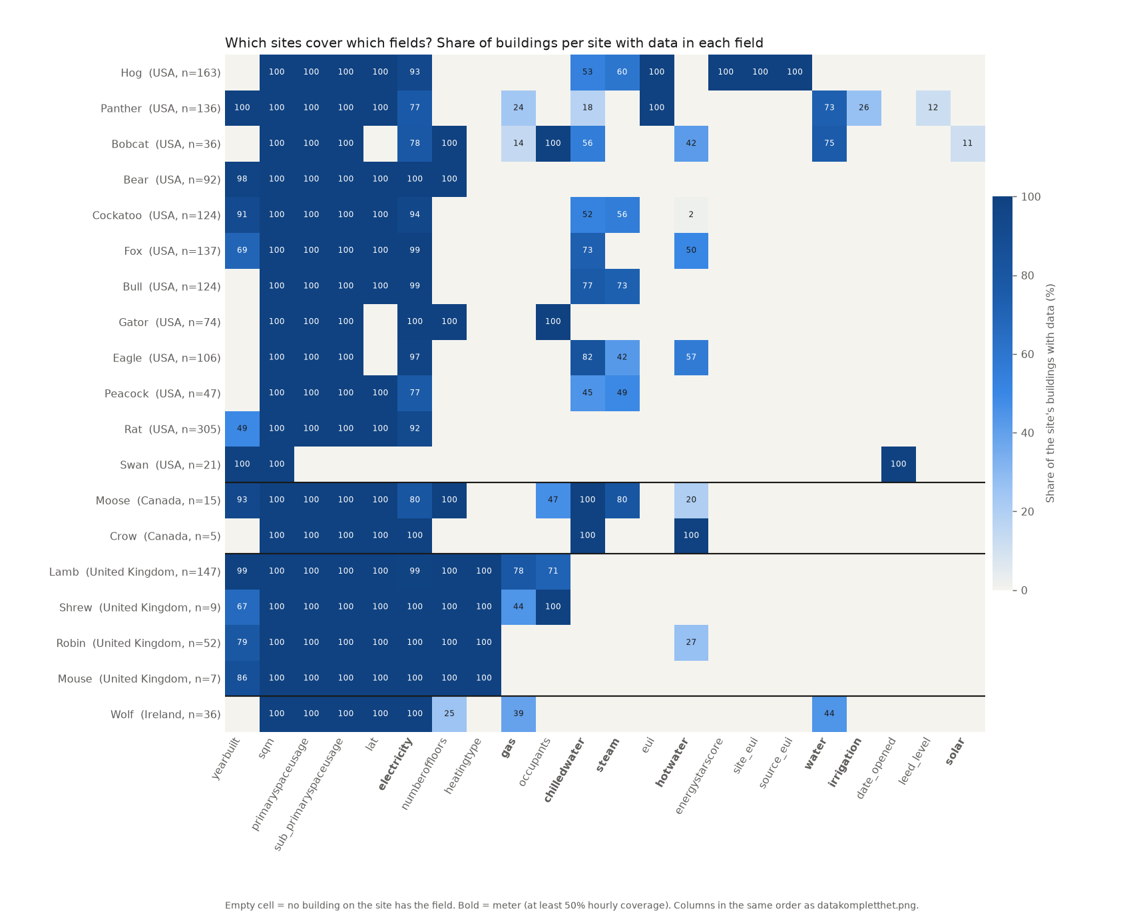
Figure 1. Share of buildings per site with data in each metadata field and meter (meters in bold). Sites are grouped by country. An empty cell means that no building on the site has the field.
Extreme point: Swan has an almost empty row: no meters at all [Method artefact]
What we see: Swan has only year built, floor area and opening date. All meter columns are empty, although the metadata states that 19 of its buildings have electricity, 16 hot water and 20 chilled water meters.
Cause: Swan only has meter data for 2017 (01.01.2017 to 31.12.2017). This gives 49.9 % coverage over the two years, just below the 50 % threshold that a meter must reach to be counted. The buildings therefore have a complete year of data but are treated as having no meters. To include Swan, coverage should be measured within the period the meter was in operation, or the threshold lowered to, for example, 40 %.

Temporal patterns and trends
Figure 2 shows daily values over the full two-year period. Consumption is shown as the mean per reporting building, so that the curve does not jump when a building is missing data. Hot water follows the outdoor temperature closely. It is high in winter and low and stable in summer, at roughly a quarter of the winter level. Its highest day (19 January 2016) fell on the two coldest days of 2016. Electricity is almost flat through the year (about 3,700–4,000 kWh per building per day). It has a clear weekly rhythm, with lower use at weekends, and a dip over the Christmas closure.
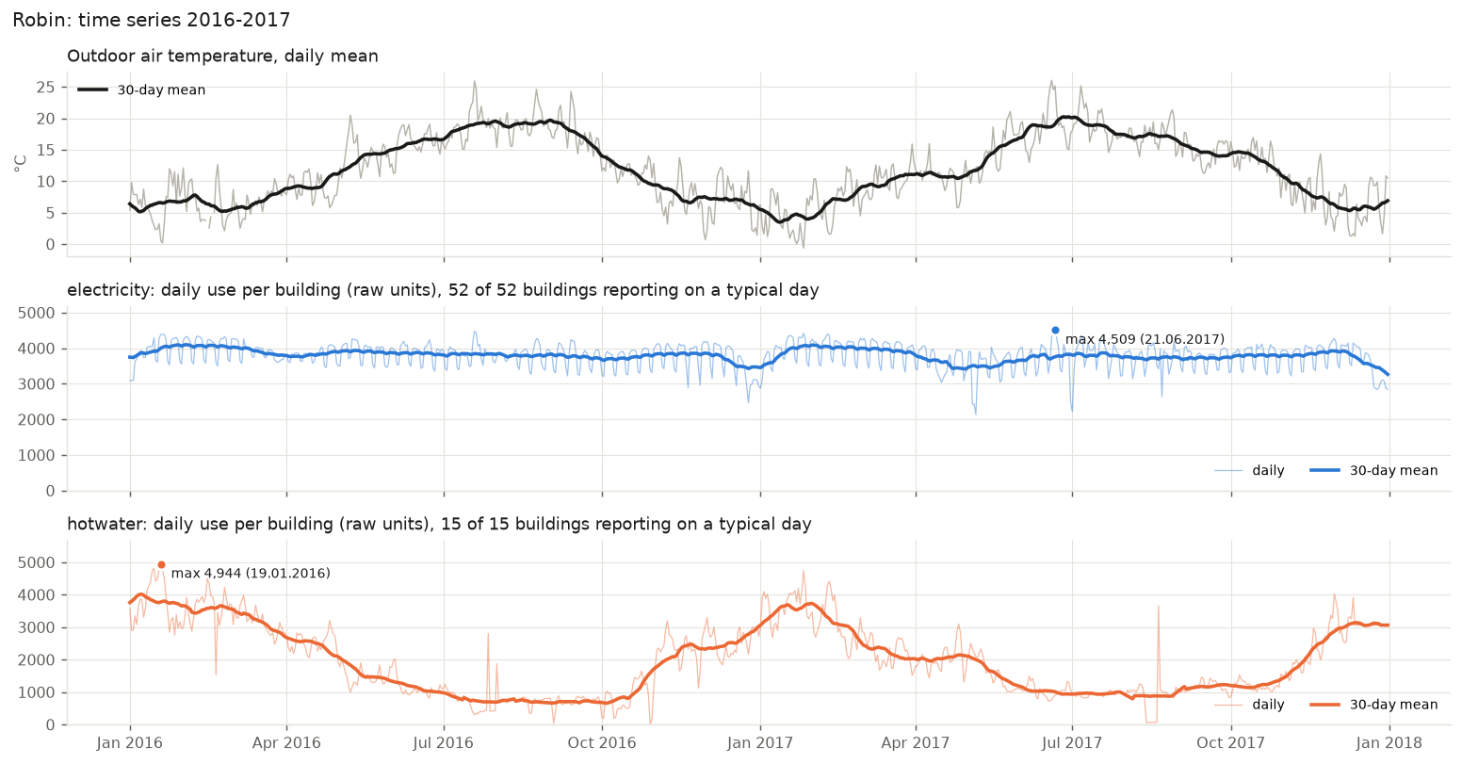
Figure 2. Robin: daily outdoor temperature and daily consumption per building for each meter type, 2016–2017. Thin lines are daily values and thick lines are 30-day running means. The highest day is marked.
Extreme point: The highest electricity days are heatwave days [Real effect]
What we see: The marked maximum (4,509 kWh per building on 21 June 2017) is hard to distinguish in the figure. It is only 13 % above a typical weekday (median 3,987 kWh) and about 2 % above the highest winter days (for example 4,418 kWh on 26 January 2017). Even so, the three highest electricity days in the whole period are all heatwave days: 21 June 2017 (33.9 °C), 19 July 2016 (32.9 °C) and 20 July 2016 (30.7 °C).
Cause: Buildings without permanent cooling use more electricity for fans, portable cooling units and server rooms on very hot days. During the June 2017 heatwave, consumption rose day by day with the temperature (4,320, 4,382 and 4,509 kWh on 19–21 June) and fell to 4,267 kWh the next day, when the maximum temperature dropped to 23 °C. The effect is real but small, which agrees with the weak correlation between electricity and temperature (ρ = −0.09, Figure 10).

Extreme point: Narrow hot water spikes in mid-summer [Measurement error]
What we see: In the otherwise flat summer period, two single days stand out as narrow spikes. On 27 July 2016 hot water reaches about 2,800 per building, 6–7 times the surrounding level. On 20 August 2017 it reaches about 3,650, more than four times the surrounding level and almost as high as in winter. These are the highest summer days in each year.
Cause: On both days, single buildings (Margarito and Adolph) report 12,000–23,000 in one hour directly after several hours of zero. This is typical of a meter that has lost communication and releases the accumulated reading when the connection is restored. One such hour lifts the site average for the whole day. The values are not real consumption.

Figure 3 overlays the two years to separate trends from seasonal variation. Annual consumption was 2 % lower in 2017 for both meter types. Differences in hot water follow the weather: use was lower in March–April 2017, which was milder than 2016, and higher in December 2017, which was colder.
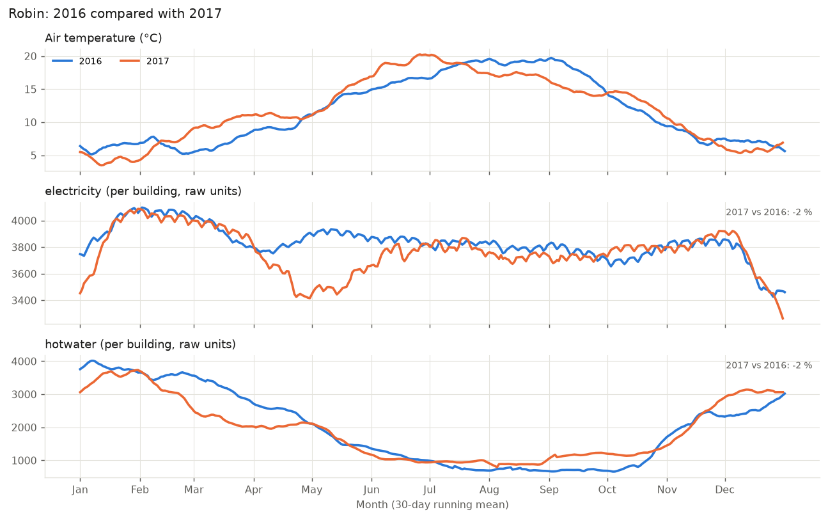
Figure 3. Robin: 30-day running means for 2016 and 2017 on a common day-of-year axis. The change in the annual mean is shown top right.
Extreme point: Electricity is 6 % lower in April–June 2017 [Measurement error]
What we see: Electricity in 2017 is clearly below 2016 from April to June (−6.2 % for the quarter and more than 10 % in late May), while the rest of the year differs by less than 0.2 %.
Cause: Temperature cannot explain the drop, because it was similar in both years. Breaking the difference down by building shows where it comes from. Lashandra had an abrupt level shift in July 2016, from about 9,800 to 2,300 kWh per day, which makes the 2016 baseline higher. Without Lashandra, the drop is −2.6 %. The rest comes from a group of 22 meters that fail at the same time on 4–6 May 2017, which points to a shared data logger. Without these three days, the drop is −1.4 %. Three buildings in the same group (Derick, Wai and Phillip) also stay at 1–2 % of their normal level for weeks to months, with no day–night pattern. Without them, 2017 is 3.5 % higher than 2016. A maintenance shutdown of a large consumer is unlikely. Robin has no data centre, the hot water in Derick continued at almost its normal level in the same months, and Wai (an office) and Phillip (a dormitory) enter their low period on the same day, 16 April 2017. This points to a data collection problem, not a real saving.

At the daily scale (Figure 4), electricity on weekdays rises from 06:00 to a plateau between 11:00 and 17:00, while the weekend profile is almost flat. Consumption is therefore driven by occupancy schedules as much as by weather, and time of day and day of week should be included as features in any model.
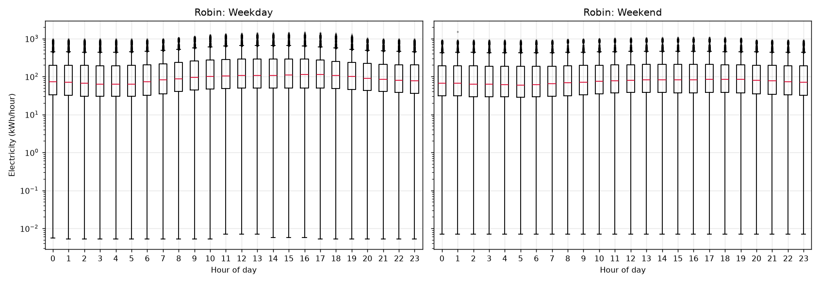
Figure 4. Robin: hourly electricity by hour of day for weekdays (left) and weekends (right), logarithmic axis.
Extreme point: Lower whiskers reach 0.005 kWh in every hour [Measurement error]
What we see: The lowest values are at the same level at every hour of the day, night and day, on weekdays and at weekends.
Cause: These values come from meters stuck at a constant near-zero value, for example 0.0053 kWh/h hour after hour at one building in September 2016. A stuck meter gives the same minimum in all 24 hours. A lower extreme with no daily pattern is a sign that it does not come from real use.

Figure 5 shows every building as a separate row, with each day coloured by its consumption relative to that building's median. Most buildings show a uniform pattern with faint weekly stripes, and the Christmas closure appears as a blue band. The figure exposes problems in individual buildings that are hidden in the site averages, and these series have to be split, corrected or excluded before modelling.
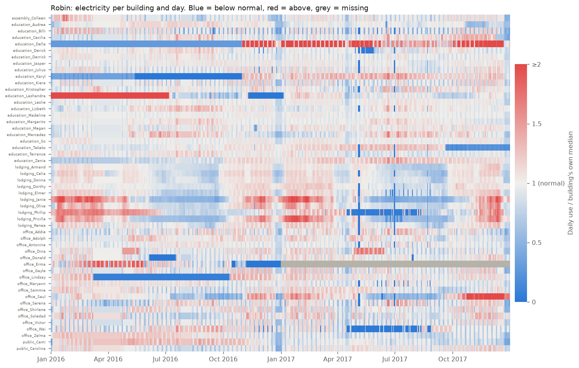
Figure 5. Robin: daily electricity per building relative to the building's own median (white = normal, blue = lower, red = higher, grey = missing).
Extreme point: Abrupt level shifts in four buildings [Measurement error]
What we see: Several rows switch abruptly from deep red to deep blue or the other way round, and stay there for months.
Cause: Lashandra uses about 9,500 kWh per day in January–June 2016 and about 2,400 after that. Karyl jumps from about 690 to 2,400 after five months at zero. Della stays at a constant 18 kWh per day for nine months before rising to about 130. Takako falls from about 5,000 to 850 in October 2017. Jumps this large and lasting almost always mean that the meter was replaced, moved to another circuit or that the building was re-divided, not that the use changed. The series should be split at the jump before modelling.

Extreme point: Vertical blue stripes in May, June and August 2017 [Measurement error]
What we see: Narrow blue stripes run through many rows on the same days.
Cause: Exactly 22 buildings are below half their normal level at the same time on 4–6 May 2017, 30 June–1 July 2017 and 22 August 2017. Since it is always the same 22 meters, they most likely share a data logger or collection system that was down. The broad blue band around New Year, in contrast, is real: the university is closed over Christmas.

Summary statistics
Table 1 summarises all hourly values at Robin. For electricity, the mean is almost twice the median, which shows a right-skewed distribution in which a few large buildings pull the average up. Almost half of the hot water hours are zero, because the systems are idle at night and in summer. The weather variables are close to symmetric, and their extremes are real events, such as Storm Katie on 28 March 2016 and a deep low on 10 December 2017. Cloud cover and precipitation are not included, because only 19 % and 0 % of hours have values.
Table 1. Summary statistics of hourly values at Robin, 2016–2017.
Variable | n | Min | Median | Max | Mean | Std | Skewness | Zeros (%)
Electricity (kWh) | 903,523 | 0.0 | 84.8 | 1,544.5 | 158.3 | 181.2 | 2.1 | 0.2
Hot water | 245,577 | 0.0 | 18.5 | 23,000.0 | 81.0 | 164.2 | 32.7 | 43.4
Air temperature (°C) | 17,515 | -4.1 | 11.6 | 33.9 | 11.8 | 6.1 | 0.2 | 0.1
Dew point (°C) | 17,515 | -8.9 | 8.1 | 20.7 | 7.7 | 5.1 | -0.2 | 0.3
Wind speed (m/s) | 17,516 | 0.0 | 3.6 | 18.5 | 4.0 | 2.2 | 0.9 | 0.2
Pressure (hPa) | 17,455 | 972.0 | 1,017.5 | 1,045.5 | 1,016.2 | 10.5 | -0.7 | 0.0

Extreme point: Hot water has a skewness of 32.7 [Measurement error]
What we see: Hot water is about 15 times more skewed than electricity, and its maximum of 23,000 is more than 1,000 times its median of 18.5.
Cause: The skewness is caused by a handful of accumulated readings after meter outages (see the summer spikes in Figure 2), not by the bulk of the data. Skewness is very sensitive to a few extreme values, so it should be recalculated after these readings are removed.

Extreme point: Cloud cover contains only the values 0 and 9 [Dataset structure]
What we see: Cloud cover is missing for 81 % of the hours, and the remaining hours are either 0 (3,339 hours) or 9 (28 hours).
Cause: In the weather code for cloud cover, 9 means that the sky could not be observed. It is a code for a missing observation, not real cloud cover. The variable therefore cannot be used for Robin and is left out of Table 1.

Distributions and skewness
The histograms in Figure 6 confirm the strong right skew of the meter data. On a linear axis, both meter types have a long tail towards high values. After a log10 transformation, the bulk of the electricity data becomes roughly symmetric between 10 and 1,000 kWh/h. The remaining negative skewness of −1.9 comes from a small cluster of near-zero values from stuck meters. A log transformation is therefore recommended for consumption data in further analysis.
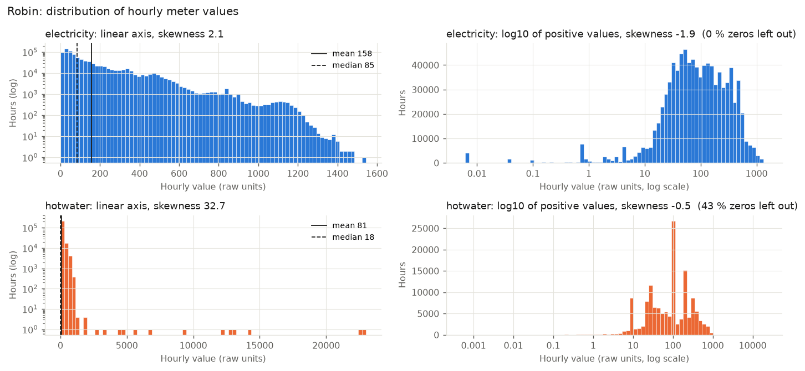
Figure 6. Robin: distribution of hourly meter values on a linear axis (left, logarithmic count) and after log10 transformation of positive values (right). Skewness is given in each title.
Extreme point: Hot water has a narrow peak at exactly 100 [Dataset structure]
What we see: In the log histogram, a single bar at exactly 100 holds more than 25,000 hours, with smaller peaks at 10 and 200.
Cause: 23,730 hours are exactly 100, 10,440 exactly 200 and 8,021 exactly 10, mostly from five buildings. These meters register consumption in whole steps of 10 or 100 units, so the hourly value is the number of steps times the step size. This is meter resolution, not an error, but individual hours are coarse and daily totals are more reliable for these buildings.

The weather variables (Figure 7) are much less skewed. Air temperature and dew point are nearly symmetric (skewness ±0.2). Wind speed is right-skewed (0.9), with mostly light winds and few storm hours. Sea level pressure is left-skewed (−0.7), with a tail towards 972 hPa from deep low-pressure systems.
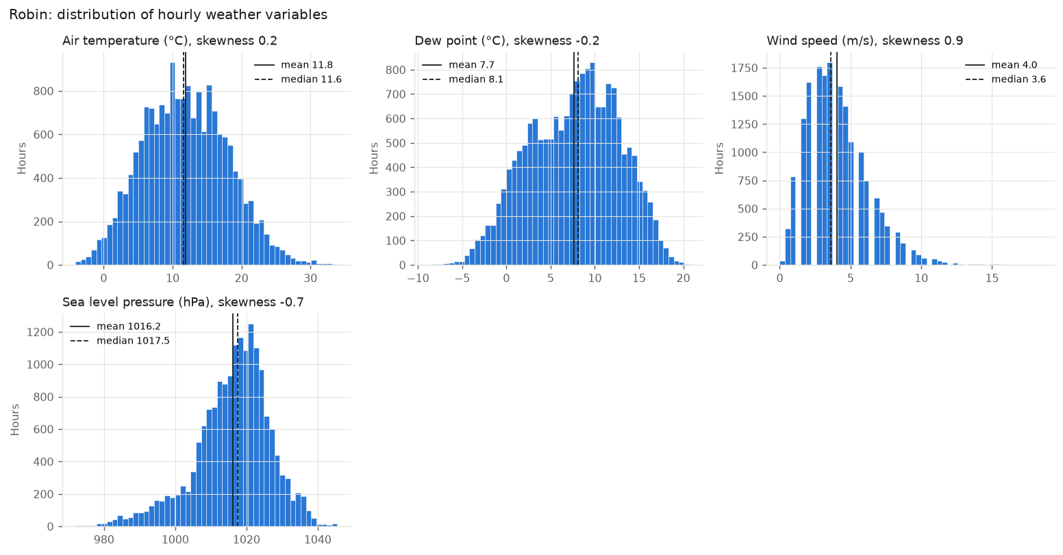
Figure 7. Robin: distribution of hourly weather variables with mean (solid) and median (dashed).
Extreme point: Empty bars in the wind speed histogram [Method artefact]
What we see: Every other bar in the wind speed histogram is empty or low, giving a comb-like pattern.
Cause: Wind speed is recorded in whole knots and converted to m/s, so the values come in steps of about 0.5 m/s (2.6, 3.1, 3.6 …). When the bars are narrower than the steps, some bars fall between two possible values and stay empty. The pattern comes from the resolution, not from the weather, and disappears with wider bars.

The box plots in Figure 8 show the spread between buildings. Median electricity varies by a factor of ten, from about 900 kWh/h at Leslie to below 100 kWh/h. Most buildings have narrow boxes and stable operation. Long lower whiskers and clusters far below the box indicate periods of almost no consumption.
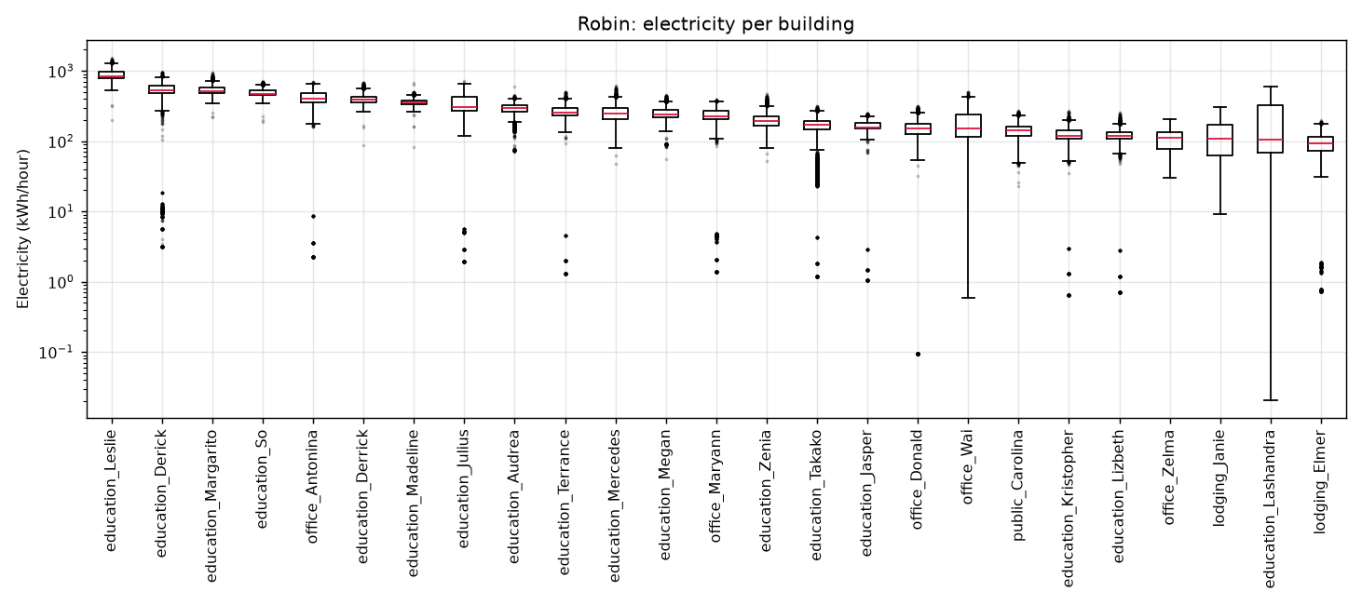
Figure 8. Robin: hourly electricity for the 25 buildings with the highest median, logarithmic axis.
Extreme point: Lashandra reaches down to 0.02 kWh/h [Measurement error]
What we see: Lashandra has the longest lower whisker of all buildings, more than three orders of magnitude below its box.
Cause: The meter stays close to zero for eight weeks, from 10 November 2016 to 5 January 2017, about 1,350 hours in total. The rest of the time consumption is normal (median 106 kWh/h). An education building using almost nothing for eight weeks during term time most likely has a meter that stopped recording.

Normalising by floor area (Figure 9) makes buildings of different size comparable. Education buildings have the highest intensity, with a median of about 0.035 kWh/h per m². This is roughly three times that of offices and four times that of residential and assembly buildings, reflecting laboratories, server rooms and long opening hours.
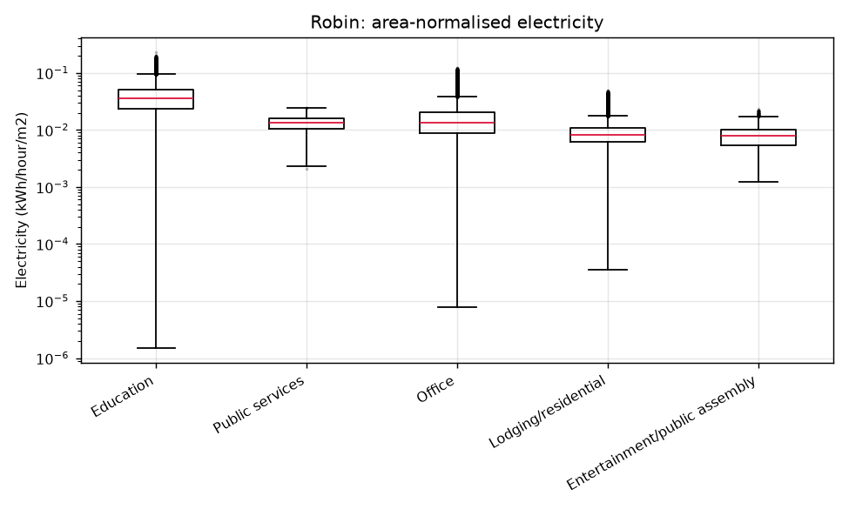
Figure 9. Robin: area-normalised hourly electricity by primary space usage, logarithmic axis.
Extreme point: Education reaches down to 10⁻⁶ kWh/h per m² [Measurement error]
What we see: The whisker for education buildings extends four orders of magnitude below the box.
Cause: These are the stuck meters from Figure 8 (among them Lashandra) divided by floor area. Normalisation scales measurement errors but does not remove them.

Relationships between variables
Figure 10 shows the Spearman correlation between daily values of weather, meters and a weekend indicator. Spearman correlation is used because several variables are strongly skewed. Hot water is strongly related to outdoor temperature (ρ = −0.89). Electricity hardly depends on temperature (−0.09) and is instead driven by the day of the week (−0.71 with weekend). Wind speed and pressure are moderately related (−0.43), since low pressure brings strong winds.
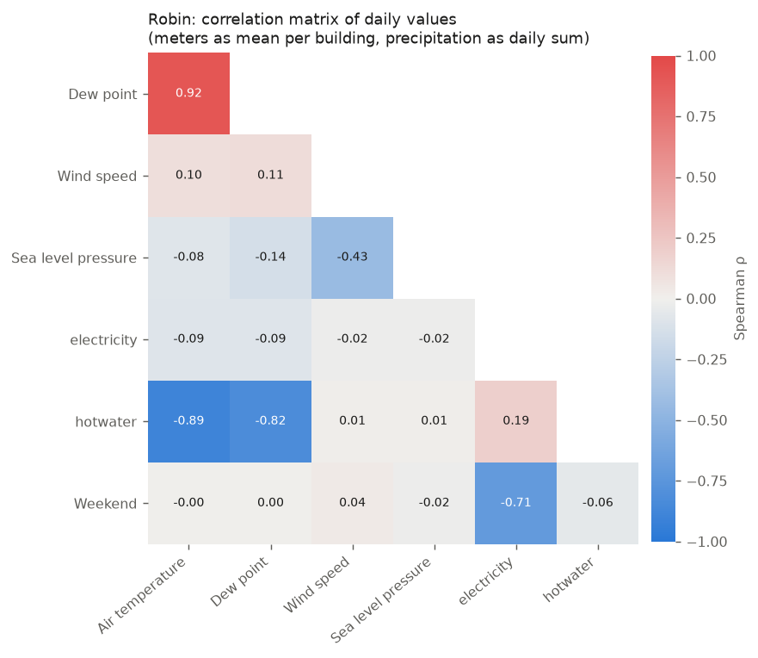
Figure 10. Robin: Spearman correlation matrix of daily values (meters as mean per building).
Extreme point: Dew point and air temperature: ρ = 0.92 [Real effect]
What we see: The strongest correlation in the matrix is between two weather variables, not between weather and consumption.
Cause: The dew point can never exceed the air temperature, and both follow the seasons, so they carry nearly the same information. This is also why dew point correlates −0.82 with hot water. Using both in a model would make their effects hard to separate. Temperature combined with relative humidity is a better choice.

The relationship between consumption and temperature depends on climate. Figure 11 compares four similar college classroom buildings of 10,000–12,000 m². Ottawa shows a U-shape, with more electricity on both cold and hot days, whereas Austin and Tempe are almost flat. Weekdays and weekends separate clearly at all four sites, which again shows the importance of occupancy.
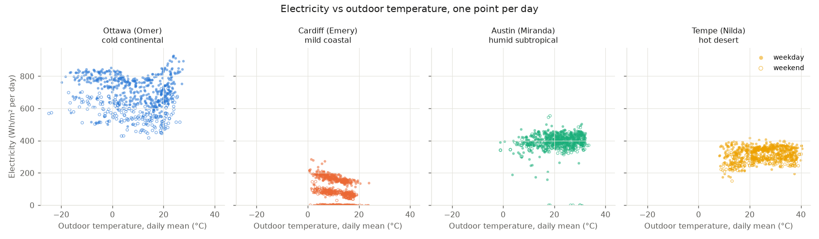
Figure 11. Daily electricity per m² against daily mean outdoor temperature for four college buildings in different climates. Filled markers are weekdays and open markers weekends.
Extreme point: Cardiff splits into three bands (~180, ~80 and 0 Wh/m²) [Measurement error]
What we see: The Cardiff points form three horizontal layers instead of one cloud.
Cause: The top band is almost only weekdays (272 of 274 days) and the middle band weekends and holidays. These two bands are real and show that the building follows the timetable. The bottom band is 184 days, mostly in 2017, when the meter recorded near zero, for long periods stuck at 0.0055 kWh/h. A 10,000 m² building cannot use that little, so the bottom band is a measurement error.

Figure 12 shows when in the year heating and cooling are used, as each month's share of annual use. Ottawa has distinct winter heating and summer cooling, with cooling switched off from November to April, while Austin and Tempe cool all year round. Climate decides both when and how much energy goes to heating and cooling.
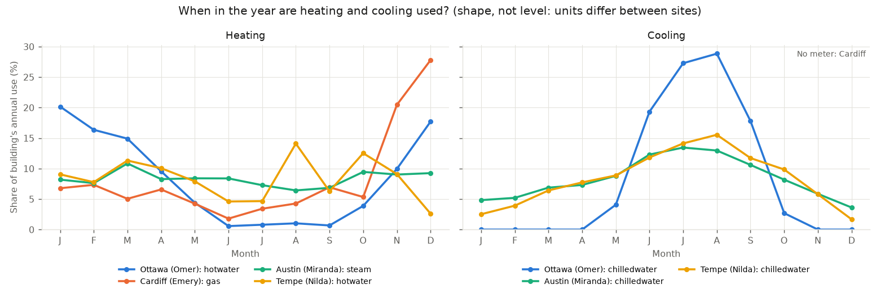
Figure 12. Monthly share of annual heating (left) and cooling (right) use for the four buildings. Units differ between sites, so only the shape is compared.
Extreme point: Cardiff uses 28 % of its annual gas in December [Measurement error]
What we see: The Cardiff curve rises steeply in November (20 %) and December (28 %), far more than in January and February, which are just as cold.
Cause: The weather does not explain it. November and December 2017 (8.2 and 6.3 °C) were not colder than the same months in 2016 (7.1 and 7.2 °C), and in the coldest month, January 2017 (5.5 °C), the building used less gas than in any other winter month. The other 113 gas meters at the site used only 9 % more than the year before. Instead, the meter jumps overnight from about 18 to 190 per hour on 30–31 October 2017 and stays there, 5–6 times higher than before. The weekday–weekend pattern continues after the jump, so the meter still follows the use of the building, only at a higher level. This points to a changed unit or scaling, or to a replaced meter that now covers more than before. It should be checked before the gas data are used.

Beyond the obvious effect of temperature, Figure 13 examines what explains heating demand across all 623 heating meters in the dataset. Temperature alone explains a median of 51 % of the daily variation. After removing the temperature effect, the strongest remaining factors are electricity use in the same building (ρ = +0.18), a proxy for occupancy, and the temperature change since the previous day (+0.11), which reflects the thermal inertia of buildings. Falling pressure and weekends also matter slightly (−0.07). Humidity, dew point and precipitation have virtually no effect. The effect of occupancy is largest at the UK and Irish sites (up to ρ = 0.63 at Wolf), where heating is provided by gas boilers in each building and scheduled with the timetable.
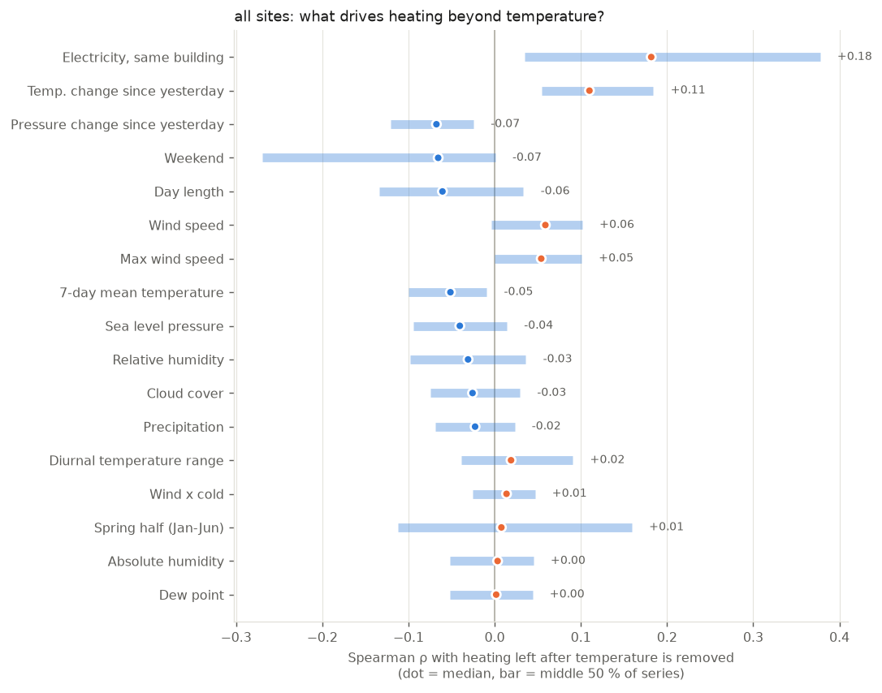
Figure 13. Correlation between heating demand and 17 factors after removing the effect of temperature, across 623 heating meters. Dots are medians and bars show the middle 50 % of meters.
Extreme point: Weekend and spring half: median near zero but very long bars [Method artefact]
What we see: The spring half (January–June) has a median of +0.01 but ranges from −0.11 to +0.16. Weekend ranges from −0.27 to 0.
Cause: The median hides that the sites pull in opposite directions. Some buildings use more heating in spring than in autumn at the same temperature (Shrew +0.37, Robin +0.24), others less. When the effects go both ways, the median ends up near zero even though the effect is clear at individual sites.

Figure 14 shows the same result in a different way, by splitting the heating–temperature curve into groups by a third factor. The curves for low, medium and high wind, humidity and cloud cover almost coincide, so these weather factors add little beyond temperature. Weekends and electricity use, in contrast, shift the curve clearly: at the same temperature, buildings use less heating at weekends and more when they are in use. Occupancy, not other weather variables, is therefore the most important factor after temperature.
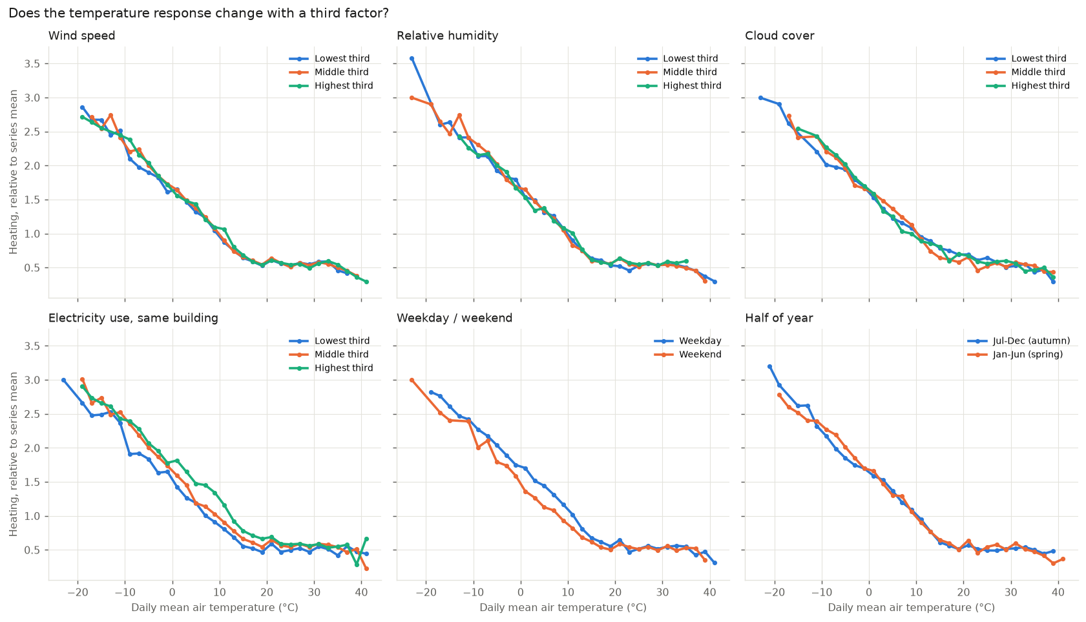
Figure 14. Heating demand (relative to each meter's mean) against daily mean temperature, split into groups by a third factor.
Extreme point: Jumps in the curves below −15 °C [Method artefact]
What we see: The curves jump up and down at the coldest temperatures (for humidity, for example, 3.6 against 3.0).
Cause: Only the coldest sites (Crow and Moose in Ottawa and Hog in Minneapolis) have days this cold, and only a few of them. Each point is therefore based on few meters and days, and the jumps are random variation, not an effect.

Summary
The exploration leads to the following conclusions:
- Structure. Variable availability is site-specific, so sites must be selected according to the variables an analysis needs.
- Temporal behaviour. Hot water follows the seasons. Electricity follows weekly and daily occupancy schedules more than the weather.
- Skewness. Meter data are strongly right-skewed and should be log-transformed and normalised by floor area before buildings are compared.
- Relationships. Hot water is driven by outdoor temperature, while electricity is driven by occupancy (weekday and time of day). Across all heating meters, occupancy is the most important factor after temperature, while humidity and precipitation add almost nothing. Dew point is nearly collinear with temperature and should not be used together with it.
- Data quality. The raw data contain accumulated readings after outages, meters stuck at constant values, abrupt level shifts, simultaneous logger outages and coarse meter resolution. These must be handled before modelling. Real extremes such as heatwaves and storms should be kept.

Missing data
Missing data in BDG2 occurs at two levels. At the building level, many buildings do not have a given meter at all. At the hour level, the meters that exist have gaps in their time series. In addition, many hourly values are exactly zero, which can mean either that a system was switched off or that a reading is missing. This section describes the availability of data for the heating and cooling sources in the dataset, with electricity as a reference. All numbers are based on the raw data.

Availability per heating and cooling source
Table 2 and Figure 15 summarise the availability per meter type. Heating is metered as hot water, steam or gas, and cooling as chilled water. The building level is the main source of missing data. Only 11 % of the 1,636 buildings have a hot water meter, 11 % a gas meter, 23 % a steam meter and 34 % a chilled water meter, compared with 96 % for electricity. When a meter exists, its time series is largely complete, with 89–97 % of the hours having a value. Steam has the most gaps, with 11 % of the hours missing.
Table 2. Availability of heating and cooling data per meter type, 2016–2017.
Meter type | Category | Buildings with meter | Share of all buildings | Sites | Hours with value | Hours missing | Zeros among values
Hot water | Heating | 185 | 11.3 % | 8 | 93.8 % | 6.2 % | 35.1 %
Steam | Heating | 370 | 22.6 % | 6 | 88.7 % | 11.3 % | 14.5 %
Gas | Heating | 177 | 10.8 % | 5 | 96.7 % | 3.3 % | 39.1 %
Chilled water | Cooling | 555 | 33.9 % | 11 | 93.1 % | 6.9 % | 17.8 %
Electricity | Reference | 1,578 | 96.5 % | 19 | 95.3 % | 4.7 % | 4.4 %

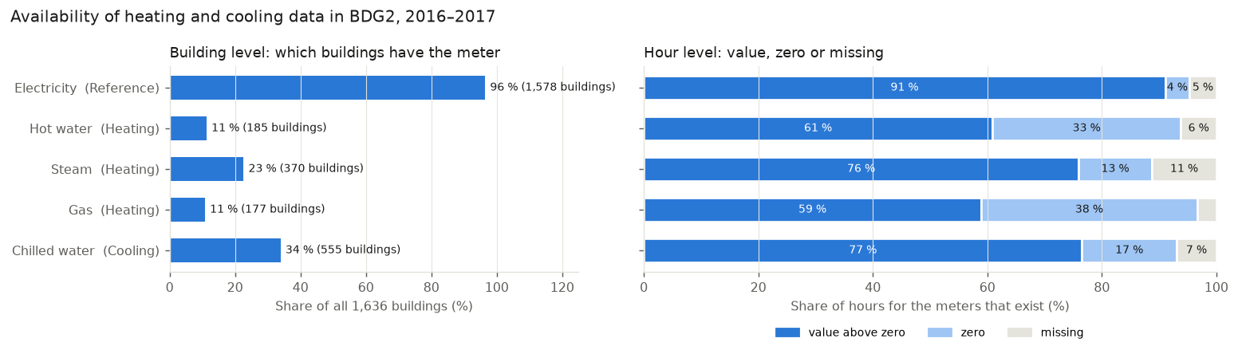
Figure 15. Left: share of all buildings that have each meter type. Right: for the meters that exist, the share of hours with a value above zero, a zero and no value.
Extreme point: 39 % of gas values and 35 % of hot water values are zero [Real effect]
What we see: Gas and hot water have far more zeros than electricity (4 %) and chilled water (18 %).
Cause: Most of the zeros are real. The share of zeros follows the seasons. For gas it rises from about 31 % of the hours in winter to 46 % in summer, and for hot water from 21 % to 43 %, because heating systems are switched off in summer and at night. However, a third of the gas hours are zero even in January, and 6 gas meters and 9 hot water meters are zero in more than 90 % of their hours. For these meters, the zeros most likely represent missing readings stored as zero, not real consumption.

Table 3 combines the meter types per building. Almost half of the buildings (49.6 %) have neither a heating nor a cooling meter, and only 27 % have both. Analyses of heating and cooling demand are therefore restricted to a subset of the dataset. The missing meters cannot be filled in, because there is no measurement to base an estimate on.
Table 3. Heating and cooling meters per building.
 | Buildings | Share of all buildings
Any heating meter | 713 | 43.6 %
A cooling meter | 555 | 33.9 %
Both | 443 | 27.1 %
Neither | 811 | 49.6 %

Missing data per site
Figure 16 shows that each heating source is tied to specific sites. Hot water is metered on 8 of the 19 sites, steam on 6 and gas on 5. Gas is found mainly on the UK and Irish sites, while steam and chilled water are found on the North American sites. Most combinations of site and meter type have more than 85 % of the hours with a value. The exceptions are steam at Cockatoo (68 %) and Peacock (69 %), gas at Bobcat (65 %) and all meters at Swan (49–50 %), which only has data for 2017.
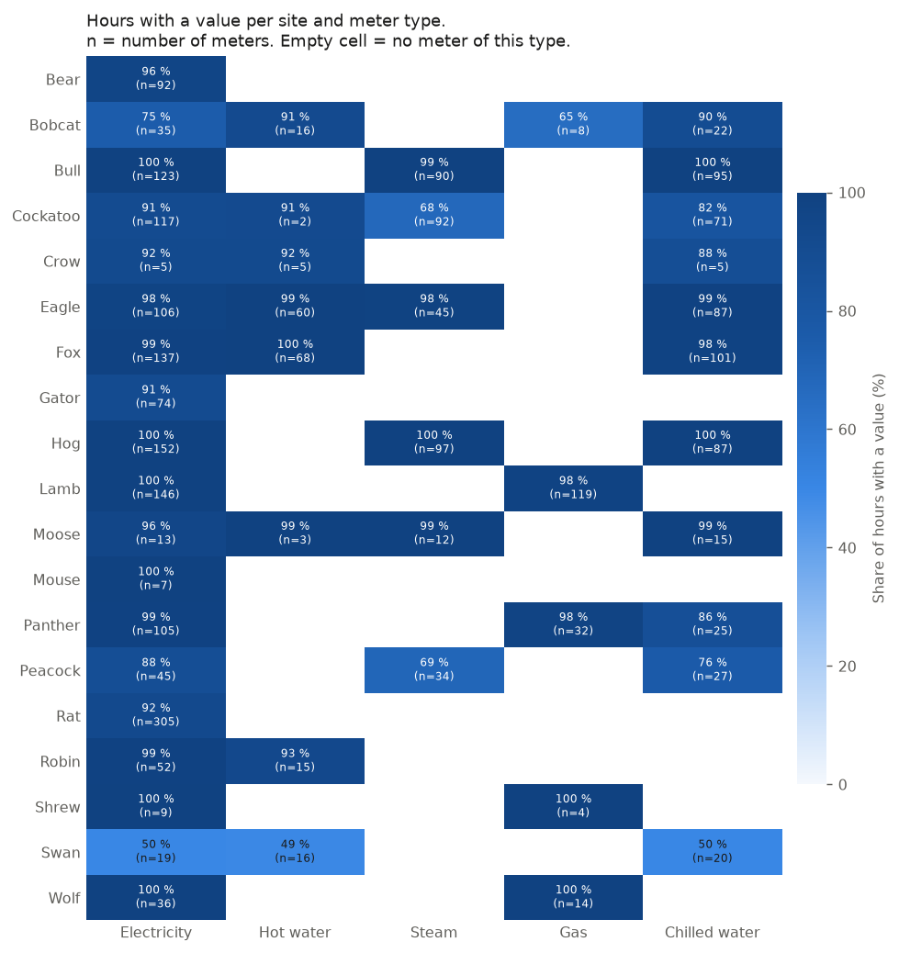
Figure 16. Share of hours with a value per site and meter type. n is the number of meters. An empty cell means that the site has no meter of this type.
Extreme point: 17 of the 92 steam meters at Cockatoo contain no data at all [Dataset structure]
What we see: Steam has the highest share of missing hours (11 %), and 19 steam meters have no values in the whole period. 17 of them are at Cockatoo and 2 at Peacock.
Cause: The meters are listed in the dataset and in the metadata, but never report a single value in 2016–2017. They have most likely never been connected to the data collection system, or have been taken out of service. In addition, the remaining steam meters at Cockatoo only report 38 % of the hours in the first quarter of 2016, which suggests that the data collection started gradually. Together, this explains the low coverage for steam.

Extreme point: Gas at Bobcat has only 65 % of the hours with a value [Dataset structure]
What we see: Five of the eight gas meters at Bobcat are complete, while the other three only have values for 7 % of the hours.
Cause: The three meters start reporting on 6–8 November 2017, so they only cover the last eight weeks of the period. They were most likely installed or connected late in 2017. The gaps therefore reflect when the meters were added, not missing readings from meters that were in operation.

Heating source in the metadata
The metadata field heatingtype describes the heating source directly, but it is recorded for only 215 of the 1,636 buildings (13 %), all of them on the four UK sites (Lamb, Robin, Shrew and Mouse). Of these, 81 % are heated by gas and 14 % by district heating (Table 4). The field can therefore not describe heating sources across the dataset, and the meter types are the only consistent indicator of how buildings are heated and cooled.
Table 4. Heating source recorded in the metadata field heatingtype.
Heating source | Buildings | Share of buildings with the field
Gas | 174 | 80.9 %
District heating | 31 | 14.4 %
Electric | 5 | 2.3 %
Steam | 2 | 0.9 %
Oil | 2 | 0.9 %
Biomass | 1 | 0.5 %
Not recorded | 1,421 | –

Implications
The missing data has the following consequences for the analysis:
- Building level. Analyses of heating and cooling must be restricted to the buildings and sites that have the relevant meters. Missing meters cannot be imputed.
- Hour level. Short gaps can be interpolated, while long gaps and meters without data should be excluded.
- Zeros. Zeros must be interpreted, not taken at face value. Meters that are zero almost all the time, and zeros in the middle of the heating season, should be checked before they are treated as real consumption.
- Metadata. The heating type is only known for UK buildings and cannot be used for the dataset as a whole.

