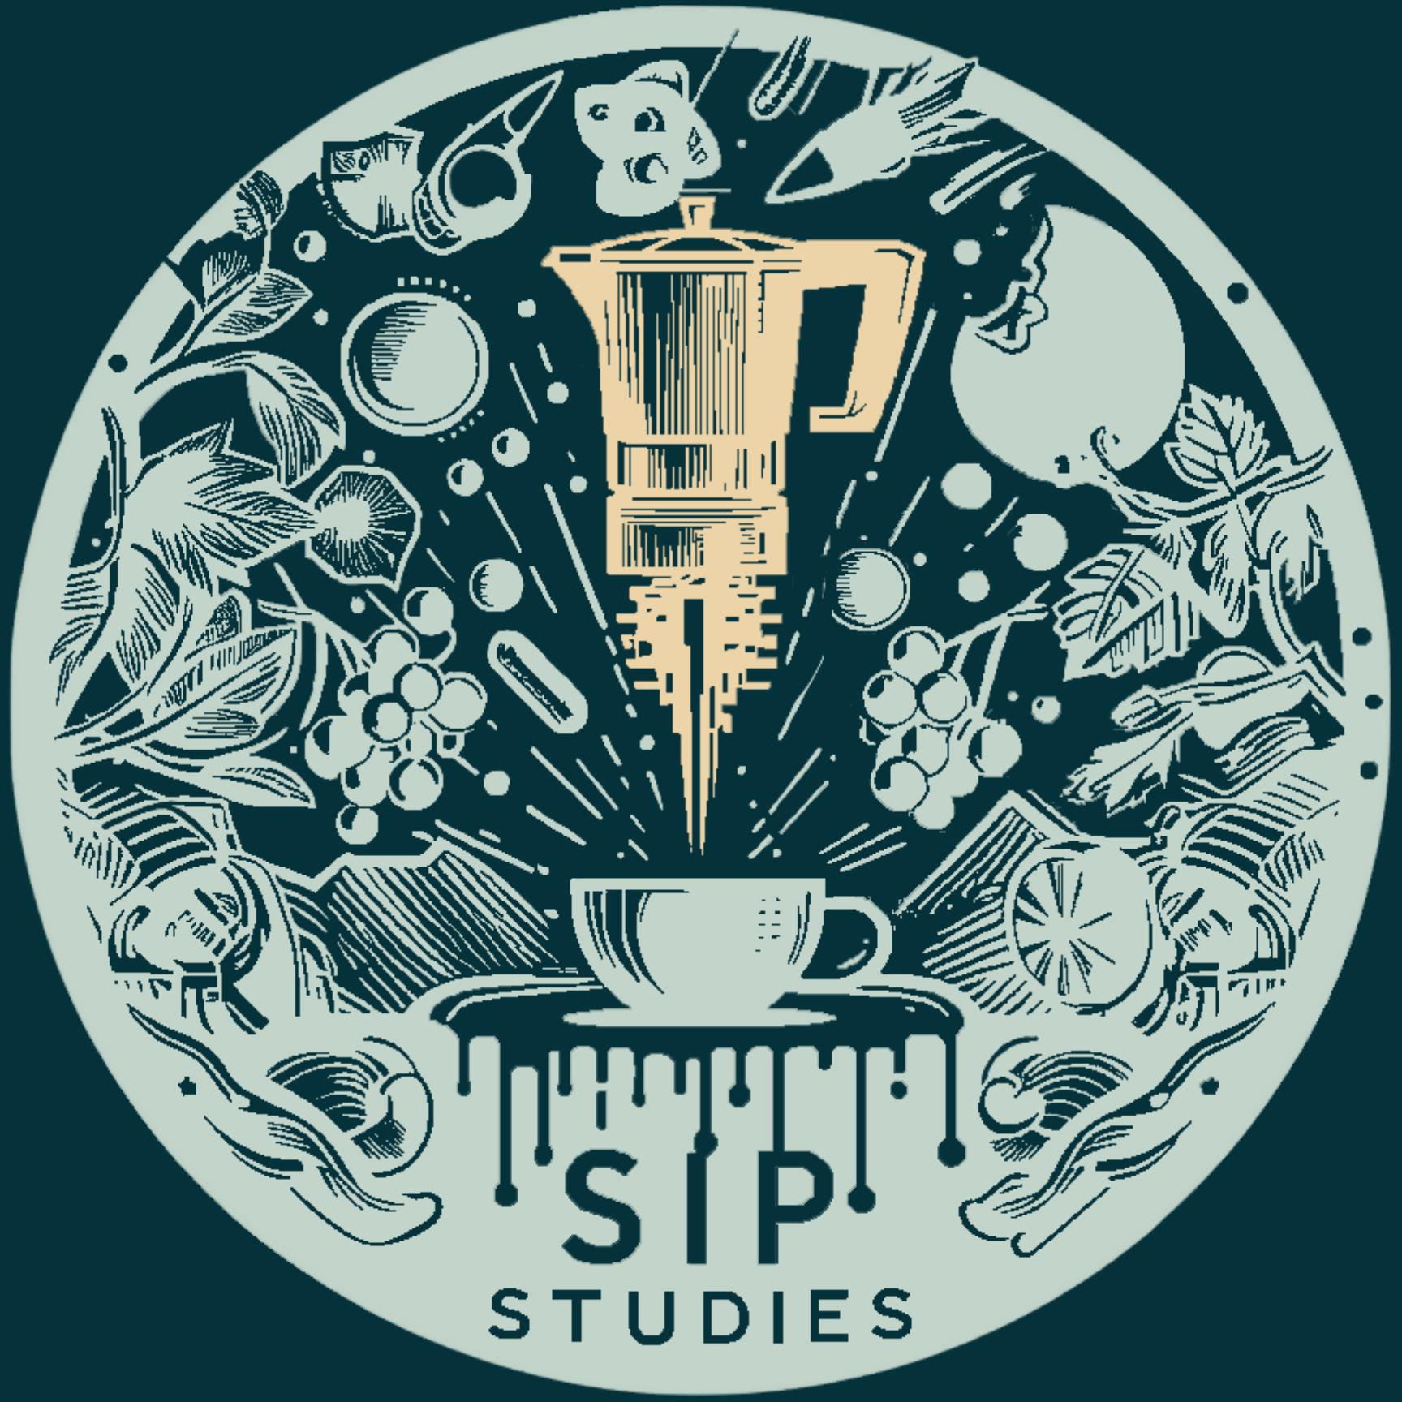

Jonathan Yu
Founder / Beverage Educator / Sales Consultant / AI Product Builder
Las Vegas, NV | JonYu3@gmail.com | 617.637.0668 | SipStudies.com | Sipopedia.com




Profile
Beverage educator and founder-builder combining 10+ years in wine and spirits sales, account analytics, formal credentials, architecture/design training, live-event production, and AI-enabled education technology. Since 2022, has used OpenAI products to turn a nontraditional coding background into repo-driven product development, documentation, media, and design execution.

Certifications
- MIT - AI: Implications for Business Strategy
- Society of Wine Educators - CWE
- Society of Wine Educators - CSS
- Court of Master Sommeliers - Certified Sommelier L2
- WSET - Level 3 Wine
- WSET - Level 2 Spirits
- WSET - Level 2 Sake
- Wine Scholar Guild / Lustau - CSWS
- Cicerone - Certified Beer Server L1

Skills
- AI/Product: advanced prompting, durable goals/threads, repo-driven AI agents, Codex-assisted project development, OpenAI product fluency since 2022
- OpenAI tools: ChatGPT, DALL-E, custom GPTs/GPT Store, Sora, Codex, image-generation workflows
- Customer Enablement: workshops, training, curriculum, adoption planning, stakeholder communication
- Analytics/Ops: POD gap analysis, inventory movement, sales velocity, account prioritization
- Beverage: wine/spirits education, supplier enablement, formal credentials

Focus Areas
- AI beverage solutions
- Account analytics + distribution strategy
- Educational training
- Beverage accessibility
- Preserving beverage data

Market Scale
- 3,800+ brands monitored
- 95,000 distribution points analyzed
- 45,542-row inventory reference file
- 23 stores reviewed
- $2.291M wine revenue lift

Experience

Sip Studies - Founder, Product Lead, Beverage Education Platform Builder
2024 - Present
- Using AI-assisted, repo-driven workflows, built a React/TypeScript, Vite, Supabase, Stripe, and Edge Function workspace across Learn, Taste, and Connect: Sip Academy, Sipopedia, Beverage Quiz, Maps, Flavor Wheel, Tasting Journal, Beverage News, AI Winecast, and Somm Events.
- Created a 20,000-row Sipopedia terminology pipeline with citation/review metadata plus a media-rich learning asset base featuring Sippy, Roma, Hummin, maps, game scenes, academy realms, equipment visuals, and infographics.
- Developed AI/news routing, Daily Sip editorial automation, terminology workflows, paid-access architecture, validation scripts, and buyer-facing valuation/IP materials around a $4.5M strategic acquisition thesis.

On Location Experience - VIP Experience Consultant
Sep 2021 - Present
- Served UFC VIP Experience as the primary event portfolio while also supporting Slap, NFL, NHL, and NASCAR premium guest experiences in high-energy live environments.

Breakthru Beverage Group - Sales Consultant - Off & On Premise Wine
Sep 2015 - Present
- Built and maintain weekly Critical On Hand / Gap Analysis workbooks used to analyze customer POD gaps, on-hand inventory, days on hand, sales movement, incentives, and account opportunities.
- Converted account, inventory, incentive, and reference-file data into weekly execution priorities for placements, displays, supplier conversations, education, and team account support.
- Earned 2018 Sales Consultant Excellence Award; expanded 3,500+ placements and increased wine revenue by $2,291,000 within Lee's Liquor.

AARP Colorado - Wine Educator
Aug 2020 - 2024
- Led Wine Walk Wednesdays regional wine education for 50+ active adults across live and recorded streams, predominantly viewed in Colorado and spanning all 50 states.
- Taught region, terroir, grapes, styles, architecture, history, culture, and geography in an accessible virtual-learning format.

Video Tech Services - Lighting, Audio & Video Technician
Aug 2013 - Jan 2018
- Worked lighting, audio, video, stage, casino, convention, and breakout-room production for events including LinkedIn, CES, Adobe, and Sage.

Total Wine & More - Wine Associate
Sep 2013 - Sep 2015
- Managed high-end customer wine sales, portfolios, cellar design support, department resets, customer events, and premium cellar presentation.
- Wrote wine-class curriculum, instructed customers, tracked P&L, and trained staff on product knowledge, service, and sales execution.

Architecture, Design & Drafting Foundation - Architectural Intern / Draftsman / AutoCAD Consultant
2008 - 2013
- Produced field investigations, as-builts, construction documents, reflected ceiling plans, signage drawings, 3D models, websites, marketing, interiors, and renovation documentation.
- Project exposure included casino interiors, restaurant renovations, ADA/SNRHA work, John E. Carson Motel, EAT patio redesign, Nacho Daddy, and 50 Church St. Cambridge renovation coordination.

Education + Outcomes
- Wentworth Institute of Technology - Bachelor of Science, Architecture
- 69 Supabase migrations + 5 Edge Functions
- 20,000 Sipopedia candidate rows
- Auth, Stripe, AI/news + terminology pipelines
- Monitored 3,800+ brands
- Weekly Critical On Hand POD gap analysis tool
- Analyzed 95,000 points of distribution in 23 stores
- 3,500+ placements
- $2.291M wine revenue lift
- $4.5M strategic acquisition thesis

