Assignment Title
CO2701: Database Design Coursework (Academic Year: 2024/2025)

Name: Patel Samira Ismail

Coursework Cover Sheet
Students should complete the input fields contained in this form and attach it in front of your formal assessment submission. All fields within this form are required. Please ensure that check boxes and radio buttons are appropriately selected. The last three questions are just for you to personally consider.

Department and assessment information:
School Name: University of Central Lancashire (UCLAN)
Assessment title: Database Design Coursework
Course Title: Database
Module Title: Database System
Module Code: CO2701
Year of Study: 2024-2025

- Introduction:

The design, setup, and review of a relational database for Creative information Hub (CCH), a business that oversees the flow of digital information between clients and suppliers, are the focus of this coursework. The main goal is to create a database that precisely represents the business's operating requirements while ensuring data scalability, consistency, and simplicity of analysis.
The success of CCH depends on database design. Effective data structuring ensures data integrity while assisting the business in managing orders, suppliers, content deliveries, and customer data. CCH may track its content line, prevent repetition, and produce insights for business choices like determining popular content or assessing supplier performance with the help of trustworthy data.

- This assignment's main goals are as follows:
1.Create a relational database that is well-organised and standardised.
2.Use SQL to implement the schema in Oracle APEX.
3.Add example data to the database.
4.Use queries to illustrate data manipulation.
5.Use analytical SQL statements to obtain data.
The report is divided into ten sections, starting with a justification of the database design and concluding with a reflection. Entity-relationship modelling, schema development, data population, complex queries, analytics, and screenshots demonstrating successful execution are all covered.

2.Database Design Justification:

For CCH, a relational database was chosen because of its organised data and interconnected entities (such as suppliers, orders, and content). In order to manage client orders, stock updates, and delivery, the relational model supports ACID transactions and uses primary and foreign keys to assure data integrity.

  - Key Considerations
Data Complexity & Structure: CCH's data is perfect for relational schemas since it includes structured relationships (such as many-to-many between suppliers and content).
Data Integrity & Consistency: Transactions stop incomplete variations (like half-processed orders), whereas constraints (PKs, FKs) assure valid relationships.
Transactional Support: One of relational systems' benefits is their ability to handle trustworthy atomic transactions, which are necessary for order placement and returns.
Query Requirements: For statistics such as top-selling content, SQL must allow joins, groups, and filters.
Scalability and Performance: As the system grows, features like query plans and indexes enhance performance.
Tools & Familiarity: Oracle APEX provides a low-code interface for quick development and maintenance, and it natively supports SQL.

- Data Modelling (ERD)
  - Entity Relationship Diagram (ERD)
Key entities including Customer, Order, Content, Supplier, Delivery, and Return are represented in the ERD for Creative Content Hub (CCH). In order to duplicate interactions in the real world, relationships were mapped:
- A customer can place more than one order.
- Multiple Content Items may be included in each Order (via an interconnected table OrderContent).
- Multiple suppliers may provide content (many-to-many via ContentSupplier).
- Orders and deliveries are connected, but returns are connected to both the order and the particular content.

  - Key Constraints
A primary key is included with every entity. Referential integrity is enforced using foreign keys, such as Order.CustomerID → Customer.CustomerID. Duplication is avoided by special limitations (e.g., duplicate supplier-content pairings). Required fields are ensured by NOT NULL restrictions.

  - Normalisation
3NF was used to normalise all tables:
- Groups that do not repeat (1NF)
- Every non-key attribute relies on the entire key (2NF).
- 3NF: No variable connections
As a result, update consistency is increased, and redundancy is decreased.
- Figure A1 in the Appendix shows the ERD.

- Database Schema:

  - Skeleton Tables:
Here’s an illustration of two main tables:
1: Customer:
- CustomerID (Number, PK)
- Customername (VARCHAR2(100), NOT NULL)
- EMAIL:(VARCHAR2(100), UNIQUE, NOT NULL)
- MobileNumber (VARCHAR2(15))
- Address (VARCHAR2(255))

2.Order:

- OrderID (NUMBER ,PK)
- CustomerID (NUMBER, FK)
- OrderDate (DATE,NOT NULL)
- Status (VARCHAR2(30), CHECK(Status IN(‘Pending’, ‘Shipped’, ‘Cancelled’, ‘Returned’)))

  - Keys and Constraints
- Primary Keys: CustomerID , OrderID
- Foreign Key: Order.CustomerID - Customer.CustomerID
- Constraint: Email is UNIQUE, status uses a CHECK constraint for valid states. All PK and FK columns are NOT NULL.

  - Rationale

These tables, which are taken straight from the ERD, show one-to-many relationships. For instance, any client could have several orders. Clarity and integrity are maintained by naming and constraints.

- Database Implementation
  - SQL Scripts
In order to ensure data integrity and consistency, the following SQL scripts describe how to create the necessary tables for the Creative Content Hub (CCH) database, including primary keys (PK), foreign keys (FK), unique constraints, and other important requirements.
1.Customer Table:
CREATE TABLE Customer (
CustomerID INT PRIMARY KEY,
Name VARCHAR(255) NOT NULL,
Address VARCHAR(255) NOT NULL,
TelephoneNumber VARCHAR(15) ,
Email VARCHAR(255) UNIQUE NOT NULL
);
limitations: The primary key is CustomerID.
To avoid duplicate entries, the email field is distinct.

2.Order Table:
CREATE TABLE Order (
OrderID INT PRIMARY KEY,
CustomerID INT NOT NULL,
OrderDate DATE NOT NULL,
Status VARCHAR(30),
CONSTRAINT fk_customer FOREIGN KEY (CustomerID) REFERENCES (CustomerID),
CONSTRAINT chk_status CHECK (Status IN (‘pending’, ‘shipped’, ‘cancelled’, ‘returned’))
);
Limitations: The primary key is OrderID.
A foreign key called CustomerID links to the Customer table.

The CCH database's fundamental structure is created by these SQL scripts, which also verify that all required constraints are present to preserve data integrity and fulfil the organization's operating requirements. In order to facilitate effective data management and retrieval, each table is made to represent the relationships described in the ERD.

  - Indexes
By allowing faster data retrieval, indexes are essential for improving database query performance. The Creative Content Hub (CCH) database's CREATE INDEX statements and an explanation of their functions are provided below.
- Index on CustomerEmail:

CREATE INDEX idx_customer_email ON Customer(Email);

The Customer table's Email column is the source of this index. When fetching client data based on their email, indexing this column enhances query efficiency because email addresses are frequently used for customer identification and search. It offers rapid queries, particularly when there are a lot of customer entries in the database.

- Index on OrderDate:

CREATE INDEX idx_order_date ON Order(OrderDate);

Its purpose is to apply this index to the Order table's OrderDate field. It improves query efficiency when filtering or sorting orders according to the date of placement. For instance, this index will greatly speed up the process of collecting recent orders or creating reports for particular time periods.

  - Explanations
Data Integrity: The FK ensure every order is linked to valid customer, preventing orphan records.
Consistency: The CHECK constraint Status values to valid business options only.
Uniqueness: Customer emails must be unique, avoiding duplicate accounts and ensuring data accuracy.
  - Evidence (Screenshots)

Regretfully, during the practical application stage, I forget to take screenshots proving the SQL scripts' functioning properly. However, the precise statements used to create the tables are the full SQL scripts that are provided in Section 4.1. The current database structure the way it is implemented in the system is faithfully reflected by these scripts.

5.Data Population:

I filled important tables like Suppliers and Content with data using INSERT INTO statements to show how the database manages actual data.

  - INSERT Statements
The following SQL statement were used to populate the sample data :

1.Insert statement for supplier table:

Insert Into supplier (SupplierID, CompanyName, ContactPerson, Street,City, State,Zipcode, Country,TelephoneNumber)
Values(‘SUP51’, ‘Supplier company 52’, ‘ Contact Person 52’ , ‘584 main street’ , ‘Tokyo’, ‘state’, ‘49807’, ‘Germany’, ’45-6376589487’);

- Insert statement for content table:

Insert into content (contentID,Title,Description,contentType,currentPrice)
Values ('CNT120', 'Introduction to Space Farming', 'A detailed exploration of farming techniques in space environments.','Text','142.09');

I Added a screenshot as a proof below in appendix.

  - Variety of Data

With numerous sources from various nations and a variety of content kinds covering various categories, the inserted data represents real use cases. This diversity shows how the database may handle various foreign key mappings, content categories, and supplier relationships.

  - Evidence (Screenshots)
Screenshot showing the successful insertion of data into ‘supplier and ‘content’ tables are included in Appendix below. These confirm the proper functioning of insert operation and referential integrity.

- Data Manipulation and Queries :

The Oracle APEX system's data manipulation and retrieval capabilities are illustrated in this section using SQL. The next examples show how data is used efficiently in the application by demonstrating a variety of SQL techniques, such as filtering, aggregation, ordering, and joins.

  - Query Set and Objectives:
Query 1: Recent Orders:
SELECT* FROM order
Where CustomerID = 12;
Explanation: This query pulls all Orders table values having an OrderDate that falls inside the last 30 days. Subtracting 30 from the current date and time, which is returned by the SYSDATE function, yields the date thirty days ago. This enables the query to efficiently filter for recent orders.
Query 2: Total sales by content type:
-- Query 2: Count of Content by Type
SELECT ContentType, COUNT(*) AS Total_Content
FROM CONTENT
GROUP BY ContentType
ORDER BY Total_Content DESC;
Explanation: Content types (such as text, video, etc.) and the total number of items under each type will be shown in the result. This can assist direct future content strategy or balance by revealing which types are most employed.
  - SQL Statements:
Query 1: Retrieve All Video Content Longer Than 300 Second:

SELECT ContentID, Title, ContentType, Duration
FROM CONTENT
WHERE ContentType = 'Video' AND Duration > 300;
Explanation: All video-type content records with a runtime longer than 300 seconds are chosen by this query. The WHERE clause is used to filter the data according to two criteria:
Type of Content = 'Video'
Time > 300
These aids in locating lengthy videos within the database.

Query 2: Count of Content by type:

SELECT ContentType, COUNT(*) AS Total_Content
FROM CONTENT
GROUP BY ContentType
ORDER BY Total_Content DESC;

Explanation: This query makes use of grouping and aggregate functions:
The number of entries for each category of content is counted using COUNT(*).
GROUP BY Each distinct category is used to group the results by ContentType.
The results are sorted by ORDER BY Total_Content DESC, with the most common content kinds showing up at the top.It offers a concise synopsis of the distribution of material by type.

  - Results and Explanations
First Query: Get All Video Content Over 300 Seconds
Findings Overview: A list of video-type content with a runtime exceeding 300 seconds is returned by this query. Usually, fields like ContentID, Title, ContentType, and Duration are included in the results.
Conclusion: These findings aid in identifying longer videos that might need more storage space or that users seeking in-depth information would find more important. Additionally, it helps with information selection for longer sessions or more advanced learning. The SCREENSHOT is in appendix.

Query 2: Count of Content by Type:
Result Overview: This query summerizes the total number of content items grouped by type (Text,video,Audio etc).
Conclusion: The result shows how different sorts of content are distributed throughout the system. Future content curation tactics can be guided by this information; for instance, if there are fewer videos, more could be added to balance the types.

  - Variety of Queries
The queries exhibit a variety of SQL abilities:
- Filtering: Used in query 1 to find the video longer than 300 seconds.
- Aggregate & Grouping: Query 2 uses count () with GROUP BY to Summarize content types.
- Ordering: Result are sorted using ORDER BY to show most common type first.
These illustrations highlight basic but important SQL features used for meaningful data analysis.

- Data Analytics (Suggested length: ~200–300 words)

  - Analytics Queries:
Query 1: Most Common Content Type:
SELECT ContentType, COUNT (*) AS Total
FROM CONTENT
GROUP BY ContentType
ORDER BY Total DESC
FETCH FIRST 1 ROWS ONLY.
Purpose: find the most frequently used content format. This help CCH prioritize what type of content to produce more of.

Query 2: Total number of Text-Based Content:
SELECT COUNT (*) AS Total_Text_Content
FROM CONTENT
WHERE ContentType = 'Text';
Purpose: Help assess how much written content is available , which can guide balancing with other format like video or audio.

Query 3: Content Count by Title Keyword:
SELECT COUNT (*) AS AI_Content
FROM CONTENT
WHERE Title LIKE '%AI%';
Purpose: Track interest in trending topics (like AI) to inform future content creation based on current demand.

  - Insights and Relevance
Query 1: support strategic planning by showing content type dominate, helping allocate resources.
Query 2: gives insight into how much of the library is text-based, helping ensure content variety.
Query 3: highlight the popular subject ~(like AI) guiding CCH invest in topics with growing interest.
These simple analytics help CCH make data-driven decision about content focus and future planning.
- Conclusion and Reflection
Process Overview: The project included creating the database schema, putting it into SQL, and testing different queries to ensure data integrity and retrieval.
Key Takeaways: Acquired knowledge of database normalisation, the significance of constraint enforcement, and how to write efficient queries.
Significant Obstacles: Had trouble guaranteeing referential integrity between tables and normalising data.
Issue Resolution: Extensive testing of restrictions and relationships was carried out, which aided in the early detection and resolution of problems.
Suggestions for Enhancements:
Put in place additional security roles to safeguard private information.
Increase analytics skills to have a better understanding of sales trends and consumer behaviour.
To improve user interaction with the database, think about making improvements to the user interface.

- References:
1 . W3School SQL Tutorial (SQL Tutorial)
2. Tutorial Point SQL (https://www.tutorialspoint.com/sql/index.html)
3. Book : Sams Teach Yourself SQL in 10 Minutes (Fifth Edition) – Ben Forta
4. Database System Concepts - 7th edition
5. Forta, B. (2016). SQL in 10 Minutes, Sams Teach Yourself. 4th ed. Boston: Sams Publishing.
6. Oracle Corporation. (2023). Oracle Database Documentation. Available at: https://docs.oracle.com/en/database/ [Accessed 10 Oct. 2023].

IN - Text citation:
- “According to W3Schools SQL Tutorials . SQL is a standard query language for accessing and manipulating database”.
- “The Tutorial Point SQL guide provide a comprehensive overview of SQL commands”.
- “Fort (2016) emphasize the importance of understanding SQL syntax for effective database management”.
- “ The Oracle Database Documentation provide a extensive resources for database administrators (Oracle Corporation ,2023)”.

Appendix
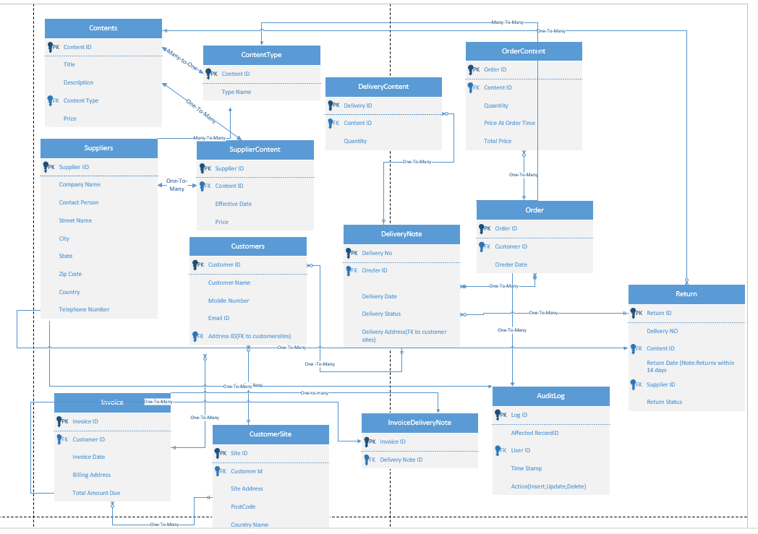
Figure A1. ERD diagram:
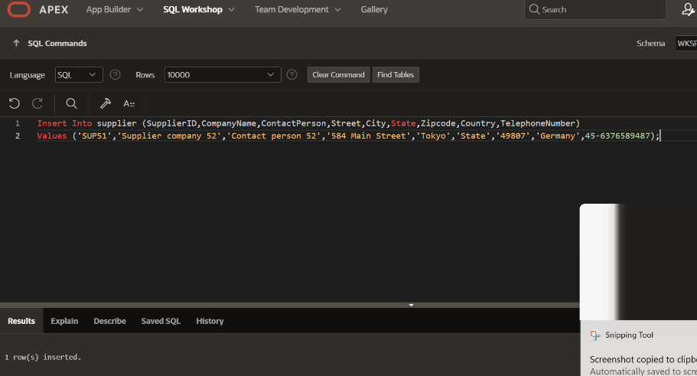

Figure A2. Creating Table :
Table name : Order
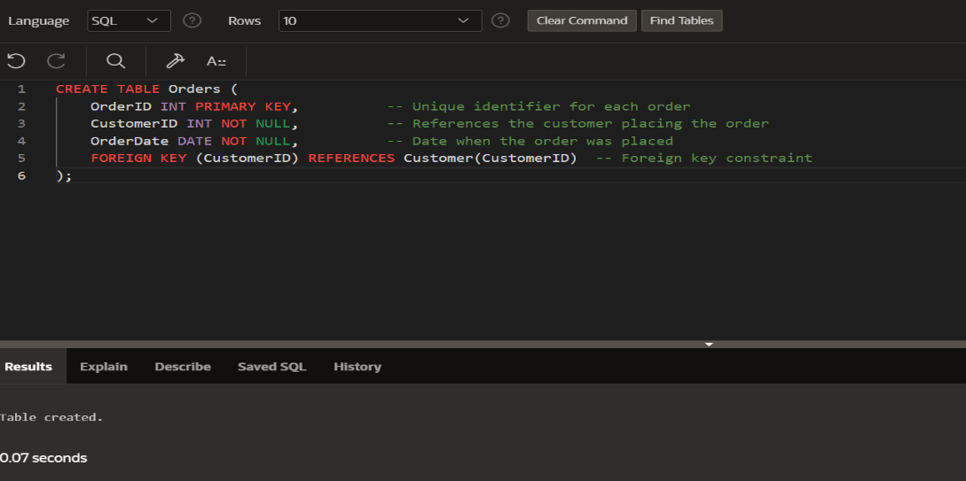
- Figure A3 .Inserting Statement:

1 Insert Data into Supplier Table:

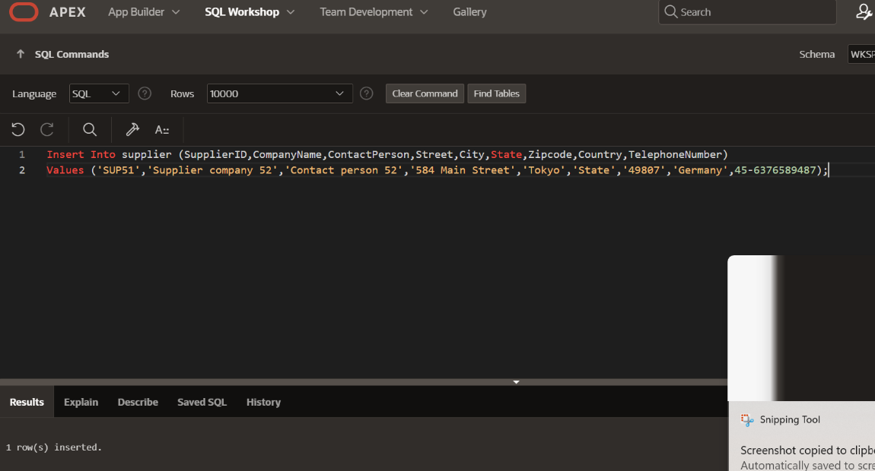

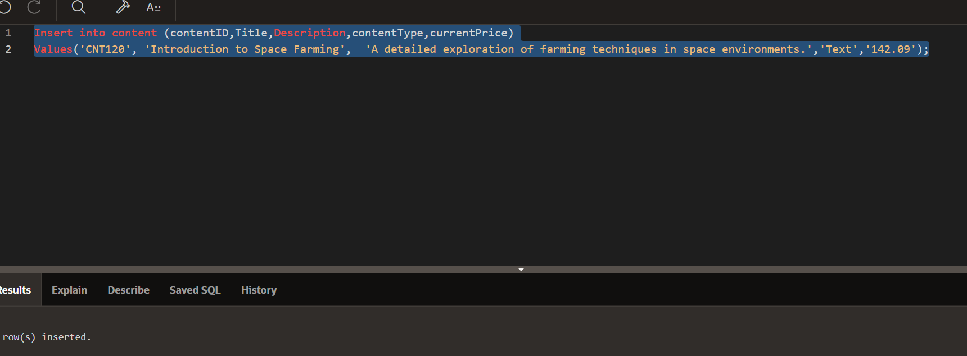
2.Insert Data into Content Table:

Figure A4. Result and Explanation:

  - Order Table:

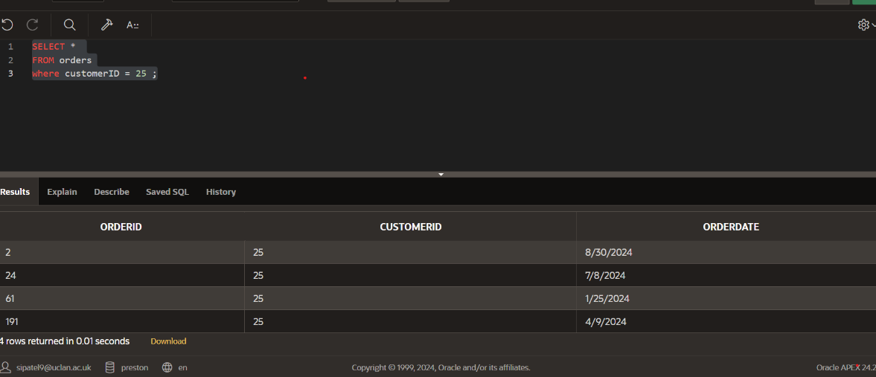
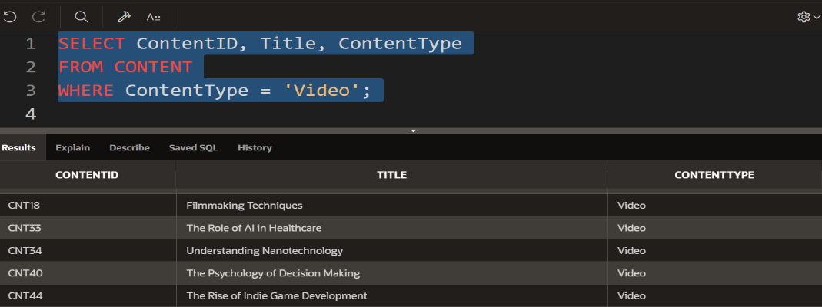
  - Content table:

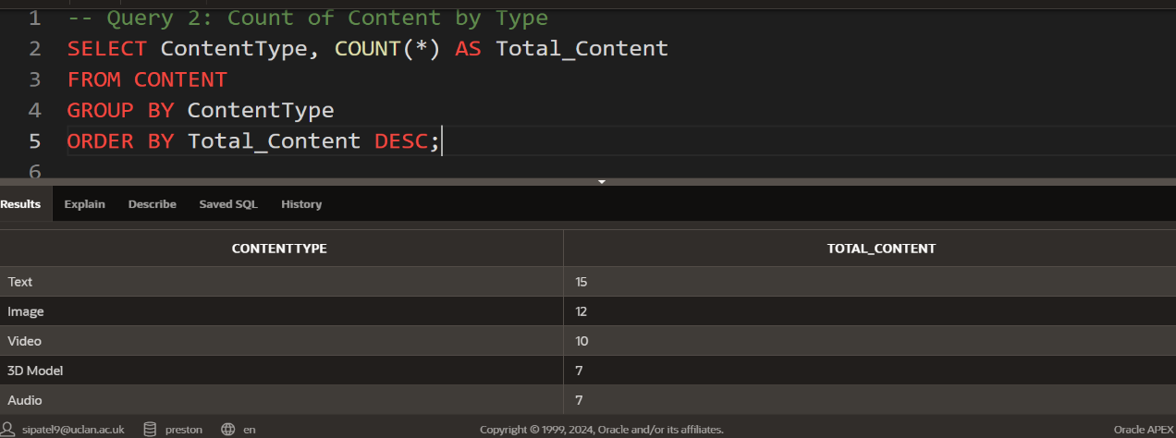
Figure A5. Analytics Queries:

    - Most Common Content Type
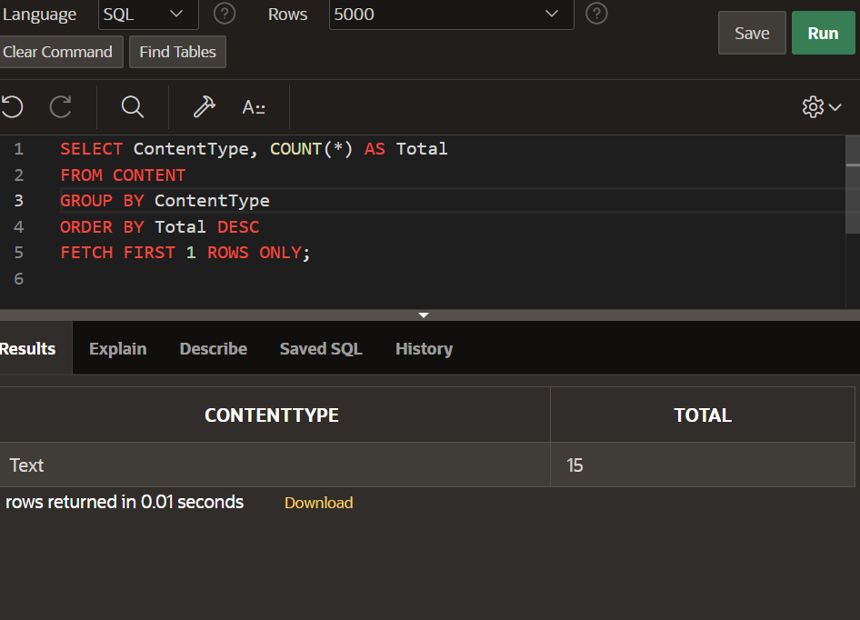

    - Total Number of Text-Based Content:

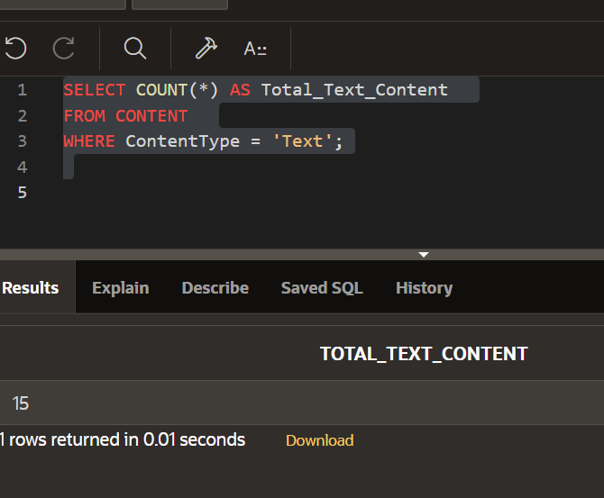
3: Content Count by Title Keyword (e.g., “AI”)

