E1131 Ntuzuma Ihobhe Road, 4359, Durban

PORTFOLIO: <https://siphah.github.io>

**RE: Junior Frontend Web Developer**

Dear Sir or Madam

I hereby apply for Junior Web Developer position in your organization. I believe that my expertise, and qualifications in S4 National Diploma Computer Systems Engineering and [Online portfolio](https://siphah.github.io) will make me a valuable asset to your organization and I would appreciate your careful consideration of my credentials as presented in the copy of my attached CV.

**As indicated on my CV, below there are the reasons why I believe I am the candidate you are looking for and how will I add value to the company to achieve its Mission and Vision.**

* **Reason 1 –** I have a portfolio showing all work I have did with examples (as blog posts) showing how I wrote the code.
* **Reason 2** –I did S4 Diploma with very important Modules like Network Systems, Programming, Software Design and Operating Systems.
* **Reason 3** – I am willing to learn and I can be easily mentored.

**I am excited about the possibility of joining your organization for Junior Frontend Web Developer.**

I can be reached at 084 444 6052or **email address** [siphamandlambokazicontact@gmail.com](mailto:siphamandlambokazicontact@gmail.com).

**I will follow up with an email message to confirm that you have received my application**.

Thank you for your consideration, and I look forward to hear from you.

Sincerely,

Siphamandla Mbokazi. 084 444 6052

*CV attached*.

PORTFOLIO: <https://siphah.github.io>

**Siphamandla**

**Cell Number**: 084 444 6052

**Email Address:** [siphamandlambokazicontact@gmail.com](mailto:siphamandlambokazicontact@gmail.com)

**Portfolio**: [siphah.github.io](https://siphah.github.io)

**Home Address**: E1131 Ntuzuma, Ihobhe Road, 4359

# Personal Details

Name : Siphamandla

Surname : Mbokazi

Title : Mr.

Gender : Male

Nationality : South African

Home Language : IsiZulu

Other Language : English (fluent)

Race : African

Health : Excellent

Disabilities : None

# Education

2018

S4 National Diploma Electrical engineering : MUT

2015

N4&N5 Nated Certificate (Heavy Electrical Engineering) : Elangeni College

2011

Grade 12 Matric NCS : Igugulabasha High School

# Skills (gAINED FROM UNIVERSITY AND SELF TAUGHT)

* **Programming Tools:** HTML5, CSS3, Vanilla JS, JQuery, Bootstrap, AJAX, PHP,SASS and CSS grids.
* **Image Processing** : Adobe Photoshop and Gimp
* **Content Management System** : WordPress
* Version Control: Git , NPM
* Editors: Atom, Visual Studio Code and Notepad++.

# Working History

01/11/ 2014 – 30 /01/2015

Company : Mugg and Bean (Restaurant)

Position Held : Salad Maker

Duties:-

Prepare food for cooking (clean, peel and cut food), store food in containers to avoid spoilage. Clean and maintain work areas.

15/12/2011 – 30/12/2012

Company : Remos Fratelli (Restaurant)

Position Held : Waiter

Duties : Serving food, taking orders, constantly ensure good customer experience.

# Career Goals

Short Term Goal

Get learning experience in Web Development industry, applying Computer Engineering Systems knowledge learned in tertiary. Experience in reliability and functionality in Computer programming code is my core interest.

Long Term Goal

Apply the experienced learned to bring value to the engineering market place as much as possible, incorporate my 50% hardware and 50% software knowledge to make big change in the industry.

# Reference

Available on Request

1. CERTIFIED ID DOCUMENT

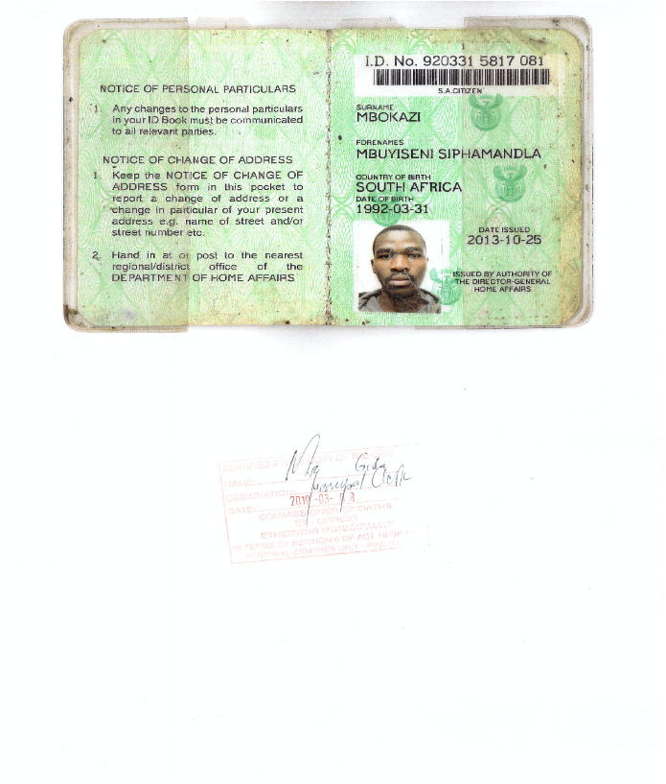

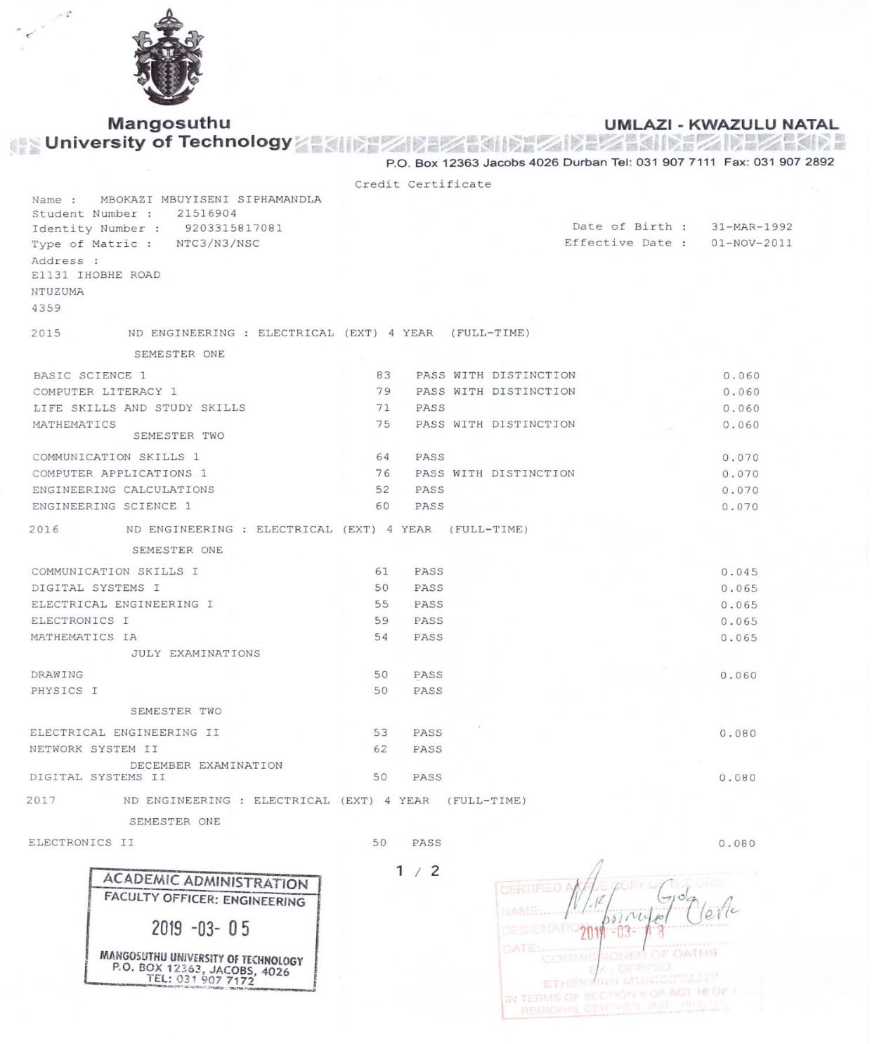2. ACADEMIC RECORD COMPUTER SYSTEMS (UNDER ELECTRICAL ENGINEERING DEPARTMENT).

3. ACADEMIC RECORD COMPUTER SYSTEMS (UNDER ELECTRICAL ENGINEERING DEPARTMENT CONTINUED).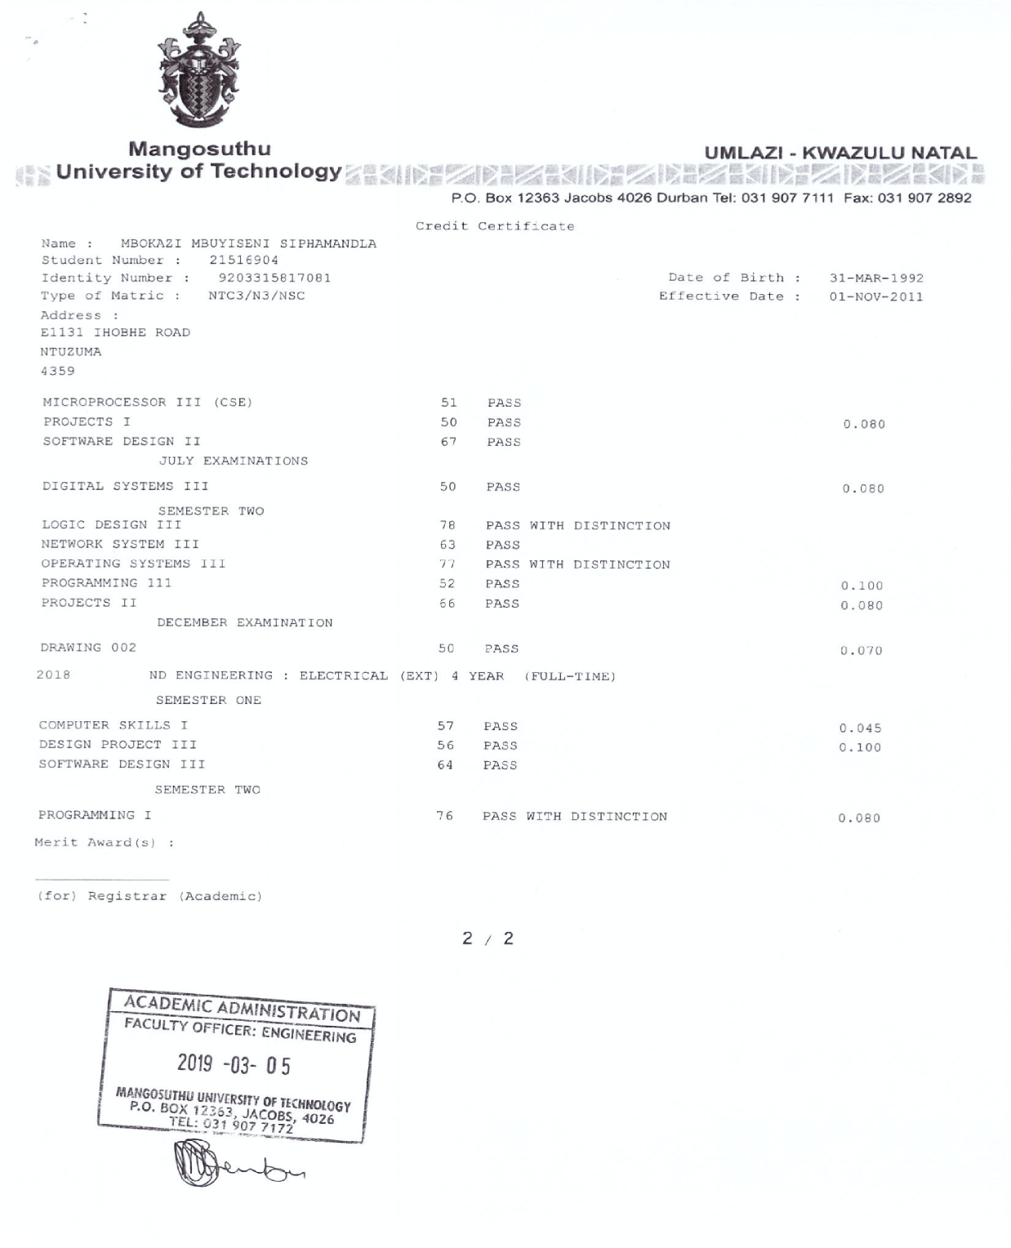

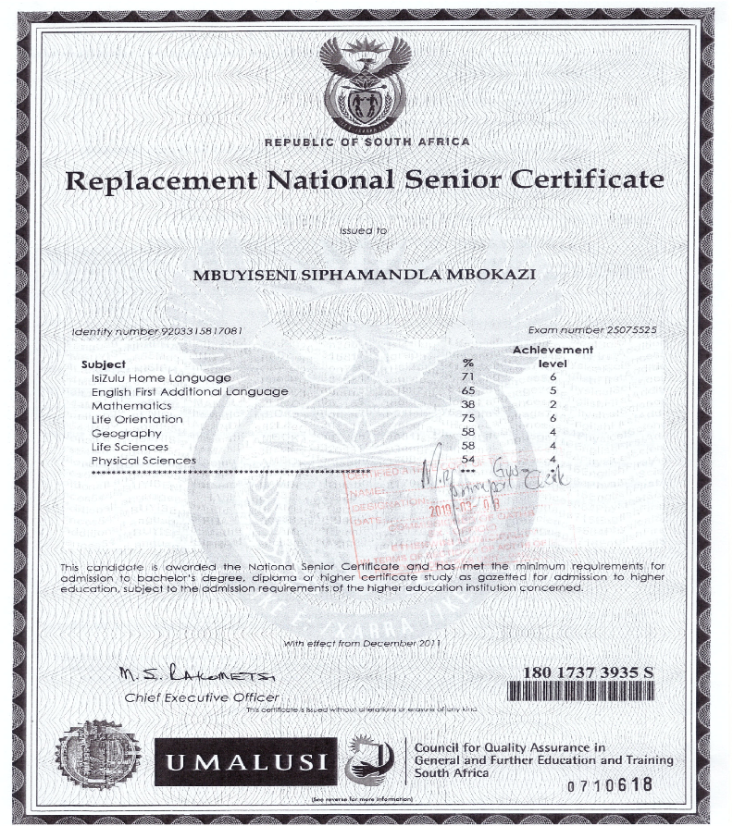 4. CERTIFIED MATRIC CERTIFICATE