 | 

BUILDING MANAGEMENT SYSTEM PROPOSAL
CSIR Campus Building 53
Head Office Upgrade Project
Proposed BMS Architecture, HVAC Control Strategy & Implementation Approach

____

PREPARED FOR  CSIR | PREPARED BY  Tshepo Mamabolo
COMPANY  Spartcon | DATE  18 September 2026

Department of Science & Innovation, South Africa · Basis of design derived from Building 53 HVAC mechanical drawings (issued for construction 07-05-2026).

Document Contents
CONTENTS Table of Contents
01 Executive Summary & Project Understanding 3
02 Proposed BMS Solution 4
03 System Architecture 5
04 HVAC Control Strategy 6
05 Monitoring, Alarms, Trends & Scheduling 8
06 Communications & Network Architecture 9
07 Implementation & Commissioning 10
08 Assumptions, Exclusions & Information Required 11
09 Commercial Information & Sign-off 12

How to read this proposal. Technical statements are qualified against their level of certainty so that confirmed information is never presented as assumption, and engineering proposals are never presented as fact.

CONFIRMED Established directly from the Building 53 HVAC drawings. OEM Supported by manufacturer capability, subject to model selection. ENGINEERING Proposed engineering basis of design. CONFIRM Requires client / OEM / HVAC contractor confirmation.

This proposal is based on the HVAC mechanical drawing set for Building 53. It does not constitute a complete BMS controls specification; the drawings do not define BMS network, controller I/O, sensor schedules or control sequences. Those items are addressed here as a proposed basis of design and are identified as requiring confirmation during detailed design.

Section 01
01 Executive Summary & Project Understanding
Spartcon has been asked to propose a Building Management System (BMS) for the CSIR Campus Building 53 – Head Office Upgrade Project. The proposed BMS will provide centralised monitoring and control of selected HVAC equipment through a network of field controllers and standard building-automation communication protocols, presented to operators through a web-based interface.
This proposal is developed from the HVAC mechanical drawing set for Building 53, comprising the Ground, First, Second and Third Floor HVAC plans, the Roof Plan HVAC, and associated plot/log information. That set was issued for construction on 07 May 2026.
What the drawings confirm
The drawings are primarily mechanical HVAC documents. They confirm the presence of the following HVAC infrastructure and equipment:
- GMS ducting
- VAV diffusers
- Return air grilles
- Ablution extract / disc valves
- High-wall split air-conditioning units
- Outdoor heat pump / air-conditioning units
- Refrigerant piping
- Condensate / drain arrangements and HVAC construction details
What the drawings do not define
The drawing set does not contain a complete BMS controls specification. There is no confirmed information for the BMS network (BACnet or Modbus), controller platform, controller I/O schedules, sensor schedule, control sequences, actuator communication protocols, lighting-control network, network topology, remote-access architecture or final BMS point count. These items are treated in this proposal as a proposed engineering basis of design and are clearly identified as requiring confirmation.
Basis of the proposal. The HVAC consultant/designer identified on the mechanical drawings is not the author of this BMS proposal and is not associated with Spartcon. This document is prepared by Spartcon as an independent BMS proposal.

Proposed direction
The proposed solution is based around a Vector Controls architecture, treated as its own controls ecosystem rather than a Tridium JACE / Niagara system. Field devices connect to Vector X2 field controllers over BACnet MS/TP or Modbus RTU, which connect over the building Ethernet network to a Vector management platform serving a web-based operator interface. Controller models, quantities and the final management platform are established from the approved I/O schedule during detailed design.
Project parameter | Position in this proposal
Project | CSIR Campus Building 53 – Head Office Upgrade Project CONFIRMED
Source information | Building 53 HVAC mechanical drawings, issued for construction 07-05-2026 CONFIRMED
Controls ecosystem | Vector Controls (Vector X2 field controllers) ENGINEERING
Management platform | Vector BAS-SMP-2000 as proposed basis; GSM-1000-BMX noted as alternative CONFIRM
BMS point count / I/O | To be established from the approved equipment schedule CONFIRM

Section 02
02 Proposed BMS Solution
The proposed BMS is a Vector-based control architecture. Field devices and HVAC equipment interfaces are connected to Vector X2 field controllers, which communicate over standard building-automation buses to a Vector management platform. Operators interact with the system through a browser-based interface for monitoring, alarms, trends and scheduling.
Vector X2 field controllers
Vector X2 controllers are presented as programmable communicating field controllers within the Vector controls ecosystem. Depending on the controller model selected, relevant communication capabilities include:
- BACnet MS/TP
- BACnet/IP
- Modbus RTU / ASCII
- Modbus TCP
Controller configuration and programming are associated with the Vector EasySet environment. Controller model selection and quantities are not fixed in this proposal; they will be determined from the final I/O schedule and the equipment interfaces confirmed during detailed design.
Management platform
The proposed basis of design for the management layer is the Vector BAS-SMP-2000. A second Vector management product, GSM-1000-BMX, is noted as a possible alternative subject to final system selection. No single management platform is treated as finally selected; the platform above is stated as the proposed basis only.
Vector compared with a Tridium JACE / Niagara system
This distinction is important and is stated precisely:
Tridium JACE / Niagara | Vector Controls
A JACE is a hardware/network automation controller that runs the Niagara framework. | Vector X2 controllers are independent field controllers belonging to the Vector controls ecosystem.
Niagara Workbench is used to engineer and configure Niagara systems. | Vector has its own configuration environment (Vector EasySet). Vector is not used to program a JACE.
Communicates using standard protocols including BACnet and Modbus. | Communicates using standard protocols including BACnet and Modbus, and can therefore operate as an independent BMS/control architecture.

Because both platforms use standard communication protocols, a Vector + Niagara/JACE hybrid architecture is technically possible where appropriate. However, this proposal is primarily evaluating a Vector-based architecture. No official partnership between Vector and Tridium is implied or claimed.
Scope note. The described capabilities reflect the Vector product ecosystem. Final controller models, the management platform, and the exact protocol used per equipment item remain subject to confirmation during detailed design and against the approved equipment schedule.

Section 03
03 System Architecture
The proposed architecture is a conventional layered building-automation topology: field devices report to field controllers, field controllers communicate over field buses to the management layer, and the management layer presents a web-based interface. The diagram below shows the proposed conceptual architecture.
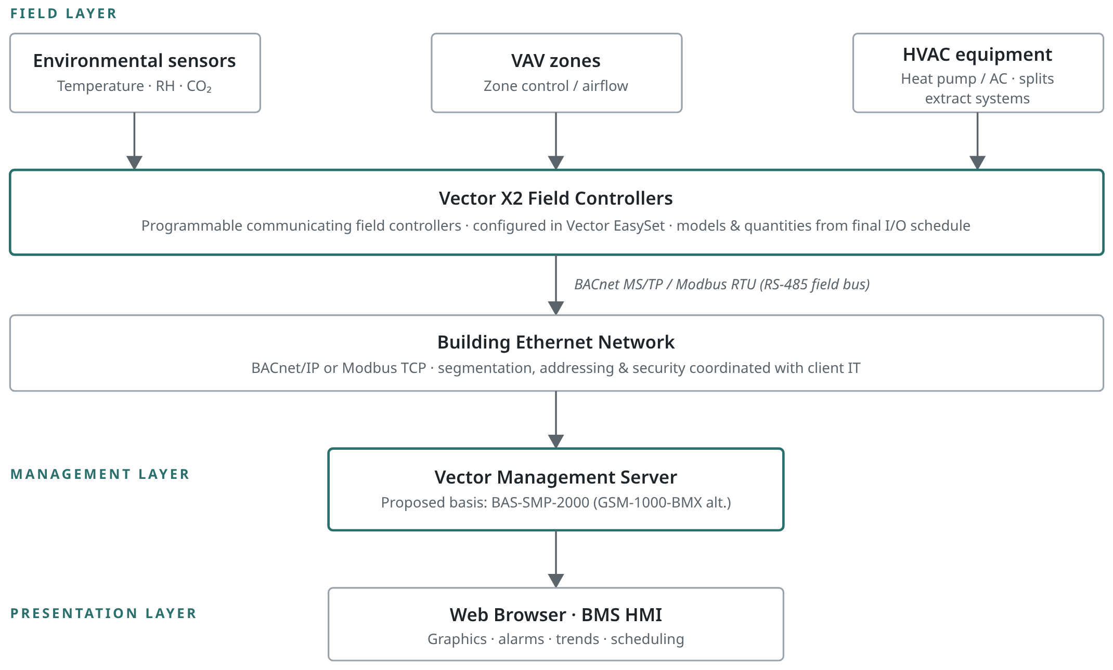

Diagram is conceptual. The final physical network architecture, device addressing and protocol assignment per equipment item are coordinated with the client IT/network team and confirmed against the approved equipment schedule during detailed design.

Section 04
04 HVAC Control Strategy
The following proposed control strategy describes the intended BMS functions per equipment type. In every case the final control points depend on the selected equipment, its controller/actuator and its available communication interface, and are confirmed during detailed design.
VAV systems
Where the installed VAV equipment supports suitable control interfaces, the BMS should be capable of:
- Monitoring zone temperature
- Monitoring relevant zone conditions
- Adjusting temperature/setpoint parameters where supported
- Monitoring VAV operating status
- Monitoring airflow-related values where available
- Managing occupied/unoccupied operation where applicable
- Generating alarms for abnormal conditions
- Trending relevant values
No particular actuator or communication protocol is assumed for any VAV. Final control points depend on the selected VAV controller/actuator. CONFIRM
Temperature / humidity / CO₂
The proposed system supports environmental sensors for temperature, relative humidity and CO₂. Where required by the final design, these values can be used for monitoring, alarming, trending and setpoint/control strategies. Exact sensor quantities and acceptable limits are not defined at this stage. CONFIRM
Heat pump / air-conditioning systems
The drawings identify outdoor heat pump / AC equipment with the following ratings taken from the mechanical drawings:
Equipment | Rating (from drawings) | Status
HP/AC01 | 302.1 kW | CONFIRMED
HP/AC02 | 585.8 kW | CONFIRMED

Manufacturer, model, protocol and exact control interface are not defined by the drawings. BMS integration will depend on the equipment OEM interface and may use BACnet, Modbus, dry contacts, gateway integration or another approved interface as applicable. Potential monitoring/control functions — all subject to OEM confirmation — may include enable/disable where supported, run status, fault/alarm status, operating mode, temperature values, setpoints and relevant equipment parameters. OEM

Section 04 · continued
04 HVAC Control Strategy (continued)
Split air-conditioning units
The drawings include high-wall split units. Integration depends on the selected split-unit manufacturer's available communication interface. Possible approaches include:
- Direct BACnet / Modbus interface
- Manufacturer gateway
- Approved third-party interface
- Monitoring-only integration where full control is unavailable
Direct integration is not claimed without confirmation of the selected manufacturer's interface. OEM
Extract systems
The proposal addresses monitoring/control of relevant extract systems where applicable. Potential points include:
- Run status
- Fault status
- Enable/disable
- Scheduling
Final points depend on the installed equipment. CONFIRM
Summary of proposed points by equipment type
Equipment | Typical proposed functions | Dependency
VAV zones | Zone temperature, zone conditions, setpoint adjust (where supported), status, airflow (where available), occupancy mode, alarms, trends | Selected VAV controller/actuator
Environmental sensors | Temperature, RH, CO₂ — monitoring, alarming, trending, control strategies | Final design / sensor selection
Heat pump / AC (HP/AC01, HP/AC02) | Enable/disable, run status, fault, mode, temperatures, setpoints, parameters | OEM interface
Split AC units | Monitoring and control per available interface; monitoring-only where control unavailable | Manufacturer interface / gateway
Extract systems | Run status, fault, enable/disable, scheduling | Installed equipment

Point allocation. The functions above are a proposed control strategy. Final point allocation will be established from the approved equipment schedule and confirmed control philosophy during detailed design.

Section 05
05 Monitoring, Alarms, Trends & Scheduling
Graphics
A browser-based graphical interface is provided for building overview, floor-level views, HVAC equipment, VAV zones, environmental conditions, equipment status and alarms. Graphics reflect the equipment confirmed in the drawings and the points established during detailed design.
Alarms
Centralised alarms are provided for conditions such as equipment faults, communication failures, sensor faults, abnormal operating conditions and other relevant HVAC alarms. Alarm points and thresholds are confirmed against the final control philosophy.
Trends
Historical trending is provided for relevant temperature, humidity, CO₂, equipment status, setpoints and other selected BMS points.
Scheduling
Schedules may be used for occupied/unoccupied operation, HVAC enable/disable, equipment operating periods and other approved schedules.
Data / reporting
Where supported by the selected management platform, the system provides historical data, alarm history, trends, operating information and basic reporting. Advanced analytics are not promised and are only included where specifically supported by the selected platform and agreed in scope.
Function | Description | Basis
Graphics | Building overview, floor views, HVAC equipment, VAV zones, conditions, status, alarms | ENGINEERING
Alarms | Equipment faults, comms failures, sensor faults, abnormal conditions, HVAC alarms | ENGINEERING
Trends | Temperature, humidity, CO₂, status, setpoints, selected points | ENGINEERING
Scheduling | Occupied/unoccupied, HVAC enable/disable, operating periods | ENGINEERING
Data / reporting | Historical data, alarm history, trends, operating info, basic reporting | CONFIRM

Section 06
06 Communications & Network Architecture
Field controllers communicate with field devices over RS-485 field buses using BACnet MS/TP or Modbus RTU. The field controllers connect to the building Ethernet network, over which they communicate with the Vector management server using BACnet/IP or Modbus TCP. The management server presents the web-based operator interface.
The final physical network architecture must be coordinated with the client's IT/network team. The following considerations apply and are confirmed during detailed design:
Consideration | Approach
IP addressing | Allocated in coordination with client IT. No IP addresses are assigned in this proposal.
Network segmentation / VLANs | Applied where required, coordinated with client IT policy.
Switch infrastructure | Confirmed against available building network infrastructure and BMS requirements.
RS-485 field buses | Field bus layout, termination and biasing per device count and cable runs.
Device addressing | BACnet/Modbus device addressing scheme defined in the I/O schedule.
Network commissioning | Bus and IP communication verified during commissioning.
Cybersecurity | Aligned with client requirements. Controllers are not exposed directly to the public internet.
Remote access | Provided only through an approved, secured method per client requirements.

Security position. Controllers will not be exposed directly to the public internet. Remote access, segmentation and cybersecurity measures are implemented per the client's IT and security requirements, which are to be confirmed.

Existing building network availability, IT/VLAN requirements, remote-access requirements and client cybersecurity requirements are all subject to confirmation. CONFIRM

Section 07
07 Implementation & Commissioning
Implementation follows a staged methodology. Each stage produces defined outputs that feed the next, so that hardware and programming decisions are grounded in a confirmed I/O schedule and control philosophy rather than assumptions.
Stage | Activity | Scope
1 | Detailed design | Review final HVAC equipment schedule; confirm equipment manufacturers/models; confirm communication interfaces; develop I/O schedule; confirm network requirements; confirm control philosophy.
2 | Hardware / panel preparation | Controller selection; sensor selection; actuator/interface selection; panel and network requirements.
3 | Installation | Field controllers; sensors; communication cabling; network connections; equipment interfaces.
4 | Programming | Controller configuration; control sequences; alarms; scheduling; graphics; trends.
5 | Commissioning | Point-to-point testing; sensor verification; equipment command verification; alarm testing; communication testing; functional testing.
6 | Handover | As-built information; controller/database backup; configuration documentation; operator orientation/training; final commissioning records.

Dependency. Stage 1 outputs — the approved equipment schedule, confirmed interfaces, I/O schedule and control philosophy — determine controller models, quantities, sensor counts and final point allocation. These are not fixed in this proposal.

Programme durations, resourcing and sequencing are confirmed on award and against the project construction programme.

Section 08
08 Assumptions, Exclusions & Information Required
This proposal is a basis of design developed from HVAC mechanical drawings. The following items are not confirmed by the drawings and require confirmation before detailed implementation. No prices, equipment quantities, compliance requirements or client standards are fabricated in this document.
Requires confirmation
- Final BMS point count
- Exact Vector controller models
- Exact controller quantities
- Sensor quantities
- VAV controller/actuator interfaces
- HVAC OEM communication protocols
- Split-unit integration
- Heat pump / AC integration
- Existing building network availability
- IT / VLAN requirements
- Remote access requirements
- Lighting-control requirements
- Client cybersecurity requirements
- Final BMS server / management platform selection
- Electrical power requirements
- BMS panel requirements & final control sequences
Assumptions
- The HVAC equipment identified in the Building 53 drawings represents the equipment to be integrated, subject to the final approved equipment schedule.
- Selected HVAC equipment provides accessible communication interfaces or points suitable for BMS integration; interface type is confirmed per OEM.
- A suitable building network is made available, or its requirements are agreed with client IT.
Exclusions
- Mechanical HVAC supply, installation and associated works.
- OEM equipment, gateways or licences not confirmed in the agreed BMS scope.
- Building IT network infrastructure beyond the BMS interface, unless specifically agreed.
- Electrical power provision to BMS panels and equipment, unless specifically agreed.
- Lighting-control scope, unless specifically agreed and defined.
Information required from client / consultant / HVAC contractor
Approved HVAC equipment schedule with manufacturers and models; OEM communication interface details for heat pump/AC, split units and extract systems; VAV controller/actuator details; building network and IT/security requirements; remote-access requirements; and confirmation of any lighting-control scope.

Section 09
09 Commercial Information & Sign-off
PRELIMINARY — TO BE COMPLETED
The table below is a preliminary commercial structure to be completed once the equipment schedule, I/O schedule and control philosophy are confirmed. No prices, quantities, labour rates or costs are stated at this stage.
Item | Description | Qty | Unit Rate | Amount
BMS controllers | To be confirmed | TBC | TBC | TBC
Sensors | To be confirmed | TBC | TBC | TBC
BMS management system | Proposed Vector platform | TBC | TBC | TBC
Installation | Field installation | TBC | TBC | TBC
Programming & commissioning | BMS configuration and commissioning | TBC | TBC | TBC

This table is a placeholder for commercial information to be completed later. It does not represent a quotation.
Conclusion
This proposal sets out a Vector-based BMS approach for CSIR Campus Building 53, developed from the available HVAC mechanical drawings. It describes the proposed architecture, HVAC control strategy, BMS functions, network approach and staged implementation, while clearly separating what is confirmed by the drawings from what remains a proposed engineering basis of design. The information identified as requiring confirmation should be resolved with the client, OEMs and HVAC contractor during detailed design, after which controller models, quantities, point counts and commercial values can be finalised.
Acceptance & Sign-off
FOR AND ON BEHALF OF SPARTCON  Name  Signature  Date | FOR AND ON BEHALF OF CSIR  Name  Signature  Date

Prepared by Tshepo Mamabolo, Spartcon · Prepared for CSIR · 18 September 2026 · CSIR Campus Building 53 – Head Office Upgrade Project.

