Short answer: Buy bias — but don’t chase blindly.

📈 What Your Chart Is Showing
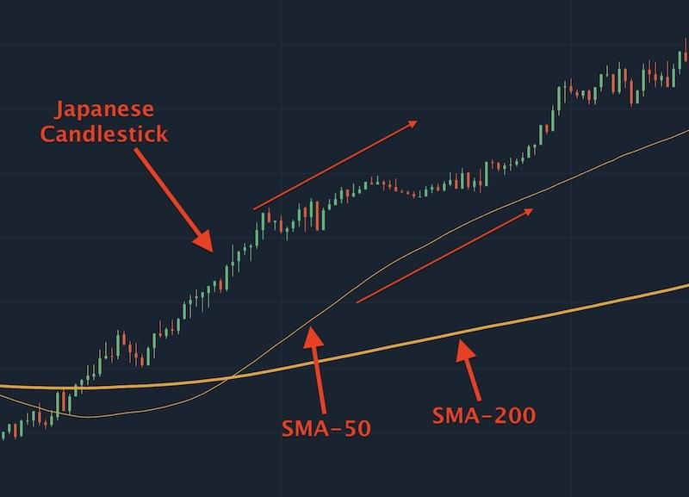
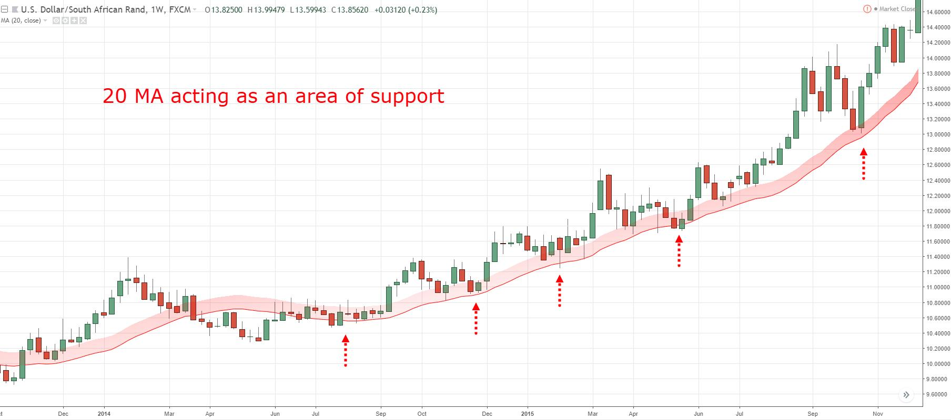
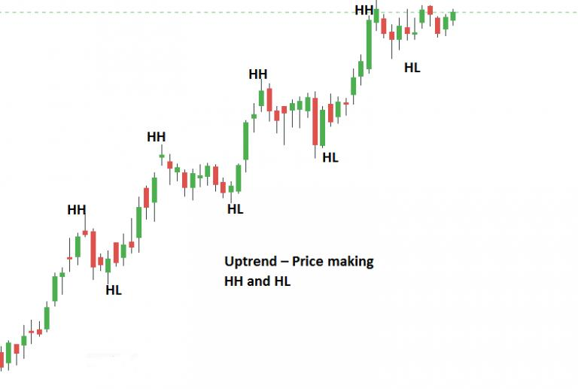
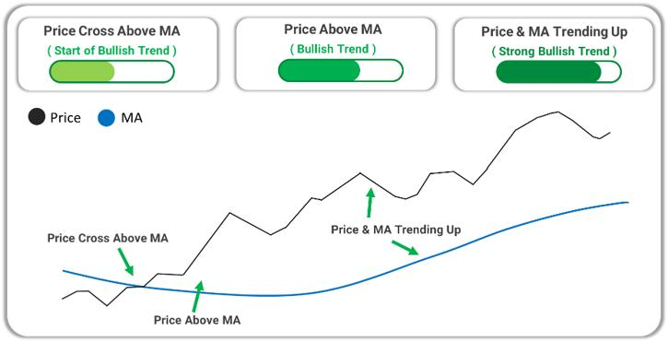
From your screenshot (AUDJPY H1):

✅ Bullish Signals
- Price is making higher highs + higher lows
- Candles are strong and pushing up
- Price is above EMA 50 (red) → bullish momentum
- EMA 50 is above EMA 200 (blue) → confirmed uptrend
👉 This is a trend-following BUY market

⚠️ But Here’s the Important Part
Right now price is:
- Extended (already ran up strongly)
- Near short-term highs
👉 That means:
- ❌ Bad place to enter impulsively
- ✅ Better to wait for a pullback

🎯 Smart Entry (What Pros Do)

Option 1: Pullback Entry (BEST)
Wait for price to:
- Come back to EMA 50
- Show bullish rejection (small candles → strong bullish candle)
👉 Then BUY

Option 2: Breakout Entry
- Wait for a clean break above current high
- Enter on retest

❌ Avoid
- Buying at the top of a big green candle
- Entering when price is far from EMA

🧠 EA Logic Perspective
Your bot (EMA + RSI + session filter) would likely:
👉 ONLY buy if:
- EMA 50 > EMA 200 ✅
- RSI > ~55 ✅
- Session = London / Overlap ✅

🔥 Final Decision
👉 Market Direction: BUY
👉 Entry Timing: WAIT (pullback or breakout)

If you want, I can:
- Mark exact entry, SL, TP zones on this chart
- Or adjust your EA so it only buys on pullbacks (much safer)

