FileName: Student.java



FileName: Triangle.java



FileName: Rectangle.java



FileName: Area.java

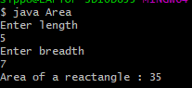

FileName: Complex.java

