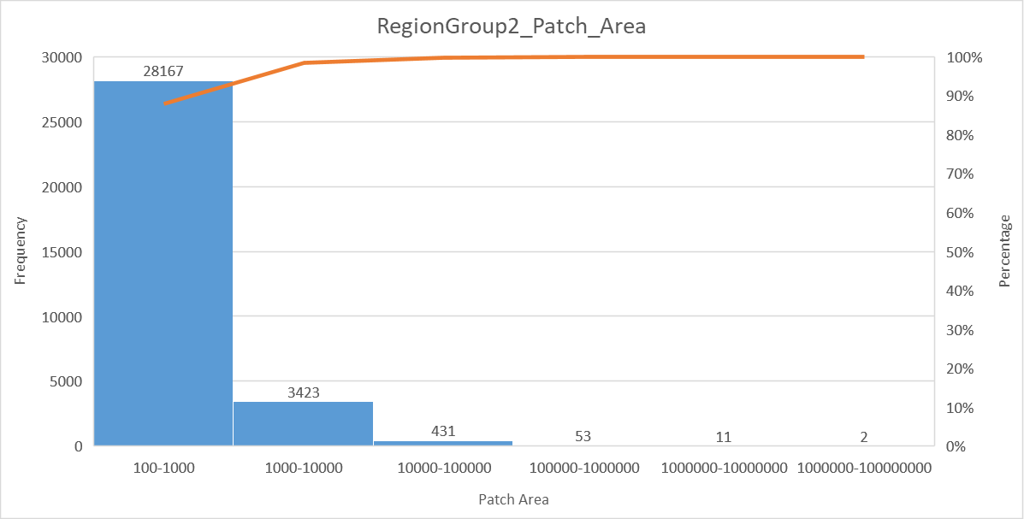

#Q:Patches smaller than 100hectar were deleted.

Has a super huge patch in around Myanmar.

Q: Are you sure we use the ForestCover2000 instead of ForestCover2019? (Clinton used 2000)