CS538 Technical Project Report
Siri Siqveland

AI Disclosure
Within the bounds of my project, I utilized the AI tool Gemini. It helped me with two main aspects of my project. First, I used it to bug test my code (Only after my own original version of the code was created). It was useful for catching syntax and logical errors that I missed. However, when it came to helping me figure out why only the right half of my DES s-box key was accurate, all of its suggestions either were already implemented previously by myself or did not help at all. In the end, neither I nor the AI could figure out the issue there.
Second, I used Gemini to help answer several questions I had about learning to code in Python. If I could not find an exact answer to a coding question I had by browsing the Web, I would instead ask Gemini. Two examples of such questions are as follows: First, I asked about what the Python equivalent of a constructor is, then I asked it follow up questions about how __Init__ (what it gave me for a constructor counterpart that worked quite well) worked conceptually. Second, I asked about how to get it to execute from a specific function since I found through error that Python does not exactly have a built-in basis for “main()” like Java does.
Besides using it to better my understanding of Python, general bug testing, and brainstorming the reason for my logical error in only getting half the s-box key correct I did not use Gemini nor any other AI for my project.

Objective & Scope (What was Built and Analyzed)
For my project I used DES Differential Cryptanalysis to attack DES encryption. DES stands for Data Encryption Standard and it is a type of block cipher. The blocks it works with are 64-bits in size for both the input plaintext and output ciphertext. Similarly, it starts with a 64-bit key that then loses every 8th bit (from Permuted Choice 1) to become a 56-bit key. That main key is then turned into 48-bit subkeys for each of the sixteen rounds needed to generate the ciphertext. The sixteen rounds all use a Feistel Network and take the 64-bit plaintext block as two 32-bit Left and Right halves. The Right is expanded with the Expansion Table into 48-bits and then xor-ed with the 48-bit subkey, put through the S-boxes, and then permuted. Essentially it uses both confusion and diffusion in order to output a 16-bit ciphertext.
Due to its structure of only having a 56-bit key space, DES is very susceptible to both brute-force attacks and cryptanalysis attacks. The latter of which is what the project aimed to utilize and understand. The original scope of the project was to use six of the sixteen rounds of DES and use a differential cryptanalysis attack to figure out the most likely sub-key, use that subkey to recreate the key, and then decrypt the ciphertext into plaintext using the key that was found.
For the purposes of my project, I coded both the encryption and decryption of DES and tested it in order to ensure that the six-rounds of DES I used were properly functioning. This code was helpful for bug testing since it let me know that despite my subkey results being off it was not because the DES process itself that I used was incorrect.
Unfortunately, the scope of the project was simplified due to time constraints due to unaccounted for bug-testing time and inaccuracies surrounding finding the correct left part of the subkey for the final subkey. Due to the lattermost reason, the scope shifted from implementing a full attack (because without understanding why only half of the subkey could be found, implementing the full attack seemed over-ambitious) to analyzing the S-box output for each round used to get the overall subkey.
The specific cryptanalysis attack (Chosen Plaintext) used takes an initial plaintext determined by the hacker (me in this case) and xor-es it with one plaintext (P1). The resulting plaintext (P2) and the original plaintext then have a known difference (the initial plaintext) which makes the analysis section easier since even with random plaintext pairs they will be related by the initial difference used to generate P2. Studying the ciphertexts of P1 and P2 to find patterns and figure out what the most likely subkey is to then figure out the actual key. This is the basis for my approach summarized in the next section.

Methodology (Approach and Hurdles)
As described in the Objective & Scope section, I implemented a Chosen Plaintext Differential Cryptanalysis Attack in my code to determine the subkey and probabilities attached to each of the S-box blocks.
In my code, I first hard-coded an initial plaintext as diffP to stand for “difference in Plaintext” that would be used to generate the plaintext pairs by flipping bits (from an xor operation) in P1 to generate P2. The resulting pairs are thrown into six rounds of DES to generate their ciphertexts C1 and C2. The resulting ciphertexts are then xored together to get their difference which helps see how diffP got mixed-up after going through the S-boxes and various tables. Since the S-boxes are where the most key-dependent changes occur I looped through several possible 6-bit subkeys and determined whether or not it was possible for the S-box to have gotten the output given the diffP determined from the ciphertext. If it is possible, the output’s guess count is increased by one. At the end the top three guesses from each of the s-boxes were displayed alongside the number of times they were guessed. The hope in this part is that the actual guess will (after the 400,000 pairs I had go through the 6-rounds) be at least a few thousand guesses above the others.
As an output, I had my code note the top three potential S-box results from each of the eight S-boxes alongside the number of times it was guessed as a key. At the top of the output, I displayed the original key (not used in the attack at all, just to compare results with for accuracy-testing purposes) and the S-box blocks the original key generated. At the end I had the actual sub-key listed above the sub-key found by my code so that the user could see for themselves the difference side by side.
Through the output discussed, I had the recurring issue of S-boxes 1-4 continuously not even having the correct values in their top three guesses. On the other hand, S-boxes 5-8 were always accurate in determining the sub-key. Even after several hours of testing, I could not (nor could Gemini when consulted) figure out the actual cause of this division. All attempts either changed nothing about the output or made the subkey guess even more incorrect. The most likely theories are either a misalignment in bit-shifting that is disproved by my encryption-decryption being accurate, my IPBox (inverse P-Box) being flawed that is disproved by triple checking it on my own and asking Gemini to generate the box itself and comparing those to be the same, and my diffP value not being strong enough. The last potential issue I would have liked to spent more time testing, but with the three values I did attempt to run it with to solve the problem, none actually did anything.
In the end, I am quite pleased with being able to find half of the sub-key. In my process I used the entire standard DES except reducing it to six rounds nothing else was altered in the process. Furthermore, since my coding of the encryption and decryption parts of DES always worked I am sufficiently pleased with my understanding of DES as a whole, although I will likely continue to play with my code after the project to see if I can get the left half to be as accurate as the right and return the whole subkey.

Appendix I: Cool Figure
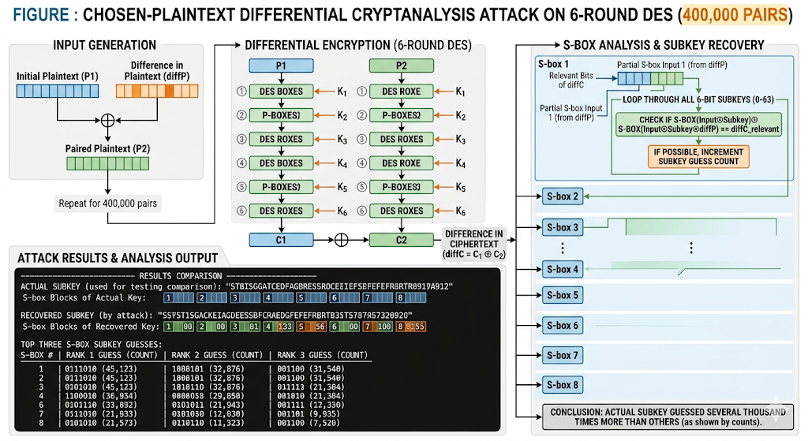
Prompt in Gemini AI: “Generate a figure that demonstrates chosen-plaintext differential cryptanalysis attack that used the following method: In my code, I first hard-coded an initial plaintext as diffP to stand for “difference in Plaintext” that would be used to generate the plaintext pairs by flipping bits (from an xor operation) in P1 to generate P2. The resulting pairs are thrown into six rounds of DES to generate their ciphertexts C1 and C2. The resulting ciphertexts are then xored together to get their difference which helps see how diffP got mixed-up after going through the S-boxes and various tables. Since the S-boxes are where the most key-dependent changes occur I looped through several possible 6-bit subkeys and determined whether or not it was possible for the S-box to have gotten the output given the diffP determined from the ciphertext. If it is possible, the output’s guess count is increased by one. At the end the top three guesses from each of the s-boxes were displayed alongside the number of times they were guessed. The hope in this part is that the actual guess will (after the 400,000 pairs I had go through the 6-rounds) be at least a few thousand guesses above the others.
As an output, I had my code note the top three potential S-box results from each of the eight S-boxes alongside the number of times it was guessed as a key. At the top of the output, I displayed the original key (not used in the attack at all, just to compare results with for accuracy-testing purposes) and the S-box blocks the original key generated. At the end I had the actual sub-key listed above the sub-key found by my code so that the user could see for themselves the difference side by side.”

