ROLL NO:19JN1A05C3

Q1): 1. In the below elements which of them are values or an expression? eg:- values can be

integer or string and expressions will be mathematical operators.

ANS: \*        ----expression

'hello'  ------value

-87.8    ------value

-    --------------expression

/       -------------------expression

+   ----------------------expression

6  ---------------------value

Q)2. What is the difference between string and variable?

ANS: String: String can be written in quotes such: "apple", 'apple'

Variable: It is the thing in which we can store data just like a container.

Q)3. Describe three different data types.

ANS: List: the list is used for storing multiple data items in a single variable.

Integer: integer can store only numerical values.

Float: float can store only floating values such as 233.33, 22.2, etc.

Q)4. What is an expression made up of? What do all expressions do?

ANS: Expression is made up of values, containers, and mathematical operators (operands) e.g

     a = 2 + 3     and expressions are used to evaluate the values or represent the result on the screen.

Q) 5. This assignment statements, like spam = 10. What is the difference between an expression and a statement?

ANS: Expression is made up of values, containers, and mathematical operators (operands) and the statement is just like a command that a python interpreter executes like print.

Q)6. After running the following code, what does the variable bacon contain?

bacon = 22

bacon + 1

Sol: it gives 23 as execution code

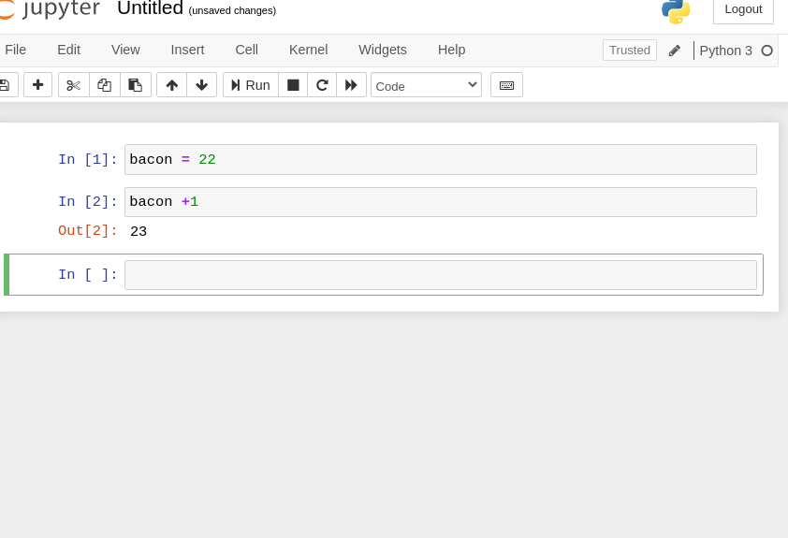

7. What should the values of the following two terms be?

ANS: 'spam' + 'spamspam'

'spam' \* 3

sol: it will be the same

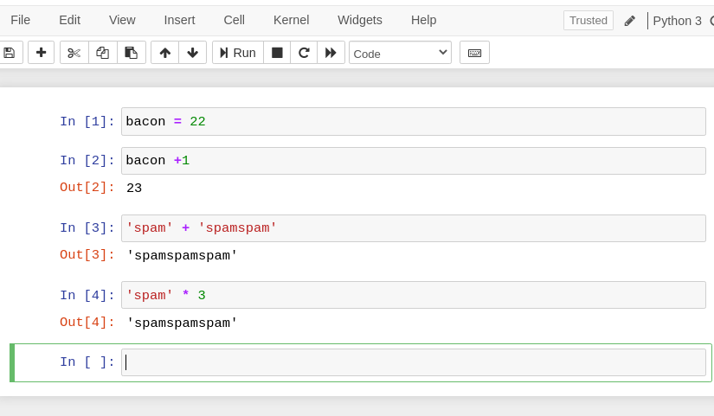

Q) 8. Why is eggs a valid variable name while 100 is invalid?

Ans:  because we can't start giving variable an integer name. if we, we should begin with, a string-like alphabet name then integer. e100 or eggs100 is valid

Q) 9. What three functions can be used to get the integer, floating-point number, or string version of a value?

ANS: str(), int(), float()

Q) 10. Why does this expression cause an error? How can you fix it?

'I have eaten' + 99 + 'burritos'

sol:  because 99 is an integer it cannot be concatenated with strings, if we have to concatenate it we need to do typecasting.