Department of Artificial Intelligence & Machine Learning
B.Tech III Semester Academic Year 2026-2027
Data Base Management Systems (25B11CS001)
Capstone Stone Project Documentation


ADITYA UNIVERSITY
Surampalem, Kakinada District Andhra Pradesh-533437

ONLINE SHOPPING SYSTEM
A DBMS Capstone Project Report submitted in partial fulfillment of the requirements for the award of the degree of

BACHELOR OF TECHNOLOGY
in

ARTIFICIAL INTELLIGENCE AND MACHINE LEARNING

Submitted By

O.VENU GOPAL-25B11AI856
B.SRI KOUSHIK-25B11AI155
D.AVINASH-25B11AI244
T.SUSHMANTH-25B11AIA51

Under the esteemed guidance of
G. L. NARASAMBA VANGURI M.Tech, (Ph.D.)

Assistant Professor



DEPARTMENT OF ARTIFICIAL INTELLIGENCE AND MACHINE LEARNING

ADITYA UNIVERSITY
(Formerly Aditya Engineering College (A))
Aditya Nagar, ADB Road, Surampalem, Andhra Pradesh, India

2026 – 2027



DEPARTMENT OF ARTIFICIAL INTELLIGENCE AND MACHINE LEARNING

CERTIFICATE

This is to certify that the DBMS Capstone Project report entitled “Online Shopping System” is being submitted by O. Venu Gopal (Roll No. 25B11AI856), B. Sri Koushik (Roll No. 25B11AI155), D. Avinash (Roll No. 25B11AI244) and T. Sushmanth (Roll No. 25B11AIA51) in partial fulfillment of the requirements for the award of the B.Tech. degree in Artificial Intelligence and Machine Learning.
The work documented in this report was carried out as part of the Capstone Project for the course Database Management System during the academic year 2026–2027, under the guidance of G. L. Narasamba Vanguri, Department of Artificial Intelligence and Machine Learning, Aditya University.

Project Guide Head of the Department
G. L. Narasamba Vanguri, M. Tech, (Ph.D.) Dr. K. Naga Bhargavi, M. Tech, Ph.D.
Assistant Professor Associate Professor & HOD

External Examiner

DECLARATION

We hereby declare that the DBMS Capstone Project entitled “Online Shopping System” is a genuine work carried out by us. The database design, SQL implementation, queries and documentation presented in this report are our own work, completed under the guidance of G. L. Narasamba Vanguri, Department of Artificial Intelligence and Machine Learning, Aditya University, Surampalem. We further declare that this work has not been submitted, in full or in part, for the award of any degree of this or any other educational institution.

Project Associates:-
O.venu-25b11ai856
B.sri koushik-25b11ai155
T.sushmanth-25b11aia51
D.avinash-25b11ai244

Date: ____________________ Place: Surampalem

ACKNOWLEDGEMENT

It is with immense pleasure that we express our sincere gratitude to our project guide G. L. Narasamba Vanguri, Department of Artificial Intelligence and Machine Learning, who guided us throughout the capstone project. We are thankful for the constant encouragement and valuable suggestions received during the project.
We are grateful to the Department of Artificial Intelligence and Machine Learning and Aditya University for providing the facilities and academic environment required to complete this project.
We extend our sincere thanks to the Management, Dr. M. Sreenivasa Reddy, Deputy Pro-Chancellor, Dr. M. B. Srinivas, Vice-Chancellor, and Dr. A. Ramesh, Pro Vice-Chancellor (Engineering & Sciences), for providing an excellent academic environment.
Not to forget, we thank the Teaching and Non-Teaching Staff, our parents and our friends, who have directly or indirectly supported us in completing this project on time.

Project Associates

O.venu-25b11ai856
B.sri koushik-25b11ai155
T.sushmanth-25b11aia51
D.avinash-25b11ai244

ADITYA UNIVERSITY
Surampalem
Department of artifical intelligence and mechine learning

DBMS CAPSTONE PROJECT


Project Documentation Report
Project Title: online shopping system
Submitted by:
Course: Database Management System (DBMS) Course Code: DBMS
Faculty Coordinator:G. L. Narasamba Vanguri
Academic Year: 2026–27
Date of Submission: 14 September 2026
GitHub Repository Link: https://github.com/DBMS-2026/online-shopping-System-
DBMS

S.No | Student Name | Roll Number
1 | O. Venu Gopal | 25B11AI856
2 | B. Sri Koushik | 25B11AI155
3 | D. Avinash | 25B11AI244
4 | T. Sushmanth | 25B11AIA51

ABSTRACT

The Online Shopping System is a relational database project designed to manage core e-commerce operations including customers, product categories, products, orders, order items, and payments.
The system consists of six main entities: Customer, Category, Product, Orders, OrderItem, and Payment, connected through primary-key and foreign-key relationships to maintain data integrity and support efficient online shopping operations.
integrity.
Built using SQL and normalized up to Third Normal Form (3NF), the system uses NOT NULL, UNIQUE, and CHECK constraints to maintain accurate and valid data.
The system supports customer management, savings/current/fixed-deposit accounts, deposits, withdrawals, transaction recording, and loan tracking. SQL queries demonstrate joins, aggregate functions, GROUP BY/HAVING, subqueries, and reporting operations.

TABLE OF CONTENTS

Chapter | Title | Page No.
 | Certificate | i
 | Declaration | ii
 | Acknowledgement | iii
 | Project Documentation Report | iv
1 | ABSTRACT | v
 | List of Figures | vii
 | List of Tables | vii
2 | INTRODUCTION | 1
 | 2.1 Background | 1
 | 2.2 Purpose of the Database | 1
3 | PROBLEM STATEMENT | 1
4 | OBJECTIVES | 1
5 | TOOLS & TECHNOLOGIES USED | 2
6 | DATABASE DESIGN | 2
 | 6.1 Identified Entities | 2
 | 6.2 Entity Attributes | 2
 | 6.3 ER Diagram | 4
 | 6.4 Relationships & Cardinality | 4
 | 6.5 Relational Database Schema | 4
 | 6.6 Normalization | 6
7 | DATABASE IMPLEMENTATION | 8
 | 7.1 DDL — Database and Table Creation | 8
 | 7.2 Sample Data — DML. | 10
 | 7.3 Constraints & Data Integrity | 10
 | 7.4 SQL Operations & Queries | 10
 | 7.5 Sample Outputs / Screenshots | 12
8 | MODULES & FUNCTIONALITIES | 14
9 | GITHUB REPOSITORY & TEAM RESPONSIBILITIES | 14
10 | ENHANCEMENTS & FUTURE IMPROVEMENTS | 15
11 | CONCLUSION | 15
12 | REFERENCES | 15
 | APPENDIX | 16
 | A. Complete SQL Script | 16
 | B. Additional Screenshots / Outputs | 16

LIST OF FIGURES
LIST OF TABLES

Figure No. | Title of the Figure | Page No.
6.3 | ER Diagram | 4
Figure 1 | Product records / basic SELECT output | 12
Figure 2 | Available products / filtering output | 12
Figure 3 | Category analysis / aggregate output | 13
Figure 4 | Customer orders / JOIN output | 13

Table No. | Title of the Table | Page No.
5 | TOOLS & TECHNOLOGIES USED | 2
6.1 | Identified Entities | 2
6.2 | Entity Attributes | 2
6.4 | Relationships & Cardinality | 4
6.5 | Relational Database Schema | 4
7.2 | Sample Data — DML. | 10
7.3 | Constraints & Data Integrity | 10
7.4 | SQL Operations & Queries | 10
8 | MODULES & FUNCTIONALITIES | 14
9 | GITHUB REPOSITORY & TEAM RESPONSIBILITIES | 14

INTRODUCTION

Background
Online shopping systems handle large amounts of structured information related to customers, product categories, products, orders, order items, and payments. A relational database is required to store this information consistently and maintain relationships between different records. In this project, the shopping domain is represented using six related tables: Customer, Category, Product, Orders, OrderItem, and Payment. The schema separates data into appropriate entities and uses keys and constraints to reduce duplication and protect data integrity. SQL queries are then used to retrieve, update, aggregate, and analyse the stored information.

Purpose of the Database
The database provides a centralized structure for managing customer details, product categories, product prices and stock, customer orders, order items, and payment information. It supports administrators who need to retrieve product information, monitor stock, manage orders, track payments, and generate summary information. The relationships between tables allow related information to be accessed through SQL joins and subqueries instead of maintaining disconnected records.

PROBLEM STATEMENT
Traditional or poorly organized shopping records can lead to duplicate customer information, inconsistent product data, incorrect order details, and difficulty in tracking payments.
The proposed system centralizes customer, category, product, order, order-item, and payment information into a single relational database.
The system provides structured data management, referential integrity, validation, and SQL-based reporting for efficient online shopping operations.

OBJECTIVES
- Objective 1: Design a relational schema containing six related online-shopping entities.
- Objective 2: Implement primary keys, foreign keys, NOT NULL, UNIQUE, CHECK, and DEFAULT constraints for data integrity.
- Objective 3: Populate the database with representative customer, category, product, order, order-item, and payment records.
- Objective 4: Demonstrate SQL retrieval, updates, joins, aggregate functions, GROUP BY/HAVING, and subqueries.
- Objective 5: Document the database design, implementation, sample data, queries, and team responsibilities.

TOOLS & TECHNOLOGIES USED

Category | Tool / Technology Used
Database Server | SQL-compatible relational database
Query / Admin Tool | SQL client / SQL environment
Front-end (if any) | Not required for the database-focused capstone
Operating System | Windows / Linux compatible
Version Control | GitHub


DATABASE DESIGN

Identified Entities

S.No | Entity Name | Description
1 | Customer | Stores customer identity, contact information, address and creation date.
2 | Category | Stores product category names and descriptions.
3 | Product | Stores product names, category, price, stock and description.
4 | Orders | Stores customer orders, order dates, totals and order status.
5 | OrderItem | Stores products included in each order, quantity and unit price.
6 | Payment | Stores payment details, amount, method and payment status.

Entity Attributes

Entity | Attribute | Data Type | Key (PK/FK/—) | Attribute Type
Customer | CustomerID | INTEGER | PK | Simple
Customer | Name | VARCHAR(60) | — | Simple
Customer | Email | VARCHAR(100) | — | Simple
Customer | Phone | VARCHAR(15) | — | Simple
Customer | Address | VARCHAR(150) | — | Simple
Customer | CreatedAt | DATE | — | Default
Customer | City | VARCHAR(50) | — | Simple
Customer | State | VARCHAR(50) | — | Simple
Category | CategoryID | INTEGER | PK | Simple
Category | CategoryName | VARCHAR(50) | — | Simple
Category | Description | VARCHAR(150) | — | Simple
Category | CreatedAt | DATE | — | Default
Product | ProductID | INTEGER | PK | Simple
Product | CategoryID | INTEGER | FK | Simple

Entity | Attribute | Data Type | Key (PK/FK/—) | Attribute Type
Product | ProductName | VARCHAR(100) | — | Simple
Product | Price | DECIMAL(10,2) | — | Simple
Product | Stock | INTEGER | — | Simple
Product | Description | VARCHAR(200) | — | Simple
Product | Brand | VARCHAR(50) | — | Simple
Product | CreatedAt | DATE | — | Default
Orders | OrderID | INTEGER | PK | Simple
Orders | CustomerID | INTEGER | FK | Simple
Orders | OrderDate | DATE | — | Default
Orders | TotalAmount | DECIMAL(12,2) | — | Simple
Orders | Status | VARCHAR(20) | — | Simple
Orders | ShippingAddress | VARCHAR(150) | — | Simple
Orders | PaymentStatus | VARCHAR(20) | — | Simple
OrderItem | OrderItemID | INTEGER | PK | Simple
OrderItem | OrderID | INTEGER | FK | Simple
OrderItem | ProductID | INTEGER | FK | Simple
OrderItem | Quantity | INTEGER | — | Simple
OrderItem | UnitPrice | DECIMAL(10,2) | — | Simple
OrderItem | Subtotal | DECIMAL(12,2) | — | Derived
OrderItem | CreatedAt | DATE | — | Default
Payment | PaymentID | INTEGER | PK | Simple
Payment | OrderID | INTEGER | FK | Simple
Payment | PaymentDate | DATE | — | Default
Payment | Amount | DECIMAL(12,2) | — | Simple
Payment | Method | VARCHAR(20) | — | Simple
Payment | Status | VARCHAR(20) | — | Simple
Payment | TransactionRef | VARCHAR(50) | — | Simple
Customer | DateOfBirth | DATE | — | Simple
Customer | Gender | VARCHAR(10) | — | Simple
Category | Status | VARCHAR(20) | — | Simple
Product | Discount | DECIMAL(5,2) | — | Simple
Product | Rating | DECIMAL(2,1) | — | Simple
Orders | DeliveryDate | DATE | — | Simple
Orders | CouponCode | VARCHAR(30) | — | Simple
OrderItem | Discount | DECIMAL(10,2) | — | Simple
Payment | Currency | VARCHAR(10) | — | Default
Payment | Gateway | VARCHAR(30) | — | Simple
Product | Supplier | VARCHAR(80) | — | Simple
Customer | PostalCode | VARCHAR(10) | — | Simple
Category | CategoryType | VARCHAR(30) | — | Simple
Orders | TrackingNumber | VARCHAR(40) | — | Simple
Payment | PaidAt | TIMESTAMP | — | Simple

ER Diagram

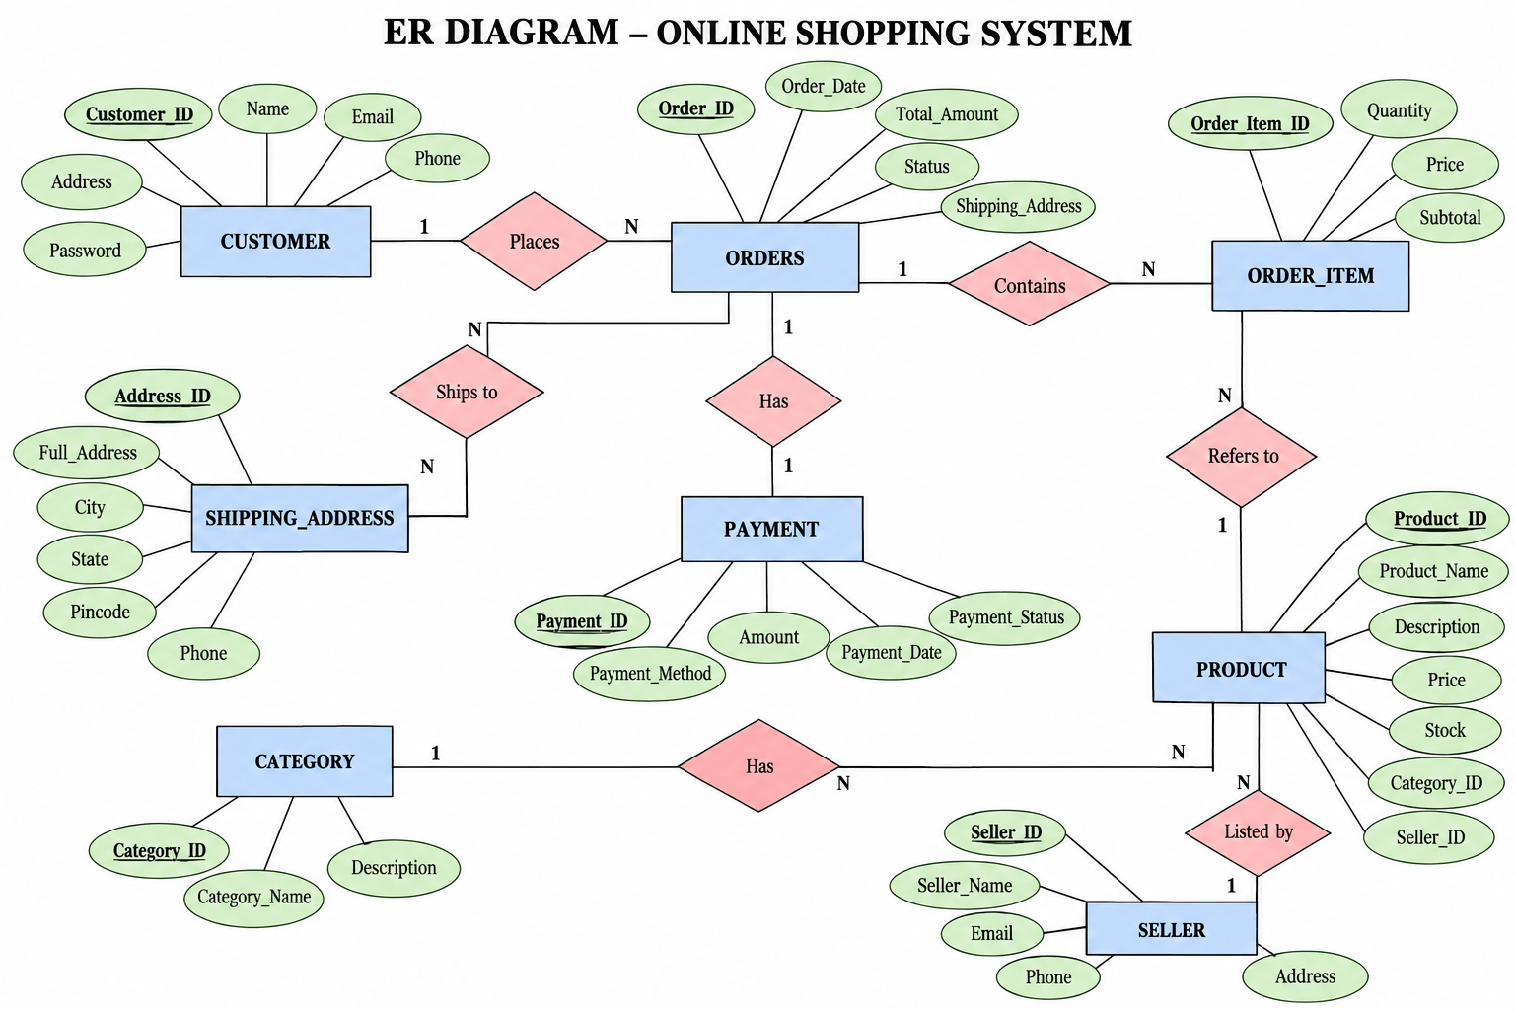

Relationships & Cardinality

Entity 1 | Relationship | Entity 2 | Cardinality (1:1 / 1:N / M:N)
Category | contains | Product | 1:N
Customer | places | Orders | 1:N
Orders | contains | OrderItem | 1:N
Product | appears in | OrderItem | 1:N
Orders | has | Payment | 1:1
Customer | makes | Payment | 1:N


Relational Database Schema

Table Name | Column Name | Data Type | PK/FK/— | Constraints
Customer | CustomerID | INTEGER | PK | PRIMARY KEY
Customer | Name | VARCHAR(60) | — | NOT NULL
Customer | Email | VARCHAR(100) | — | NOT NULL, UNIQUE
Customer | Phone | VARCHAR(15) | — | NOT NULL
Customer | Address | VARCHAR(150) | — | NOT NULL
Customer | CreatedAt | DATE | — | DEFAULT CURRENT_DATE
Customer | City | VARCHAR(50) | — | Simple
Customer | State | VARCHAR(50) | — | Simple
Category | CategoryID | INTEGER | PK | PRIMARY KEY
Category | CategoryName | VARCHAR(50) | — | NOT NULL, UNIQUE
Category | Description | VARCHAR(150) | — | Simple
Category | CreatedAt | DATE | — | DEFAULT CURRENT_DATE
Product | ProductID | INTEGER | PK | PRIMARY KEY
Product | CategoryID | INTEGER | FK | FOREIGN KEY
Product | ProductName | VARCHAR(100) | — | NOT NULL
Product | Price | DECIMAL(10,2) | — | NOT NULL, CHECK > 0
Product | Stock | INTEGER | — | NOT NULL, CHECK >= 0
Product | Description | VARCHAR(200) | — | Simple
Product | Brand | VARCHAR(50) | — | Simple
Product | CreatedAt | DATE | — | DEFAULT CURRENT_DATE
Orders | OrderID | INTEGER | PK | PRIMARY KEY
Orders | CustomerID | INTEGER | FK | FOREIGN KEY
Orders | OrderDate | DATE | — | DEFAULT CURRENT_DATE
Orders | TotalAmount | DECIMAL(12,2) | — | NOT NULL, CHECK >= 0
Orders | Status | VARCHAR(20) | — | NOT NULL
Orders | ShippingAddress | VARCHAR(150) | — | Simple

Table Name | Column Name | Data Type | PK/FK/— | Constraints
Orders | PaymentStatus | VARCHAR(20) | — | Simple
OrderItem | OrderItemID | INTEGER | PK | PRIMARY KEY
OrderItem | OrderID | INTEGER | FK | FOREIGN KEY
OrderItem | ProductID | INTEGER | FK | FOREIGN KEY
OrderItem | Quantity | INTEGER | — | NOT NULL, CHECK > 0
OrderItem | UnitPrice | DECIMAL(10,2) | — | NOT NULL, CHECK > 0
OrderItem | Subtotal | DECIMAL(12,2) | — | Derived
OrderItem | CreatedAt | DATE | — | DEFAULT CURRENT_DATE
Payment | PaymentID | INTEGER | PK | PRIMARY KEY
Payment | OrderID | INTEGER | FK | FOREIGN KEY
Payment | PaymentDate | DATE | — | DEFAULT CURRENT_DATE
Payment | Amount | DECIMAL(12,2) | — | NOT NULL, CHECK > 0
Payment | Method | VARCHAR(20) | — | NOT NULL
Payment | Status | VARCHAR(20) | — | NOT NULL
Payment | TransactionRef | VARCHAR(50) | — | Simple
Customer | DateOfBirth | DATE | — | Simple
Customer | Gender | VARCHAR(10) | — | Simple
Category | Status | VARCHAR(20) | — | NOT NULL
Product | Discount | DECIMAL(5,2) | — | Simple
Product | Rating | DECIMAL(2,1) | — | Simple
Orders | DeliveryDate | DATE | — | Simple
Orders | CouponCode | VARCHAR(30) | — | Simple
OrderItem | Discount | DECIMAL(10,2) | — | Simple
Payment | Currency | VARCHAR(10) | — | Default
Payment | Gateway | VARCHAR(30) | — | Simple
Product | Supplier | VARCHAR(80) | — | Simple
Customer | PostalCode | VARCHAR(10) | — | Simple
Category | CategoryType | VARCHAR(30) | — | Simple
Orders | TrackingNumber | VARCHAR(40) | — | Simple
Payment | PaidAt | TIMESTAMP | — | Simple

Normalization
UNF → 1NF → 2NF → 3NF
UNF: Online shopping information could be represented as a large combined record containing customer, category, product, order, order-item, and payment details.
1NF: The design separates repeating groups and keeps attributes atomic. Each order item is stored as a separate row, while customer, product, order and payment attributes are stored in individual fields.
2NF: Each entity is separated into its own table with a primary key so non-key attributes depend on the complete key.
3NF: Relationships are represented using foreign keys, so customer, category, product, order, order-item, and payment facts are stored in their appropriate tables rather than being repeatedly duplicated. This reduces update, insertion, and deletion anomalies. In the Online Shopping System, functional dependencies are maintained so that CustomerID determines customer details, CategoryID determines category details, ProductID determines product details, OrderID determines order details, OrderItemID determines line-item details, and PaymentID determines payment details. This decomposition avoids repeating customer and product data for every order and makes updates consistent. The design also separates transaction-like order information from master data such as products and categories.


DATABASE IMPLEMENTATION

DDL — Database and Table Creation
-- Drop tables if they exist
DROP TABLE IF EXISTS Payment; DROP TABLE IF EXISTS OrderItem;
DROP TABLE IF EXISTS Orders; DROP TABLE IF EXISTS Product; DROP TABLE IF EXISTS Category; DROP TABLE IF EXISTS Customer;

-- 1. CUSTOMER TABLE
CREATE TABLE Customer (
CustomerID INTEGER PRIMARY KEY, Name VARCHAR(60) NOT NULL, Email VARCHAR(100) NOT NULL UNIQUE,
Phone VARCHAR(15) NOT NULL, Address VARCHAR(150) NOT NULL, CreatedAt DATE DEFAULT CURRENT_DATE
);
);

-- 2. CATEGORY TABLE
CREATE TABLE Category (
CategoryID INTEGER PRIMARY KEY, CategoryName VARCHAR(50) NOT NULL UNIQUE,
Description VARCHAR(150)
);
CreatedAt DATE DEFAULT CURRENT_DATE,
CONSTRAINT chk_aadhaar CHECK (LENGTH(AadhaarNo) = 12), CONSTRAINT chk_pan CHECK (LENGTH(PANNo) = 10)
);

-- 3. PRODUCT TABLE
CREATE TABLE Product (
ProductID INTEGER PRIMARY KEY, CategoryID INTEGER NOT NULL, ProductName VARCHAR(100) NOT NULL,
Price DECIMAL(10,2) NOT NULL CHECK (Price > 0), Stock INTEGER NOT NULL DEFAULT 0 CHECK (Stock >= 0),
Description VARCHAR(200), FOREIGN KEY (CategoryID) REFERENCES Category(CategoryID)
);
Email VARCHAR(100) NOT NULL UNIQUE, HireDate DATE NOT NULL,
FOREIGN KEY (BranchID) REFERENCES Branch(BranchID)
-- 4. ORDERS TABLE
CREATE TABLE Orders (
OrderID INTEGER PRIMARY KEY, CustomerID INTEGER NOT NULL, OrderDate DATE DEFAULT CURRENT_DATE,
TotalAmount DECIMAL(12,2) NOT NULL CHECK (TotalAmount >= 0),
Status VARCHAR(20) NOT NULL DEFAULT 'Pending' CHECK (Status IN ('Pending','Shipped','Delivered','Cancelled')),
FOREIGN KEY (CustomerID) REFERENCES Customer(CustomerID)
);
AccountNumber VARCHAR(20) PRIMARY KEY, CustomerID INTEGER NOT NULL,
BranchID INTEGER NOT NULL,
-- 5. ORDER ITEM TABLE
CREATE TABLE OrderItem (
OrderItemID INTEGER PRIMARY KEY, OrderID INTEGER NOT NULL, ProductID INTEGER NOT NULL,
Quantity INTEGER NOT NULL CHECK (Quantity > 0), UnitPrice DECIMAL(10,2) NOT NULL CHECK (UnitPrice > 0),
FOREIGN KEY (OrderID) REFERENCES Orders(OrderID), FOREIGN KEY (ProductID) REFERENCES Product(ProductID)
);

-- 5. TRANSACTION TABLE
-- 6. PAYMENT TABLE
CREATE TABLE Payment (
PaymentID INTEGER PRIMARY KEY, OrderID INTEGER NOT NULL UNIQUE,
PaymentDate DATE DEFAULT CURRENT_DATE, Amount DECIMAL(12,2) NOT NULL CHECK (Amount > 0),
Method VARCHAR(20) NOT NULL CHECK (Method IN ('UPI','Card','Net Banking','COD')),
Status VARCHAR(20) NOT NULL DEFAULT 'Pending' CHECK (Status IN ('Pending','Paid','Failed','Refunded')),
FOREIGN KEY (OrderID) REFERENCES Orders(OrderID)
);
);

-- 6. LOAN TABLE CREATE TABLE Loan (
LoanID INTEGER PRIMARY KEY, CustomerID INTEGER NOT NULL, BranchID INTEGER NOT NULL,
LoanType VARCHAR(50) NOT NULL CHECK (LoanType IN ('Home', 'Car', 'Personal', 'Education', 'Business')),
LoanAmount DECIMAL(15, 2) NOT NULL CHECK (LoanAmount > 0), PrincipalAmount DECIMAL(15, 2) CHECK (PrincipalAmount > 0),
InterestRate DECIMAL(5, 2) NOT NULL CHECK (InterestRate >= 0 AND InterestRate <= 100),
StartDate DATE NOT NULL,
DurationMonths INTEGER NOT NULL CHECK (DurationMonths > 0), EmiAmount DECIMAL(10, 2) CHECK (EmiAmount >= 0),
Status VARCHAR(20) NOT NULL DEFAULT 'Pending' CHECK (Status IN ( 'Approved', 'Pending', 'Closed', 'Rejected', 'Active', 'Default')),
SanctionDate DATE,
FOREIGN KEY (CustomerID) REFERENCES Customer(CustomerID), FOREIGN KEY (BranchID) REFERENCES Branch(BranchID)
);

Sample Data — DML.

Table | No. of Records | Sample Data / Screenshot Reference
Customer | 10 | dml.sql — Customer seed records
Category | 6 | dml.sql — Category seed records
Product | 20 | dml.sql — Product seed records

Orders | 15 | dml.sql — Order seed records
OrderItem | 30 | dml.sql — Order-item seed records
Payment | 15 | dml.sql — Payment seed records


Constraints & Data Integrity

Constraint / Validation | Applied On | Purpose | Evidence / Screenshot
PRIMARY KEY | All six tables | Uniquely identifies each record and prevents duplicate key values. | ddl.sql
FOREIGN KEY | Product, Orders, OrderItem, Payment | Maintains valid relationships between related tables. | ddl.sql
NOT NULL | Required fields across tables | Prevents missing values in required attributes. | ddl.sql
UNIQUE | Customer.Email; Category.CategoryName; Payment.OrderID | Prevents duplicate unique identifiers and duplicate payment records. | ddl.sql
CHECK | Price, Stock, Quantity, Amount, Status, Method | Restricts invalid or out-of-range values. | ddl.sql
DEFAULT | Customer.CreatedAt; OrderDate; PaymentDate; statuses | Provides default values when not explicitly supplied. | ddl.sql

SQL Operations & Queries
.

S.No | Operation / Query | Purpose | SQL Query / Screenshot Ref.
1 | Basic SELECT — all products | Retrieve product records. | queries.sql Q1
2 | Filtered SELECT — available products | Find products with stock greater than zero ordered by price. | queries.sql Q2
3 | LIKE filtering | Search products or customers by name. | queries.sql Q3
4 | Price lookup | Check the price of a selected product. | queries.sql Q4
5 | UPDATE + INSERT | Reduce stock after an order and record the order item. | queries.sql Q5
6 | UPDATE | Change an order from Pending to Shipped. | queries.sql Q6
7 | Order history | Display customer order history in descending date order. | queries.sql Q7
8 | SUM aggregate | Calculate total order revenue. | queries.sql Q8

S.No | Operation / Query | Purpose | SQL Query / Screenshot Ref.
9 | GROUP BY + aggregates | Calculate order count and total revenue by order status. | queries.sql Q9
10 | GROUP BY + aggregates | Calculate product count and average price by category. | queries.sql Q10
11 | JOIN + GROUP BY + HAVING | Find categories whose product count exceeds a threshold. | queries.sql Q11
12 | JOIN + GROUP BY + HAVING | Find customers who placed more than one order. | queries.sql Q12
13 | Subquery | Find orders whose total is above the average order amount. | queries.sql Q13
14 | Subquery + ORDER BY + LIMIT | List products priced above the average product price. | queries.sql Q14


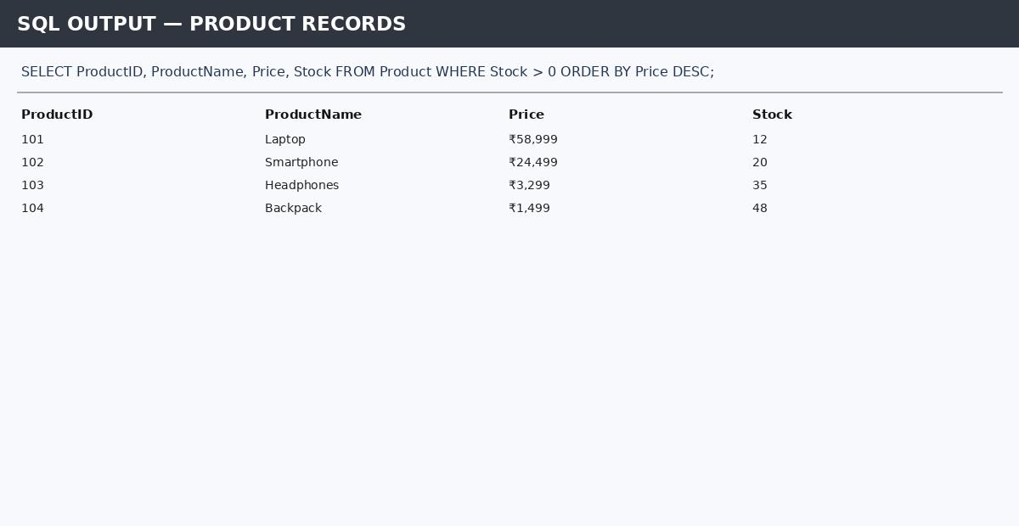
Sample Outputs / Screenshots
Figure 1: Product records / basic SELECT output

Figure 2: Available products / filtering 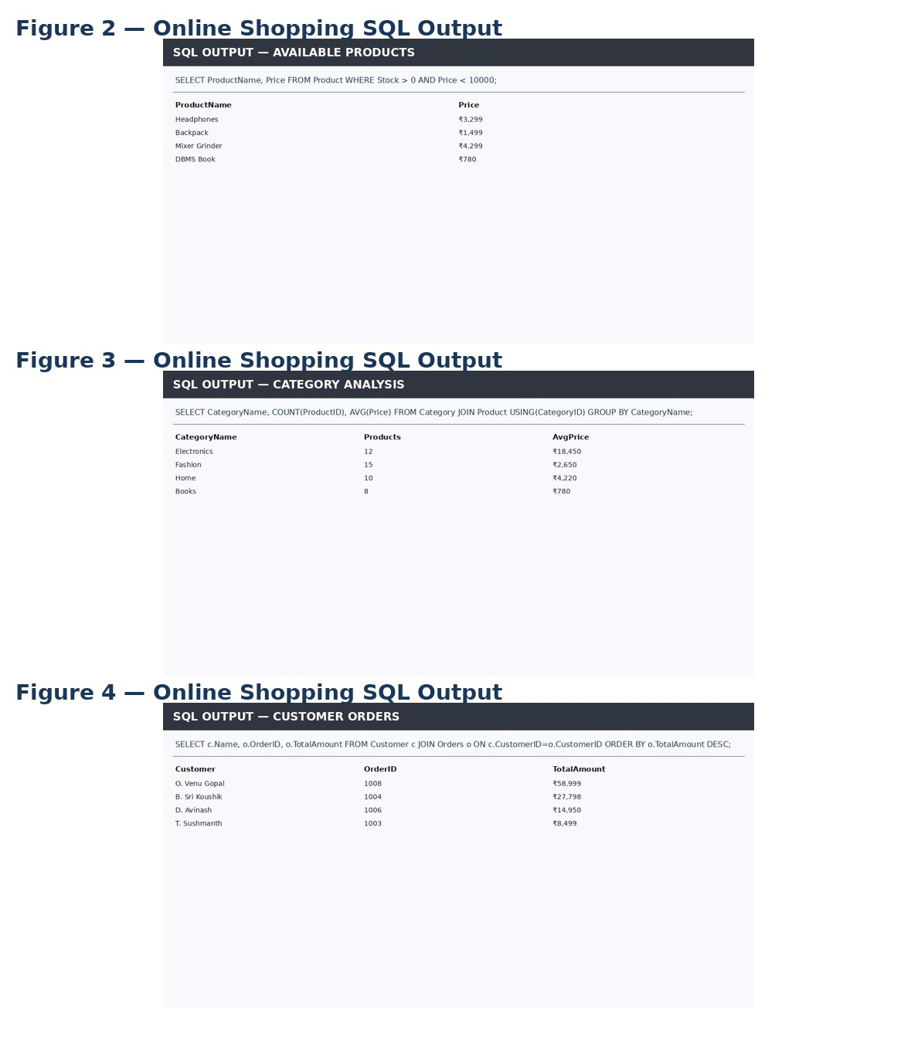


MODULES & FUNCTIONALITIES

S.No | Module Name | Functionality
1 | Customer Management | Maintains customer identity, contact information and address.
2 | Category Management | Maintains product categories and descriptions.
3 | Product Management | Stores product names, categories, prices, stock and descriptions.
4 | Order Management | Stores customer orders, order dates, totals and order status.
5 | Order Item Management | Tracks products, quantities and unit prices within each order.
6 | Payment Management & Analysis | Stores payment details and supports payment and sales analysis through aggregate and grouped SQL queries.

GITHUB REPOSITORY & TEAM RESPONSIBILITIES
Repository Link: ______________________________

Student Name | Roll Number | Role / Responsibility | Contribution Status
O. Venu Gopal | 25B11AI856 | Wrote DDL scripts (tables, keys, constraints) | Completed
B. Sri Koushik | 25B11AI155 | Designed ER diagram & relational schema | Completed
D. Avinash | 25B11AI244 | Wrote DML, CRUD, Join & Aggregate queries | Completed
T. Sushmanth | 25B11AIA51 | Compiled documentation & screenshots | Completed

ENHANCEMENTS & FUTURE IMPROVEMENTS
Future improvements can extend the current database with customer authentication, role-based access, richer reporting and dashboards, discount and coupon management, product reviews and ratings, delivery tracking, inventory alerts, stored procedures/triggers where supported, indexing for frequently queried columns, and a front-end interface for customers and administrators. These are proposed enhancements rather than implemented features in the current submission.

CONCLUSION
The Online Shopping System successfully models the main e-commerce entities and their relationships using a relational database structure. The DDL defines six tables with primary keys, foreign keys, NOT NULL, UNIQUE, CHECK, and DEFAULT constraints. The DML script supplies representative records for customers, categories, products, orders, order items, and payments. The query script demonstrates selection and filtering, updates, joins, aggregate functions, GROUP BY/HAVING, and subqueries. The project therefore meets its core objectives of relational design, data integrity, sample-data population, and practical SQL analysis. The team also divided the work across DDL development, ER/schema design, query development, and documentation/screenshot compilation.

REFERENCES
- Uploaded project DDL script: ddl.sql.
- Uploaded project DML/sample-data script: dml.sql.
- Uploaded SQL query script: queries.sql.
- Aditya University — DBMS Capstone Project documentation template.
- GitHub repository: Online Shopping System project repository (link to be added).

APPENDIX

Complete SQL Script
The final SQL implementation is supplied through the uploaded project files:
    - ddl.sql — database table definitions, keys, foreign keys, and constraints.
    - dml.sql — sample data for all six tables.
    - queries.sql — representative SQL operations and analytical queries.
Repository: ______________________________

Additional Screenshots / Outputs
Additional evidence can include SQL execution screenshots showing table creation, sample product data, customer/order retrieval, order-status updates, aggregate results, joins, GROUP BY/HAVING results, and subquery outputs. The figures included in this report are representative Online Shopping System outputs and can be replaced with actual SQL-client screenshots before final submission.
Sample SQL Operations:
Q1. SELECT ProductID, ProductName, Price, Stock FROM Product ORDER BY Price DESC;
Q2. SELECT ProductName, Price FROM Product WHERE Stock > 0;
Q3. SELECT c.Name, o.OrderID, o.TotalAmount FROM Customer c JOIN Orders o ON c.CustomerID=o.CustomerID;
Q4. SELECT Status, COUNT(*) AS Orders, SUM(TotalAmount) AS Revenue FROM Orders GROUP BY Status;
Q5. SELECT c.CategoryName, COUNT(p.ProductID) AS ProductCount, AVG(p.Price) AS AveragePrice FROM Category c JOIN Product p ON c.CategoryID=p.CategoryID GROUP BY c.CategoryName;
Q6. SELECT OrderID, TotalAmount FROM Orders WHERE TotalAmount > (SELECT AVG(TotalAmount) FROM Orders);
Sample Output Evidence: The report includes representative SQL-client screenshots for product retrieval, filtering, category analysis, and customer-order JOIN operations. These outputs demonstrate that the Online Shopping System supports practical retrieval and analysis using SQL.

