Belief Network Report

1. Experiment 1 (M1=5 M2=4 M3=1)

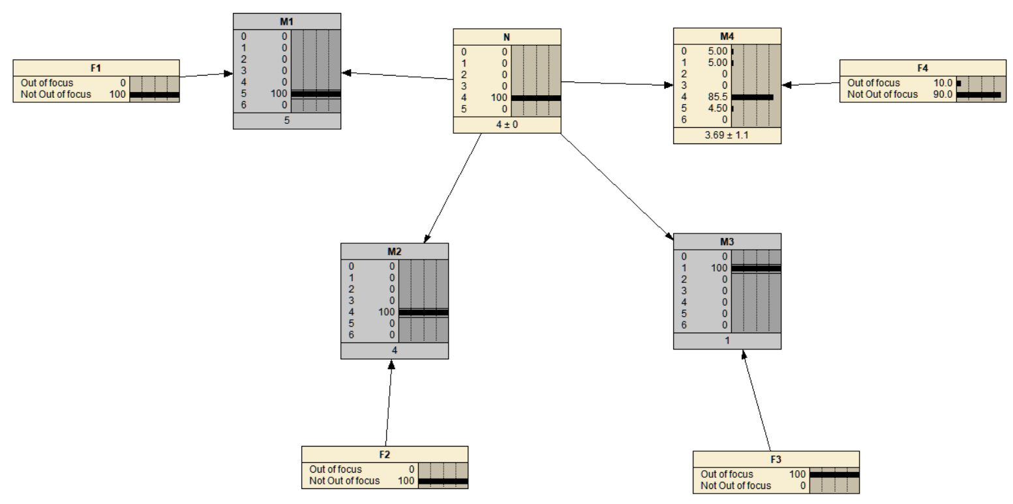

F1

Out_of_focus 0

Not_Out_of_focus 1

F2

Out_of_focus 0

Not_Out_of_focus 1

F3

Out_of_focus 1

Not_Out_of_focus 0

F4

Out_of_focus 0.1

Not_Out_of_focus 0.9

M1

0 0

1 0

2 0

3 0

4 0

5 1

6 0

M2

0 0

1 0

2 0

3 0

4 1

5 0

6 0

M3

0 0

1 1

2 0

3 0

4 0

5 0

6 0

M4

0 0.05

1 0.05

2 0

3 0

4 0.855

5 0.045

6 0

N

0 0

1 0

2 0

3 0

4 1

5 0

1. Experiment 2 (M1=4 M2=4 M3=0, M4=1)

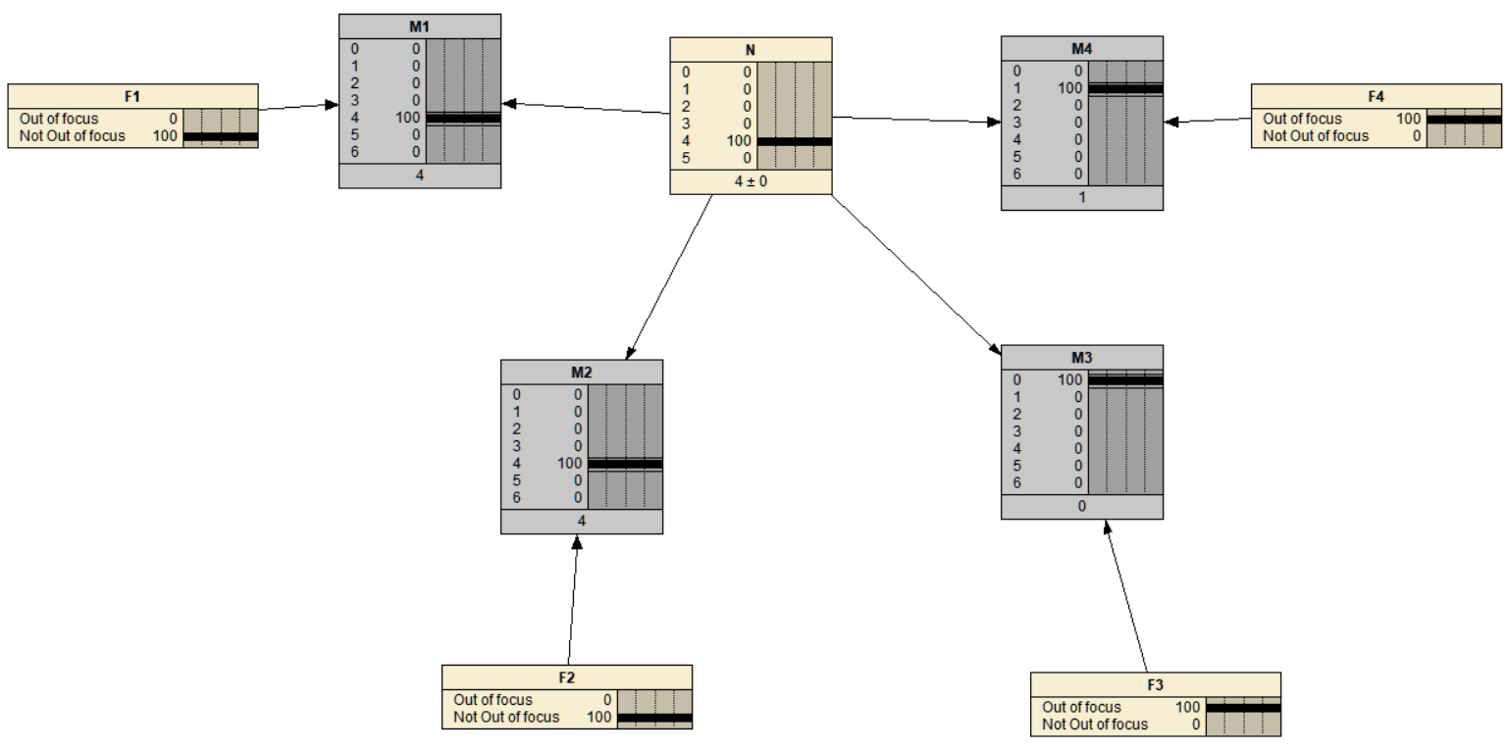

F1

Out_of_focus 0

Not_Out_of_focus 1

F2

Out_of_focus 0

Not_Out_of_focus 1

F3

Out_of_focus 1

Not_Out_of_focus 0

F4

Out_of_focus 1

Not_Out_of_focus 0

M1

0 0

1 0

2 0

3 0

4 1

5 0

6 0

M2

0 0

1 0

2 0

3 0

4 1

5 0

6 0

M3

0 1

1 0

2 0

3 0

4 0

5 0

6 0

M4

0 0

1 1

2 0

3 0

4 0

5 0

6 0

N

0 0

1 0

2 0

3 0

4 1

5 0

1. Experiment 3 (N=4, M2=1, M3=0)

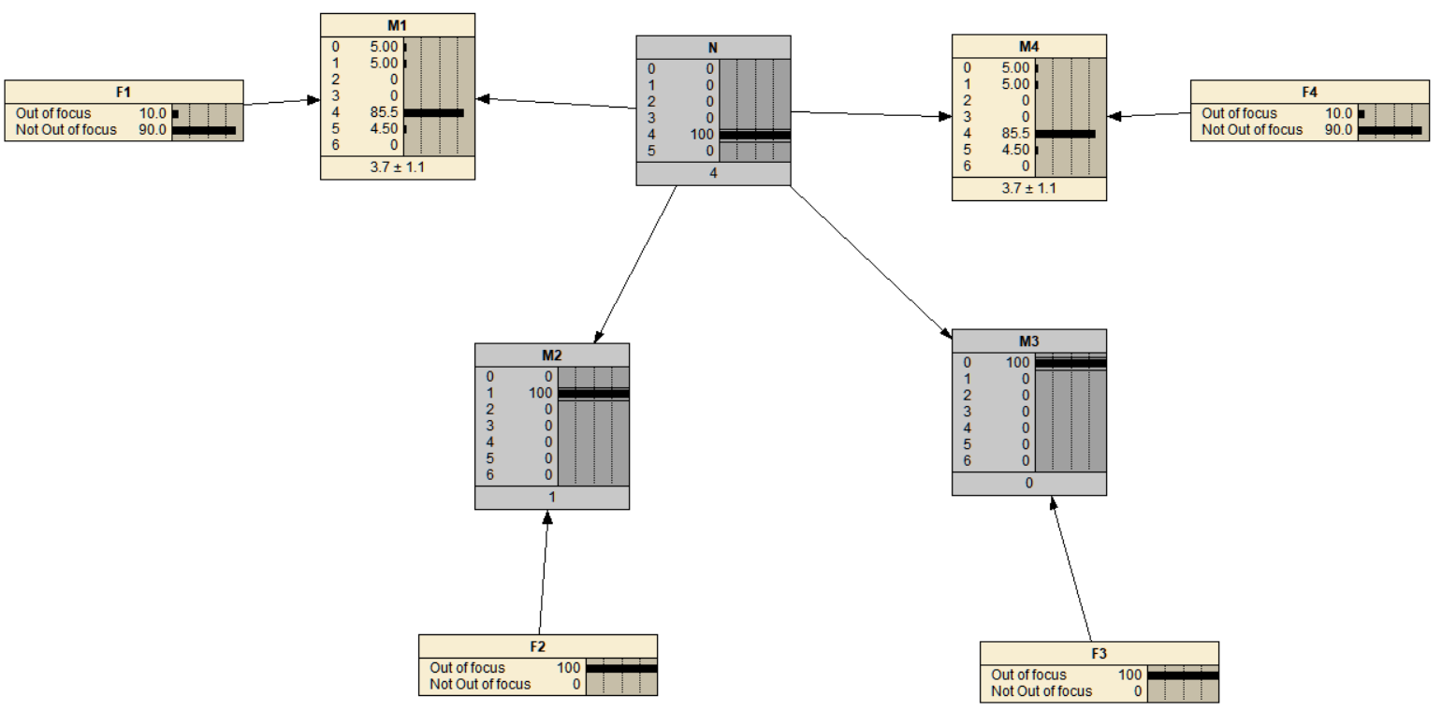

F1

Out_of_focus 0.1

Not_Out_of_focus 0.9

F2

Out_of_focus 1

Not_Out_of_focus 0

F3

Out_of_focus 1

Not_Out_of_focus 0

F4

Out_of_focus 0.1

Not_Out_of_focus 0.9

M1

0 0.05

1 0.05

2 0

3 0

4 0.855

5 0.045

6 0

M2

0 0

1 1

2 0

3 0

4 0

5 0

6 0

M3

0 1

1 0

2 0

3 0

4 0

5 0

6 0

M4

0 0.05

1 0.05

2 0

3 0

4 0.855

5 0.045

6 0

N

0 0

1 0

2 0

3 0

4 1

5 0

1. Experiment 4 (M1=0 M2=5 M3=5 M4=4)

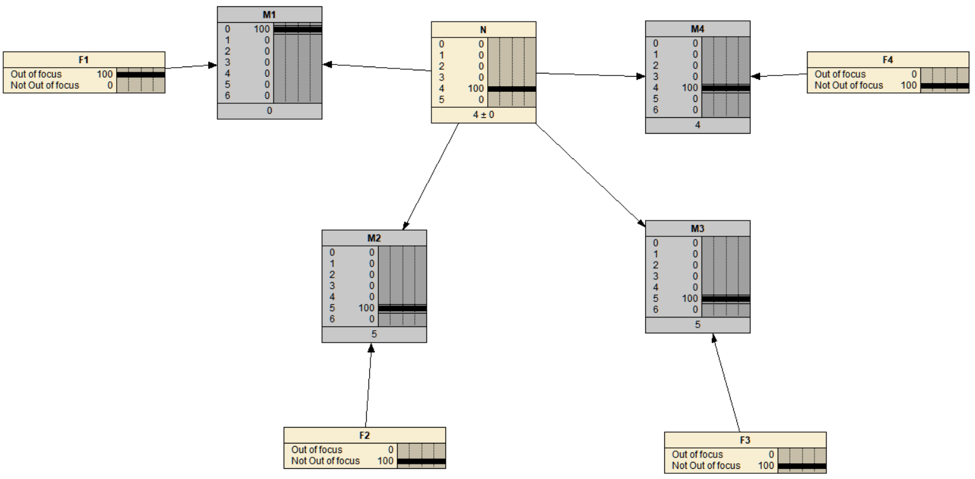

F1

Out_of_focus 1

Not_Out_of_focus 0

F2

Out_of_focus 0

Not_Out_of_focus 1

F3

Out_of_focus 0

Not_Out_of_focus 1

F4

Out_of_focus 0

Not_Out_of_focus 1

M1

0 1

1 0

2 0

3 0

4 0

5 0

6 0

M2

0 0

1 0

2 0

3 0

4 0

5 1

6 0

M3

0 0

1 0

2 0

3 0

4 0

5 1

6 0

M4

0 0

1 0

2 0

3 0

4 1

5 0

6 0

N

0 0

1 0

2 0

3 0

4 1

5 0

1. Experiment 5 (N=4 F1=0 F2=0 F3=1 F4=1)

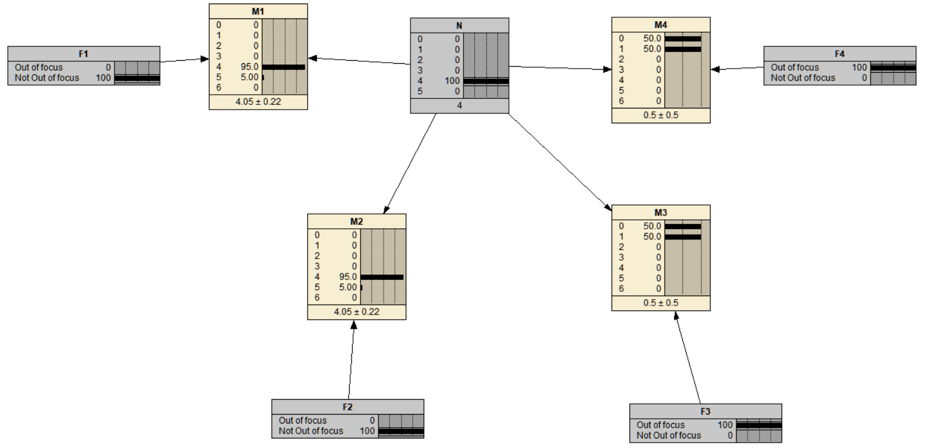

F1

Out_of_focus 0

Not_Out_of_focus 1

F2

Out_of_focus 0

Not_Out_of_focus 1

F3

Out_of_focus 1

Not_Out_of_focus 0

F4

Out_of_focus 1

Not_Out_of_focus 0

M1

0 0

1 0

2 0

3 0

4 0.95

5 0.05

6 0

M2

0 0

1 0

2 0

3 0

4 0.95

5 0.05

6 0

M3

0 0.5

1 0.5

2 0

3 0

4 0

5 0

6 0

M4

0 0.5

1 0.5

2 0

3 0

4 0

5 0

6 0

N

0 0

1 0

2 0

3 0

4 1

5 0

1. Experiment 6 (N=5)

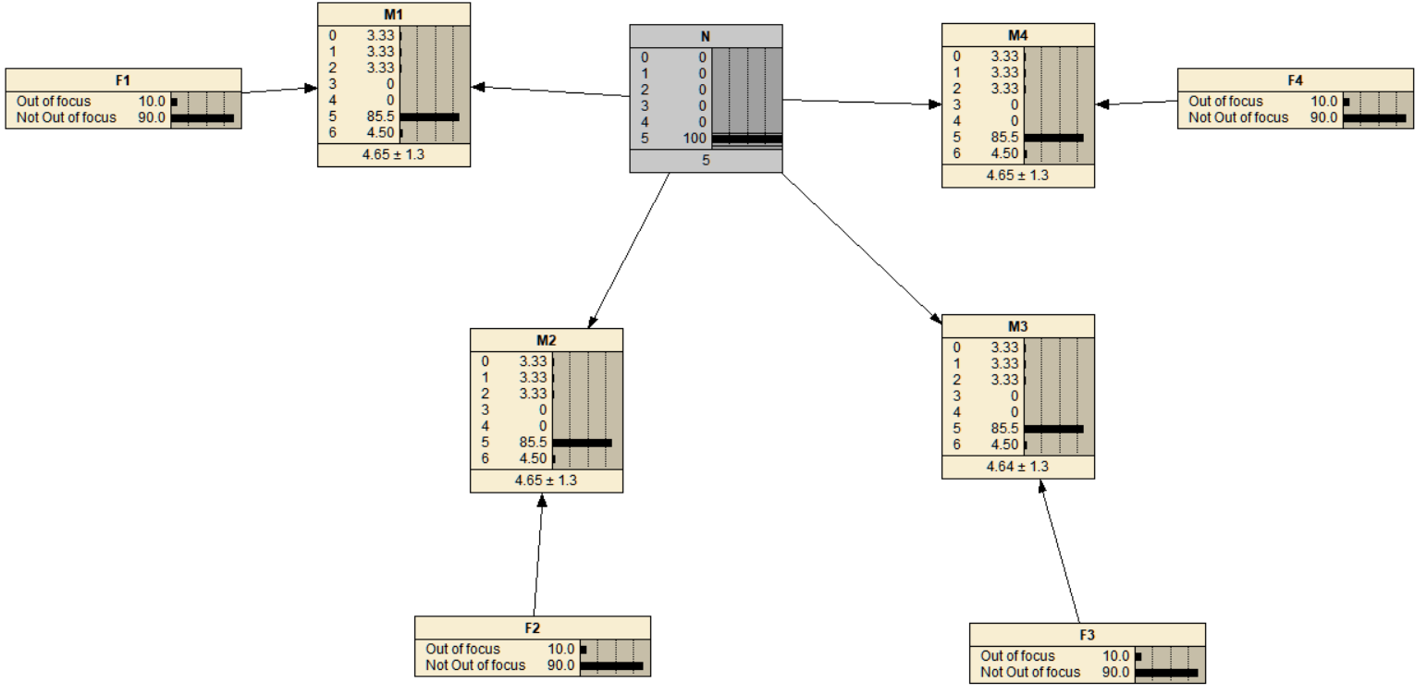

F1

Out_of_focus 0.1

Not_Out_of_focus 0.9

F2

Out_of_focus 0.1

Not_Out_of_focus 0.9

F3

Out_of_focus 0.1

Not_Out_of_focus 0.9

F4

Out_of_focus 0.1

Not_Out_of_focus 0.9

M1

0 0.033333

1 0.033333

2 0.033333

3 0

4 0

5 0.855

6 0.045

M2

0 0.033333

1 0.033333

2 0.033333

3 0

4 0

5 0.855

6 0.045

M3

0 0.033333

1 0.033333

2 0.033333

3 0

4 0

5 0.855

6 0.045

M4

0 0.033333

1 0.033333

2 0.033333

3 0

4 0

5 0.855

6 0.045

N

0 0

1 0

2 0

3 0

4 0

5 1

1. Experiment 7 (no parameter)

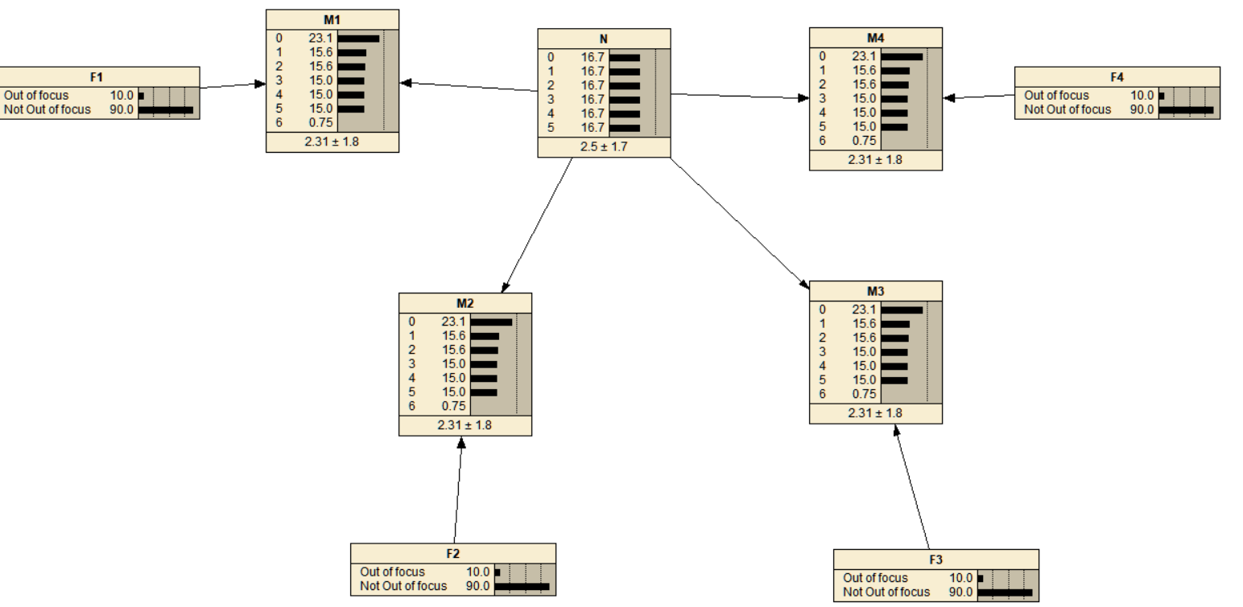

F1

Out_of_focus 0.1

Not_Out_of_focus 0.9

F2

Out_of_focus 0.1

Not_Out_of_focus 0.9

F3

Out_of_focus 0.1

Not_Out_of_focus 0.9

F4

Out_of_focus 0.1

Not_Out_of_focus 0.9

M1

0 0.23056

1 0.15639

2 0.15556

3 0.15

4 0.15

5 0.15

6 0.0075

M2

0 0.23056

1 0.15639

2 0.15556

3 0.15

4 0.15

5 0.15

6 0.0075

M3

0 0.23056

1 0.15639

2 0.15556

3 0.15

4 0.15

5 0.15

6 0.0075

M4

0 0.23056

1 0.15639

2 0.15556

3 0.15

4 0.15

5 0.15

6 0.0075

N

0 0.16667

1 0.16667

2 0.16667

3 0.16667

4 0.16667

5 0.16667