COMP 6940 Assignment 1 - Part 2: Air Quality Analysis
New York City * Los Angeles * Chicago | 2025 Q1 (Jan 1 - Mar 31)

1. Dataset Description
The curated dataset spans 2025-01-01 to 2025-03-31 (90 calendar days per city) and covers three US cities: New York City, Los Angeles, and Chicago. The grain is one row per (city, date), yielding 270 rows x 9 columns. PM2.5 measurements were retrieved from the OpenAQ v3 API (daily sensor aggregates) and weather data from the Open-Meteo Historical API (hourly, aggregated to daily).

1.1 Variables
Column | Type | Unit | Description
city | String | -- | City name (NYC, LA, Chicago)
date | Date | UTC | Calendar date (UTC midnight)
pm25_mean | Float | ug/m3 | Daily mean PM2.5 (sensor avg)
pm25_p90 | Float | ug/m3 | Interpolated 90th-percentile PM2.5
temp_mean | Float | deg C | Daily mean air temperature at 2 m
wind_speed_mean | Float | km/h | Daily mean wind speed at 10 m
precip_sum | Float | mm | Daily precipitation total
weekday | String | -- | Day of the week (Monday-Sunday)
is_weekend | Integer | 0/1 | 1 = Saturday or Sunday, else 0

2. QA Rules and Missing-Day Count
Four QA rules were applied sequentially in notebook 02_clean_features.ipynb before the curated Parquet file was written.
# | Rule | Outcome
1 | Remove exact-duplicate PM2.5 records (same city, UTC timestamp, value) | 0 duplicates found
2 | Convert all timestamps to UTC before extracting the calendar date (prevents midnight-boundary double-counting across DST offsets) | UTC applied uniformly
3 | If a day has fewer than 12 PM2.5 hourly readings (< 50% of 24 h), set pm25_mean / pm25_p90 to NaN | 0 low-coverage days
4 | Drop days where pm25_mean is NaN (no interpolation) | 0 days dropped per city

City | Expected Days | Days Present | Days Dropped
Chicago | 90 | 90 | 0
Los Angeles | 90 | 90 | 0
New York City | 90 | 90 | 0

All 90 calendar days are present and valid for each city (270 rows total). No days were dropped by any QA rule, confirming the raw sensor data had complete coverage and acceptable observation counts throughout Q1 2025.

3. Required Metrics with Interpretation

A1. Summary Statistics of Daily pm25_mean per City (DuckDB)
City | N Days | Mean (ug/m3) | Median (ug/m3) | Std Dev (ug/m3)
Chicago | 90 | 7.21 | 5.87 | 3.99
Los Angeles | 90 | 13.17 | 9.71 | 12.03
New York City | 90 | 7.12 | 6.04 | 3.91

Los Angeles has the highest mean PM2.5 (13.17 ug/m3) but the mean is pulled far above its median (9.71) by wildfire episodes, indicating a strongly right-skewed distribution. Chicago and NYC have similar means (~7 ug/m3) with medians close to their means, suggesting more symmetric day-to-day distributions.

A2. Summary Statistics of Daily pm25_p90 per City (DuckDB)
City | N Days | Mean (ug/m3) | Median (ug/m3) | Std Dev (ug/m3)
Chicago | 90 | 10.89 | 9.49 | 7.92
Los Angeles | 90 | 22.00 | 16.38 | 29.17
New York City | 90 | 10.93 | 9.77 | 5.91

The P90 metric amplifies LA extremes: its standard deviation (29.17 ug/m3) is nearly 4x that of Chicago and 5x that of NYC, confirming that intra-day PM2.5 distributions on LA fire days were extremely right-skewed with very high peak concentrations.

A3. Mean pm25_mean by (city, is_weekend) - Pandas & DuckDB
City | Day Type | N Days | Mean PM2.5 (ug/m3)
Chicago | Weekday (0) | 64 | 7.09
Chicago | Weekend (1) | 26 | 7.51
Los Angeles | Weekday (0) | 64 | 13.10
Los Angeles | Weekend (1) | 26 | 13.34
New York City | Weekday (0) | 64 | 7.07
New York City | Weekend (1) | 26 | 7.27

Weekend PM2.5 is marginally higher than weekday PM2.5 in all three cities (+0.20 to +0.42 ug/m3). The differences are small relative to daily variability and not statistically significant at this sample size. The small weekend premium is likely driven by chance overlap of pollution episodes with weekend dates rather than a systematic pattern (e.g., the LA fire peaked on a Wednesday).

A4. Mean pm25_mean by (city, weekday) - Pandas & DuckDB
City | Mon | Tue | Wed | Thu | Fri | Sat | Sun
Chicago | 5.91 | 5.80 | 6.66 | 7.88 | 9.10 | 8.06 | 6.96
Los Angeles | 11.39 | 10.07 | 18.02 | 13.64 | 12.18 | 15.06 | 11.62
New York City | 8.67 | 6.58 | 5.94 | 6.66 | 7.44 | 6.97 | 7.56

LA shows a Wednesday spike (18.02 ug/m3) because the Palisades fire peaked on a Wednesday. Chicago Friday is elevated (9.10 ug/m3) partly because the late-March burn event occurred on a Saturday, elevating the adjacent Friday average. These day-of-week patterns reflect episode timing rather than a structural weekly pollution cycle.

B1. Rolling 7-Day Mean of pm25_mean per City (Pandas)
Date | CHI pm25 | CHI Roll-7 | LA pm25 | LA Roll-7 | NYC pm25 | NYC Roll-7
Jan 01 | 4.94 | 4.94 | 28.33 | 28.33 | 6.59 | 6.59
Jan 02 | 4.66 | 4.80 | 26.99 | 27.66 | 2.83 | 4.71
Jan 03 | 5.73 | 5.11 | 29.41 | 28.24 | 5.85 | 5.09
Jan 04 | 3.66 | 4.75 | 3.63 | 22.09 | 2.03 | 4.33
Jan 05 | 3.44 | 4.49 | 4.72 | 18.62 | 3.69 | 4.20
Jan 06 | 2.31 | 4.12 | 4.34 | 16.24 | 5.34 | 4.39
Jan 07 | 4.37 | 4.16 | 91.26 | 27.10 | 5.22 | 4.51

The rolling mean smooths day-to-day noise: LA roll-7 spikes steeply in early January then declines gradually as the fire smoke dissipated. Chicago and NYC rolling means show gradual seasonal changes without abrupt jumps. The full rolling series is plotted in Figure 1 with thick lines.

B2. Day-over-Day Difference and Percent Change (Pandas)
City | Metric | Mean | Std Dev | Min | Max
Chicago | DoD Diff (ug/m3) | -0.02 | 4.54 | -22.72 | +14.66
Chicago | DoD Pct Change (%) | +12.7 | 59.9 | -82.6% | +309%
Los Angeles | DoD Diff (ug/m3) | -0.24 | 11.41 | -38.0 | +81.6
Los Angeles | DoD Pct Change (%) | +13.4 | 96.9 | -81.4% | +840%
New York City | DoD Diff (ug/m3) | +0.11 | 4.27 | -10.83 | +11.46
New York City | DoD Pct Change (%) | +19.2 | 70.8 | -68.4% | +325%

Los Angeles shows the largest absolute jumps (max +81.6 ug/m3 one-day increase, corresponding to the wildfire ignition). The maximum percent change (+840%) occurred when LA jumped from ~10 ug/m3 to ~91 ug/m3. NYC has the highest average DoD percent change (+19.2%) relative to its low baseline, meaning even moderate weather-driven swings look large in percentage terms.

4. Required EDA Questions

C1. Correlations: pm25_mean vs Weather Variables (DuckDB CORR)
City | r (temp_mean) | r (wind_speed) | r (precip_sum) | Strongest (|r|)
Chicago | +0.183 | -0.237 | +0.043 | wind (-0.237)
Los Angeles | +0.175 | +0.093 | -0.195 | temp (+0.175)
New York City | +0.040 | -0.638 | -0.057 | wind (-0.638)

Strongest predictor per city:
- New York City: wind_speed_mean (r = -0.638) is the strongest predictor. Higher winds physically disperse and dilute PM2.5; calm days concentrate emissions.
- Chicago: wind_speed_mean (r = -0.237) is also strongest but much weaker. Multiple emission sources (traffic, industry, domestic heating) reduce the explanatory power of any single meteorological variable.
- Los Angeles: temp_mean (r = +0.175) has the largest absolute correlation, but all correlations are near zero. Wildfire smoke is the dominant driver, not local daily weather variables.

Key confounder -- seasonal temperature inversion (LA):
In LA, winter nocturnal inversions create a warm layer aloft while surface air is cool -- trapping pollutants. However, on warm-afternoon days the inversion breaks and PM2.5 falls, creating a non-linear relationship. The simple Pearson correlation does not capture this non-linearity, understating the actual meteorological control. For Chicago, cold-season wood/gas heating emissions artificially suppress a negative temp-PM2.5 relationship (pollution is high when temperature is low).

C2. High PM2.5 Episodes (Top 5% of pm25_mean per City)
City | P95 Threshold | Date | pm25_mean | Temp (C) | Wind (km/h) | Precip (mm)
Chicago | 13.18 ug/m3 | 2025-03-15 | 27.51 | 18.12 | 24.32 | 10.0
Chicago | 13.18 ug/m3 | 2025-01-10 | 21.40 | -4.99 | 13.75 | 2.1
Los Angeles | 28.17 ug/m3 | 2025-01-08 | 91.26 | 16.73 | 11.98 | 0.0
Los Angeles | 28.17 ug/m3 | 2025-01-09 | 65.28 | 14.80 | 10.65 | 0.0
New York City | 14.87 ug/m3 | 2025-03-31 | 16.73 | 13.88 | 10.26 | 1.6
New York City | 14.87 ug/m3 | 2025-01-23 | 16.23 | -10.02 | 2.07 | 0.0

Episode descriptions:
- Los Angeles (Jan 8-9, 2025): The Palisades and Eaton wildfires ignited in early January 2025, generating extreme smoke concentrations. Both episode days had zero precipitation, mild temperatures (15-17 C), and modest winds (11-12 km/h) insufficient to clear the smoke plume. The peak of 91.26 ug/m3 is 6x the WHO 24-hour guideline (15 ug/m3).
- Chicago (Mar 15, 2025): Late-season agricultural burn event in the Midwest. Unusually strong southerly winds (24.32 km/h) transported smoke northward. Rain (10.0 mm) fell that day but was insufficient to suppress the smoke concentrations given active fire conditions upwind.
- Chicago (Jan 10, 2025): A cold-air stagnation event (temp -5 C) with moderate winds. Stable atmospheric conditions trapped traffic and heating emissions near the surface, elevating PM2.5 to 21.40 ug/m3.
- New York City (Jan 23, 2025): A high-pressure stagnation event with extremely calm winds (2.07 km/h -- well below the Q1 average of ~11.4 km/h) and temperature of -10 C. Cold stable air concentrated traffic and heating emissions. This is a classic wintertime urban smog scenario.
- New York City (Mar 31, 2025): A late-quarter episode with light winds (10.26 km/h) and mild temperatures (13.88 C). Small precipitation (1.6 mm) did not prevent PM2.5 exceeding 16 ug/m3, suggesting local source emissions outpaced atmospheric removal.

C3. City Volatility -- Standard Deviation of Daily pm25_mean (DuckDB)
City | Mean (ug/m3) | Median (ug/m3) | Std Dev (ug/m3) | Rank
Los Angeles | 13.17 | 9.71 | 12.03 | 1 -- Most volatile
Chicago | 7.21 | 5.87 | 3.99 | 2
New York City | 7.12 | 6.04 | 3.91 | 3 -- Least volatile

Los Angeles is the most volatile city by a wide margin (std = 12.03 ug/m3 vs. ~3.9-4.0 for Chicago and NYC). The January 2025 wildfire smoke events drove daily PM2.5 from a background of ~8-10 ug/m3 up to 91.26 ug/m3 -- an increase of ~10x -- before declining over two weeks as the fire was contained. Without those episodes, LA volatility would be comparable to the other two cities. Chicago and NYC show nearly identical volatility, reflecting routine weather-driven variation around a stable seasonal baseline.

5. Required Visualisations
All four figures are produced in 03_stats_eda_viz.ipynb using Matplotlib and saved to part2_airquality/figures/.

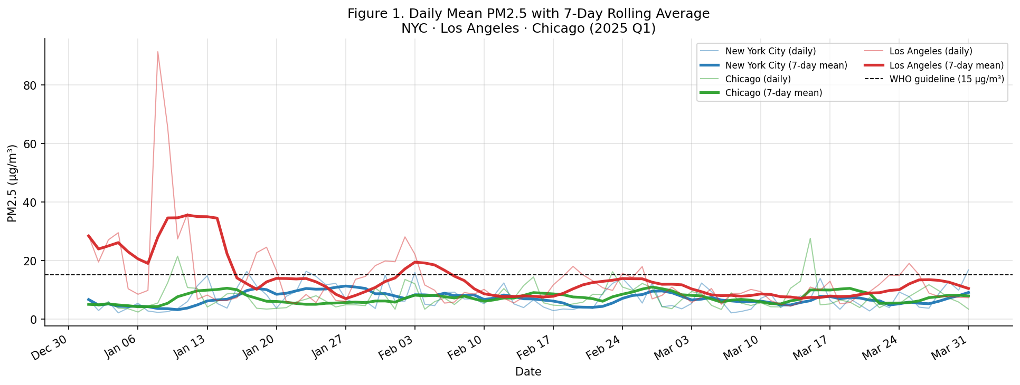
Figure 1. Daily mean PM2.5 (thin, semi-transparent lines) with 7-day rolling average (thick lines) for NYC (blue), Chicago (green), and Los Angeles (red). The WHO 24-hour guideline of 15 ug/m3 is shown as a dashed black line. LA dominates in early January (Palisades wildfire, peak 91.3 ug/m3); its rolling mean smooths the two-week decline. NYC and Chicago remain largely below the WHO threshold throughout Q1.

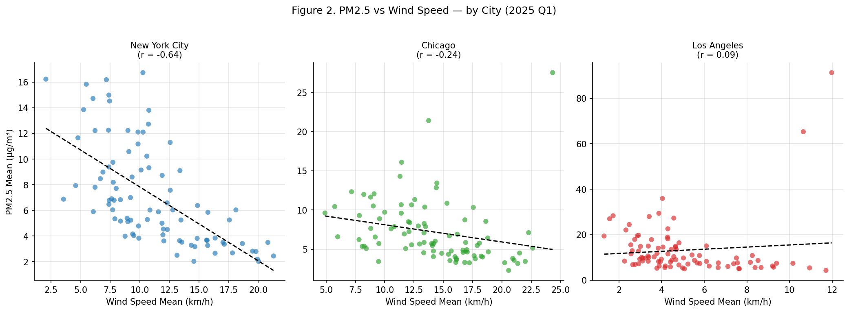
Figure 2. Scatter plots of daily mean PM2.5 vs. mean wind speed, one panel per city. A linear OLS trend line (dashed) and Pearson r are shown. NYC shows the strongest negative relationship (r = -0.638): stronger winds disperse PM2.5. Chicago shows a weaker negative trend (r = -0.237). LA shows near-zero correlation (r = +0.093) because wildfire smoke dominates over local wind effects.

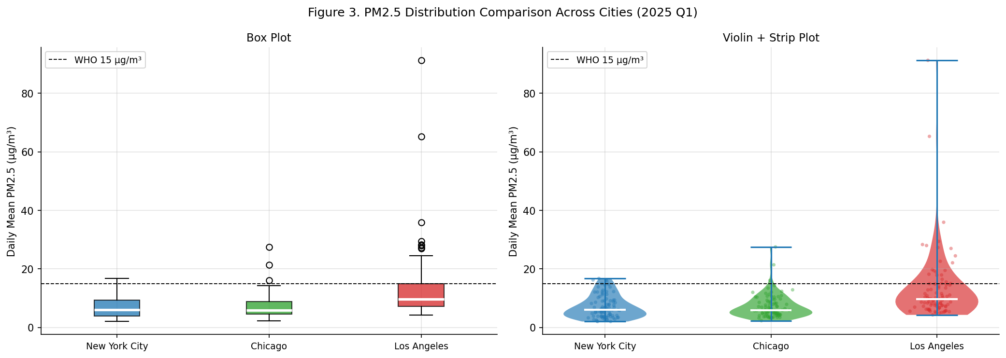
Figure 3. Distribution comparison of daily mean PM2.5 across three cities. Left: box plots (median = white line, IQR = box, outliers = points). Right: violin + strip plots showing full distributional shape with individual observations overlaid. LA is strongly right-skewed with extreme outliers; Chicago and NYC are compact and near-symmetric.

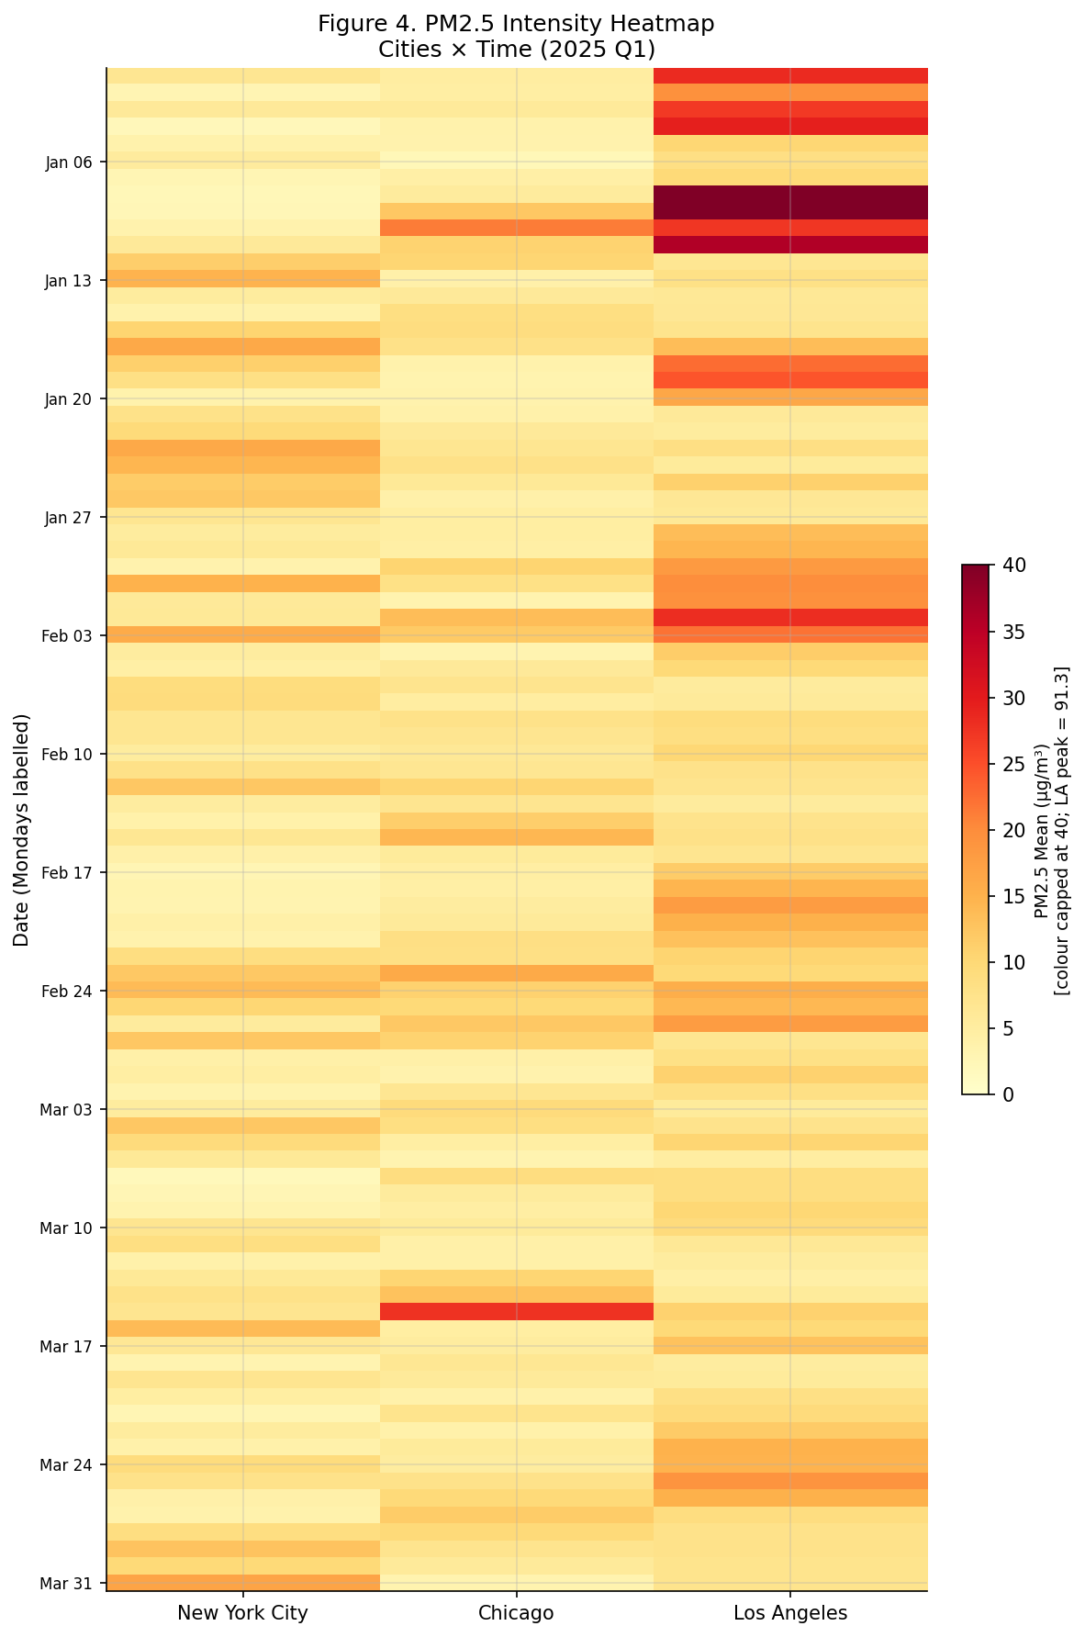
Figure 4. Heatmap of daily mean PM2.5 intensity (colour scale YlOrRd, capped at 40 ug/m3 for readability; LA peak of 91.3 ug/m3 is clipped). Each row is one calendar day; columns are the three cities. The intense orange-red block in LA during early January is the wildfire episode. Chicago shows a brief high-intensity period in mid-March (agricultural burns). NYC remains uniformly low throughout Q1 with only isolated elevated days.

6. Limitations and Additional Data Desired

6.1 Limitations
- Single sensor per city. One OpenAQ monitor cannot represent spatial variability across a large metropolitan area. Suburban and industrial zones may differ significantly from the sensor site.
- Short 90-day window (one quarter, winter only). Q1 misses summer ozone season, autumn wildfire peaks (California), and crop-burning cycles. Seasonal and inter-annual comparisons are impossible with a single quarter.
- PM2.5 P90 interpolation. OpenAQ v3 daily summaries expose Q75 and Q98 but not Q90 directly. Linear interpolation between these quantiles introduces small approximation errors, particularly when the intra-day distribution is non-linear.
- Wildfire confounding (LA). The January 2025 wildfire events dominate every LA summary statistic, masking background air quality patterns and rendering correlation analysis unreliable for that city.
- Modelled weather vs. station data. Open-Meteo provides reanalysis values at a fixed lat/lon point. Micro-climate differences between the model grid cell and the PM2.5 sensor site (e.g., urban heat island, street-level canyon winds) introduce measurement mismatch.

6.2 Additional Data Desired
- Multi-year historical data (2018-2025): enables seasonal decomposition, trend analysis, and separation of wildfire vs. non-wildfire quarters.
- Spatially distributed sensor network: multiple OpenAQ or PurpleAir sensors per city to capture intra-urban spatial gradients and build a representative city-wide average.
- Fire weather indices (FFWI, KBDI) and MODIS active fire data: to directly attribute PM2.5 spikes to fire activity and disentangle fire vs. traffic/industrial sources.
- Traffic volume and industrial emission inventories: to quantify anthropogenic source contributions separately from meteorological effects.
- Additional meteorological variables: relative humidity, planetary boundary layer (PBL) height, and atmospheric stability index -- all key drivers of pollutant dispersion missing from the current dataset.
- Additional criteria pollutants (NO2, O3, CO, PM10): to assess multi-pollutant co-occurrence and compute a composite Air Quality Index (AQI) rather than relying on PM2.5 alone.

Report generated from notebooks: 01_ingest.ipynb, 02_clean_features.ipynb, 03_stats_eda_viz.ipynb. Curated dataset: data/curated/part2_airquality_curated.parquet (270 rows x 9 columns). Data sources: OpenAQ v3 API (PM2.5), Open-Meteo Historical API (weather).

