Enhancing Clinical Decision-Making in Heart Transplantation Through Predictive Modeling
Erik Pak
Advisor: Dr. Ilyas Ustun
DePaul University
erikpak.email@gmail.com

ABSTRACT
Heart transplantation is a life-saving intervention for patients with end-stage heart failure, yet predicting long-term survival remains a complex challenge due to the multifaceted nature of donor and recipient characteristics. This study leverages the United Network for Organ Sharing (UNOS) dataset—a large-scale, nationally representative registry of heart transplant cases, which is a crucial resource in the field of heart transplantation research. The UNOS dataset provides comprehensive and reliable data on donor and recipient characteristics, making it an ideal source for developing and evaluating machine learning models for predicting three-year post-transplant survival. Our study follows a comprehensive data science pipeline which includes data acquisition, rigorous preprocessing (imputation, discretization, and normalization), exploratory data analysis, advanced feature engineering, and feature selection. We benchmarked multiple classification algorithms—Logistic Regression, Random Forest, XGBoost, K-Nearest Neighbors (KNN), and AdaBoost—using stratified cross-validation with Bayesian hyper-parameter optimization. Model performance was assessed using AUC-ROC, F1-score, precision, and recall. SHAP (SHapley Additive exPlanations) values were employed to interpret model predictions and identify key predictors of survival, ensuring transparency and robustness in our research. This study aims to improve predictive accuracy and support evidence-based clinical decision-making in heart transplantation by comparing model performance and uncovering the most influential features.

Keywords
Machine Learning Classification Algorithms Feature Engineering Data Preprocessing
Bayesian Optimization Heart Transplant

INTRODUCTION
Since the first human heart transplant on December 3, 1967, by surgeon Christiaan Barnard at Groote Schuur Hospital in Cape Town, South Africa, where a 25-year-old woman fatally injured in a car accident was transplanted into Lewis Washkansky, a 53-year-old South African grocer dying from chronic heart disease. Barnard’s achievement was built upon years of pioneering research by American surgeon Norman Shumway and his colleagues at Stanford University, who had developed and refined heart transplantation techniques in animal models throughout the 1950s and achieved the first successful heart transplant in a dog at Stanford University in California in 1958[1].
We focused on adult patients who underwent heart transplantation between 2011 and 2021 to ensure sufficient follow-up data and account for any pharmaceutical and surgical advances for a three-year survival analysis. The dataset includes various demographic, clinical, procedural, and post-operative variables used to explore advanced predictive analytics in this domain. Traditional statistical methods often struggle to model complex nonlinear relationships and variable interactions. In contrast, modern machine learning approaches can capture these intricate patterns, potentially enhancing clinical decision-making.
In this context, our study addresses the critical challenge of predicting three-year post-transplant survival by applying machine learning algorithms to heart transplant patients from the UNOS database, a comprehensive and reliable source of transplant data. We aim to balance predictive performance with interpretability, enabling clinicians to trust the outputs and understand the underlying factors driving outcomes. This research ultimately seeks to support more informed decision-making in allocating and managing donor hearts.

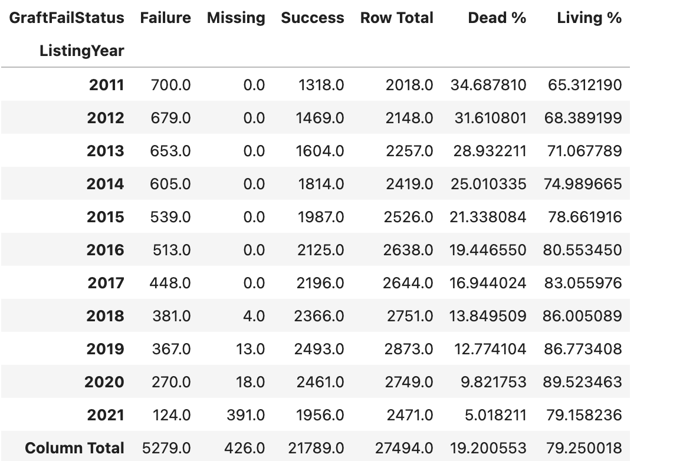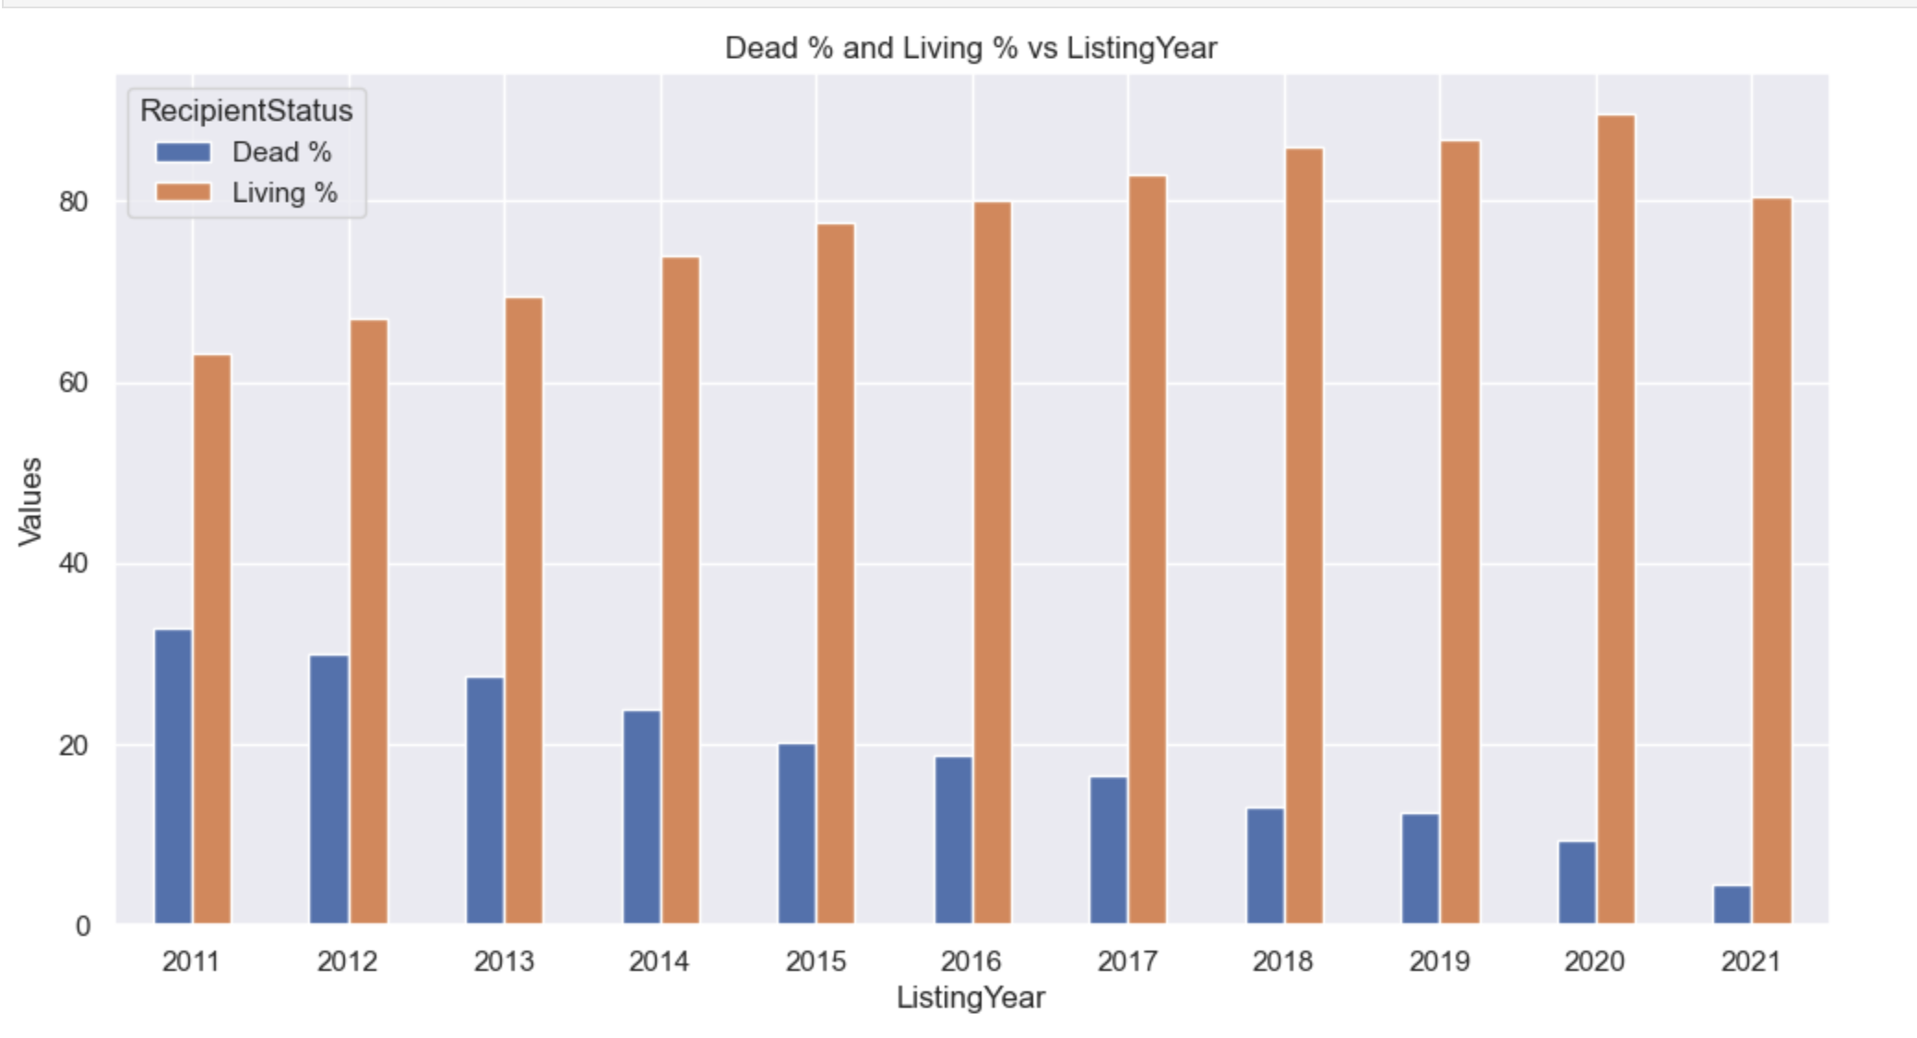
Figure 1: Contingency Table Figure 2: Survival & Death Rate

PREPROCESSING
We focused our analysis on adult patients, defined as individuals aged 18 years or older, who received a heart transplant between 2011 and 2021. This timeframe was selected to ensure the availability of sufficient follow-up data to evaluate three-year post-transplant survival outcomes, which served in the study. By restricting to this period, we aimed to capture contemporary clinical practices and outcomes relevant to current heart transplantation care.
To ensure the quality and relevance of our dataset, we embarked on a meticulous data cleaning process. We began with a comprehensive registry from the United Network for Organ Sharing (UNOS), which initially included data from 1984 to 2021 and removed any variables that were not currently being used or any duplicate variables. After applying inclusion criteria and data cleaning procedures, the resulting dataset contained 28,751 patient records and 317 features. To address the issue of incomplete data, we excluded features with greater than 80% missing values since they were primarily categorical features; therefore, a new categorical feature called "Missing" was created for any missing features that were part of the inclusion, thereby retaining enough categorical variables for meaningful analysis.
Further data preprocessing steps were undertaken to enhance the dataset's consistency and usability. Categorical features were mapped according to the official UNOS data dictionary, ensuring standardized representation across all variables. Additionally, we updated the data types within the DataFrame to accurately reflect the nature of each variable, such as converting category strings to categorical objects.

VISUALIZATION

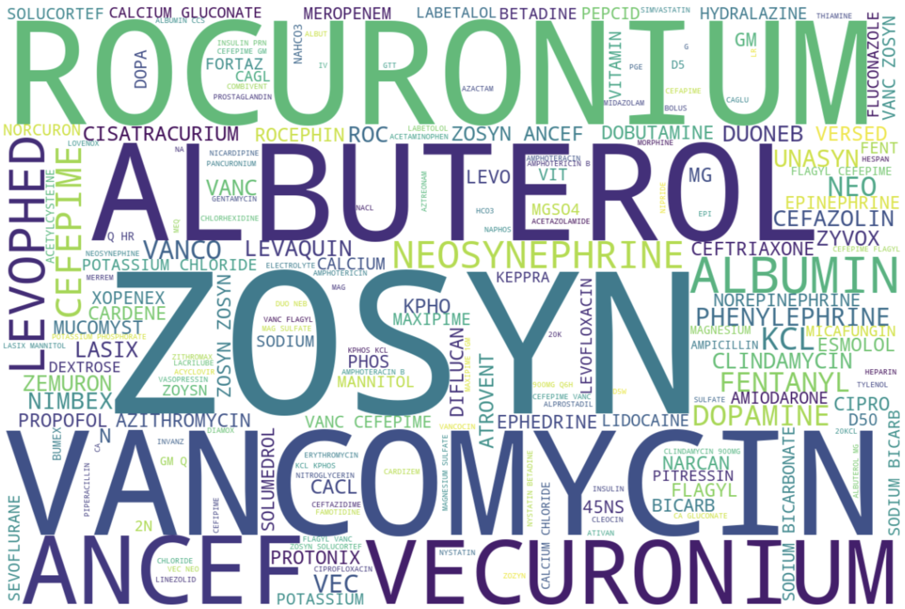
Figure 3: Candidate Drug Usage

ZOSYN (piperacillin and tazobactam for injection, USP) is an injectable antibacterial combination product consisting of the semisynthetic antibiotic piperacillin sodium and the β-lactamase inhibitor tazobactam sodium for intravenous administration. Piperacillin sodium is derived from D(-)-α-aminobenzyl-penicillin.
Rocuronium is a non-depolarizing neuromuscular blocker widely used to produce muscle relaxation to help facilitate surgery and ventilation of the lungs in elective and emergent situations.
Vancomycin is a tricyclic glycopeptide antibiotic originally derived from the organism Streptococcus orientalis. Vancomycin is used to treat and prevent various bacterial infections caused by gram-positive bacteria, including methicillin-resistant Staphylococcus aureus (MRSA).
Vecuronium is a nondepolarizing agent that achieves skeletal muscle paralysis by competing with acetylcholine for cholinergic receptor sites and binding with the nicotinic cholinergic receptor at the postjunctional membrane of the motor endplate
Albuterol is used to prevent and treat difficulty breathing, wheezing, shortness of breath, coughing, and chest tightness caused by lung diseases such as asthma and chronic obstructive pulmonary disease (COPD; a group of diseases that affect the lungs and airways).

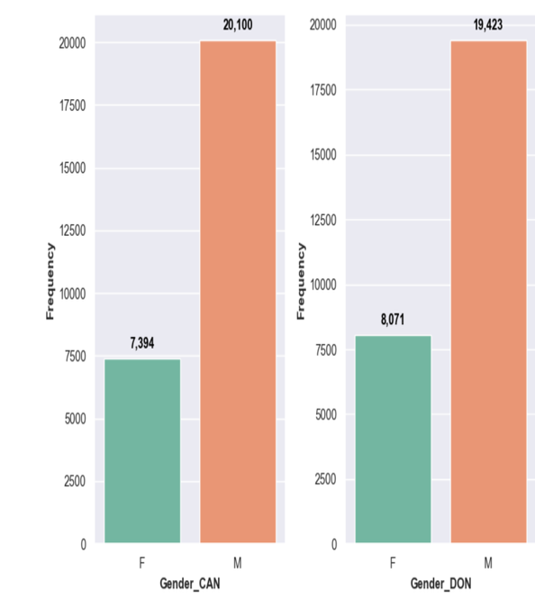
The gender distribution in Gender_CAN (Candidate) and Gender_DON (Donor) is similar, with about 70% males and 30% females, slightly more in female donors. This indicates a consistent demographic pattern across candidates and donors, suggesting that males have a higher frequency of heart transplants in the UNOS dataset.
Figure 4: Gender

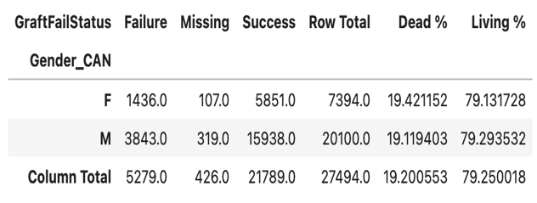
The data reveal a negligible difference in heart transplant outcomes between male and female candidates, indicating that gender may not be a significant factor in post-transplant success.
Figure 5: Contingency Table for Gender & Graft Status
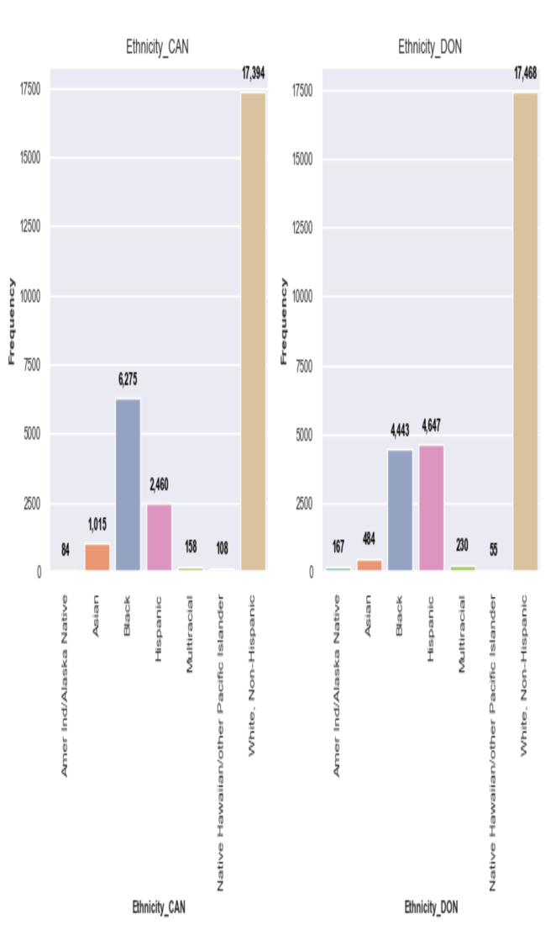
The Ethnicity_CAN group predominantly comprises White, non-Hispanic individuals, with Black, non-Hispanic, and Hispanic/Latino populations representing the following most significant segments. At the same time, other ethnicities are present in much smaller numbers among transplant candidates. In contrast, the Ethnicity_DON group shows a comparatively higher proportion of Hispanic/Latino and American Indian/Alaska Native donors compared to the recipients. However, White, non-Hispanic individuals remain the largest donor group overall, outpacing the recipients. These patterns reveal notable demographic differences between transplant candidates and donors, suggesting potential disparities in donation rates or reflecting broader population trends. Understanding these differences is essential for advancing organ donation and warrants further investigation.
Figure 6: Ethnicity

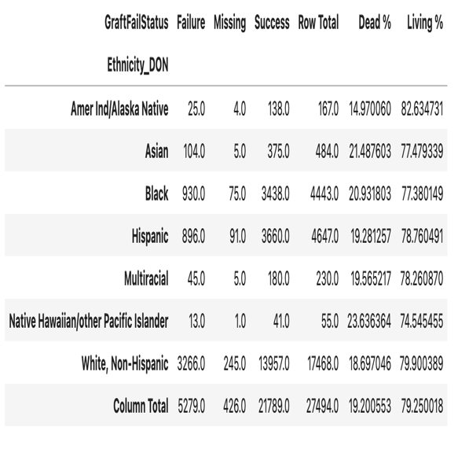
The data shows notable disparities in graft outcomes and donor demographics by ethnicity. White, non-Hispanic donors have the most significant representation, lowest failure rate, and highest proportion of living donors. In contrast, Black, Hispanic, Asian, and Native Hawaiian/Other Pacific Islander donors experience higher graft failure rates, with living donor proportions varying across groups. These patterns suggest underlying disparities in transplant outcomes that warrant further investigation.
Figure 7: Contingency Table for Ethnicity & Graft Status

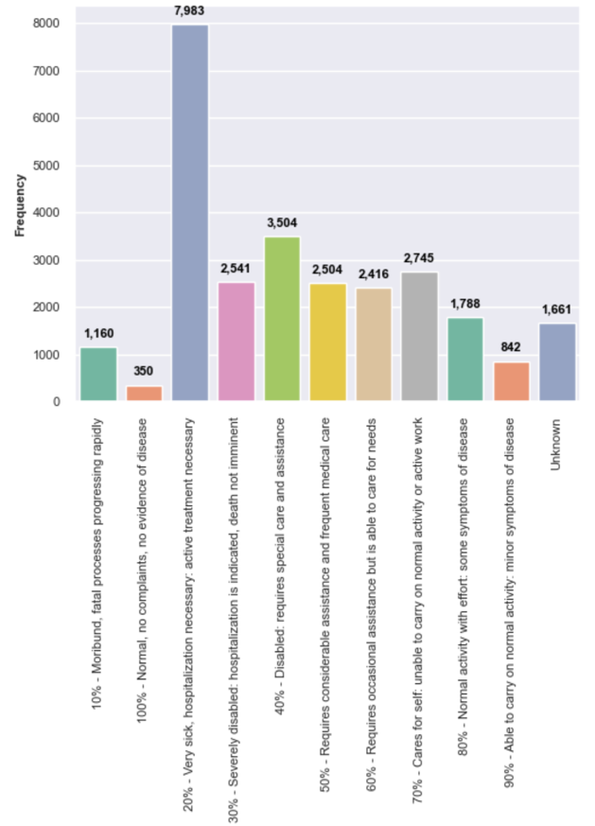
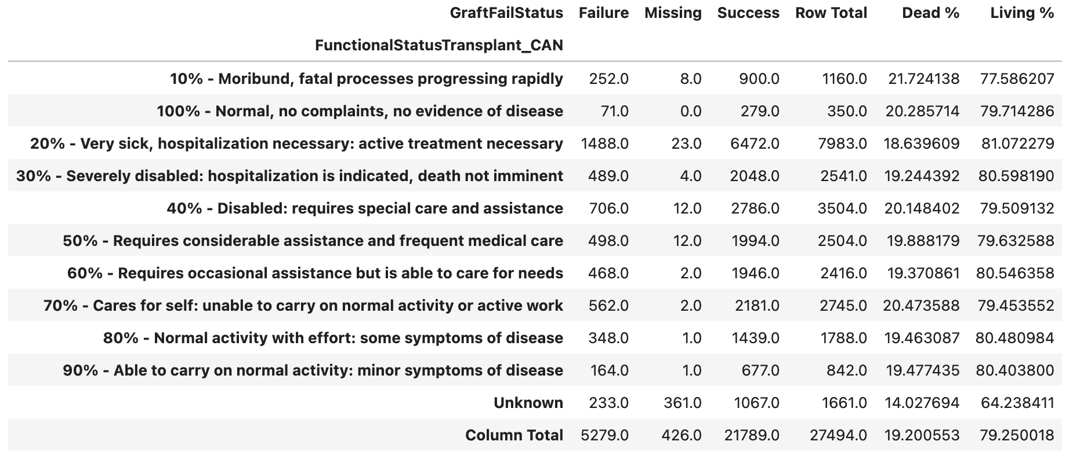
Figure 8: Functional Status Transplant (Candidate)

Figure 9: Contingency Table for Functional Status & Graft Status

The Functional Status at Transplant feature analysis significantly contributes to understanding how pre-transplant health influences post-transplant outcomes among heart transplant recipients. This valuable resource categorizes patients by functional status before transplantation and tracks subsequent graft outcomes, classified as Success or Failure.
A clear trend emerges among patients in the most critical condition, specifically those labeled as "10% - Moribund, fatal processes progressing rapidly." This group experienced a graft failure rate of 21.7%, with only 77.6% achieving successful outcomes. This finding is consistent with clinical expectations, as severely ill patients are at greater risk for complications and adverse outcomes following transplantation due to their unstable baseline health.
Interestingly, even patients at the opposite end of the spectrum, categorized as "100%—Normal, no complaints, no evidence of disease," were not exempt from risk, exhibiting a graft failure rate of 20.3%. This relatively high rate among otherwise healthy individuals suggests that a complex connection of factors beyond physical status, such as strength of immune systems, perioperative events, and post-transplant care, influences graft survival.
The largest cohort in the dataset, nearly 8,000 patients classified as "20% - Very sick, hospitalization necessary: active treatment necessary," demonstrated a slightly improved graft survival rate, with 81.1% success and 18.6% failure. Patients with intermediate functional status (30% to 90%) showed relatively stable outcomes, with success rates generally between 79.5% and 80.6% and failure rates around 19% to 20%. This consistency across intermediate categories suggests that, while baseline health is essential, other medical and procedural factors play a significant role in determining outcomes.
One notable outlier in our analysis is the 'Unknown' functional status group, which comprises over 1,600 cases. This subgroup reported a lower graft failure rate of 14.0%. However, the interpretation is complicated by a high proportion of missing outcome data (21.7%). The incomplete data in this group may obscure the proper relationship between functional status and graft outcomes, underscoring the importance of complete data in understanding the relationship between pre-transplant health and post-transplant outcomes.
Our analysis highlights the importance of a comprehensive evaluation that combines functional status with clinical, immunological, and psychosocial factors. Although pre-transplant functional status is an essential predictor of graft survival, it alone does not explain the full outcome variability. Even patients with normal health at the time of transplant remain at risk for graft failure, underscoring the multifaceted and complex nature of transplant success. These insights can help refine patient selection and post-transplant management strategies, ultimately supporting more personalized and effective care for transplant recipient.

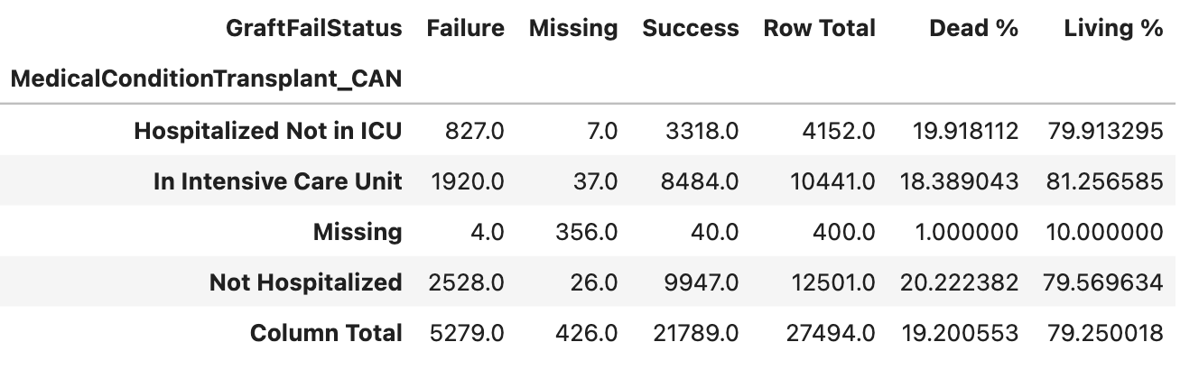
The largest group of patients not hospitalized at the time of transplant had a graft failure rate of 20.2%, with a success rate of 79.6%. This indicates that even clinically stable patients face notable graft risks, likely due to other underlying health factors. Hospitalized patients not in the ICU showed a slightly lower failure rate of 19.9%. Surprisingly, patients in the ICU had the lowest failure rate at 18.4%, with an 81.3% success rate. This counterintuitive outcome may reflect
Figure 10: Contingency Table for Medical Condition & Graft Status
intensified monitoring or expedited care with otherwise favorable transplant profiles. The "Missing" category (400 records) yielded unreliable results due to data gaps, with only 10% success and 356 missing outcomes. This suggests that these entries should be interpreted cautiously. In summary, while hospitalization status is a valuable health indicator, differences in graft failure rates across ICU, non-ICU, and non-hospitalized patients are modest. ICU patients showed slightly better outcomes, highlighting the need for deeper evaluations beyond hospitalization alone.

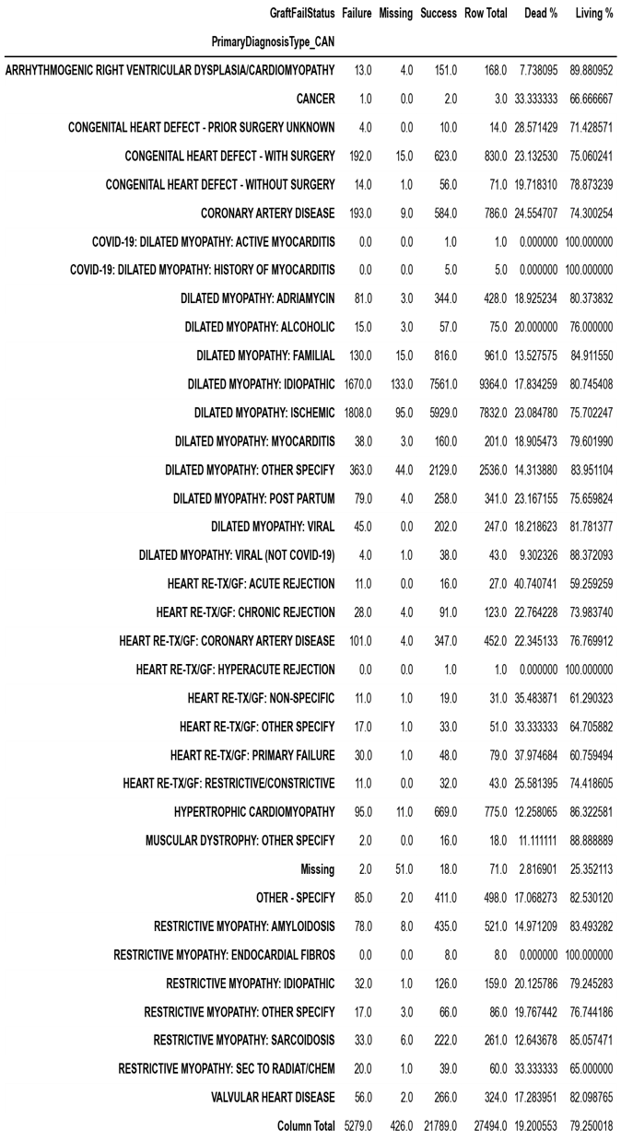
Figure 11: Contingency Table for Diagnosis Type & Graft Status

The Primary Diagnosis Type feature focuses on the relationship between underlying heart conditions and post-transplant success or failure. Each diagnosis is evaluated based on graft failure, success outcomes, along with calculated mortality ("Dead%") and survival ("Living%") rates. Dilated Myopathy: Idiopathic accounted for 9,364 cases (34% of the total cohort), making it the most prevalent diagnosis among transplant recipients. Despite its frequency, this group had a mortality rate of 17.8%, which is slightly below the overall average, with over 80% of patients surviving post-transplant. Similarly, Dilated Myopathy: Ischemic, the second most common, with 7,832 patients, showed a slightly higher mortality rate of 23.1%, suggesting a more complex post-transplant outcome potentially influenced by ischemic damage or coexisting cardiovascular conditions. Different underlying factors demonstrated above-average post-transplant survival rates.

For example, Hypertrophic Cardiomyopathy (775 cases) had a mortality rate of only 12.3%, and a high survival rate of 86.3%, suggesting a favorable transplant prognosis in these patients. Likewise, Dilated Myopathy: Familial (961 cases) and Restrictive Myopathy: Sarcoidosis (261 cases) showed promising outcomes, with 13.5% and 12.6% mortality rates, respectively. These results indicate that despite severe underlying conditions, patients may experience better-managed disease courses or present with more optimal recipient profiles at the time of transplant. On the other end of the spectrum, re-transplantation cases and graft failure-related diagnoses showed significantly poorer outcomes. Patients with Heart Re-TX/GF: Acute Rejection had the highest mortality rate of 40.7%, followed by Primary Graft Failure (37.9%) and Non-Specific Graft Failure (35.5%). These high mortality rates show that re-transplantation and transplant complications carry significant risks. This underscores the importance of better risk assessment before transplant, early intervention, and careful management after transplant for these high-risk patients. Although sample sizes were small, several rare heart conditions were associated with perfect or near-perfect survival rates. For instance, all one patient with COVID-19: Dilated Myopathy: Active Myocarditis, and all five patients with a history of myocarditis related to COVID-19, survived. Similarly, Restrictive Myopathy: Endocardial Fibrosis (8 cases) and Restrictive Myopathy: Secondary to Radiation/Chemotherapy (60 instances) also had survival rates of 100% and 65%, respectively. These numbers, while optimistic, must be interpreted cautiously due to the limited data points. In congenital conditions, patients with prior corrective surgery (830 cases) showed a mortality rate of 23.1%.
In comparison, those without prior surgery (71 cases) had a lower mortality rate of 19.7%, and patients with previous surgery status unknown (14 cases) had a mortality rate of 28.6%. These differences may reflect underlying differences in case complexity, surgical timing, or health system access. In summary, primary diagnosis is one of the key determinants in graft success, with idiopathic and ischemic dilated cardiomyopathy being the most common and generally successful categories. Re-transplantation, rare myopathies, and some congenital defects present a higher risk, emphasizing the need for tailored transplant strategies based on cardiac ailments.

For example, Hypertrophic Cardiomyopathy (775 cases) had a mortality rate of only 12.3%, and a high survival rate of 86.3%, suggesting a favorable transplant prognosis in these patients. Likewise, Dilated Myopathy: Familial (961 cases) and Restrictive Myopathy: Sarcoidosis (261 cases) showed promising outcomes, with 13.5% and 12.6% mortality rates, respectively. These results indicate that despite severe underlying conditions, patients may experience better-managed disease courses or present with more optimal recipient profiles at the time of transplant. On the other end of the spectrum, re-transplantation cases and graft failure-related diagnoses showed significantly poorer outcomes. Patients with Heart Re-TX/GF: Acute Rejection had the highest mortality rate of 40.7%, followed by Primary Graft Failure (37.9%) and Non-Specific Graft Failure (35.5%). These high mortality rates show that re-transplantation and transplant complications carry significant risks. This underscores the importance of better risk assessment before transplant, early intervention, and careful management after transplant for these high-risk patients. Although sample sizes were small, several rare heart conditions were associated with perfect or near-perfect survival rates. For instance, all one patient with COVID-19: Dilated Myopathy: Active Myocarditis, and all five patients with a history of myocarditis related to COVID-19, survived. Similarly, Restrictive Myopathy: Endocardial Fibrosis (8 cases) and Restrictive Myopathy: Secondary to Radiation/Chemotherapy (60 instances) also had survival rates of 100% and 65%, respectively. These numbers, while optimistic, must be interpreted cautiously due to the limited data points. In congenital conditions, patients with prior corrective surgery (830 cases) showed a mortality rate of 23.1%.
In comparison, those without prior surgery (71 cases) had a lower mortality rate of 19.7%, and patients with previous surgery status unknown (14 cases) had a mortality rate of 28.6%. These differences may reflect underlying differences in case complexity, surgical timing, or health system access. In summary, primary diagnosis is one of the key determinants in graft success, with idiopathic and ischemic dilated cardiomyopathy being the most common and generally successful categories. Re-transplantation, rare myopathies, and some congenital defects present a higher risk, emphasizing the need for tailored transplant strategies based on cardiac ailments.

Contingency Table for Diagnosis Type & Graft Status



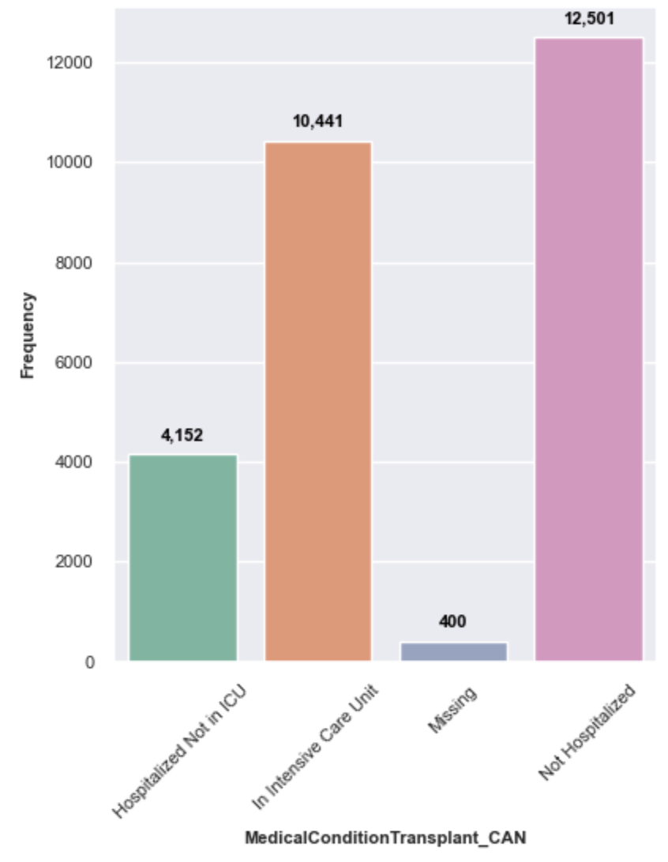

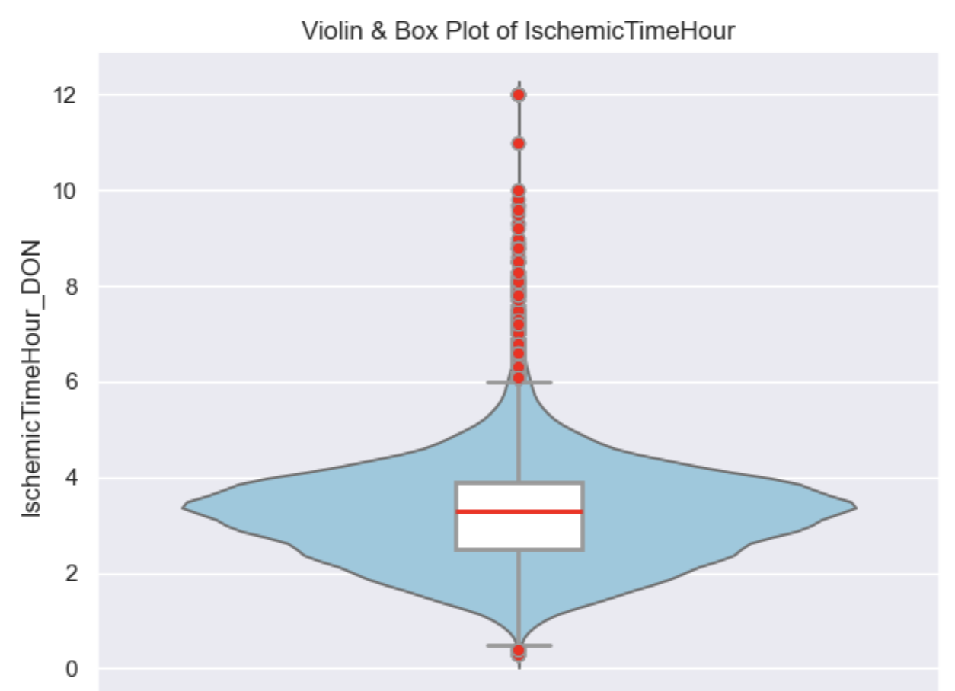

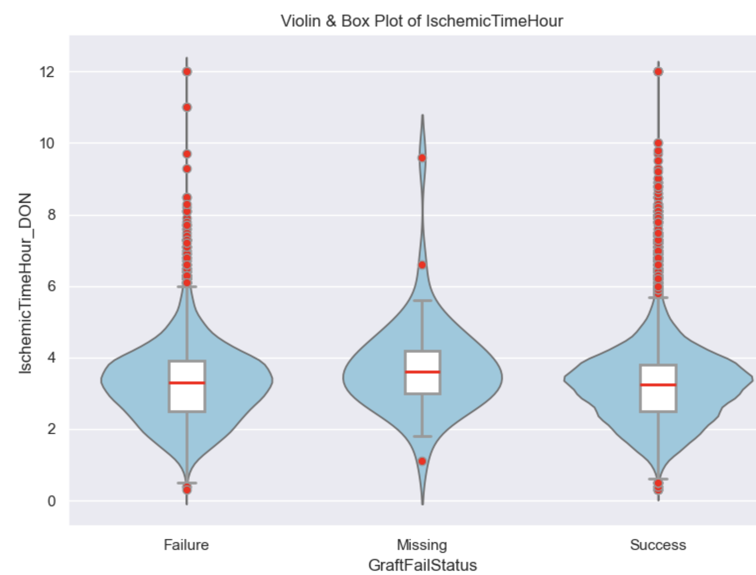

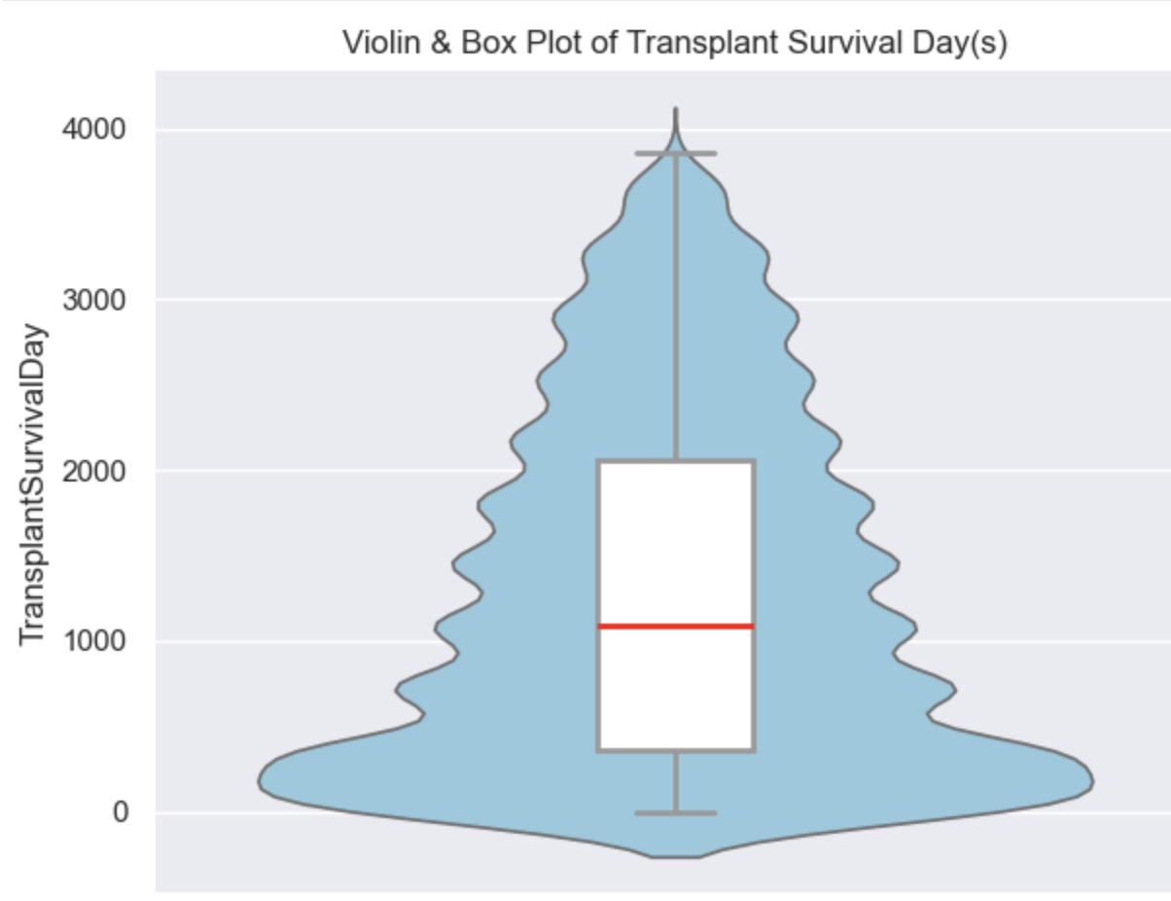

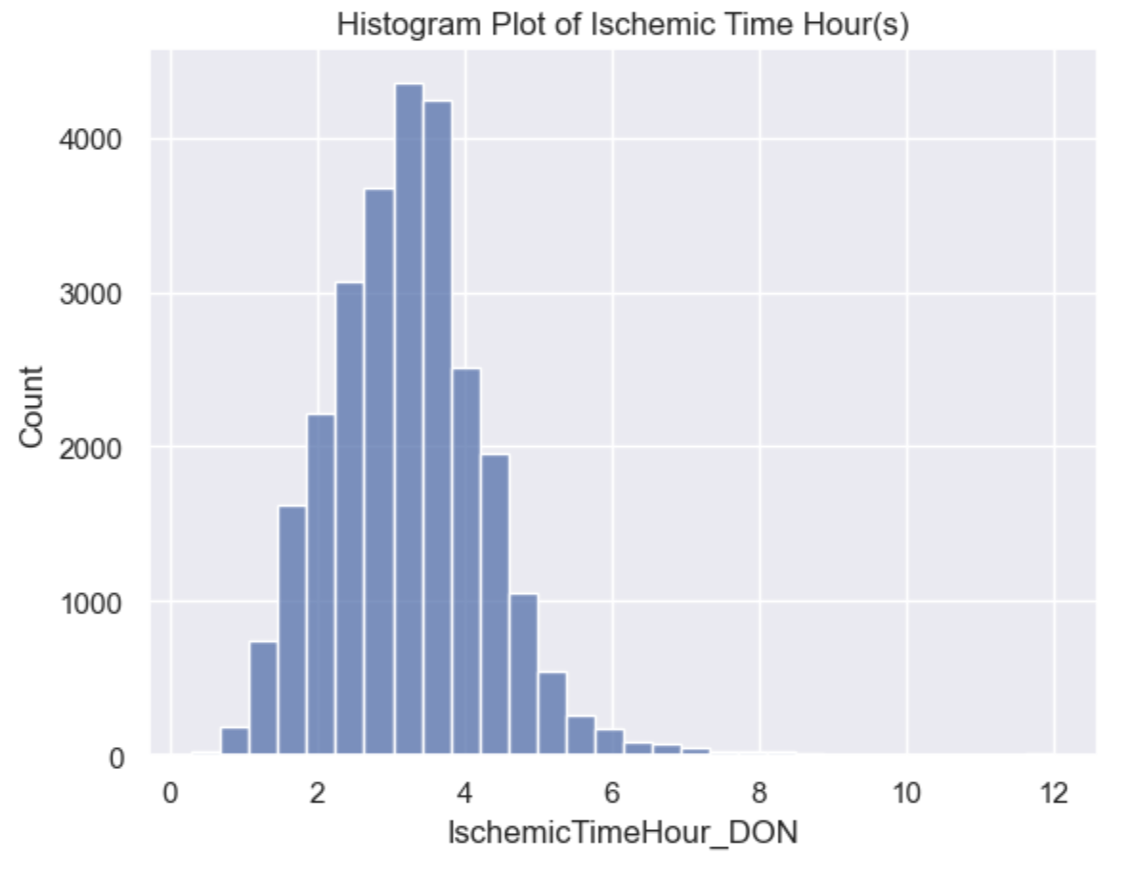
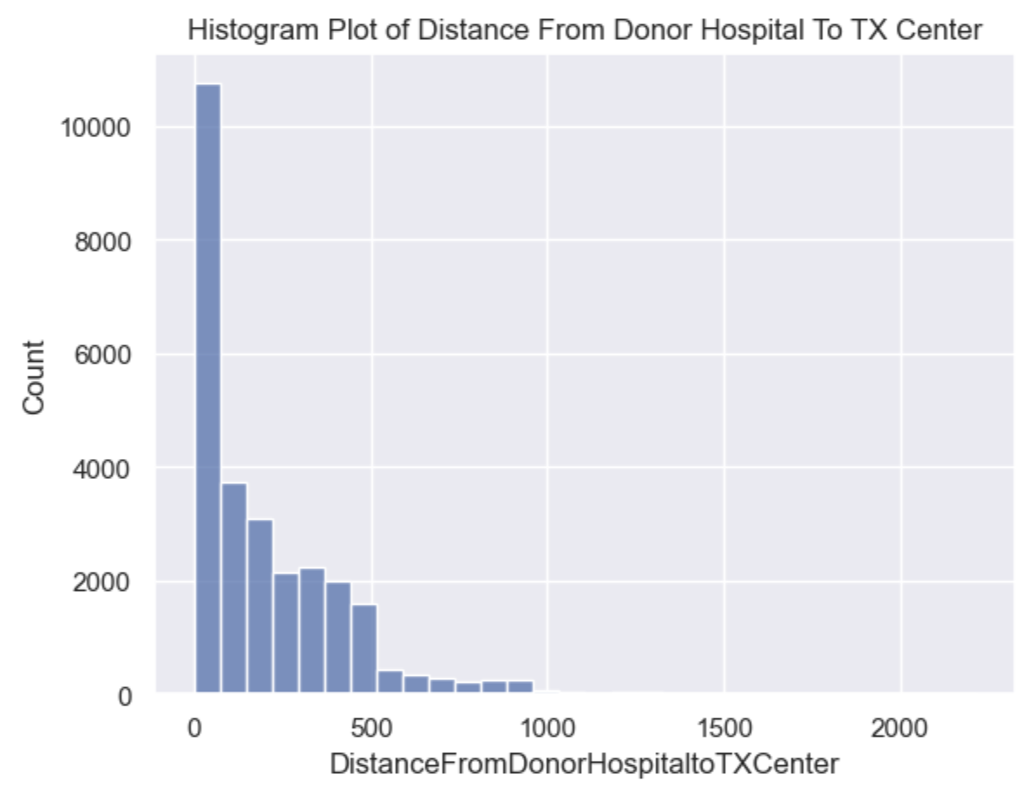

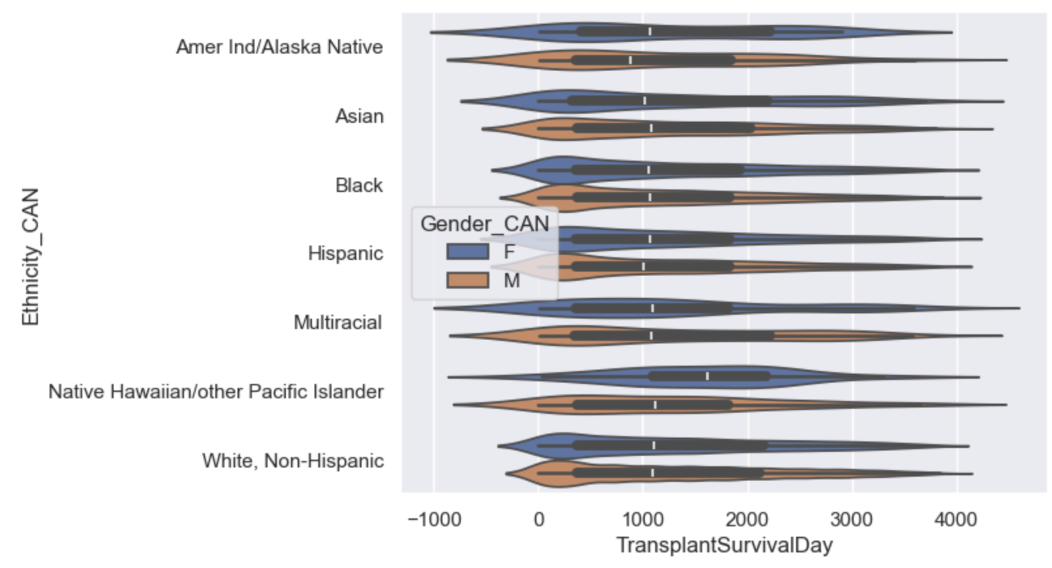

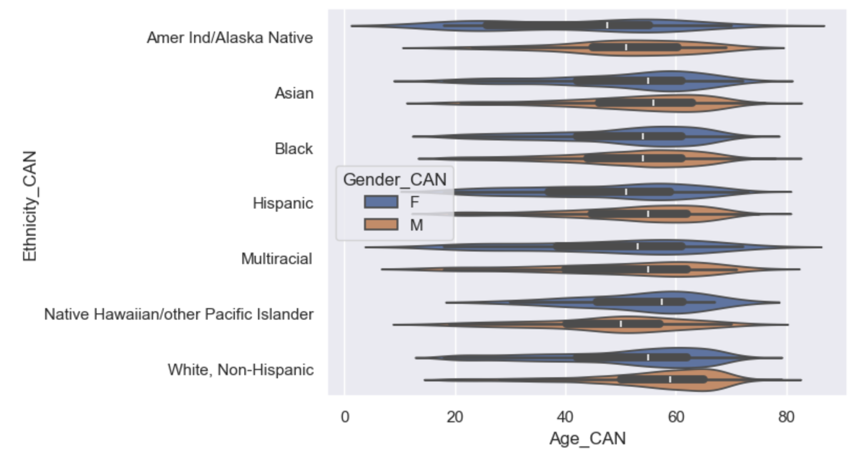
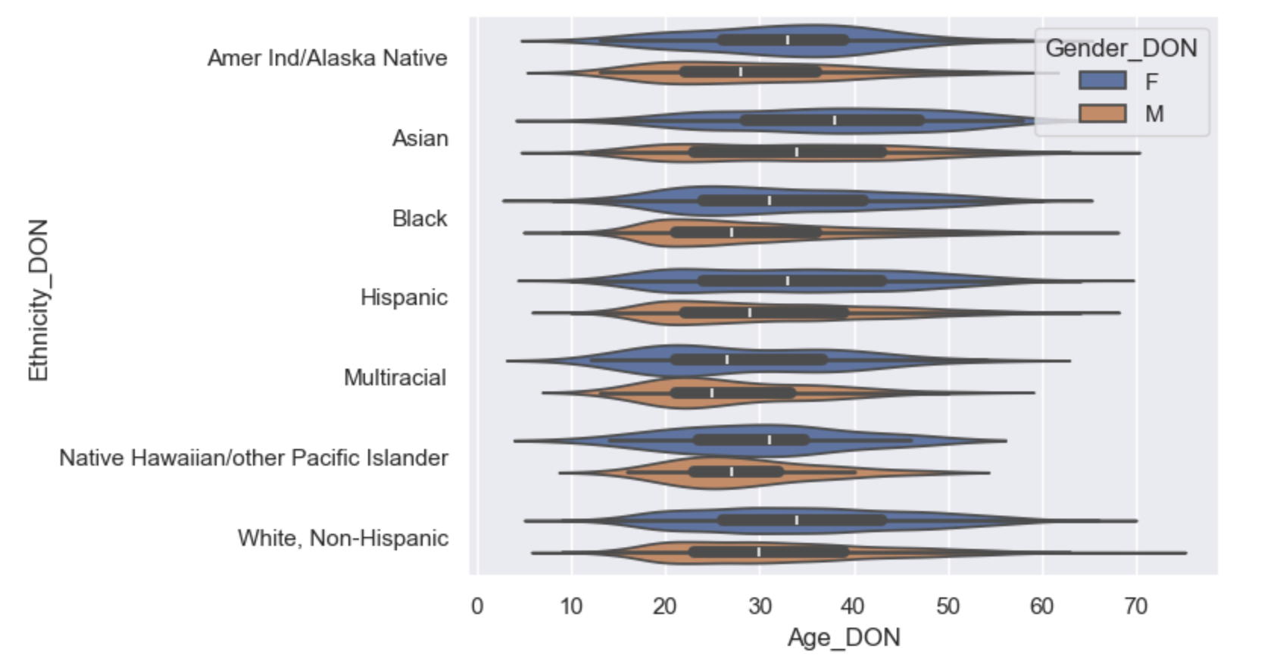
REFERENCES
[1] https://optn.transplant.hrsa.gov/news/first-heart-transplant-performed-35-years-ago/

