Cook-more Site Plan

Gabe Edstrom

WDD 130

Overview

Purpose
Explore how cooking is both fun and practical. Share some recipes and strategies that demonstrate how to implement those ideas into your schedule.

Audience
Approachable by anyone, but with an emphasis on fellow students.

Branding

Website Logo
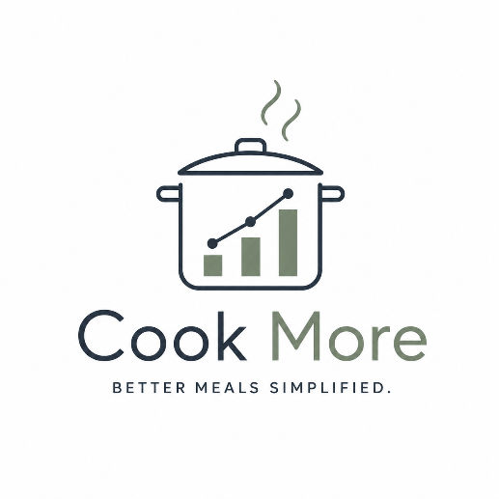

Style Guide

Color Palette
Primary | Secondary | Accent 1 | Accent 2
#F0F8FF | #2B3744 | #788571 | #788571

Typography

Heading Font: "Lora", serif

Paragraph Font: "Inter", sans-serif;

Navigation
Home Recipes Method

Content

Homepage:

I think the ability to make your own meal is a skill every adult human should possess. Cooking at home is more fun, costs less, and can be healthier and quicker, too. Let’s explore some of the principles that make cooking at home a breeze, and some of my favorite recipes that you can try for yourself.

Child 1 (method)

Header: How to do it
Subheader: Maximize variety while keeping costs low and effort equally low.

Grocery Shopping: I like to keep things modular so that I can get more variety out of fewer ingredients. Chicken is a staple that goes well with pasta, rice, potatoes, and pretty much any carb you can think of.

Prep and storage: Cook your proteins ahead of time. You can store them in the fridge for about five days, or in the freezer for about 3 months. I like using a large quart or gallon plastic bag for convenience, but a Tupperware works great if you don’t plan to freeze it. During the week, you can mix and match with different carbs and vegetables that typically cook quickly.

I love frozen vegetables because, with rare exception, they’re just as good (or better than) fresh. Usually I sauté them, but a quick trick if you have an Instant Pot and are doing rice is to throw your veggies on top and cook them together.

Sauce is your friend! You can make all kinds of different flavor profiles just by throwing a new sauce into rotatiom. Go crazy! No rules for this one.

Child 2 (recpies)

Header: My bread and butter recipes

Subheader: These are a couple recipes that I make frequently, and that lend well to my modular approach.

Broiler Chicken Thighs: Use any boneless skinless chicken thighs. If desired, you can trim the excess fat. Lightly coat them in olive oil or whatever you’ve got, then season with salt, black pepper, smoked paprika, and a lot of garlic powder. Place them on a cookie sheet and on the highest oven rack (or second highest if that’s only an inch or two away from the element) under a preheated broiler, about 450 degrees F/medium high. Cook for about 20 minutes. They should be suber golden brown with just a touch of char if you did it right. Start keeping an eye on it about 10-12 minutes in if it’s your first time to make sure everything is going well. It should look cooked on top and only lightly brown at that point.

Garlic Pasta: cook any pasta of your choice. While the water is coming to a boil, heat a stainless or non-stick on low heat. When the pasta has about 5 minutes left, through some freshly minced garlic and crushed red pepper into the oil to VERY lightly sizzle. Careful, garlic burns easy! Once cooked, use a slotted spoon to scoop the pasta into the oil. We want that startchy pasta water in there! You will likely need to add some more of that water once it’s all in there, then toss to combine on medium low heat—there should be a light simmer. Once that looks sauce-like but not quite thick, take off the heat to cool for a moment then add about a tablespoon of butter, tossing until combined off the heat. This should make it super glossy and thicken it a bit. This pasta is super versatile—put some cheese in there of your choosing, and serve with any protein or veggies you like.

Wireframes

Home
https://wireframe.cc/VvpbLU

Child

https://wireframe.cc/eselxK

