1. [Dhruv_Deveshkumar_Shah](https://lms.cerebrumhub.com/courses/course-v1:Cerebrum_Hub+CS0006+2023_T4/discussion/forum/users/60)

5 months ago

* + Vote for this post, there are currently 0 votes

I competed first introduction course but it shows that its not complete. I also summited my task. And its shows progress also around 94%.

* 1. Don't worry, that is probably because your mentor didn't mark your last assignment. Once it is done, your progress will be 100%.

posted 5 months ago by [Georgi_Ilikajev](https://lms.cerebrumhub.com/courses/course-v1:Cerebrum_Hub+CS0006+2023_T4/discussion/forum/users/70)

* 1. What Georgi said :) Mentors are reading your diaries right now.

posted 5 months ago by [margo.loor@cerebrumhub.com](https://lms.cerebrumhub.com/courses/course-v1:Cerebrum_Hub+CS0006+2023_T4/discussion/forum/users/25)

* 1. I have this situation. I have got my grades for diary and evrything is done yet progress is 94%.

posted 5 months ago by [Priti_Jadav](https://lms.cerebrumhub.com/courses/course-v1:Cerebrum_Hub+CS0006+2023_T4/discussion/forum/users/93)

* 1. Dhruv, I see from LMS, that your progress is now correctly indicating 100%. Priti, I will respond to you through the Support Center.

posted 5 months ago by [margo.loor@cerebrumhub.com](https://lms.cerebrumhub.com/courses/course-v1:Cerebrum_Hub+CS0006+2023_T4/discussion/forum/users/25)

Add a comment

Your question or idea (required)

1. [Maria_Vakmann](https://lms.cerebrumhub.com/courses/course-v1:Cerebrum_Hub+CS0006+2023_T4/discussion/forum/users/65)

5 months ago

* 1. Vote for this post, there are currently 3 votes

*"Prepare yourself for the first Sprint that will start with your team next week Monday."*

What exactly does this statement mean? Am I supposed to just surf around Jira and Confluence? And do we need to have watched all the videos at project 1 knowledge base? Or what exactly do I need to have prepared for Monday? :))

* 1. Please watch all the materials under the "Project Launch: Food Delivery Application" unit, it will help you to be better prepared for the Monday Sprint Planning call. Also check Confluence, ensure that you found the proper space with the project documentation.

posted 5 months ago by [andres](https://lms.cerebrumhub.com/courses/course-v1:Cerebrum_Hub+CS0006+2023_T4/discussion/forum/users/33)

Add a comment

Your question or idea (required)

1. [Mihhail_Karuzin](https://lms.cerebrumhub.com/courses/course-v1:Cerebrum_Hub+CS0006+2023_T4/discussion/forum/users/90)

5 months ago

* 1. Vote for this post, there are currently 0 votes

Good evening! My question is about the feedback form of last live workshop - where it possible to take for filling ?

* 1. Please find the feedback form here <https://forms.gle/NAZf6a1oLVjvzUFp8>

posted 5 months ago by [margo.loor@cerebrumhub.com](https://lms.cerebrumhub.com/courses/course-v1:Cerebrum_Hub+CS0006+2023_T4/discussion/forum/users/25)

Add a comment

Your question or idea (required)

1. [Andres_Raev](https://lms.cerebrumhub.com/courses/course-v1:Cerebrum_Hub+CS0006+2023_T4/discussion/forum/users/57)

5 months ago

* 1. Vote for this post, there are currently 2 votes

Hi,

Me and my team are having a Sprint #1 call on monday morning but before that, there is following info under calendar event "Learning session #4" : " - Study the sprint #1 assignments in the LMS (section "Sprint #1). Every assignment has a description, expected results and additional materials. - Organise a Sprint Planning meeting with your team. Get familiar with each other and discuss key Sprint planning questions. Before you have a Sprint Planning we recommend you to check this material."

When will we have access to Sprint #1 materials in LMS?

Thank you in advance!

* 1. Same question from me!

posted 5 months ago by [Denis_Lahe](https://lms.cerebrumhub.com/courses/course-v1:Cerebrum_Hub+CS0006+2023_T4/discussion/forum/users/59)

* 1. Same here. Thank you.

posted 5 months ago by [Aleksandra_Nikonovich](https://lms.cerebrumhub.com/courses/course-v1:Cerebrum_Hub+CS0006+2023_T4/discussion/forum/users/124)

* 1. Sprint #1 materials were released on midnight to Monday (UTC) and the relevant units should now be visible and available for you.

posted 5 months ago by [margo.loor@cerebrumhub.com](https://lms.cerebrumhub.com/courses/course-v1:Cerebrum_Hub+CS0006+2023_T4/discussion/forum/users/25)

* 1. Very nice analytical feedback to your weekly team meetings, Andres!

posted 5 months ago by [margo.loor@cerebrumhub.com](https://lms.cerebrumhub.com/courses/course-v1:Cerebrum_Hub+CS0006+2023_T4/discussion/forum/users/25)

Add a comment

Your question or idea (required)

1. [Andrejs_Vorobjovs](https://lms.cerebrumhub.com/courses/course-v1:Cerebrum_Hub+CS0006+2023_T4/discussion/forum/users/133)

5 months ago

* 1. Vote for this post, there are currently 0 votes
  3. How much important are the "Leaderboard" progress points?
  4. I have completed and done everything I can, but I'm still not in the 1st place :D Why?
  5. That "Leaderboard", which you were looking at, is not important at all. It is automatically created by the LMS and shows points based on activity.

The real "Leaderboard" is the one you get from the top horizontal menu of this page. There's nothing there yet. It will be based on your sprint results. We will be releasing the first leaderboard, after Sprint #1. The first individual assignment gave too little points to make any difference between Tribe members. 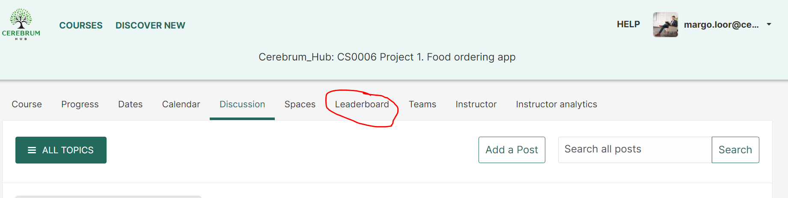



posted 5 months ago by [margo.loor@cerebrumhub.com](https://lms.cerebrumhub.com/courses/course-v1:Cerebrum_Hub+CS0006+2023_T4/discussion/forum/users/25)

Add a comment

Your question or idea (required)

1. [Ilja_Prokopjev](https://lms.cerebrumhub.com/courses/course-v1:Cerebrum_Hub+CS0006+2023_T4/discussion/forum/users/71)

5 months ago

* 1. Vote for this post, there are currently 0 votes

Hi, we have link in calendar : Organise a Sprint Planning meeting with your team. Get familiar with each other and discuss key Sprint planning questions. Before you have a Sprint Planning we recommend you to check **this material.** But then I follow link, I have following rude message from Atlassian: **You’ve stumbled on a restricted space There’s nothing for you to see here, so let’s get you back to where you came from. Learn more about space permissions**. How can I check material?

* 1. Hi Ilja, The link takes you to Project 1 Knowledge Base in Confluence. You need to be logged into Confluence to be able to view the material, because it is intended for our Tribe members only, it is not globally public. If you are logged into Confluence, but still are locked out of Knowledge Base, then something has gone wrong with giving you the correct level of rights. In this case, please let us know here again and our technical team will solve the issue for you ASAP.

posted 5 months ago by [margo.loor@cerebrumhub.com](https://lms.cerebrumhub.com/courses/course-v1:Cerebrum_Hub+CS0006+2023_T4/discussion/forum/users/25)

* 1. Our tech team checked and verified, that you are an active Confluence user and you have the correct rights level, so it should just be a matter of logging into Confluence to view the Knowledge Base.

posted 5 months ago by [margo.loor@cerebrumhub.com](https://lms.cerebrumhub.com/courses/course-v1:Cerebrum_Hub+CS0006+2023_T4/discussion/forum/users/25)

Add a comment

Your question or idea (required)

1. [Ilona_Soomann](https://lms.cerebrumhub.com/courses/course-v1:Cerebrum_Hub+CS0006+2023_T4/discussion/forum/users/72)

5 months ago

* 1. Vote for this post, there are currently 7 votes

Hello! Under assignments in Project 1, there is a sentence: Do not forget to mark your team meetings as completed under the "Sprint meetings" assignment. Where is this assignment exactly?

Thank you in advance!

* 1. same question

posted 5 months ago by [Anatoli_Sergejev](https://lms.cerebrumhub.com/courses/course-v1:Cerebrum_Hub+CS0006+2023_T4/discussion/forum/users/56)

* 1. Same for me.

posted 5 months ago by [Timofejs_Popovs](https://lms.cerebrumhub.com/courses/course-v1:Cerebrum_Hub+CS0006+2023_T4/discussion/forum/users/132)

* 1. Same

posted 5 months ago by [Allan_Särg](https://lms.cerebrumhub.com/courses/course-v1:Cerebrum_Hub+CS0006+2023_T4/discussion/forum/users/54)

* 1. Same

posted 5 months ago by [Aleksandra_Nikonovich](https://lms.cerebrumhub.com/courses/course-v1:Cerebrum_Hub+CS0006+2023_T4/discussion/forum/users/124)

* 1. Hello! This assignment will be available for you since Saturday, as a separate assignment under Sprint 1 unit. It needs to be submmited by every team member.

posted 5 months ago by [andres](https://lms.cerebrumhub.com/courses/course-v1:Cerebrum_Hub+CS0006+2023_T4/discussion/forum/users/33)

* 1. thank you Andres!

posted 5 months ago by [Anastassia_Vassilevskaja](https://lms.cerebrumhub.com/courses/course-v1:Cerebrum_Hub+CS0006+2023_T4/discussion/forum/users/55)

* 1. Is it Since Saturday(28.01) or from Saturday( as in 04.02)?

posted 5 months ago by [Madli-Mai_Norma](https://lms.cerebrumhub.com/courses/course-v1:Cerebrum_Hub+CS0006+2023_T4/discussion/forum/users/87)

* 1. It will be published and available for you from 04.02.

posted 5 months ago by [andres](https://lms.cerebrumhub.com/courses/course-v1:Cerebrum_Hub+CS0006+2023_T4/discussion/forum/users/33)

* 1. It is now available, you can go and submit the survey about your Team meetings this week.

posted 5 months ago by [margo.loor@cerebrumhub.com](https://lms.cerebrumhub.com/courses/course-v1:Cerebrum_Hub+CS0006+2023_T4/discussion/forum/users/25)

Add a comment

Your question or idea (required)

1. [Mihkel_Hõbemägi](https://lms.cerebrumhub.com/courses/course-v1:Cerebrum_Hub+CS0006+2023_T4/discussion/forum/users/91)

5 months ago

* 1. Vote for this post, there are currently 0 votes

Do UC1, UC2 and UC3 directly correspond to the main outcomes of the checklist assignment?

Therefore:

* 1. Menu browsing and Product preview = UC1
  2. Search and Filtering functionality = UC2
  3. Ordering functionality = UC3
  4. The Use cases are currently organised in the following way:
     + UC1. Menu browsing with search
     + UC2. Previewing products
     + UC3. Ordering products

So the mapping with the outcomes is the following:

* + - Menu browsing and Product preview = covered by UC 1 and UC2
    - Search and Filtering functionality = covered by UC1
    - Ordering functionality = covered by UC3

Hope it is helpful.



posted 5 months ago by [andres](https://lms.cerebrumhub.com/courses/course-v1:Cerebrum_Hub+CS0006+2023_T4/discussion/forum/users/33)

Add a comment

Your question or idea (required)

1. [Anu_Koitmets](https://lms.cerebrumhub.com/courses/course-v1:Cerebrum_Hub+CS0006+2023_T4/discussion/forum/users/58)

5 months ago

* 1. Vote for this post, there are currently 0 votes

There is "table number" in submitting the order (UC3). Is it optional? Because, as I understand, a new customer can use it, too? And what happens if the customer doesn´t remember or know the table number?

* 1. The "Table number" field must be mandatory, because without that staff will not be able to know where to deliver the order.

Every table in the restaurant will have a number, that customer will be able to see and enter, when he or she is making an order.



posted 5 months ago by [andres](https://lms.cerebrumhub.com/courses/course-v1:Cerebrum_Hub+CS0006+2023_T4/discussion/forum/users/33)

* 1. So, the pick up option is not available then? Ordering food from home, picking your food up at the restaurant. Just curious :)

posted 5 months ago by [Veronika_Rebane](https://lms.cerebrumhub.com/courses/course-v1:Cerebrum_Hub+CS0006+2023_T4/discussion/forum/users/103)

* 1. Yes, this app is built only for inside ordering and is intended to replace the menu. No "Take away" option for now :)

posted 5 months ago by [andres](https://lms.cerebrumhub.com/courses/course-v1:Cerebrum_Hub+CS0006+2023_T4/discussion/forum/users/33)

Add a comment

Your question or idea (required)

1. [Ilja_Prokopjev](https://lms.cerebrumhub.com/courses/course-v1:Cerebrum_Hub+CS0006+2023_T4/discussion/forum/users/71)

5 months ago

* 1. Vote for this post, there are currently 0 votes

Question, we have alcohol in the list, should it be mentioned with age restriction? Clearly, it can not be served to minors. But account can be done by anyone. Should it be part of testing? It can part of any test. Thanks in advance

* 1. Because this functionality is not described in the use case the "age restriction" is not part of testing. But it is great that you noticed that and we will consider it as future improvement possibility.

posted 5 months ago by [andres](https://lms.cerebrumhub.com/courses/course-v1:Cerebrum_Hub+CS0006+2023_T4/discussion/forum/users/33)

Add a comment

Your question or idea (required)

1. [Signe_Salumets](https://lms.cerebrumhub.com/courses/course-v1:Cerebrum_Hub+CS0006+2023_T4/discussion/forum/users/115)

5 months ago

* 1. Vote for this post, there are currently 0 votes

In materials about "How to creat a good testing check list.... " is advise to 'Open your application and try to follow the steps and familiarise yourself with the functionality. Try out different combinations, observe how the system behaves.'

Where can I find the app? Or the app is not available for us yet?

<https://cerebrumhubstudents.atlassian.net/wiki/spaces/P1KBQ/pages/108167181/How+to+create+a+good+testing+checklist+based+on+a+use+case>

* 1. You can find the link to the application under the Assignment 3: Perform Browser Testing. 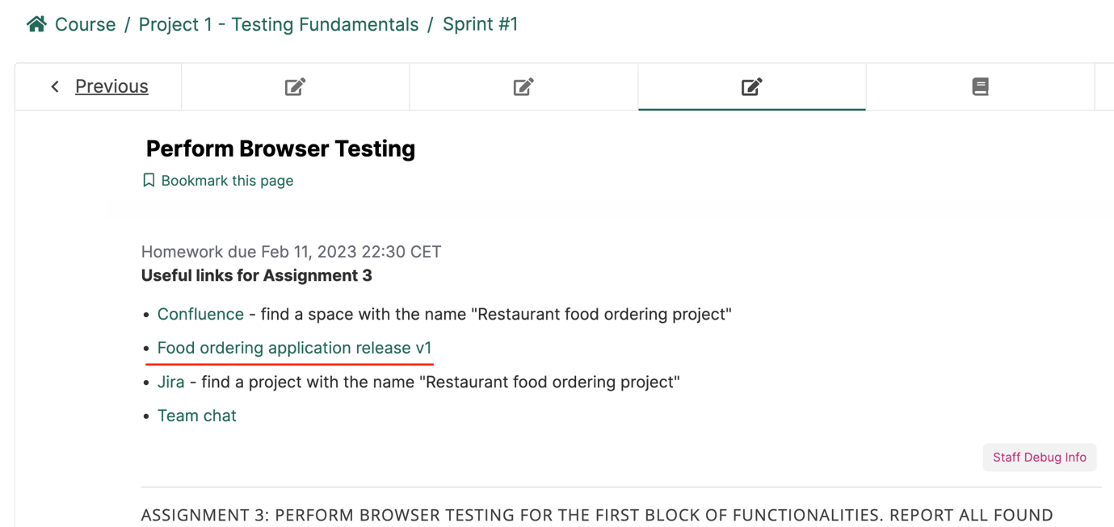

posted 5 months ago by [andres](https://lms.cerebrumhub.com/courses/course-v1:Cerebrum_Hub+CS0006+2023_T4/discussion/forum/users/33)

* 1. Thank you.

posted 5 months ago by [Signe_Salumets](https://lms.cerebrumhub.com/courses/course-v1:Cerebrum_Hub+CS0006+2023_T4/discussion/forum/users/115)

Add a comment

Your question or idea (required)

1. [Andres_Raev](https://lms.cerebrumhub.com/courses/course-v1:Cerebrum_Hub+CS0006+2023_T4/discussion/forum/users/57)

5 months ago

* 1. Vote for this post, there are currently 0 votes

In LMS - Sprint #1 - Perform Browser Testing there is written that "All discovered bugs and issues must be reported to the bug tracking system (Jira) in accordance with the guidelines, that you will find in the knowledge base."

My question: Is it also recommended to start doing [Sprint testing report](https://cerebrumhubstudents.atlassian.net/wiki/spaces/P1KBQ/pages/106430564/What+is+a+Sprint+testing+report) and do we have to submit this at the end of Sprint #1 or this is for future Use cases and at the moment this isn't necessary?

Thanks for clarification!

* 1. The Sprint testing report is not necessary in the Sprint #1. We will do it in the Sprint #2, and you will have a separate assignment about it there.

posted 5 months ago by [andres](https://lms.cerebrumhub.com/courses/course-v1:Cerebrum_Hub+CS0006+2023_T4/discussion/forum/users/33)

Add a comment

Your question or idea (required)

1. [Svetlana_Obrezkova](https://lms.cerebrumhub.com/courses/course-v1:Cerebrum_Hub+CS0006+2023_T4/discussion/forum/users/99)

5 months ago

* 1. Vote for this post, there are currently 3 votes

In the project overview is written, that UK and US state governments require the restaurant to hold a record of customer details. The data should be stored to comply with GDPR, but Google says that this regulation applies only to the EU and EEA. UC.3 says, „The user must see the total price of all added products to the order (in euros).” I like mysteries and wonder where is Bella’s pizzeria located.

* 1. Hello Svetlana

Thanks for noticing, I have fixed the project overview and removed UK and US references from there.



posted 5 months ago by [andres](https://lms.cerebrumhub.com/courses/course-v1:Cerebrum_Hub+CS0006+2023_T4/discussion/forum/users/33)

* 1. Thank you for your answer, Andres!

posted 5 months ago by [Svetlana_Obrezkova](https://lms.cerebrumhub.com/courses/course-v1:Cerebrum_Hub+CS0006+2023_T4/discussion/forum/users/99)

Add a comment

Your question or idea (required)

1. [Anatoli_Sergejev](https://lms.cerebrumhub.com/courses/course-v1:Cerebrum_Hub+CS0006+2023_T4/discussion/forum/users/56)

5 months ago

* 1. Vote for this post, there are currently 0 votes

Question about filtering in the same bin (Food ordering app). When the user filters several items should the algorithm return logical "or" or logical "and". For example: I am filtering in the bin "Highlight" - "vegan" and "spicy", so I prefer that I will have dish, which is spicy and vegan the same time. But the system thinks that I want to see either spicy or vegan and returns all vegan and spicy options. Is it a bug or a feature?

* 1. It is a bug. The common logic for the filtering is logical "and", so the returned result must match both entered conditions.

posted 5 months ago by [andres](https://lms.cerebrumhub.com/courses/course-v1:Cerebrum_Hub+CS0006+2023_T4/discussion/forum/users/33)

* 1. thank you!

posted 5 months ago by [Anatoli_Sergejev](https://lms.cerebrumhub.com/courses/course-v1:Cerebrum_Hub+CS0006+2023_T4/discussion/forum/users/56)

Add a comment

Your question or idea (required)

1. [Anatoli_Sergejev](https://lms.cerebrumhub.com/courses/course-v1:Cerebrum_Hub+CS0006+2023_T4/discussion/forum/users/56)

5 months ago

* 1. Vote for this post, there are currently 0 votes

If the same bug is in the all browsers, should we make a new ticket for everyone, or we can mark all browsers in only one ticket?

* 1. One ticket, just mention that you were able to reproduce the same bug in different browsers.

posted 5 months ago by [andres](https://lms.cerebrumhub.com/courses/course-v1:Cerebrum_Hub+CS0006+2023_T4/discussion/forum/users/33)

* 1. In this case, do we just edit one of the issues to have multiple browsers stated and change the title to eg. "Menu - incorrect picture for salad on multiple browsers" ?

posted 5 months ago by [Martin_Saar](https://lms.cerebrumhub.com/courses/course-v1:Cerebrum_Hub+CS0006+2023_T4/discussion/forum/users/88)

* 1. Also, in case of having the same bug on multiple products, can we lump them all up into one Issue ticket or make separate ones ?

posted 5 months ago by [Martin_Saar](https://lms.cerebrumhub.com/courses/course-v1:Cerebrum_Hub+CS0006+2023_T4/discussion/forum/users/88)

* + 1. In this case, do we just edit one of the issues to have multiple browsers stated and change the title to eg. "Menu - incorrect picture for salad on multiple browsers" ?

**Yes, just mention in the description of the bug all the browsers, where you were able to reproduce this bug.**

2.Also, in case of having the same bug on multiple products, can we lump them all up into one Issue ticket or make separate ones ?

**Yes, you can do that, it makes sense.**



posted 5 months ago by [andres](https://lms.cerebrumhub.com/courses/course-v1:Cerebrum_Hub+CS0006+2023_T4/discussion/forum/users/33)

Add a comment

Your question or idea (required)

1. [Veronika_Rebane](https://lms.cerebrumhub.com/courses/course-v1:Cerebrum_Hub+CS0006+2023_T4/discussion/forum/users/103)

5 months ago

* 1. Vote for this post, there are currently 0 votes

Question about checklist. We write checklist based on user case right, but should we also add some extra steps to the cheklist when we discover them while testing bugs. I will provide an example for clearification: Preview order - delete products - notice appears - confirmation if sure we want to delete. So, my question is: should we add for example "Delete confirmation displayed" to the Ordering checklist as well or not nessecery?

* 1. Yes, you can add those steps to your checklists.

posted 5 months ago by [andres](https://lms.cerebrumhub.com/courses/course-v1:Cerebrum_Hub+CS0006+2023_T4/discussion/forum/users/33)

Add a comment

Your question or idea (required)

1. [Veronika_Rebane](https://lms.cerebrumhub.com/courses/course-v1:Cerebrum_Hub+CS0006+2023_T4/discussion/forum/users/103)

5 months ago

* 1. Vote for this post, there are currently 0 votes

One more question that needs clearification. It has been said on a LIVE call that we should combine one topic under one bug (create one bug for one issue). This is clear as a sentence. But if to think about typos/misspelled words then these are to be found on many pages. So, the question is, should we create one issue reporting typos on the whole site (including the menu page, preview pages, etc.) or create separate issues for the menu page, preview pages in general, or every preview page individually?

* 1. The point on the LIVE workshop was, that if you repeatedly see very similar mistake several times (like typos and misspelled words) then it makes since not to create a separate ticket for every typo.

The way how you combine them together can be different. You can create a separate ticket for every page or for example for every use case. It is important, that you clearly state that in the header of the bug - For example: "Typos on Menu page. " or "Typos in UC1 functionalities".



posted 5 months ago by [andres](https://lms.cerebrumhub.com/courses/course-v1:Cerebrum_Hub+CS0006+2023_T4/discussion/forum/users/33)

* 1. Thanks! I got what I needed :)

posted 5 months ago by [Veronika_Rebane](https://lms.cerebrumhub.com/courses/course-v1:Cerebrum_Hub+CS0006+2023_T4/discussion/forum/users/103)

Add a comment

Your question or idea (required)

1. [Timofejs_Popovs](https://lms.cerebrumhub.com/courses/course-v1:Cerebrum_Hub+CS0006+2023_T4/discussion/forum/users/132)

4 months ago

* 1. Vote for this post, there are currently 0 votes

I have two questions: 1. Who is supposed to fill page "Team X 4. Retrospective", team lead or all team members have to contribute? 2. [Here](https://cerebrumhubstudents.atlassian.net/wiki/spaces/P1KBQ/pages/113606673/How+to+format+testing+checklists+in+Confluence) it says that we are supposed to add test results to the checklist(watch attached picture) but what for is the "Team X 2. Final report" page? A screenshot of a computer

* 1. Hello Timofejs

The page "Team X 4. Retrospective" must be filled by all team members. But it is not your assignment right now. You will be using this page on next week, after Sprint 1 ends.

The page "Team X 2. Final report" is intended for the Sprint #2, so you should not use it either. The recommendations that you highlighted can be used for Final Report and also for the page with Testing Checklists, if you decide to add there your intermediate testing results. You can see the example formatting in the end of this page (table) - <https://cerebrumhubstudents.atlassian.net/wiki/spaces/P1KBQ/pages/113606673/How+to+format+testing+checklists+in+Confluence>



posted 4 months ago by [andres](https://lms.cerebrumhub.com/courses/course-v1:Cerebrum_Hub+CS0006+2023_T4/discussion/forum/users/33)

Add a comment

Your question or idea (required)

1. [Andrejs_Vorobjovs](https://lms.cerebrumhub.com/courses/course-v1:Cerebrum_Hub+CS0006+2023_T4/discussion/forum/users/133)

4 months ago

* 1. Vote for this post, there are currently 0 votes

Hi, is QA engineers position slowly going to extinct and the one wich is going to replace it is SDET (Software Development Engineer in Test)? So we must be much more advanced for tomorrow job market than we are learning now? Ofcourse we must start somewhere, but do we need already watching higher to learn, than just QA?

* 1. Hello Andrejs

You are right, that the demand for the classic Manual Software Tester position has a negative trend. That's why this course has 4 month of automation testing module, where you will learn about how to become a software development engineer focusing on automating software testing.

Our goal here is to give you all necessary skills and knowledge so you will be a demanded specialist on the market today and also give you a great basis in case you decide later to become software developer, or system analyst and so on.



posted 4 months ago by [andres](https://lms.cerebrumhub.com/courses/course-v1:Cerebrum_Hub+CS0006+2023_T4/discussion/forum/users/33)

Add a comment

Your question or idea (required)

1. [Aleksandr_Kravtšuk](https://lms.cerebrumhub.com/courses/course-v1:Cerebrum_Hub+CS0006+2023_T4/discussion/forum/users/52)

4 months ago

* 1. Vote for this post, there are currently 0 votes

I would like to get a clarification how should the final product look like? If I understand correctly if we find the same bug using different operation systems and different devices, then we should make a combined report about that bug where it was found (for example RFDS - 0000)? Or how exactly should it be reported? Please provide an example. There can be multiple approaches for that and we would like to know what expectations do you have?

* 1. I will assume, that the final product you are talking about now is a bug - if not, feel free to ask additional questions. First project is quite simple and it contains simple bugs, typos, pictures missing, etc. Those defects will most probably look the same in different browsers, so it will be enough to put your current browser and operating system info into the bug. One is enough. You can find some examples of nicely reported bugs here <https://cerebrumhubstudents.atlassian.net/wiki/spaces/P1KBQ/pages/108331023/Examples+of+properly+reported+bugs>

posted 4 months ago by [dv_jana](https://lms.cerebrumhub.com/courses/course-v1:Cerebrum_Hub+CS0006+2023_T4/discussion/forum/users/48)

Add a comment

Your question or idea (required)

1. [Anu_Koitmets](https://lms.cerebrumhub.com/courses/course-v1:Cerebrum_Hub+CS0006+2023_T4/discussion/forum/users/58)

4 months ago

* 1. Vote for this post, there are currently 0 votes

I can´t paste or upload screenshot in Jira (creating an issue) 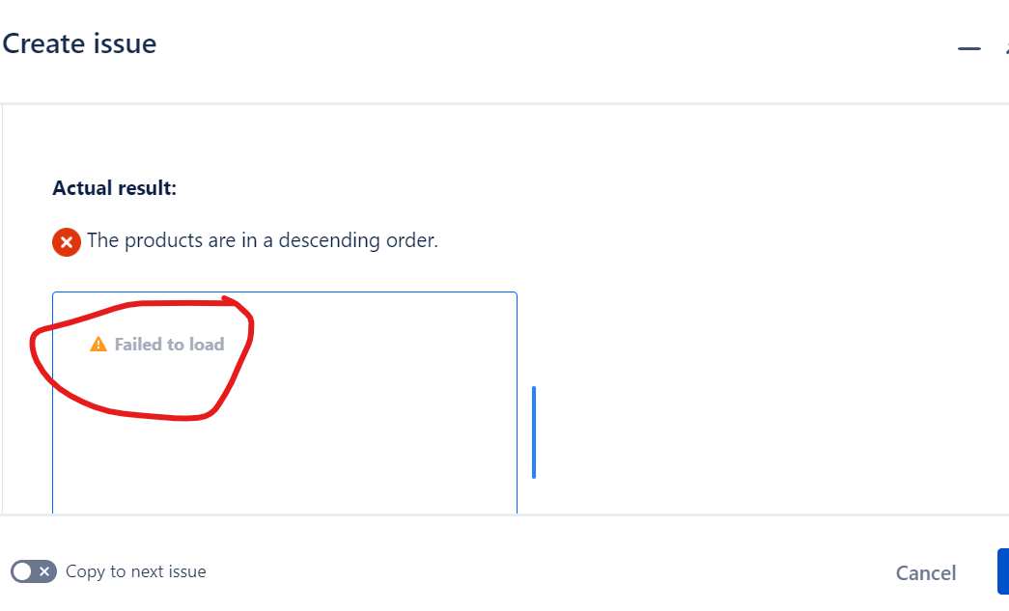

* 1. Hello! I've checked the RFDS project and tried to add an image to my existing bug - everything worked smoothly. I would suggest you to pretend, that you are reporting a bug, but in a simplified way. In order to help you, I need the following information: 1. (title + description) Which ticket are you working on, link to jira or id (like RFDS-1 would be enough) 2. (steps) How are you adding the image and in which section (bug body or the images section, drag and drop or with add image button). PS: you might try to refresh the page or try to perform the same operation in other browser, just in case.

posted 4 months ago by [dv_jana](https://lms.cerebrumhub.com/courses/course-v1:Cerebrum_Hub+CS0006+2023_T4/discussion/forum/users/48)

* 1. Anu, I had the same problem. I closed the "Create issue" window and opened a new one. I noticed I had that problem if I'm making copies and not opening new windows for reporting a bug. I hope you understand what I mean :)

posted 4 months ago by [Ilona_Soomann](https://lms.cerebrumhub.com/courses/course-v1:Cerebrum_Hub+CS0006+2023_T4/discussion/forum/users/72)

* 1. Thanks. The problem is solved for me now. I don´t know how :D

posted 4 months ago by [Anu_Koitmets](https://lms.cerebrumhub.com/courses/course-v1:Cerebrum_Hub+CS0006+2023_T4/discussion/forum/users/58)

Add a comment

Your question or idea (required)

1. [Timofejs_Popovs](https://lms.cerebrumhub.com/courses/course-v1:Cerebrum_Hub+CS0006+2023_T4/discussion/forum/users/132)

4 months ago

* 1. Vote for this post, there are currently 0 votes
  3. What is the right portion/serve for Garlic bread?
  4. Does every product must have some information in “allergy information” section or only this section existence by itself is mandatory?
  5. Should Pizza have Eggs as allergen, cause dough is probably made using eggs?

Second checkbox of the “Adding products to the order” functionality of our checklist is next:

”*Each product must have a "+" button for adding product to the order in it’s own preview.*”

And the 5th is next:

“*The user must not be able to order products that are out of stock.*”

So in fact there is no such a button for Pasta Carbonara. The question is - Should Pasta Carbonara have this button and it simply must be not clickable or is the missed button something intended cause this product is marked as “Out Of Stock”?

* 1. Same question about allergy information.

posted 4 months ago by [Ilona_Soomann](https://lms.cerebrumhub.com/courses/course-v1:Cerebrum_Hub+CS0006+2023_T4/discussion/forum/users/72)

* 1. Hello Timofejs,
     1. The portion size for the garlic bread is correct, leave it as is.
     2. No, allergy information is actual only for certain products, it's not mandatory for ALL the products.
     3. Our customer did not list eggs as a an allergen for pizza, so here is no need to report it.
     4. Pasta Carbonara is out of stock, and we do not display the '+' icon.

posted 4 months ago by [dv_jana](https://lms.cerebrumhub.com/courses/course-v1:Cerebrum_Hub+CS0006+2023_T4/discussion/forum/users/48)

Add a comment

Your question or idea (required)

1. [Andrejs_Vorobjovs](https://lms.cerebrumhub.com/courses/course-v1:Cerebrum_Hub+CS0006+2023_T4/discussion/forum/users/133)

4 months ago

* 1. Vote for this post, there are currently 0 votes

Hi, For some reasons I wasn't able to participate on yesterday's live Tribe 4 meating. I watched the whole meeting on YouTube today, and my question is, will that affect my grade?

* 1. Hello Andrejs, no this will not affect your grade.

posted 4 months ago by [dv_jana](https://lms.cerebrumhub.com/courses/course-v1:Cerebrum_Hub+CS0006+2023_T4/discussion/forum/users/48)

Add a comment

Your question or idea (required)

1. [Erlend_Anderson](https://lms.cerebrumhub.com/courses/course-v1:Cerebrum_Hub+CS0006+2023_T4/discussion/forum/users/125)

4 months ago

* 1. Vote for this post, there are currently 0 votes

Hello!

Is it okay to suggest adding "Tax" field to the Order Preview or that's something we should not think of?

* 1. Hello Erlend, Tax is not mandatory for the Order Preview, so there is no need to report a bug or an improvement.

posted 4 months ago by [dv_jana](https://lms.cerebrumhub.com/courses/course-v1:Cerebrum_Hub+CS0006+2023_T4/discussion/forum/users/48)

* 1. But it's a good idea, though, Erlend! Nice suggestion.

posted 4 months ago by [margo.loor@cerebrumhub.com](https://lms.cerebrumhub.com/courses/course-v1:Cerebrum_Hub+CS0006+2023_T4/discussion/forum/users/25)

Add a comment

Your question or idea (required)

1. [Vasileios_Makrygiannis](https://lms.cerebrumhub.com/courses/course-v1:Cerebrum_Hub+CS0006+2023_T4/discussion/forum/users/130)

4 months ago

* 1. Vote for this post, there are currently 0 votes

Hey guys I was wondering. On the call yesterday Jana talked not to make any suggestions. What if there is a very serious issue (of legal consequence )? For example, the beer should have an informational pop-up for the customer to verify if he is 18 because it is required by law. (EU legislation) Can we put this as a suggestion?

* 1. As I understand, this app is for in restaurant use, so I think the waiter can verify the age of the customer before accepting the order. But of course answer of the mentor would be better, to be sure :)

posted 4 months ago by [Ilona_Soomann](https://lms.cerebrumhub.com/courses/course-v1:Cerebrum_Hub+CS0006+2023_T4/discussion/forum/users/72)

* 1. Hello Vasileios, I like the way you think and analyse the application. The point you brought up is well though and important. But we are not building a rocket here, it's a small raw project for a small family owned restaurant. It might be not the final version, and it would be a nice idea to mention this to customer. But we (Cerebrum Hub) are setting some limits on complexity and things you need to report and check in order to guide you. It works like that in real life as well. You should ask your team if you have doubts; in case if you are told that certain parts should be left as is - there is no need to spend your and your company money on doing not needed things. It takes time to learn the list of important things in the project, and it might differ from your perception, and sometimes it might differ from the common sense as well (:

posted 4 months ago by [dv_jana](https://lms.cerebrumhub.com/courses/course-v1:Cerebrum_Hub+CS0006+2023_T4/discussion/forum/users/48)

Add a comment

Your question or idea (required)

1. [Signe_Salumets](https://lms.cerebrumhub.com/courses/course-v1:Cerebrum_Hub+CS0006+2023_T4/discussion/forum/users/115)

4 months ago

* 1. Vote for this post, there are currently 0 votes

In UC3 is requirement: The user must see the amount of added products and the total price per product. Currently the app shows the amount of added products, and the total price per product, but it is common to show also unit price.

Is this a bug if price per unit is missing from order preview? Or customer has decided not to have unit price / rate in order preview?

* 1. Hello Signe, nice observation! Customer has requested only total price per product and the quantity, it's conscious choice. There is no need to report a bug.

posted 4 months ago by [dv_jana](https://lms.cerebrumhub.com/courses/course-v1:Cerebrum_Hub+CS0006+2023_T4/discussion/forum/users/48)

Add a comment

Your question or idea (required)

1. [Jaanus_Gilden](https://lms.cerebrumhub.com/courses/course-v1:Cerebrum_Hub+CS0006+2023_T4/discussion/forum/users/75)

4 months ago

* 1. Vote for this post, there are currently 0 votes

Is "Berry smoothie" meant to be Spicy, and in "Hot drinks" Category? Cinnamon is not particularly spicy, but it's the only spicy product, and most (but not all) smoothies which including yogurt are cold.

* 1. Hello Jaanus, nice question - you caught an issue! 'Berry smoothie' is a cold drink, so categorisation is not correct. If we talk about the spices, not all spices are hot. So cinnamon still categorise the smoothie as 'Spicy'.

posted 4 months ago by [dv_jana](https://lms.cerebrumhub.com/courses/course-v1:Cerebrum_Hub+CS0006+2023_T4/discussion/forum/users/48)

Add a comment

Your question or idea (required)

1. [Aleksandra_Nikonovich](https://lms.cerebrumhub.com/courses/course-v1:Cerebrum_Hub+CS0006+2023_T4/discussion/forum/users/124)

4 months ago

* 1. Vote for this post, there are currently 0 votes

Hello :)

I have a question - I still don´t get where I have to submit our sprint review or stand-up results to the Learning Management System. :) Thank you in advance.

* 1. Hello Aleksandra

You report them to this [survey](https://app.cerebrumhub.com/learning/course/course-v1:Cerebrum_Hub+CS0006+2023_T4/block-v1:Cerebrum_Hub+CS0006+2023_T4+type@sequential+block@14af2345aa9d41e7891fdeb47b3b1f92/block-v1:Cerebrum_Hub+CS0006+2023_T4+type@vertical+block@77dc2013eb7845d9910b179301fddf58). Every team member needs to do that by them own.



posted 4 months ago by [andres](https://lms.cerebrumhub.com/courses/course-v1:Cerebrum_Hub+CS0006+2023_T4/discussion/forum/users/33)

* 1. Hello! It is confusing, I have completed this survey (according to the check mar), but i can do it again, and again infinite times? What about the result of that, is it overwriting or submitting a lot of surveys?

posted 4 months ago by [Jevgeni_Koltatšuk](https://lms.cerebrumhub.com/courses/course-v1:Cerebrum_Hub+CS0006+2023_T4/discussion/forum/users/76)

* 1. Hello Jevgeni! We allow to submit that several times because we are using it on a weekly basis. So every week you are again reporting your progress by choosing the proper week from the list.

You can submit it infinite times and it is your job to keep it clean and submit it **correctly ones per week.**



posted 4 months ago by [andres](https://lms.cerebrumhub.com/courses/course-v1:Cerebrum_Hub+CS0006+2023_T4/discussion/forum/users/33)

Add a comment

Your question or idea (required)

1. [Svetlana_Obrezkova](https://lms.cerebrumhub.com/courses/course-v1:Cerebrum_Hub+CS0006+2023_T4/discussion/forum/users/99)

4 months ago

* 1. Vote for this post, there are currently 0 votes

Hello, I've got a question about this week's assignments (1 and 2). How to submit and format them? If I understood assignment 1 correctly, a sprint coordinator should submit it and it should be our team's collective answer. As for assignment 2 - should every team member submit it in his own version of LMS or just a spring coordinator? Regarding the confluence feedback page, should we post there a general response about a person on behalf of the whole team, or every team member should give feedback to each team member separately? 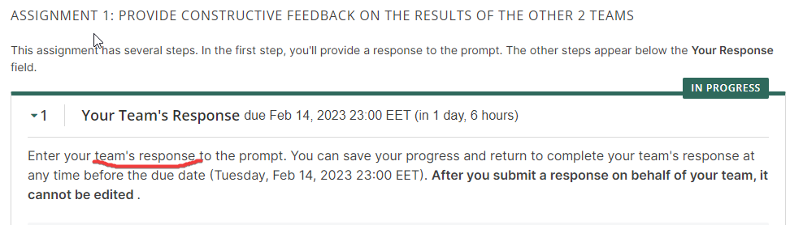

* 1. 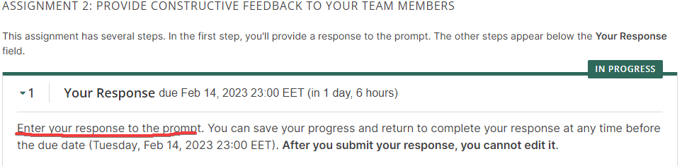

posted 4 months ago by [Svetlana_Obrezkova](https://lms.cerebrumhub.com/courses/course-v1:Cerebrum_Hub+CS0006+2023_T4/discussion/forum/users/99)

* 1. Hello Svetlana
     + The Assignment 1 is a **team assignment**. **Only one team member** must submit it. To complete this assignment, copy links to the Confluence pages, where you have added feedback, as it is written in the description of the assignment. The assignment must be done together with your team members, so have a call, discuss and give the feedback all together. 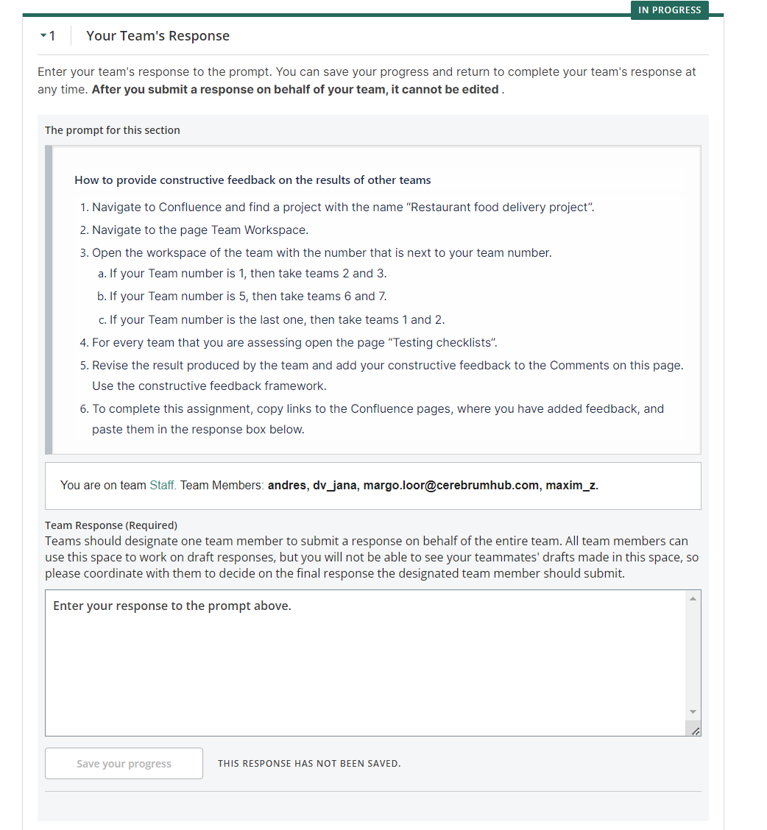
     + The Assignment 2 is individual, so every learner must do it individually. Again as it is written in assignment **every team member** must add **his/her personal feedback** to the Confluence page and then submit assignment in LMS by providing us link to the page, where the feedback was added. 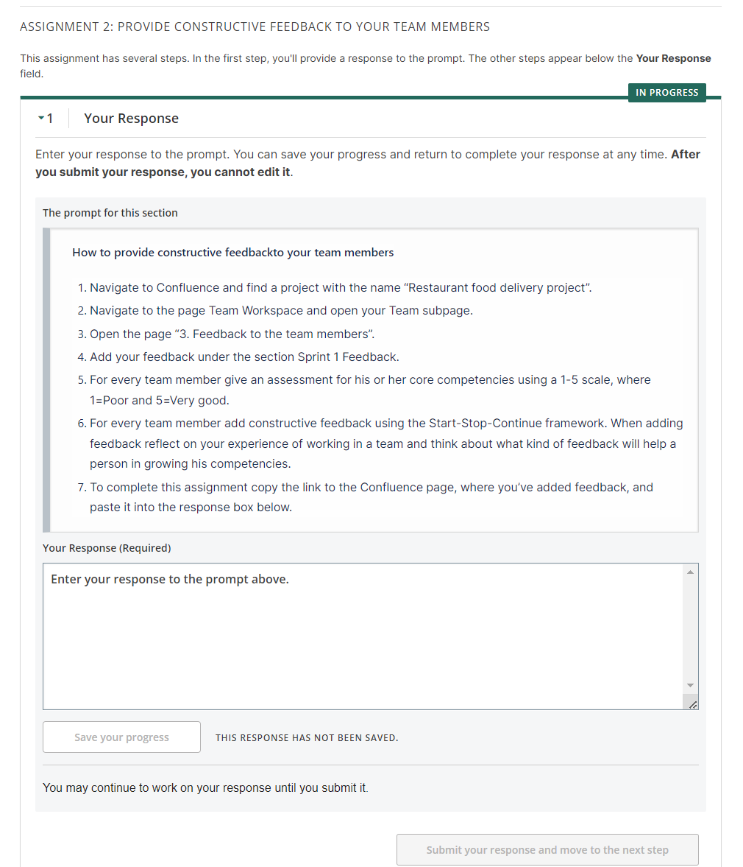

Hope it is helpful.



posted 4 months ago by [andres](https://lms.cerebrumhub.com/courses/course-v1:Cerebrum_Hub+CS0006+2023_T4/discussion/forum/users/33)

* 1. Yes, for the first assignment only one person from the team should make a work space for the team and etc.

For the second assignment (prepare checklists) - each team member should do it by his own



posted 4 months ago by [maxim_z](https://lms.cerebrumhub.com/courses/course-v1:Cerebrum_Hub+CS0006+2023_T4/discussion/forum/users/49)

* 1. Thank you, it was really helpful!

posted 4 months ago by [Svetlana_Obrezkova](https://lms.cerebrumhub.com/courses/course-v1:Cerebrum_Hub+CS0006+2023_T4/discussion/forum/users/99)

Add a comment

Your question or idea (required)

1. [Jevgeni_Koltatšuk](https://lms.cerebrumhub.com/courses/course-v1:Cerebrum_Hub+CS0006+2023_T4/discussion/forum/users/76)

4 months ago

* 1. Vote for this post, there are currently 0 votes

Hello, Did I understand correctly that if we have 4 team members, then we need to add another team member 4 line and also a team member 4 column and a Start Stop Continue for team member 3? If yes, do we need to add the Assessment of core competencies grades for ourselves too?

* 1. Hello Jevgeni

Yes, you understood it right, you need to add additional column for team member 4.

No, you do not need to grade yourself, only other team members.



posted 4 months ago by [andres](https://lms.cerebrumhub.com/courses/course-v1:Cerebrum_Hub+CS0006+2023_T4/discussion/forum/users/33)

Add a comment

Your question or idea (required)

1. [Martin_Saar](https://lms.cerebrumhub.com/courses/course-v1:Cerebrum_Hub+CS0006+2023_T4/discussion/forum/users/88)

4 months ago

* 1. Vote for this post, there are currently 0 votes

Hey!

I had a question or two about the feedback assignment regarding other teams - Are we supposed to be giving feedback only on the checklists or should we also include bug tickets?

What is more, it seems to me that most of the other teams have created, what I would describe more as testing reports than the simple checklists shown [here](https://cerebrumhubstudents.atlassian.net/wiki/spaces/P1KBQ/pages/113606666/Testing+checklist+examples) . Is this something that was instructed to be done? I ask because I can't seem to find anything referring to this.

Thanks in advance,

Martin

* 1. Hello Martin

You need to give feedback to both - testing checklists and bug tickets.

Regarding the testing report - no, it was't the part of the assignment to create that. We mentioned it as optional thing and some teams decided to follow this recommendation.



posted 4 months ago by [andres](https://lms.cerebrumhub.com/courses/course-v1:Cerebrum_Hub+CS0006+2023_T4/discussion/forum/users/33)

* 1. Thanks!

posted 4 months ago by [Martin_Saar](https://lms.cerebrumhub.com/courses/course-v1:Cerebrum_Hub+CS0006+2023_T4/discussion/forum/users/88)

Add a comment

Your question or idea (required)

1. [Viljar_Soots](https://lms.cerebrumhub.com/courses/course-v1:Cerebrum_Hub+CS0006+2023_T4/discussion/forum/users/104)

4 months ago

* 1. Vote for this post, there are currently 0 votes

Hey,

There are 2 deadlines one of them is probably correct.

* 1. The second deadline is correct - Feb, 14. Please put attention to it.

posted 4 months ago by [andres](https://lms.cerebrumhub.com/courses/course-v1:Cerebrum_Hub+CS0006+2023_T4/discussion/forum/users/33)

Add a comment

Your question or idea (required)

1. [Timofejs_Popovs](https://lms.cerebrumhub.com/courses/course-v1:Cerebrum_Hub+CS0006+2023_T4/discussion/forum/users/132)

4 months ago

* 1. Vote for this post, there are currently 0 votes

I thought that 14.02 23:00PM is more like just recommendation since there is text on this page that says "Homework due Feb 18, 2023 23:30 EET". So the question is - If I have failed to submit response on time, will it be open again?

* 1. Please put attention to the deadline near the assignment description. This is the proper final deadline. We will explore why LMS is showing 2 different dates and confuses you.

I added one more day for the assignments 1 and 2, so now you can submit them before 15th of February 22:00.



posted 4 months ago by [andres](https://lms.cerebrumhub.com/courses/course-v1:Cerebrum_Hub+CS0006+2023_T4/discussion/forum/users/33)

Add a comment

Your question or idea (required)

1. [Anatoli_Sergejev](https://lms.cerebrumhub.com/courses/course-v1:Cerebrum_Hub+CS0006+2023_T4/discussion/forum/users/56)

4 months ago

* 1. Vote for this post, there are currently 0 votes

Hi! Can You please once again explain to us what the surveys are giving an extra points? I wonder where we have lost one point 😀

* 1. I am wondering the same🤷🏼‍♀️. Which survey was not submitted correctly? 🤪 Thanks.

posted 4 months ago by [Veronika_Rebane](https://lms.cerebrumhub.com/courses/course-v1:Cerebrum_Hub+CS0006+2023_T4/discussion/forum/users/103)

Add a comment

Your question or idea (required)

1. [Ilja_Prokopjev](https://lms.cerebrumhub.com/courses/course-v1:Cerebrum_Hub+CS0006+2023_T4/discussion/forum/users/71)

4 months ago

* 1. Vote for this post, there are currently 0 votes

I have an idea. Is any chance to create a list of all requirements to get all maximum points, such as: home tasks, meeting reviews, resumes. So we can go one by one and not going to miss any? It will bring more structure and less points missing.

* 1. Hello Ilja

Thanks, this is really a great idea. We will consider creating such checklist of all project requirements for the upcoming projects.



posted 4 months ago by [andres](https://lms.cerebrumhub.com/courses/course-v1:Cerebrum_Hub+CS0006+2023_T4/discussion/forum/users/33)

Add a comment

Your question or idea (required)

1. [Timofejs_Popovs](https://lms.cerebrumhub.com/courses/course-v1:Cerebrum_Hub+CS0006+2023_T4/discussion/forum/users/132)

4 months ago

* 1. Vote for this post, there are currently 0 votes

* 1. Hello Timofejs

Thanks for reporting this issue. Yes, we have discovered the bug with showing the results of graded assignment. Our development team is working to deliver a fix for it as soon as possible.

Because the bug is pretty complicated it will take some time. We have exported all grades and feedback to this page so you will be able to see it right now. You can find it here: <https://cerebrumhubstudents.atlassian.net/wiki/spaces/RFDPT4/pages/160530433/Mentors+grades+and+feedback>



posted 4 months ago by [andres](https://lms.cerebrumhub.com/courses/course-v1:Cerebrum_Hub+CS0006+2023_T4/discussion/forum/users/33)

Add a comment

Your question or idea (required)

1. [Ilona_Soomann](https://lms.cerebrumhub.com/courses/course-v1:Cerebrum_Hub+CS0006+2023_T4/discussion/forum/users/72)

4 months ago

* 1. Vote for this post, there are currently 0 votes

Hello! I have a question about checklists. If our team had a feedback, that it's better to have one checkpoint as at least two separate ones, can we change it now before we will perform regression testing? Is it ok to make changes, or it's better to leave checks for UC 1-3 same as they are now?

* 1. Hello. Yes, it is important to update your checklists according to the comments, so they will be in a good shape before regression testing. As well as you are training to make them better.

posted 4 months ago by [maxim_z](https://lms.cerebrumhub.com/courses/course-v1:Cerebrum_Hub+CS0006+2023_T4/discussion/forum/users/49)

Add a comment

Your question or idea (required)

1. [Ilja_Prokopjev](https://lms.cerebrumhub.com/courses/course-v1:Cerebrum_Hub+CS0006+2023_T4/discussion/forum/users/71)

4 months ago

* 1. Vote for this post, there are currently 0 votes

Morning. How can we get access to admin login to test it? I have tried few times but not able to do it with my email. is it a bug or we will get access with "admin" mail and password?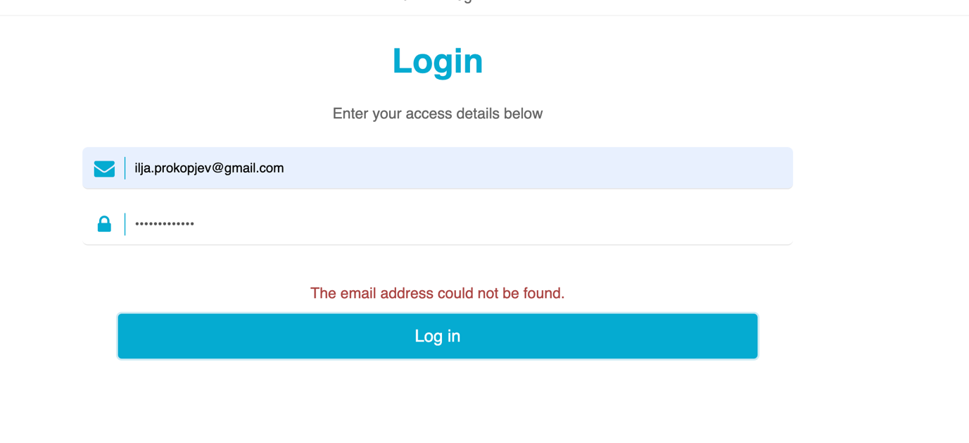

* 1. Hi! Check from Use Case 4, on the bottom there is Login info for admin: <https://cerebrumhubstudents.atlassian.net/wiki/spaces/RFDPT4/pages/122978357/UC4.+Login+to+the+administration+panel>

posted 4 months ago by [Andres_Raev](https://lms.cerebrumhub.com/courses/course-v1:Cerebrum_Hub+CS0006+2023_T4/discussion/forum/users/57)

* 1. hello. I have tried to use my email (from Cerebrum registration) and gmail password. Same result. Still have no access to admin panel. :(

posted 4 months ago by [Ilja_Prokopjev](https://lms.cerebrumhub.com/courses/course-v1:Cerebrum_Hub+CS0006+2023_T4/discussion/forum/users/71)

* 1. Ilja, did you check the link I added? There is written

Credentials for testing Login: admin@email.com Password: admin



posted 4 months ago by [Andres_Raev](https://lms.cerebrumhub.com/courses/course-v1:Cerebrum_Hub+CS0006+2023_T4/discussion/forum/users/57)

* 1. my bad. sorry

posted 4 months ago by [Ilja_Prokopjev](https://lms.cerebrumhub.com/courses/course-v1:Cerebrum_Hub+CS0006+2023_T4/discussion/forum/users/71)

Add a comment

Your question or idea (required)

1. [Andres_Raev](https://lms.cerebrumhub.com/courses/course-v1:Cerebrum_Hub+CS0006+2023_T4/discussion/forum/users/57)

4 months ago

* 1. Vote for this post, there is currently 1 vote

Hi! Thinking little bit ahead to manage our time wisely. On the Tribe 4 Mentor session week 4 I asked about new functionalities testing and regression testing in different environments (browser/OS)- <https://www.youtube.com/live/fxZ2kuydlzk?feature=share&t=3325> - there you answered that regression testing has to be done at least in 1 browser.

So to be clear: New functionalities we test in all browsers but regression testing can be done in 1 browser? I ask this because in LMS is that we have to test everything in all browsers

* 1. Good question! I'd also like to know. :)

posted 4 months ago by [Maria_Vakmann](https://lms.cerebrumhub.com/courses/course-v1:Cerebrum_Hub+CS0006+2023_T4/discussion/forum/users/65)

* 1. I would also like to clarify whether our team grade will be affected for the worse if we conduct regression testing in less than 3 browsers.

posted 4 months ago by [Svetlana_Obrezkova](https://lms.cerebrumhub.com/courses/course-v1:Cerebrum_Hub+CS0006+2023_T4/discussion/forum/users/99)

* 1. Hello,

Thanks for the great question. You will receive points for every additional browser you take for testing. Up to 3 points if you do regression in all 3 browsers.



posted 4 months ago by [andres](https://lms.cerebrumhub.com/courses/course-v1:Cerebrum_Hub+CS0006+2023_T4/discussion/forum/users/33)

Add a comment

Your question or idea (required)

1. [John_Ikegwuonu](https://lms.cerebrumhub.com/courses/course-v1:Cerebrum_Hub+CS0006+2023_T4/discussion/forum/users/77)

4 months ago

* 1. Vote for this post, there are currently 0 votes

Hello,

Can you please give some direction as to how to complete the task in the attached screenshot?



* 1. Hello

You do that in the same way as previously - starting from Saturday you will see the "Meeting Survey" survey under Sprint 2 assignments.

The Survey is individual i.e. each team member fills it out personally. The survey needs to be taken once every week, at the end of the week. The best time is Saturday, after you are done with your learning activities for the week. It does not matter, if you have had a Sprint week or a RAP (review-assessment-planning) week, you still fill in this survey at the end of the week.



posted 4 months ago by [andres](https://lms.cerebrumhub.com/courses/course-v1:Cerebrum_Hub+CS0006+2023_T4/discussion/forum/users/33)

* 1. Hello Andres,

Thats clear now! Thanks alot! :)



posted 4 months ago by [John_Ikegwuonu](https://lms.cerebrumhub.com/courses/course-v1:Cerebrum_Hub+CS0006+2023_T4/discussion/forum/users/77)

Add a comment

Your question or idea (required)

1. [Andrejs_Vorobjovs](https://lms.cerebrumhub.com/courses/course-v1:Cerebrum_Hub+CS0006+2023_T4/discussion/forum/users/133)

4 months ago

* 1. Vote for this post, there are currently 0 votes

Hello, when will the glitch that I've had for about a week be fixed?

* 1. Hello Andrejs

We cannot give right now any exact time estimate regarding when exactly this bug will be solved. This is quite complicated issue of the LMS and our development partner is working hard to solve it as soon as possible.

So far you can find your grades and mentors feedback in the Confluence, here - <https://cerebrumhubstudents.atlassian.net/wiki/spaces/RFDPT4/pages/160530433/Mentors+grades+and+feedback>



posted 4 months ago by [andres](https://lms.cerebrumhub.com/courses/course-v1:Cerebrum_Hub+CS0006+2023_T4/discussion/forum/users/33)

Add a comment

Your question or idea (required)

1. [Timofejs_Popovs](https://lms.cerebrumhub.com/courses/course-v1:Cerebrum_Hub+CS0006+2023_T4/discussion/forum/users/132)

4 months ago

* 1. Vote for this post, there are currently 0 votes
  3. UC5 "Completing and declining orders" section, point 3. It says that "order must move to the appropriate section in the orders list view". What is this "appropriate section"? Aint no such a UC that provide us with description of some sections on the Orders Manage page.
  4. UC6 point 4. tells us that "newly added product must appear in the top of the menu (as the first item)" but UC1 point 3. says that products must be sorted by ASC sequence. As I see - both pages describen in UCs 1 nad 6 is the same page with only difference that it described in terms of admin and simple user.
     1. It means that after changing the Order status, the Order must be shown rather under status "Completed" or “Declined”. (You can open those section by using the Filtering).
     2. Yes, that is great, that you noticed the contradiction between requirements in UC1 and UC6. I fixed the requirement in UC6 to eliminate the conflict between requirements.

posted 4 months ago by [andres](https://lms.cerebrumhub.com/courses/course-v1:Cerebrum_Hub+CS0006+2023_T4/discussion/forum/users/33)

Add a comment

Your question or idea (required)

1. [Signe_Salumets](https://lms.cerebrumhub.com/courses/course-v1:Cerebrum_Hub+CS0006+2023_T4/discussion/forum/users/115)

4 months ago

* 1. Vote for this post, there are currently 0 votes

About UC5 Viewing and managing orders. I noticed that older orders (made over 24 hours ago) are not displayed in order list. In Viewing orders page is the text "Displaying all orders received in the last 24 hours."

As this 24 hours rule is not mentioned in the UC, please confirm if this is what the customer has requested?

* 1. No, it seems to be a bug, because this is not requested by the customer and Use case description.

posted 4 months ago by [andres](https://lms.cerebrumhub.com/courses/course-v1:Cerebrum_Hub+CS0006+2023_T4/discussion/forum/users/33)

Add a comment

Your question or idea (required)

1. [Svetlana_Obrezkova](https://lms.cerebrumhub.com/courses/course-v1:Cerebrum_Hub+CS0006+2023_T4/discussion/forum/users/99)

4 months ago

* 1. Vote for this post, there are currently 0 votes

I have a bunch of questions considering assignment1 and 2.

* 1. In UC4 it is said, that *“All users must see the “Login as administrator” button at the bottom of the menu”*, but in Food ordering application release v2 Version 0.0.3 this button is called “Access admin screen”. Is this a bug or not?
  2. One of our team members checked, that he could stay logged in to the administration panel for at least 24h. What could be a limit for timeout?
  3. Considering UC5. Some preconditions are indicated: *“The user must be successfully authenticated. At least one order must be created and submitted to the restaurant.”* My question is, should we mention these preconditions in our checklist?
  4. About UC6. Adding new products panel.  
     You can enter only special characters or numbers in the product “Name” field and successfully add a new product. Can we consider it a bug, ok not?
  5. UC2 says- *„The user must see the following information about every product: .. Product description – comma-separated list“*. But in UC6 there is no such requirement for the „Description“ field. How should we treat this contradiction: as a bug, because this leads to errors in the product preview page, or just a flaw in documentation?
  6. In UC6 *“Highlight - optional dropdown with options:…”,* but UC2- *“The user must see the following information about every product: Product highlight - at least one value should exist”*. How to treat this, as a bug or a documentation issue?
  7. SKU code field (I guess it stands for Stock keeping unit) is not mentioned in the documentation but is present in Food ordering application release v2 version 0.0.3. How should we treat it? What are the requirements for this field: mandatory, optional, numbers, letters?
  8. Picture – was mandatory in UC1 and UC2, but now you can add a new product without a picture. In UC6 is just said, that *“Image - the administrator must be able to upload image in formats “jpg” or “png”.* A bug, not a bug, documentation contradictions? My question is also what is a good limit for the file size of a picture? Up to 2-10MB? Asking, because I could upload 54MB photo.
  9. Allergy information. In previous UC-s and app version 0.0.1 allergens were just: Eggs, Gluten and Milk, but in UC6 also Celery, Fish, Lupin, Molluscs, Mustard, Nuts, Sesame, Soybeans, Sulphur dioxide and sulphites. How should we reflect it in our checklists?
  10. Hello Svetlana,

Here are answers to your questions.

* + 1. It is a bug, because functionality is not consistent with the documentation.
    2. Currently there are no limit asked in the Use case. But sure, it is part of the security best practices. I would suggest to register an improvement ticket and the developers will figure our the proper timeout for it.
    3. You can mention it in case those preconditions I important for your specific testing scenario. But for sure there is no point to mention it again and again in every check.
    4. It is not a bug if there is no validation requirements defined in the Use case. Currently the expectation is that the customer will enter valid values by themselves and verify that all is correct.
    5. It is a bug of documentation, because it is blocking the proper functioning of other functionality. Report it.
    6. It is a bug of documentation. Report and describe the issue.
    7. It is a bug of documentation. Report.
    8. Also report it, it seems to be a bug of documentation. Regarding the limits of files, the proper limit could be around 5MB, but it must be specified in the documentation.
    9. You can reflect it via testing the scenario, where you add products with such allergens and ensure, that UC2 is still working correctly and properly showing this information.

posted 4 months ago by [andres](https://lms.cerebrumhub.com/courses/course-v1:Cerebrum_Hub+CS0006+2023_T4/discussion/forum/users/33)

* 1. Many Thanks for your comprehensive answers!

posted 4 months ago by [Svetlana_Obrezkova](https://lms.cerebrumhub.com/courses/course-v1:Cerebrum_Hub+CS0006+2023_T4/discussion/forum/users/99)

* 1. How or to where are we supposed to report errors in the documentation?

posted 4 months ago by [Maria_Vakmann](https://lms.cerebrumhub.com/courses/course-v1:Cerebrum_Hub+CS0006+2023_T4/discussion/forum/users/65)

* 1. I have the same question. Based on what I've learned from the discussion board and the workshop on Thursday, the business logic or use cases considered the "bible" for our project's documentation, right? If we discover functionalities in the app that are not included in the documentation, should we report them as bugs in Jira without evaluating their correctness? For instance, suppose we find an extra SKU field in the adding product section. Should we report it as an issue, even if it is a useful feature that the client may accept? Is it up to the stakeholders, including the client, to decide whether or not to keep such functionalities if they have been accidentally developed?

What does the phrase "default in documentation" mean? Was the field mistakenly left out from the documentation or intentionally excluded because it was not deemed necessary for the app's functionality?

It is hard to understand at the moment if the developers had the information from somewhere (but it is not in the documentation) or they have come up with the additional stuff themselves.

Thanks!



posted 4 months ago by [Veronika_Rebane](https://lms.cerebrumhub.com/courses/course-v1:Cerebrum_Hub+CS0006+2023_T4/discussion/forum/users/103)

Add a comment

Your question or idea (required)

1. [Vasileios_Makrygiannis](https://lms.cerebrumhub.com/courses/course-v1:Cerebrum_Hub+CS0006+2023_T4/discussion/forum/users/130)

4 months ago

* 1. Vote for this post, there are currently 0 votes

It s not a question as an admission and request. By accident, I deleted the berry smoothie from the app. I don t know if I did it in general for everybody so, in advance a huge apology from my side to everyone. Can someone from the tech gurus you have in your company, correct it or replace it?

* 1. Hello Vasileios

Don't worry, anyways this is a testing data. We will later restore it.



posted 4 months ago by [andres](https://lms.cerebrumhub.com/courses/course-v1:Cerebrum_Hub+CS0006+2023_T4/discussion/forum/users/33)

Add a comment

Your question or idea (required)

1. [Tatjana_Geller](https://lms.cerebrumhub.com/courses/course-v1:Cerebrum_Hub+CS0006+2023_T4/discussion/forum/users/110)

4 months ago

* 1. Vote for this post, there are currently 0 votes

I have a question about admin menu. In uc is not mentioned about log out option , but obviously should be. In app is “back” button, that doesn’t have any point, because if you are logged in, you are not able to get back (UC4 The user must be automatically redirected to the administration panel if he was previously already logged in.) Is it a bug or what is the function of “back” button? May be those are two separate bugs, or this is one big issue?

* 1. Hello Tatjana

Is, you are correct that this functionality is necessary. Unfortunately there were no development resource to include it in this development iteration and it will be developed later. So it is not a bug, this functionality just will be developed later.



posted 4 months ago by [andres](https://lms.cerebrumhub.com/courses/course-v1:Cerebrum_Hub+CS0006+2023_T4/discussion/forum/users/33)

Add a comment

Your question or idea (required)

1. [Ilja_Prokopjev](https://lms.cerebrumhub.com/courses/course-v1:Cerebrum_Hub+CS0006+2023_T4/discussion/forum/users/71)

4 months ago

* 1. Vote for this post, there are currently 0 votes

Question. UC5 says The administrator can filter orders by status to see “Completed”, but in app we have button "Complete". It is confusing. Is it status "completed" or action needs to be done?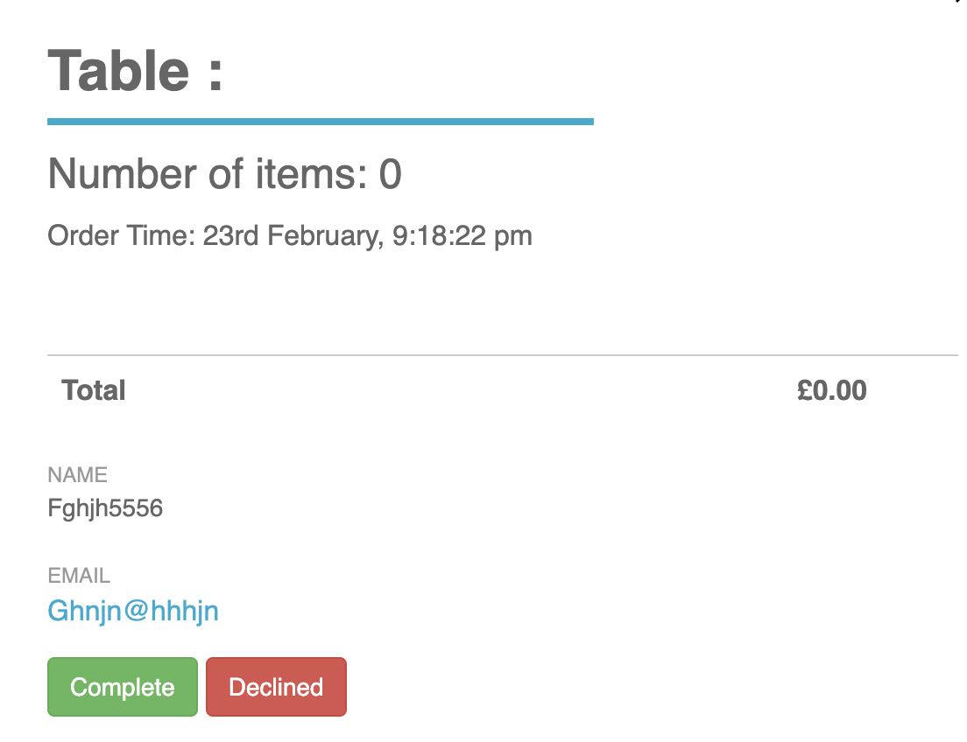

* 1. same comes in UC5 Completing and declining orders: **The administrator must see buttons “Complete” and “Decline” in the order’s detailed information view.** its unclear please clarify, otherwise testing can not executed

posted 4 months ago by [Ilja_Prokopjev](https://lms.cerebrumhub.com/courses/course-v1:Cerebrum_Hub+CS0006+2023_T4/discussion/forum/users/71)

* 1. These two buttons in detailed view are actions, so they must be "Complete" and "Decline". In the filtering field in orders list from other hand there are statuses, and they must be "Completed" and "Declined" imho.

posted 4 months ago by [Anatoli_Sergejev](https://lms.cerebrumhub.com/courses/course-v1:Cerebrum_Hub+CS0006+2023_T4/discussion/forum/users/56)

* 1. Agree, I can not test without clarification

posted 4 months ago by [Ilja_Prokopjev](https://lms.cerebrumhub.com/courses/course-v1:Cerebrum_Hub+CS0006+2023_T4/discussion/forum/users/71)

* 1. Ilja, I will ask you a question, I hope it will guide you into the right direction. What a QA does, if there is a mismatch between requirements and the implemented product?

And one more hint, Anatoli gave you a really nice idea to consider.

PS: you can test, you can report bugs, and you can amend and adjust them if later you get additional contradicting information. It will be additional practice for you, which is never excess.



posted 4 months ago by [dv_jana](https://lms.cerebrumhub.com/courses/course-v1:Cerebrum_Hub+CS0006+2023_T4/discussion/forum/users/48)

* 1. After team meeting I decided to report typo as a bug and keep testing. Thx

posted 4 months ago by [Ilja_Prokopjev](https://lms.cerebrumhub.com/courses/course-v1:Cerebrum_Hub+CS0006+2023_T4/discussion/forum/users/71)

Add a comment

Your question or idea (required)

1. [John_Ikegwuonu](https://lms.cerebrumhub.com/courses/course-v1:Cerebrum_Hub+CS0006+2023_T4/discussion/forum/users/77)

4 months ago

* 1. Vote for this post, there is currently 1 vote

Hello Mentors,

My team and I were wondering why all assignments have the same deadlines. If we are expected to perform regression testing, why is the deadline for the 2nd assignment which is reporting found bugs to Jira the same? How do we perform regression testing when the deadline for the previous/prerequisite assignment is the same? Please give us direction

Thanks

* 1. Hello John

You have assignments for the sprint (2 week period) and you need to plan and understand how to distrubute the work properly. It is important that all assignments **will be completed by the end of the sprint.**

You can follow the calendar, where you will find recommendations about how to align your work in a proper order. You will find, that there it is written, that first you need to complete assignments 1 and 2, and then you can start with the assignment nr 3. It also was discussed on our previous mentoring workshop, so please check the recording.



posted 4 months ago by [andres](https://lms.cerebrumhub.com/courses/course-v1:Cerebrum_Hub+CS0006+2023_T4/discussion/forum/users/33)

* 1. Hello Andres. Thanks for clarifying.

posted 4 months ago by [John_Ikegwuonu](https://lms.cerebrumhub.com/courses/course-v1:Cerebrum_Hub+CS0006+2023_T4/discussion/forum/users/77)

Add a comment

Your question or idea (required)

1. [Signe_Salumets](https://lms.cerebrumhub.com/courses/course-v1:Cerebrum_Hub+CS0006+2023_T4/discussion/forum/users/115)

4 months ago

* 1. Vote for this post, there are currently 0 votes

Hi, I am coming back to the allergy question as the previous answer was not clear for me.

In UC 1 the allergy list was: “Eggs”, “Gluten”, “Milk”, but in UC 6 the allergy list is longer: Celery, Gluten, Eggs, Fish, Lupin, Milk, Molluscs, Mustard, Nuts, Sesame, Soybeans, Sulphur dioxide and sulphites.

Has the customer changed their requirements and we should follow UC6 list?

* 1. Hey Signe This question was asked above in long post from Svetlana and answer from mentors: You can reflect it via testing the scenario, where you add products with such allergens and ensure, that UC2 is still working correctly and properly showing this information.

posted 4 months ago by [Ilja_Prokopjev](https://lms.cerebrumhub.com/courses/course-v1:Cerebrum_Hub+CS0006+2023_T4/discussion/forum/users/71)

* 1. Thanks Ilja.

posted 4 months ago by [andres](https://lms.cerebrumhub.com/courses/course-v1:Cerebrum_Hub+CS0006+2023_T4/discussion/forum/users/33)

Add a comment

Your question or idea (required)

1. [Ilja_Prokopjev](https://lms.cerebrumhub.com/courses/course-v1:Cerebrum_Hub+CS0006+2023_T4/discussion/forum/users/71)

4 months ago

* 1. Vote for this post, there is currently 1 vote

Suggestion: in order should be marked time when it was declined or completed. Chefs opinion.

Add a comment

Your question or idea (required)

1. [Maria_Vakmann](https://lms.cerebrumhub.com/courses/course-v1:Cerebrum_Hub+CS0006+2023_T4/discussion/forum/users/65)

4 months ago

* 1. Vote for this post, there are currently 0 votes

To where and how should we report bugs we find in documentation and conflicts between different UC's?

* 1. Maria, our ultimate tool for reporting any bugs is Jira.

posted 4 months ago by [dv_jana](https://lms.cerebrumhub.com/courses/course-v1:Cerebrum_Hub+CS0006+2023_T4/discussion/forum/users/48)

Add a comment

Your question or idea (required)

1. [Veronika_Rebane](https://lms.cerebrumhub.com/courses/course-v1:Cerebrum_Hub+CS0006+2023_T4/discussion/forum/users/103)

4 months ago

* 1. Vote for this post, there is currently 1 vote

Based on what I've learned from the discussion board and the workshop on Thursday, the business logic or use cases considered the "bible" for our project's documentation, right? If we discover functionalities in the app that are not included in the documentation, should we report them as bugs in Jira without evaluating their correctness? For instance, suppose we find an extra SKU field in the adding product section. Should we report it as an issue, even if it is a useful feature that the client may accept? Is it up to the stakeholders, including the client, to decide whether or not to keep such functionalities if they have been accidentally developed?

What does the phrase "default in documentation" mean? Was the field mistakenly left out from the documentation or intentionally excluded because it was not deemed necessary for the app's functionality?

It is hard to understand at the moment if the developers had the information from somewhere (but it is not in the documentation) or they have come up with the additional stuff themselves.

Thanks!

* 1. Hello Veronka

1.If we discover functionalities in the app that are not included in the documentation, should we report them as bugs in Jira without evaluating their correctness?

**Yes, you should report then as bugs. The customer anyways can check it before, but from the software testing perspective it is a bug.**

2.The SKU field was added to allow "Product in stock" functionality, which is required by the UC2. Sure this is missing in the UC6, so in general all this situation must be reported as a bug. The developer and analyst will be able to clarify that between themselves and come up with the solution.



posted 4 months ago by [andres](https://lms.cerebrumhub.com/courses/course-v1:Cerebrum_Hub+CS0006+2023_T4/discussion/forum/users/33)

Add a comment

Your question or idea (required)

1. [Jevgeni_Koltatšuk](https://lms.cerebrumhub.com/courses/course-v1:Cerebrum_Hub+CS0006+2023_T4/discussion/forum/users/76)

4 months ago

* 1. Vote for this post, there are currently 0 votes

Dear Mentors! Please clarify:

* 1. UC6 f. Price - required number element
     + user must input only **number** here? (no symbols, letters)
     + should we consider word *required* , as a mandatory field?
  2. UC6 g. Size - required text element
     + user must input only **text** here? (no symbols, numbers)
     + should we consider the word *required* , as a mandatory field?

Thank you in advance!

* 1. I would like to add one more questions - UC6 Product size - it makes sense to me that instead of **text**, **number** is required. In the menu is 200 (ml) or 1 (serve).

Does the customer wants to see product sizes in menu in format a or b? a) two hundred ml (required text element) b) 200 ml (required number element)



posted 4 months ago by [Signe_Salumets](https://lms.cerebrumhub.com/courses/course-v1:Cerebrum_Hub+CS0006+2023_T4/discussion/forum/users/115)

* + 1. Price - yes, only number. Required = mandatory.
    2. Size - Text means that all possible symbols can be entered, including numbers and special characters. Required = mandatory.
    3. Product size - Yes, you are correct, this will be better. You can report it as a suggestion for the Use case.

posted 4 months ago by [andres](https://lms.cerebrumhub.com/courses/course-v1:Cerebrum_Hub+CS0006+2023_T4/discussion/forum/users/33)

Add a comment

Your question or idea (required)

1. [Viljar_Soots](https://lms.cerebrumhub.com/courses/course-v1:Cerebrum_Hub+CS0006+2023_T4/discussion/forum/users/104)

4 months ago

* 1. Vote for this post, there are currently 2 votes

About regression testing, I think Mentor Andres 2 times explained that the first sprint tickets will be moved to in testing column and if the bug is fixed we have to move it to the done column and if it is still broken then to the do-do column. Who is going to move the "old" tickets to "intesting" column or have I understood something totally wrong:)

Thanks:)

* 1. Same question

posted 4 months ago by [Anatoli_Sergejev](https://lms.cerebrumhub.com/courses/course-v1:Cerebrum_Hub+CS0006+2023_T4/discussion/forum/users/56)

* 1. Also, a wrong tickets what marked "DELETE" are still there

posted 4 months ago by [Anastassia_Vassilevskaja](https://lms.cerebrumhub.com/courses/course-v1:Cerebrum_Hub+CS0006+2023_T4/discussion/forum/users/55)

* 1. It is now done, so you can start doing the regression testing.

posted 4 months ago by [andres](https://lms.cerebrumhub.com/courses/course-v1:Cerebrum_Hub+CS0006+2023_T4/discussion/forum/users/33)

Add a comment

Your question or idea (required)

1. [Anatoli_Sergejev](https://lms.cerebrumhub.com/courses/course-v1:Cerebrum_Hub+CS0006+2023_T4/discussion/forum/users/56)

4 months ago

* 1. Vote for this post, there are currently 0 votes

According to the assignment 3, we have to perform comprehensive retest of all our checklists. At the moment due to created plenty of different products in menu without names, photos, sizes etc, there is a huge amount of new bugs. Should we report all this rubbish we have created by ourselves?

* 1. A screenshot of a menu

     Description automatically generated with medium confidence

posted 4 months ago by [Anatoli_Sergejev](https://lms.cerebrumhub.com/courses/course-v1:Cerebrum_Hub+CS0006+2023_T4/discussion/forum/users/56)

* 1. Anatoli, in my opinion, if we will on screenshot You provide, we have few bugs in 'registration form', 'add new product' and 'manage product'. Few bugs in customers panel: Creating orders. All those pics just confirm it. As suggestion: 1. I would recommend PRODUCT owner create manual for staff. 2. Customers site should have restriction in form. Such as Table Numbers, correct email and so on Just sharing my point

posted 4 months ago by [Ilja_Prokopjev](https://lms.cerebrumhub.com/courses/course-v1:Cerebrum_Hub+CS0006+2023_T4/discussion/forum/users/71)

* 1. Anatoli, there is no point to report testing data as a bug, because it can be added and removed by testers. So focus on functionalities and do not take the data itself under the consideration.

posted 4 months ago by [andres](https://lms.cerebrumhub.com/courses/course-v1:Cerebrum_Hub+CS0006+2023_T4/discussion/forum/users/33)

Add a comment

Your question or idea (required)

1. [Timofejs_Popovs](https://lms.cerebrumhub.com/courses/course-v1:Cerebrum_Hub+CS0006+2023_T4/discussion/forum/users/132)

4 months ago

* 1. Vote for this post, there are currently 0 votes

Regarding "Highlights", "Allergy information" and "Description" fields, both on Add New Product page and Product Manage page.

1.) Highlights - according to UC6 this field has to be presented as a dropdown, but dropdown by itself only imply opportunity to choose one option, even though there are already some products in the menu with more than one highlight. So the question is - can we keep it as it is(list of checkboxes) and mention in our checklist that it supposed to be so?

2.) Same for Allergy information.

3.) Description field - now it is text field, but how much sense in this solution? If every product should be comma separated list, then could it be better to make this field as a list of some elements(that ca possibly looks like filter with multiple pill-formed elements), where admin have to manually add each element one by one... with only text validation, even without spaces?

We would like build our checklist in a way to follow this ideas. Are we allowed?

Now regarding weekly google form about meetings. I can not find it (see attached picture).

* 1. Timofejs, you can find meeting survey in the end of sprint 1.

posted 4 months ago by [Tatjana_Geller](https://lms.cerebrumhub.com/courses/course-v1:Cerebrum_Hub+CS0006+2023_T4/discussion/forum/users/110)

* + 1. Highlights - the dropdown element can also be a multiselect (https://mdbootstrap.com/docs/standard/extended/multiselect/). Considering, that in the Use case it is asked to have a dropdown, I suggest reporting it as a bug.
    2. Same as previous.
    3. The text area element for the "Description" field allows the customer entering data in a format they want to. It is important considering that description of Wine and Pizza can be very different. So I do not really see any benefits in your proposed solution.
    4. The meeting form must be available by now, please check.

posted 4 months ago by [andres](https://lms.cerebrumhub.com/courses/course-v1:Cerebrum_Hub+CS0006+2023_T4/discussion/forum/users/33)

Add a comment

Your question or idea (required)

1. [Svetlana_Obrezkova](https://lms.cerebrumhub.com/courses/course-v1:Cerebrum_Hub+CS0006+2023_T4/discussion/forum/users/99)

4 months ago

* 1. Vote for this post, there are currently 0 votes

Hello, I have a question. I did the following steps: 1. Submitted an order as a client and got a confirmation letter 2. Logged in as admin, picked up that order, and clicked the "Decline" button in the order's detailed view 3. As a client I didn't get any rejection letter Is it a bug or just a feature, which was not yet developed?

* 1. Hello Svetlana

This is not a bug, because this behaviour currently is not described by the Use case (so there is no expectation, that customer will receive an email about rejected order). This feature will be developed later.



posted 4 months ago by [andres](https://lms.cerebrumhub.com/courses/course-v1:Cerebrum_Hub+CS0006+2023_T4/discussion/forum/users/33)

* 1. ok, thanks

posted 4 months ago by [Svetlana_Obrezkova](https://lms.cerebrumhub.com/courses/course-v1:Cerebrum_Hub+CS0006+2023_T4/discussion/forum/users/99)

Add a comment

Your question or idea (required)

1. [Jevgeni_Koltatšuk](https://lms.cerebrumhub.com/courses/course-v1:Cerebrum_Hub+CS0006+2023_T4/discussion/forum/users/76)

4 months ago

* 1. Vote for this post, there are currently 0 votes

Dear Mentors!

In UC6 e. Highlight is an optional choice, but in UC2 it says Product highlight - at least one value should exist

Should this be considered as a regression testing failure for UC2, or a bug report for UC6?

Thank you in advance!

* 1. Hello Jevgeni,

This is a bug report for UC6. Please do not forget to describe this issue in details (that requirement for mandatory value is coming from UC2).



posted 4 months ago by [andres](https://lms.cerebrumhub.com/courses/course-v1:Cerebrum_Hub+CS0006+2023_T4/discussion/forum/users/33)

Add a comment

Your question or idea (required)

1. [Allan_Särg](https://lms.cerebrumhub.com/courses/course-v1:Cerebrum_Hub+CS0006+2023_T4/discussion/forum/users/54)

4 months ago

* 1. Vote for this post, there are currently 0 votes

I have a question. UC4 has the following text: The email field must have a validation - entered value must contain the “@” symbol + contain domain extension (example: @domain.com). If the email is wrong following error message must be shown: "Please enter a valid email." This message is sent by the application only if there is no @ sign. If there is @, the browser will indicate with a separate box "Please enter an email address". Other browsers also do this, although the wording of the message is different. Should this email field be considered validated, or must the application also understand and signal with a message?

* 1. Hello Allan

The validation must work exactly as it is described in the Use Case. So the current behaviour is incorrect and must be reported.



posted 4 months ago by [andres](https://lms.cerebrumhub.com/courses/course-v1:Cerebrum_Hub+CS0006+2023_T4/discussion/forum/users/33)

Add a comment

Your question or idea (required)

1. [Ilona_Soomann](https://lms.cerebrumhub.com/courses/course-v1:Cerebrum_Hub+CS0006+2023_T4/discussion/forum/users/72)

4 months ago

* 1. Vote for this post, there are currently 0 votes

I want to be sure, I understand everything correctly, so can you please comment: We have tickets in Jira from UC1-3, that have to be retested and then moved to the "done" or "to do" columns. So is this the part of regression testing or is it different task for our team?

* 1. Yes, you understand it correctly. You retest UC1-3 as part of regression testing assignment.

posted 4 months ago by [andres](https://lms.cerebrumhub.com/courses/course-v1:Cerebrum_Hub+CS0006+2023_T4/discussion/forum/users/33)

Add a comment

Your question or idea (required)

1. [Tatjana_Geller](https://lms.cerebrumhub.com/courses/course-v1:Cerebrum_Hub+CS0006+2023_T4/discussion/forum/users/110)

4 months ago

* 1. Vote for this post, there are currently 0 votes

Question regarding the regression test. For example: In sprint 1 was created bug in the product preview section about missing picture. But in fact now this bug refers to adding a product, because there fields are not marked as required. How should we mark this in the product preview section? In fact it's not a bug of product preview, but just missing necessary details(picture). If bug about required fields will be fixed, then we'll get product preview in correct form. Should we mark this checkpoint as passed?

* 1. I would suggest to close (move to "Done") this bug (where picture for specific product is missing) and add to the comment, that this bug will be solved automatically, when the bug about mandatory picture will be solved.

posted 4 months ago by [andres](https://lms.cerebrumhub.com/courses/course-v1:Cerebrum_Hub+CS0006+2023_T4/discussion/forum/users/33)

Add a comment

Your question or idea (required)

1. [Vasileios_Makrygiannis](https://lms.cerebrumhub.com/courses/course-v1:Cerebrum_Hub+CS0006+2023_T4/discussion/forum/users/130)

4 months ago

* 1. Vote for this post, there is currently 1 vote

Hello guys some items with bugs in version 001 are missing form 003. I know that Berry smoothie I have deleted by mistake, I have reported it but it s still not there. Latte is missing also. Both had bugs in the first version .and we need them to verify them. Are they going to be re-introduced on the menu, so we check them for the regression test? In addition, some other products that we have now we don't have any info if they are additions from you guys or from our side just for checking.

* 1. No, they are not going to be reintroduced. Currently you have a possibility to manage the product data by yourself, so there is no point to test the data (because it can be easily changed). I suggest focusing on testing the functionalities and removing testing checklists, that were created for testing the specific data of specific products (it is not relevant anymore).

posted 4 months ago by [andres](https://lms.cerebrumhub.com/courses/course-v1:Cerebrum_Hub+CS0006+2023_T4/discussion/forum/users/33)

Add a comment

Your question or idea (required)

1. [Anatoli_Sergejev](https://lms.cerebrumhub.com/courses/course-v1:Cerebrum_Hub+CS0006+2023_T4/discussion/forum/users/56)

4 months ago

* 1. Vote for this post, there are currently 0 votes

Hi people! I would like to know is it a logical behaviour and supposed to be like that: when admin clicks on the "Manage products" option, he is being navigated to the common customer's "Browse menu" page? Imho logically there must be some kind "Manage products" page with a different interface. Or it is a budget saving solution?

* 1. I'm interested in that answer also, because for me, this is a bug, because it means that you can manage products without being logged in.

posted 4 months ago by [Ilona_Soomann](https://lms.cerebrumhub.com/courses/course-v1:Cerebrum_Hub+CS0006+2023_T4/discussion/forum/users/72)

* 1. Actually you can not. Try in incognito mode without logging in. But the same page confuses a little bit yeah

posted 4 months ago by [Anatoli_Sergejev](https://lms.cerebrumhub.com/courses/course-v1:Cerebrum_Hub+CS0006+2023_T4/discussion/forum/users/56)

* 1. But you can't view orders anymore after being redirected. So you need to click log in at the bottom again or go back to previouse page.

posted 4 months ago by [Ilona_Soomann](https://lms.cerebrumhub.com/courses/course-v1:Cerebrum_Hub+CS0006+2023_T4/discussion/forum/users/72)

* 1. Yes, you named it correctly, that it is a budget saving solution. The same page is reused to simplify the development efforts. I agree with the point of Ilona, that it may not be convenient for the end user, but from the functional testing perspective all is working fine.

posted 4 months ago by [andres](https://lms.cerebrumhub.com/courses/course-v1:Cerebrum_Hub+CS0006+2023_T4/discussion/forum/users/33)

Add a comment

Your question or idea (required)

1. [Svetlana_Obrezkova](https://lms.cerebrumhub.com/courses/course-v1:Cerebrum_Hub+CS0006+2023_T4/discussion/forum/users/99)

4 months ago

* 1. Vote for this post, there is currently 1 vote

Hi, I have a question about bug reporting. Some buttons and pages have incorrect names in ver. 0.0.3 (e.g. "Access admin screen" should be “Login as administrator”, "Add a new product" page is called "Manage product" now) I have to add steps to reproduce the bug when creating a report. Do I have to call these buttons with proper names or as I see in this application version now when I'm describing the steps?

* 1. When you are creating a bug report, it will be better if you name those buttons in the same way **as they are named in the released version of the application.** Otherwise it may be very confusing for the person, who will try to reproduce it.

posted 4 months ago by [andres](https://lms.cerebrumhub.com/courses/course-v1:Cerebrum_Hub+CS0006+2023_T4/discussion/forum/users/33)

Add a comment

Your question or idea (required)

1. [Üllar_Kappak](https://lms.cerebrumhub.com/courses/course-v1:Cerebrum_Hub+CS0006+2023_T4/discussion/forum/users/134)

4 months ago

* 1. Vote for this post, there are currently 0 votes

When following use case which use case takes priority when they are contracting itself commonly? For example UC1-3 vs UC4-6. In the documentation there's no info if UC4-6 are written specifically for app 0.0.3. If it is then I assume UC4-6 takes priority over UC1-3 because maybe client wanted some changes to the app? If not then UC1-3 takes priority?

* 1. In general all use cases must be consistent. So there should be no situation, when UC1-3 states some other requirements, that are in conflict with the UC4-6. If you see such conflicts between requirements, then you need to clarify them here on the discussion board.

posted 4 months ago by [andres](https://lms.cerebrumhub.com/courses/course-v1:Cerebrum_Hub+CS0006+2023_T4/discussion/forum/users/33)

Add a comment

Your question or idea (required)

1. [Anatoli_Sergejev](https://lms.cerebrumhub.com/courses/course-v1:Cerebrum_Hub+CS0006+2023_T4/discussion/forum/users/56)

4 months ago

* 1. Vote for this post, there are currently 0 votes

How to report documentation bugs? If some contradictions between the use cases, or something is missing etc., should we do the same bug reports as with the application bugs, for example: Go to the UC2, read point 3, then go to the UC6 and read point 2 - compare them...?

* 1. Report them here on the discussion board and I will answer what is a correct expected behaviour.

posted 4 months ago by [andres](https://lms.cerebrumhub.com/courses/course-v1:Cerebrum_Hub+CS0006+2023_T4/discussion/forum/users/33)

Add a comment

Your question or idea (required)

1. [Üllar_Kappak](https://lms.cerebrumhub.com/courses/course-v1:Cerebrum_Hub+CS0006+2023_T4/discussion/forum/users/134)

4 months ago

* 1. Vote for this post, there are currently 0 votes

Question about UC6 out of stock radio button "Is product out of the stock or not. (Radio button Yes/No)."

This one button works both ways to save development time. If you tick it, then product is out of stock and if you don't tick it then its not out of stock if that makes sense. But use case wording makes it confusing.. so I don't know, could be 50/50 to be a bug or not. Should there be 2 buttons? [ ] Yes and [ ] NO

* 1. Yes, according to the use case there must be a radio button component (here you can see how it works - <https://developer.mozilla.org/en-US/docs/Web/HTML/Element/input/radio>) which must offer two options "Yes" and "No". So having checkbox instead of radio button is a bug.

posted 4 months ago by [andres](https://lms.cerebrumhub.com/courses/course-v1:Cerebrum_Hub+CS0006+2023_T4/discussion/forum/users/33)

Add a comment

Your question or idea (required)

1. [Veronika_Rebane](https://lms.cerebrumhub.com/courses/course-v1:Cerebrum_Hub+CS0006+2023_T4/discussion/forum/users/103)

3 months ago

* 1. Vote for this post, there are currently 0 votes

Could you please review the feedback for Team 3's final report and provide additional clarification on the final report results? I have reviewed the feedback but still have some questions about what needs improvement. Here's what I understand from the staff comments:

* 1. Regarding regression testing, I understand that if a bug has been fixed in a new version, we should mark the corresponding ticket in Jira as "passed" and exclude it from the final report.
  2. The feedback mentions that block colors should indicate whether a point has passed or failed and that there is no need for yellow if there are only suggestions.
  3. When clicking on the "I" icon, additional information about the testing report is provided. However, it has been noted that this information does not include all previously created checklists. Could you please clarify what should be included in the testing report and provide more detail?
  4. As for no clear overview of the regression testing results, there is a lack of clear overview on how it should be conducted. Could you please provide an example or some guidelines on how to approach this? Thank you!
  5. The final testing report contains all previously created checklists and test results look tidy and readable. Report is very well-structured and easy to follow and is informative (checkpoint description gives an understanding of what was tested). Different colors are used to indicate testing results and additional comments are added. Your team is basically supposed to have 2 points based what you have in the report but somehow I put 1 point. **The grade for your team was entered incorrectly to LMS, and we corrected it. Probably it was one of the sources of your confusion.**
     1. Exactly. After regression testing in a newly released version, in case a bug is already fixed, it means the testing result is ‘Passed’. The bug report related to this bug should be closed and the testing result shown on the report of course will also be ‘Passed’. The closed bug report link is not necessary to be included in the final testing report.
     2. Actually there is not a big problem if you really want to indicate the passed functionalities which need improvement with yellow color. Potentially it could be misleading especially when you also had a bug report link beside.
     3. To answer your 3rd and 4th question, I can provide you with our assessment criteria for the final testing report. This assessment criteria can give you an overview what should be included and some rules to follow to make a decent report. 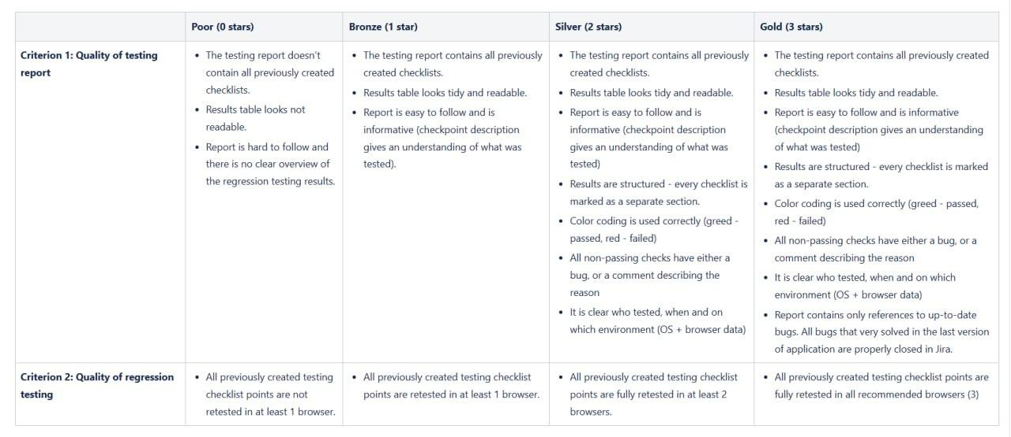

posted 3 months ago by [andres](https://lms.cerebrumhub.com/courses/course-v1:Cerebrum_Hub+CS0006+2023_T4/discussion/forum/users/33)

* 1. Hello Andres

Thank you for reviewing our team work and providing additional clarifications. The explanations you provided have helped us to better understand the assessment criteria.

However, I would like to bring to your attention that although you mentioned in your comment that you would be giving 2 points instead of 1, the issue has not been resolved in the LMS as I still see only 1 point assigned. I am not sure if the LMS has not recognized the points added or if there has been some other error. Would appreciate it if you could check the matter again and let us please know if we understood the points right or if the system has it right.



posted 3 months ago by [Veronika_Rebane](https://lms.cerebrumhub.com/courses/course-v1:Cerebrum_Hub+CS0006+2023_T4/discussion/forum/users/103)

* 1. It must be OK by now. Please check.

posted 3 months ago by [andres](https://lms.cerebrumhub.com/courses/course-v1:Cerebrum_Hub+CS0006+2023_T4/discussion/forum/users/33)

* 1. Thanks again :). Now it shows 2 points.

posted 3 months ago by [Veronika_Rebane](https://lms.cerebrumhub.com/courses/course-v1:Cerebrum_Hub+CS0006+2023_T4/discussion/forum/users/103)

Add a comment

Your question or idea (required)

1. [Ilja_Prokopjev](https://lms.cerebrumhub.com/courses/course-v1:Cerebrum_Hub+CS0006+2023_T4/discussion/forum/users/71)

3 months ago

* 1. Vote for this post, there are currently 0 votes

Team10. We don't really understand logic in 0 points and and good comments.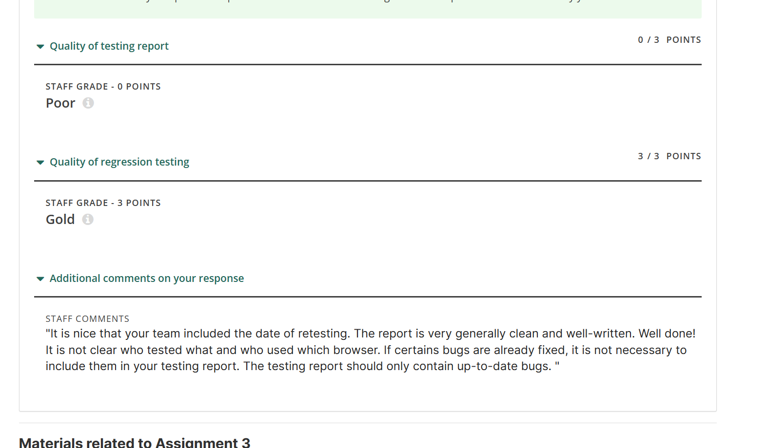 plz explain

* 1. Hello Ilja

Sorry for the confusion. The grade for this assignment was entered incorrectly and now it is fixed. Thank you for letting us know.



posted 3 months ago by [andres](https://lms.cerebrumhub.com/courses/course-v1:Cerebrum_Hub+CS0006+2023_T4/discussion/forum/users/33)

Add a comment

Your question or idea (required)

1. [Sigrid_Marga](https://lms.cerebrumhub.com/courses/course-v1:Cerebrum_Hub+CS0006+2023_T4/discussion/forum/users/96)

3 months ago

* 1. Vote for this post, there are currently 0 votes

Could you please comment on the result of team14 regarding testing? We have gone through the feedback and we agree that we have not been attentive enough and found too few errors. But is this result really worth zero points? While we may not have been at the required level, we did our best. Zero points are as if we did not test at all. Could you perhaps share the evaluation criteria?

* 1. Hello Sigrid

Sorry for the confusion. The grade for this assignment was entered incorrectly and now it is fixed. Thank you for letting us know.



posted 3 months ago by [andres](https://lms.cerebrumhub.com/courses/course-v1:Cerebrum_Hub+CS0006+2023_T4/discussion/forum/users/33)

Add a comment

Your question or idea (required)

1. [Vladislav_Anufrijev](https://lms.cerebrumhub.com/courses/course-v1:Cerebrum_Hub+CS0006+2023_T4/discussion/forum/users/111)

3 months ago

* 1. Vote for this post, there is currently 1 vote

It is normal that these three tasks are not marked as completed?(although it is written on these pages that everything is completed)

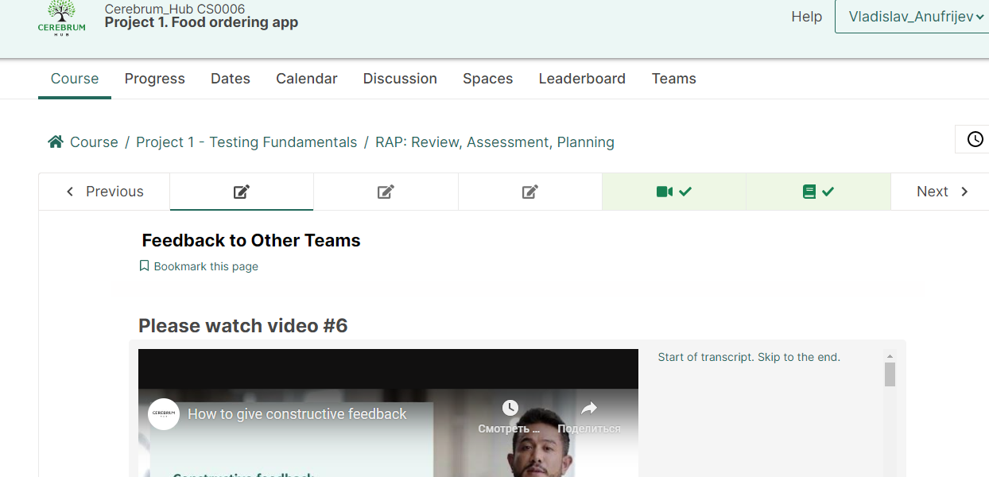

* 1. I have the same issue.

posted 3 months ago by [Kaspar_Raun](https://lms.cerebrumhub.com/courses/course-v1:Cerebrum_Hub+CS0006+2023_T4/discussion/forum/users/80)

Add a comment

Your question or idea (required)

1. [Martin_Saar](https://lms.cerebrumhub.com/courses/course-v1:Cerebrum_Hub+CS0006+2023_T4/discussion/forum/users/88)

3 months ago

* 1. Vote for this post, there are currently 0 votes

Hi!

I missed the deadline to submit ASSIGNMENT 4: UPDATE YOUR LEARNING DIARY. I realize that I should have double checked the deadline for this, even though, during the Live meeting, Andres said something that we could also do it on Sunday, if need be. It is what it is. Now, however, I am finding myself not able to submit the assignment at all, even with the grace-period of one day. Could you kindly let me know how to still submit this assignment, if at all possible.

Thanks in advance,

Martin.

Add a comment

Your question or idea (required)

1. [Sergei_Krasii](https://lms.cerebrumhub.com/courses/course-v1:Cerebrum_Hub+CS0006+2023_T4/discussion/forum/users/107)

3 months ago

* 1. Vote for this post, there are currently 0 votes

Should we "Update" or "Dismiss"? :)

Environments: All browsers :)

Steps to reproduce:

* 1. Open Jira
  2. Click "Apps" at the top menu
  3. Click "Timesheet"

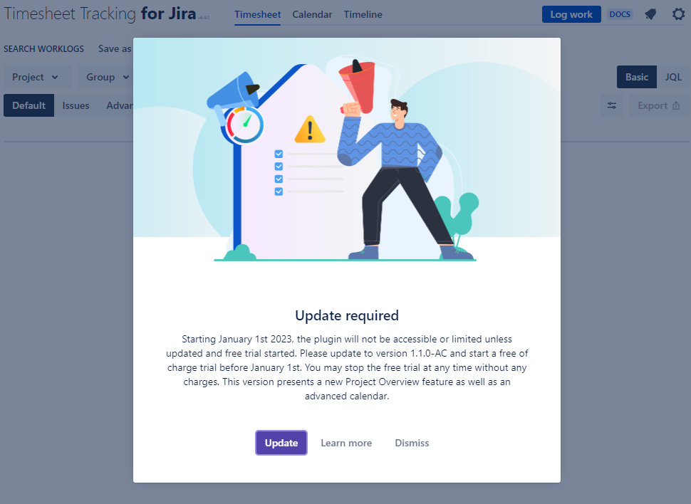

Add a comment

Your question or idea (required)

Preview

Submit

1. [Veronika_Rebane](https://lms.cerebrumhub.com/courses/course-v1:Cerebrum_Hub+CS0006+2023_T4/discussion/forum/users/103)

3 months ago

* 1. Vote for this post, there are currently 0 votes

Hi there!

Team 4 has some inquiries regarding our admin user login. We were able to successfully log in on Friday using team4_admin@ebay.com, but starting on Saturday and continuing today, we've been receiving an error message stating that the email address cannot be found. We have a few issues that we would like to report to Jira, and during the live call on the 16th, we were informed that the team user login should be functioning properly. Based on the comments made during the call, it seems that there may be something amiss on your end.

Our question is whether we can investigate the recent issues with the general admin account without bringing up any specific names.