Outline of Modules and Classes

- Our program will be divided into some programmable classes. Every class inside the software is responsible for something inside the NGFW. For example, the header_checker class is responsible for checking the headers of the packet, the logger class is responsible for the logging of packets entering and exiting the appliance, and so on.

- The classes can be aggregated to form something called module, the module generalises a full behaviour or strategy applied by the NGFW. For example, the IP_header_checker, TCP_header_checker and Payload_checker are all classes that can be aggregated to form a module which is called “Stateful Inspection Module”; also the Entering_packet_logger class and Exiting_packet_logger class are classes that are aggregated to form the “Logging and Auditing Module”; and so on.

- The module can be aggregated only by one class (it is not condition to make a module by multiple classes).

- It is not condition for the class to aggregate a module; it can be standalone – think about “aggregation” that means that the classes are collected and renamed by “module”, not “composition” in which the module is composed of some classes. As an example of standalone classes, the packet_capture class which does not belong to any of the modules because it is used in the main engine of the appliance.

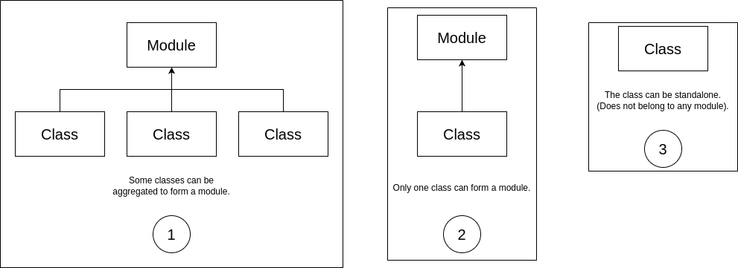Figure 1: The three classes of modules and classes aggregating it

