Cloud-Based Produce Market for Independent Farmers, Grocers and Retailers

Abir Rahman, Ishfaq Zaman, Jawad Aziz Khan, Dr. Mohammad Monirujjaman Khan  
Department of Electrical and Computer Engineering  
North South UniversityDhaka, Bangladesh  
abir.rahman1995@gmail.com, uzushin101@gmail.com, jawad.aziz.khan.jak@gmail.com

*Abstract*—Bangladesh suffer from fluctuating prices of produce due to several factors, such as transport costs, seasonal supply demand changes, forced price inflation by stocking goods when demand is high and many more. Each of these factors is a unique problem but some of the solutions to these problems are data driven. For example, when farmers produce too much product and respective demand is not up to the same level, farmers lose money and a lot of the production is wasted. This could have been easily solved by researching demand supply data for products to predict to a certain accuracy of how profitable it would be to produce a certain crop. Another example would be the unregulated middle man that independent farmers interact with to get their products to retailers. This buy and resell procedure, including the transport and logistics, increases the price of produce by every kilometer. These are situations that justify the existence of systems such as ’Amago’. (*Abstract*)

Keywords—farming, agriculture, market, economy, farmer, retailer, data, produce, harvest, crop

# Introduction (*Heading 1*)

In this paper, we propose an efficient, semi-automated produce warehousing platform that will quickly accumulate produce directly from the farmers based on market demand and ship them to urban retail grocery stores.

Farmers will post a sell request through an android application. Our system will process these requests and accumulate the produce until reaching maximum storage capacity. Retailers will be able to order through a online web interface, once an order is received it will be directly shipped to their specified store/outlet. The optimisation objective of the platform is to minimise the time the produce spends inside the warehouse.

# Previous Work

Currently there exists no such solution in the market. Studies show that there are several challenges that have affected the agricultural industry over the years, this includes climate change, inefficient use of water and fertilizers, pests, lack of quality seeds, unfair pricing and insufficient investment in research [1]. There are multiple emerging agro-tech startups that are planning to tackle these challenges.

## iFarmer

"ifarmer.asia" [2] is a Bangladesh based startup that is providing an investment platform for farmers. Farmers can sign up to work for designated farms. These farms are then advertised for sponsorship by the platform. The sponsor and farmer share the profit from the farm giving a commission to the platform.

## Impact Terra

"Impact Terra" [3], a Myanmar Based startup, is designing an application to help smallholder farmers by providing real-time recommendation of leading agricultural information. Their digital service "Golden Paddy" consist of a web+android application and a Facebook page. Aiming to be an effective tool for efficient farming.

## Plantix

"Plantix" [4] is an android based farming assistant tool. It provides crop health checking through the use of computer vision, connects farmers to scientists, experienced farmers and plant experts.

# Working Procedure

Our project "Amago" aims to output an online service coupled with an app and a web client that will digitally connect the aforementioned users in a produce marketplace, similar to modern e-commerce services.

The project consists of the following key hurdles:

* Segment the Client Types
* Android App for Produce
* Web Interface for Retail
* Database Storage
* Introduce to IRL users
* Leverage Data for prediction models

Currently, for the first half of our project, we have accomplished planning and setting up or database, start building a prototype android app with Bangla support and a website frontend that uses the application layer API.

We've begun working on our backend database running on PostgreSQL running on a cloud hosting platform called Heroku. The database has been initialized with relevant dummy data to begin testing queries and API calls.

We have also used Node.js to connect with the Heroku database and written API to handle HTTP requests and responses between the client and the server.

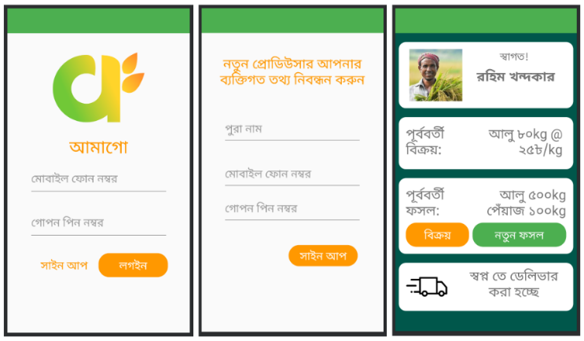End-users such as farmers will use the Android app. They will login simply with their phone number and PIN, curate harvests and post them onto the app. The app even allows users to select between Bangla and English as their interface language, to maintain user-friendliness. The current state of the app can be seen below:

1. Screenshots from the Android app.

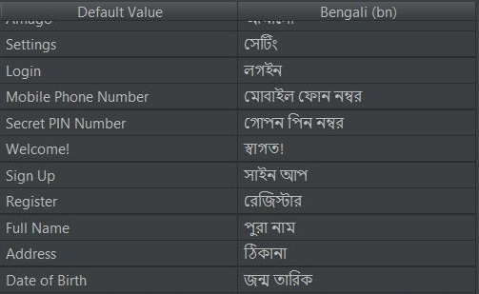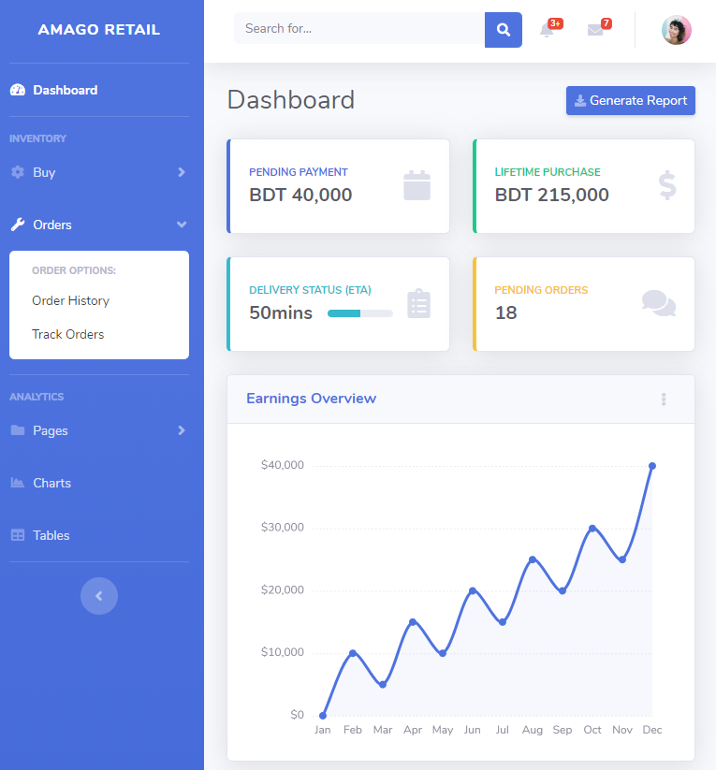For client-side retailers, we have started work on a web frontend where currently users can login, register and view the main dashboard where they can track their store's orders and other information. Below is a screenshot of the website:

1. Screenshots from the Android app.

# System Architecture

The proposed system will operate using a PostgreSQL RDMS (Relational Database Management System) database. The database will log user account details, transaction requests, warehouse inventory, retail chain store inventory, logistic information. The backend will be managed using Node.js. The robust framework will be used to create APIs (Application Programming Interface) that will be used for communication with the server through an android application/web interface. There will be two separate android applications one for farmers, the other for drivers of logistic vehicles.

Our retail clients will be provided with a web interface. The web interface will be a dynamic website designed using HTML, CSS and JavaScript. The clients will be able to place orders for produce based on their needs. Below is a simple diagram of our system:

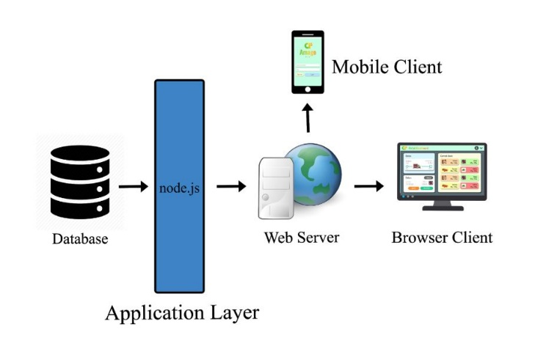

1. Overall System Architecture.

The Android applications will use Google's map API, our server API and the UX will follow Google's "Material Design" principle. Farmers will be able to post sell requests through our app. The request will be sent to the server through our API. The request will be logged in a database table. The request will then be processed by checking our warehouse inventory, retail order demands. If requirements are met the request will be accepted. The request will then be sent to the driver app through our API as a JSON response. It will contain the geolocation of the farm along with produce information such as type, quantity etc. The driver can choose to accept the delivery and deliver it to our warehouse. Upon delivery our database will be updated. The app also has a dynamic locale management system where users can pick what language they wish to view the app in. It is maintained by cross translating every string possible in a reference table as seen below:

1. Screenshot of Translation table.

# Results and Discussion

The last four months have been used to mostly develop the knowledge base to attempt a project like this. Market research and choosing the right technologies for the job was a crucial part of the time spent. Initially we had spent most of our hours going through tutorials and documentations of Node.js, PostgreSQL and Android Studio development.

We found that using node.js as our primary application server technology would triumph over using raw PHP as it provides much higher scalability due to its asynchronous network command execution. This enables it to handle much higher user traffic compared to PHP.

We created an API based server side application that would make it easy for future expansion and upgrades, also making it easy to develop. Our initial strides were to make sure future development is smooth. Planning took a major portion of the project timeline because of the extensive scale of the project.

Results of this planning mostly include an in-progress Android application and backend services. We mostly focused on building the backend services to make sure that they were as dynamic as possible to help ease the way of development further down the line.

## Future Plan

We plan on leveraging the large data that the system will amass if users join the platform. We plan to apply machine learning to make sensible understanding of all that data. We also plan to introduce new features such as farmer support and automated warehouse management tools. Computer vision models can also be used to help farmers identify crop health and other useful info, similar to "plantix".

# Conclusion

In conclusion, the first phase of our project has forced us to take up new and exciting technology, that we plan to fully take advantage of. Development went along as planned, with some unavoidable and unfavorable hurdles.

##### Acknowledgment

Our special and humble thanks goes to our supervisor, Dr. Mohammad Monirujjaman Khan, for his intense support during the duration of the first stage of the project. We would also like to thank Shabbir Khan, Koushik Roy and Nur Islam for their friendly support.

##### References

1. Mohammad H. Mondal, “Challenges And Opportunities Of Sustainable Crop Production In Bangladesh.” Eighth Biennial Agronomy Convention. Bangladesh Society Of Agronomy, 2010.
2. iFarmer.Asia. https://ifarmer.asia/
3. Impact Terra. https://www.impactterra.com/
4. Plantix. https://plantix.net/en