Declaration of Originality

Name: Elliott Mills

Student ID: @00611353

Programme: Electronic Engineering

Title of report: Computer Vision Based Intelligent Object Recognition

In presenting my Part 1 report of the Final Year Project, declare that I have read and understood the University Policy on Academic Misconduct (available at:
https://testlivesalfordac.sharepoint.com/sites/QEO/All%20QEO%20Documents/Forms/AllItems.aspx?id=%2Fsites%2FQEO%2FAll%20QEO%20Documents%2FAcademicMisconductProcedure%2Epdf&parent=%2Fsites%2FQEO%2FAll%20QEO%20Documents )
and that:

- this work is my own.

- the work of others used in its completion has been duly acknowledged.

- experimental and other investigative results have not been falsified.

Signature: Date: 9th Dec 2022

Final Year Project Part 1 Report: Computer Vision Based Intelligent Object Recognition
Elliott. J. Mills, E.mills1@edu.salford.ac.uk
University of Salford, Manchester, M5 4WT, UK

Abstract
This document is the first part of two reports which detail the review of relevant current literature on the chosen field of research as well as personal research and review of a system designed to fit the brief, which will be reported on in part two of this report.

Introduction

The study of computer vision involves many different aspect and subsystems which can be seen as separate fields of study. This report is predominantly a literature reviews of relevant papers regarding object recognition systems. It also contains a proposed timeline for the development of a system being produced in part 2.

With the coming disruption of AI, referred to by PwC as “one of the biggest commercial opportunities in today’s fast-changing economy” [1]. Recent developments, cannot be understated for their potential impact. With areas such as; abnormality detection in the medical field, self-driving cars, digital security and automation being some of the largest.
The aim of this report is to outline the recent methods of object detection in commercial use and in development. It also provides justification of the method that will be used in the system for part 2. The objects being recognised for this study are Lego building blocks, although this is not the first time a system like this has been built, previous work will be expanded upon. Projects like the ‘BrickIt’ app [2], published in November 2019 to the IOS mobile market, have proven the concept of identifying Lego Bricks. Something that was the subject of an April fools by the Lego group themselves only 7 months earlier [3].
The design in part 2 will include dedicated hardware, selected as an off the shelf solution for running the software to be produced. Analysis and comparisons of applicable hardware will be made, along with a justification of the chosen product. Research will also be carried out into the “AI acceleration” hardware that has gained popularity in new prototype development boards on sale. Intelligent systems being produced recently mainly include the use of machine learning and neural networks. The results of these methods often have the best results, especially regarding computer vision. The main disadvantage of AI is the large amount of data required for “Training” the system and processing power needed to run the program for real time operation. For a training dataset in the method proposed, a simulation for training data is proposed in in section 4.
The scope of this project will be limited by the use of the hardware selected and the chosen software solution used to produce the system. Described in section three is the importance and reasoning behind choosing a convolution neural network as the underlying method to produce the desired results. The desired outcome of the recognition software is to accurately detect individual Lego bricks in pile of unorganised blocks within a time frame of under 5 seconds. The areas of project integration include; theory, software development, testing and computing. Results from the device will be shown on an on-board screen, making the system a standalone package for identifying Lego Blocks.
Section 2 includes a timeline of the projects with more detail of the project’s goals.

Project Plan and Timeline

Work on part 2 of this report is set to begin on the 19th of December. Delays from the Christmas season will inevitably slow down the first week although this period will only be used to finalise the research into Convolutional Neural Networks. Regardless of delays the hardware for the system will be selected and purchased on the 1st of January. This will allow just over a month for the hardware to arrive before it is required for the implementation of the system.

The Gantt chart shown in figure 1 gives a simplified version of the project timeline.


[Figure 1, Gantt Chart Condensed View]

As it shows the project has been split into two group stages. Stage one contains all of the tasks that need to be completed for a working prototype to be built, including the building itself. Stage two is an iteration of the first stage, after a review of minimum viable product and a write up of the initial tasks. Improvements will be looked into and any deemed possible with in the 4-week timeframe will be implemented. This gives time for a review and new documentation to be written. During the final two week of testing, the finalisation of the report formatting will start. All information being included in Part 2 will be present at this time, these last weeks will be a change to proof read and correct any errors.

Shown below is an expanded view of the Timeline for Stage 1, split into two figures for clarity. This stage is expected to be 12 weeks long and to produce a working prototype model by its completion. It also includes 4 sub stages; Research, Data Collection (simulation), Model Training and Testing. The majority of research was completed before the start date of the project although two weeks have been allocated to complete this. The simulation building to follow this is a complex area of the project and has a high possibility for potential setbacks. An early completion of the research would reduce any risks here and also allow for a higher lead time on parts.


[Figure 2.1, Gantt Chart Stage 1, Part 1]

Completion of the data collection substage will provide a dataset of labelled images, ready to be used as a training set on the CNN being produced in the next stage- Model Training. This stage has been allocated three weeks to produce working model. Although an ambitious timeline for creating the system from first principles, the model being used in the system will be produced by an online learning resource for Machine Learning “Edge Impulse” [4]. During these three weeks the model produced by their software will be adapted to fit the training data produced with no delay expected as they have resources to help with this.


[Figure 2.2, Gantt Chart Stage 1, Part 2]

The final part of stage 1 includes testing of the concept system, followed by two weeks of allocated time for documenting the work carried out up to this stage. Testing of the system will be carried out with the use of a confusion matrix to build comparable analytical data for the stage 2.

Stage 2, shown below in figure 3 allows for 6 week of design iteration, testing and documenting before the report is complete. During this time, although not explicitly listed in the chart it is expected that further research will be part of the process of improving the model. Comparisons of the “improved system” and the prototype will be made in the conclusion of the final two weeks.


[Figure 3, Gantt Chart Stage 2]

It is expected that following stage 2, the accuracy of the system will increase. However, it is possible that setbacks and mistakes in the process will produce a reduction in accuracy. The potential of undesirable results can only be mitigated by the quality of research behind the implementation. Therefore, reviewing current literature in the object detection field and following the guidance of field leaders is crucial. Section three highlights influential papers and literature on the subject. It contains a selection of papers deemed to be the most relevant to this project and a brief history of the technology behind computer vision.

Literature Review

The field of object detection (OD) and its advancement are excellently described in the paper “Object detection in 20 years: A survey” submitted to IEEE TPAMI [5]. As in all good subjects of study, the history of the field is an invaluable resource for understanding the problems that have been overcome and how we are where we are today. In order to avoid pitfalls in future research and see the progress that different algorithms and hardware advances have made to the field, a review of the OD roadmap is crucial.

3.1 Brief history of AI and Object Detection

Modern techniques of artificial intelligent mostly focus on using artificial neural networks (ANN), work on which began with Warren McCulloch and Walter Pitts in 1942 [6]. Backpropagation, another important mathematically tool which was first described in a control theory paper by Henry J. Kelley in 1960 [7] also holds a large significance.

The theory of these underlying methods has been improved upon mostly through examples in application. These traditional methods of AI have now been developed into large NNs with many layers and abstraction, leading to what is known as a Deep Neural Network (DNN). These networks are responsible for many of the major improvements seen in the last few years with many different variations. Including Convolutional NNs (CNNs), Long Short-Term Memory Networks (LSTMs), Recurrent NNs (RNNs) and many more.

Computer vision (CV) has many different subsets of its own including; object detection, tracking, image restoration, 3D estimation etc… Although other subsets of computer vision can provide valuable information, they are not the focus of this study and will not be discussed further here.

Object detection is seen to have two groups of methods which can be divided into the sets; Non-Neural and Neural network approaches. Figure 2 of “Object detection in 20 years: A survey” [4] gives a great example of the timeline of Object detection milestones, which can be found in appendix A. The most notable works included in the timeline being:

- Viola Jones Detectors. They became the first detectors to solve first real-time detection of faces [8][9].

- AlexNet, known for its performance in the 2012 ImageNet LSVRC by using a Deep-CNN, it set a new precedent in the field. As of 2022, the paper has been cited over 50,000 times [10].

- YOLO (you only look once), being the first one-stage detector and an incredibly fast method [11].

- RCNN, Fast RCNN and Faster RCNN. Iteration on this two-stage detector have made the faster RCNN the first near-Realtime detector [12].

From these works, the influence of the convolutional method is clear. For a better understanding of CNNs, it is important to separate the convolution method from the artificial neural network. In section 3.2 the operation of convolution in the context of image processing is discussed further. Section 3.3 then provides analysis of neural networks.

3.2 Convolutional Image Processing.

The mathematical operation of convolution is lesser known outside the world of science and engineering, however detailed analysis on the broader term is out of scope of this report. This section explores the method in the context of Image processing. Figure 4 gives a represent the effect of convolution on the crest of Salford University. In this example each pixel in the image has been extracted into a 5 by 5 array, with the target pixel at the centre. This array of values is then convoluted with another matrix of the same size. To create this blurred effect, parts in the convolving matrix are equally weighted. After the calculation, the target pixel is put in its original position but its value has been changed. The equal weighting here results in the pixel having an average value of the 24 pixels inside the 5 by 5 matrix, which causes its original abrupt colour change to “soften”.




efeff∗ [5 x 5] =

Fig 4, Convolutional Effect on the Salford University Crest (5x5)

“Understanding of a Convolutional Neural Network” from IEEE’s ICET 2017 [13], gives great insight into the workings of a CNN. In this paper, the array used in the convolution process is often referred to as the filter matrix but is sometime known as the kernel as it is in figure 5. Here the effect of different filters can be seen on an image. For the purpose of object detection, the interesting filters here are the ridge and edge detection kernels. These can be used to in conjunction with other methods for an algorithm to be able to detect a shapes edge and therefore the position of objects in a scene.

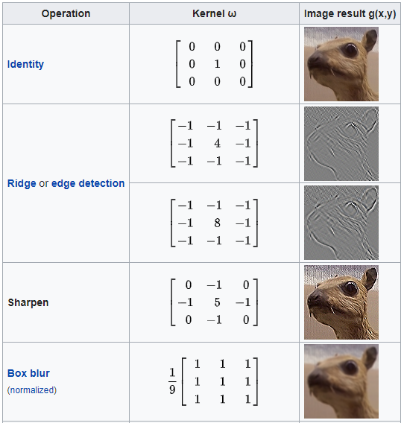
Edge detection is a fundamental part of object recognition. Modern CNNs contain many convolutional layers in their approach. By applying these filters to multiple images and using them in the network to create custom filter shapes. They can then apply these filters through a comparator to new test sets of data, concluding within a probability if the shape it has been trained to find is there.

Section 3.3 gives more insight into the process of an artificial neural network and deep-nets. “Object Detection with Deep Learning: A Review” from IEEE’s TNNLS 2018 [14], highlights the advantages of deep learning well. “They have deeper architectures with the capacity to learn more complex features than the shallow ones. Also, the expressivity and robust training [Figure 5, filter matrix examples] algorithms allow to learn informative object
representations without the need to design features manually.”

  - Artificial Neural Networks

Neural networks as stated in section 3.1 have a long history. They are a form of machine learning and some including CNNs are deep networks. Giving them a higher degree of autonomy with an increased ability to establish and recognise relationships between datasets and real word examples. Figure 6 represents the relation of the terms AI, Machine learning and deep learning.
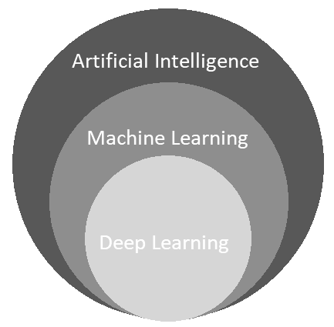
A paper in Procedia Computers Science: “Application of Deep learning for object detection” [15] has a simplified approach in the explanation of CNNs. Appendix B, taken from this paper shows the layered architecture of a CNN for object detection. Here the target object is horse, which is a more complex object that the Lego Block being detected in the proposed system of part two. The Steps in the approach are similar to those shown although less convolution layers and smaller kernels are necessary to detect less complicated objects like blocks.

Although academic resources can be valuable. Intuitive [Figure 6, AI Terms] understanding of NNs is best made with secondary resources such as the brilliant video on YouTube; “But what is a neural network? | Chapter 1, Deep learning” [16]. This chapter of a longer series on the subject begins with examples of detecting handwritten numbers. It proceeds to explain a 4-layer system, breaking an initial 28² pixel image into its 784 components. Then by using two 16 parameter layers, it provides an estimate of the initial number. The two 16-layer components can be viewed as comparisons layers. The first uses kernels similar to the edge detection methods mentioned in 3.2 and the seconds uses more complex filters. Figure 7 depicts a visualisation from this material with an example of their respective filters.
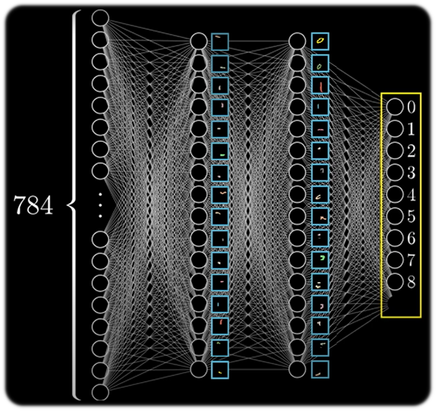
The “pathways” in a network have a weighted value, these pathways along with the filters and a bias parameter with each filter can be manually changed for desired results. However, this simple network has 13,002 total parameters from the weights and biases:
Weights: 784*16 + 16*16 + 16*10 = 12960
Biases: 16 + 16 + 10 = 42
Total = 13,002

The laborious task of changing the parameters is automated within the training process. Most of which in the proposed Lego system will be handled by Edge Impulse with a customer training dataset made by simulation. A review of the produced code will follow. [Figure 7, Neural Net Example [16]]

The final section of this report gives a structure of methodology for both stages of the development process and the current progress toward achieving each goal.

Methodology Preparation and Conclusion

The proposed plan set out in section 2 consists of many technical parts which involve their own set of skills, components in this design has been expanded below and discussed individually.

4.1 Simulation (data collection)
Creating a training dataset via simulation is a necessity task due to the lack of availability of Lego blocks. This simulation will be performed using the Unity engine, a 3D modelling software and game development platform. This simulation engine was chosen because of personal experience with this software and its ability to manipulate lighting effects. It is expected to give excellent training data. However, it is accepted that the simulation data has the chance of producing inaccurate results. In this event, other datasets are available. One example of which by Joost Hazelzet [17] can be substituted.

4.2 Model training
This will initially be handed by Edge Impulse. Improvements on the model will be made and analysis of the code will be present in part 2 of the report. The combination of the training model and test set lead to the results given by the system. It’s important to iterate of each and this will occur during the initial three weeks of stage 2.

4.3 Testing
Providing analytical data is an import part of testing. This process will involve the inclusion of a confusion matrix [18] to represent the accuracy of the system. Model overfitting and anomalous results in this stage will be address during the seconds stage where the same technique will be applied and compared to the original.

4.4 Customisation
The reviews in journals from IEEE and material from individual content creators like 3Blue1Brown [16], have provided detailed analysis of the theory and application of CNNs. This knowledge will be applied in the customisation of the network and through further reading, the outcome is expected to be positive.

4.5 Conclusion
The papers highlighted here have been chosen for their significance and due to the scope of this report, limited resources have been mentioned. The further reading section in references gives a list of other relevant works from the many publications in the field [5]. The review of this literature has provided a solid foundation for stage 2, highlighted areas of possible setback and given examples of ways to mitigate them
References:

[1] E. Cameron. J, Andrews and J. Gillham, (2017), The economic impact of artificial intelligence on the UK economy, PWC. https://www.pwc.co.uk/economic-services/assets/ai-uk-report-v2.pdf

[2] Leonid. Aleksandrov. (2019, November). BrickIt. https://brickit.app/

[3] Lego Group. (2019, 1st April). The long search is finally over. https://twitter.com/LEGO_Group/status/1112625676836880384

[4] Edge Impulse Inc. (2022). We put ML into real products. Retrieved March 1, 2022, from https://www.edgeimpulse.com/

[5] Z, Zou, Z, Shi. Y, Guo and J, Ye. (2019). “Object detection in 20 years: A survey,” arXiv: 1905.05055v2, 1–39.

[6] McCulloch, Warren and Walter, Pitts. (1943). "A Logical Calculus of Ideas Immanent in Nervous Activity". Bulletin of Mathematical Biophysics. 115–133.

[7] Kelley, Henry. (1960). "Gradient theory of optimal flight paths". ARS Journal. 30 (10), 947–954.

[8] P, Viola and M, Jones. (2001) “Rapid object detection using a boosted cascade of simple features” CVPR 2001. IEEE Computer Society Conference vol. 1

[9] P. Viola and M, Jones, (2004) “Robust real-time face detection”, International journal of computer vision, vol. 57, no. 2.

[10] A. Krizhevsky, I. Sutskever, and G. E. Hinton. (2012) “Imagenet classification with deep convolutional neural networks”, Advances in neural information processing systems. 1097–1105.

[11] J. Redmon, S. Divvala, R. Girshick, and A. Farhadi. (2016) “You only look once: Unified, real-time object detection”, IEEE conference on computer vision and pattern recognition, 779–788.

[12] M. D. Zeiler and R. Fergus. (2014) “Visualizing and understanding convolutional networks”, European conference on computer vision. Springer, 818–833.

[13] S. Albawi, T. A. Mohammed and S. Al-Zawi. (2017) "Understanding of a convolutional neural network," 2017 International Conference on Engineering and Technology (ICET), 1-6

[14] Z. -Q. Zhao, P. Zheng, S. -T. Xu and X. Wu. (2019) "Object Detection with Deep Learning: A Review", IEEE Transactions on Neural Networks and Learning Systems, vol. 30, no. 11, 3212-3232.

[15] Ajeet Ram Pathak, Manjusha Pandey, Siddharth Rautaray. “Application of Deep Learning for Object Detection” Procedia Computer Science, Volume 132, 2018, Pages 1706-1717
[16] sanderson, grant. (2017, October 5). But what is a neural network? | Chapter 1, Deep Learning. YouTube. Retrieved December 1, 2022, from https://www.youtube.com/watch?v=aircAruvnKk&t=31s

[17] Hazelzet, J. (2019, December 31). Images of lego bricks. Kaggle. Retrieved December 1, 2022, from https://www.kaggle.com/datasets/joosthazelzet/lego-brick-images
[18] Wikimedia Foundation. (2022, August 31). Confusion matrix. Wikipedia. Retrieved December 1, 2022, from https://en.wikipedia.org/wiki/Confusion_matrix

Further Reading:

[19] Padilla, R., Netto, S. L., & da Silva, E. A. (2020). A survey on performance metrics for object-detection algorithms. 2020 International Conference on Systems, Signals and Image Processing (IWSSIP). https://doi.org/10.1109/iwssip48289.2020.9145130
[20] Z. -Q. Zhao, P. Zheng, S. -T. Xu and X. Wu. (2019). "Object Detection With Deep Learning: A Review", 2019 International Conference on Neural Networks and Learning Systems (IWCCLS). https://doi.org/10.1109/TNNLS.2018.2876865.
[21] Muhammad, K., Khan, S., & Baik, S. W. (2020). Efficient convolutional neural networks for fire detection in surveillance applications. Deep Learning in Computer Vision, 63–88. https://doi.org/10.1201/9781351003827-3
[22] Liu, Y., Sun, P., Wergeles, N., & Shang, Y. (2021). A survey and performance evaluation of deep learning methods for small object detection. Expert Systems with Applications, 172, 114602. https://doi.org/10.1016/j.eswa.2021.114602
[23] Zhenghua, Z., Ling, J., & Qingqing, H. (2021). A survey of small object detection based on Deep Learning. The Proceedings of The 8th International Conference on Intelligent Systems and Image Processing 2021. https://doi.org/10.12792/icisip2021.009
[24] Zhang, D., Hu, J., Li, F., Ding, X., Kumar Sangaiah, A., & S. Sheng, V. (2021). Small object detection via precise region-based fully convolutional networks. Computers, Materials & Continua, 69(2), 1503–1517. https://doi.org/10.32604/cmc.2021.017089
[25] Wang, J., Song, L., Li, Z., Sun, H., Sun, J., & Zheng, N. (2021). End-to-end object detection with fully convolutional network. 2021 IEEE/CVF Conference on Computer Vision and Pattern Recognition (CVPR). https://doi.org/10.1109/cvpr46437.2021.01559

APPENDIX A

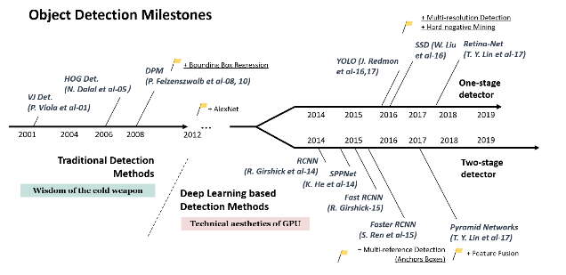
Figure 2 from [4]

APPENDIX B

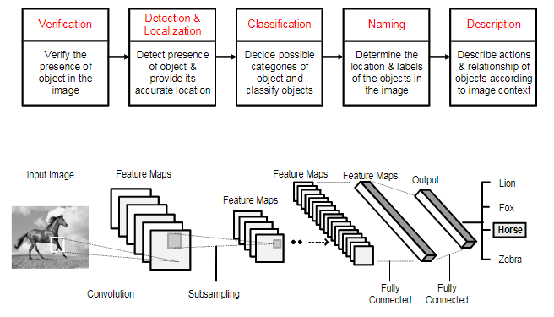
Figure 4 from [15]

