Requirements:

(1) Wordpress, MAMPS - Prerequite

(2) Plugins – Gutenberg, Block Lab

(3) Themes – news_themes, (includes images assets, json, blocks)

Step-by-step Instructions:

1. Be sure that MAMPS and wordpress were installed into your machine before proceeding with the website creation.

Wordpress at <https://wordpress.org/download/>

2. Once wordpress has been installed into your machine. Install the following plugins: Gutenberg and block lab.

2-a. Go to Plugins->Add New

2-b. Search and Activate these 2 plugins

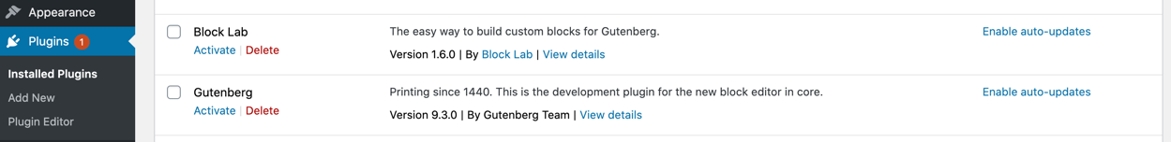

3. Update your themes into news_themes

3-a. Upload your news_themes (or copy new_themes into /themes folder)

3-b. Got to wordpress Plugins->themes

3-c. Select and Activate news_themes

3-d. Be sure that your permalinks is in Post Name

Go to Settings->Permalinks

Select Post Name

4. Create Blocks – create the following blocks Mastheads and Request Quote form

4.a. Create Mastheads logos

Select Add New

4-b. Then, fill up the following fields:

Field Label is Logo Urls

Field Name is logo-urls

Field Types is Url

Category is Custom Category

New Category is News Blocks

Click Publish.

4c. Click the Close Field button and create Block for Request Quote

Field Label is Request Quote Url

Field Name is request-quote-url

Field Types is Url

Category is Custom Category

New Category is News Blocks

4-d. Then Activate the 2 Blocks

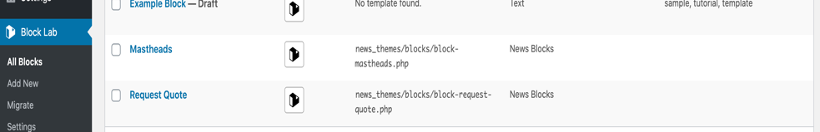

5. Create Request Quote page.

5-a. In wordpress, Go to Pages->Add New

Click the + button. Then search for the 2 News Block that we’ve created.

5-b. Select Mastheads. Then put the url - <http://www.hexsoftstudio.com/demo/wp-content/themes/news_themes/json/mastheads.json> or just in your local <http://localhost:8888/wordpress/wp-content/themes/news_themes/json/mastheads.json>

A similar draft will be shown below:

5-c. Click View Page button.

5-d. Then, Update other settings

6. At the page, Click customise

6-a. Then update the Header Image

6-b. Click Add new image. Then upload the image provided in /themes/news_themes/assets

6-c. Crop the image similar to below:

6-d. Click Publish and you’ll be able to see the header in the page

6-e. You might need to update the Site Identity and Tag Line

6-f. Click Publish.

7. Remove unnecessary widgets

7-a. For demo purposes, please remove widgets. Go to Customiser, select Widgets.

7-b. Please remove the following. (Note this can be remove in php but, for this purpose, we just remove widgets)

8. Request Quote – Your page should be at least similar to the page below: has subscription links, header, request a quote button, mastheads logo, form request, footer.

Or go to this Url for live page: <http://www.hexsoftstudio.com/demo/request-quote>

Demo Pages:

Website Quote - <http://www.hexsoftstudio.com/demo/request-quote>

Themes – attached zip (themes, docs, json, blocks, php)

Json Mastheads - <http://www.hexsoftstudio.com/demo/wp-content/themes/news_themes/json/mastheads.json> or <http://localhost:8888/wordpress/wp-content/themes/news_themes/json/mastheads.json>

React Form – <https://fathomless-ocean-14867.herokuapp.com>

PHP Test: please see themes

Doc: please see themes

Author: Jose Quitain