**Abstract**

Indigo is a natural dye that is widely used in the textile industry worldwide. However, the synthesis of indigo using toxic compounds such as aniline, formaldehyde, and hydrogen cyanide leads to environmental pollution and poses a threat to workers' health. To overcome these challenges, bio-indigo or indigo biosynthesis has been proposed to replace indigo synthesized from aniline. Among the various biosynthesis methods, Flavin-containing Monooxygenases (FMOs) have been found to achieve the highest yield (1700 mg/L) of bio-indigo. However, the commercialization of indigo biosynthesis still faces several challenges. This review explores the history of indigo biosynthesis by FMOs and identifies the expensive substrate L-tryptophan, unsuitable chassis Escherichia coli, and relatively low yield and high cost compared with the chemical method as the main reasons. Additionally, this paper summarizes the strategies to improve the yield and applications of indigo synthesized by FMOs.

**Keywords:** Flavin-containing Monooxygenase, Indigo

**Introduction**

Indigo, a naturally occurring dye derived from botanical sources, boasts a historical legacy of more than 6,000 years, with extraction methods deeply rooted in tradition. Its prominent application in the textile industry, notably in the dyeing of jeans and various fabrics, underscores its industrial significance. However, the prevailing manufacturing paradigm, yielding approximately 80,000 tonnes of indigo annually, relies extensively on non-renewable petrochemicals. This conventional approach concurrently precipitates the formation of deleterious compounds (Stasiak et al. (2014) and Linke, J.A. et al. (2023)). In response to the environmental ramifications intrinsic to such processes, the conceptualization of bio-indigo has emerged as a prospective avenue. This innovative paradigm employs synthetic biology methodologies to effectuate the synthesis of indigo from tryptophan or indole, presenting a promising trajectory towards a sustainable and environmentally benign indigo production methodology.

While numerous countries, including China, the United States, and France, host companies actively engaged in the commercialization of bio-indigo, progress has been impeded by suboptimal yields. Addressing this challenge, flavin-containing monooxygenases (FMOs) have emerged as focal points of investigation, given their demonstrated capability to synthesize bio-indigo. Notably, FMOs have become the subject of extensive research over the past decades, positioning them as one of the pivotal enzymatic entities in endeavors to overcome the limitations associated with bio-indigo production.

Flavin-containing monooxygenase (FMO, EC 1.14.13.8), classified as a member of the class B flavoprotein monooxygenases (FPMOs), is encoded by a singular gene and features a tightly bound flavin adenine dinucleotide (FAD) cofactor. Recent investigations have brought to light a comprehensive indigo-catalytic model of FMOs, as detailed by Ziegler in 1993 (Fig. 4E). The catalytic process unfolds in five discrete stages: (1) the NADPH-driven reduction of FAD to FADH2, accompanied by an additional H+; (2) the interaction of FADH2 with O2, yielding a stable C4a-(hydro)peroxide intermediate; (3) the substrate undergoes unassisted oxidation without specific binding; (4) release of the residual oxygen atom as H2O; and (5) the entire cycle resets to the initial state upon the dissociation of NADP+ from FMO.

**1. The Research History of Indigo Biosynthesis by FMOs**

In the quest for indigo biosynthesis, exploration into microbial synthesis pathways has been proposed. Engineered *Escherichia coli* (*E. coli*) has notably demonstrated its efficacy as a viable platform for indigo biosynthesis, as evidenced by seminal studies (Ensley et al., 1983; Murdock et al., 1993; Berry et al., 2002; Doukyu et al., 2003). Throughout the research discussed in this chapter, *E. coli* predominantly serves as the chosen chassis for investigating indigo synthesis pathways.

Following the oxidation of indole to indoxyl, the subsequent spontaneous dimerization of two indoxyl molecules, accompanied by a reaction with oxygen, results in the formation of indigo. Consequently, a pivotal aspect in the biosynthesis of indigo revolves around the judicious selection of an appropriate oxidase to catalyze the conversion of indole to indoxyl. Therefore, this review will explore the history of indigo biosynthesis in the order of the utilization of different oxidases in this transformative process.

**1.1 Early Research on Indigo Biosynthesis**

The earliest record of indigo biosynthesis arises from the study of naphthalene dioxygenases (NDO) form *Pseudomonas putida* PpG7. In 1983, Ensley pioneered the construction of the initial synthetic indigo-producing Escherichia coli (E. coli) strain by introducing NDO, yielding an indigo production of 25 mg/L. Notably, native *E. coli* tryptophanase (TRP/TnaA) was utilized to convert L-tryptophan to indole, subsequently catalyzed by NDO to form indigo (Ensley et al., 1983). Building upon this foundation, Ensley and colleagues further explored NDO expression by employing various plasmids and inducers in 1988, providing crucial insights for subsequent investigations. The construction of the pBS959 plasmid in 1989, based on the nahA gene (NDO expressing gene) and pUC19 vector, marked a milestone in realizing indigo synthesis within recombinant E. coli (Boronin et al., 1989). However, the initial expression levels of indigo in recombinant *E. coli* was much lower compared to *Pseudomonas putida*.

In 1993, Murdock et al. enhanced indigo production by incorporating a lac promoter and operator into the plasmid, approaching expression levels comparable to *Pseudomonas putida*, resulting in a yield of 135 mg/L—a notable 5.4-fold increase. The engineered E. coli strain also demonstrated the capacity to produce indigo from glucose by inactivating the trpB gene. Nevertheless, a feedback effect was identified during the formation of 3-deoxy-D-arabino-heptulosonate 7-phosphate (DAHP), indicating the downstream product indigo could inhibit DAHP formation. To overcome this challenge, Berry et al. in 2002 achieved a 60% increase in indigo production by engineering a feedback-resistant DAHP synthase (Berry et al., 2002).

Research extended to explore NDO from different species. In 2010, NDO from *Pseudomonas sp.* HOB1 demonstrated the capability to transform 0.3 mM indole in 8 hours, yielding an impressive indigo production of 246 mg/L (Pathak and Madamwar, 2010). Subsequently, Qu et al. conducted a study in 2012 utilizing an indigo-producing strain named *Comamonas sp.* MQ, which, with the consumption of 0.05 g/L indole and 0.2 g/L naphthalene, produced 32.2 mg/L of indigo (Qu et al., 2012b).

Another extensively explored oxidase for indigo synthesis is toluene dioxygenases. In 1989, Stephens et al. integrated a toluene dioxygenase from *Pseudomonas putida* NCIB 11767 into *E. coli* HB101 using pIG, achieving the synthesis of approximately 60 mg/L of indigo through the supplementation of 5 mM tryptophan (Stephens et al., 1989).

Some recombinant *E. coli* systems for indigo synthesis have been constructed based on multicomponent phenol hydroxylases. From *Acinetobacter sp.* ST-550, Doukyu et al. identified a functional enzyme akin to multicomponent phenol hydroxylases, demonstrating the capacity for indigo synthesis. In 2002, they assessed the performance of *Acinetobacter sp.* ST-550 cultured with 10% diphenylmethane and 0.9 mg/ml indole, resulting in an indigo production of 292 mg/L (Doukyu et al., 2002). Subsequently, in 2003, they engineered the recombinant *E. coli* strain OST3410 with this functional enzyme, yielding a production of 52.1±1.6 mg/L of indigo under the conditions of 10% diphenylmethane and 0.9 mg/ml indole (Doukyu et al., 2003). In 2012, Qu et al. identified a multicomponent phenol hydroxylase from *Arthrobacter sp.* W1 (PHw1), including the measurement of its kinetic parameters to indole (Qu et al., 2012a).

However, it is crucial to note that the practical applications of multicomponent enzymes are constrained by their fermentation conditions. The yield of indigo synthesized by these enzymes has not surpassed 300 mg/L due to the requisite stability of each component under specific conditions, rendering flavin-containing monooxygenases (FMOs) with simpler components more operationally practical.

Moreover, evidence suggests that class D flavoprotein monooxygenases, closely related to FMOs, are capable of synthesizing indigo. Notably, an indole oxygenase (indAB) was identified in *Cupriavidus sp.* SHE has demonstrated the ability to synthesize indigo, achieving a production level of 307 mg/L with the provision of 1.0 g/L tryptophan (Dai et al., 2019). However, further research is needed to elucidate the underlying biosynthetic mechanisms at play in this process.

**1.2 Indigo Biosynthesis by Bacterial FMO**

Researchers aspire to enhance bio-yield and simplify production conditions, with current emphasis on Flavin-containing monooxygenase (FMO) standing out prominently in these endeavors. Bacterial FMO, also referred to as trimethylamine monooxygenase (TMM), exhibits a versatile substrate profile, encompassing the oxidation of various nitrogen and sulfur-containing compounds. Notably, it can catalyze the oxidation of indole, trimethylamine (TMA), dimethylsulfate (DMS), and dimethylsulfoxide (DMSO) (Chen et al., 2011; Choi et al., 2003).

Of great significance is understanding the mechanism by which FMOs contribute to indigo synthesis. In bacterial systems, tryptophan is initially converted to indole by tryptophanase (TRP), and subsequently, FMOs oxidize indole to form either 2-hydroxyindole or 3-hydroxyindole. These intermediates are further oxidized to indoxyl by oxygen. The indoxyls subsequently undergo dimerization, yielding either indigo or indirubin (Fig. 5C). This intricate process underscores the pivotal role of FMOs in the biosynthesis of indigo.

**1.2.1 Bio-indigo Synthesis with mFMO**

The first bacterial FMO employed in engineered *Escherichia coli* for indigo production was *Methylophaga aminisulfidivorans* MPT (mFMO/bFMO). This enzyme was introduced into *E. coli* DH5α via the pBlue 2.0 vector. Following a 12-hour fermentation period supplemented with 2.00 g/L tryptophan, the recombinant E. coli successfully generated 160 mg/L of indigo (Choi et al., 2003). The kinetic parameters of mFMO to indole were measured by Alfieri et al. in 2008 (Alfieri et al., 2008). In 2019, Lončar et al. conducted a re-analysis of the kinetic parameters of wild-type mFMO catalyzing indole (Lončar et al., 2019b).

Nevertheless, the productivity of the original plasmid harboring mFMO exhibited limitations, prompting the implementation of optimization strategies. Through the removal of redundant sequences, the enhanced plasmid demonstrated a significant improvement in indigo yield, reaching 662 mg/L—a remarkable increase of 413% compared to the original production level of 160 mg/L (Han et al., 2008). Subsequently, through culture optimization with the method of response surface methodology (RSM), a notable milestone was achieved with a yield of 920 mg/L in a 5L fermenter. Further advancements led to the development of a larger-scale fermentation system, culminating in an impressive yield of 911 ± 22 mg/L of indigo in a 3,000 L/batch setup, with an input of 2 g/L of tryptophan (Han et al., 2011). Han et al. also reported a continuous fermentation conducted in a 5L system supplied with 3 g/L tryptophan, in which 23 g of indigo was produced for 110 hours, at a rate of 11.3 mg/L/h (Han et al., 2011).

The redox reaction of the tightly linked flavin adenine dinucleotide (FAD) cofactor, intrinsic to flavin-containing monooxygenases (FMO), is contingent upon the assistance of nicotinamide adenine dinucleotide phosphate (NADPH) (Alfieri et al., 2008; Eswaramoorthy et al., 2006; Krueger and Williams, 2005). However, in extracellular enzyme reaction systems or recombinant cells, the rate of NADPH regeneration may constrain the overall reaction rate. To address this, an optimized strategy involved the fusion of mFMO and phosphate dehydrogenase (PTDH), exploiting phosphate as a cost-effective and sacrificial substrate (Rioz-Martinez et al., 2011). The researchers further examined the catalytic efficiency of purified PTDH-mFMO and cell-free extract (CFE), discovering that the purified enzyme exhibited superior performance, yielding 300 mg/L of indigo when supplied with 10 mM indole (Lončar et al., 2019b).

Furthermore, directed evolution was employed to modify mFMO, utilizing a computational library design protocol named FRESCO, a structure-based enzyme engineering tool for stabilization (Wijma et al., 2018). FRESCO was leveraged to enhance mFMO's thermostability. Lončar et al. conducted screening for site-directed mutants and multichange isothermal mutagenesis (MISO) mutants. Some of these mutants exhibited an increase in the apparent melting temperature (Tm) by 3 °C, while others demonstrated enhanced catalytic performance on indole (Lončar et al., 2019b). Notably, in 2022, the catalytic efficiency of mFMO was improved by 6.6-fold through the application of FRESCO (Sun et al., 2022).

Additionally, the enzyme tryptophanase (TRP) can convert tryptophan into indole and pyruvate (Shimada et al., 2004). Given that pyruvate can serve as a substrate for the generation of NADPH within the cell, a comprehensive integration of earlier research on yield improvement, including sequence optimization, led to the development of a bifunctional fusion enzyme, mFMO-TRP. This novel approach enabled the efficient conversion of 2.0 g of tryptophan into 1.7 g of indigo per liter of culture, representing the highest amount ever reported in the literature (Fabara and Fraaije, 2020). In 2023, utilizing TnaA, a TRP from E. coli K12, Ham et al. achieved indigo production of 1.08 g/L when supplied with 10 mM tryptophan (Ham et al., 2023).

Methods for indigo production using glucose as a substrate have been developed, as researched by Murdock et al., and later applied by Du et al. (Du et al., 2018). Chen et al. further investigated and enhanced this process by introducing a novel approach involving the use of 5 g/L glycerol as a substrate for indigo production. This modification resulted in a production yield of 104.3 mg/L, surpassing the performance achieved using glucose alone (Chen et al., 2021).

Rioz-Martinez et al. illustrated the efficacy of mFMO-PTDH by catalyzing the oxidation of indole and indole thioanisole derivatives, resulting in the synthesis of a diverse array of indigo compounds, each manifesting distinctive colors (Rioz-Martinez et al., 2011). Notably, mFMO-PTDH exhibited the capability to synthesize modified indigo, including halogenated indigo variants (Schnepel et al., 2021). This bifunctional enzyme, mFMO-PTDH, not only showcases proficiency in oxidizing indole and its analogs but also demonstrates potential in chirality selection, particularly in the biocatalytic sulfoxide oxidation of prochiral sulfides (Pereira et al., 2022; Wojaczyńska and Wojaczyński, 2020). A consecutive two-cell reaction system was devised for the synthesis of dichloro-indigo, a halogenated variant of indigo, starting from tryptophan.

Indigo's intrinsic insolubility in water necessitates the addition of reductants, such as sodium sulfate, to transform it into a water-soluble dye during practical production. However, this conventional approach brings about economic and environmental burdens. To overcome the insolubility challenge of indigo in water, a novel strategy involving chemical group protection has been proposed. This innovative method entails the co-expression of a glycosyltransferase from Polygonum tinctorium with mFMO in Escherichia coli. This co-expression introduces a glucose group to protect the active hydroxyl group of hydroxyindole, resulting in the creation of a water-soluble and stable pigment named indican (Hsu et al., 2018). Through fed-batch fermentation, the recombinant E. coli strain TMH011 successfully produced 2.9 g/L of indican. Given that two indoxyl molecules are required to produce one indigo molecule, the fermentation result can be converted to 1.4 g/L of indigo production. This approach offers a promising solution to enhance the environmental sustainability and economic viability of indigo synthesis.

Indirubin, an indole alkaloid with applications as a drug in chronic myeloid leukemia, has exhibited anticancer effects (Yang et al., 2022). Traditional production methods have relied on plant cell culture extraction. However, with the utilization of the improved mFMO (Han et al., 2008), the biosynthetic pathway of indirubin has been further explored. Cysteine was identified to enhance the selectivity of FMO for 2-hydroxyindole (Han et al., 2013), resulting in a yield of 223.6 mg/L under optimized conditions. In a fed-batch fermentation conducted by Du et al., mFMO and *Escherichia coli* tryptophanase (TRP) were employed to biologically synthesize indirubin using glucose as the primary substrate. This system yielded 56 mg/L of indirubin and 640 mg/L of indigo with a fed glucose concentration of 5.4 g/L (Du et al., 2018). Subsequent studies revealed that cysteine significantly influenced the catalytic selectivity of mFMO. As the concentration of cysteine increased during the oxidation catalytic process, the reaction tended towards indirubin synthesis (Kim et al., 2019), holding considerable significance for the synthesis of indirubin by mFMO. In 2022, a semi-rational design, combined with modifications in two regions (K223R/D317S) of FMO, was applied. Through metabolic engineering technology, E. coli strains were screened to achieve high indirubin production, reaching the current maximum yield of 860.7 mg/L (Sun et al., 2022).

The bio-production of indigo can be extended by co-culturing with other materials to achieve in vitro coloration. In 2023, Cho et al. demonstrated the simultaneous production of polyhydroxybutyrate (PHB) film and isobutanol in *E. coli* BL21(DE3) along with indigo catalyzed by mFMO. This innovative approach yielded 1.1 mg of indigo per gram of PHB content (Cho et al., 2023a) and 194.1 mg/L of indigo with the production of 5.8 g/L of isobutanol (Cho et al., 2023b). This research showcases the potential for versatile applications of indigo bio-production in combination with other materials.

**1.2.2 Bio-indigo Synthesis with Other FMOs**

In addition to mFMO, researchers have explored other flavin-containing monooxygenases (FMOs) for indigo synthesis.

In 2015, Ameria et al. discovered an FMO from *Corynebacterium glutamicum* (cFMO) and cloned it into *E. coli* WCO21 using pMCF14. After 48 hours of fermentation with a supplementation of 2.50 g/L tryptophan, the system produced 685 mg/L of indigo and 103 mg/L of indirubin (Ameria et al., 2015). Subsequently, Jung et al. investigated cFMO through site-directed mutagenesis. The mutant with T326S was cloned into E. coli WTS326, resulting in a production of 1040 mg/L of indigo and 112 mg/L of indirubin (Jung et al., 2018).

In 2019, Lončar et al. identified a new FMO from *Nitrincola lacisaponensis* (NiFMO), which exhibited an optimum catalytic temperature of 51 °C. Sequence alignment indicated that NiFMO shares 74% sequence identity with mFMO. In 2021, Inoue et al. cloned the FMO from *Polygonum tinctorium* (PtFMO), a plant from which indigo is naturally extracted. The recombinant *E. coli* demonstrated the capability to produce indigo, yielding 30 mg/L in 24 hours (Lončar et al., 2019; Inoue et al., 2021).

**2. The Difference between Synthetic Technologies**

This chapter will review the differences among synthetic technologies. Initially, we will delve into the technologies employed in crafting the biosynthetic system, beginning with the genetic modification of the host cell's metabolic pathway in the upstream process, extending to fermentation in various scales and under diverse fermentation conditions in the downstream. Subsequently, we will compare different research methodologies, starting with enzyme purification and culminating in the assessment of indigo fermentation rates.

In light of this article, we chose to define the improvement in yield after the implementation of each technology as the variable for measurement. It is worth mentioning the complexity of these technologies and the potential for their simultaneous utilization. Thus, in our subsequent discussion, we will categorize and evaluate each synthetic technology to present a comprehensive and responsible analysis of their individual and collective contributions to indigo biosynthesis.

**2.1 Genetic Modification of the Host Cell’s Metabolic Pathway**

The central objective of modifying host cells is to optimize conditions for the efficient production of indigo within recombinant cells. While the technical feasibility of an industrial bioconversion process, using E. coli expressing NDO, to transform tryptophan or indole into indigo exists, its economic attractiveness may be limited. Additionally, considering the toxicity associated with indole, the prospect of combining de novo synthesis of indole and the synthesis of indigo within a single cell appears more promising.

To tackle these challenges, researchers strategically deactivated the *trpB* gene. This deactivation was aimed at confirming indigo expression from glucose or other carbon substrates involved in the metabolic pathway that leads to the formation of phosphoenolpyruvate (PEP). Known as the Chorismate pathway, PEP can further react with erythrose 4-phosphate (E4P) to synthesize 3-deoxy-D-arabino-heptulosonate 7-phosphate (DAHP), marking the initial step of the pathway. This Chorismate pathway triggers a sequence of reactions leading to tryptophan synthesis. The trpB enzyme catalyzes the final step of synthesizing tryptophan from indole within this pathway. Deactivating trpB in the host cell with the method of substituting the arginine at position 379 with a proline validated the most accumulation of indole from carbon substrates. Besides, this modification from prior research on the oxidase of naphthalene dioxygenases (NDO) offers the advantage of being seamlessly extended to FMOs in the pursuit of enhanced indigo production. (Murdock et al., 1993)

Subsequent investigations conducted by Berry et al. have revealed that, during the initial step of DAHP synthesis, the final product, indigo, can deactivate the DAHP synthase, showing a feedback effect. In response to this challenge, researchers engineered the synthase into a feedback-resistant type as a crucial intervention. In response to this challenge, researchers engineered the synthase into a feedback-resistant type as a crucial intervention. The production of recombinant microorganisms was approximately 10 g/L of indigo in a fed-fermentation, falling short of the expected yield (about 37 g/L). Further metabolic engineering was undertaken to achieve higher production.

Another enzyme in the Chorismate pathway, anthranilate synthase, encoded by the trpE gene, was also modified to be insensitive to feedback inhibition by tryptophan. Berry et al. also enhanced the activity of DAHP synthase through two methods. The first method involved increasing the copy number of the DAHP synthase-encoding gene, while the second method focused on amplifying the enzyme catalyzing the synthesis of E4P, and improving the accumulation of PEP, thereby increasing the accessibility of DAHP synthase to substrates. The combination of these strategies resulted in a system showing approximately 16 g/L of indigo production after 60 hours, representing a 60% increase. (Berry et al., 2002) This metabolic engineering approach was subsequently applied to the indirubin biosynthesis system constructed by recombinant mFMO in 2018 (Du et al., 2018).

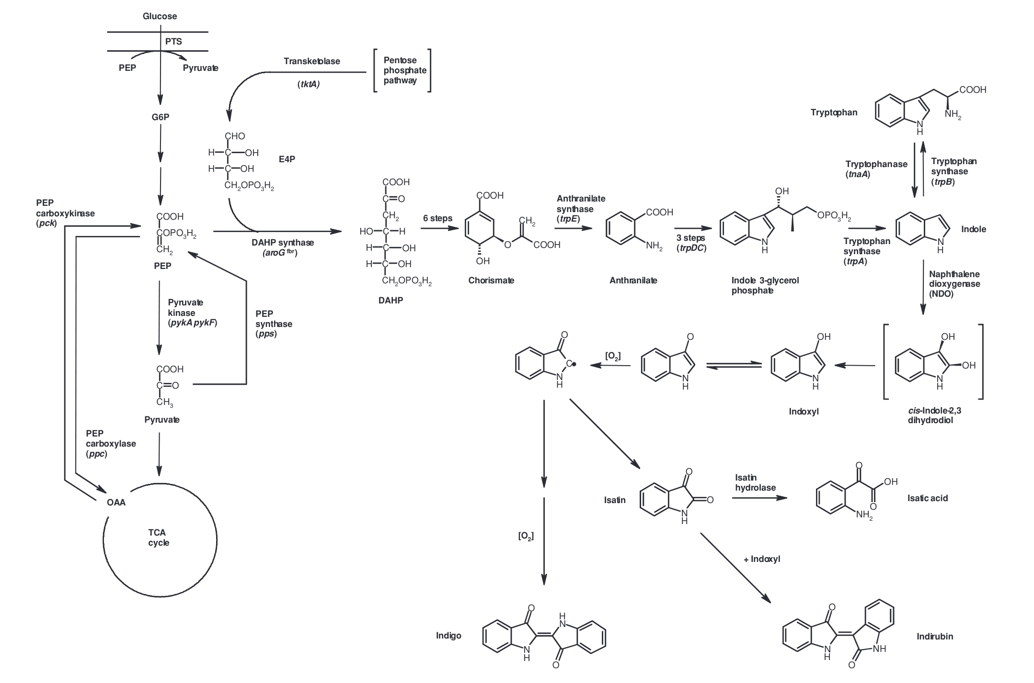

(Berry et al., 2002)

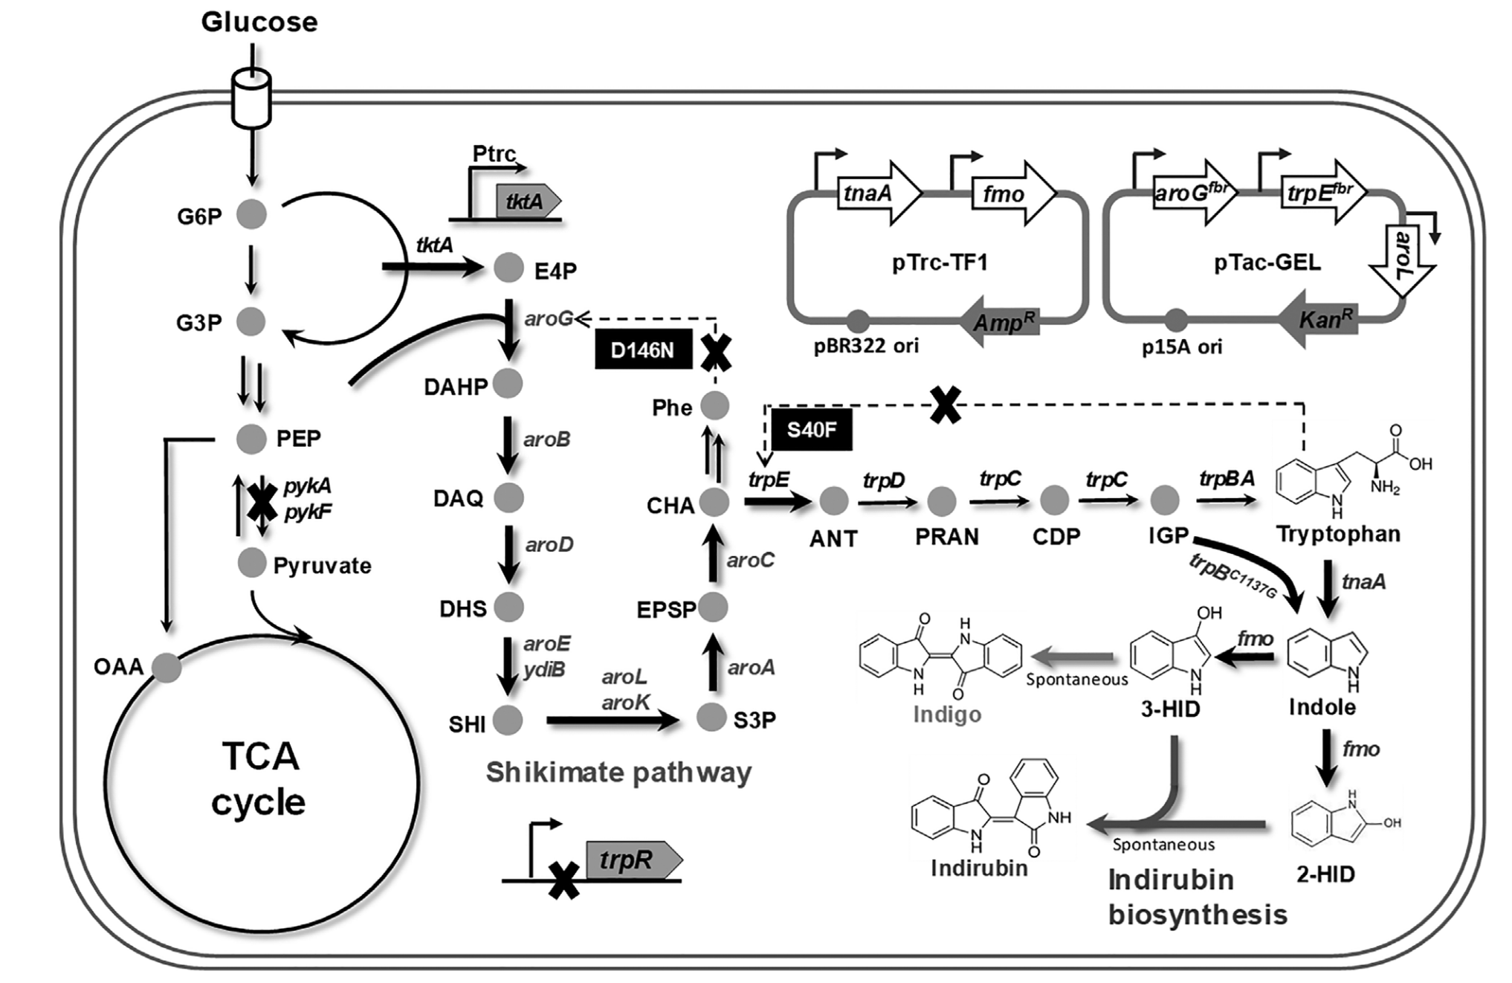

(Du et al., 2018)

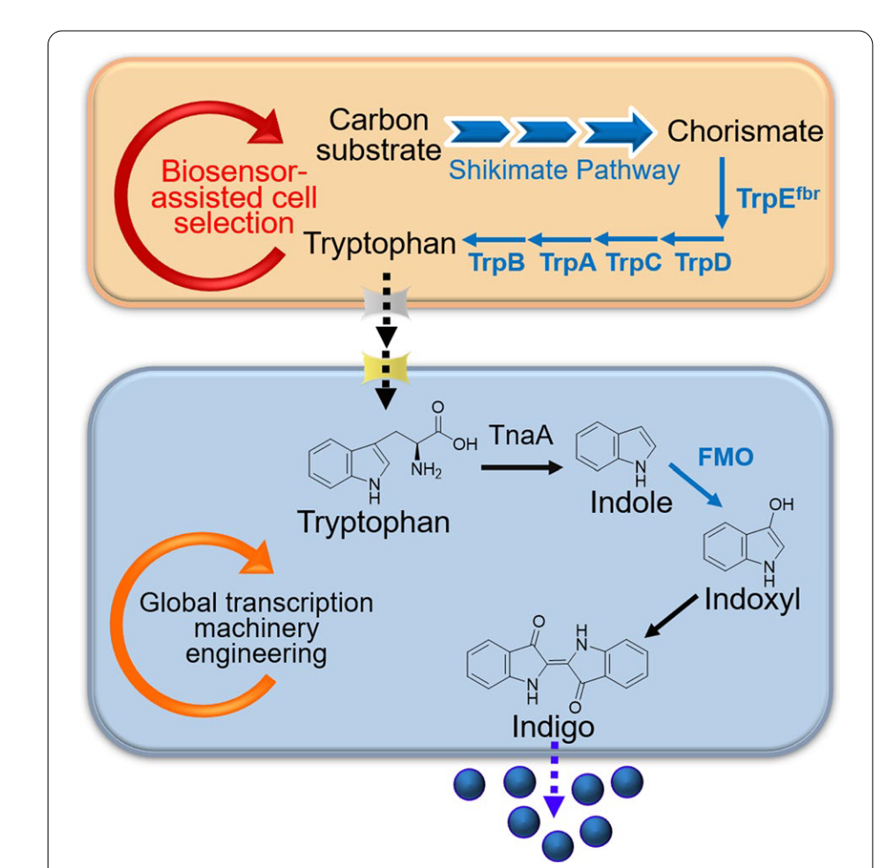

(Chen et al., 2021)

(figure 5 C can be improved by adding the information of Chorismate pathway (Shikimate pathway) from these two figures)

**2.2 The Optimization of, Plasmid, Promoter, and Enzyme Sequence**

The early research on Naphthalene Dioxygenases (NDO) has investigated how the choice of plasmid could influence the production of indigo. After the construction of the first recombinant microorganisms capable of producing indigo, Ensley et al. promptly explored the differences between various recombinant plasmids and inducers (Ensley et al., 1988). In 1989, due to the high structural stability of the recombinant plasmid pBS959, Boronin et al. introduced pBS959 into the fermentation system. The initial construction of mFMO, expressed through the vector pBlue 2.0, was accomplished by Choi et al. in 2003 (Choi et al., 2003). Subsequently, in 2008, Han et al. investigated the impact of plasmid length on yield outcomes. They systematically removed redundant sequences from the plasmid by truncating the insert, conducting research spanning from pBlue 1.6 to 2.0. In comparison to various catalytic solutions explored previously, they achieved the highest yield of 662 mg/L with the plasmid pBlue 1.7 (Han et al., 2008). This improvement represented a substantial 4.14-fold increase over Choi's initial result of 160 mg/L.

Directed evolution was employed as an approach to achieve higher apparent melting temperature (Tm) and enhanced catalytic activity in mFMO. Utilizing a computational library design protocol named FRESCO, Lončar et al. successfully improved mFMO's thermostability by 7.7 °C, aligning it more closely with industrial requirements. Screening for site-directed mutants and multichange isothermal mutagenesis (MISO) mutants was conducted, and the C78I mutant achieved the highest kcat to indole of 0.31 s-1, while the Y207W mutant obtained the lowest Km of 0.1 mM. In comparison to the kinetic parameters of the wild-type mFMO (0.85 s-1 of kcat and 400 mM of Km), these mutants demonstrated significant improvements (Lončar et al., 2019b). Notably, in 2022, the catalytic efficiency of mFMO saw a remarkable 6.6-fold improvement through the application of FRESCO, as reported by Sun et al. (2022).

The choice of inducers has been shown to yield varying results. In the early investigation of NDO, it was observed that the expression level of recombinant microorganisms was significantly lower than that of *Pseudomonas putida* PpG7. To address this, Murdock et al. successfully enhanced catalytic activity in recombinant cells by incorporating a strong λPL promoter, bringing them closer to the activity levels observed in *P. putida*, with an increase of indigo production by 5.4-fold. To achieve high expression of mFMO, some researchers chose the T7 promoter (Qu et al., 2012a; Hsu et al., 2018; Chen et al., 2021). In 2018, Du et al. introduced a pTrc-TF1 plasmid expressing TnaA under the *trc* promoter and mFMO under the *tac* promoter, resulting in higher production compared to other plasmids with different promoter settings (Du et al., 2018). Moreover, studies catalyzing indigo using FMO from *Corynebacterium glutamicum* (cFMO) have also employed plasmids containing the *tac* promoter (Ameria et al., 2015; Jung et al., 2018).

**2.3 Fermentation Engineering**

Batch fermentation serves as the foundational format for fermentation processes, typically executed in a 500mL batch (Ensley et al., 1983; Doukyu et al., 2002). This format can be scaled up significantly, with larger-scale fermentations reaching volumes as substantial as 3000L. The duration of fermentation plays a pivotal role in indigo production and exhibits variability based on the fermentation scale. Han et al. (2011) successfully scaled up fermentation to 3000L, demonstrating consistent indigo yields between their 5L culture (920 mg/L) and the larger 3000L batch (911 ± 22 mg/L) (Han et al., 2008; Han et al., 2011). In typical batch fermentation scenarios, the duration ranges from 8 to 24 hours (Doukyu et al., 2002). However, alternative fermentation methods introduce variations in production times.

Fed-batch fermentation represents an extension of production time, often spanning 48 to 72 hours. This method involves the gradual addition of nutrients throughout the fermentation process, optimizing conditions to enhance indigo yield. In 2002, Berry et al. applied fed-batch fermentation to NDO-catalyzed indigo biosynthesis, achieving the highest biosynthetic indigo production of 23 g/L, with a feed of 400 g/L tryptophan over 42 hours. Similarly, Sun et al. utilized fed-batch fermentation with mFMO, resulting in indirubin production reaching 860.7 mg/L, equivalent to 18 mg/(L*h) (Sun et al., 2022).

Specialized fermentation methods, like continuous fermentation, introduce an extended timeline, with completion times reaching up to 110 hours. This extended duration, as demonstrated in the 5 L continuous fermentation system constructed by Han et al. in 2011, facilitates a continuous supply of nutrients and substrates, contributing to sustained indigo production. In this specific system, the outcome was 23 g of indigo produced, equivalent to 11.3 mg/(L*h) (Han et al., 2011).

**3. The Substrates of Indigo Biosynthesis by FMOs**

Over the past four decades, researchers have dedicated significant efforts to the study of substrates involved in the biosynthesis of indigo. Their endeavors have been focused on gaining a profound understanding of the mechanisms of enzymes and the intricate reaction pathways associated with different substrates. Leveraging cutting-edge technologies, researchers have employed genetic modification strategies, manipulating microbial hosts such as *Escherichia coli*. Additionally, through optimizing the genes encoding crucial enzymes in the synthesis pathway, researchers have sought to fine-tune the activity of these enzymes, exploring the use of various plasmids and promoters to achieve the highest conversion rates for the selected substrates.

It should be mentioned here that indole has toxicity to the host microorganism. Therefore, it is not appropriate to directly use indole as the fermentation substrate. Usually, tryptophan was used as an alternative. Then we’ll discuss the development of substrates used in the fermentation.

**3.1 The Enzymatic Properties of Different FMOs**

**3.1.1 Kinetic Parameters of Different FMO Subtypes on Indole**

Firstly, the kinetic parameters show the properties that FMOs have in the catalysis of indole to indigo. Showing this will help the researchers in the future to compare the differences and make the choice of the FMO they would further study to create more productive strains helping indigo fermentation. The kinetic parameter was investigated by ---, and the result showed the difference between the catalytic properties of site-directed mutants and multiple-site mutants. The range also showed a trend of lower kcat getting lower Km.

|  |  |  |  |  |  |  |  |  |
| --- | --- | --- | --- | --- | --- | --- | --- | --- |
| **Species** | **Subtype** | **Variant** | | **Synthetic technology / Remarks** | **kcat, s-1 (indole)** | **Km, μM (indole)** | **Reference** | |
| *Methylophaga aminisulfidivorans* MPT | | | mFMO | same to origin | analysis of the enzymatic properties of mFMO | 0.7 ± 0.03 | 90 ± 14 | Alfieri et al., 2008 |
| mFMO-PTDH | fused to phosphite dehydrogenase (an optimized strategy to recycle NADPH), oxidize indole and indole thioanisole derivatives into a variety of indigo compounds | ~0.5 | 100 to 600 | Rioz-Martinez et al., 2011 |
| WT | wild type mFMO re-analysis | 0.85 | 400 | Lončar et al., 2019b |
| C78I | directed evolution, site-directed mutants | 1.28 | 800 |
| C78V | 1.04 | 700 |
| C78L | 0.7 | 800 |
| C78A | 0.79 | 400 |
| W319A | 0.42 | 900 |
| W319F | 0.64 | 400 |
| Y207W | 0.31 | 100 |
| Y207W/W319A | MISO (multichange isothermal mutagenesis) mutants | 0.8 | 800 |
| C78I/Y207W/W319A | 0.93 | 800 |
| WT |  | 0.22 ± 0.01 | 980 ± 120 | Sun et al., 2022 |
| K223R/D317S | Structure-guided enzyme engineering | 0.79 ± 0.03 | 550 ± 140 |
| *Nitrincola lacisaponensis* | | | NiFMO | WT, PTDH-NiFMO | optimum catalytic temperature reaches 51 °C, sequence identity with mFMO is 74% | 0.11 ± 0.01 | 137 ± 23 | Lončar et al., 2019a |
| **early research of indigo synthesis by other enzymes** | | | | | | | | |
| *Pseudomonas sp.* HOB1 | | |  | WT | new indigo assay procedure: anionic surfactants |  | 300 | Pathak and Madamwar, 2010 |
| *Arthrobacter sp.* W1 (PHw1) | | | multicomponent phenol hydroxylases | WT |  | 2.137 | 5.429 | Qu et al., 2012a |

**Table 1.** The kcat and Km of different FMO subtypes on indigo

In the biosynthetic strategy, indole is used as a substrate or intermediate in the pathway. With the help of heterologous FMO, indole is oxidized to 3-hydroxyindole (indoxyl), which further forms indigo by spontaneous dimerization under aerobic conditions (Choi, 2020; Han et al., 2008).

**3.1.2 Selectivity of FMOs**

In 2013, Han et al. investigated the selective production of 2-hydroxyindole and 3-hydroxyindole (indoxyl) catalyzed by mFMO, examining the influence of different reducing agents on the production outcome. The addition of 0.36 g/L cysteine to the tryptophan medium significantly boosted indirubin production, indicating an enhanced selectivity for 2-hydroxyindole within the 0 to about 2 μM range. This outcome suggested that cysteine has the capacity to modulate the regioselectivity of mFMO. However, it's crucial to note that cysteine also has the side effect of inhibiting the harboring of the fmo gene. The experiment conducted by Han et al. revealed a substantial 9.85-fold decrease in cell numbers upon adding 0.36 g/L cysteine to the medium, indicating a significant impact on the growth of the host cell. Despite these considerations, the minimum concentration of cysteine required for indirubin production was determined to be 0.06 g/L.

Kim et al. elucidated the underlying mechanisms by which cysteine reacted with 3-hydroxyindole to generate 2-cysteinylindoleninone, inhibiting the dimerization of 3-hydroxyindole to generate indigo. This process resulted in the formation of indirubin as the major product (Kim et al., 2019). To enhance indirubin production, cysteine was utilized to screen mFMO mutants with higher indirubin catalytic activity. The N291T mutant, in particular, exhibited a 5.05-fold increase in production compared to the wild-type mFMO (Sun et al., 2022).

**3.2 Culture Improvements**

To address the challenge of indole toxicity, researchers have devised several solutions, one of which involves implementing a two-phase culture system to separate indole and microorganisms. In this system, microorganisms are dispersed in an organic medium. Two key components crucial for the success of this approach are the non-aqueous media and the tolerance of organic solvents by microorganisms. In 1998, Doukyu et al. identified an organism, Pseudomonas sp. strain ST-200, which exhibited tolerance to the organic solvent cyclohexane (Doukyu et al., 1998). Subsequent research efforts led to the isolation of other organic solvent-tolerant microorganisms, such as Acinetobacter sp. ST-550 in 2002, capable of producing indigo at 292 mg/L within a 24-hour timeframe (Doukyu et al., 2002). Expanding on this concept, Doukyu, in 2003, applied the two-phase culture system to E. coli strain JA300 and its cyclohexane-resistant mutant, OST3410. This implementation resulted in an indigo production of 52.1±1.6 mg/L (Doukyu et al., 2003). As the enzyme catalyzing the reaction in this system has not been extensively studied, the potential for improvement in production capacity through methods like metabolic engineering holds promise for future advancements.

When utilizing suitable substrates like tryptophan, it becomes imperative to optimize the culture conditions, disregarding the potential substrate toxicity. Employing proper methodologies such as response surface methodology (RSM) allows for the identification of the most conducive environment for engineering microorganisms to enhance indigo production. In 2008, Han et al. successfully applied RSM to improve indigo production in recombinant microorganisms, elevating it from 662 mg/L to 920 mg/L, representing a remarkable 1.39-fold increase (Han et al., 2008). Building on this success, subsequent research in 2013 focused on altering the culture environment for indirubin production from an anoxic condition to an aerobic condition. This strategic modification resulted in a substantial 2.71-fold increase in production, surging from 82.5 mg/L (anoxic condition) to 223.6 mg/L (aerobic condition) (Han et al., 2013).

**3.3 Using Other Substrates by Engineering**

**3.3.1 Using Tryptophan as Substrate**

In 1983, during the initial discovery of indigo biosynthesis in *Pseudomonas putida* PpG7, researchers observed that supplementing the culture with 10 mM tryptophan or 1 mM indole enhanced indigo production. Subsequent studies highlighted the adverse impact of indole toxicity on microorganisms, prompting increased attention toward tryptophan as a more suitable substrate for indigo synthesis (Murdock et al., 1993; O'Connor et al., 1997). The indigo synthesis mechanism from tryptophan was investigated, leveraging the presence of native tryptophanase (TRP/TnaA) in E. coli. This process involves the conversion of indole to tryptophan and the subsequent TRP-catalyzed reaction, transforming tryptophan into indole and pyruvate. The pyruvate, in turn, fuels the downstream reactions of indigo synthesis (Berry et al., 2002). Notably, the highest recorded indigo production to date was achieved by Fabara and Fraaije in 2020, employing the fusion of TRP with mFMO. This innovative approach resulted in a production of 1.7 g/L with the addition of 2.0 g/L tryptophan to the culture, fermented over 84 hours (Fabara and Fraaije, 2020).

In the catalytic cycle of Flavin-containing Monooxygenases (FMOs), the flavin cofactor is reduced by NADPH to initiate subsequent reactions (Eswaramoorthy et al., 2006). However, in extracellular enzyme reaction systems or recombinant cells, the rate of NADPH regeneration may limit the overall reaction rate. Researchers have addressed this limitation by fusing dehydrogenase with FMOs or constructing recombinants to express these enzymes. Various dehydrogenases, such as those utilizing phosphite, ethanol, and malate as substrates, have been employed for NADPH recycling (Doukyu et al., 2003; Rioz-Martinez et al., 2011). The choice of dehydrogenase depends on the substrates catalyzed to replenish NADPH. An enhancement in the tryptophan system involves utilizing pyruvate generated from TRP catalysis for intracellular metabolism, yielding NADPH to fuel FMO catalysis. Another method for NADPH regeneration involves the use of phosphite dehydrogenase (PTDH), with different dehydrogenases offering diverse substrate options for NADPH recycling (Rioz-Martinez et al., 2011; Lončar et al., 2019b; Lončar et al., 2019a; Pan et al., 2023).

In 2020, Fabara and Fraaije conducted a comparative study on the efficiency of indigo production by recombinant fusion enzymes PTDH-mFMO and TRP-mFMO. The results revealed that the production of TRP-mFMO was 2.54 times higher than that of PTDH-mFMO (Fabara and Fraaije, 2020).

**3.3.2 Using Glucose and Glycerol as Substrates**

The deactivation of the *trpB* gene played a crucial role in enabling indigo expression from glucose, glycerol, or other carbon substrates involved in the metabolic pathway leading to the formation of phosphoenolpyruvate (PEP). This strategic genetic modification allowed for the validation of indigo accumulation from various carbon sources, expanding the substrate flexibility for indigo production.

Subsequent investigations by Berry et al. revealed a feedback effect during the initial step of 3-deoxy-D-arabino-heptulosonate 7-phosphate (DAHP) synthesis, where indigo had a deactivating impact on DAHP synthase. To address this challenge, researchers engineered the synthase into a feedback-resistant type, mitigating the inhibitory effect and enhancing the overall indigo production process. Although the initial fed-fermentation achieved approximately 10 g/L of indigo, it fell short of the anticipated 37 g/L, prompting further metabolic engineering interventions.

Berry et al. delved into modifications of anthranilate synthase encoded by the trpE gene in the Chorismate pathway. Additionally, they amplified DAHP synthase activity, enhancing the accessibility of DAHP synthase to substrates. These comprehensive strategies were not only effective in improving indigo production but were also seamlessly applied to the indirubin biosynthesis system constructed by recombinant monooxygenase (mFMO) in 2018. This successful application showcased the versatility and applicability of utilizing glucose or glycerol as substrates for enhanced indigo production, opening new avenues for sustainable and flexible production processes (Berry et al., 2002; Du et al., 2018; Chen et al., 2021).

**3.4 Modified Indigo Synthesized by FMOs**

In the exploration of mFMO's application in indigo synthesis, researchers have delved into its ability to oxidize not only indole but also various indole derivatives. In 2011, Rioz-Martinez et al. conducted a comprehensive study on the reaction rates of different indole derivatives catalyzed by mFMO. The substrates included chloro-, bromo-, nitro-, hydroxy-, methyl-, and methoxy-indoles, producing indigo derivatives in a spectrum of colors ranging from white and yellow to dark blue (Rioz-Martinez et al., 2011).

Building on this research, Schnepel et al. utilized the fusion enzyme PTDH-mFMO to catalyze bromo-indoles, resulting in dibromo-indigo. This approach explored novel indigoids with distinctive spectral properties (Schnepel et al., 2021). In 2021, further investigations into halogenated indigo synthesis by PTDH-mFMO unveiled different colors in the reaction mixtures, showcasing the versatility of the method with dichloro-, dibromo-, and dichloro-indigos (Lee et al., 2021).

These studies underscore the potential of mFMO in generating a diverse range of indigo derivatives, each with unique properties, contributing to the development of novel pigments and materials in the field of indigo synthesis (Rioz-Martinez et al., 2011; Schnepel et al., 2021).