Name – Mayank

Course – B.Sc.(hons) Computer Science

Roll number – 16113

**Practical Programs :-**

**Program 1:**

\documentclass{article}

\begin{document}

\begin{center}

Hello World! \\

Prof. Naveen Kumar \\

November 15, 2022 \\

\end{center}

Hello World! Today I am learning \LaTeX{}. \LaTeX{} is a great program for writing math. I can write in-line math such as $a^2 + b^2 = c^2$. I can also give equations their own space:

\[

\gamma^2 + \theta^2 = \omega^2

\]

\end{document}

**Screenshots:**

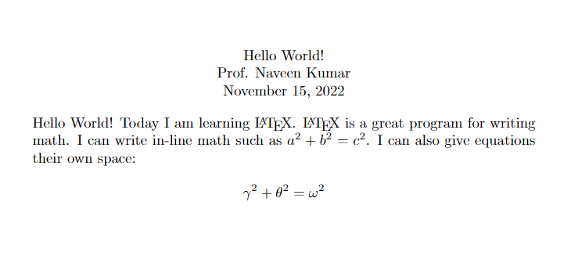

**Program 2:**

\documentclass{article}

\usepackage{amsmath}

\title{}

\author{}

\date{17 April 2023}

\begin{document}

\maketitle

\section{Integrals}

Integrals $\int_{a}^{b} x^2\,dx$ inside text.

The same integral on display:

\[\int_{a}^{b} x^2\,dx\]

and multiple integrals:

\begin{align*}

\iint_V \mu(u,v)\,du\,dv \\

\iiint_V \mu(u,v,w)\,du\,dv\,dw

\end{align*}

\[

\oint_V f(s) \,ds

\]

\section{Sums and Products}

Sum $\sum_{n=1}^{\infty} 2^{-n} = 1$ inside text.

The same sum on display:

\[\sum_{n=1}^{\infty} 2^{-n} = 1\]

Product $\prod_{i=a}^{b} f(i)$ inside text.

The same product on display:

\[\prod_{i=a}^{b} f(i)\]

\section{Limits}

Limit $\lim_{x\to\infty} f(x)$ inside text.

The same limit on display:

\[\lim_{x\to\infty} f(x)\]

\end{document}

**Screenshots:**

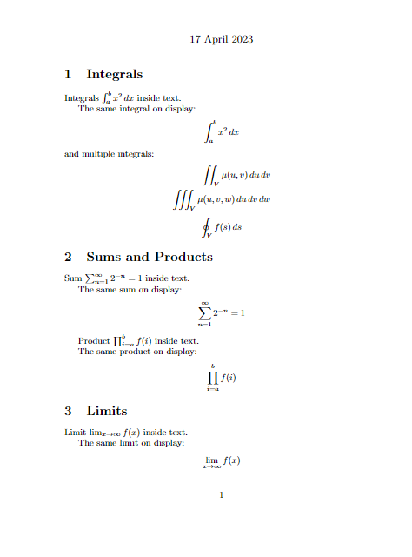

**Program 3:**

\documentclass{article}

\usepackage{amsmath}

\title{}

\author{}

\date{17 April 2023}

\begin{document}

\maketitle

\section{Equation}

\textbf{Hello World!} Today I am learning \LaTeX. \LaTeX{} is a great program for writing math such as $a^2 + b^2 = c^2$. I can also give equations their own space.

\[

\gamma^2 + \theta^2 = \omega^2

\]

\section{Maxwell's Equations}

"Maxwell's equations" are named for James Clark Maxwell and are as follows:

By Gauss's Law

\begin{equation}

\vec{\nabla} \cdot \vec{E} = \dfrac{\rho}{\epsilon_0}

\end{equation}

By Gauss's Law for Magnetism

\begin{equation}

\vec{\nabla} \cdot \vec{B} = 0

\end{equation}

By Faraday's Law for Magnetism

\begin{equation}

\vec{\nabla} \times \vec{E} = -\frac{\partial \vec{B}}{\partial t}

\end{equation}

By Ampere's Circuital Law

\begin{equation}

\vec{\nabla} \times \vec{B} = \mu_0 \left(\epsilon_0 \frac{\partial \vec{E}}{\partial t} + \vec{J}\right)

\end{equation}

\section{Matrix Equation}

\begin{equation*}

\begin{pmatrix}

a_{11} & a_{12} & \dots & a_{1n} \\

a_{21} & a_{22} & \dots & a_{2n} \\

\vdots & \vdots & \ddots & \vdots \\

a_{n1} & a_{n2} & \dots & a_{nn}

\end{pmatrix}

\begin{bmatrix}

v_{1} \\

v_{2} \\

\vdots \\

v_{n}

\end{bmatrix}

=

\begin{bmatrix}

w_{1} \\

w_{2} \\

\vdots \\

w_{n}

\end{bmatrix}

\end{equation*}

\end{document}

**Screenshots:**

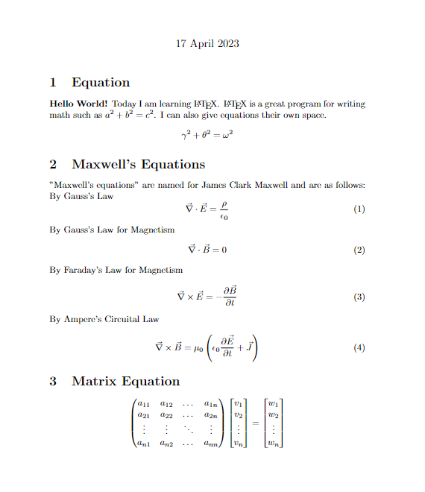

**Program 4:**

\documentclass{article}

\begin{document}

\begin{itemize}

\item Trigonometric functions

\begin{itemize}

\item sine

\item cosine

\item tangent

\end{itemize}

\item Special functions

\begin{itemize}

\item Beta function

\item Gamma function

\item Riemann zeta function

\end{itemize}

\end{itemize}

\end{document}

**Screenshots:**

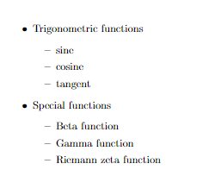

**Program 5:**

\documentclass[11pt]{article}

\usepackage[margin=3cm]{geometry}

\usepackage{algorithm2e}

\begin{document}

\RestyleAlgo{ruled}

%% This is needed if you want to add comments in

%% your algorithm with \Comment

\SetKwComment{Comment}{/* }{ */}

\begin{algorithm}[hbt!]

\caption{An algorithm with caption}\label{alg:two}

\KwData{$n \geq 0$}

\KwResult{$y = x^n$}

$y \gets 1$\;

$X \gets x$\;

$N \gets n$\;

\While{$N \neq 0$}{

\eIf{$N$ is even}{

$X \gets X \times X$\;

$N \gets \frac{N}{2} $ \Comment*[r]{This is a comment}

}{\If{$N$ is odd}{

$y \gets y \times X$\;

$N \gets N - 1$\;

}

}

}

\end{algorithm}

\end{document}

**Screenshots:**

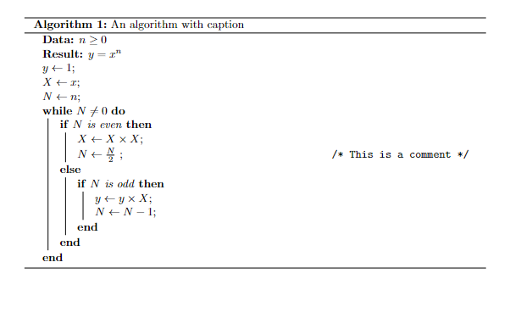

**Program 6:**

\documentclass{article}

\usepackage{array} % Required for custom column widths

\begin{document}

\begin{tabular}{|c|c|c|}

\hline

col1 & col2 & col3 \\

\hline

Multiple row & cell2 & cell3 \\

& cell5 & cell6 \\

& cell8 & cell9\\

\hline

\end{tabular}

\end{document}

**Screenshots:**

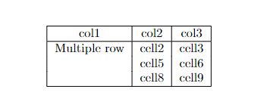

**Program 7:**

\documentclass{article}

\begin{document}

\begin{center}

\begin{tabular}{|c|c|c|}

\hline

\multicolumn{3}{|c|}{Country List} \\

\hline

Country Name & ISO ALPHA 2 & ISO ALPHA 3 \\

\hline

Afghanistan & AF & AFG \\

Aland Islands & AX & ALA \\

Albania & AL & ALB \\

Algeria & ? & DZA \\ % Replace ? with a standard character

American Samoa & AS & ASM \\

Andorra & AD & AND \\

Angola & AO & AGO \\

\hline

\end{tabular}

\end{center}

\end{document}

**Screenshots:**

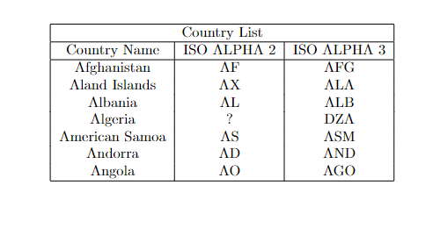

**Program 8:**

\documentclass{article}

\usepackage{graphicx}

\begin{document}

\begin{figure}[h!]

\centering

\includegraphics[width=0.3\textwidth]{Screenshot 2023-12-04 215919.png} % Replace 'image1' with the actual filename of your first image

\caption{Caption for Image 1}

\end{figure}

\begin{figure}[h!]

\centering

\includegraphics[width=0.3\textwidth]{Screenshot 2023-12-04 220136.png} % Replace 'image2' with the actual filename of your second image

\caption{Caption for Image 2}

\end{figure}

\begin{figure}[h!]

\centering

\includegraphics[width=0.3\textwidth]{Screenshot 2023-12-04 220158.png} % Replace 'image3' with the actual filename of your third image

\caption{Caption for Image 3}

\end{figure}

\begin{figure}[h!]

\centering

\includegraphics[width=0.3\textwidth]{Screenshot 2023-12-04 220218.png} % Replace 'image4' with the actual filename of your fourth image

\caption{Caption for Image 4}

\end{figure}

\end{document}

**Screenshots:**

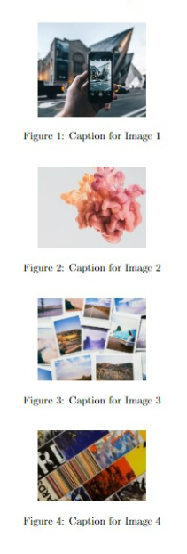

**Program 9:**

\documentclass{article}

\usepackage{lipsum}

\begin{document}

\tableofcontents

\newpage

\section{First Section}

\lipsum[1-2]

\section{Second Section}

\lipsum[3-4]

\listoftables

\begin{table}[h!]

\centering

\begin{tabular}{|c|c|}

\hline

Table Header 1 & Table Header 2 \\

\hline

Data 1 & Data 2 \\

Data 3 & Data 4 \\

\hline

\end{tabular}

\caption{Just a table.}

\end{table}

\listoffigures

\begin{figure}

\centering

\rule{4cm}{3cm} % Dummy figure, replace with \includegraphics{your_image_file}

\caption{This is an image}

\end{figure}

\end{document}

**Screenshots:** 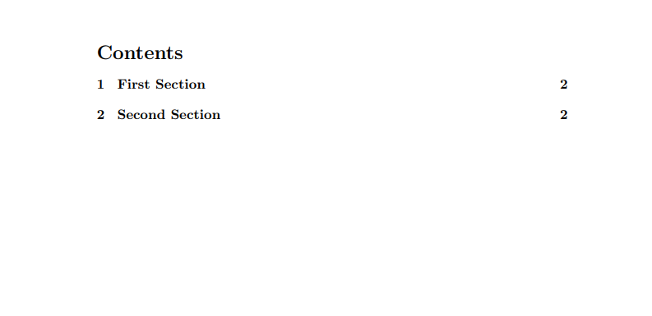

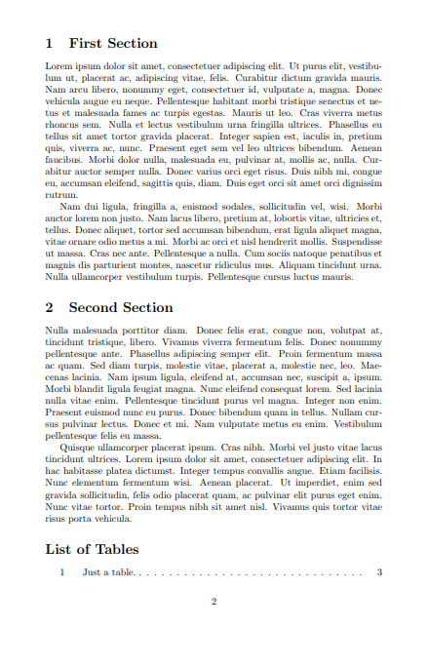 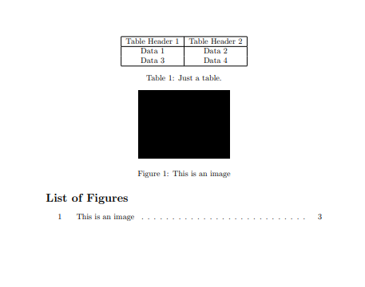

**Program 10:**

\documentclass{article}

\usepackage{natbib}

\usepackage{url}

\begin{document}

This document is an example of the \texttt{natbib} package used in bibliography management. Three items are cited: The \textit{LaTeX Companion} book [2], the Einstein journal paper [1], and Donald Knuth's website [3]. The \LaTeX{} related items are [2,3].

\bibliographystyle{plain}

\bibliography{your-bib-file} % Replace 'your-bib-file' with the actual name of your bibliography file

\section*{References}

\begin{enumerate}

\item A. Einstein. Zur Elektrodynamik bewegter Körper. (German) [On the electrodynamics of moving bodies]. Annalen der Physik, 322(10):891-921, 1905. doi: \url{http://dx.doi.org/10.1002/andp.19053221004}.

\item M. Goossens, F. Mittelbach, and A. Samarin. The \LaTeX{} Companion. Addison-Wesley, Reading, Massachusetts, 1993.

\item D. Knuth. Knuth: Computers and typesetting. \url{http://www-cs-faculty.stanford.edu/~uno/abcde.html}.

\end{enumerate}

\end{document}

**Screenshots:**

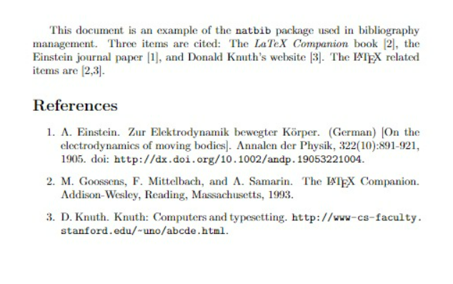

**Program 11:**

\documentclass{article}

\usepackage{amsmath}

\begin{document}

\begin{eqnarray*}

1 + 2 &=& 3 \\

4 + 5 + 0 &=& 7 + 8 \\

9 + 10 + 11 + 12 &=& 13 + 14 + 15 \\

16 + 17 + 18 + 19 + 20 &=& 21 + 22 + 23 + 24 \\

25 + 26 + 27 + 28 + 29 + 30 &=& 31 + 32 + 33 + 34 + 35 \\

\end{eqnarray*}

\begin{eqnarray*}

(a + b)^2 &=& (a + b)(a + b) \\

&=&(a + b)a + (a + b)b\\

&=& a(a + b) + b(a + b) \\

&=& a^2 + ab + ba + b^2 \\

&=& a^2 + 2ab + b^2 \\

\end{eqnarray*}

\begin{eqnarray*}

\tan(\alpha + \beta + \gamma) &=& \frac{\tan(\alpha + \beta)}{1-\tan(\alpha + \beta)\tan\gamma} \\

&=&\frac{\frac{\tan \alpha+\tan \beta}{1- \tan \alpha \tan \beta}+ \tan \gamma}{1- \left ( \frac{\tan \alpha+ \tan \beta}{1- \tan \alpha \tan \beta} \right) \tan \gamma} \\

&=& \frac{\tan\alpha+\tan\beta+(1-\tan\alpha\tan\beta)\tan\gamma}{1-\tan\alpha\tan\beta-(\tan\alpha+\tan\beta)\tan\gamma}\\

\end{eqnarray*}

\end{document}

**Screenshot:**

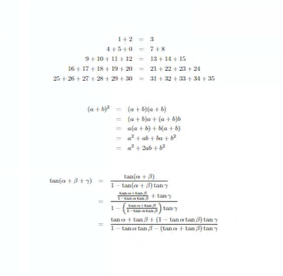

**Program 12:**

\documentclass{article}

\begin{document}

Positive numbers $a$, $b$, and $c$ are the side lengths of a triangle if and only if $a + b > c$, $b + c > a$, and $c + a > b$.

The area \(A\) of the triangle can be calculated using Heron's formula:

\[

A = \sqrt{s(s-a)(s-b)(s-c)}

\]

where \(s\) is the semi-perimeter given by \(s = \frac{{a+b+c}}{2}\).

The volume \(V\) of a regular tetrahedron with edge length \(l\) is given by:

\[

V = \frac{{\sqrt{2}}}{12} \cdot l^3

\]

The quadratic equation $ax^2 + bx + c = 0$ has roots

\[

r_{1},r_{2} = \frac{{-b \pm \sqrt{b^2 - 4ac}}}{{2a}}

\]

The derivative of a function \(f\), denoted \(f'\), is defined by

\begin{center}

\[

f'(x) = \lim_{{h \to 0}} \frac{{f(x+h)-f(x)}}{h}

\]

\end{center}

A real-valued function \(f\) is convex on an interval \(I\) if

\[

f(\lambda x + (1-\lambda)y) \leq \lambda f(x) + (1-\lambda) f(y)

\]

for all \(x, y \in I\) and \(0 \leq \lambda \leq 1\).

\end{document}

**Screenshot:**

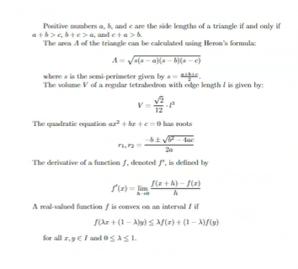

**Program 13:**

\documentclass [a4paper, 12pt]{book}

\usepackage[a4paper, inner=1.5cm,

outer=3cm,top=2cm, bottom=3cm, bindingoffset=1cm] {geometry}

\usepackage[english] {babel}

\usepackage{blindtext}

\usepackage{lipsum}

\usepackage{setspace}

\begin{document}

\chapter (Exploring the page Layout}

In this chapter we will study the layout of pages

\section{Some filler text}

\onehalfspacing

\lipsum[1]

\section{A lot more filler text} 18 More dummy text will follow,

\doublespacing

\subsection (Plenty of filler text} 21 blindtext [100]

\end{document}

**Screenshot:**

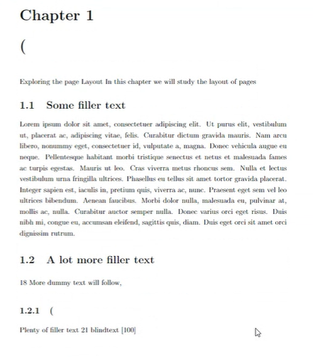

**Program 14:**

\documentclass{book}

\title{BOOK}

\begin{document}

\maketitle

\chapter*{Preface}

\section*{Purpose}

The use of probability models and statistical methods for analyzing data has become common practice in virtually all scientific disciplines. This book attempts to provide a comprehensive introduction to those models and methods most likely to be encoun- tered and used by students in their careers in engineering and the natural sciences. Although the examples and exercises have been designed with scientists and engi- neers in mind, most of the methods covered are basic to statistical analyses in many other disciplines, so that students of business and the social sciences will also profit from reading the book.

\section*{Approach}

Students in a statistics course designed to serve other majors may be initially skeptical of the value and relevance of the subject matter, but my experience is that students can be turned on to statistics by the use of good examples and exercises that blend their every- day experiences with their scientific interests. Consequently, I have worked hard to find examples of real, rather than artificial, data-data that someone thought was worth col- lecting and analyzing. Many of the methods presented, especially in the later chapters on statistical inference, are illustrated by analyzing data taken from published sources, and many of the exercises also involve working with such data. Sometimes the reader may be unfamiliar with the context of a particular problem (as indeed I often was), but I have found that students are more attracted by real problems with a somewhat strange context than by patently artificial problems in a familiar setting.

\section*{Mathematical Level}

The exposition is relatively modest in terms of mathematical development. Substantial use of the calculus is made only in Chapter 4 and parts of Chapters 5 and 6. In particu- lar, with the exception of an occasional remark or aside, calculus appears in the inference part of the book only in the second section of Chapter 6. Matrix algebra is not used at all. Thus almost all the exposition should be accessible to those whose mathematical background includes one semester or two quarters of differential and integral calculus.

\section*{Content}

Chapter 1 begins with some basic concepts and terminology population, sample, descriptive and inferential statistics, enumerative versus analytic studies, and so on- and continues with a survey of important graphical and numerical descriptive methods. A rather traditional development of probability is given in Chapter 2, followed by prob- ability distributions of discrete and continuous random variables in Chapters 3 and 4, respectively. Joint distributions and their properties are discussed in the first part of Chapter 5. The latter part of this chapter introduces statistics and their sampling distri- butions, which form the bridge between probability and inference. The next three chapters cover point estimation, statistical intervals, and hypothesis testing based on a single sample. Methods of inference involving two independent samples and paired data are presented in Chapter 9. The analysis of variance is the subject of Chapters 10 and 11 (single-factor and multifactor, respectively). Regression makes its initial appearance in Chapter 12 (the simple linear regression model and correlation) and

xiii

\chapter{Overview and Descriptive Statistics}

\section*{Introduction}

Statistical concepts and methods are not only useful but indeed often indispensable in understanding the world around us. They provide ways of gaining new insights into the behaviour of many phenomenon that you will encounter in your chosen field of specialization in engineering or science.

\section {Populations, Samples and Processes}

Students in a statistics course designed to serve other majors may be initially skeptical of the value and relevance of the subject matter, but my experience is that students can be turned on to statistics by the use of good examples and exercises that blend their every- day experiences with their scientific interests. Consequently, I have worked hard to find examples of real, rather than artificial, data-data that someone thought was worth col- lecting and analyzing. Many of the methods presented, especially in the later chapters on statistical inference, are illustrated by analyzing data taken from published sources, and many of the exercises also involve working with such data.

Chapter 1 begins with some basic concepts and terminology population, sample, descriptive and inferential statistics, enumerative versus analytic studies, and so on- and continues with a survey of important graphical and numerical descriptive methods. A rather traditional development of probability is given in Chapter 2, followed by prob- ability distributions of discrete and continuous random variables in Chapters 3 and 4, respectively. Joint distributions and their properties are discussed in the first part of Chapter 5. The latter part of this chapter introduces statistics and their sampling distri- butions, which form the bridge between probability and inference. The next three chapters cover point estimation, statistical intervals, and hypothesis testing based on a single sample. Methods of inference involving two independent samples and paired data are presented in Chapter 9. The analysis of variance is the subject of Chapters 10 and 11 (single-factor and multifactor, respectively). Regression makes its

\section{Pictorial and Tabular Methods in Descriptive Statistics}

The exposition is relatively modest in terms of mathematical development. Substantial use of the calculus is made only in Chapter 4 and parts of Chapters 5 and 6. In particu- lar, with the exception of an occasional remark or aside, calculus appears in the inference part of the book only in the second section of Chapter 6. Matrix algebra is not used at all. Thus almost all the exposition should be accessible to those whose mathematical background includes one semester or two quarters of differential and integral calculus.

\subsection{Notation}

The use of probability models and statistical methods for analyzing data has become common practice in virtually all scientific disciplines. This book attempts to provide a comprehensive introduction to those models and methods most likely to be encoun- tered and used by students in their careers in engineering and the natural sciences. Although the examples and exercises have been designed with scientists and engi- neers in mind, most of the methods covered are basic to statistical analyses in many other disciplines, so that students of business and the social sciences will also profit from reading the book.

\end{document}

**Screenshot:**  