AISHA - Comprehensive Technical Diagrams
This document contains various Software Engineering and Architecture diagrams requested for the AISHA system, generated automatically using Mermaid.

Class Diagram
This class diagram illustrates the backend models and their relationships, detailing the properties and methods for primary entities like Users, Students, Opportunities, and Applications.
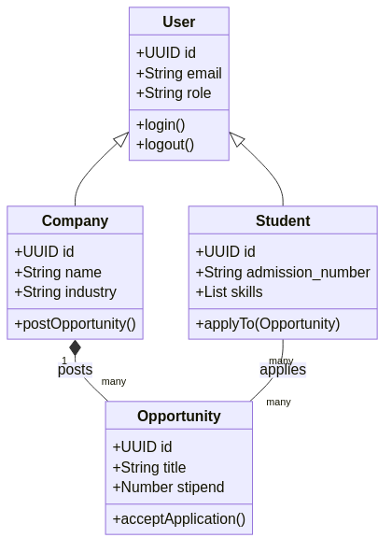
---

Component Diagram
Shows the high-level structural components of the system, including the frontend UI components, the API gateway, microservices, and databases.
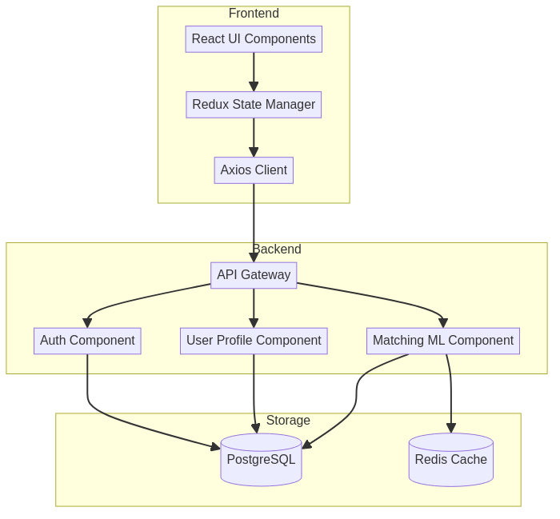
---

Deployment Diagram
Demonstrates how software components are mapped to the physical or cloud hardware architecture for deployment.
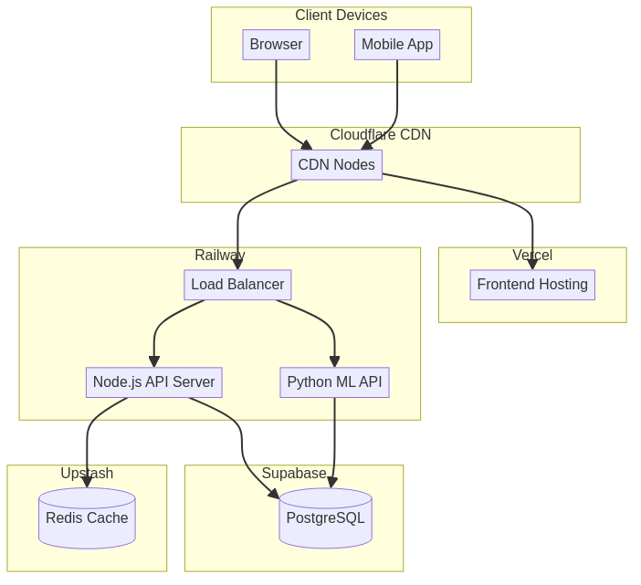
---

Package Diagram
Illustrates the organization of the codebase packages and their dependencies, primarily focusing on the backend node/python packages.
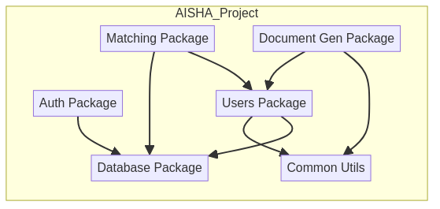
---

Object Diagram
Shows a snapshot of specific instances of classes at a moment in time. Here it depicts a Specific Student applying to a Specific Opportunity.
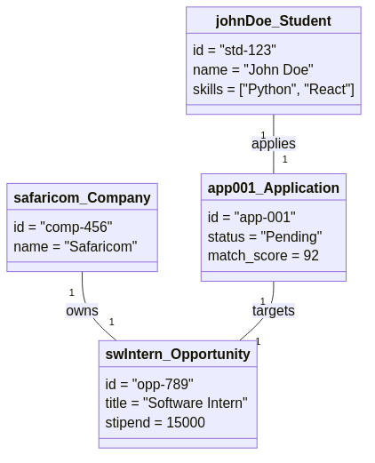
---

Composite Structure Diagram
Shows the internal structure of the AI Matching Engine component and its interaction points (ports).
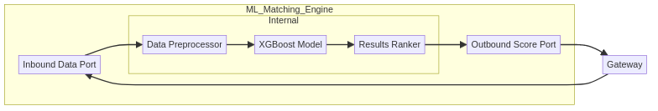
---

Profile Diagram
Used in UML to define custom stereotypes. This diagram shows the custom profiles created for AI/ML services within the system.
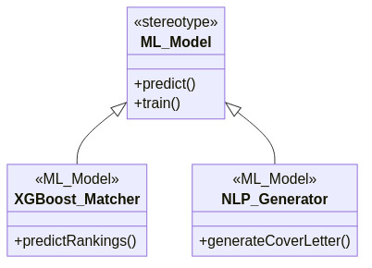
---

Use Case Diagram
Shows the different user actors in the system and the broad actions or use cases they can perform.
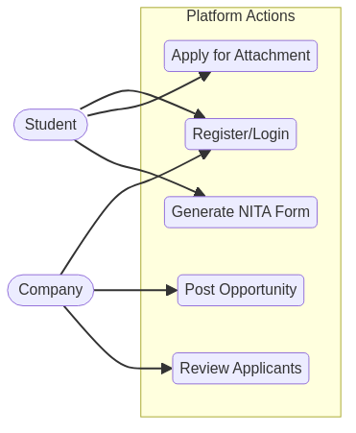
---

Activity Diagram
Shows the flow of activities for the Student Application Process, from discovering opportunities to receiving an offer.
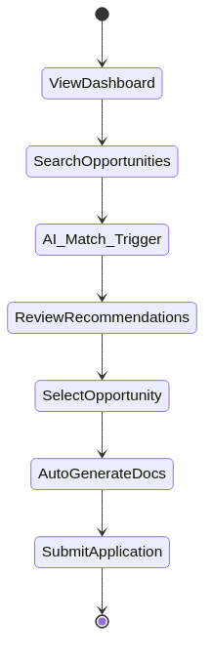
---

Sequence Diagram
Demonstrates the sequential flow of messages during the AI Document Generation process when submitting an application.
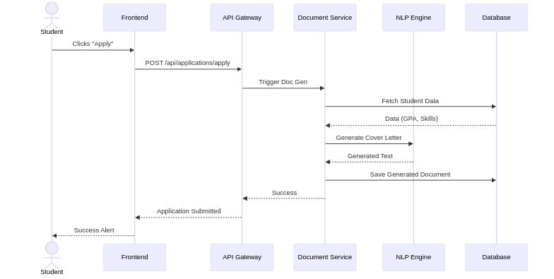
---

State Machine Diagram
Shows the possible states and transitions for an Application entity within the system.
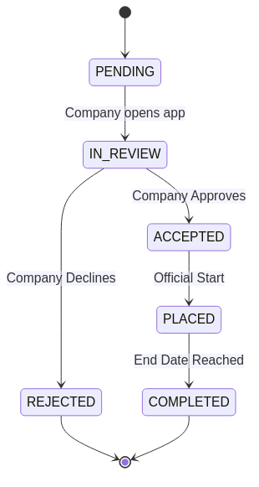
---

Communication Diagram
Highlights the network of communications between objects without emphasizing time/sequence.
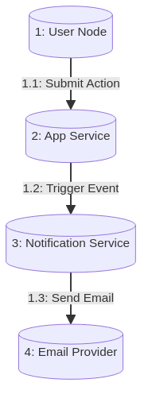
---

Timing Diagram
Shows state changes over time, using a typical timeline/Gantt chart to represent the ML retraining cycle.
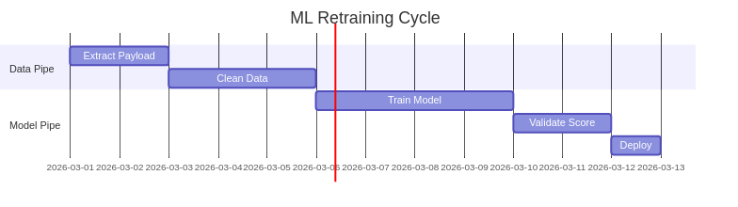
---

Interaction Overview Diagram
A high-level view that ties together different activity states, visualizing how distinct interaction sequences combine into a broader flow.
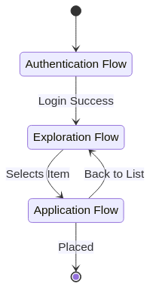
---

Entity-Relationship Diagram (ERD)
Displays the relationship between core database tables in PostgreSQL.
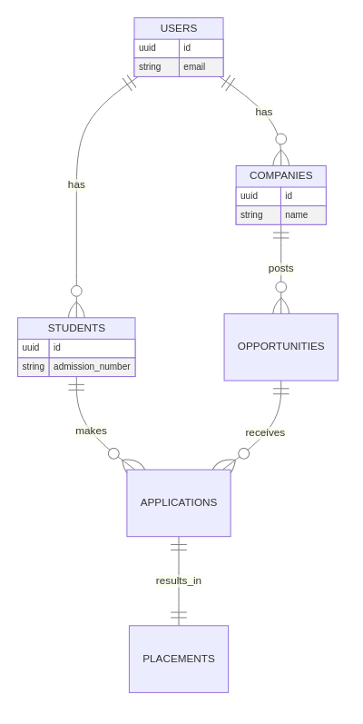
---

Data Flow Diagram (DFD)
Illustrates how unstructured data (resumes) flow through the system and are converted to vector embeddings for matching.
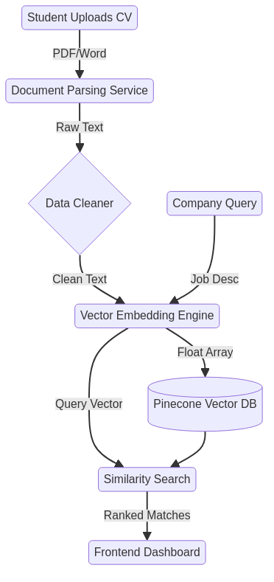
---

System Context Diagram (C4 Context)
A high-level view showing the software system in relation to the users and external systems it interacts with.
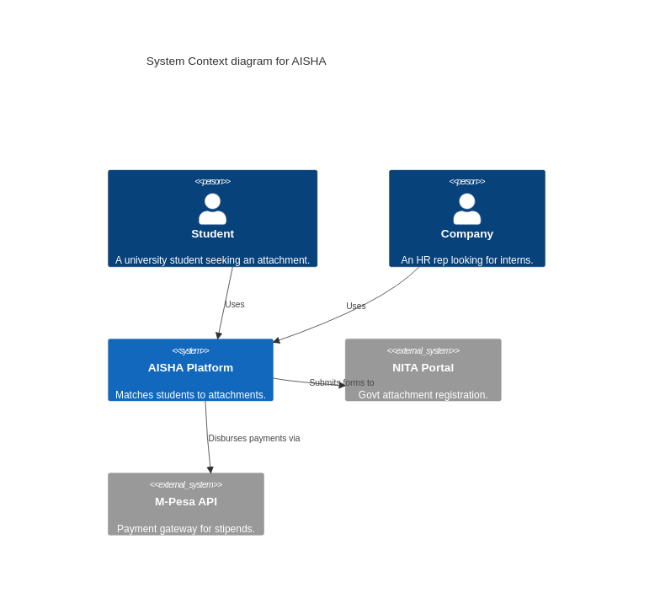
---

System Architecture Diagram
Shows the logical architecture dividing the application into layered boundaries (Presentation, Business, Data).
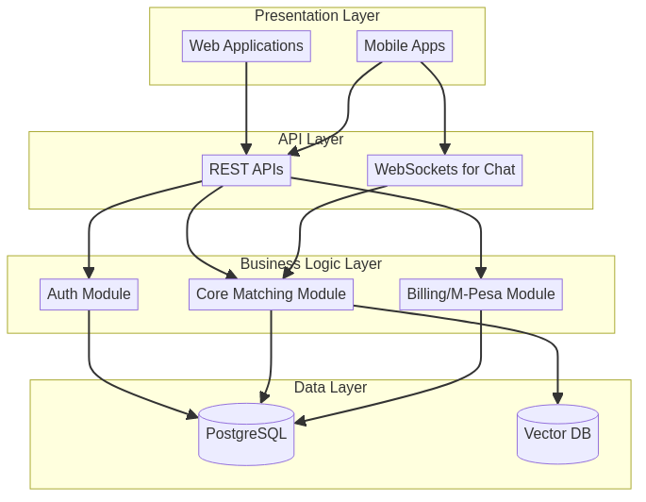
---

C4 Container Diagram
Zooms into the AISHA system boundary to show the containers (applications, data stores) that make up the system.
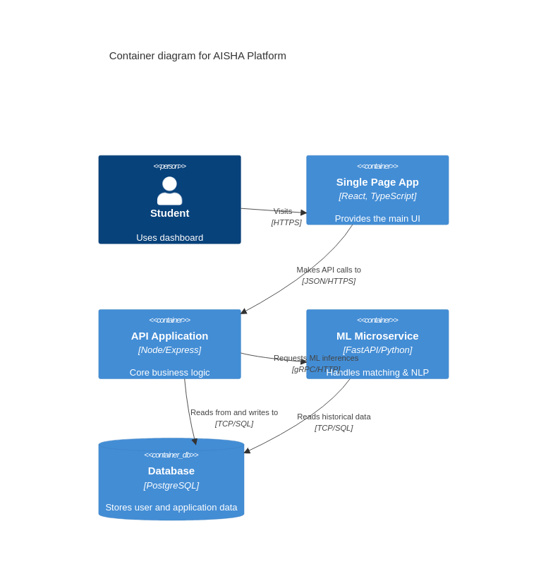
---

C4 Component Diagram
Zooms into the API Application container to show its internal components.
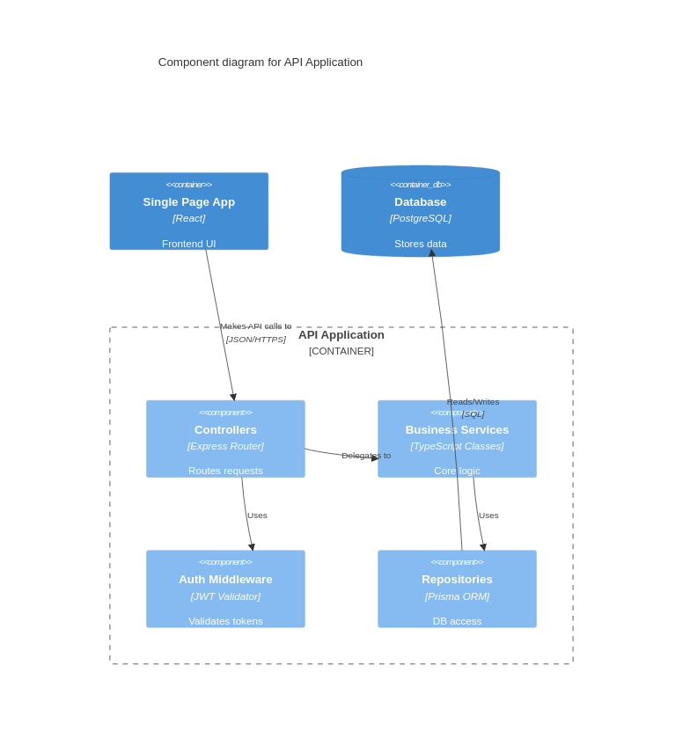
---

Business Process Model and Notation (BPMN)
A standard flowchart representation representing the business process of matching and contracting.



