AISHA: AI-Powered Industrial Attachment Matching Platform

Software Design Document (SDD)

Version: 1.0
Date: February 2026

1. Introduction
This Software Design Document (SDD) provides a comprehensive architectural and detailed design overview of the AISHA (AI-Powered Industrial Attachment Matching Platform) system. It includes structural, behavioral, and architectural diagrams that describe the system's components, their interactions, and the data structures.

2. Architectural & System Design

2.1 System Context
The System Context diagram provides a high-level view showing the software system in relation to the users and external systems it interacts with, such as the NITA Portal and M-Pesa API.
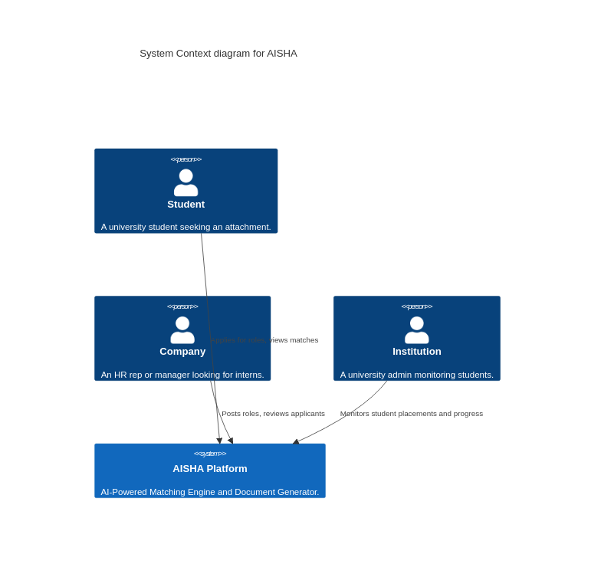

2.2 System Architecture Layering
The logical architecture divided into Presentation, API, Business Logic, and Data layers.
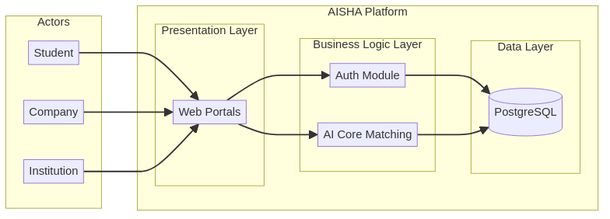

2.3 C4 Container Diagram
Zooms into the system boundary to show the discrete containers (SPA, Node API, ML Microservice, Database).
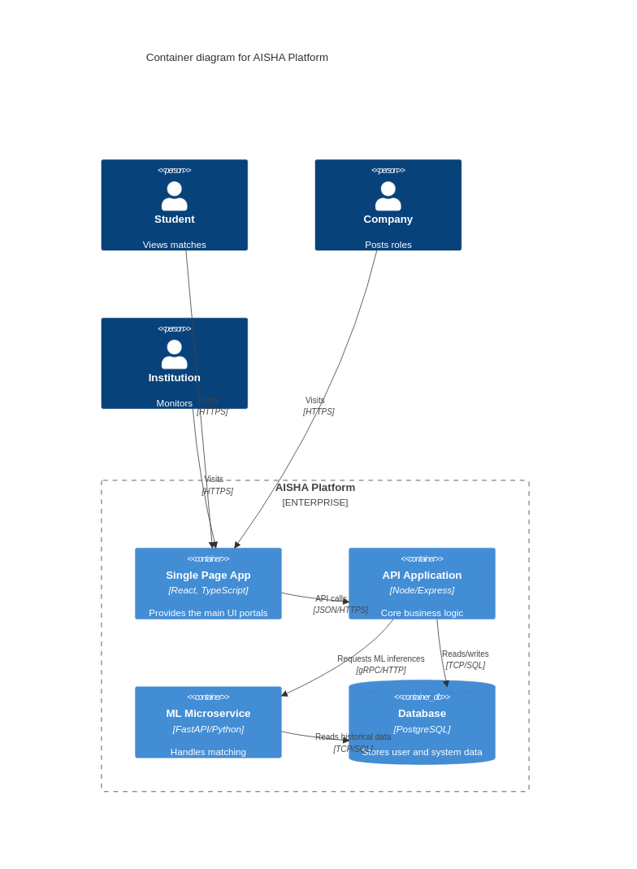

2.4 C4 Component Diagram
Details the internal components of the primary API Application container.
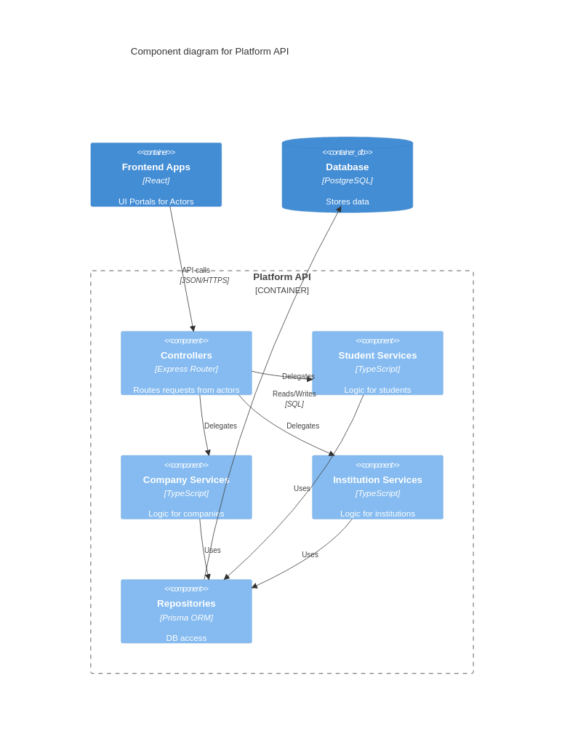

2.5 Deployment Architecture
Demonstrates how software components are mapped to the cloud hardware architecture (Vercel, Railway, Supabase).
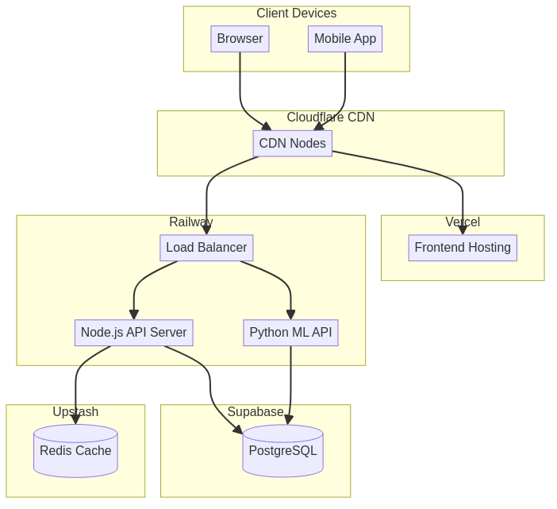

3. Structural Design

3.1 Component Diagram
Shows the high-level structural components of the system, including the UI, Gateway, and Backend Services.
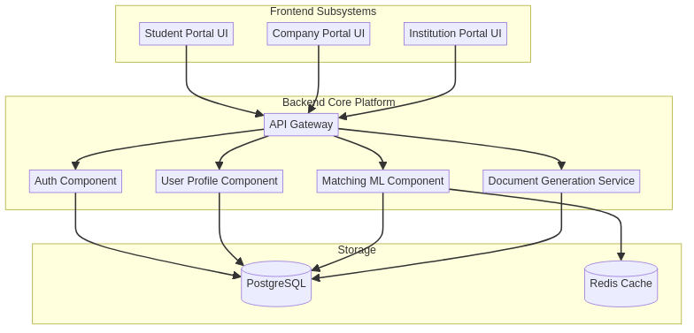

3.2 Package Diagram
Illustrates the organization of the codebase packages and their dependencies.
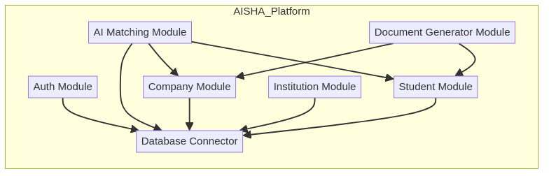

3.3 Class Diagram
Details the backend models and their relationships, detailing properties and methods for Users, Students, Companies, and Opportunities.
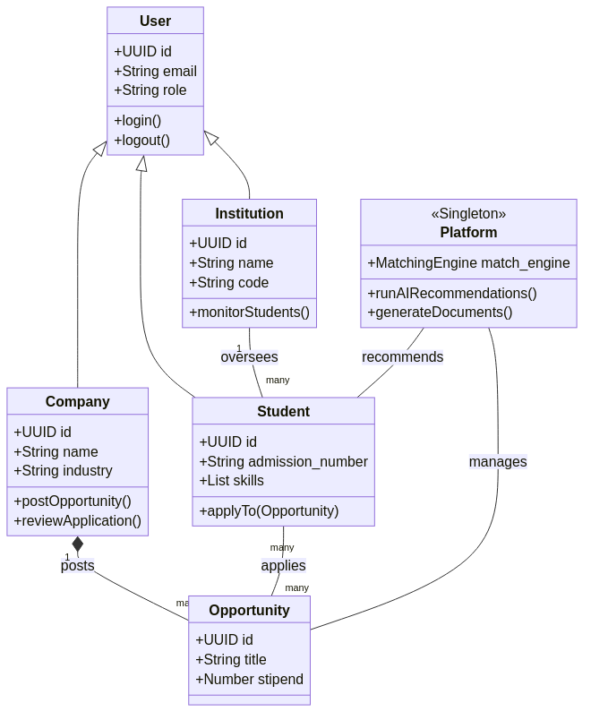

3.4 Object Diagram
Provides a snapshot of specific instances of classes at a moment in time (e.g., a specific student applying to a specific opportunity).
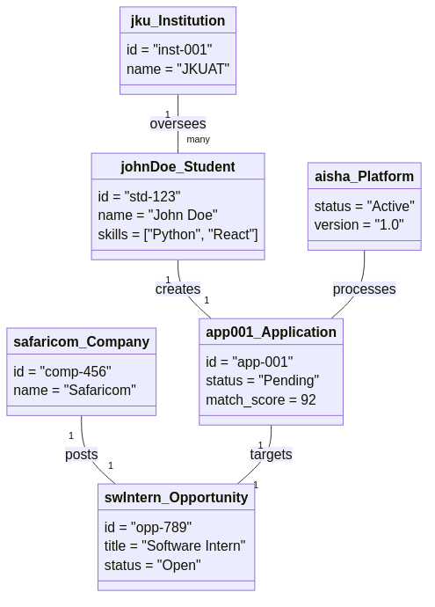

3.5 Composite Structure Diagram
Shows the internal structure of the AI Matching Engine component and its interaction points.
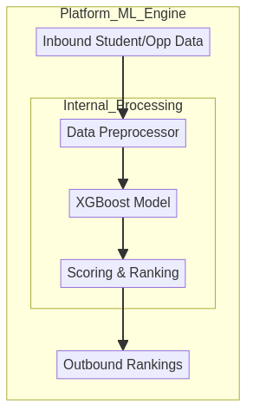

3.6 Profile Diagram
Shows custom UML stereotypes created for AI/ML services within the system.
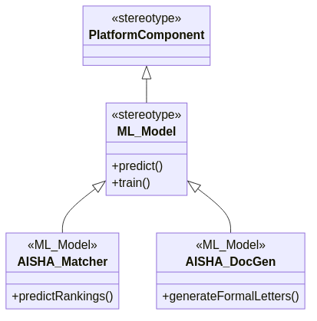

4. Data Design

4.1 Entity-Relationship Diagram (ERD)
Displays the relationships between core database tables in PostgreSQL.
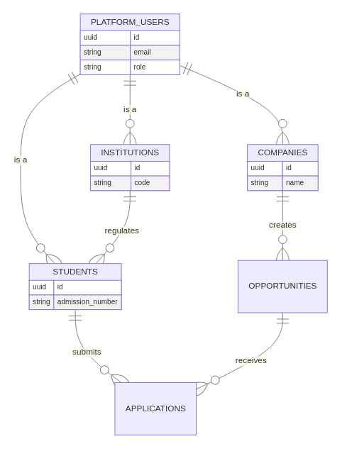

4.2 Data Flow Diagram (DFD)
Illustrates how unstructured data (like resumes) flow through the system to be converted into vector embeddings for ML matching.
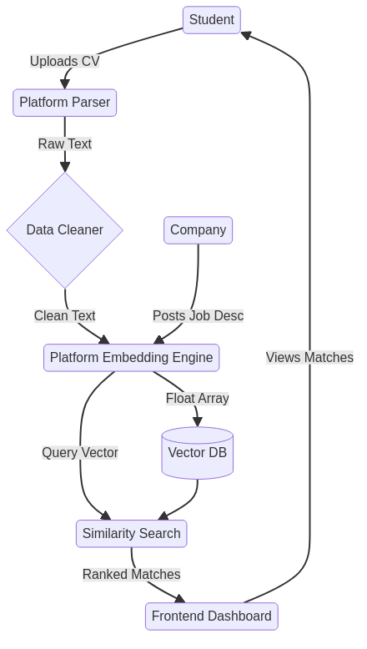

5. Behavioral Design

5.1 Use Case Diagram
Shows the different user actors in the system and the broad actions or use cases they can perform.
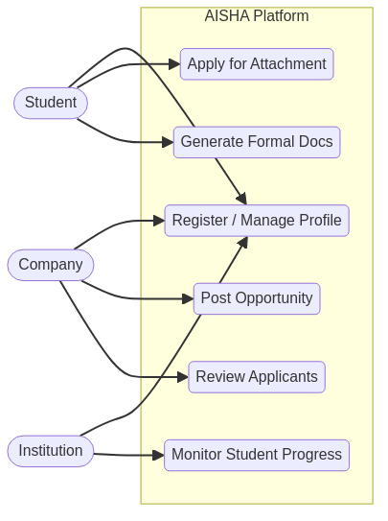

5.2 Business Process Model and Notation (BPMN)
A standard flowchart representation of the business process for matching and contracting.
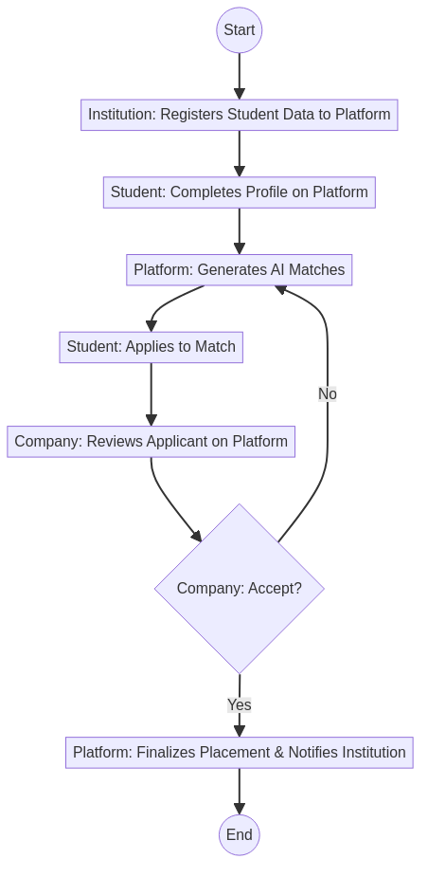

5.3 Activity Diagram
Shows the flow of activities for the Student Application Process.
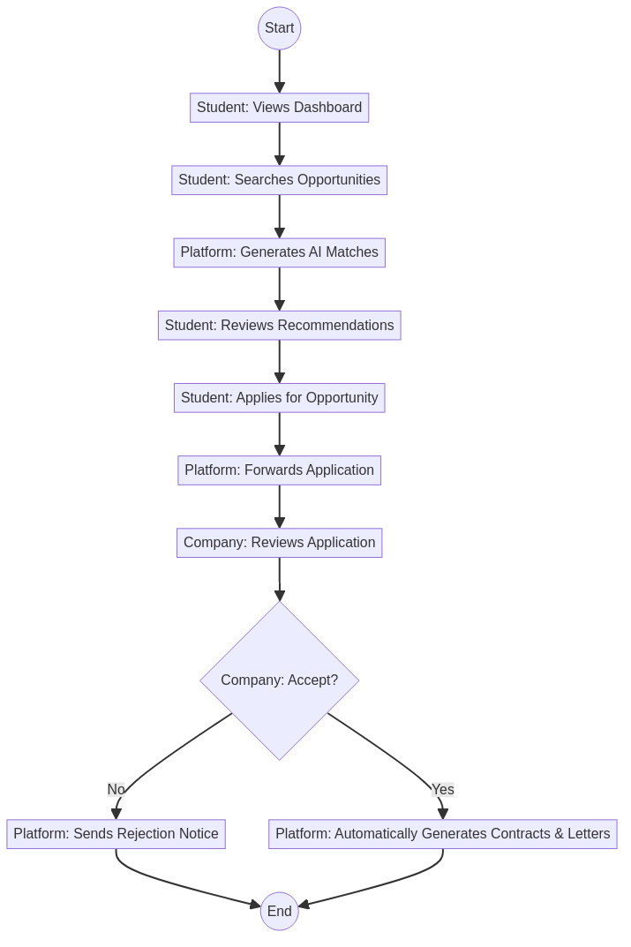

5.4 Sequence Diagram
Demonstrates the sequential flow of messages during the AI Document Generation process.
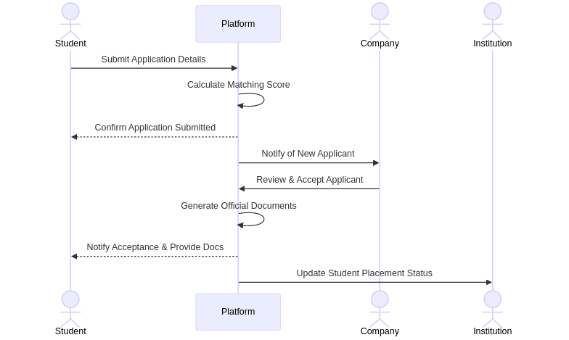

5.5 State Machine Diagram
Shows the possible states and transitions for an Application entity.
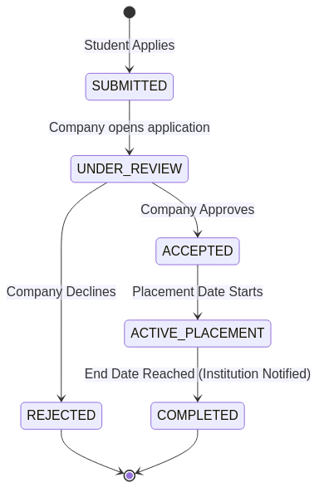

5.6 Communication Diagram
Highlights the network of communications between objects without emphasizing sequence.
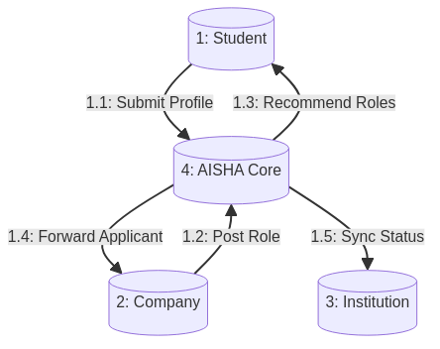

5.7 Interaction Overview Diagram
A high-level view that ties together different activity states into a broader flow.
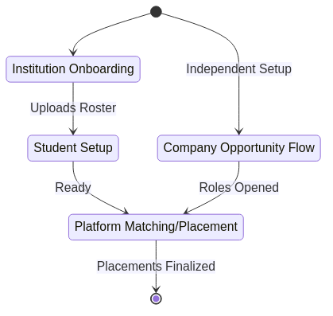

5.8 Timing Diagram
Shows state changes over time, using a timeline to represent the ML retraining cycle.
