**Blockchain Deep Dive – Learning Project**

A Project by Graffins Rowen Kusimba

Certified by Binance Academy

# Introduction

This project is a showcase of my learning journey through the Blockchain Deep Dive Course from Binance Academy. It summarizes the key concepts I explored, presents them in simple notes, and uses diagrams to reinforce understanding. The course awarded me a certificate, which validates my competence in blockchain fundamentals, interoperability, scalability, and Web3 ecosystems.

# Module 1: Foundations of Blockchain

## 1.1 What’s in a Block?

Blocks contain a header, transactions, and a cryptographic hash, chained together immutably.

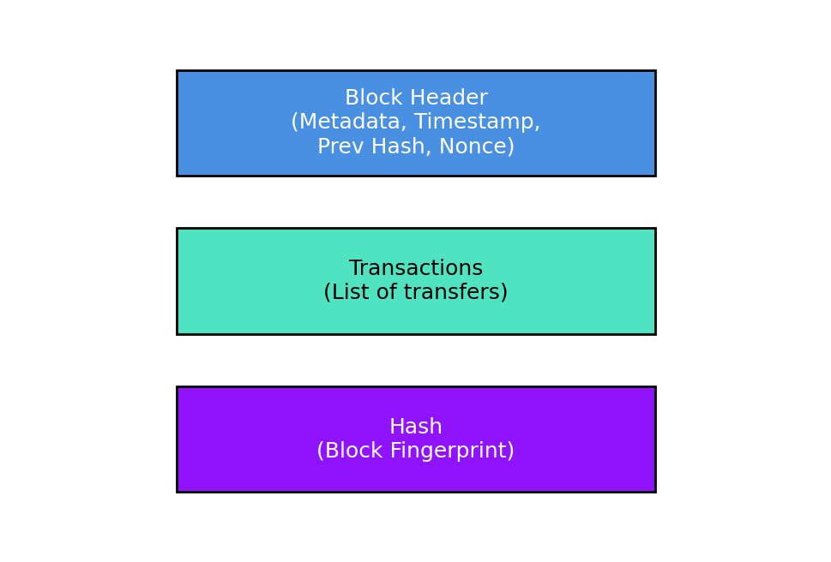

## 1.2 How Are Transactions Authenticated?

Transactions are signed with cryptographic keys and verified before inclusion in a block.

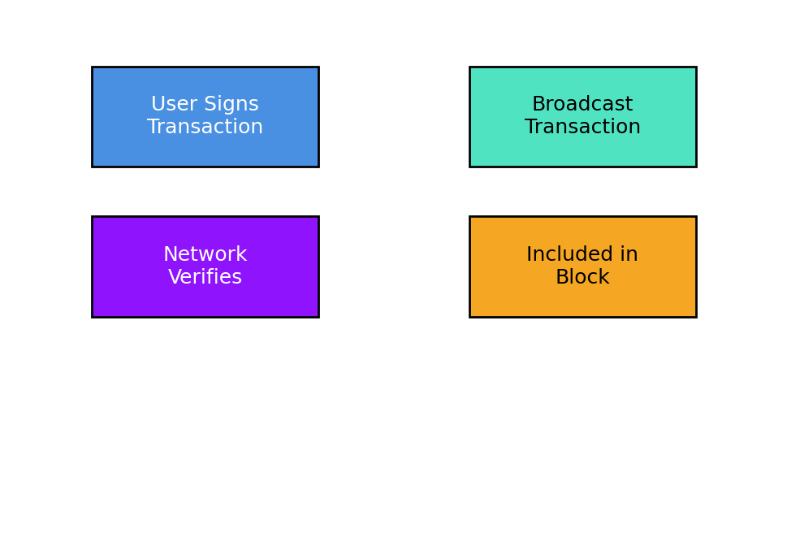

## 1.3 Building Consensus

Consensus ensures network nodes agree. Common types: Proof of Work, Proof of Stake.

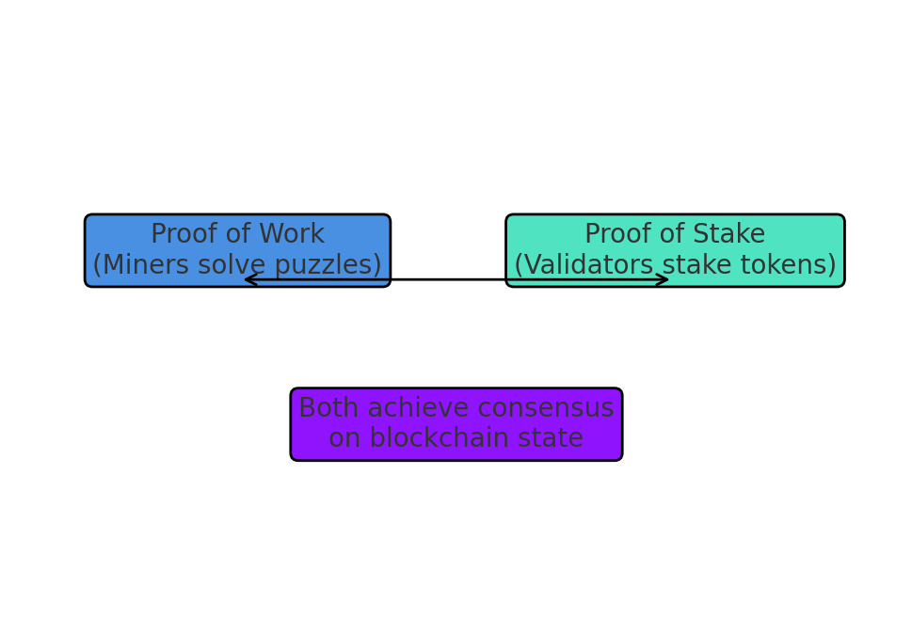

## 1.4 Blockchain Spectrum

Includes public, private, consortium, and hybrid blockchains.

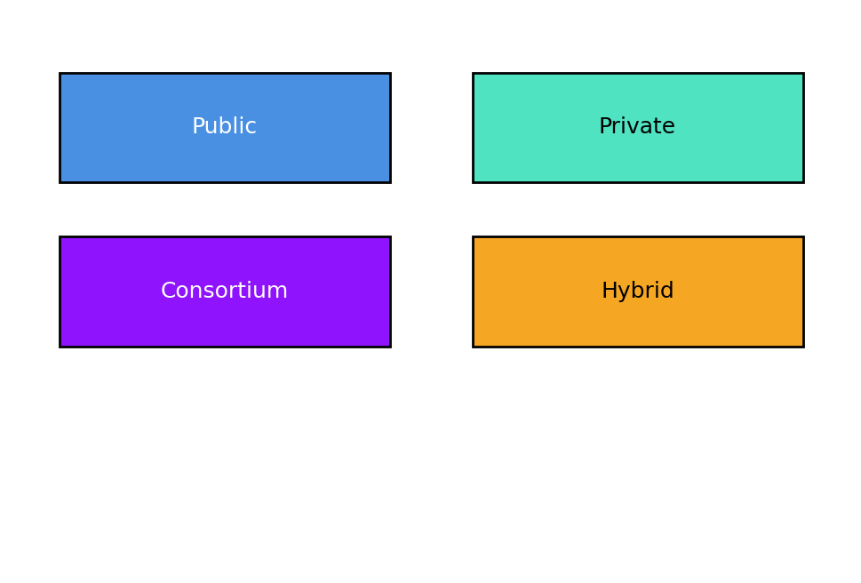

# Module 2: Blockchain Scalability & Interoperability

## 2.1 Blockchain Interoperability Solutions

Bridges connect different blockchains for communication.

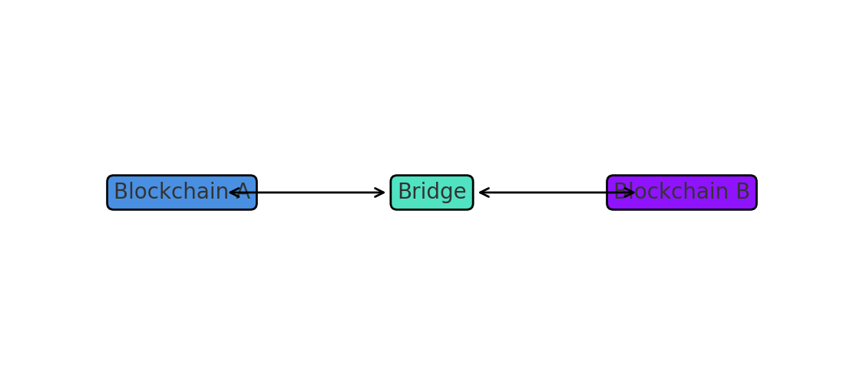

## 2.2 The Blockchain Trilemma

Trade-offs exist between security, scalability, and decentralization.

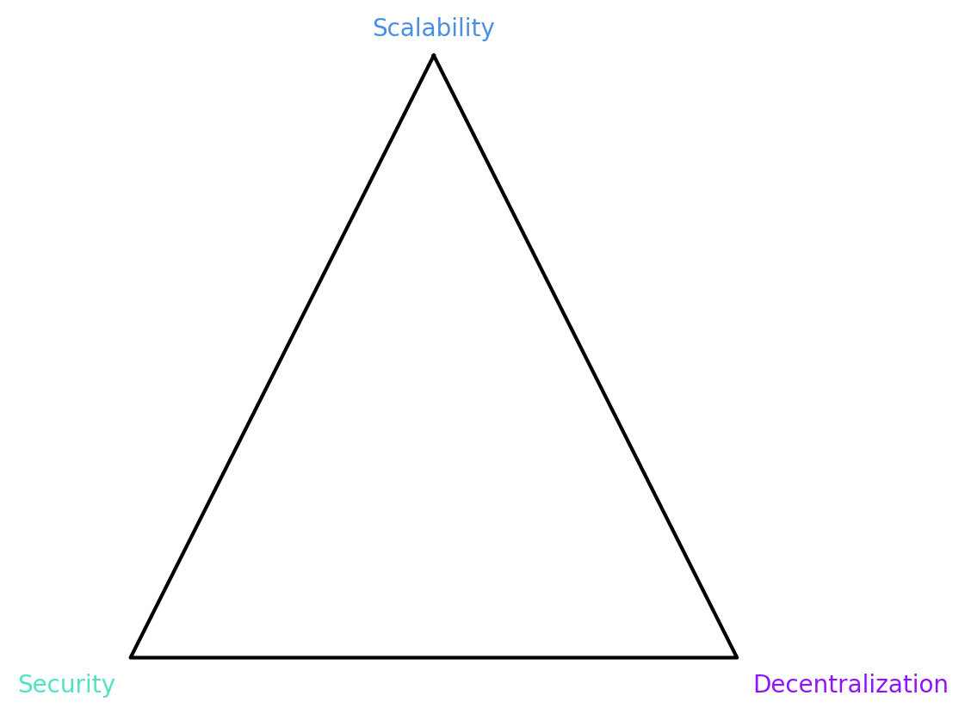

## 2.3 On-Chain Scaling Solutions

Includes larger blocks, sharding, and improved consensus algorithms.

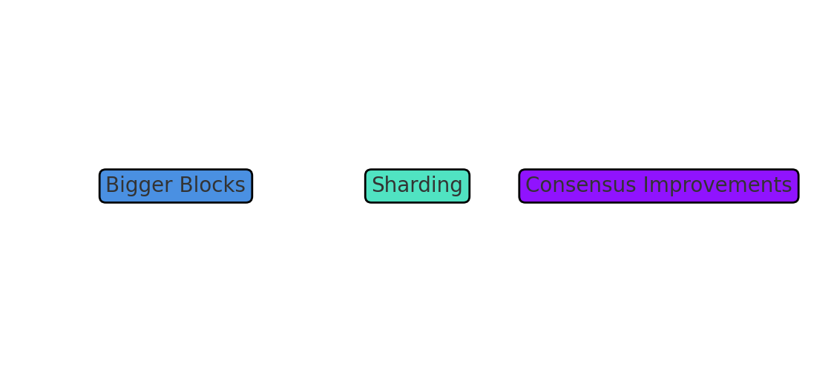

## 2.4 Off-Chain Scaling Solutions

Includes sidechains and rollups such as zk-rollups and optimistic rollups.

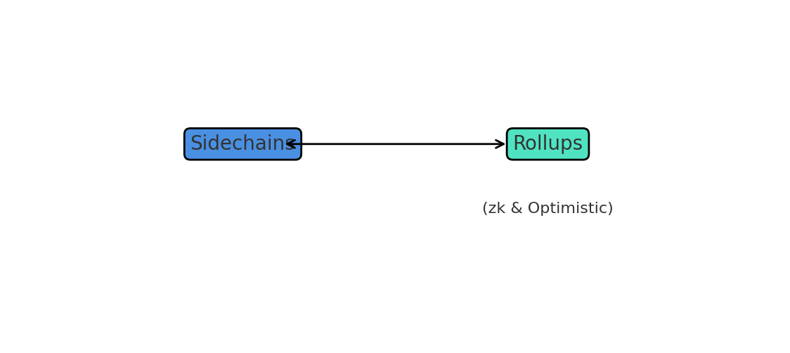

# Module 3: Web3 and the Future

## 3.1 Blockchain, Web3, and Data Ownership

Web3 enables decentralized storage, privacy, and self-sovereign identity.

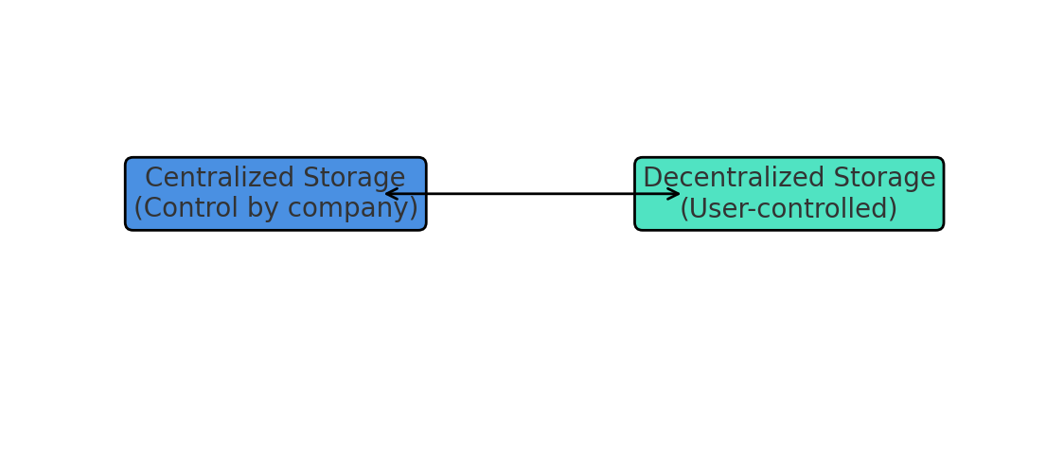

## 3.2 Web3 Business Models and Tokenomics

Web3 uses utility and governance tokens to drive ecosystems.

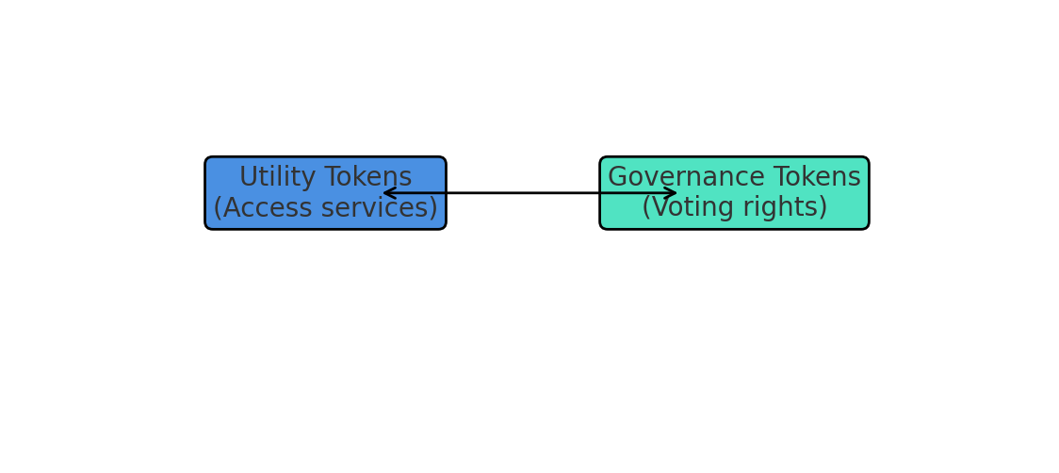

## 3.3 Web3 Use Cases and Ecosystems

Examples include DeFi, NFTs, DAOs, and Metaverse applications.

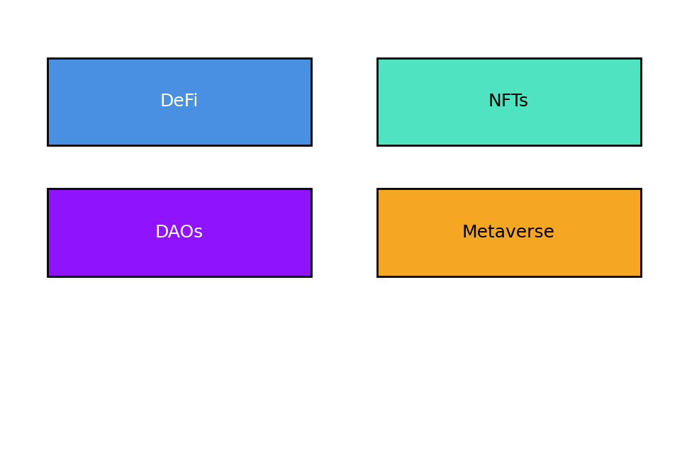

# Certification

This project is backed by my Binance Academy Certificate in Blockchain Fundamentals (Blockchain Deep Dive Course).

Awarded to Graffins Rowen Kusimba for successfully completing the course.

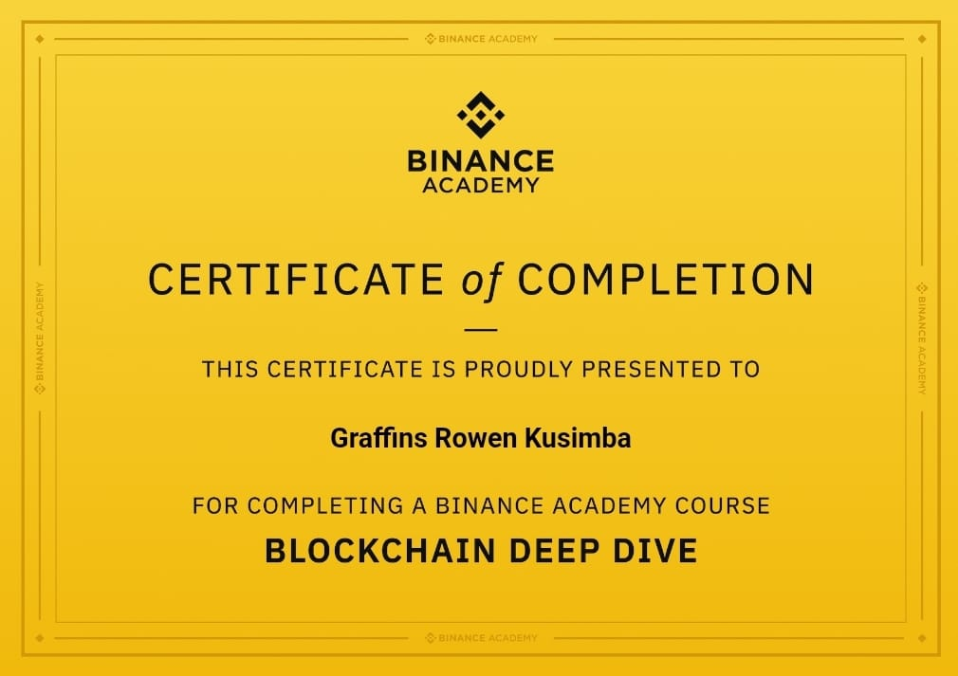

# Conclusion

This project summarizes the key aspects of blockchain technology, scalability challenges, and Web3 opportunities. By completing this course, I have gained a strong foundation that will support my continued growth in blockchain and emerging technologies.