Paper Ideas
Nathan Hughes (nah31@aber.ac.uk)
August 2, 2018
1
Introduction
<Not sure on>
1
August 2, 2018
2
Results
2.1
Domestication
Previous studies have shown that domestication has led to an increase in grain size [1,
2],
though the precise
changes were not identified.
Here we have shown that both emmer and einkorn species have both increased
significantly in grain width and depth, with length remaining similar (our analysis has shown a 36% in einkorn
and 49% probability in emmer that the mean values of grain length overlap over domestication state).
2.2
Ploidy
2.2.1
Domesticated
Across ploidy in domesticated einkorn and emmer,
2N and 4N respectively,
grain parameters are generally
significantly different.
The one parameter which we report almost no significant change in is grain width.
A
p = 0.17
in difference in sample mean width was calculated using the Welch T-test.
A probability of
mean
overlap of 50% was observed for width at an individual level.
Grain length, depth and volume at both population mean and individual grain report highly significant change
(
p < 0.01
and
Likeihood < 10%
of mean overlap).
(See table:7 for full
results))
Citations needed to verify?
2.2.2
Wild
In wild species of einkorn and emmer no significant change is seen in individual grain length or width; Across
population means non-significance is observed in grain length and width (all
of which have
likelihood > 33%
of overlapping means and
p > 0.01
).
Significant changes are seen in depth, volume and surface area of grains (
p < 0.01
), indicating that the change
in depth effected overall grain shape.
Citations needed to verify?
3
Methods
3.1
Materials
< Plants which were used > . . .
3.1.1
How they were sourced
3.1.2
Any additional information
3.2
3D Scanning of Spikes
From the genotypes selected, fully dried, representative spikes were chosen for micro-CT scanning.
Spikes were
placed in plastic holders (34x70mm tubes) and imaged using a a CT100 scanner (Scanco Medical,
Switzer-
land).
The imaging system was configured with an X-ray source ranging from 20 to 100 kVp, a detector of 3072 x 400
elements.
A resolution of 68.8 micro-meters per pixel was used for all scans.
2 of 9
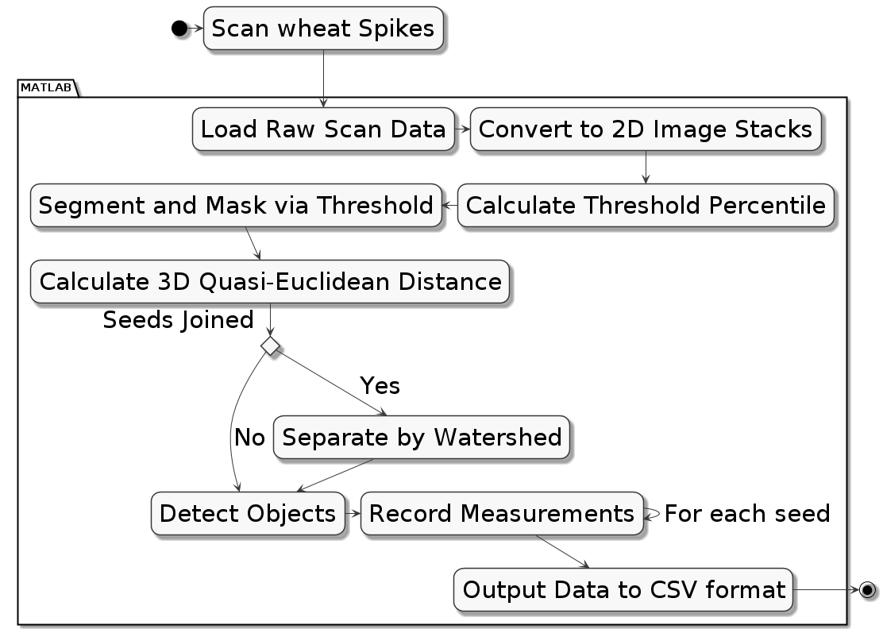
3.3
Computational Methods
August 2, 2018
3.3
Computational Methods
Using software developed for previous wheat studies by the National
Plant Phenomics Centre [3].
New and
novel additions are implemented in the watershedding and segmentation processes, of the existing pipeline, in
order to work with the more complex primitive species of wheat.
Due to the optimised resolution of the imaging technique (68.6µ meters per pixel) objects can appear connected
which are not, particularly in primitive grain.
A three dimensional watershedding algorithm is used to correct
any objects which appear connected when they should not be.
The software, developed in MATLAB [4], is freely available at <insert link to NPPC>.
3.3.0.1
Pipeline
The scanning and MATLAB routine pipeline:
Figure 1:
Pipeline
3.3.1
Morphometric Features
The features/phenotypes used are extracted during the imaging process.
• Length is calculated using the major axis of the whole grain.
• Width and depth are the major and minor axis of a cross section, found by selecting the grain’s midpoint.
• Volume is a complete connected pixel count per grain
• Surface area is a single pixel perimeter calculation mapped in 3 dimensions
• Length X Depth X Width is a post-image-processing value calculated by the interaction between the three
dimension descriptors.
Values used in statistical functions and measurements are presented as metric units, derived from µ-CT image
pixel values.
The equation:1 is presented here.
mm =
pixel × 68.8
1000
(1)
3.3.2
Error Removal
The data were checked for false positives, this is done by first removing outliers which are found by the 0.025
upper and lower percentiles of the data.
Additionally constraints are applied to the data based on findings from
previous studies [3], this adds robustness.
3 of 9
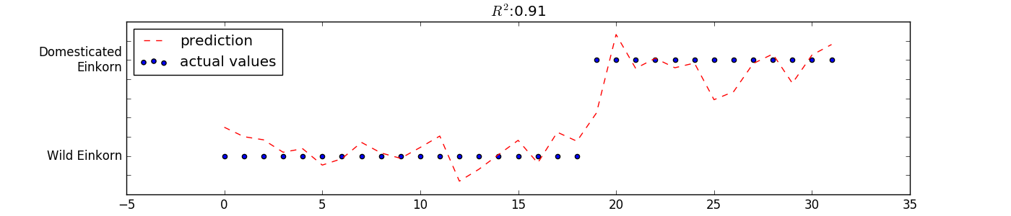
3.4
Bayesian Modelling
August 2, 2018
3.3.3
LWD
An additional phenotype is created to describe the interaction between the geometric parameters; the interaction
is described in equation:2.
geometry interaction
= length × depth × width
(2)
3.3.4
Image Analysis Methods
I could provide a lot of info on this, but weary of going off-track, more can be added (or taken
away) if needed, what’s in comp methods could be enough I think.
3.4
Bayesian Modelling
To provide deeper insight into the size of
change or similarity in hypothesis testing,
a Bayesian model
is
used.
To estimate probability of
two samples containing the same mean the method uses Bayes theorem
(
P (A|B) ∝ P (B|A) × P (A)
) [5]
along with Markov-Chain-Monte-Carlo (MCMC) to draw random samples
from a normal population.
From Krusches’ method a percentage likelihood of difference is produced.
3.5
Linear Modelling
A linear model allowed for an R
2
value of 0.91 in einkorn species when predicting domestication status.
3.5.1
Draft Supplemental figure for dom
Figure 2:
is showing a multiple regression of r=.91 by using length, width and depth to correctly ID domesti-
cation status.
3.5.2
Draft Supplemental figure for volume
3.5.3
Least Squares Model
Equation, where the intercept (
β
0
) has been set by surface area
Y = β
0
+ ×β
1
length × β
2
depth × β
3
width +
4 of 9
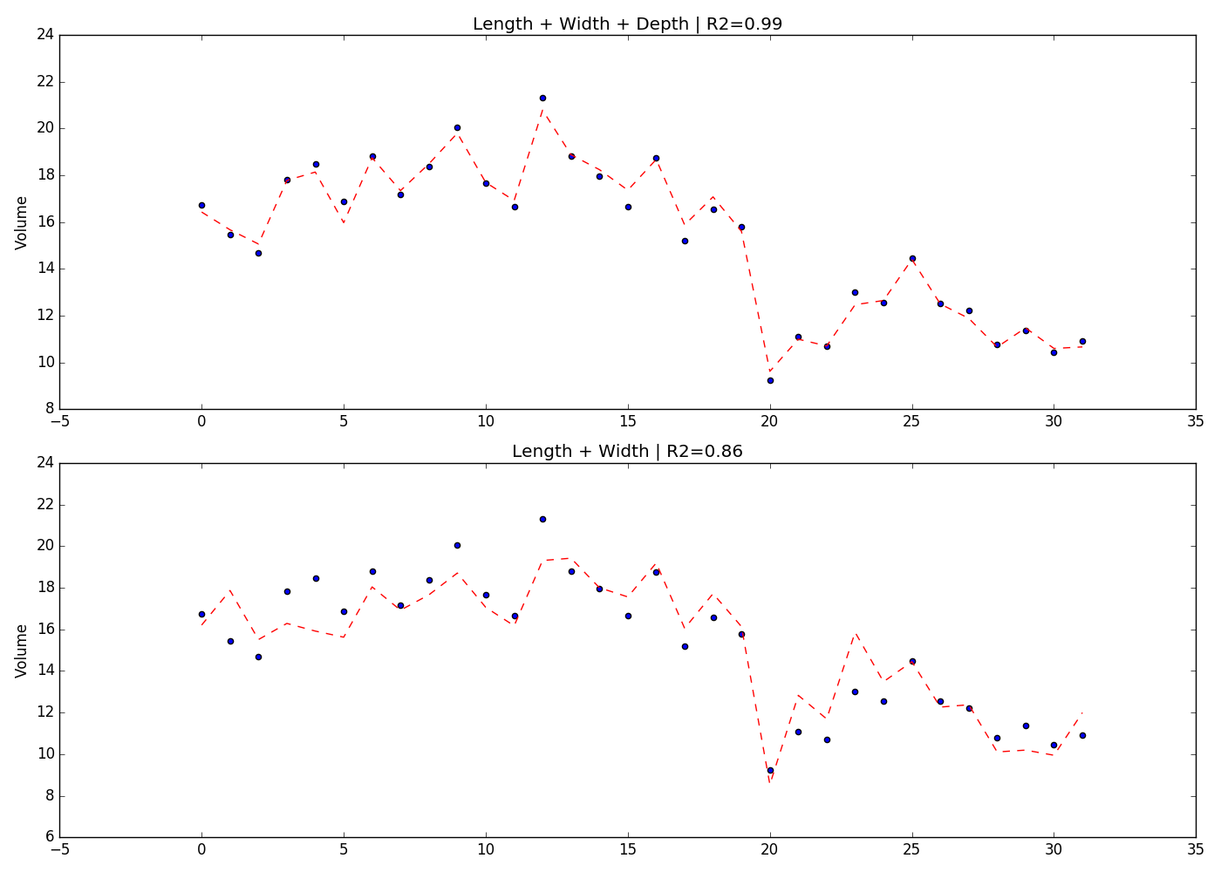
August 2, 2018
Figure 3:
Showing the importance of 3rd dimension of depth
3.5.4
Misc
The model produced an r
2
value by:
1 −
n
P
i=0
r
2
n
P
i=0
(y
i
− y)
2
4
Misc Information to fold into discussion?
Fuller has evidenced that grain volume is used when initially identifying wheat grain which is recovered as
being domesticated [6].
Therefore justification for our model is very useful.
On the other hand [7] found that barley is much harder to identify from it’s domesticated relatives.
Volume is
not significantly different!
Which fits perfectly with our results!
Wondering outloud, with the wild 2n/4n an oberserved change in surface area.
Would there be a reason for why
grains would want to develop a larger surface area? Alternatively we can work off-of volume, as that changes
also
5 of 9
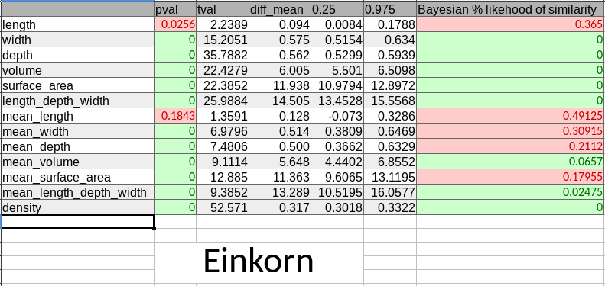
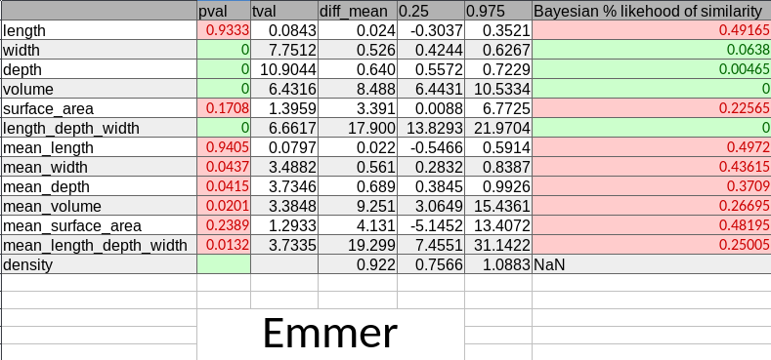
August 2, 2018
5
Data Tables
5.1
einkorn
Figure 4:
einkorn table
5.2
emmer
Figure 5:
emmer table
6 of 9
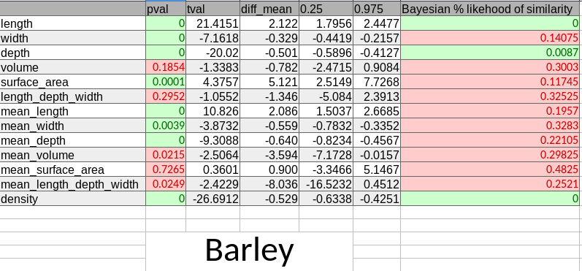
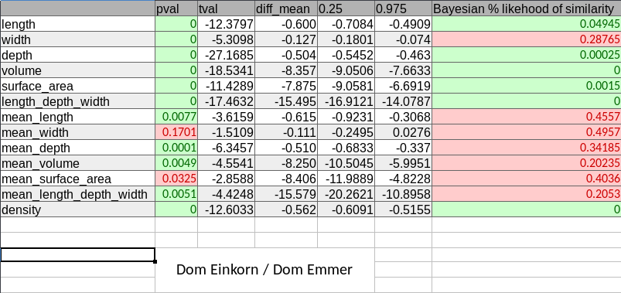
5.3
Barley
August 2, 2018
5.3
Barley
Figure 6:
barley table
5.4
Domesticated 2N, 4N
Figure 7:
domesticated 2N, 4N table
7 of 9
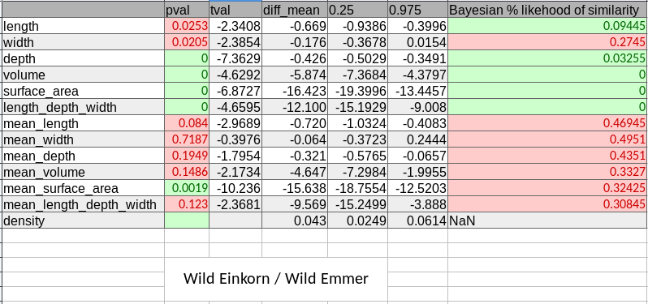
5.5
Wild 2N, 4N
August 2, 2018
5.5
Wild 2N, 4N
Figure 8:
wild 2N, 4N table
8 of 9
REFERENCES
August 2, 2018
References
[1]
Vasilis C.
Gegas,
Aida Nazari,
Simon Griffiths,
James Simmonds,
Lesley Fish,
Simon Orford,
Liz Sayers,
John H. Doonan, and John W. Snape.
A Genetic Framework for Grain Size and Shape Variation in Wheat.
The Plant Cell, 22(4):1046–1056, 2010.
[2]
Junhua H. Peng, Dongfa Sun, and Eviatar Nevo.
Domestication evolution, genetics and genomics in wheat.
Molecular Breeding, 28(3):281–301, oct 2011.
[3]
Nathan Hughes,
Karen Askew,
Callum P.
Scotson,
Kevin Williams,
Colin Sauze,
Fiona Corke,
John H.
Doonan,
and Candida Nibau.
Non-Destructive,
high-Content analysis of
wheat grain traits using X-ray
micro computed tomography.
Plant Methods, 13(1), 2017.
[4]
The MathWorks Inc.
MathWorks - Support - MATLAB & Simulink, 2018.
[5]
John Kruschke.
Bayesian estimation Supersedes the t-test.
Journal
of Experimental
Psychology:
General,
142(2):573–603, 2013.
[6]
D. Q. Fuller. Contrasting Patterns in Crop Domestication and Domestication Rates:
Recent Archaeobotan-
ical Insights from the Old World.
Annals of Botany, 100(5):903–924, jul 2007.
[7]
George Willcox.
Measuring grain size and identifying Near Eastern cereal domestication:
evidence from the
Euphrates valley.
Journal
of Archaeological
Science, 31(2):145–150, feb 2004.
9 of 9

