Paper Ideas

Nathan Hughes (nah31@aber.ac.uk)

Introduction
<Not sure on>
\clearpage

Results

Domestication
Previous studies have shown that domestication has led to an increase in grain size [Gegas2010], though the precise changes were not identified. Here we have shown that both Emmer and Einkorn species have both increased significantly in grain width and depth, with length remaining similar (our analysis has shown a 36% in Einkorn and 49% probability in Emmer that the mean values of grain length overlap over domestication state).

Ploidy

Domesticated
Across ploidy in domesticated einkorn and emmer, 2N and 4N respectively, grain parameters are generally significantly different. The one parameter which we report almost no significant change in is grain width. A $p=0.17$ in difference in sample mean width was calculated using the Welch T-test. A probability of mean overlap of 50% was observed for width at an individual level.
Grain length, depth and volume at both population mean and individual grain report highly significant change ($p<0.01$ and $Likeihood <10\%$ of mean overlap).
(See table:5.4.1 for full results))
Citations needed to verify?

Wild
In wild species of einkorn and emmer no significant change is seen in individual grain length or width; Across population means non-significance is observed in grain length, width, depth and volume (all of which have $likelihood > 33%$ of overlapping means and $p>0.01).
Citations needed to verify?

Modelling
A linear model allowed for an R2 value of 0.91 in Einkorn species when predicting domestication status.

Draft Supplemental figure for dom
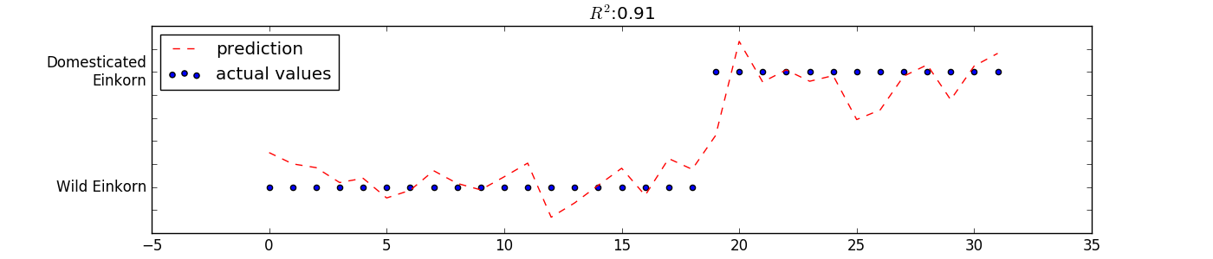 Figure 2.3.1: is showing a multiple regression of r=.91 by using length, width and depth to correctly ID domestication status.

Draft Supplemental figure for volume
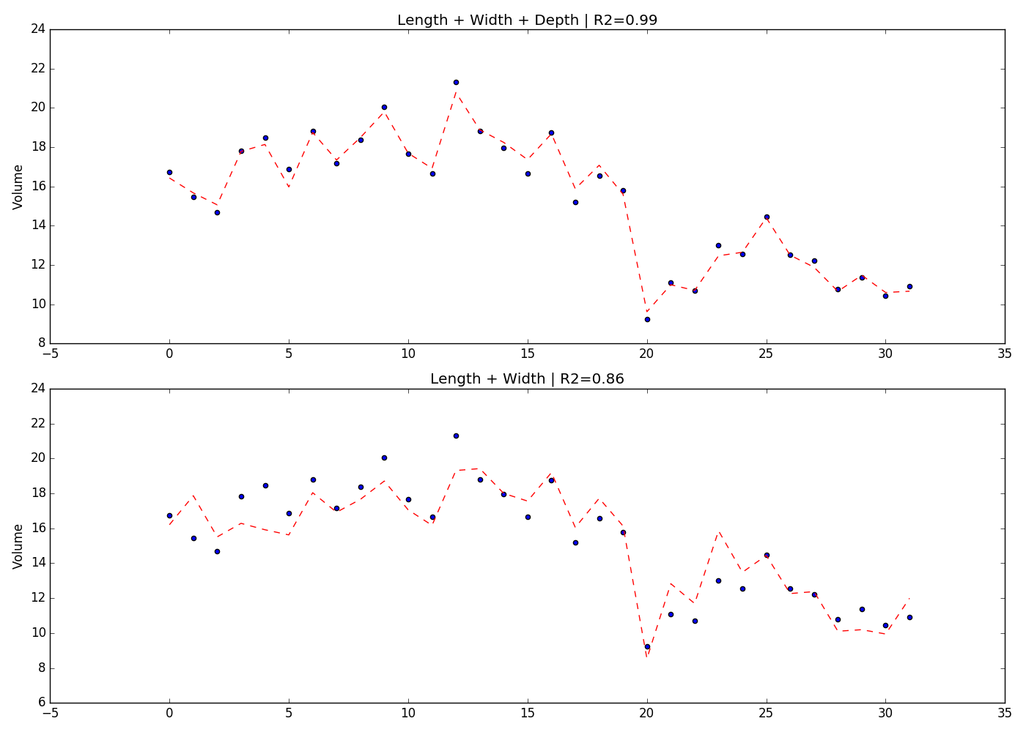 Figure 2.3.2: Showing the importance of 3rd dimension of depth

Least Squares Model
Equation, where the intercept (β0) has been set by surface area
$$ Y = \beta_0 + \times \beta_1 length \times \beta_2 depth \times \beta_3 width + \epsilon $$

Misc
The model produced an r2 value by:
\begin{equation}
1- \frac{\sum\limits_{i=0}^{n}{r^2}}{\sum\limits_{i=0}^{n}{(y_i - \overline{y})^2 }}
\end{equation}

Methods

Materials
< Plants which were used > …

How they were sourced

Any additional information

3D Scanning of Spikes
From the genotypes selected, fully dried, representative spikes were chosen for micro-CT scanning. Spikes were placed in plastic holders (34x70mm tubes) and imaged using a a μCT100 scanner (Scanco Medical, Switzerland).
The imaging system was configured with an X-ray source ranging from 20 to 100 kVp, a detector of 3072 x 400 elements. A resolution of 68.8 micro-meters per pixel was used for all scans.

Computational Methods

Misc Information to fold into discussion?
Fuller has evidenced that grain volume is used when initially identifying wheat grain which is recovered as being domesticated [Fuller2007]. Therefore justification for our model is very useful.
On the other hand [Willcox2004] found that barley is much harder to identify from it's domesticated relatives. Volume is not significantly different! Which fits perfectly with our results!
\clearpage

Data Tables

Einkorn
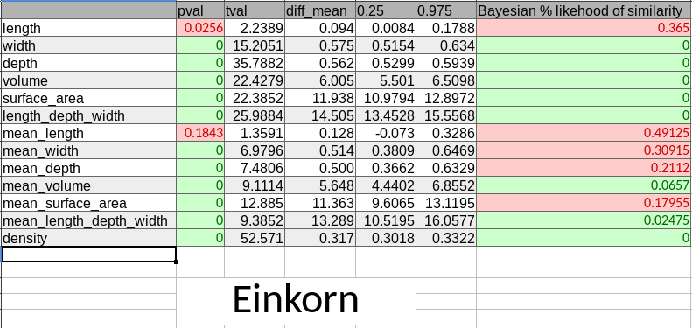 Figure 5.1.1: einkorn table

Emmer
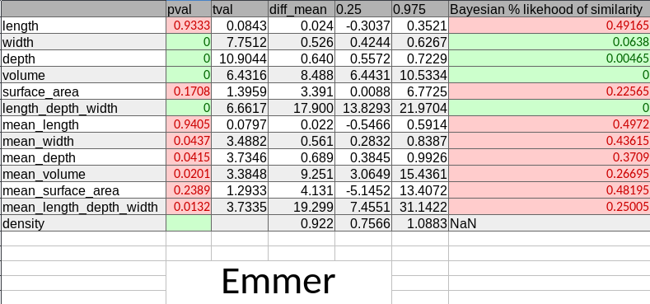 Figure 5.2.1: emmer table
\clearpage

Barley
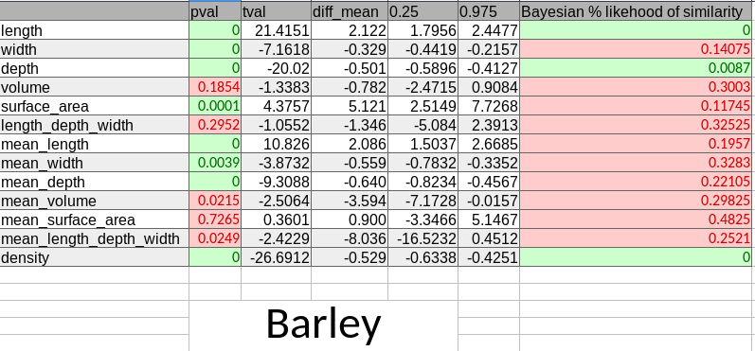 Figure 5.3.1: barley table

Domesticated 2N, 4N
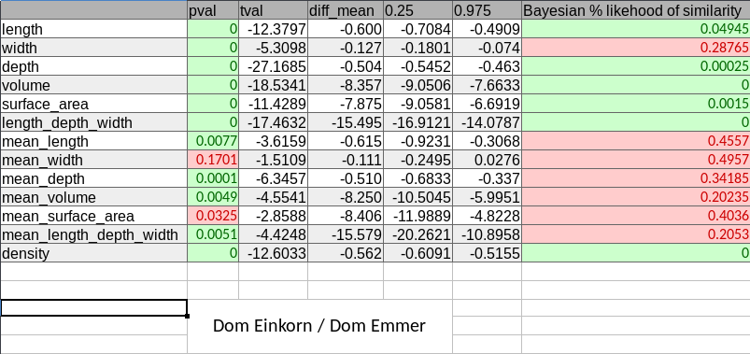 Figure 5.4.1: domesticated 2N, 4N table
\clearpage

Wild 2N, 4N
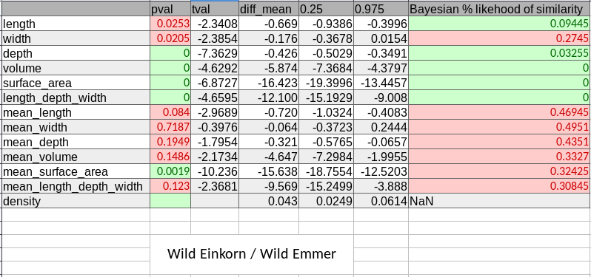 Figure 5.5.1: wild 2N, 4N table
\clearpage [Gegas2010] Gegas, Nazari, Griffiths, Simmonds, Fish, Orford, Sayers, Doonan \& Snape, {A Genetic Framework for Grain Size and Shape Variation in Wheat}, <i>{The Plant Cell}</i>, <b>22(4)</b>, 1046--1056 (2010). <a href="http://www.plantcell.org/lookup/doi/10.1105/tpc.110.074153">link</a>. <a href="http://dx.doi.org/10.1105/tpc.110.074153">doi</a>. [Fuller2007] Fuller, {Contrasting Patterns in Crop Domestication and Domestication Rates: Recent Archaeobotanical Insights from the Old World}, <i>{Annals of Botany}</i>, <b>100(5)</b>, 903--924 (2007). <a href="https://academic.oup.com/aob/article-lookup/doi/10.1093/aob/mcm048">link</a>. <a href="http://dx.doi.org/10.1093/aob/mcm048">doi</a>. [Willcox2004] Willcox, {Measuring grain size and identifying Near Eastern cereal domestication: evidence from the Euphrates valley}, <i>{Journal of Archaeological Science}</i>, <b>31(2)</b>, 145--150 (2004). <a href="https://www.sciencedirect.com/science/article/pii/S0305440303001055">link</a>. <a href="http://dx.doi.org/10.1016/J.JAS.2003.07.003">doi</a>.

