CHAPTER THREE

PROCEDURES AND IMPLEMENTATION

3.1 Requirements Gathering
Primary data for this project was obtained through direct observation of existing ride-hailing services and Google search engine. Secondary data was gathered through a review of technical documentation and similar web applications, including Uber, Bolt, and InDrive. From these sources, both functional requirements (such as registration, ride booking, and driver job acceptance) and non-functional requirements (such as security, performance, and usability) were identified and documented.

The gathered requirements were further analysed to determine the scope of the system, identify the relevant user roles (client, driver, and admin), and define clear system boundaries. This analysis directly informed the system design phase that followed.

3.2 System Design
The system design phase involved creating the database schema, designing the user interface wireframes, and defining the overall system architecture. A relational database was chosen for data storage, with tables designed to store user profiles, ride requests, bookings, driver availability records, and transaction history.

The system follows a three-tier client-server architecture: the presentation tier (React/TypeScript frontend rendered via Inertia.js), the logic tier (Laravel 13 backend using the MVC pattern), and the data tier (PostgreSQL database managed through Laravel Eloquent ORM). Users interact with the React frontend in their browsers; Inertia.js intercepts navigation events and exchanges JSON payloads with the Laravel backend without full page reloads, delivering a smooth single-page application experience. The backend processes business logic, applies authentication and authorisation, and queries the PostgreSQL database through Eloquent models before returning typed props to the React views.

The relational database consists of over twenty tables managed through Laravel migrations. The key tables include users (storing full name, email, phone, hashed password, user type, and account status), rides (storing client and driver IDs, pickup and drop-off locations, fare, and ride status), driver_profiles (storing vehicle details, online status, and location), wallet_transactions (storing transaction type, amount, and balance), and driver_kyc_documents (storing identity and licence verification records). The system distinguishes between three user roles, Client, Driver, and Admin, identified through a user_type field, with each role redirected to its own dashboard upon login.
Use case, flowchart, and data flow diagrams were developed to model the expected behaviour of the system and guide implementation, as shown in Figures 3.1 to 3.3.
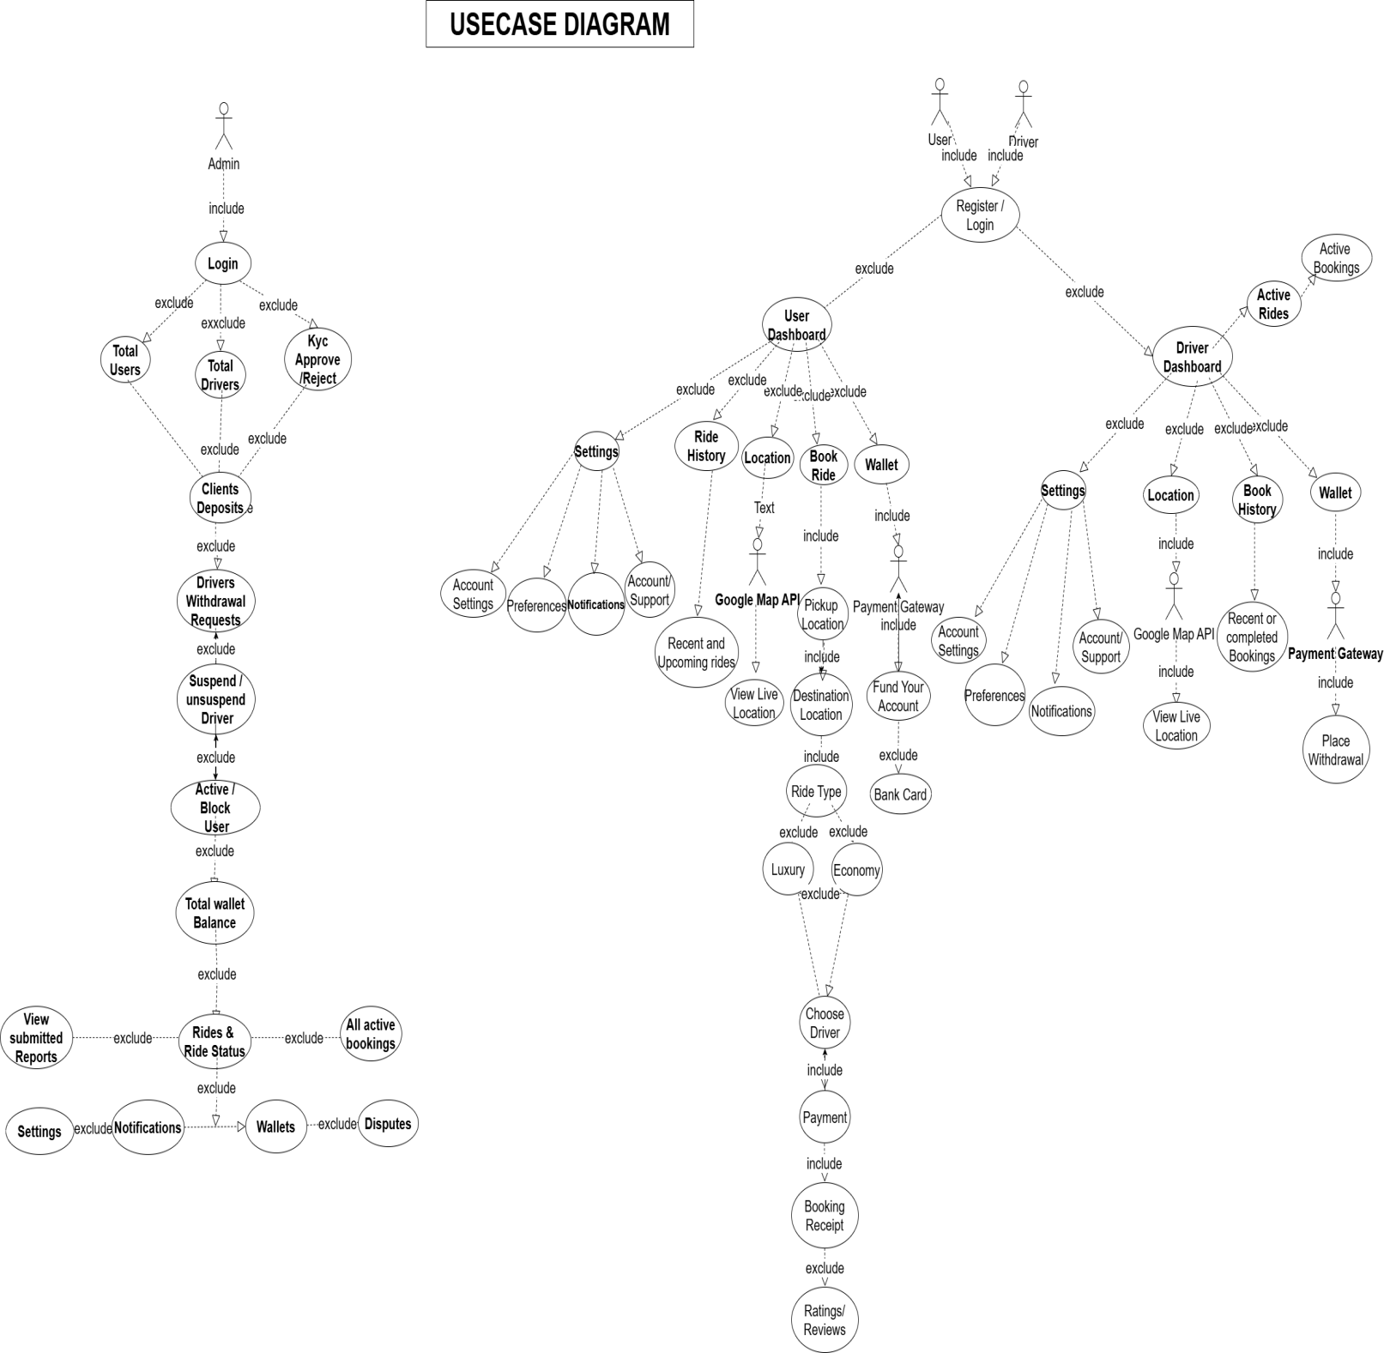

Figure 3.1: Use Case Diagram

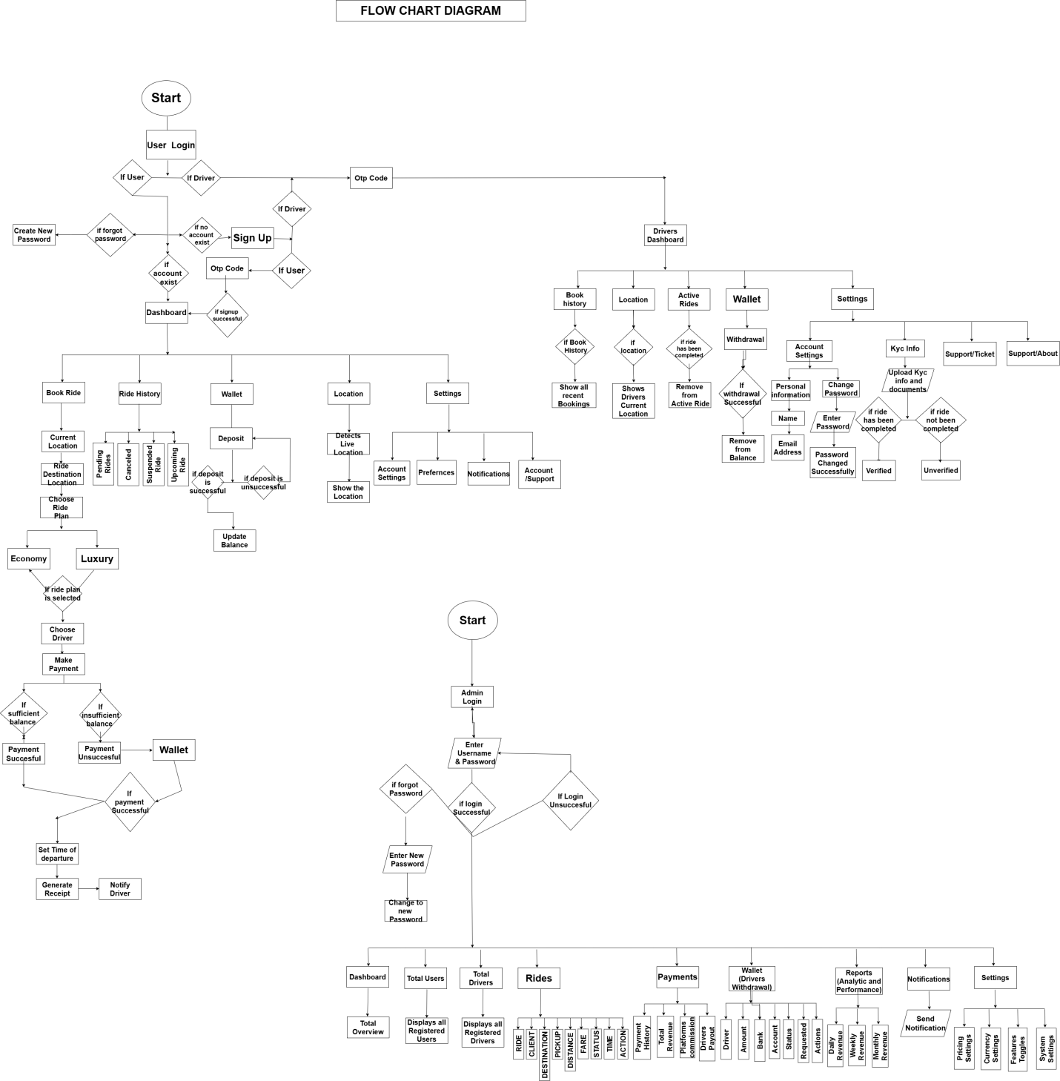
Figure 3.2: System Flowchart Diagram

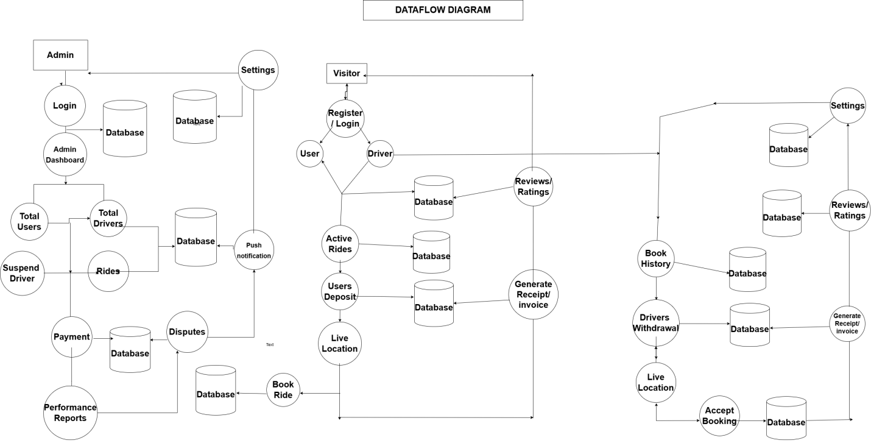
Figure 3.3: Data Flow Diagram

3.3 Tools and Technologies Used
The selection of tools and technologies for this project was guided by ease of use, cost (open-source preference), compatibility, community support, and suitability for a web-based diploma-level project. The following were used:
- Programming Language: PHP (via Laravel 13) for server-side logic, and TypeScript for the client-side frontend.
- Frontend Framework: React, for a responsive, mobile-friendly user interface that adapts to different screen sizes, integrated with the backend via Inertia.js.
- Backend Framework: Laravel 13, a widely used PHP framework with excellent support for web application development and MySQL database interaction.
- Database: PostgreSQL, a reliable, open-source relational database management system suitable for managing structured application data.
- Build Tooling: Vite (with pnpm as the package manager), providing fast hot-module replacement during development and optimised production bundles.
- Code Editor: Visual Studio Code, used as the primary development environment for writing and managing code.
- Operating System: Windows 11 was served as the operating system of the PC used in developing this project.
- Third-Party Services: Korapay for payment processing, Google Cloud maps for mapping and routing, and phpMyAdmin for visual database administration during development.

These tools collectively provide a stable, well-documented, and cost-effective foundation for the ride booking platform, and are widely taught and supported in the Nigerian educational technology context.

3.4 Development Process
Development followed the Waterfall model of the System Development Life Cycle (SDLC), proceeding through the following steps:
- Planning: Defined the project scope, objectives, and timeline based on the requirements gathered.
- Design: Produced the database schema, system architecture, and interface wireframes described in section 3.2.
- Coding: Implemented the system using Laravel 13 for server-side scripting, PostgreSQL for database management, and React/TypeScript for the frontend, integrating Korapay for payments and Google cloud map for live location. The implementation was carried out iteratively, with each module tested before integration into the overall system.
- Testing: Conducted unit testing of individual modules, integration testing of combined components, and user acceptance testing (UAT) with a sample group of volunteer users. Bugs and errors identified during testing were documented and corrected.
- Deployment: Hosted the completed application on a live server with a registered domain name, and documented installation and configuration steps for future reference.

