**Quad Copter Competition**

**W**

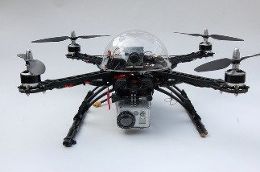**hat is a drone?** Quad copters, or drones, are flying devices that use four propellers instead of a tail rotor in order to provide the necessary torque to keep the device stable in flight. They have become increasingly popular in many industries including search-and-rescue and photography, but also have a large hobby following. Hobby groups stage races, obstacle courses, and other task-based competitions all over the world.

**Drone Competition:** LLTC, partnered with the Minnesota Space Grant Consortium and NASA, are exploring the possibility of competing in a new event, sponsored by MSGC. The competition consists of two parts.

* Each team will build a drone from a kit and then customizing it to fulfill a forthcoming challenge. Among the things that we may have to add to the drone are cameras, grabbing attachments, hooks, cargo bays, and many other specializations.
* On the competition day, someone from each team will have to fly the drone through a series of tasks in a sort of obstacle course. This may involve locating and taking a picture of an object, picking up and carrying objects. Taking off, flying, and landing with precision, etc.

**When:** The event is still in the planning phases, but as we move through the semester, we should have some solid dates by mid Fall semester and maybe even start building by early November. The competition will likely be in the Spring of 2020.

**Who:** All current students, no matter what major, are welcome to join the team! Only students who participate in the build and practice flying the drone will be able to come along for the competition.

**Why:** This competition will likely include a wide array of skills from soldering to programming to less tangible things like problem solving. We will have to think outside the box in order to accomplish all of the competition goals. Mostly, it should be really fun!

**Where:** The competition is being hosted by the University of Minnesota and will likely take place in Minneapolis at the U of M campus.

**Interested?** Contact Eric Kuha at [eric.kuha@lltc.edu](mailto:eric.kuha@lltc.edu) or in the halls at LLTC for more information or to sign up!