INVENTION DISCLOSURE FORM

Applicant Name- Siraj Sharif
Applicant Address- CGC Jhanjeri

- Particulars of Inventors

FIRST NAME | LAST NAME | DEPARTMENT | ROLL NUMBER | COURSE | MOB -NUMBER | EMAIL ID
SIRAJ | SHARIF | CSE APEX | 2420607 | AI&ML | 8847532423 | Sirajsharif.developer@gmail.com
PRINCE | RAJ | CSE APEX | 2420584 | AI&ML | 7070268434 | princeraj97086@gmail.com

Title of the Invention
Machine Learning Based Intelligent Educational Recommendation System for Personalized Study Materials, Books, and Learning Videos
S.NO. | TOPIC | PAGE NO.
1. | ABSTRACT | 02
2. | FIELD OF INVENTION | 03
3. | BACKGROUND OF THE INVENTION | 03
4. | OBJECTIVES OF THE INVENTION | 04
5. | SUMMARY OF THE INVENTION | 04
6. | BRIEF DESCRIPTION OF DRAWINGS | 05
7. | DETAILED DESCRIPTION OF THE INVENTION | 07
8. | ADVANTAGES OF INVENTION | 09
9. | CLAIMS | 10
10 | CONCLUSION | 12

Title of the Invention
Machine Learning Based Intelligent Educational Recommendation System for Personalized Study Materials, Books, and Learning Videos

Abstract
The present invention relates to an intelligent educational recommendation system designed to provide personalized learning resources using machine learning techniques. With the rapid growth of digital learning platforms and the increasing availability of online educational content, students often face difficulties in identifying the most relevant study materials from a vast collection of books, lecture notes, and educational videos. The proposed system addresses this challenge by developing a machine learning–based recommendation framework that analyzes educational datasets and generates personalized learning recommendations tailored to individual learners.
The system collects and processes educational resource data obtained from structured datasets containing information about study materials, books, and learning videos. These datasets include multiple attributes such as topic categories, difficulty level, keywords, content descriptions, and user interaction history. The system performs data preprocessing techniques such as data cleaning, normalization, and feature extraction to transform raw educational data into a structured format suitable for machine learning analysis.
After preprocessing, machine learning algorithms are applied to identify patterns, similarities, and relationships between different learning resources. The system evaluates content attributes and user preferences to determine the most relevant materials for each learner. Content-based filtering and similarity analysis techniques are used to recommend educational resources that closely match the learner’s interests, learning goals, and previous interactions with study materials.
Based on the analysis of user input and content attributes, the system generates a ranked list of recommended learning resources that may include textbooks, research articles, study notes, tutorial videos, and other educational materials. The ranking mechanism ensures that the most relevant and useful resources appear at the top of the recommendation list, allowing students to access appropriate learning content efficiently.
The proposed intelligent recommendation system aims to improve learning efficiency and enhance the overall educational experience by helping students discover relevant resources quickly and effectively. By providing personalized recommendations, the system supports adaptive learning environments that respond to individual learning patterns, preferences, and academic needs.
Furthermore, the invention contributes to the development of modern digital education platforms by integrating machine learning–based recommendation capabilities into educational systems. This approach not only reduces the time students spend searching for learning materials but also promotes effective knowledge acquisition through targeted and personalized educational content.

Field of the Invention
The present invention relates generally to the fields of Artificial Intelligence (AI), Machine Learning (ML), and Educational Technology (EdTech). More particularly, the invention relates to an intelligent recommendation system designed to provide personalized educational resources, including study materials, books, and learning videos, to learners based on their preferences, learning behavior, and content similarity.
With the rapid expansion of digital education platforms and online learning resources, a vast amount of educational content is available to students in the form of textbooks, research papers, lecture notes, and instructional videos. However, the abundance of such resources often makes it difficult for learners to efficiently identify the most relevant materials that match their individual learning requirements. Traditional educational systems and many digital platforms typically provide generic recommendations that do not fully consider the unique learning interests, knowledge level, and study patterns of individual users.
The present invention addresses this limitation by introducing a machine learning–based recommendation framework capable of analyzing educational datasets and user interaction data in order to generate personalized learning suggestions. The system applies data processing techniques and machine learning algorithms to evaluate resource attributes such as topic relevance, difficulty level, keywords, and content similarity, as well as user-specific factors including learning preferences and previously accessed materials.
By integrating intelligent recommendation mechanisms into digital learning environments, the invention aims to assist students in discovering suitable educational resources more efficiently. The system enhances the learning experience by providing targeted recommendations that align with the learner’s academic interests, thereby supporting adaptive and personalized learning processes.
Overall, the invention contributes to the advancement of intelligent educational systems by combining machine learning technologies with modern digital learning platforms to improve the accessibility, relevance, and effectiveness of educational content.

Background of the Invention
The rapid growth of digital learning platforms has resulted in an enormous amount of educational content available online, including books, tutorials, study materials, and instructional videos. Although this abundance of resources provides valuable learning opportunities, it also creates challenges for students in identifying the most relevant materials for their learning needs.
Traditional search systems typically rely on keyword matching or static categorization, which may not accurately reflect user preferences or learning objectives. As a result, learners may spend significant time searching for appropriate resources.
Existing recommendation systems attempt to address this issue but often suffer from limitations such as limited personalization, insufficient handling of diverse educational resource types, and inability to adapt to user behaviour dynamically.
Therefore, there is a need for an intelligent system capable of analysing educational content and user preferences to generate personalized recommendations for multiple types of learning resources including books, study materials, and educational videos.

Objectives of the Invention
The main objectives of the invention are:
- To develop a machine learning based recommendation system for educational resources.
- To provide personalized recommendations of study materials, books, and learning videos.
- To improve resource discovery in digital learning environments.
- To analyze user preferences and content similarity for generating relevant recommendations.
- To enhance the learning experience by reducing the time required to find appropriate study resources.

Summary of the Invention
The present invention proposes a machine learning based educational recommendation system that analyses educational datasets and user preferences to generate personalized recommendations.
The system utilizes datasets obtained from online educational repositories and processes them through several stages including data pre-processing, feature extraction, and similarity analysis. Machine learning algorithms are applied to identify relationships between educational resources and user interests.
The system architecture includes modules for data collection, pre-processing, feature extraction, recommendation generation, and ranking. The recommendation engine calculates similarity scores between resources and generates a ranked list of suggested study materials, books, and learning videos.
The proposed system aims to provide students with relevant educational resources tailored to their learning interests and preferences.

Brief Description of Drawings
The invention may be illustrated through the following figures:
Figure 1: System architecture of the educational recommendation system.

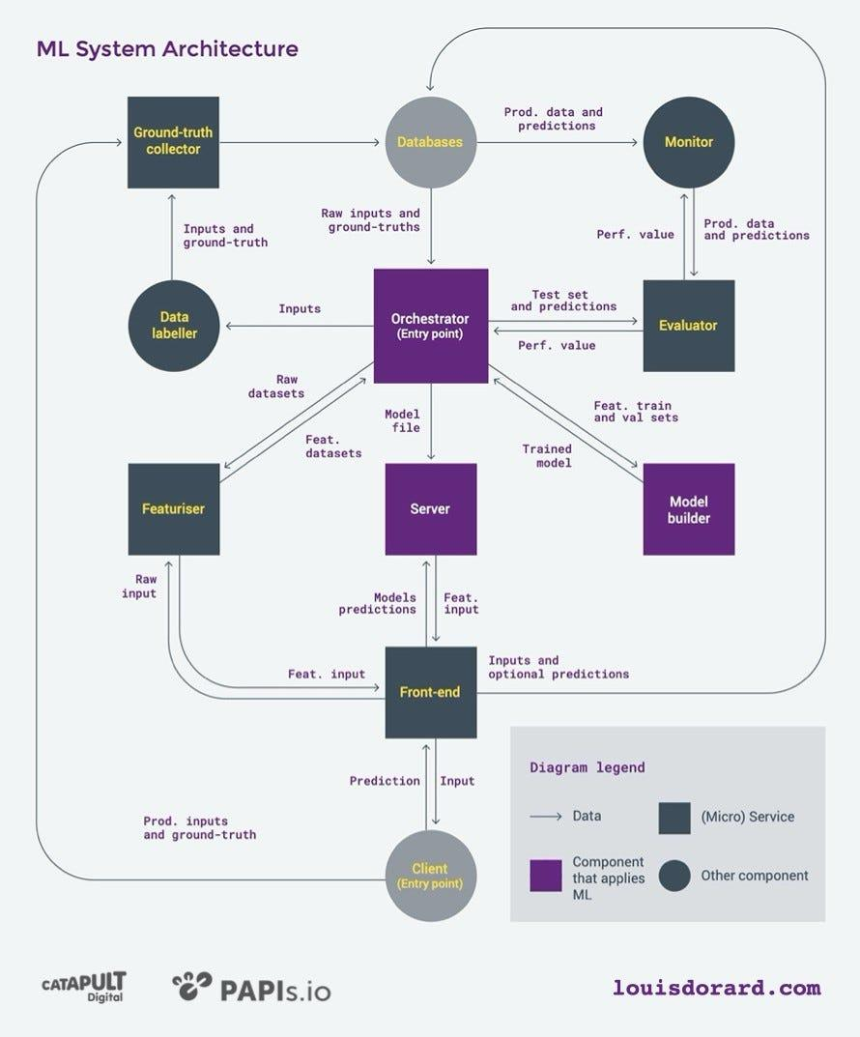

Figure 2: Data processing and machine learning pipeline.
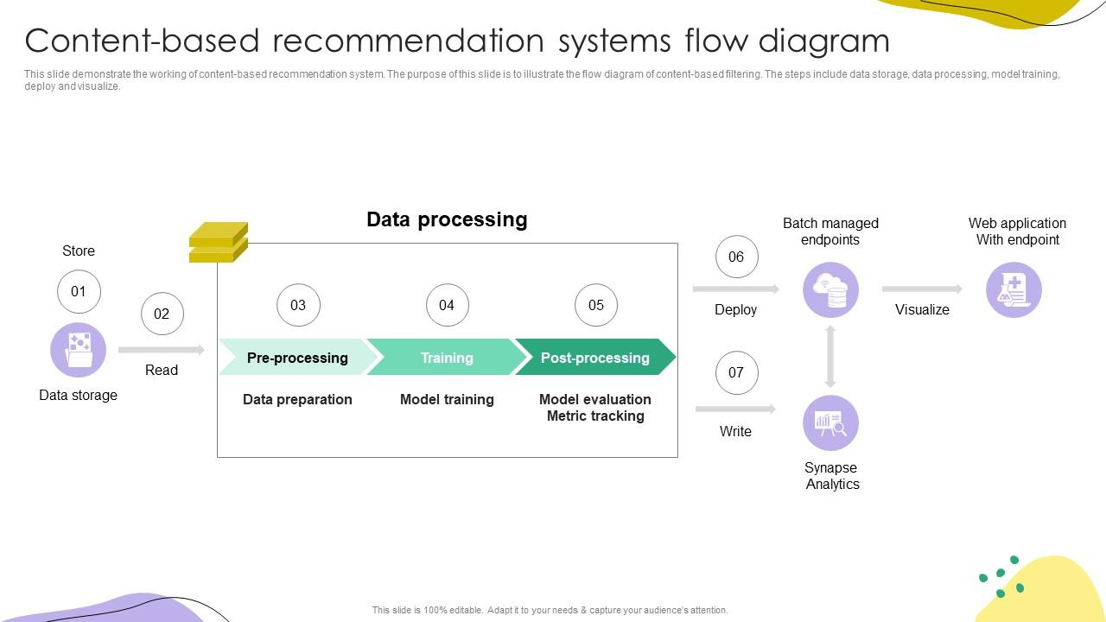

Figure 3: Workflow for ML Pipeline
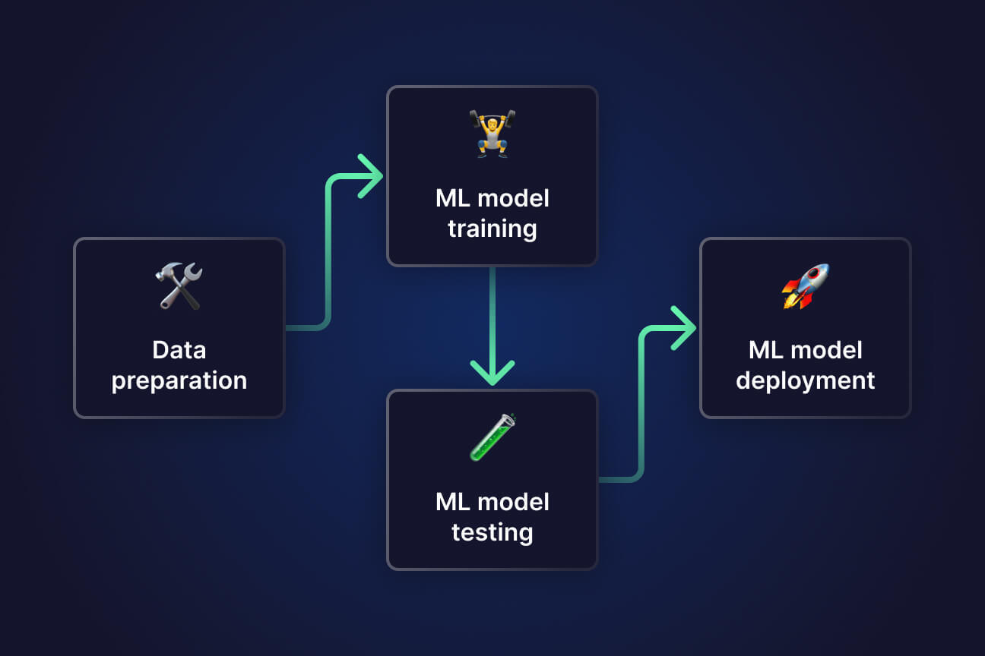

Detailed Description of the Invention

1. Data Collection
The system utilizes educational datasets obtained from publicly available repositories such as Kaggle. These datasets contain metadata related to educational resources including books, tutorials, study materials, and learning videos.
Typical dataset attributes include:
- Title of resource
- Subject category
- Keywords
- Resource type (book, study material, video)
- Ratings or popularity indicators

2. Data Pre-processing
Before training the recommendation model, the collected data undergoes pre-processing steps including:
- Removing missing or inconsistent data entries
- Cleaning text fields
- Normalizing textual and categorical information
- Organizing data into structured formats suitable for machine learning models
These steps ensure the dataset is consistent and ready for further processing.

3. Feature Extraction
Relevant features are extracted from the dataset to represent educational resources numerically.
Important features may include:
- Subject or domain
- Keywords describing the resource
- Resource category
- Difficulty level
- User preference indicators
Text-based features can be converted into numerical vectors using techniques such as term frequency–inverse document frequency (TF-IDF).

4. Recommendation Engine
The core component of the system is the machine learning recommendation engine.
The engine uses machine learning techniques such as:
- Content-based filtering
- Similarity analysis
- Nearest neighbour based recommendation
These methods analyses relationships between educational resources and user preferences.

5. Similarity Calculation
The system calculates similarity between different resources using vector similarity measures.
Based on these similarity scores, resources that are closely related to a user's selected topic or interest are identified.

6. Recommendation Generation
After calculating similarity scores, the system generates a ranked list of recommended educational resources.
The recommendations may include:
- Study materials related to a selected subject
- Books relevant to the learner’s interests
- Learning videos covering similar topics
The top-ranked resources are presented to the user as personalized recommendations.

7. User Interaction
Users interact with the system by selecting topics, courses, or resources of interest. The system analyses this input and produces customized recommendations.
Future improvements may include adapting recommendations based on user feedback and interaction history.

Advantages of the Invention
The proposed intelligent educational recommendation system provides several significant advantages that improve the process of discovering and utilizing educational resources in digital learning environments. By incorporating machine learning techniques, the system enhances the accessibility, relevance, and effectiveness of educational content for learners. The major advantages of the invention are described as follows:
1. Personalized Learning Recommendations
The system provides personalized recommendations tailored to the individual needs, preferences, and learning behavior of each student. By analyzing user interactions, search patterns, and previously accessed learning materials, the system suggests educational resources that closely match the learner’s interests and academic goals. This personalization helps students focus on content that is most beneficial for their learning progress.
2. Efficient Discovery of Educational Resources
With the increasing volume of online educational content, students often struggle to find the most relevant study materials. The proposed system simplifies this process by intelligently filtering and recommending resources based on content similarity and user preferences. As a result, students can quickly discover suitable study materials without spending excessive time searching through large datasets.
3. Support for Multiple Types of Learning Content
The system is capable of recommending various types of educational resources, including textbooks, reference books, lecture notes, research papers, and instructional videos. This multi-format recommendation capability allows learners to access diverse learning materials according to their preferred learning style, whether it is reading-based learning or visual and video-based learning.
4. Enhanced Learning Experience
By delivering intelligent and relevant suggestions, the system significantly improves the overall learning experience. Students receive recommendations that align with their current level of understanding and subject interests, which helps them engage more effectively with educational content and achieve better learning outcomes.

5. Scalable and Adaptable System Architecture
The architecture of the proposed system is designed to be scalable and adaptable, making it suitable for integration with modern digital learning platforms such as online education portals, university learning management systems, and e-learning applications. The system can efficiently handle large volumes of educational datasets and user interactions while maintaining reliable recommendation performance.

6. Continuous Learning and Improvement
The recommendation system can continuously improve its accuracy by learning from user feedback and interaction data. As more students use the system, the machine learning algorithms can refine their predictions and provide increasingly accurate recommendations over time.

Claims
Claim 1
A machine learning based educational recommendation system comprising:
- a dataset collection module configured to obtain educational resource data,
- a pre-processing module configured to clean and organize the dataset,
- a feature extraction module configured to convert resource attributes into machine learning features,
- a recommendation engine configured to analyses similarities between resources,
- and a ranking module configured to generate personalized recommendations.

Claim 2
The system of claim 1, wherein the recommendation engine is configured to generate personalized recommendations for multiple types of educational resources, including study materials, books, and learning videos. The recommendation engine analyzes processed educational datasets and user interaction data to determine relevant learning resources based on content attributes, topic similarity, and user preferences. The generated recommendations are presented to the user in a ranked order according to their relevance, thereby enabling learners to efficiently access appropriate study materials, reference books, and instructional videos that correspond to their individual learning requirements.

Claim 3
The system of claim 1, wherein the recommendation engine utilizes a content-based filtering approach to determine similarity between educational resources. The recommendation engine analyzes attributes associated with the educational resources, including subject category, keywords, topic descriptions, difficulty level, and other metadata features, in order to identify relationships and similarities among study materials, books, and learning videos.
The content-based filtering mechanism processes these attributes through feature extraction and similarity measurement techniques to compute a relevance score between different educational resources. Based on the calculated similarity scores and user preferences, the recommendation engine generates and presents a ranked list of educational resources that are most closely related to the user’s previously accessed or selected content, thereby providing personalized and context-relevant learning recommendations.

Claim 4
The system of claim 1, wherein educational resource metadata including subject category, keywords, topic descriptions, and other descriptive attributes are utilized by the recommendation engine for generating recommendations. The system analyzes the metadata associated with each educational resource to identify relationships and similarities between different study materials, books, and learning videos.
The metadata is processed through feature extraction and similarity evaluation techniques to determine the relevance of available educational resources with respect to user preferences and previously accessed content. Based on this analysis, the recommendation engine generates a ranked list of recommended educational resources that closely match the subject interests and learning requirements of the user, thereby improving the accuracy and effectiveness of the recommendation process.

Claim 5
The system of claim 1, wherein similarity between educational resources is calculated using vector similarity measures. In particular, the system represents educational resources, including study materials, books, and learning videos, as numerical feature vectors derived from resource metadata such as subject categories, keywords, topic descriptions, and other relevant attributes.
The recommendation engine applies vector similarity techniques, including similarity computation methods, to determine the degree of relevance between different educational resources. Based on the calculated similarity scores, the system identifies and ranks resources that are most closely related to the user’s selected or previously accessed learning materials, thereby enabling accurate and personalized recommendations within the educational recommendation system.

Claim 6
The system of claim 1, wherein the system is configured to generate and present a ranked list of recommended educational resources based on calculated similarity scores. The recommendation engine evaluates the similarity between educational resources using predefined similarity measurement techniques and assigns a relevance score to each resource in relation to the user’s selected or previously accessed content.
The resources are then arranged in a ranked order according to their respective similarity scores, such that educational materials with higher relevance scores are displayed at higher positions in the recommendation list. The ranked output may include various types of educational content, including study materials, books, and learning videos, thereby enabling users to efficiently access the most relevant learning resources that align with their interests and learning requirements.
.

Conclusion
The present invention introduces a machine learning–based educational recommendation system designed to provide personalized learning experiences by recommending study materials, books, and learning videos tailored to the individual needs of each learner. Traditional educational approaches often provide uniform content to all students, which may not align with diverse learning preferences, abilities, or study habits. In contrast, the proposed system leverages machine learning algorithms to analyze educational datasets, content attributes, and user behavior to generate relevant and meaningful recommendations.
By processing resource metadata, topic descriptions, keywords, and user interaction data, the system identifies relationships and similarities between different learning materials. It then generates a ranked list of recommended resources, ensuring that students can efficiently access content that aligns with their academic goals, interests, and current knowledge level. This reduces the time and effort required to discover appropriate study materials and promotes a more focused and productive learning process.
The system’s intelligent recommendation engine enhances digital learning environments by adapting to each learner’s behavior over time. As students interact with the system, it continuously refines its recommendations using feedback and historical data, thereby creating an adaptive, personalized, and data-driven learning pathway. Additionally, the system supports multiple content formats, including textbooks, research articles, lecture notes, and educational videos, making it versatile and suitable for diverse learning styles.
Overall, the invention contributes to the advancement of educational technology by combining machine learning techniques with intelligent recommendation strategies. It promotes effective knowledge acquisition, improved engagement, and better learning outcomes, while providing a scalable framework that can be integrated into modern online education platforms, e-learning portals, and university learning management systems. The system represents a significant step toward personalized and adaptive education, ensuring that learners can access the most relevant content efficiently and achieve academic success.

