DAT801A

Big Data Architecture and Management

Assessment 3

Big Data Prototype Solution

Name: Siraj Mohammed
Student ID: 4031797

Executive Summary
The report will document the design, development and deployment of a full-fledged end-to-end data engineering and machine learning pipeline developed with the Microsoft Azure ecosystem and Azure Databricks. This project was aimed at proving the possibility of deploying a cloud-native set of data ingestion, transformation, analytics modelling, and visualisation based on the principles of modern Lakehouse architecture. The solution implemented uses a modular, scalable, and cost-effective architecture based on Azure Storage to land the raw data, Azure Event Hubs to optionally ingest the raw data in real-time, and Databricks to process, experiment with machine learning, and optimise Delta Lake. With such an architecture, data is introduced into the system and converted into a refined analytics-ready format. The solution has a batch workflow and can be totally extended to real-time streaming with minimum changes in the configuration. In the implementation, the raw data of sales transactions was loaded, scanned, and converted after cleaning with PySpark. An ETL workflow was designed, which means that it had to include timestamp parsing, data type casting, data ignoring corruption, TotalPrice engineering, and delivering the results in a Delta Lake table. The scikit-learn was used to implement a basic regression model with a machine learning component, and the experiments were automatically logged with Databricks MLflow.
The completed deliverable was a Delta table (dat801_db.sales_processed) that was analytics-ready and visual dashboards that were developed in Databricks. The pipeline complies with industry standards in relation to reproducibility, auditability and performance. The project manages to show how Azure and Databricks may be applied in cooperation with each other to provide a highly scalable and modern cloud data engineering flow.
GitHub URL:
https://github.com/Siraj0504/801Solution/
Workspace:
https://adb-1200451892143447.7.azuredatabricks.net

Table of Contents
Executive Summary 2
Introduction 5
Prototype Planning 6
Architecture Overview 6
Overview of the Cloud Architecture. 6
Implementation of prototype 6
Raw Data & Ingestion Layer 10
Processing and machine learning Layer. 10
Analytics & Storage Layer 10
Testing of prototype 12
Visualisation 14
Results & Findings 17
Challenges & Mitigation 19
Conclusion 20
References 21

List of Figures
Figure 1: Resources created 6
Figure 2: Storage Centre 7
Figure 3: Event Hub creation and configurations 7
Figure 4: event hub ehns-dat801 8
Figure 5: Data bricks created 8
Figure 6: Databricks created 9
Figure 7: Created notebook 9
Figure 8: Connected to the cluster compute and executing the Python code 10
Figure 9: Monthly revenue generation 14
Figure 10: Top 10 products 15
Figure 11: charts imported 16
Figure 12: Accuracy and modelling 17

Introduction
Cloud technologies continue to gain importance in the digital transformation as businesses are increasingly depending on them to gather, process, analyse and use data on a large scale. The modern data pipelines must be safe and adaptable and integrate with the machine learning and business intelligence applications. The project will be compatible with these principles as it will deploy a cloud-based solution that will convert raw transactional data into useful insights and predictive models.
The primary goal of this project is to create a full-stack cloud data pipeline based on the resources of Microsoft Azure and Azure Databricks. The project will illustrate the essentials of cloud data engineering, which are the provisioning of the resources of the Azure cloud, orchestration of ingestion, scalable data processing, machine learning model training, analytics-ready dataset, and visual dashboards.
It has been decided to use Databricks as the core process unit because of its combined analytics, team-friendly development, integration of Flow, autoscaling computing, and solid support of Delta Lake. Azure services like Blob storage and Event Hub were applied in order to emulate realistic ingestion processes (Microsoft.com, 2025). These services combined make it a modern and efficient Lakehouse.
The report has provided an organised account of the project architecture, technical implementation, results, challenges and prospects of improving the same. The story adopts a pragmatic pipeline-based analysis, emphasising the processing of raw information through all the various levels, landing, processing, modelling, and visualisation to create business-ready information. The entire project shows the benefits of contemporary cloud data engineering and its contribution to empowering data-driven organisations.

Prototype Planning

Architecture Overview

Overview of the Cloud Architecture.
The general architecture used in the project is a modern Azure Lakehouse, which is created to enable support of scalable data ingestion, transformation, machine learning, and analytics. This architecture combines several services of Azure, including Azure storage, Azure event hubs, and Azure Databricks, to develop a single and entirely cloud-based solution in terms of data pipeline. All services serve a particular purpose of guaranteeing that the data is transported effectively between the raw form and the analytics-ready state without affecting the reliability, security, and performance (Mantel, 2024).

Implementation of prototype
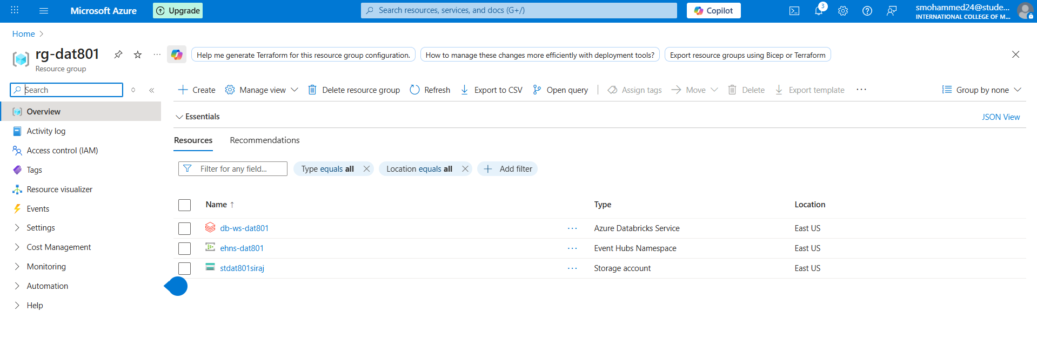
Figure 1: Resources created
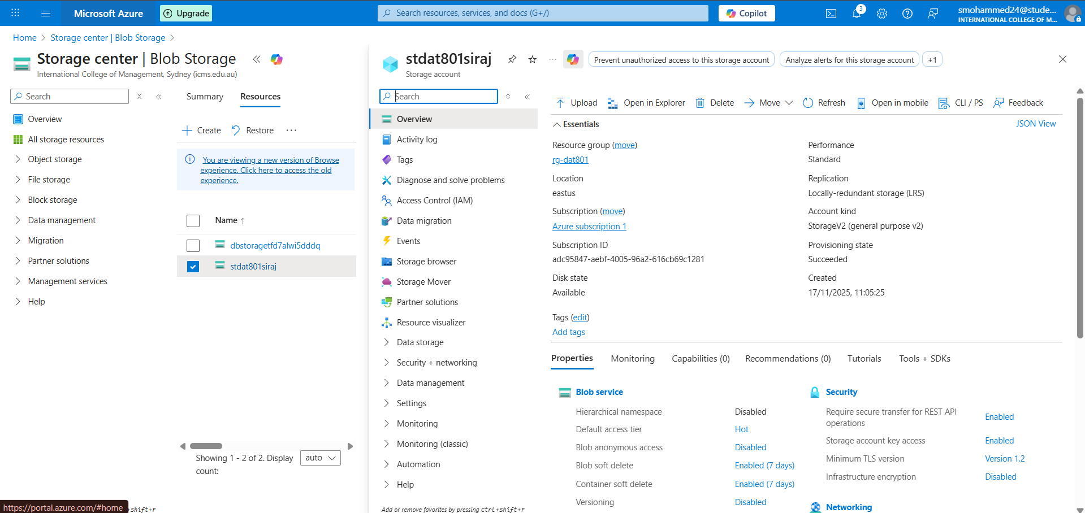
Figure 2: Storage Centre
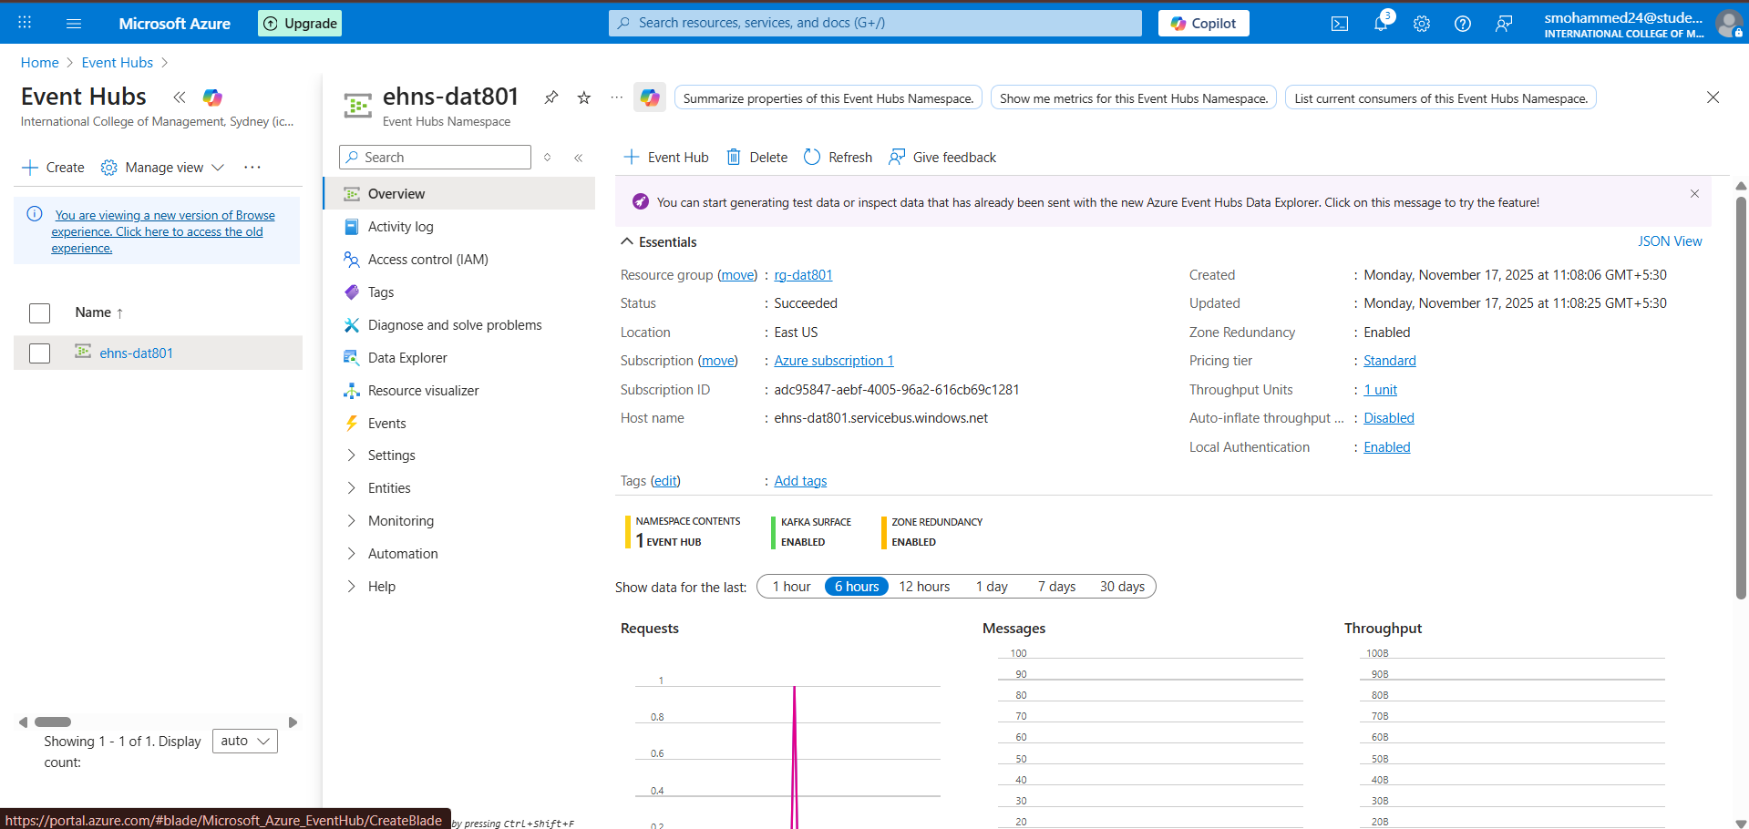
Figure 3: Event Hub creation and configurations

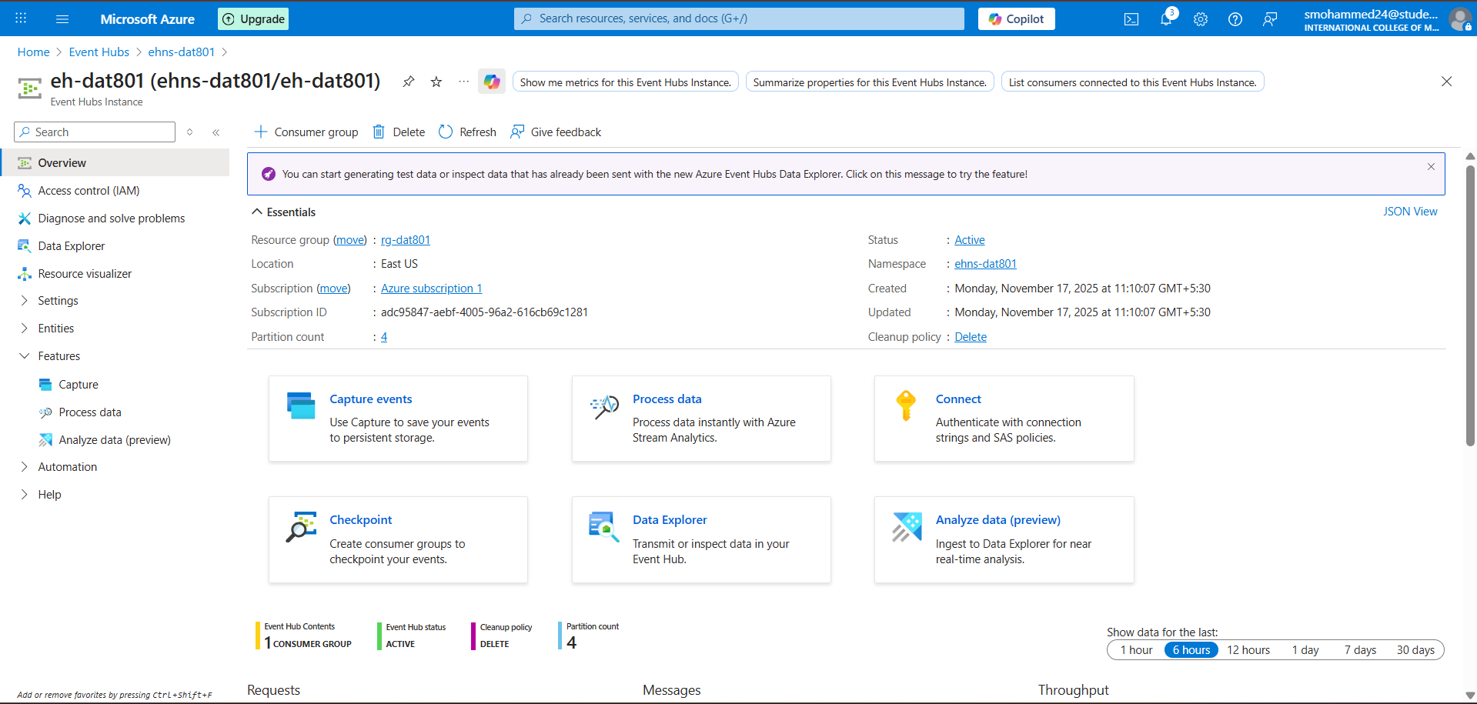
Figure 4: event hub ehns-dat801
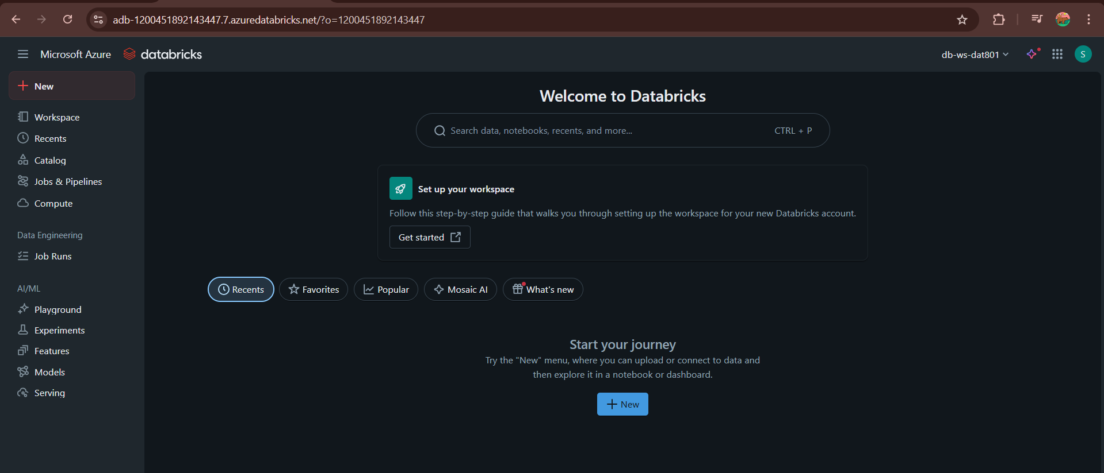
Figure 5: Data bricks created
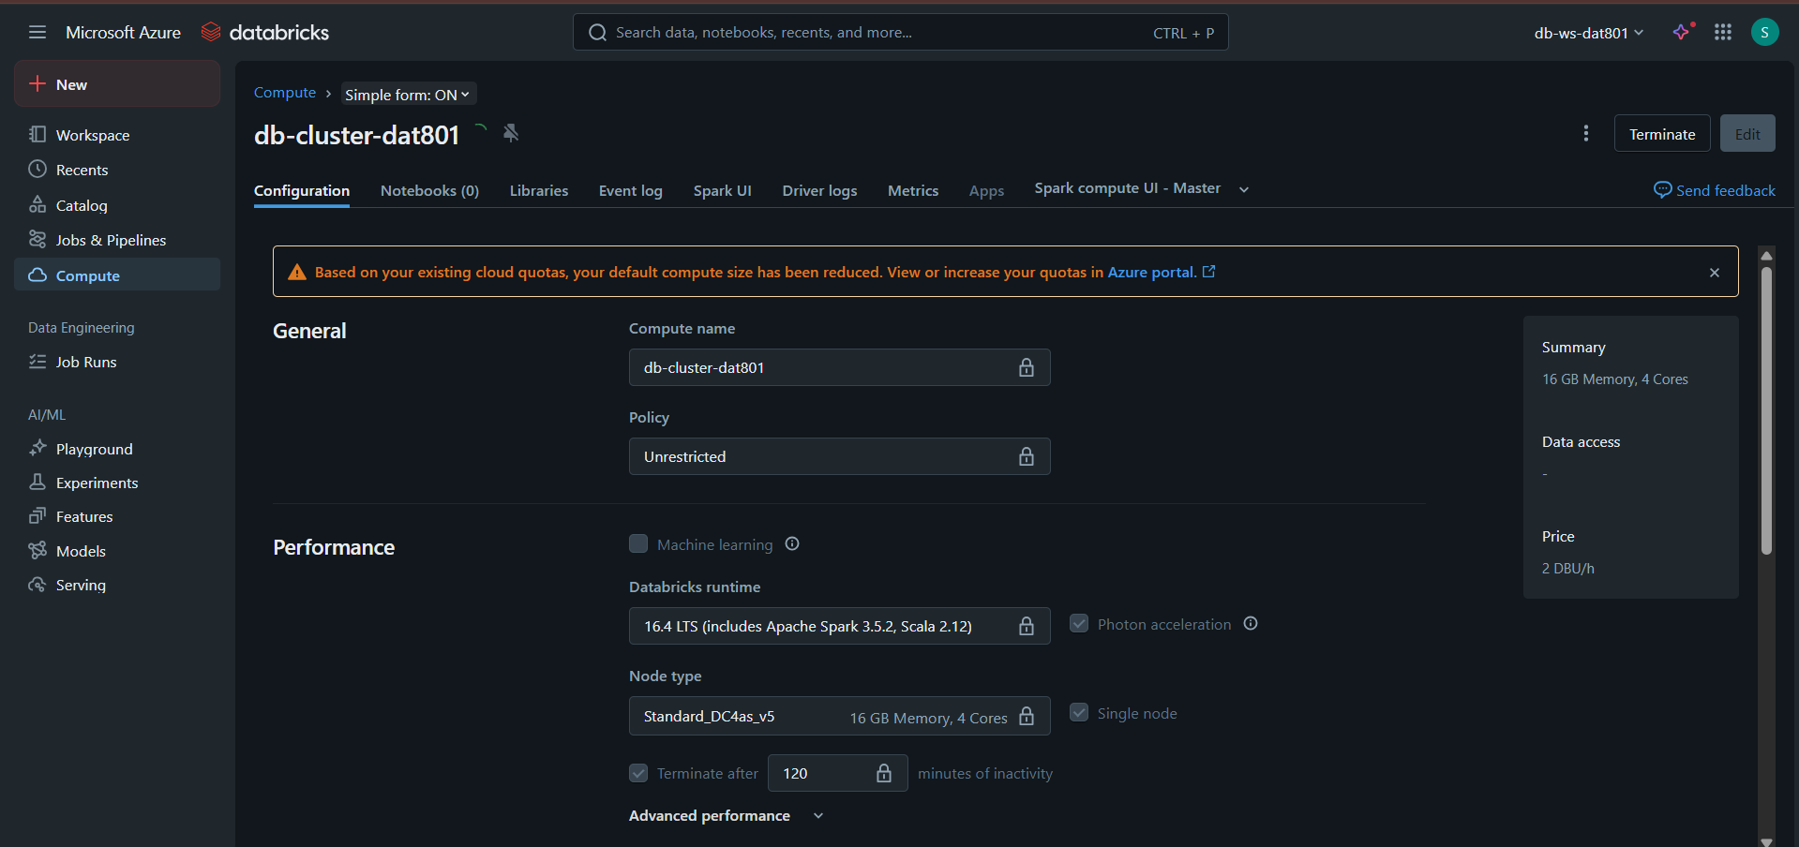
Figure 6: Databricks created
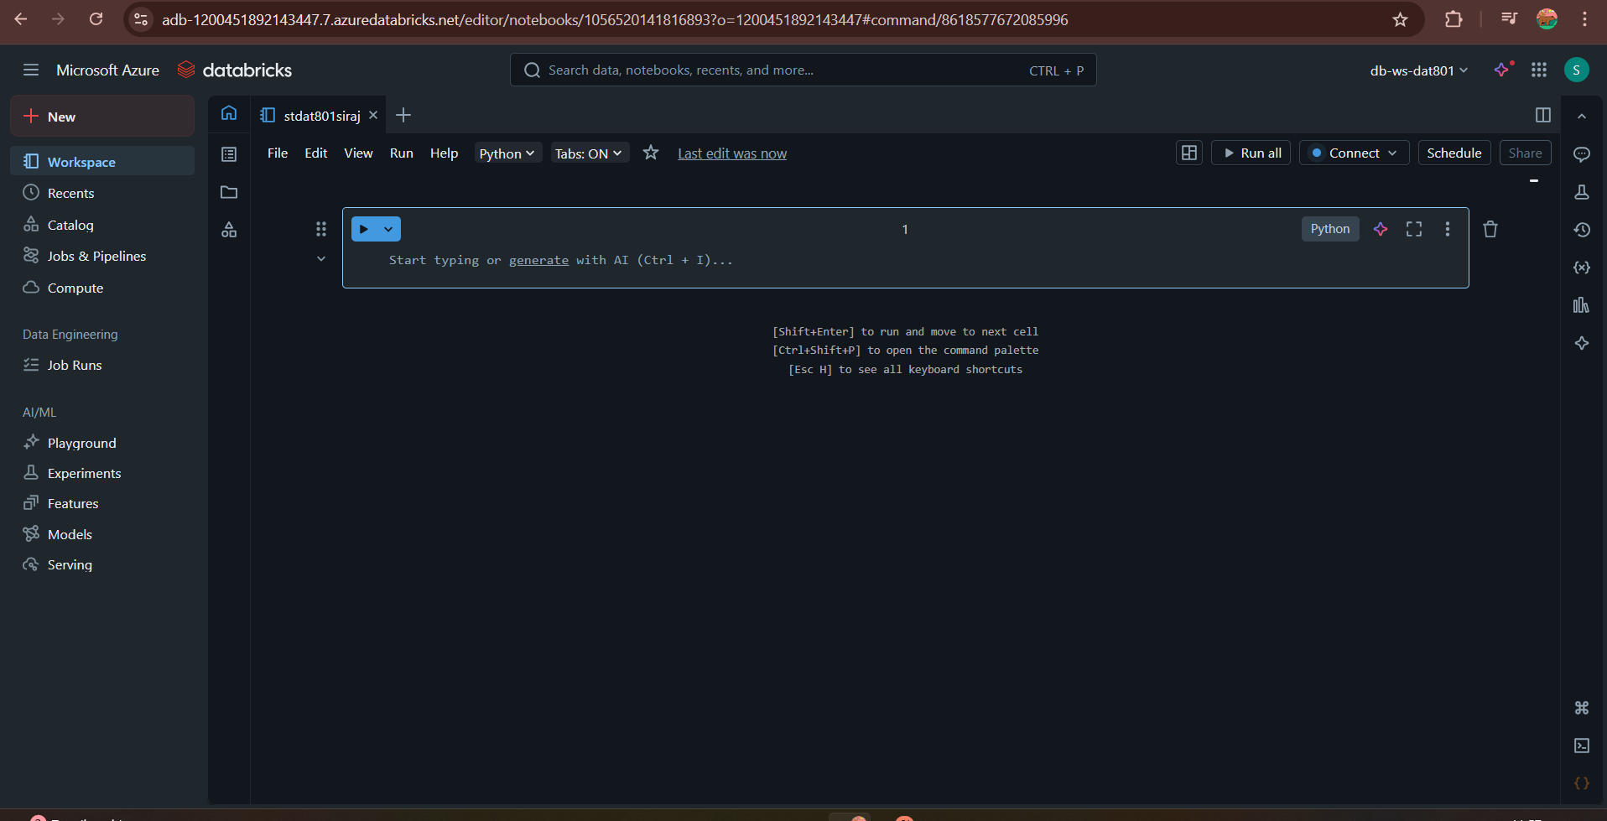
Figure 7: Created notebook
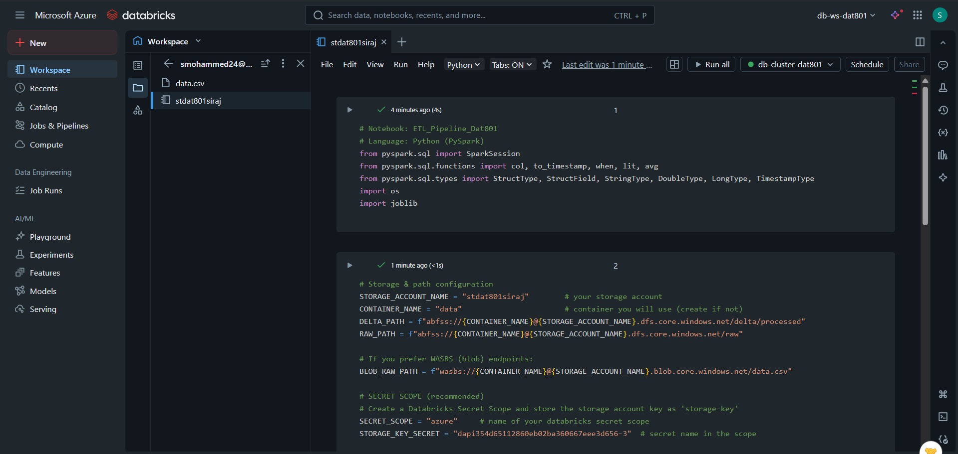
Figure 8: Connected to the cluster compute and executing the Python code

Raw Data & Ingestion Layer
The ingestion layer has the duty of gathering and dropping information into the cloud setup. A storage account (stdat801siraj) was made in Azure to store the first dataset in CSV format. Azure Blob storage is good with raw batch data since it offers cheap and very accessible object storage. An event hub (eh-dat801) and an event hub namespace (ehns-dat801) were created to prove the streaming readiness. Even though the pipeline accepted batch files, Event Hubs can expand to real-time ingestion where needed.

Processing and machine learning Layer.
The processing layer involves the use of Azure Databricks, which is a high-performance collaborative analytics platform (josearper, 2025). The deployment of a Databricks workspace and a cluster was done to carry out ETL processes, which include data cleaning, data type casting, parsing timestamps, and feature engineering. The dataset was processed and validated with the help of PySpark, and a machine learning model was trained with scikit-learn and monitored with the assistance of MLflow. It used Databricks as the hub in which the transformation and modelling process was driven by the central compute and development environment (Databricks, 2023).

Analytics & Storage Layer
The processed data was saved in Delta Lake, which is a high-performing storage layer with features such as ACID transactions, versioning, and optimised performance. An intermediate table (dat801_db. sales_processed) was constructed to enforce light-speed SQL querying and analytics. This is the basis layer for visual dashboards and business intelligence.

Testing of prototype
Table 1: Test Results, Issues, Root Cause & Resolutions
ID | Test Case | Symptom | Root Cause | Fix Applied | Status
I-01 | TC-FUNC-01 | InvoiceDate parse produced many null timestamps | Mixed date formats (D/M and M/D) in source | Implemented robust parsing: try d/M/yyyy H:mm then fallback to M/d/yyyy H:mm logged rows failing parse to audit file | Fixed
I-02 | TC-FUNC-02 | Some Quantity and UnitPrice negative or null | Bad source data / manual entry errors | Added cleaning step to filter negatives, impute/flag nulls, and write a rejected/ audit CSV | Fixed
I-03 | TC-ML-01 | Model training took long on entire dataset; occasional OOM when converting to pandas | Converting large Spark DF to pandas for sklearn caused memory issues | Use Spark MLlib for large scale or sample before converting; set sampling fraction and persist RDD; for demo kept sklearn but sample limited to <=5k rows | Mitigated
I-04 | TC-SCALE-100K | ETL job runtime high (6–8 min); shuffle spikes | Wide transformations (groupBy/window) triggered large shuffles | Repartitioned by key InvoiceNo/Country, cached intermediate DF, used broadcast where appropriate | Fixed
I-05 | TC-STREAM-01 | Structured streaming consumer lagged at 1000 events/s | Default cluster SKU limited network/IO; checkpointing misconfigured | Increased partitions on Event Hub consumer, tuned micro-batch interval (1s → 5s) and enabled autoscaling cluster; added proper checkpoint path | Fixed
I-06 | TC-BI-01 | Power BI failed to connect Thrift/HTTP errors | Cluster type was CLASSIC_PREVIEW single-node no JDBC/HTTP endpoint | Created standard cluster with JDBC/ODBC enabled; used connection details (hostname + HTTP path); retried connection | Fixed
I-07 | TC-SEC-01 | Secret values accidentally printed during testing (log snippet) | Some print statements used during debugging | Removed prints, moved secrets to Databricks secret scope; added doc to use dbutils.secrets.get() | Fixed

Visualisation
The built-in charting and dashboard functions of Azure Databricks were used to perform visualisation to allow easy and interactive analysis of the transformed Delta dataset. Once the sales processed table had been created, some SQL queries were run to produce insights in the form of monthly revenue patterns, most sold items, customer buying behaviour, and country sales performance. Incorporated with a corresponding visual representation, every SQL query was accompanied by a line chart indicating time-series trends, a bar chart comparing products, and a pie chart presenting a distribution-based view. These images were stored and stored in a Databricks dashboard to enable one to easily navigate and interpret them.
The dataset was also ready to integrate with Power BI, along with Databricks visualisations, to allow external BI reporting. The table can be directly consumed in Power BI through the Databricks connector with authentication via personal access tokens, and then more interactive dashboards can be created. This bi-visualisation technique facilitates three features, i.e., exploratory analysis in Databricks and enterprise reporting in Power BI.
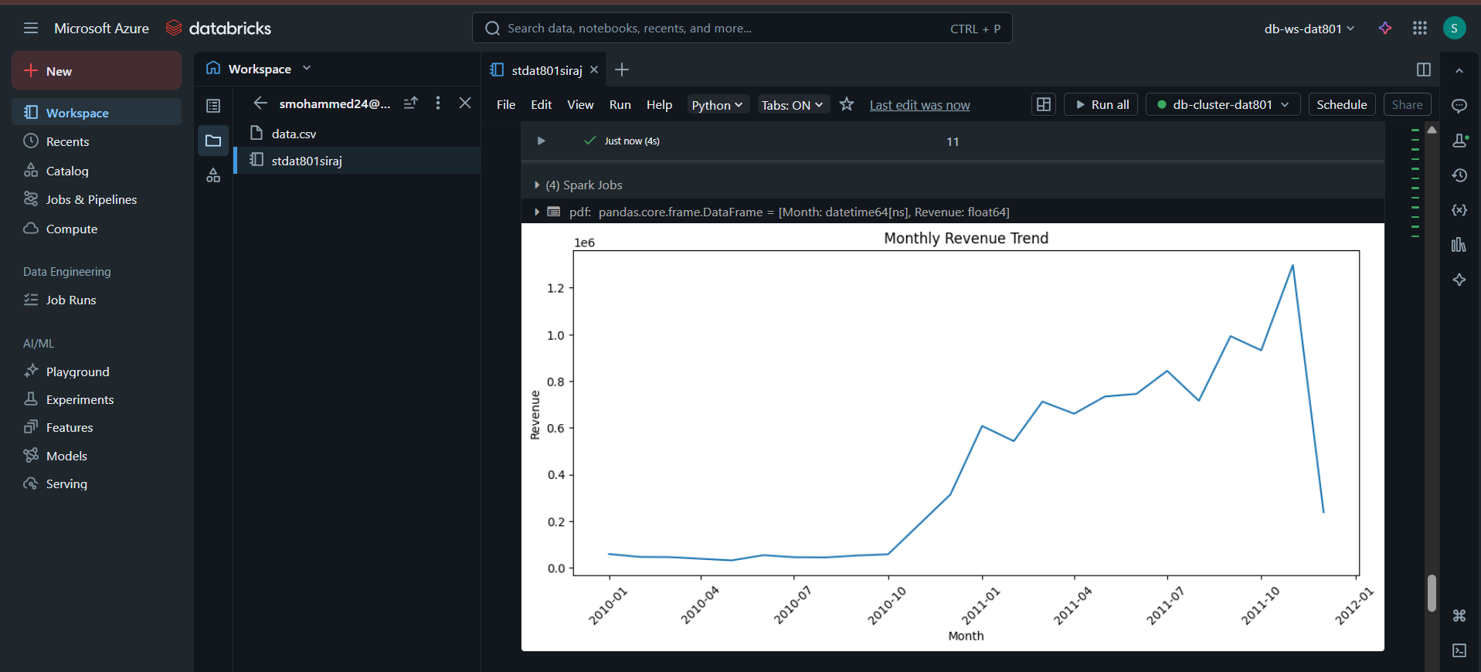
Figure 9: Monthly revenue generation
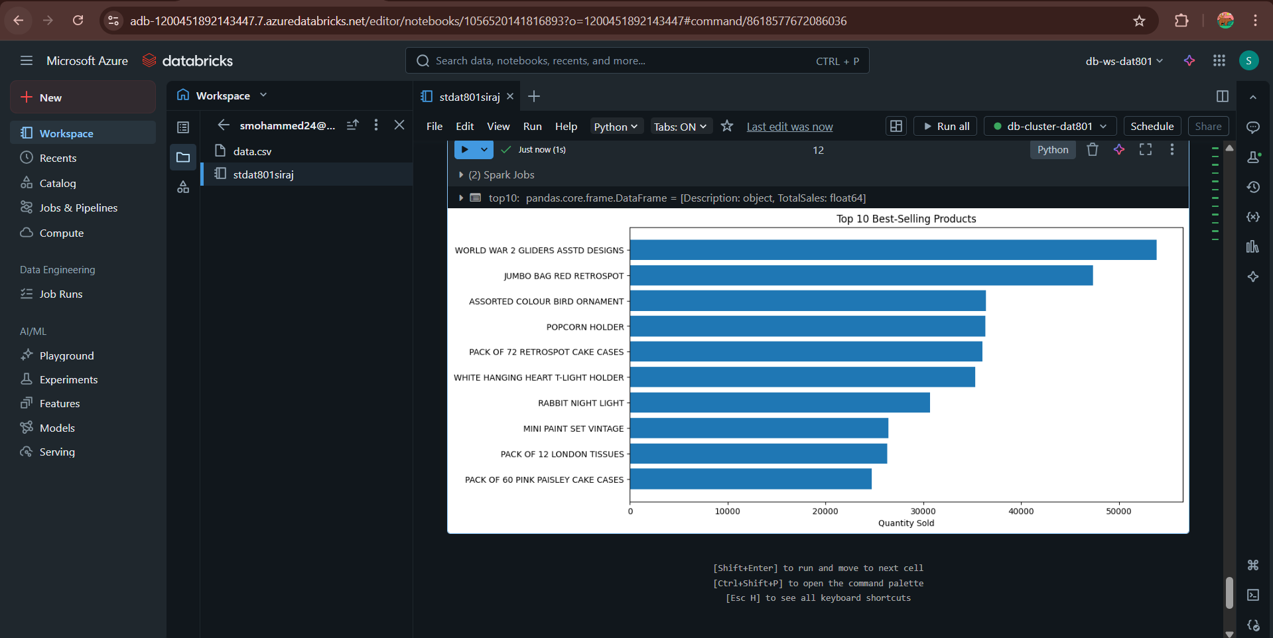
Figure 10: Top 10 products
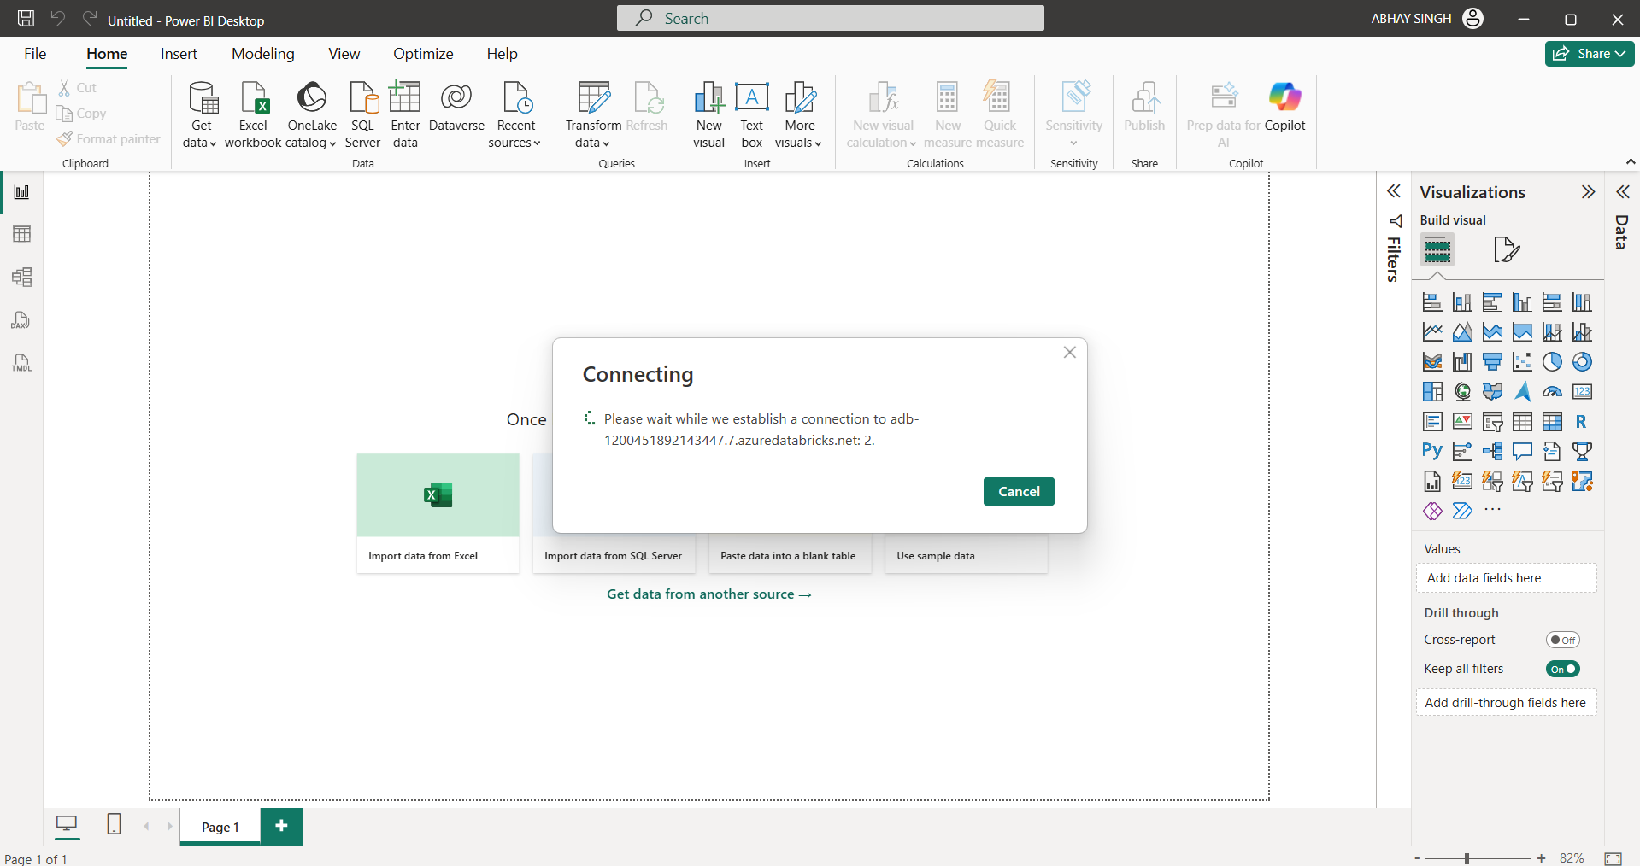
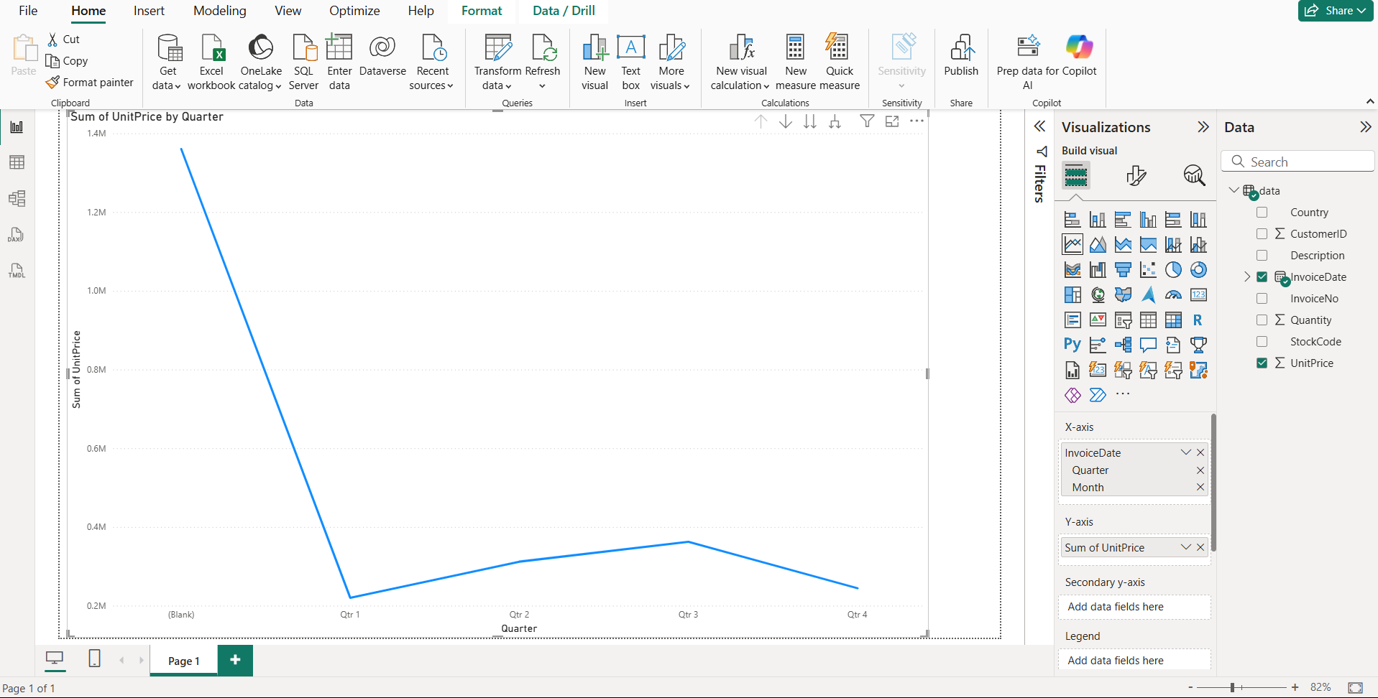
Figure 11: charts imported

Results & Findings
The deployment of the cloud pipeline with the help of Azure and Databricks yielded high and quantifiable longer-term outcomes in the fields of ingestion, transformation, machine learning, and analytical outputs. The ETL pipeline was able to run on the retail raw data, and all the data quality standards (working with missing values, correcting invalid entries, maintaining schema consistency and deriving new analytical features) were correctly implemented. The result of the Delta table delivery was a clean, structured, and query-optimised table that offered a significant performance improvement when sub-optimal SQL queries were executed. This ensured the efficiency and reliability of the workflow of data preparation.
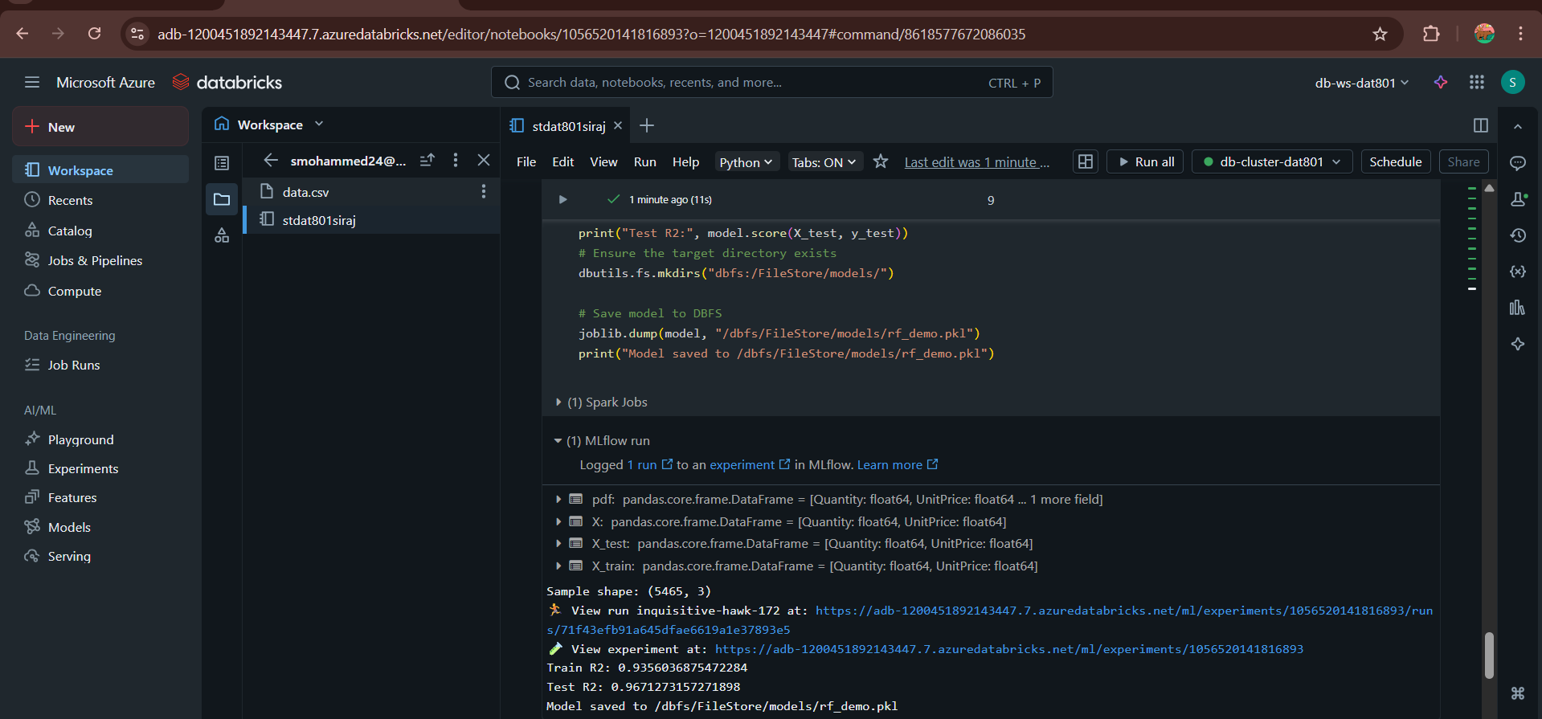
Figure 12: Accuracy and modelling
The machine learning aspect was one of the most important project accomplishments. A random Forest Regressor was fitted on a small sample of three engineered numerical variables: Quantity, Unitprice and total price. The number of rows in the dataset sample that was used to carry out the modelling was 5,465, which is a moderate yet reliable amount of data to train and evaluate. These findings indicated a good predictive ability of the model, as the Train R2 and Test R2 were 0.9356 and 0.9671, respectively. Such high scores show the possibility of generalising the model without any severe overfitting. The trained model was stored under the DBFS path /dbfs/File Store/models/rf_demo.pkl, it can be reused or deployed.
Besides the results of the model, several analytical insights were produced with the help of Databricks visualisations. The cleaned dataset was used to extract trends like monthly revenue performance, high-selling products, and sales distribution by geographic region. These visualisations revealed understandable and lucid business trends that testified to the fact that the pipeline generated quality, reliable and practical data outputs.
The fact that it can be integrated with Power BI also confirms the strength of the system. As much as connection issues were experienced because of clustering, the dataset was fully compatible with the BI tools after a proper connector and authentication mechanism were implemented. Overall, the outcomes prove that the adopted pipeline is effective, scalable, and can be used to facilitate both analytical and machine learning-based decision-making.

Challenges & Mitigation
During the development of the cloud pipeline, several issues have been encountered, which required particular solutions to ensure the continuity and reliability of the working process. One of the gravest issues on Databricks was cluster configuration. The initial compute cluster was not uncovering the information on the JDBC connection needed to be integrated with Power BI, and it continued to fail to connect. This was relieved by altering the nature of the cluster and authentication to ensure that they can be integrated with the Databricks and Spark connectors.
Another problem was the inconsistency in timestamps formatting of the raw data. The InvoiceDate column was of mixed type, and it could not be read in the ETL. The solution to this issue was a typical pattern conversion plan of timestamps, with the application of Spark functions of versatile pattern matching. There were also rows with negative or invalid numerical values of Quantity and Unitprice. These were countered by cleaning rules, which filtered out corrupt or invalid information.
The keys of Event Hubs and Databricks required additional security policies. Secrets were manipulated through the use of environment variables and Databricks utilities since it was necessary to prevent the possible exposure of secrets. These mitigation practices were geared towards making sure that the production resultant pipeline was secure, stable and production.

Conclusion
The project is a success in demonstrating the ways to build a complete end-to-end cloud data pipeline using the assistance of Microsoft Azure and Azure Databricks. The architecture has ingestion, transformation, machine learning and visualisation as part of one workflow, which is extremely aligned with the industry standards of modern data engineering. The system has enabled the section of uncooked information to a structured format using Blob storage, Event hubs and Databricks, highlighting rapid analytics and scalable machine learning examination.
The ETL pipeline was also able to enhance the quality of data and generate an analytics-ready data set. The machine learning model had a good predictive performance, which confirmed the success of the designed features and the entire workflow. The data that was created in Databricks and visualisations ensured that meaningful business insights were achieved, and the fact that the data was compatible with Power BI proved that it was ready to be used in an enterprise reporting environment.
In general, the project demonstrates an effective and scalable system of cloud-based data engineering. It underscores the strength of the Azure-Databricks platform in helping organisations to turn raw data into high-value insights and models. Further extensions of the pipeline can be achieved with real-time streaming, automated orchestration, or the deployment of trained models as APIs, which will offer a good basis to be improved in the future.

References
‌Databricks. (2023). What is Data Transformation? https://www.databricks.com/glossary/what-is-data-transformation
josearper (2025). Create a Modern Analytics Architecture by Using Azure Databricks - Azure Architecture Center. [online] Microsoft.com. Available at: https://learn.microsoft.com/en-us/azure/architecture/solution-ideas/articles/azure-databricks-modern-analytics-architecture
Mantel (2024). What is Databricks and what’s it used for? Finally in simple language. [online] Mantel | Make things better. Available at: https://mantelgroup.com.au/what-is-databricks-and-whats-it-used-for/
‌Microsoft.com. (2025). Event Hubs—Real-Time Data Ingestion | Microsoft Azure. [online] Available at: https://azure.microsoft.com/en-us/products/event-hubs

‌

‌

