Tutorial Two

THREE QUESTIONS

**Sultan Alatawi**

**Roll**

**University**

**EE-XXX: Learning MATLAB**

**Siraj Tayyab Khan**

**November 19th, 2022**

**~ (Qno.1) ~**

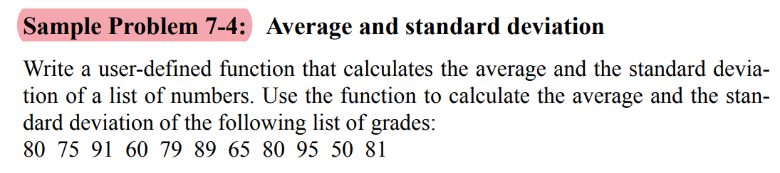

**MATLAB Function Code:**

%%%Using Nested Function Technique%%%

%Primary function name is same as the function file name

function [average StandardDeviation] = findAvgAndSTD_Nested(InputVector)

%Creating subfunctions

%Which means subfunctions cannot be called outside of the primary function

%files

%You can declare inside primary functions in any order

%Creating subfunction

%Note that Nested function internal variable is not accessible outsider

%Here AvgResult is internal variable name in function definition

function AvgResult = findAverage(InputVector)

AvgResult = sum(InputVector)/length(InputVector);

end

%Creating nested function above and using another cousin nested inside this

%nested function so that we do not have to code again for finding average

function StdResult = findSTD(InputVector)

StdResult = (sum((InputVector-findAverage(InputVector)).^2)/(length(InputVector)-1))^(1/2);

end

%Now what I am actually doing in my primary function

average = findAverage(InputVector);

StandardDeviation = findSTD(InputVector);

end

**MATLAB Script Code:**

clc

clear all

x = [80 75 91 60 79 89 65 80 95 50 81];

%Using Nested functions technique

[avg std] = findAvgAndSTD_Nested(x)

%Using Subfuncrions

[avg std] = findAvgAndSTD_SubFunction(x)

**~ (Qno.2) ~**

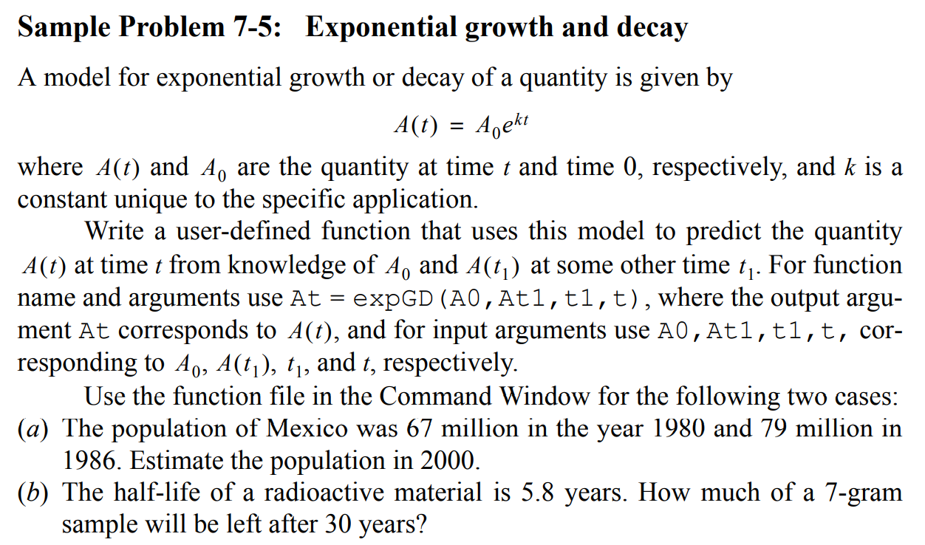

**MATLAB Function Code:**

function quantityT = findPredictionAtT(quantityT0, quantityT1, deltaT, T)

%First find the value of k

%Changing population from quantity 0 to quantity 1 in deltaT time.

k = log(quantityT1/quantityT0)/deltaT;

quantityT = quantityT0 * exp(k*T);

end

**MATLAB Script Code:**

clc

clear all

%Problem2

MexicoPopulationAt1980 = 67;

MexicoPopulationAt1986 = 79;

TimeOne = 1980;

TimeTwo = 1986;

TimeDiff = TimeTwo-TimeOne;

TimeGapOfInterest = 2000-TimeOne;

MexicoPopulationAt2000 = findPredictionAtT(MexicoPopulationAt1980, MexicoPopulationAt1986, TimeDiff, TimeGapOfInterest);

**~ (Qno.3) ~**

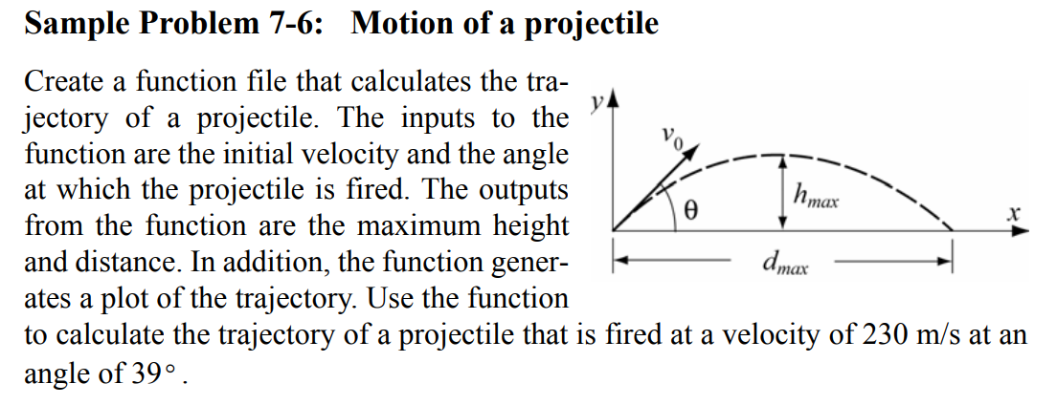

**MATLAB Function Code:**

function maxHeight = findMaxHeightAndPlotTrajectory(velocity, angle, timeVector)

initialVelocityY = velocity*sin(angle);

initialVelocityX = velocity*cos(angle);

%Time is independent variable and we would differentiate or integerate with

%respect to it

syms time

%Now making an equation

velocityExpressionY = initialVelocityY - 9.8*time

velocityExpressionX = initialVelocityX + 0*(time^0)

%To get displacement equation we integerate velocity function with time

%int expression does integerate expression with respect to syms

displacementExpressionY = int(velocityExpressionY)

displacementExpressionX = initialVelocityX*time

%Now generating vectors or arrays from equation by pluging in values of

%time of interest vector to get corresponding values

vectorDisplacementX = vpa(subs(displacementExpressionX,time,timeVector))

vectorDisplacementY = vpa(subs(displacementExpressionY,time,timeVector))

%Now simply plotting those vectors

%plot(vpa(vectorDisplacementX),vpa(vectorDisplacementY))

%xlabel('Displacement in x direction')

%ylabel('Displacement in y direction')

%title('Trajectory View')

%To find max height covered we would take derivative of displacement with

%respect to time

%we know at peak height derivative gets zero

%Solve equation at derivative equal to zero would give solutions for

%possible maximas

displacementExpressionYDerivative = diff(vectorDisplacementY, time)

timeSolutionRoots = solve(displacementExpressionYDerivative,time)

%Now substituting in time solution roots in displacement equations to get max

%displacement in y direction

MaximasAndMinimas = vpa(subs(displacementExpressionY,time,timeSolutionRoots))

maxHeight = max(MaximasAndMinimas)

end

**MATLAB Script Code:**

clc

clear all

syms x

%f= x*sin(x)

%g=int(f,x)

%h=diff(f,x)

%output=vpa(subs(f,x,90))

%a = 90.5

output_test = findMaxHeightAndPlotTrajectory(230, 39, 0:0.01:30)