How Web Browser Work Actually /-Article by Siraj Ahmed

- What is the Web Browser:
- Browser is a software application use to open website like amzon.com through URL , the of tech works behind this we will discuss on later.

- Iside the browser (main thing)
- User Interface (UI): UI is Everything you see on screen and interact with them suppose you click on button and search website change theme and adding your account etc.
- Browser Engine: Browser engine converts your raw code suppose you code in html, CSS, and JS. Browser Engine convert their code into visual format means good design format user interface.
- Rendering Engine: Rendering Engine is nothing but you convert your same html, CSS code file into Visuals or user readable format, I have an image you see the difference between Browser engine and rendering engine and I also attached some real-life example

- 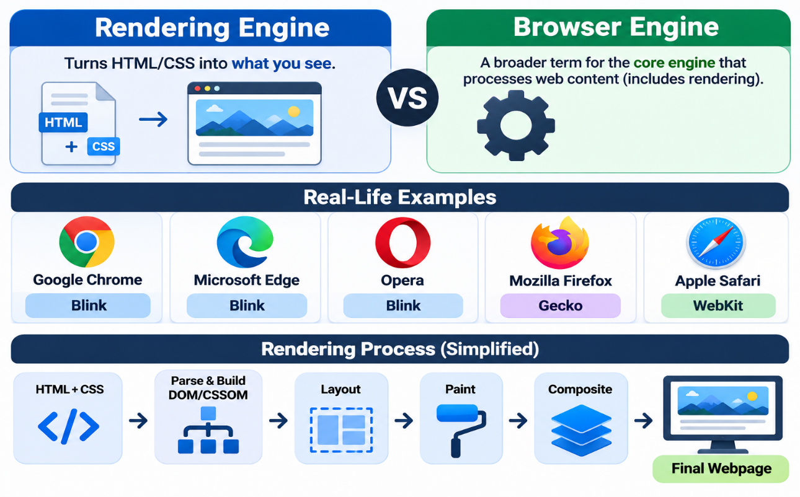

- Networking: Fetches resources from the internet using HTTP/HTTPS: HTML, CSS, JS, images, API data. It also handles DNS lookup, caching, and cookies.

- JavaScript Interpreter: It’s an engine reads and runs JS code so pages become interactive

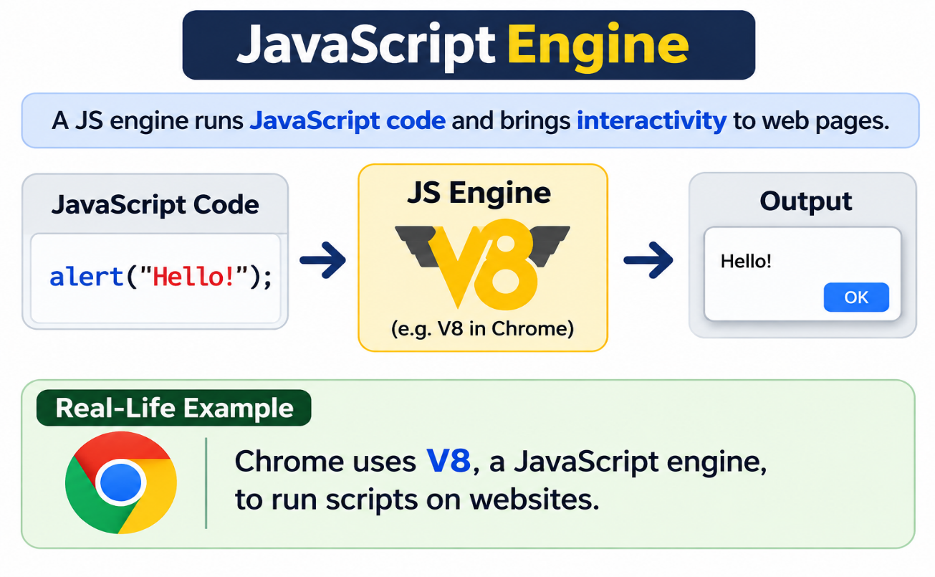

- UI Backend: U see the URL bar on the browser, there is save u click and use for searching link, already store in computer

- Data Storage (disk API): Saves data locally on your device: cookies, local Storage, Indexed DB, and cache. This is what keeps you logged in after you close the tab.

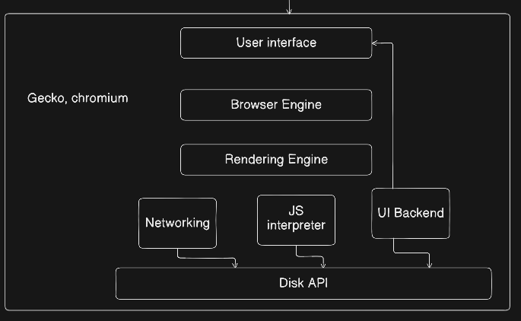

- HTML & CSS
- HTML (HyperText Markup Language): the structure and content of a page. It tells the browser what is on the page: headings, paragraphs, images, buttons, links.
- CSS (Cascading Style Sheets): the look and design. It tells the browser how things should appear: colours, fonts, spacing, layout.
- What is parsing
- Parsing: reading raw text and converting it into a structured form a program can understand. The browser receives HTML and CSS as plain text. It can’t use text directly, so it parses it into trees.
- HTML Parser: reads HTML text and builds a tree of nodes, called the DOM (Document Object Model).
html
└── body
├── h1 → "Hello"
└── p → "Hi"
- CSS Parser: reads CSS text and builds a tree of style rules, called the CSSOM (CSS Object Model).
stylesheet
├── body → font-size: 16px
└── h1 → colour: blue
- What is Content Sink
- Content sink: the part of the rendering engine that receives parsed nodes and adds them to the DOM tree (an older Gecko/Firefox term from Tali Garbiel’s article).
- What is Dom
- DOM (Document Object Model): the browser’s live, in-memory tree of your HTML. Every tag becomes an object (node) you can read and change with JavaScript.
- What is CSSOM
- CSSOM (CSS Object Model): the browser’s tree of your CSS rules, with each rule’s selectors and properties.

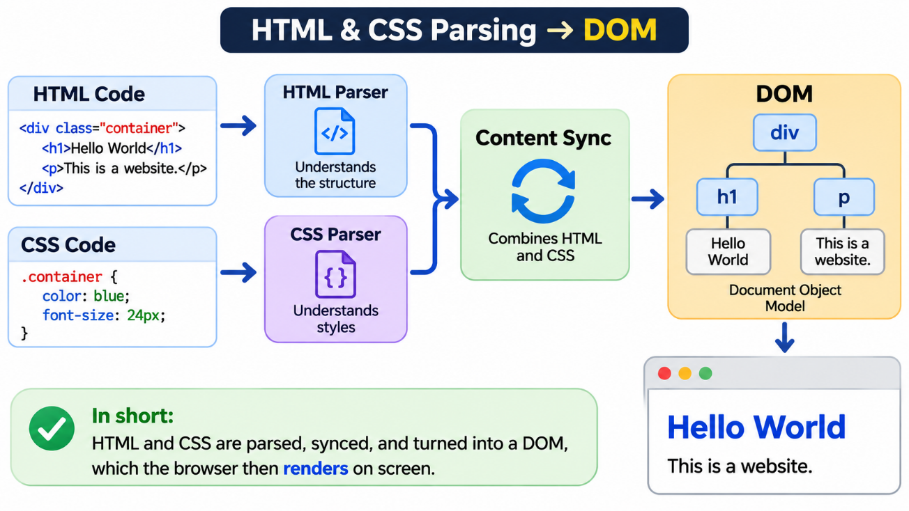

- What is conventional and unconventional parsing?

- Conventional parsing
Reading code that follows strict rules. One mistake and it fails. Used for CSS and JavaScript.
- Unconventional parsing
Reading code that is messy or forgiving. The browser fixes mistakes automatically and keeps going. Used for HTML.

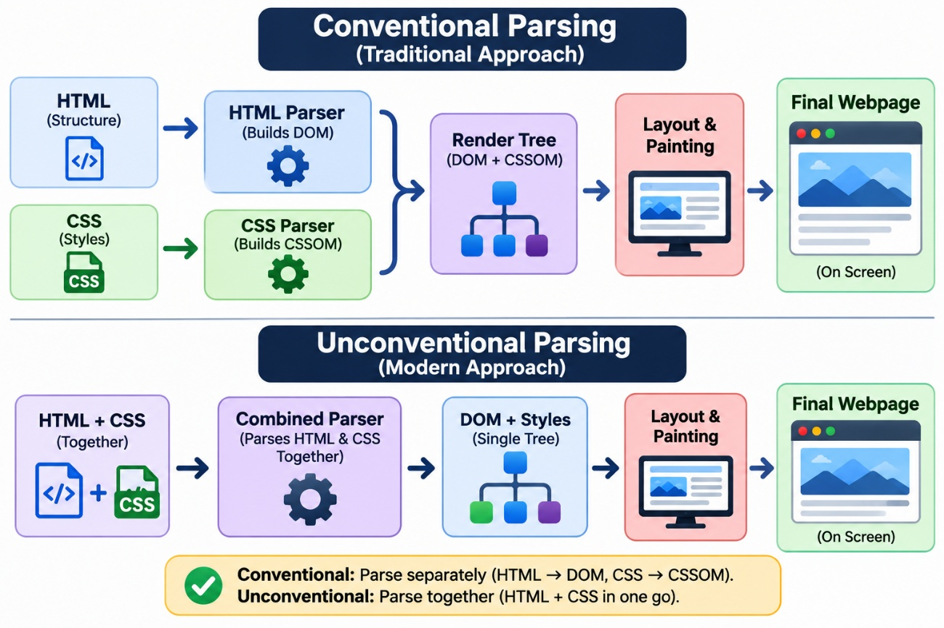

When you open a website, the browser takes plain text and turns it into the page you see, step by step:
- You type a URL: the UI collects your request.
- Browser engine: passes your request to the right part.
- Networking: goes to the internet and downloads the HTML, CSS, and JS files.
- HTML parser: reads the HTML and builds the DOM (the structure tree).
- CSS parser: reads the CSS and builds the CSSOM (the style tree).
- JS engine: runs the JavaScript, which can change the DOM and CSSOM.
- Render tree: the DOM and CSSOM are combined, keeping only visible elements with their styles.
- Layout: works out the size and position of every element.
- Paint: the rendering engine draws the pixels, using the UI backend to talk to your OS.
- Storage: saves cookies, cache, and local data for next time.

