The Climate Economy Education Inc

Other Education

Sustainable Infrastructure Capstone

Posted 2 weeks ago∙Apply by February 26, 2026 at 11:59 PM
SaveShareApply

At a glance
Hybrid, based in Marion, IL, Carbondale, IL, +2
Work in person for part of the week, from one of the locations
Internship
Part-time∙From February 1, 2026 to April 30, 2026
US work authorization not required
Sustainable Infrastructure Implementation Lab (Capstone)
Academic Category: Project Management / Sustainable Development / Civil Engineering
Project Goal
The objective of this Capstone is to take a validated "Foundry Blueprint" (AI-augmented climate solution) and manage its physical implementation within a local community context. A team of 3–5 learners will act as Project Leads, coordinating stakeholders, securing resources, and documenting the measurable environmental impact of a pilot build (e.g., a community solar hub, a modular garden network, or a circular waste lab).
Specific Deliverables
To satisfy the requirements for completion, the student team will upload:
Project Management Plan (PMP): A comprehensive Gantt chart or Kanban roadmap developed in WP Project Manager, detailing milestones, budget allocation, and risk mitigation strategies.
Verified Implementation Case Study: A 15–20 page formal report detailing the "Build" process, including "Before and After" data, site maps (via WPGeoDirectory), and photographic evidence.
Impact Metric Dashboard: A structured data set submitted via WPForms documenting specific outcomes (e.g., Carbon offset, gallons of water saved, or community participants engaged).
Final Presentation Video: A 10-minute "Post-Mortem" presentation summarizing the challenges of moving from an AI-generated blueprint to a physical reality.
Step-by-Step Tasks (Semester Schedule)
Milestone 1: Localization & Stakeholder Approval (Weeks 1-3): Select a Foundry Template. Identify a pilot site. Pitch the plan to a community stakeholder (landlord, campus official, etc.) and secure a "Memorandum of Understanding" (MOU).
Milestone 2: Resource Procurement & Logistics (Weeks 4-6): Source materials (prioritizing circular/reclaimed waste streams). Finalize the budget and identify necessary workforce/volunteer support.
Milestone 3: The Build Phase (Weeks 7-10): Execute the physical project. Manage the "Foundry Brigade" (volunteers or fellow students) to complete the infrastructure according to the blueprint.
Milestone 4: Data Collection & Reporting (Weeks 11-14): Monitor the project for a 2-week "burn-in" period. Collect impact data. Publish the final results to the global Success Gallery on TheClimateEconomy.com.
Why this fits a "Single Academic Program"
This project is designed for Sustainable Management or Climate Policy cohorts. It requires learners to apply classroom theories of Agile Project Management, Stakeholder Theory, and Environmental Impact Assessment to a tangible, high-consequence project.
"Our organization provides the digital infrastructure for this Capstone, including WP Project Manager for task tracking and WPGeoDirectory for spatial reporting. This ensures students gain hands-on experience with the same professional project management stacks used in the clean-tech industry."

Climate Resilience Architect

Posted 2 weeks ago∙Apply by February 26, 2026 at 11:59 PM
SaveShareApply
SaveApply

At a glance
Remote, based in United States
Work from home
Internship
Full-time∙From February 1, 2026 to April 30, 2026
US work authorization not required
Climate Resilience Project Architect (AI-Augmented)
Academic Category: Environmental Science / Urban Planning / Professional Writing
Project Goal
The objective of this project is to develop three high-fidelity Climate Action Blueprints that address specific community resilience challenges (e.g., urban heat, local food security, or energy efficiency). Learners will use the "Foundry Architect" generative AI tool to draft initial technical plans and then conduct secondary research to refine these drafts into "Implementation-Ready" templates for community use.
Specific Deliverables (What the student uploads)
To satisfy the requirements for completion, the learner will provide:
3 Technical Project Blueprints: A structured document (PDF) for each project including a Step-by-Step Execution Plan, Estimated Budget, and Revenue/Sustainability Model.
AI Orchestration Log: A brief report (300–500 words) detailing the prompts used, the AI’s initial output, and the specific "human-in-the-loop" corrections made to ensure local feasibility.
Transferable Skills Reflection: A final one-page summary connecting the project tasks to their specific academic curriculum (e.g., how the project applied concepts of Circular Economy or Urban Resilience).
Step-by-Step Tasks
Task 1: Problem Identification (Hours 1-5): Select three distinct "Community Pain Points" from the Climate Economy Index. Research local demographics and geographic constraints for a hypothetical pilot city.
Task 2: AI Orchestration (Hours 6-15): Input problem sets into the Foundry Architect AI. Iteratively "chain" prompts to generate a comprehensive technical draft that includes materials, costs, and workforce requirements.
Task 3: Feasibility Review (Hours 16-30): Conduct secondary research using peer-reviewed sources or municipal data to "fact-check" the AI’s cost estimates and logistics. Adjust the blueprint to reflect real-world constraints.
Task 4: Template Finalization (Hours 31-40): Format the finalized data into the "Foundry Template" style and upload it to the organization's Project Library for public re-use.
This project is designed specifically for Environmental Studies or Sustainable Development students. It applies classroom knowledge of Sustainable Development Goals (SDGs) and Resource Management to the modern workflow of AI-assisted planning.
Learners will use a standardized digital reporting portal (theclimateeconomy.com) to submit their milestones, ensuring clear data structure and consistent evaluation.
Less

What they're looking for
You match some qualifications.
DoctorateJuniorAlumniSecond Year Community / Technical CollegeBusiness Administration & Management majorFinance & Financial Management majorMarketing majorEconomics majorActuarial/Risk Analysis major
+ 12
Matching is based on your profile.

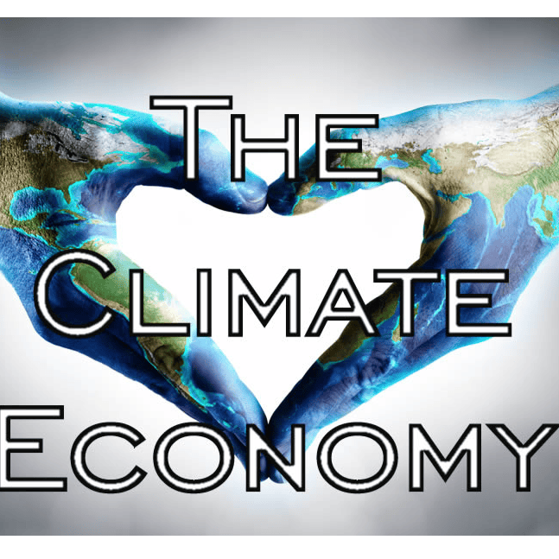
The Climate Economy Education Inc
1700 Robinson Hill Road, Makanda, Illinois 62958, United States
Follow
https://www.theclimateeconomy.com
Tuesday, Feb 17, 10:00 am - 2:00 pm CST
Building the Future of Climate Action through AI-Driven Innovation. Description: > The Climate Economy Education Inc (TCE) is a mission-driven "Impact Lab" based in Southern Illinois. We bridge the gap between climate theory and real-world execution using our proprietary AI engine, the Foundry Architect. While we are a 501(c)(3) nonprofit, we operate at the intersection of SaaS and Sustainability Consulting. Our platform empowers students and communities to turn climate "pain points" into "Project Blueprints" for clean energy, food security, and circular waste systems. Why Join Us? We don't do "busy work." Whether you are an Intern (Architect) or a Capstone Group (Builder), you will gain high-demand, transferable skills in: AI Prompt Orchestration: Managing generative models to build technical project roadmaps. SaaS & CRM Management: Using our WordPress-based project stack (WP Project Manager, GeoDirectory). Sustainability Consulting: Developing ROI models for local green infrastructure. Join us at the SIU Job Fair to learn how you can build a portfolio that proves you can lead in the 2026 green economy. We aren't just surviving the climate crisis; we are Thriving Authentically.
Job TitlesSustainable Infrastructure Capstone, Climate Resilience Architect
School YearsAlumni, Postdoctoral Studies, Doctorate, Masters of Business Administration, Masters, Senior, Junior
Job TypeExperiential Learning, Internship
MajorsWorkforce Educ & Development, Technical Resource Management, Sociology, Rehabilitation Services, Recreation Professions, Radio, TV, and Digital Media, Psychology, Political Science, Mathematics, Mass Communication & Media Art, Marketing, Management, Journalism, Interior Design, Information Technology, Human Nutrition & Dietetics, Horticulture, Hospitalty, Tourism, Evnt Mgmt, Geography & Environ. Resources, Forestry, Fermentation Science, Electrical and Computer Engineering (dual degree), Economics, Cybersecurity & Cyber Systems, Crop, Soil, Environmental Mgmt, Creative Writing, Counseling and Rehabilitation Education, Computer Science, Computer Engineering, Communication Studies, Business Analytics, Business Administration, Behavior Analysis and Therapy, Anthropology, Agricultural Systems & Educat., Agribusiness Economics, Advanced Energy and Fuels Mgmt
Work AuthorizationNo US work authorization required
Less

