ELL780

Computer Architecture



ASSIGNMENT-1

Submitted by -
Ahmad Siraj Hashmi
(2024EET2376)

Question – To Find the Inverse of a matrix and if there exsist no inverse , output no Inverse possible.

1.Software Requirement Specification

Specification | Details
Software Name | VS Code
Development  Language | RISC-V ISA
Extension | RISC-V Venus Simulator
Operating System | Platform-independent

Table 1: Software Specification Details

Functionality | Details
Purpose | Finding and verifying Inverse of a Matrix using Gaussian elimination.
Input | Augmented Matrix of m * n
Precision | up to 2²³ (single-precision floating-point).
Error Handling | Encountered Singular matrix

Table 2: Functional Details

Execution  Platform | Details
Processor Type | RISC-V architecture (e.g., RV32I, RV64I)
Instruction Set | RISC-V ISA (possibly with extensions)
Memory  Requirements | Used Integer and Float Registers to store Variable
Assembler

Table 3: Platform Details
2. Development Method:
a. VS-Code:
Visual studio code (VSCode) is a free and open-source code editor developed by Microsoft. It is a highly popular and versatile tool for software development. This VSCode has many extensions which is used to compile a program.
Using VSCode with the Venus Simulator for RV32IMAF architectures means you have support for Floating point (F) instructions and these instruction follows IEEE-754 32-bit format for floating-point numbers.

b. RISC-V Venus Simulator embedded in VS Code:
This Visual Studio Code extension embeds the popular Venus RISC-V simulator. It provides a standalone learning environment as no other tools are needed. It runs RISC-V assembly code with the standard debugging capabilities of VS Code.

c. Compiler Explorer:
Used compiler explorer for figuring out the methodology and approach behind development I n RISC V.

3. Steps:
- Basic Computer Architecture for learning the instructions
- Googled pseudo codes and wrote C code for different parts like loop, ration , various row operations
- Used the material provided
- Utilizing several google resources wrote code in RISC V in Venus using C code as framework.
- Matching the solution at several BreakPoints eg. First Matrix, Augmented Matrix, Subroutines .
- Debugging any error at all the breakpoints and kept on matching with register values.
4. Logic Behind Finding Inverse.

Representing the Matrix as an Augmented Matrix:
- Step 1: To find the inverse of a matrix, we start by representing the given matrix as an augmented matrix. For a 3x3 matrix, this means augmenting the matrix with an identity matrix of the same size.
- Example:
  - Let's consider the following 3x3 matrix:
Matrix A = 1 2 1
1 2 1
1 2 1
  - We augment this matrix with the identity matrix of size 3x3:
Matrix Augmented Matrix [A∣I ] = 1 2 1 | 1 0 0
  - 2 1 2 | 0 1 0
1 2 1 | 0 0 1

Elimination Step:
- Step 2: The next step is to perform elimination to transform the augmented matrix into row echelon form (REF).
- Step 3: For each row below the current row, we subtract a multiple of the current row from that row to make the element below the pivot element zero. The multiple is chosen so that the element below the pivot becomes zero.
- Example:
  - Iteration 1:
    - Use row operations to create zeros in the first column below the pivot element in the first row (pivot = 1):
R2=R2−2×R1andR3=R3+R1
    - The matrix now looks like this:
1 2 1 | 1 0 0
0 -3 0 | -2 1 0
0 4 2 | 1 0 1
  - Iteration 2:
    - Next, create a zero in the second column below the pivot in the second row (pivot = -3):
R3 = R3−(−4/-3)×R2
    - The matrix now looks like this:
  - Iteration 3:
    - Finally, normalize the pivot element in the third row:
R3 = 1/2 (R3)
    - The matrix now looks like this:
1 2 1 | 1 0 0
0 -3 0 | -2 1 0
0 0 1 | -1/2 -2/3 1/2

Final Matrix:
- Step 4: After performing all elimination steps, the matrix on the left side of the augmented matrix is reduced to the identity matrix, and the right side of the augmented matrix becomes the inverse of the original matrix.
- Final Augmented Matrix:
1 0 0 | 1 2 -1
0 1 0 | -2 -1 2
0 0 1 | 3 -4 1
- Result:
  - The right side of the matrix now contains the inverse of the original matrix A.
Inverse of A = 1 2 -1
-2 -1 2
3 -4 1

5. Architectural Strategies.

Gaussian Elimination Algorithm:
Gaussian Jordan Elimination is the efficient algorithm to find the inverse of a matrix. The algorithm we have used here is partial pivoting which reduces complexity for mathematical calculations.

Modular Design:
Program should be easy to read for that I have used labels which make it readable. In order to reduce memory requirement, program is designed such that it reuses many registers.

Data Types and Sizes:
I’m using 32-bit IEEE 754 single-precision floating-point numbers, with 1 bit for sign, 8 bits for the exponent, and 23 bits for the fraction. This format represents real numbers with a sign, magnitude, and precision suitable for various applications.

6. Software Architecture.

1.Representing Equations as an Augmented Matrix

To solve a matrix and and find its inverse , we start by representing it as an augmented matrix

The augmented matrix combines the coefficients of matrix and identity matrix

2. Partial Pivoting:
- When pivot is found to be zero, we use partial pivoting to choose the pivot element in the current column.
- The pivot element is selected as the largest absolute value among the remaining elements in that column.
- If necessary, we swap rows to place the pivot element in the current row.
- This choice of pivot element minimizes division by small numbers, which improves numerical stability.

3. Elimination step
- We perform the elimination step to transform the augmented matrix into row echelon form.
- For each row below the current row, we subtract a multiple of the current row from that row to make the element below the pivot element zero.
- The multiple is chosen so that the element below the pivot becomes zero.

4. Handling Singular Matrices:
- The ability of Gaussian elimination with partial pivoting to detect and handle singular matrices is one of its advantages.
- By performing row swaps to ensure that the pivot element is the largest absolute value in its column, the algorithm reduces the likelihood of encountering zero pivot elements.

5. Solution:
- The result of the Gauss Jordan elimination process provides the inverse of a matrix if it is possible.

7. Detailed System Design.

Functions:
In the program there is many functions and conditions here is one code snippet of a function.

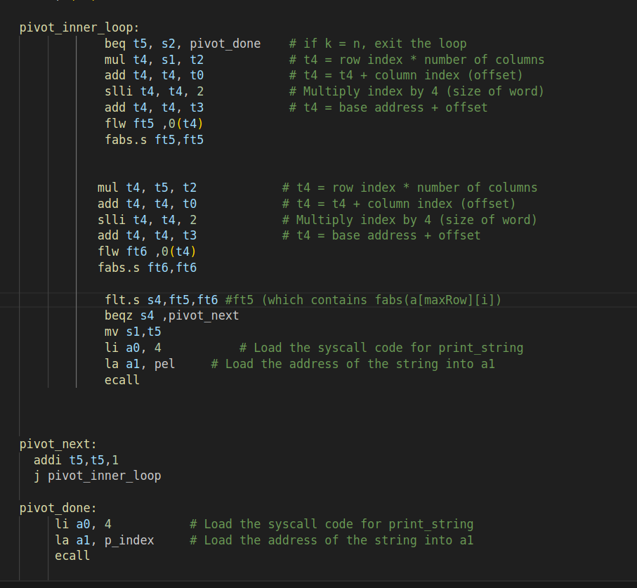

4.1 Functional Requirements
- Input: Accept a square matrix of order n (up to a predefined maximum size) as input from the user.
- Output: Display the inverse of the input matrix if it exists.
- Error Handling: Detect and report singular matrices (matrices that do not have an inverse).
- Augmentation: Automatically augment the input matrix with the identity matrix.
- Partial Pivoting: Ensure numerical stability by performing partial pivoting during the elimination process.

4.2 Non-Functional Requirements
- Performance: The system should efficiently handle matrix operations even for larger matrices.
- Scalability: The system should be able to handle different sizes of matrices as defined by the SIZE macro.
- Usability: The system should display results in a readable format.

4.3.3 Error Handling Module
- Purpose: Identify and handle potential errors, such as singular matrices.
- Functions:
  - Singular Matrix Detection:
    - Function: Checks if any diagonal element is zero after pivoting and elimination, indicating that the matrix is singular.
    - Data Flow: If a singular matrix is detected, the system outputs an error message and terminates the process.

4.3.4 Output Module
- Purpose: Display the final inverse matrix to the user.
- Functions:
  - Matrix Display:
    - Function: Prints the inverse matrix in a formatted manner for easy readability.
    - Data Flow: Receives the inverse matrix from the core processing module and displays it.

4.4 Control Flow
- Input Phase:
  - The user enters the order of the matrix and the elements of the matrix along with that augments the matrix with an identity matrix of the same order.
- Processing Phase:
  - Partial pivoting is performed.
  - Rows are swapped if necessary.
  - The system performs row elimination to convert the matrix to row echelon form.
  - The matrix is then normalized to create an identity matrix on the left side of the augmented matrix.
- Output Phase:
  - The system checks for singular matrices. If found, it displays an error message.
  - If no errors are detected, the system displays the inverse of the matrix.

8. Pseudo Code.

1. Start
2. Order of Matrix (n).
3. Read Matrix (A):
For i = 1 to n
For j = 1 to n
Read Ai,j
Next j
Next i

4. Augment Identity Matrix of Order n to Matrix A:
For i = 1 to n
For j = 1 to n
If i = j
Ai,j+n = 1
Else
Ai,j+n = 0
End If
Next j
Next i

5. Apply Gauss Jordan Elimination on Augmented Matrix (A):
For i = 1 to n
If Ai,i = 0
Do Partial Pivoting
If Ai,i still=0
Print "Mathematical Error!"
Stop
End If
End If

For j = 1 to n
If i ≠ j
Ratio = Aj,i / Ai,i

For k = 1 to 2*n
Aj,k = Aj,k - Ratio * Ai,k
Next k
End If
Next j
Next i

6. Row Operation to Convert Principal Diagonal to 1:
For i = 1 to n
For j = n+1 to 2*n
Ai,j = Ai,j / Ai,i
Next j
Next i

7. Display Inverse Matrix:
For i = 1 to n
For j = n+1 to 2*n
Print Ai,j
Next j
Next i

8. Stop
6. Testing.

6.1 Declaration and Initialization:
In the .data section I have declared and initialized a matrix of size 5x5 and along with that a augmented matrix (mat) along with that there are few strings also I have initialized the space foo the identity matrix (inorder to check the multiplication of our inverse matrix and original matrix) and inverse matrix if exsists to store the final results.
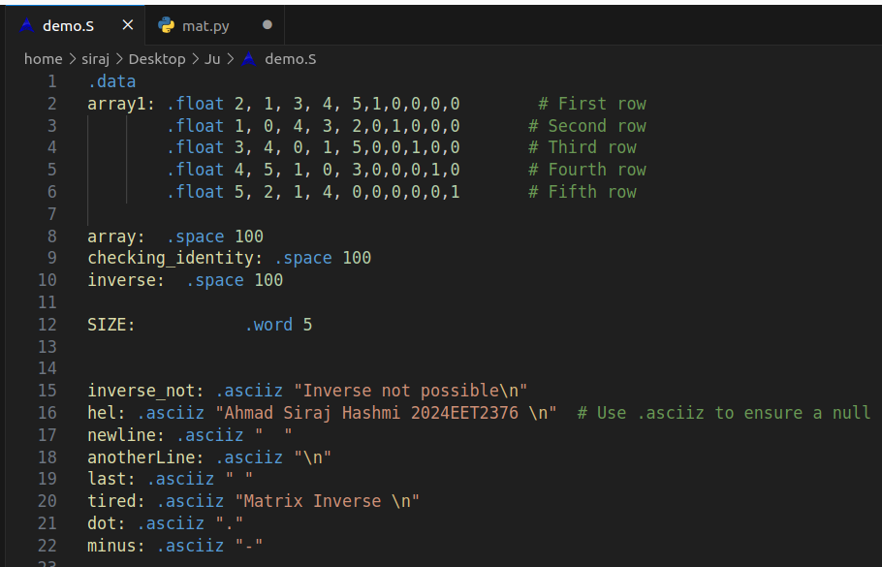
6.2 Testing Method:
I have written the c code which takes the matrix and then apply Gaussian Elimination on it. O/P of the script is Inverse of the matrix .
Now I compare actual o/p (which script gave) with the o/p generated from RISCV code for the Above matrix .
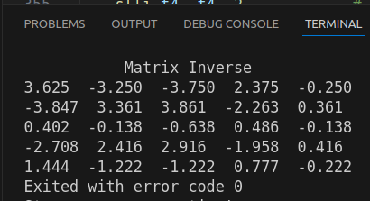
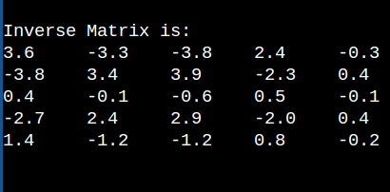
<-Risc

Script ->

6.3 Add on :
I have also written a python code to generate the random matrix provided we just give the order of the matrix as said in the assignment sheet. Also I have made this code free of the order of matrix and hardcoded this 5 cross 5 matrix only.

