Assignment 1: Automated Instance Management Using AWS Lambda and Boto3

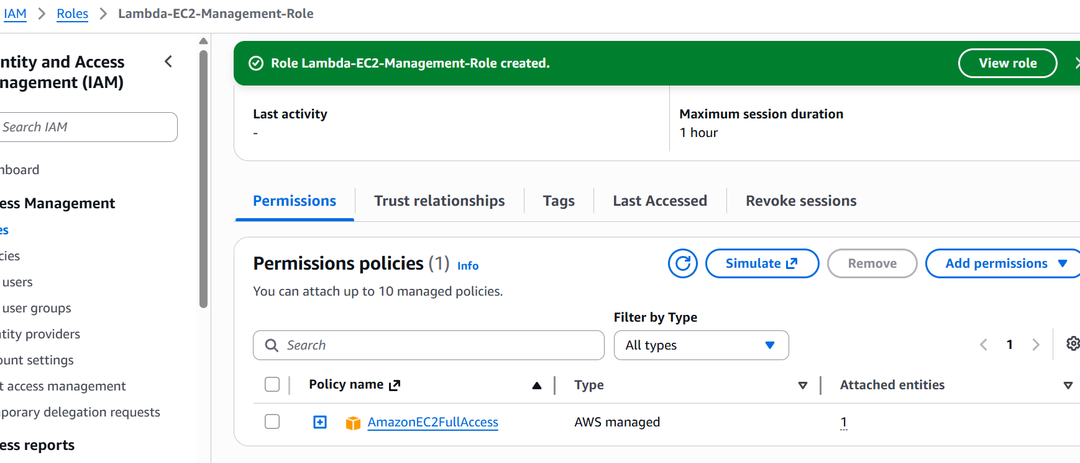

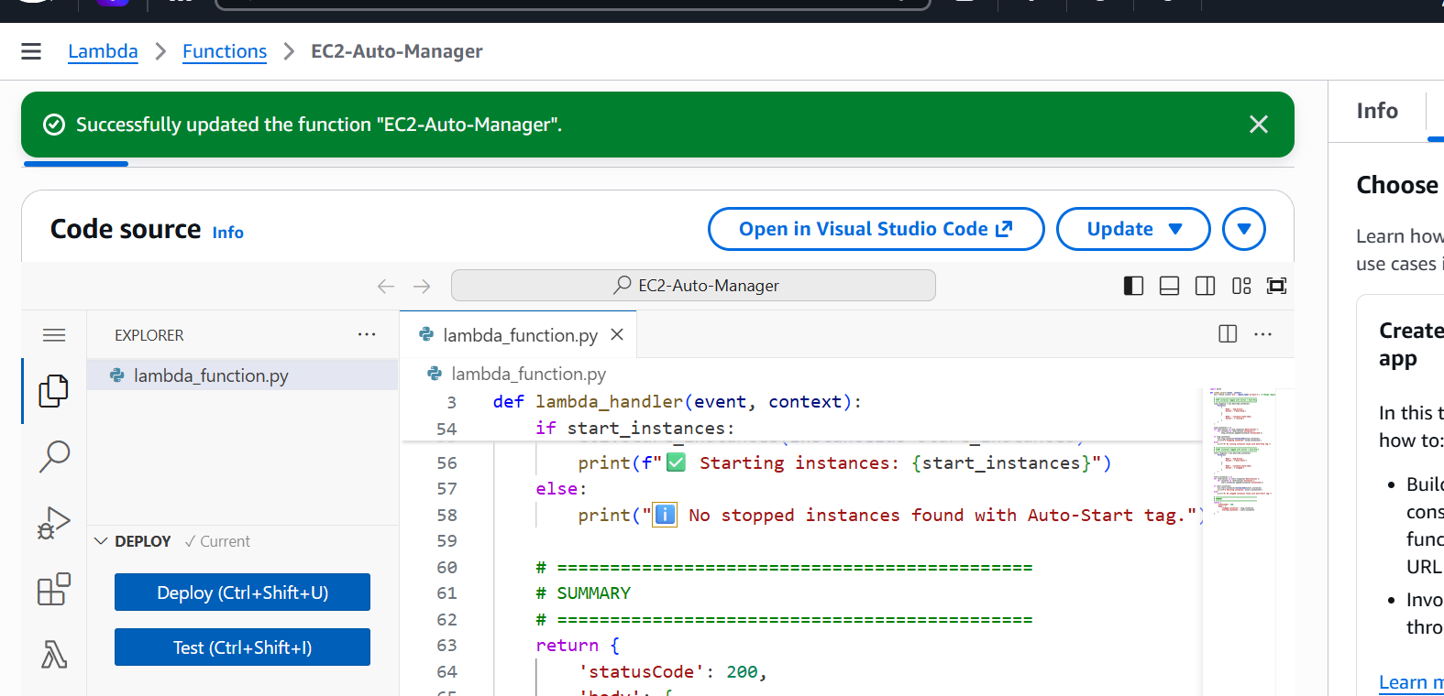

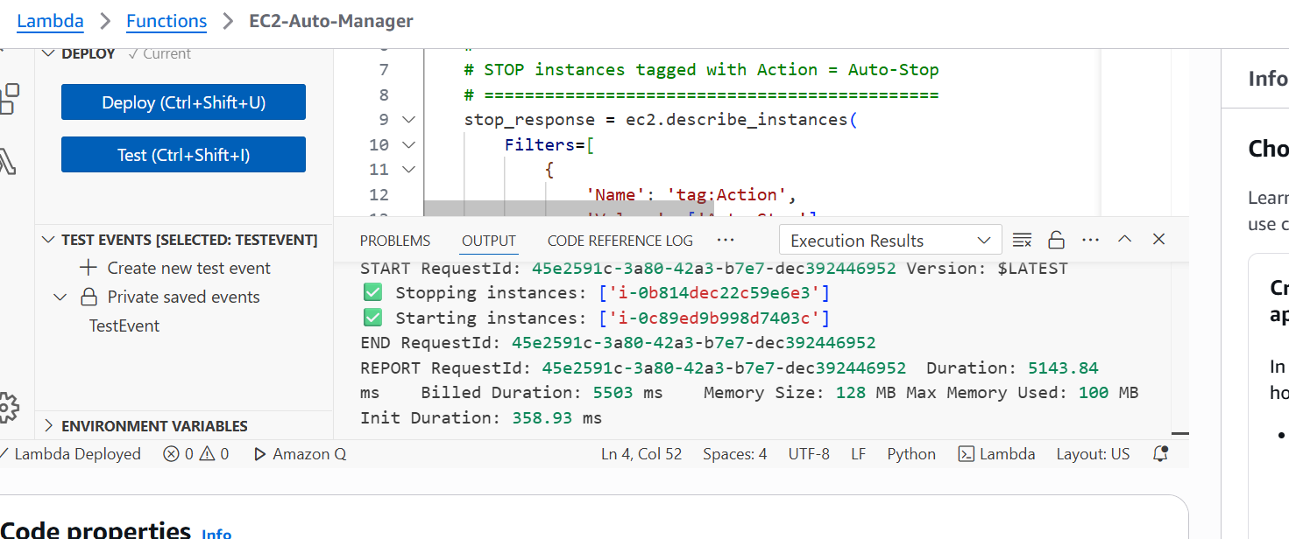

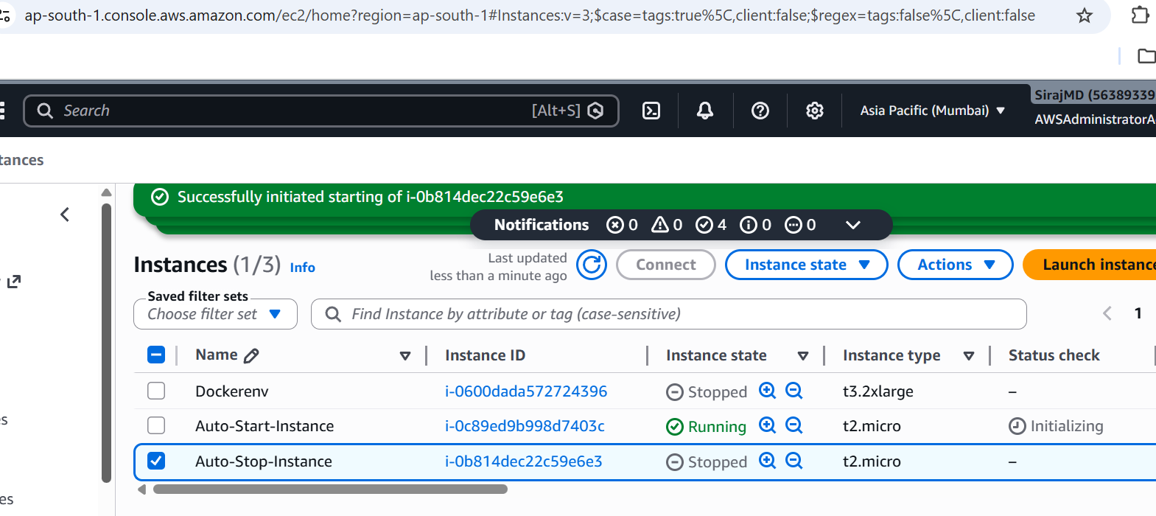

Assignment 2: Automated S3 Bucket Cleanup Using AWS Lambda and Boto3
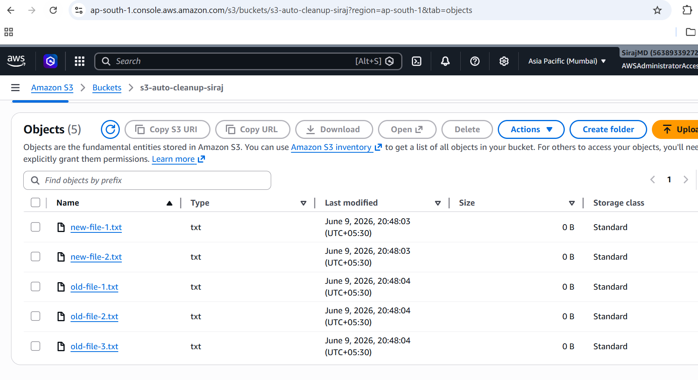
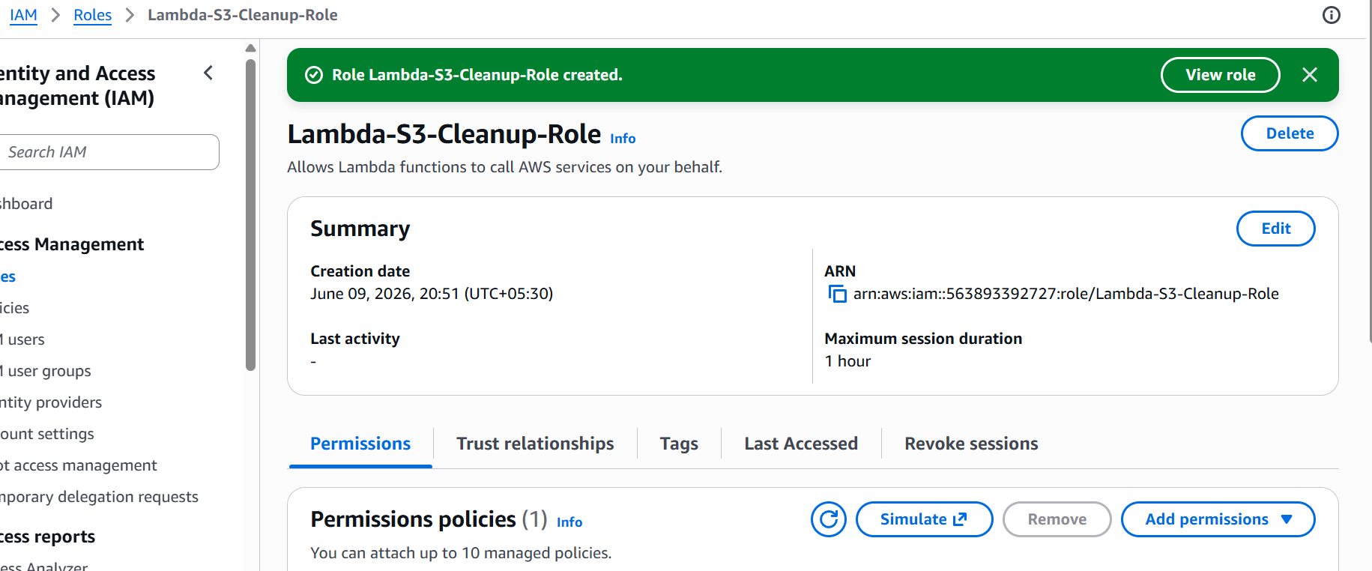

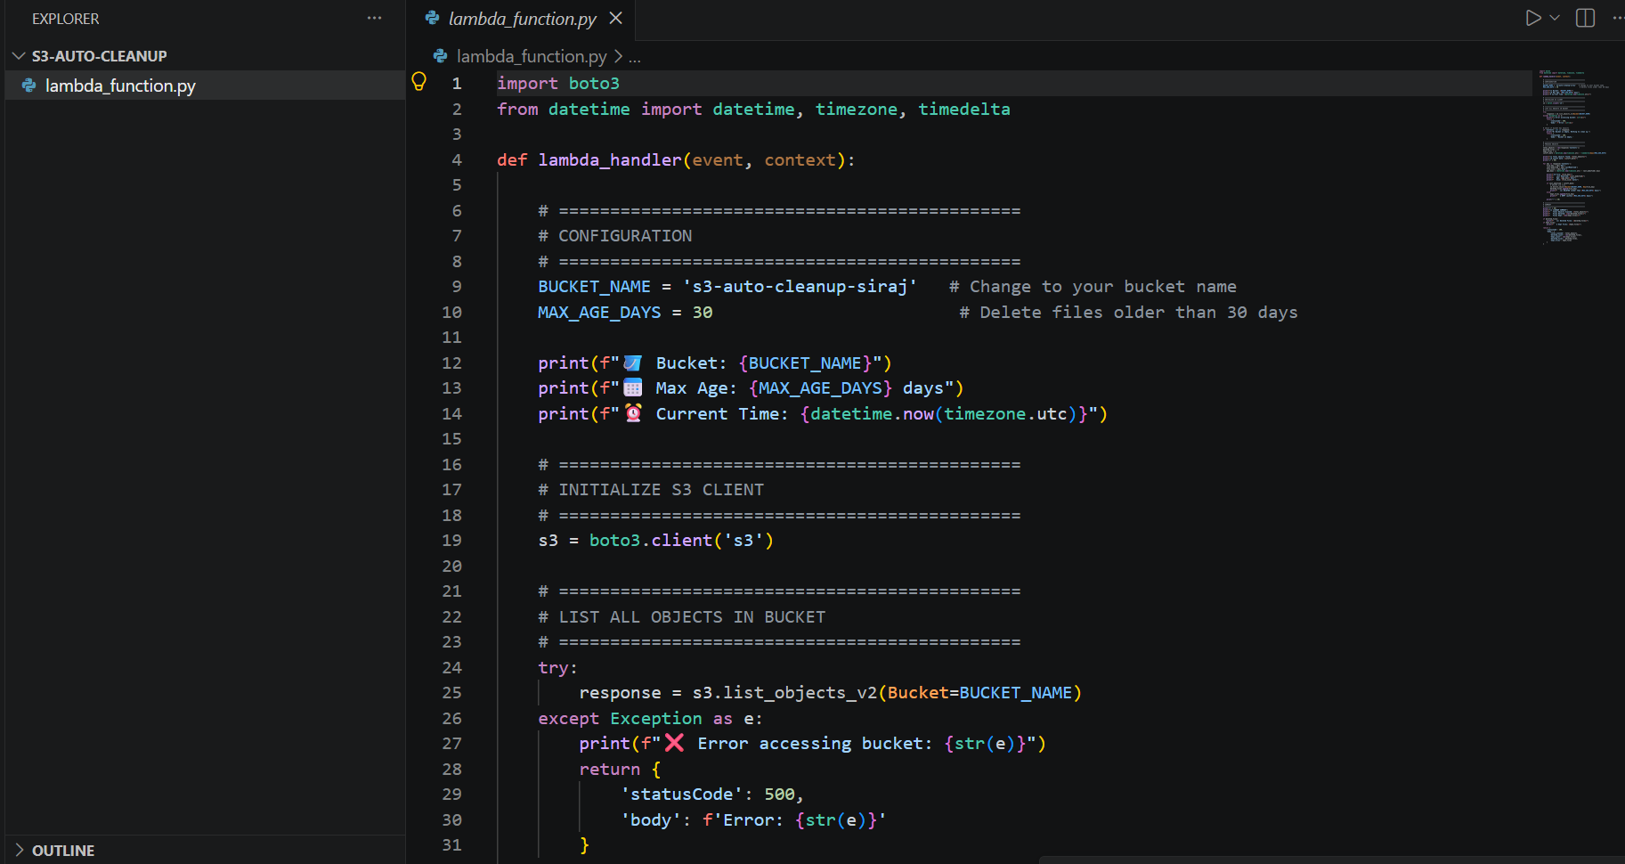

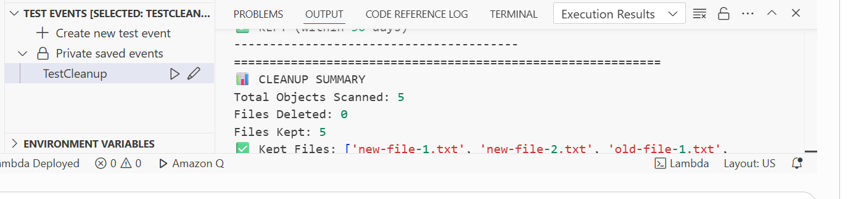
Assignment 4: Automatic EBS Snapshot and Cleanup Using AWS Lambda and Boto3
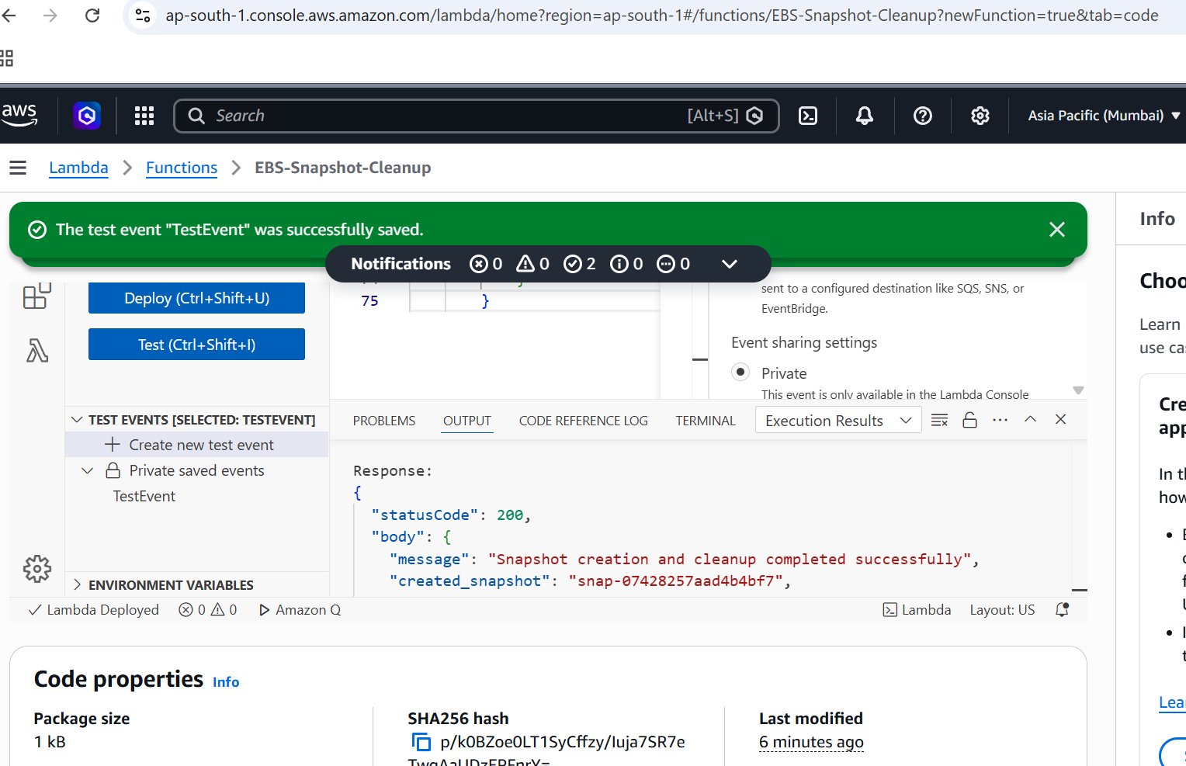

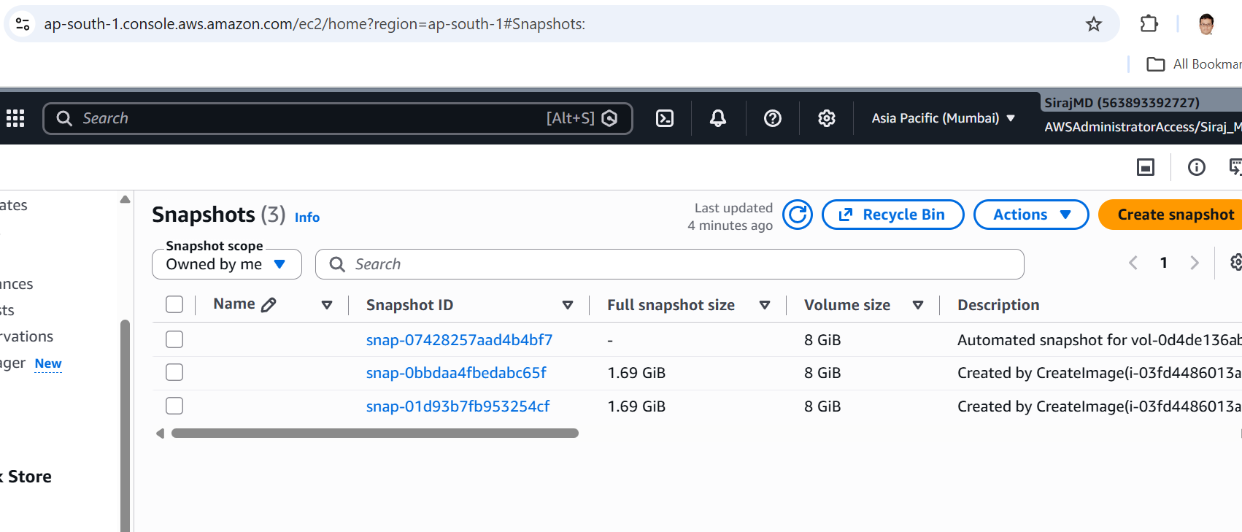

Boto3 code-
import boto3
from datetime import datetime, timezone, timedelta

# Initialize EC2 client
ec2 = boto3.client('ec2')

# Configuration
VOLUME_ID = 'vol-0d4de136ab5f74fb8' # Replace with your actual Volume ID
RETENTION_DAYS = 30

def lambda_handler(event, context):
created_snapshot_id = None
deleted_snapshots = []

try:
# 1. Create snapshot
description = f"Automated snapshot for {VOLUME_ID} on {datetime.now(timezone.utc).strftime('%Y-%m-%d %H:%M:%S UTC')}"

response = ec2.create_snapshot(
VolumeId=VOLUME_ID,
Description=description,
TagSpecifications=[
{
'ResourceType': 'snapshot',
'Tags': [
{'Key': 'CreatedBy', 'Value': 'Lambda'},
{'Key': 'VolumeId', 'Value': VOLUME_ID},
{'Key': 'Purpose', 'Value': 'AutomatedBackup'}
]
}
]
)

created_snapshot_id = response['SnapshotId']
print(f"Created snapshot: {created_snapshot_id}")

# 2. Calculate retention threshold
cutoff_date = datetime.now(timezone.utc) - timedelta(days=RETENTION_DAYS)

# 3. List snapshots created by this account for the specific volume
snapshots = ec2.describe_snapshots(
OwnerIds=['self'],
Filters=[
{'Name': 'volume-id', 'Values': [VOLUME_ID]}
]
)['Snapshots']

# 4. Delete old snapshots
for snapshot in snapshots:
snapshot_id = snapshot['SnapshotId']
start_time = snapshot['StartTime'] # timezone-aware datetime in UTC

if start_time < cutoff_date:
ec2.delete_snapshot(SnapshotId=snapshot_id)
deleted_snapshots.append(snapshot_id)
print(f"Deleted old snapshot: {snapshot_id}")

return {
'statusCode': 200,
'body': {
'message': 'Snapshot creation and cleanup completed successfully',
'created_snapshot': created_snapshot_id,
'deleted_snapshots': deleted_snapshots
}
}

except Exception as e:
print(f"Error: {str(e)}")
return {
'statusCode': 500,
'body': {
'message': 'Error during snapshot creation/cleanup',
'error': str(e)
}
}

Assignment 3: Monitor Unencrypted S3 Buckets Using AWS Lambda and Boto3

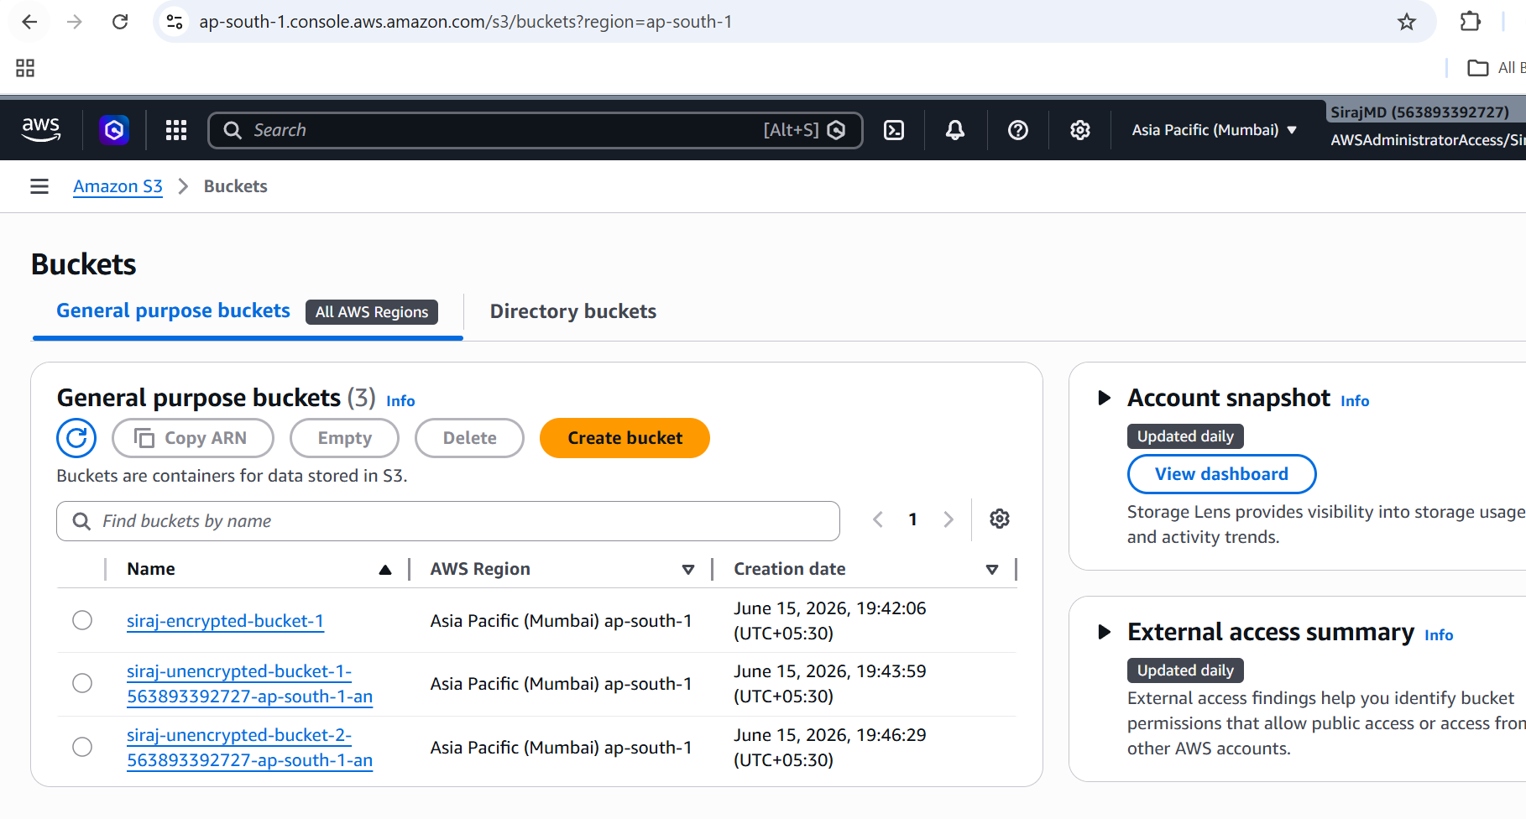
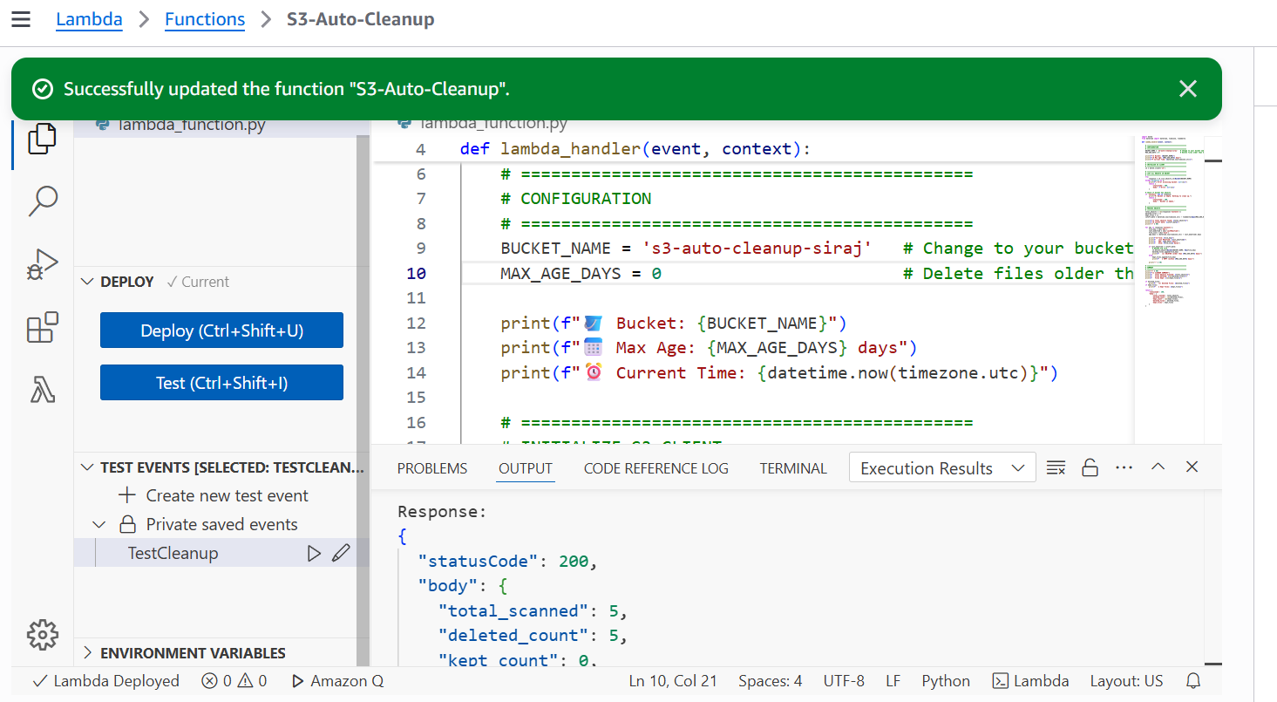

Boto3 code-
import boto3
from botocore.exceptions import ClientError

s3 = boto3.client('s3')

def lambda_handler(event, context):
unencrypted_buckets = []

try:
response = s3.list_buckets()
buckets = response.get('Buckets', [])

print("Scanning S3 buckets for default server-side encryption...")

for bucket in buckets:
bucket_name = bucket['Name']

try:
s3.get_bucket_encryption(Bucket=bucket_name)
print(f"Bucket '{bucket_name}' has server-side encryption enabled.")

except ClientError as e:
error_code = e.response['Error']['Code']

if error_code == 'ServerSideEncryptionConfigurationNotFoundError':
print(f"Bucket '{bucket_name}' does NOT have server-side encryption enabled.")
unencrypted_buckets.append(bucket_name)
else:
print(f"Error checking bucket '{bucket_name}': {str(e)}")

print("----- Scan Complete -----")
if unencrypted_buckets:
print("Unencrypted buckets found:")
for name in unencrypted_buckets:
print(name)
else:
print("All buckets have default server-side encryption enabled.")

return {
"statusCode": 200,
"unencrypted_buckets": unencrypted_buckets,
"message": "S3 bucket encryption scan completed successfully"
}

except Exception as e:
print(f"Unexpected error: {str(e)}")
return {
"statusCode": 500,
"message": "Failed to scan S3 buckets",
"error": str(e)
}
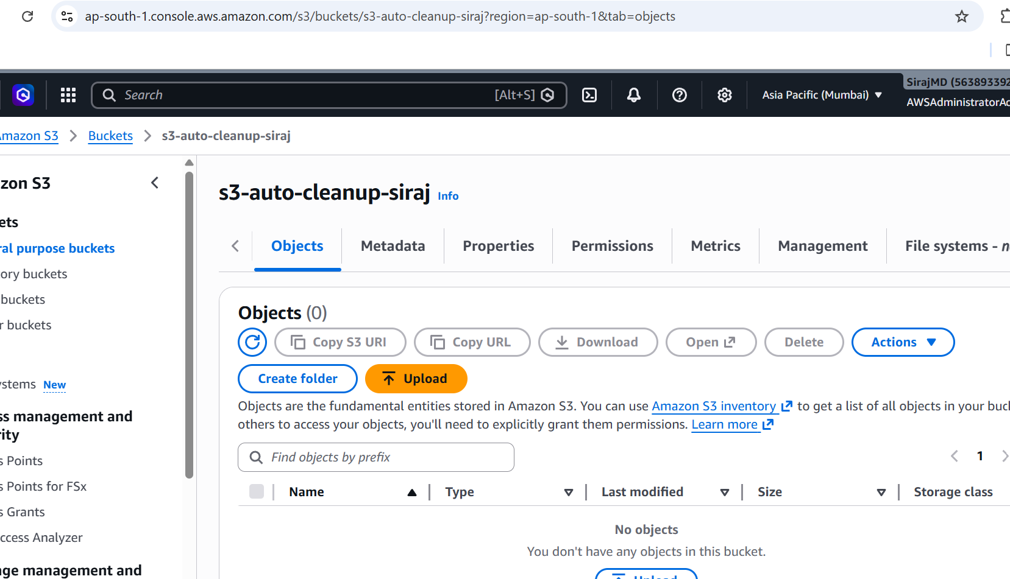

Assignment 5: Auto-Tagging EC2 Instances on Launch Using AWS Lambda and Boto3

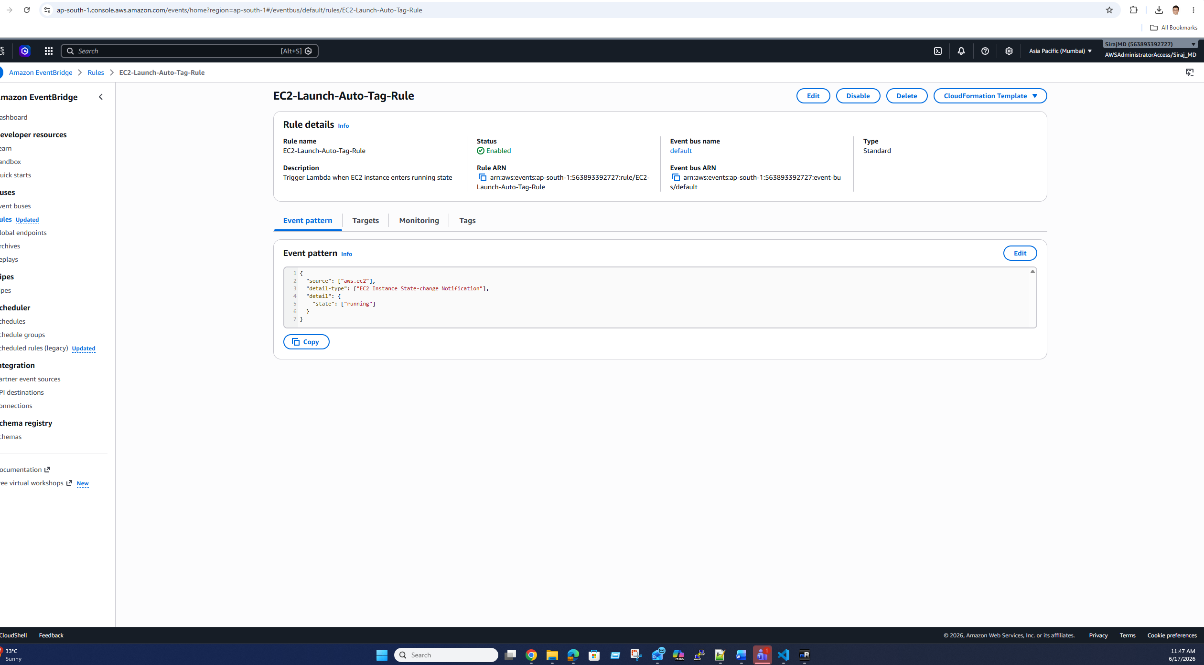

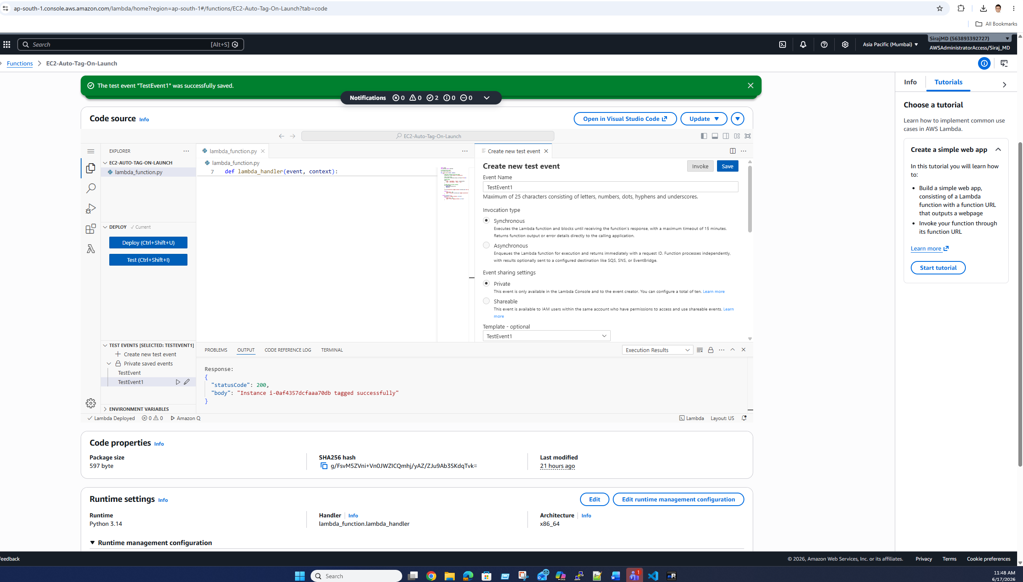

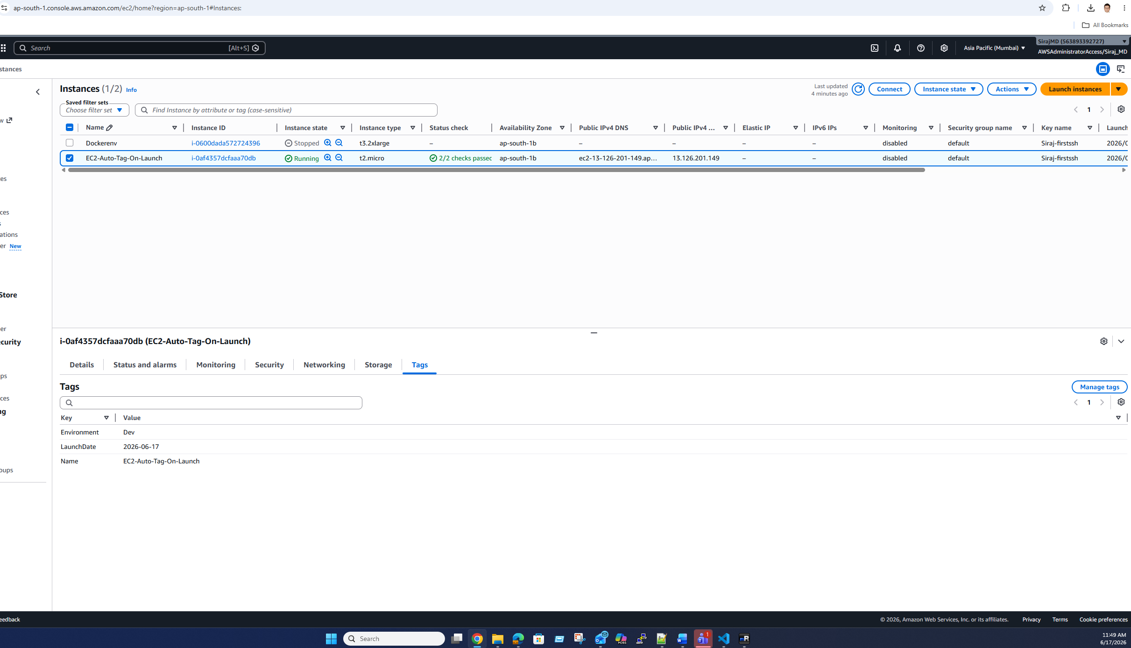

https://github.com/Sirajmd1/AWS-Serverless-Architecture-amp-Cloud-Automation.git

