The Generalized Maximum Belief Entropy Model

Siran Lia, Rui Caia,∗

*aBusiness College, Southwest University, Rongchang District, Chongqing, 402460, China*

# Abstract

In evidence theory, the generalized belief entropy model unifies ~~Reny~~ Renyi entropy, Tsallis entropy, and Deng entropy. In order to further unify the maximum values of ~~Reny~~ Renyi entropy, Tsallis entropy, and Deng entropy, this paper proposes a maximum model of generalized belief entropy by analyzing the generalized belief entropy model, this model shows that the size of the maximum generalized belief entropy is not related to the specific mass value, but is related to the size of each propositional space, and the maximum values of R-D entropy and T-D entropy are obtained through this model. In addition, the applicability of the proposed model is obtained through verification tests and sensitivity analysis of the model.

*Keywords:* Entropy; Uncertainty measure; Tsallis entropy; ~~Reny~~ Renyi entropy; Shannon entropy; Deng entropy

# Introduction

Entropy is a measure of uncertainty, and many studies have focused on the essence of entropy [1]. When the classical thermodynamic entropy is evolving [2, 3], the concept of entropy is also widely used in various disciplines [4–10] and industries [11–13]. In the field of information theory, Shannon proposed information entropy [14], classical information entropy is often used to compare with the newly proposed entropy [15, 16], literature [17] followed up on the aforementioned literature [15] and made some notes.

For further processing of uncertain information, Dempster and Shafar proposed the Dempster-Shafer evidence theory [18]. Based on Dempster-Shafer evidence theory, scholars such as Mehran Khalaj extended the measure of cross entropy to uncertain situations, and thus defined a new measure of cross entropy between two belief sets [19]. In evidence theory, the main factor describing uncertainty is BPA (basic probability assignment function). one important operation for BPA in evidence theory is the combination of evidence and the corresponding rule is also called the evidence combination rule. Evidence combination rules, as an important part of D-S evidence theory, are also constantly developing. Many researchers have improved the evidence combination rules [20–22]. And there are also many scholars who apply the combination of evidence to technical practice [23–25]. Evidence theory itself has a wide range of applications such as information fusion [26–30], decision making [19, 31, 32], prediction [33] and pattern recognition [34, 35], while developing [36], it also maintains a good integration with other subjects [37, 38]. There are many theories developed based on evidence theory, the generalized evidence theory [39], which extended the carrier that defining the discernment framework to the open world, was proposed. It better solves the problems of classical evidence theory in the case of incomplete discernment framework.

Both evidence theory and information entropy can be used to process information. How to apply classic information entropy to evidence theory has been the work of some scholars. In this process, many entropies has been proposed [40–49], Renyi proposed the Renyi entropy [50], which is widely used in statistics [51]. As a kind of extension of Boltzmann entropy, Tsallis entropy [52] is a non-scalable entropy that also has a wide range of applications [53]. Recently, Deng entropy [54] was proposed as a new kind of entropy used to measure the uncertainty of BPA, Deng entropy better solves the problem of uncertainty measurement of multi-element sets. ~~The greater the Deng entropy, the higher the degree of uncertainty.~~ Based on Deng entropy, the Generalized Ordered Propositions Fusion is presented in [55]. This article obtains the generalized ordered proposition by extending the basic support function on the power set of the ordered proposition, and proposes a fusion method of the generalized ordered proposition. Some scholars have proposed an improved belief entropy based on Shannon entropy and Deng entropy [56], the improved belief entropy fully considers the relationship between the subsets, which makes it have a better effect in the measurement of uncertainty. Different with Deng entropy, a new belief entropy is proposed in [57], which consists of two parts, the first part is the Shannon entropy with plausibility transform, the second part is Dubois-Prade’s definition of entropy of basic probability assignments in the DS theory. What is important is that it also satisfies the six expected properties of the entropy of the DS belief function theory. We often discuss entropy based on the principle of maximum entropy, the principle of maximum retains all the uncertainty and minimizes the unknown. Applying the principle of maximum entropy and Generalized Belief Propagation, [58] presents an algorithm for estimating the distribution by taking into account the dependencies among variables, so that a larger distribution can be estimated

∗Corresponding author:Prof. Dr.Cairui,Business College of Southwest University.Tel(Fax): 86(23)-46751399

*Email addresses:* [lisiranswu@163.com](mailto:lisiranswu@163.com) (Siran Li), [cairui686@swu.edu.cn](mailto:cairui686@swu.edu.cn) (Rui Cai)

*Preprint submitted to Elsevier June 13, 2020*

from a smaller subset distribution using the principle of maximum entropy. It is often used in statistics [59–62], especially parameter estimation [63, 64] and some aspects of biochemistry [65], some theories [66–68] are also improved based on it. The principle of maximum entropy can also be used to determine BPA. [69] proposes a new model for determining BPA. This model has certain significance for determining BPA when the available information is limited. The principle of maximum entropy is also reflected in the field of information theory: the maximum Deng entropy model [70] gives the necessary and sufficient conditions for the maximum Deng entropy to appear and the model of the maximum Deng entropy. Given that Shannon entropy is a special case of Renyi entropy, Tsallis entropy, and Deng entropy, scholars have begun to study the relationship between the three. Masi’s work [71] unifies Renyi and Tsallis entropy. Lately, the generalized belief entropy model [72] was proposed as a unified model of Renyi entropy, Tsallis entropy, and Deng entropy.

According to the previous ideas, a natural question will be asked: what is the maximum value of the generalized belief entropy model? And under what conditions does the generalized belief entropy reaches this maximum, this subject has not been covered by too many scholars. In this paper, we will discuss the conditions when the generalized belief entropy reaches a maximum value, and give the maximum generalized belief entropy based on the results of the discussion. Through the work of this paper, the maximum Shannon entropy, the maximum ~~Renyii-Deng~~ Renyi-Deng entropy, and the maximum Tsallis-Deng entropy can be unified.

The structure of this paper is as follows: The Preliminaries in the second section introduce the related concepts of evidence theory, Deng entropy, Renyi entropy, Tsallis entropy, generalized belief entropy (R-D entropy, T-D entropy). In section 3, the generalized maximum belief entropy model is proposed, and the maximum values of R-D entropy and T-D entropy are obtained according to this model. The fourth section is the conclusion of this paper.

# Preliminaries

* 1. *Dempster Shafer Evidence Theory*

D-S evidence theory [18] is a theory that can be used to describe the uncertainty of a system. It can deal with the uncertainty caused by the unknown prior probability. Evidence theory models uncertainty by studying multiple-element subsets, so compared to probability theory, where the research field is a single element subset, evidence theory adapts to weaker axiom systems than probability theory. Some basic concepts of evidence theory are introduced below.

Let Ω be a finite set of all possible values of a variable *X*, and each element in Ω is mutually exclusive. It is called an frame of discernment and Ω is defined as:

2Ω is the power set of Ω:

Ω = {*x*1*, x*2*, ..., xn*}

2Ω = {{∅}*,* {*x*1}*, ...,* {*xn*}*,* {*x*1*, x*2}*, ...*{*x*1*, ..., xi*}*,* Ω}

the probability assignment *m*(*Ai*) of the frame of discernment Ω is a mapping from 2Ω to [0*,* 1] defined on a power set in the form:

*m*(*Ai*) : 2Ω → [0*,* 1]

*Ai* is a subset of the frame of discernment. *m*(*Ai*) is the probability assignment function (BPA), which satisfies the following conditions:

Σ

* 1. *Deng Entropy*

*m*(∅) = 0*,*

*Ai*⊆Ω

*m*(*Ai*) = 1

The form of Deng entropy [54] in evidence theory is as follows:

*Ed* = −

Σ

*Ai*⊆Ω

*m*(*Ai*) × log

*m*(*Ai*)

2 2|*Ai*| − 1

where *Ai* is a subset of the frame of discernment Ω, and *Ai* is the cardinality of the set *Ai*. Another form of Deng Entropy is:

| |

Σ

Σ

*Ed* =

*Ai*⊆Ω

*m*(*Ai*) log2(2|*Ai*| − 1) −

*Ai*⊆Ω

The formula Σ*A* ⊆Ω *m*(*Ai*) log2(2|*Ai*| − 1) represents the non-specificity of the entire system, and the formula Σ*A* ⊆Ω *m*(*Ai*) log2 *m*(

*m*(*Ai*) log2 *m*(*Ai*)

*i*

represents the inconsistency,

The formula:

*A*Σ*i*⊆Ω

*i*

*m*(*Ai*) log2(2|*Ai*| − 1)

represents the non-specificity of the entire system, and the formula:

*A*Σ*i*⊆Ω

*m*(*Ai*) log2 *m*(*Ai*)

represents the inconsistency, that is, the conflict, of the entire system. ~~when~~ When it is a single-element subset, Deng entropy degenerates to Shannon entropy [14]:

* 1. *Renyi Entropy*

*Ed* = −

*Ai*⊆Ω

Σ

*m*(*Ai*) log2 *m*(*Ai*)

Assuming *Pθ* = *pi i* = 1*,* 2*,* 3*, ...* is the probability distribution of the discrete random variable *θ*, then Renyi [50] entropy can be defined as:

{ | }

*H* (*p , p , p , ..., p*

*α*

1

2

3

) = 1 log (Σ *pα*)

*k*=1

where *α >* 0 and *α* ƒ= 1. In particular, Renyi entropy degenerates to Shannon entropy when *α >* 1:

*N*

*n*

1 − *α*

2

*k*

*n*

lim *H* (*p , p , p , ..., p* ) = Σ *p* log 1

*k*=1

*α*→1

*α*

1

2

3

*n*

*k*

2 *pk*

* 1. *Tsallis Entropy*

Given a discrete random variable *Y* and its probability distribution is *pi i* = 1*,* 2*,* 3*, ...* , then the Tsallis entropy [52] can be expressed as:

{ | }

*n*

*S* (*p* ) = *k* (1 − Σ *pq*)

*i*=1

*q*

*i*

*q* − 1

*i*

where *k, q* are parameters, and *k* is often set to 1 in statistics. And *q* reflects the degree of non-extensiveness. In particular, when *q* → 1, Tsallis entropy degenerates to Shannon entropy:

lim *Sq*(*pi*) = *S*1(*pi*) ≡ − Σ *pi* log2 *pi*

*i*

*n*

*q*→1

It should be noted that the literature [73] suggests that the Tsallis entropy can be used to replace Shannon entropy when *q* = 2, so that logarithmic operations can be avoided. In the latter part of this article, the situation of *q* = 2 will also be included in the discussion, so *q* = 2 is a special case of this article.

* 1. *Generalized Belief Entropy*

Let *Ai* be a subset of the frame of discernment Ω, *Ai* denote the cardinality of the set *Ai*, and *m*(*Ai*) be the probability assignment function on the power set 2Ω. Then the definition of generalized belief entropy [72] is as follows:

| |

1 ΣΣΣ

*E*

(*m*(*Ai*)) =

(

*t,r*

1 − *r*

*i*

*m*(*A* )

Σ 1*−r* Σ

)*t*(2|*Ai*| − 1)

where *r*, *t* are parameters. When *r* → 1, generalized belief entropy degenerates to R-D entropy:

*i*

2|*Ai*| − 1

1*−t* − 1

*E* (*m*(*A* )) = 1 *ln*ΣΣ( *m*(*Ai*) )*α*(2|*Ai*| − 1)Σ

*i*

*α*

*i*

1 − *α*

2|*Ai*| − 1

when *r* → *q*, the generalized belief entropy degenerates to T-D entropy:

*E* (*m*(*A* )) = 1 Σ1 − Σ( *m*(*Ai*) )*q*(2|*Ai*| − 1)Σ

*i*

*q*

*i*

*q* − 1

2|*Ai*| − 1

in particular, when *q* → 1 or *α* → 1, the T-D entropy and R-D entropy degenerate to Deng entropy:

lim *E* (*m*(*A* )) = lim *E*

*q*→1

*q*

*i*

*α*→1

*α*

(*m*(*A* )) = Σ *m*(*A* )*ln*( *m*(*Ai*) )

*i*

# Generalized Maximum Belief Entropy Model

*i*

*i*

2|*Ai*| − 1

Let *Ai* be a subset of the frame of discernment Ω, *Ai* denote the cardinality of the set *Ai*, and *m*(*Ai*) be the probability assignment function on the power set 2Ω.

| |

* 1. *The Necessary And Sufficient Condition Of The Maximum Generalized Belief Entropy*

**Theorem 1.** *The maximum generalized belief entropy achieves the maximum value if and only if: m*(*A* ) = Σ2*|Ai|* −1

Proof.

*E*

(*m*(*Ai*)) =

(

*i*

2|*Ai*| − 1

)*t* × (2|*Ai*| − 1)

1*−t* − 1

1 ΣΣΣ

*t,r*

1 − *r*

*i*

*m*(*A* )

Σ 1*−r* Σ

*i j* 2*|Ai|* −1

its Lagrange function can be defined as follows:

*Ft,r*(*m*(*Ai*))

*A*Σ*i*⊆Ω

*m*(*Ai*) = 1

1 ΣΣΣ *m*(*A* )

*i*

Σ 1*−r* Σ Σ

then we can get:

=

1 − *r*

( *i*

2|*Ai*| − 1

)*t*(2|*Ai*| − 1)

1*−t* − 1

+*λ*(

*i*

*m*(*Ai*) − 1)

*∂Ft,r*(*m*(*Ai*))

*∂m*(*Ai*)

Σ

Σ

Σ 1*−r*

1

=

1 − *t*

( *m*(*Ai*) 2|*Ai*| − 1

)*t*(2|*Ai*| − 1)

1*−t*

*t*( *m*(*Ai*) 2|*Ai*| − 1

)*t*−1 + *λ* = 0

where *t* and *λ* are constants, then we can get:

. Σ*i*

*i*

*m*(*A* ) *t*−1

*t* × 2|*Ai*| − 1 ×

*i*

Σ . Σ*t*

*m*(*Ai*) *t*

2|*Ai*| − 1

Σ. Σ

× (2|*Ai*| − 1) = *µ*

in the formula above, the value of the term

*m*(*Ai*)

is fixed. So we can get:

*i* 2*|Ai|* −1

*m*(*A*1) *m*(*A*2) *m*(*Ai*)

= = *...* =

2|*A*1 | − 1

and according to the ratio property, we can get:

2|*A*2 | − 1

2|*Ai*| − 1

*m*(*A*1) + *m*(*A*2) + *...* + *m*(*An*) *m*(*Ai*)

=

then we can get:

(2|*A*1 | − 1) + (2|*A*2 | − 1) + *...* + (2|*An*| − 1) (2|*Ai*| − 1)

1 *m*(*Ai*)

Σ

so we can finally get:

=

*j* 2|*Aj* | − 1 2|*Ai*| − 1

2|*Ai*| − 1

Σ

*m*(*Ai*) =

*j*

2|*Aj* | − 1

So based on the process of inference above, the necessary and sufficient condition for the generalized belief entropy to reach the maximum is:

2|*Ai*| − 1

Σ

*m*(*Ai*) =

* 1. *The Generalized Maximum Belief Entropy Model*

*j* 2|*Aj* | − 1

We substitute the obtained necessary and sufficient condition:

2|*Ai*| − 1

Σ

into the generalized belief entropy model:

*m*(*Ai*) =

*j*

2|*Aj* | − 1

1 ΣΣΣ. *m*(*A* ) Σ*t*

*E*

(*m*(*Ai*)) =

*i*

2|*Ai*| − 1

*t,r*

1 − *r*

*i*

Σ 1*−r* Σ

× (2|*Ai*| − 1)

then we can get the generalized maximum belief entropy model:

1*−t* − 1

*E* (*A* ) = 2|*A* | − 1 − 1Σ

1 Σ.Σ Σ1−*r*

*j*

*r i max*

1 − *r j*

* 1. *The Maximum R-D entropy and Maximum T-D entropy*

The proposition *Ai* in the generalized maximum belief entropy model proposed above is obejective, so we mainly discuss the value of parameter r to obtain the maximum value of the generalized maximum belief entropy model. We find the partial derivative about r for the generalized maximum belief entropy model obtained, that is:

.Σ Σ1−*r*Σ .Σ Σ Σ

*j* 2|*Aj* | − 1

− ln

*j* 2|*Aj* | − 1

(1 − *r*) − 1

*∂Er*(*Ai*)*max* =

= 0

*∂r*

then we can get two values of *r*:

*r* = 1 +

(1 − *r*)2

1

.Σ Σ *, r* = 1

ln

*j* 2|*Aj* | − 1

we first substitute the first *r* value into the generalized maximum belief entropy model and we can get:

*j*

*Er*(*Ai*)*max* = ln.Σ

*j*

2|*Aj* | − 1ΣΣ1 −

.Σ*j*

2|*Aj* | − 1

Σ− ln

.Σ 2*|Aj|* −1

Σ*−*1 Σ

(1)

we simplify the equation (1) to get:

*E* (*A* )

*r*

*i max*

= ln.Σ 2|*Aj* | − 1Σ(1 − 1 )*<* ln.Σ 2|*Aj* | − 1Σ

*j*

*j*

while *r* → 1, we can get the maximum of the the generalized maximum belief entropy model in the form of limit:

*e*

lim 1 Σ.Σ 2|*A* | − 1Σ1−*r* − 1Σ

*j*

*r*→1 1 − *r j*

.Σ

Σ − .Σ|*A* |2 − 1 × ln

1 *r*

*j*

*j*

= lim

*r*→1 1

*j* 2|*Aj* | − 1Σ

= ln.Σ 2|*Aj* | − 1Σ

*j*

Therefore, the maximum value of the generalized maximum belief entropy model can be described as follows:

*Er*(*Ai*)*max* = ln.Σ 2|*Aj* | − 1Σ

*j*

→

→

Since our model is based on the generalized belief entropy model [72], the generalized belief entropy shows that when *r* 1, the generalized belief entropy degenerates to R-D entropy, when *r q*,the generalized belief entropy degenerates to T-D entropy. In order to prove that our model is equally applicable to these two cases, we discuss the corresponding two cases separately:

When *r* → 1, this situation is the same as what we have discussed above, so we will not go into details. And when *r* → *q*,we can get:

Σ

lim

1 Σ.Σ

1−*r*

2|*Aj* | − 1

− 1Σ

*r*→*q* 1 − *r j*

= 1 Σ.Σ

2|*Ai*| − 1

Σ1−*q*

− 1Σ

(2)

1 − *q j*

Σ (1−*q*) ln.Σ*j*

1

2*|Aj|* −1Σ Σ

−

= *e* 1

1 − *q*

then we perform power series expansion on equation above to get:

*n*

Σ .Σ ΣΣ*n*

(2) =

*j*

1

1 − *q*

Σ1 + (1 − *q*) ln.Σ

2|*Aj* | − 1Σ +

Σ*i*=2

(1 − *q*)*n* ln

*j* 2|*Aj* | − 1

*n*!

− 1Σ

next we can get:

Σ .Σ ΣΣ*n*

*n*

(2) = ln.Σ

2|*Aj* | − 1Σ + 1 Σ

(1 − *q*)*n* ln

*j* 2|*Aj* | − 1

(3)

*j*

for the Eq.3 we discuss the scope of *q* in two cases:

1 − *q i*=2 *n*!

1. when 0 ≤ *q <* 2, that is 1 − *q* ∈ [−1*,* 1), and for a definite frame of discernment Ω, *j* 2|*Aj* | − 1 is also definite, so we can get:

.Σ Σ

ΣΣ

*n*!

lim

(1 *q*)*n*

Σ

*n*

*n*→∞ *i*=2

−

Σln.Σ

*n*

*j* 2|*Aj* | − 1

= 0

so Eq.3 can be rewritten as : ln.Σ*j* 2|*Aj* | − 1Σ + 0, therefore, in this situation, the maximum value of T-D entropy is: ln.Σ*j* 2|*Aj* | − 1Σ.

1. when *q* ≥ 2, we can transform Eq.3 and get the following expression:

Σ .Σ

*j*

ln.Σ

*j*

2|*Aj* | − 1Σ +

1 (1−*q*) ln

*e*

1 − *q*

2*|Aj|* −1Σ

− (1 − *q*) ln.Σ

*j*

2|*Aj* | − 1Σ

− 1Σ

(4)

and let us consider the expression :

(1−*q*)×ln.Σ*j*

*e*

2*|Aj|* −1Σ

− (1 − *q*) ln.Σ

*j*

2|*Aj* | − 1Σ − 1

let :

*x* = (1 − *q*) ln.Σ 2|*Aj* | − 1Σ(*x <* 0)

*j*

then we can rewrite the expression above to get a function about *x*:

*f* (*x*) = *ex* − *x* − 1(*x <* 0) (5)

now we consider the monotonicity of Eq.5:

d*f* (*x*) = *ex* 1 = 0 d*x*

−

then we can get *x* = 0, that is, the Eq.5 decreases monotonically when *x <* 0, so we can get:

so *f*(*x*) *<* 0, and for Eq.3, we can get:

1−*q*

*f* (*x*) *> f* (0) = 0

(3) *<* ln.Σ 2|*Aj* | − 1Σ

*j*

so, when *r* → *q*, the maximum value of T-D entropy demostrates as follows:

*T* − *Dmax* = ln.Σ 2|*Aj* | − 1Σ

*j*

In summary, the maximum value of both entropies expressed as:

*Emax* = ln.Σ 2|*Aj* | − 1Σ

*j*

We compared the entropy mentioned in the article, as shown in Table.1. It can be seen that the conditions for the maximum value of Renyi entropy and Tsallis entropy proposed earlier are the same, that is, at this time, each *pi* occupies the same possibility, and the system is most uncertain. The maximum value of Tsallis entropy is consistent with the maximum value of Renyi entropy when *q* 1. Deng entropy generalizes the individual in question to multi-element subsets. The condition for Deng entropy to obtain the maximum value can be understood as that for each multi-element subset, all its possible values (power set) account for all possible elements of all multi-element subsets. Value ratio, this idea is in line with Renyi entropy and Tsallis entropy. Our model is based on a multi-element subset, and the condition and maximum form of our maximum value are consistent with Deng entropy, R-D entropy and T-D entropy.

→

Table 1: Uncertainty measures

Name Expression Conditions Maximum value

Renyi Entropy *Hα*(*pi*) = 1 log (Σ*N*

1−*α*

2

*k*=1

*q*

*i*

*q*−1

*i*=1

*i*

*pα*) *pk* = 1

*k*

*N*

*i*

log (*N* )

2

Tsallis Entropy *S* (*p* ) = *k*

(1 − Σ*n pq*) *p*

= 1

*N*

1−*N* 1*−q*

*q*−1

Deng Entropy *E* = − Σ

*m*(*A* ) × log

*m*(*Ai*)

*m*(*A* ) = 2*|Ai|* −1

*j*

log .Σ

2|*Aj* | − 1Σ

*Eα*(*m*(*Ai*)) =

*d*

*Ai*⊆Ω

*i*

2 2*|Ai|* −1

*i*

2*|Aj|* −1

2

*j*

R-D Entropy Σ

Σ

Σ

*m*(*Ai*)

2*|Ai|* −1

*i*

Σ

2*|Aj|* −1

2

*j*

*j*

1

1−*α*

ln

*i*

(

Σ *m*(*A* ) = 2*|Ai|* −1

)*α*(2|*Ai*| − 1)

*j*

log .Σ

2|*Aj* | − 1Σ

*Eq*(*m*(*Ai*)) =

T-D Entropy Σ

Σ

1

*q*−1

1 −

*i*

(

*m*(*Ai*)

2*|Ai|* −1

Σ *m*(*A* ) = 2*|Ai|* −1

*j*

log .Σ

2|*Aj* | − 1Σ

*Et,r*(*m*(*Ai*)) =

)*q*(2|*Ai*| − 1)

*i*

Σ

2*|Aj|* −1

2

Gen Entropy ΣΣ

Σ

( *m*(*Ai*) )*t*(2|*Ai*| 1)

2*|Ai|* −1

1

1−*r*

*i*

Σ Σ *m*(*A* ) = 2*|Ai|* −1

−

*j*

log .Σ

2|*Aj* | − 1Σ

In the framework of D-S evidence theory, there are many ways to measure uncertainty. We can degenerate our model into other measures of uncertainty by changing the parameters of the maximum generalized entropy model, thus adapting our model to situations that are met by other measures:

1*−r*

1*−t* − 1

*i*

Σ

2*|Aj|* −1

2

*j*

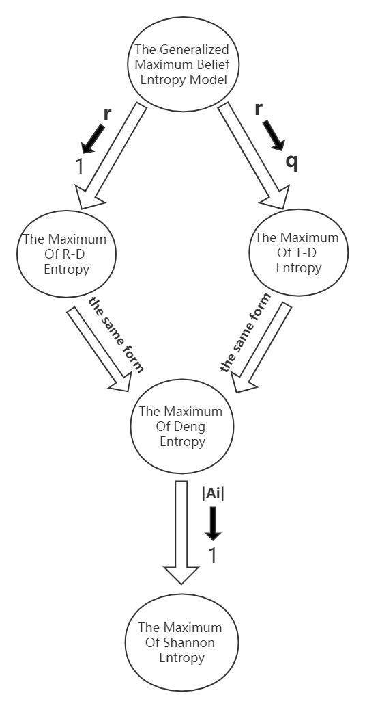

Figure 1: Relationship between several maximum entropy models.

As shown in Fig.1, we can see that:

1. When the value of r tends to 1, the maximum generalized belief entropy model degenerates into the maximum R-D entropy model.
2. When the value of r tends to q, the maximum generalized belief entropy model degenerates into the maximum T-D entropy model.
3. The maximum R-D entropy model and the maximum T-D entropy model are consistent in expression [72] with the maximum Deng entropy.
4. The maximum Deng entropy degenerates to the maximum Shannon entropy in the case of a single element subset. [70]

# Numerical Examples

* 1. *Example 1*

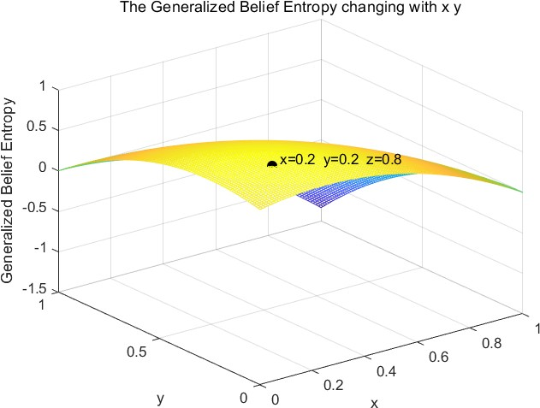

Figure 2: The Generalized Belief Entropy changing with x y

Based on the model proposed in [72], which is the basis of our work, we select the discernment frame with the elements

*a, b* , and the parameter *r, t* in the [72] model is set to 2. Then we obtained the figure above.

{ }

From the above figure, we can see that the maximum value of the generalized belief entropy in the this case is obtained when *x* = *y* = 0*.*2, and the maximum value is 0*.*8. We apply the above conditions to our proposed model, namely:

1

*E*(*Ai*) = 1 − Σ

*j*

2|*Aj*| − 1

under the premise that the power set is {{*a*}*,* {*b*}*,* {*a, b*}*,* ∅}, the value of formula *j* 2|*Aj*| − 1 is 5, therefore, we can calculate the maximum value of generalized belief entropy under our model: *E*(*Ai*)*max* = 0*.*8. And according to the conditions when it reaches the maximum value, it can be obtained: *m*( *a* ) = *m*( *b* ) = 1*/*5 = 0*.*2 therefore, our model is

Σ

{ } { }

consistent with [72] in the actual situation.

* 1. *Example 2*

In the third section, we derive the maximum values of R-D entropy and T-D entropy through the obtained model, and here we verify it.

In [72], it is mentioned that the condition for R-D entropy and T-D entropy to achieve the maximum value is:

2|*Ai*| − 1

Σ

*m*(*Ai*) =

*j*

(6)

2|*Aj* | − 1

We substitute Eq.6 into R-D entropy [72] and we can get the maximum model of R-D as:

*R* − *Dmax* = ln .Σ 2|*Aj* | − 1Σ

*j*

this is consistent with the conclusion drawn by our model on the issue of maximum R-D. Then we substitute Eq.6 into T-D entropy [72] too, and what we can actually get is:

*T* − *D*

= 1 Σ1 − 1 Σ

*max*

ΣΣ

.

*q* − 1

ΣΣ*j*

*q*−1

2|*Ai*| − 1

in fact, the equation above and Eq.2 are essentially the same. Therefore, the maximum R-D entropy and T-D entropy have been verified.

* 1. *Example 3*

In this example, we mainly discuss the motivation of maximum generalized belief entropy. We will explain how to adapt this model to the maximum R-D entropy model, the maximum T-D entropy model, and the maximum Deng entropy model by modifying the parameters in the maximum generalized entropy model.

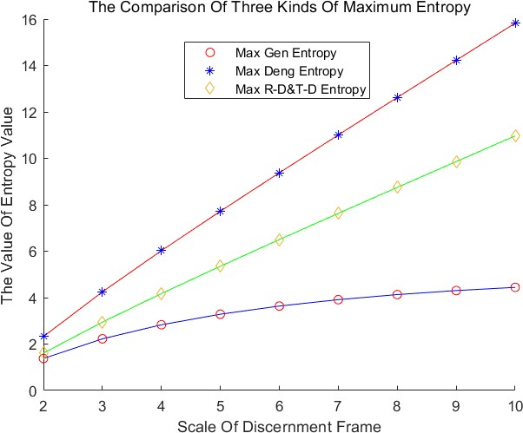

Figure 3: The Comparison Of Three Kinds Of Maximum Entropy

In order to discuss the relationship between the maximum values of the three entropies, we fixed the value of the parameter r so that our model was determined. Furthermore, we discuss the difference in the maximum values of the three types of entropy under different discernment frames, and draw the figure above. From the figure above, we can see that although our model and the maximum entropy value under different discernment frames are the same in the overall trend, the specific value is not very satisfactory. Therefore, we consider the effect of the value of parameter r on this experiment.

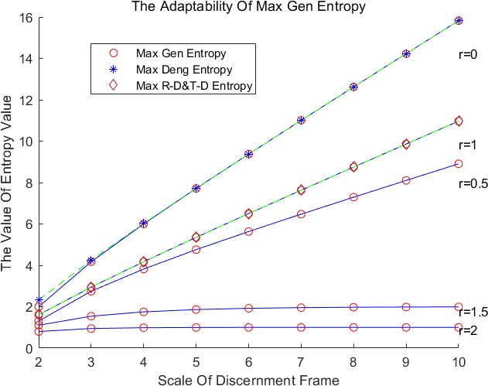

Figure 4: The Adaptability Of Max Gen Entropy

Under the change of r, our model also changes accordingly. From Fig.4, we can see that the value of r is between 0-2. When r equals 2, the value calculated by our model under each discernment frame tends to be gentle. When the value of r is within 1-2, we can see that our model is approaching the maximum R-D entropy and the maximum T-D entropy. In particular, when r = 1, our model coincides with the maximum R-D entropy and maximum T-D entropy models, which is consistent with what we described in Section III. It is worth mentioning that r = 1 is a singularity of our model, so at this point the values under different discernment frames are obtained by the limit. When the value of r is within 0-1, our model is approaching the maximum Deng entropy(Can be seen from Fig.5 below). In particular, when r = 0, our model basically coincides with the maximum Deng entropy model. What needs to be explained here is that in the experiment with r*<*1, we performed log processing on the obtained data.

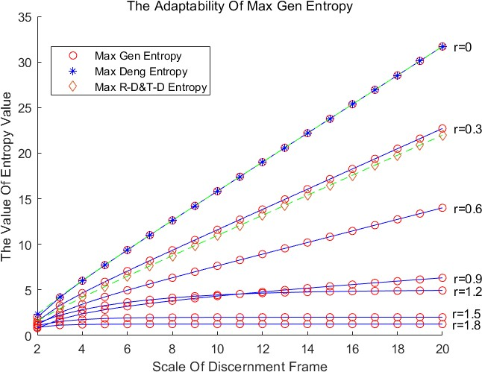 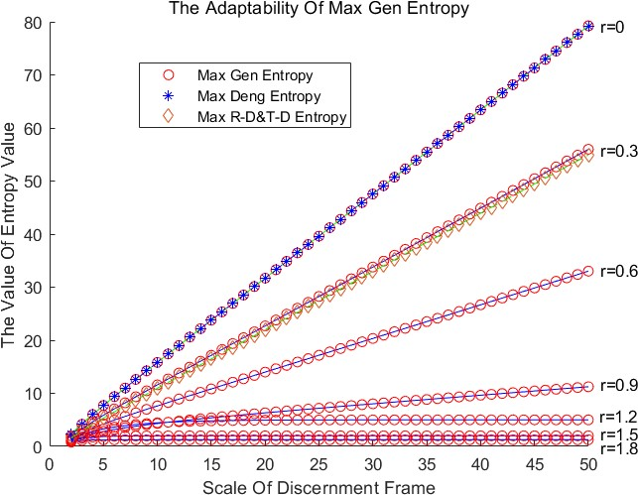

(a) *|*FOD*|*=20 (b) *|*FOD*|*=50

Figure 5: More Larger FOD

Fig.5 shows the performance of our model under a larger FOD. When the maximum generalized belief entropy holds, the distribution of BPA is determined for a certain identification framework, namely:

2|*Ai*| − 1

Σ

*m*(*Ai*) =

*j*

2|*Aj* | − 1

so it can be said that in this case, the distribution of BPA is fixed. From Fig.5 we can see that the performance of our model under larger FOD is consistent with Fig.4. It is worth mentioning that in Fig.5, the step size of the r iteration has changed. We can see that when *r* = 0*.*3, our model is very close to the maximum R-D entropy and the maximum T-D entropy. Referring to the case where the limit value is obtained when r=1 mentioned above, maybe in this case (*r* = 0*.*3) a non-limiting model that is sufficiently close to the maximum R-D entropy and maximum T-D entropy models can be obtained.

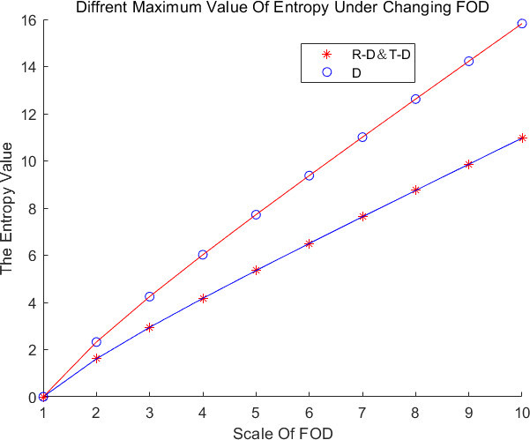

Figure 6: Diffrent Maximum Value Of Entropy Under Changing FOD

In view of the change in the value of r will cause changes in our model, we discuss the relationship between the maximum R-D entropy, maximum T-D entropy and maximum Deng entropy model. Their relationship is shown in Fig.6. From the figure above, we can see that the maximum R-D entropy, maximum T-D entropy, and maximum Deng entropy are consistent under different discernment frames. But the maximum Deng entropy value is higher than the maximum R-D entropy and maximum T-D entropy.

Table 2: The quantitative relationship between entropy

|  |  |  |  |
| --- | --- | --- | --- |
| Scale of FOD | R-D&T-D Entropy | Deng Entropy | R-D&T-D/Deng |
| 2 | 1.6094 | 2.3219 | 1.4427 |
| 3 | 2.9444 | 4.2479 | 1.4427 |
| 4 | 4.1744 | 6.0224 | 1.4427 |
| 5 | 5.3519 | 7.7211 | 1.4427 |
| 6 | 6.4998 | 9.3772 | 1.4427 |
| 7 | 7.6300 | 11.0077 | 1.4427 |
| 8 | 8.7491 | 12.6223 | 1.4427 |
| 9 | 9.8612 | 14.2266 | 1.4427 |
| 10 | 10.9686 | 15.8244 | 1.4427 |

From the data in the ~~above table~~ table above, we can see that the mutiple between maximum R-D entropy, the maximum T-D entropy and the maximum Deng entropy is 1.4427. This is due to the calculation method of the two entropies. The maximum R-D entropy and maximum T-D entropy calculated by our model do the logarithm of the natural logarithm base *e* at the end, and the maximum Deng entropy is based on the logarithm of 2 bases, so the difference between the two will be *log*2(*e*) times.

* 1. *Example 4*

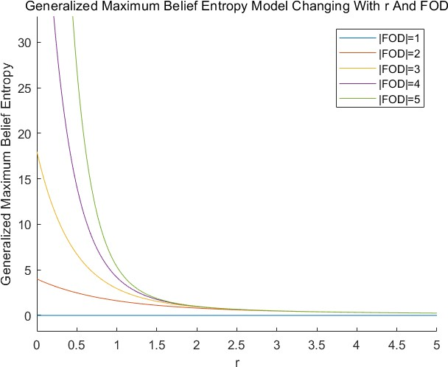

Figure 7: Generalized Maximum Belief Entropy Model Changing With r And FOD

From the ~~above figure~~ figure above, we can see that our model performs the same under different discernment frame and different *r*, from this perspective, our model is insensitive to r. At the same time, we can see that ~~at~~ when *r* = 1, the convergence rate of the model slows down rapidly, and at r = 2, for the same model, the difference between the maximum values calculated by different discernment frame through this model is not particularly obvious. Therefore, we determined the value of r as 2 in Example 1, which helps the generality of Example 1. In fact, from Example.3, we recommend that

the value of r is between 0 − 2.

# Conclusion

In this article, we propose the generalized maximum belief entropy model, and use this model to derive the analytical solutions of maximum R-D entropy and maximum T-D entropy. At the same time, the relationship between the generalized maximum belief entropy model, maximum R-D entropy, maximum T-D entropy, maximum Deng entropy, and maximum Shannon entropy is revealed.

The novelty of our work lies in the unification of the maximum R-D entropy model, the maximum T-D entropy model and the maximum Deng entropy model through the maximum generalized entropy model we have obtained. The unification process is demostrated in Section 4.3.

We have not discussed the practical significance of r in the generalized maximum belief entropy model, which can become the direction of future work, and we will also try to apply the maximum generalized entropy model to information conflict handling.

# Acknowledgment

This research is supported by the Fundamental Research Funds for the Central Universities, SWU1909785.

# References

1. A. L. Kuzemsky, Temporal evolution, directionality of time and irreversibility, RIVISTA DEL NUOVO CIMENTO 41 (10) (2018) 513–574. doi:10.1393/ncr/i2018-10152-0.
2. R. H. Swendsen, The definition of the thermodynamic entropy in statistical mechanics, Physica A: Statistical Mechanics and its Applications 467 (2017) 67 – 73. doi:https://doi.org/10.1016/j.physa.2016.10.032.
3. R. H. Swendsen, J.-S. Wang, Negative temperatures and the definition of entropy, Physica A: Statistical Mechanics and its Applications 453 (2016) 24 – 34. doi:https://doi.org/10.1016/j.physa.2016.01.068.
4. I.-M. Dragan, A. Isaic-Maniu, An innovative model of reliability—the pseudo-entropic model, Entropy 21 (9) (2019) 846.
5. T. S. Bir´o, Z. N´eda, A. Telcs, Entropic divergence and entropy related to nonlinear master equations, Entropy 21 (10) (2019) 993.
6. J. Shen, J. Zhou, Calculation formulas and simulation algorithms for entropy of function of lr fuzzy intervals, Entropy 21 (3). doi:10.3390/e21030289.
7. J. Abellan, J. G. Castellano, Improving the Naive Bayes Classifier via a Quick Variable Selection Method Using Maximum of Entropy, ENTROPY 19 (6). doi:10.3390/e19060247.
8. J. Das, B. C. Bag, Bounds of the entropy production of the irreversible thermodynamics and its relation with the non-equilibrium temperature, Physica A: Statistical Mechanics and its Applications 520 (2019) 433 – 449. doi:https://doi.org/10.1016/j.physa.2019.01.010.
9. L. M. Martyushev, S. N. Zubarev, Entropy production and luminosity–effective temperature relation for main-sequence stars, Physica A: Statistical Mechanics and its Applications 528 (2019) 121403. doi:https://doi.org/10.1016/j.physa.2019.121403.
10. S. Viaggiu, Entropy, temperature and internal energy of trapped gravitons and corrections to the black hole entropy, Physica A: Statistical Mechanics and its Applications 488 (2017) 72 – 84. doi:https://doi.org/10.1016/j.physa.2017.07.009.
11. A. Mehri, H. Agahi, H. Mehri-Dehnavi, A novel word ranking method based on distorted entropy, Physica A: Statistical Mechanics and its Applications 521 (2019) 484 – 492. doi:https://doi.org/10.1016/j.physa.2019.01.080.
12. G. de Novaes Pires Leite, A. M. Arau´jo, P. A. C. Rosas, T. Stosic, B. Stosic, Entropy measures for early detection of bearing faults, Physica A: Statistical Mechanics and its Applications 514 (2019) 458 – 472. doi:https://doi.org/10.1016/j.physa.2018.09.052.
13. T. Dimpfl, F. J. Peter, Group transfer entropy with an application to cryptocurrencies, Physica A: Statistical Mechanics and its Applications 516 (2019) 543 – 551. doi:https://doi.org/10.1016/j.physa.2018.10.048.
14. C. SHANNON, A MATHEMATICAL THEORY OF COMMUNICATION, BELL SYSTEM TECHNICAL JOURNAL 27 (3) (1948) 379–423. doi:10.1002/j.1538-7305.1948.tb01338.x.
15. A. Karci, Fractional order entropy: New perspectives, Optik 127 (20) (2016) 9172–9177.
16. I˙. Tu˘gal, A. Karcı, Comparisons of karcı and shannon entropies and their effects on centrality of social networks, Physica A: Statistical Mechanics and its Applications 523 (2019) 352–363.
17. A. Karci, Notes on the published article “fractional order entropy: New perspectives” by ali karci, optik-international journal for light and electron optics, volume 127, issue 20, october 2016, pages 9172–9177, Optik 171 (2018) 107–108.
18. A. DEMPSTER, UPPER AND LOWER PROBABILITIES INDUCED BY A MULTIVALUED MAPPING, ANNALS OF MATHEMATICAL STATISTICS 38 (2) (1967) 325–&. doi:10.1214/aoms/1177698950.
19. M. Khalaj, R. Tavakkoli-Moghaddam, F. Khalaj, A. Siadat, New definition of the cross entropy based on the dempster- shafer theory and its application in a decision-making process, Communications in Statistics-Theory and Methods 49 (4) (2020) 909–923. doi:10.1080/03610926.2018.1554123.

URL <Go to ISI>://WOS:000505438300009

1. J. Wang, K. Qiao, Z. Zhang, An improvement for combination rule in evidence theory, Future Generation Computer Systems 91 (2019) 1–9.
2. J. An, M. Hu, L. Fu, J. Zhan, A novel fuzzy approach for combining uncertain conflict evidences in the dempster-shafer theory, IEEE Access 7 (2019) 7481–7501.
3. C. LUO, Y. CHEN, H. XIANG, W. WANG, Z. WANG, Evidence combination method in time domain based on reliability and importance, Journal of Systems Engineering and Electronics 29 (6) (2018) 1308–1316.
4. Y. Zhang, Y. Liu, Z. Zhang, H.-C. Chao, J. Zhang, Q. Liu, A weighted evidence combination approach for target identification in wireless sensor networks, IEEE Access 5 (2017) 21585–21596.
5. Y. Zhang, Y. Liu, Z. Zhang, N. Zhao, Collaborative fusion for distributed target classification using evidence theory in iot environment, IEEE Access 6 (2018) 62314–62323.
6. N. Khan, S. Anwar, Time-domain data fusion using weighted evidence and dempster–shafer combination rule: Appli- cation in object classification, Sensors 19 (23) (2019) 5187.
7. X. Fan, Y. Guo, Y. Ju, J. Bao, W. Lyu, Multisensor fusion method based on the belief entropy and ds evidence theory, Journal of Sensors 2020. doi:10.1155/2020/7917512.
8. Y. Tang, D. Zhou, F. T. S. Chan, An extension to deng’s entropy in the open world assumption with an application in sensor data fusion, Sensors 18 (6). doi:10.3390/s18061902.
9. W. Jiang, B. Wei, C. Xie, D. Zhou, An evidential sensor fusion method in fault diagnosis, ADVANCES IN MECHAN- ICAL ENGINEERING 8 (3). doi:10.1177/1687814016641820.
10. A. D. Jaunzemis, M. J. Holzinger, M. W. Chan, P. P. Shenoy, Evidence gathering for hypothesis resolution using judicial evidential reasoning, Information Fusion 49 (2019) 26–45.
11. H. Seiti, A. Hafezalkotob, Developing pessimistic–optimistic risk-based methods for multi-sensor fusion: An interval- valued evidence theory approach, Applied Soft Computing 72 (2018) 609–623.
12. D. Zhou, Y. Tang, W. Jiang, An improved belief entropy and its application in decision-making, Complexity- doi:10.1155/2017/4359195.
13. Z. He, W. Jiang, An evidential Markov decision making model, INFORMATION SCIENCES 467 (2018) 357–372. doi:10.1016/j.ins.2018.08.013.
14. G. L. Prajapati, R. Saha, Reeds: Relevance and enhanced entropy based dempster shafer approach for next word prediction using language model, Journal of Computational Science 35 (2019) 1–11.
15. H. Cui, Q. Liu, J. Zhang, B. Kang, An Improved Deng Entropy and Its Application in Pattern Recognition, IEEE ACCESS 7 (2019) 18284–18292. doi:10.1109/ACCESS.2019.2896286.
16. J. Vandoni, E. Aldea, S. Le H´egarat-Mascle, Evidential query-by-committee active learning for pedestrian detection in high-density crowds, International Journal of Approximate Reasoning 104 (2019) 166–184.
17. R. Jirousek, P. P. Shenoy, A new definition of entropy of belief functions in the Dempster-Shafer theory, INTERNA- TIONAL JOURNAL OF APPROXIMATE REASONING 92 (2018) 49–65. doi:10.1016/j.ijar.2017.10.010.
18. Y. Wang, F. Liu, A. Zhu, Bearing fault diagnosis based on a hybrid classifier ensemble approach and the improved dempster-shafer theory, Sensors 19 (9) (2019) 2097.
19. W. Zhu, H. Yang, Y. Jin, B. Liu, A method for recognizing fatigue driving based on dempster-shafer theory and fuzzy neural network, Mathematical Problems in Engineering 2017.
20. Y. Deng, Generalized evidence theory, APPLIED INTELLIGENCE 43 (3) (2015) 530–543. doi:10.1007/s10489-015- 0661-2.
21. H. Cui, Q. Liu, J. Zhang, B. Kang, An improved deng entropy and its application in pattern recognition, Ieee Access 7 (2019) 18284–18292. doi:10.1109/access.2019.2896286.
22. W. Jiang, S. Wang, An uncertainty measure for interval-valued evidences, International Journal of Computers Com- munications & Control 12 (5) (2017) 631–644. doi:10.15837/ijccc.2017.5.2950.
23. R. Jirousek, P. P. Shenoy, A new definition of entropy of belief functions in the dempster-shafer theory, International Journal of Approximate Reasoning 92 (2018) 49–65. doi:10.1016/j.ijar.2017.10.010.
24. M. D. Mambe, T. N’Takpe, N. G. Anoh, S. Oumtanaga, A new uncertainty measure in belief entropy framework, International Journal of Advanced Computer Science and Applications 9 (11) (2018) 600–606.
25. Y. Tang, D. Zhou, S. Xu, Z. He, A weighted belief entropy-based uncertainty measure for multi-sensor data fusion, Sensors 17 (4). doi:10.3390/s17040928.
26. D. Wang, J. Gao, D. Wei, A new belief entropy based on deng entropy, Entropy 21 (10). doi:10.3390/e21100987.
27. X. Wang, Y. Song, Uncertainty measure in evidence theory with its applications, Applied Intelligence 48 (7) (2018) 1672–1688. doi:10.1007/s10489-017-1024-y.
28. Y. Zhao, D. Ji, X. Yang, L. Fei, C. Zhai, An improved belief entropy to measure uncertainty of basic probability assignments based on deng entropy and belief interval, Entropy 21 (11). doi:10.3390/e21111122.
29. D. Zhou, Y. Tang, W. Jiang, A modified belief entropy in dempster-shafer framework, Plos One 12 (5). doi:10.1371/journal.pone.0176832.
30. Q. Pan, D. Zhou, Y. Tang, X. Li, J. Huang, A Novel Belief Entropy for Measuring Uncertainty in Dempster-Shafer Evidence Theory Framework Based on Plausibility Transformation and Weighted Hartley Entropy, ENTROPY 21 (2). doi:10.3390/e21020163.
31. A. Reny, On measures of entropy and information, Symposium on Mathematics Statistics and Probabilities (1961) 547–561.
32. K. Ghoshal, M. Kumbhakar, V. P. Singh, Distribution of sediment concentration in debris flow us- ing r´enyi entropy, Physica A: Statistical Mechanics and its Applications 521 (2019) 267 – 281. doi:https://doi.org/10.1016/j.physa.2019.01.081.
33. C. TSALLIS, POSSIBLE GENERALIZATION OF BOLTZMANN-GIBBS STATISTICS, JOURNAL OF STATISTI- CAL PHYSICS 52 (1-2) (1988) 479–487. doi:10.1007/BF01016429.
34. A. Gholami, H. Bonakdari, A. Mohammadian, A method based on the tsallis entropy for characterizing threshold channel bank profiles, Physica A: Statistical Mechanics and its Applications 526 (2019) 121089. doi:https://doi.org/10.1016/j.physa.2019.121089.
35. Y. Deng, Deng entropy, CHAOS SOLITONS & FRACTALS 91 (2016) 549–553. doi:10.1016/j.chaos.2016.07.014.
36. Y. Li, Y. Deng, Generalized ordered propositions fusion based on belief entropy, International Journal of Computers Communications & Control 13 (5) (2018) 792–807.

URL <Go to ISI>://WOS:000445916200003

1. H. Yan, Y. Deng, An improved belief entropy in evidence theory, Ieee Access 8 (2020) 57505–57516. doi:10.1109/access.2020.2982579.

URL <Go to ISI>://WOS:000527411700135

1. R. Jirousek, P. Shenoy, A new definition of entropy of belief functions in the dempster-shafer theory, International Journal of Approximate Reasoning 92. doi:10.1016/j.ijar.2017.10.010.
2. R. H¨ons, Using maximum entropy and generalized belief propagation in estimation of distribution algorithms, Adap- tation, Learning, and Optimization 14.
3. L. H. Gunn, H. Gzyl, E. ter Horst, M. J. Ariza, G. Molina, Maximum entropy in the mean methods in propensity score matching for interval and noisy data, Communications in Statistics-Theory and Methods 48 (18) (2019) 4581–4597. doi:10.1080/03610926.2018.1497656.

URL <Go to ISI>://WOS:000478058200008

1. H. Gzyl, Construction of contingency tables by maximum entropy in the mean, Communications in Statistics-Theory and Methodsdoi:10.1080/03610926.2020.1723639.

URL <Go to ISI>://WOS:000512794400001

1. A. Hazan, A maximum entropy network reconstruction of macroeconomic models, Physica A: Statistical Mechanics and its Applications 519 (2019) 1 – 17. doi:https://doi.org/10.1016/j.physa.2018.12.020.
2. A. K. Tanak], G. M. Borzadaran], J. Ahmadi, Maximum tsallis entropy with generalized gini and gini mean difference indices constraints, Physica A: Statistical Mechanics and its Applications 471 (2017) 554 – 560. doi:https://doi.org/10.1016/j.physa.2016.12.018.
3. P. Macedo, Ridge regression and generalized maximum entropy: An improved version of the ridge-gme parameter estimator, Communications in Statistics-Simulation and Computation 46 (5) (2017) 3527–3539. doi:10.1080/03610918.2015.1096378.

URL <Go to ISI>://WOS:000402090000015

1. P. Macedo, M. Scotto, E. Silva, Regularization with maximum entropy and quantum electrodynamics: The merg(e) estimators, Communications in Statistics-Simulation and Computation 45 (3) (2016) 1143–1157. doi:10.1080/03610918.2014.957838.

URL <Go to ISI>://WOS:000372527900022

1. A. Doboviˇsek, R. Markoviˇc, M. Brumen, A. Fajmut, The maximum entropy production and maximum shannon information entropy in enzyme kinetics, Physica A: Statistical Mechanics and its Applications 496 (2018) 220 – 232. doi:https://doi.org/10.1016/j.physa.2017.12.111.
2. O. Parkash, Mukesh, Contribution of maximum entropy principle in the field of queueing theory, Communications in Statistics-Theory and Methods 45 (12) (2016) 3464–3472. doi:10.1080/03610926.2013.875574.

URL <Go to ISI>://WOS:000375864900005

1. L. Khribi, M. Fredette, B. Macgibbon, The poisson maximum entropy model for homogeneous poisson processes, Com- munications in Statistics-Simulation and Computation 45 (9) (2016) 3435–3456. doi:10.1080/03610918.2014.944827.

URL <Go to ISI>://WOS:000382518900022

1. K. Okada, Gyarmati’s principle and edelen representation of thermodynamic forces in the maxi- mum entropy formalism, Physica A: Statistical Mechanics and its Applications 489 (2018) 40 – 46. doi:https://doi.org/10.1016/j.physa.2017.07.021.
2. T. Zu, R. Kang, M. Wen, Q. Zhang, Belief reliability distribution based on maximum entropy principle, Ieee Access 6 (2018) 1577–1582. doi:10.1109/access.2017.2779475.

URL <Go to ISI>://WOS:000425686800015

1. B. Kang, Y. Deng, The Maximum Deng Entropy, IEEE ACCESS 7 (2019) 120758–120765. doi:10.1109/ACCESS.2019.2937679.
2. M. Masi, A step beyond Tsallis and Renyi entropies, PHYSICS LETTERS A 338 (3-5) (2005) 217–224. doi:10.1016/j.physleta.2005.01.094.
3. F. Liu, X. Gao, J. Zhao, Y. Deng, Generalized Belief Entropy and Its Application in Identifying Conflict Evidence, IEEE ACCESS 7 (2019) 126625–126633. doi:10.1109/ACCESS.2019.2939332.
4. M. S. Tabass, G. R. M. Borzadaran, The generalized maximum tsallis entropy estimators and applications to the portland cement dataset, Communications in Statistics-Simulation and Computation 46 (4) (2017) 3284–3293. doi:10.1080/03610918.2015.1082589.

URL <Go to ISI>://WOS:000400186200051