Flash card:

Purpose: help students remember facts.

Features:

* Add new card
* Delete card
* Edit card
* Use these cards one by one as they wish.

How to use:

1. Input username and password. If no account with the username exists, a new account will be added.
2. Type the set name and click on the “+” button to add a new set.

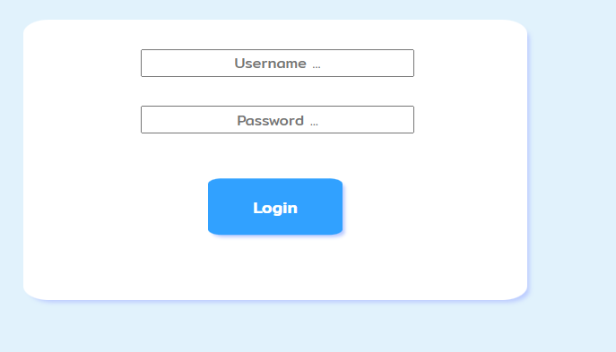

1. Use the pencil icon on the set to edit, use the bin icon to delete.

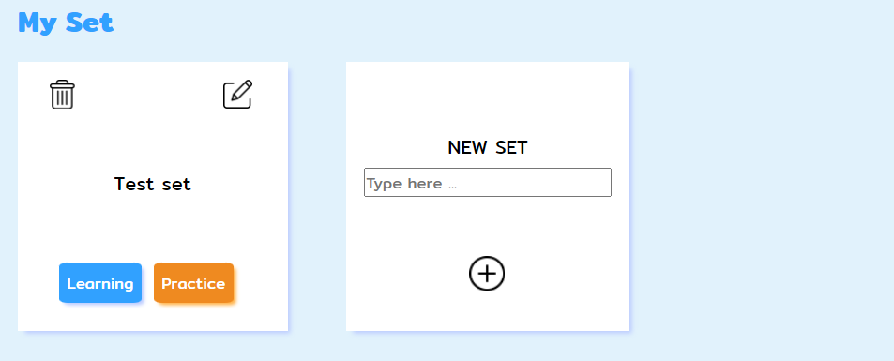

1. 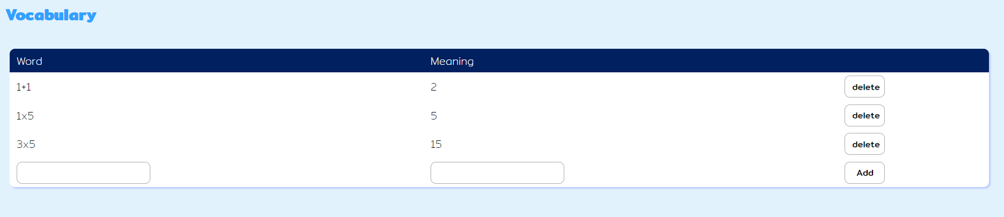Input words and meanings to the vocabulary to add. Click delete to delete.
2. Learning mode will display flash cards, the practice mode will prompt the user to complete the practice and display score.

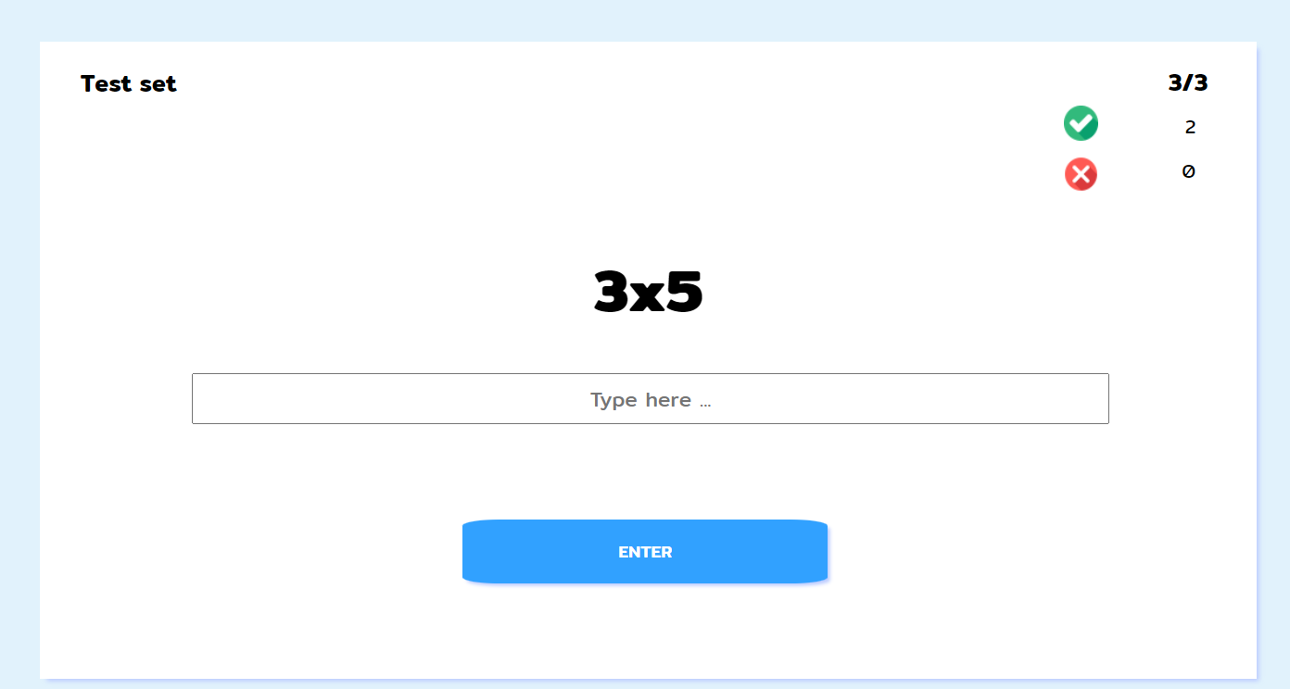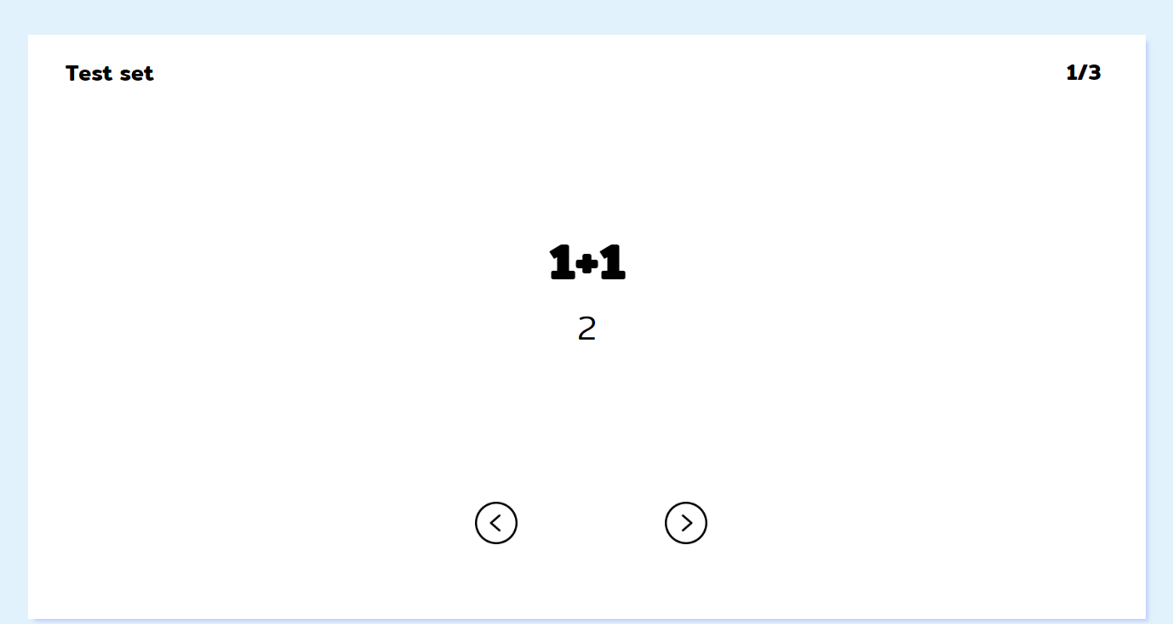

Requirements:

This application is a single page web application, does not use external frameworks or libraries, and helps students remember words or facts. Its use has been tested on PC and mobile with different window sizes and works correctly.

Contributors:

6432184721: This documentation and ideas.

The contribution history can be tracked in github.