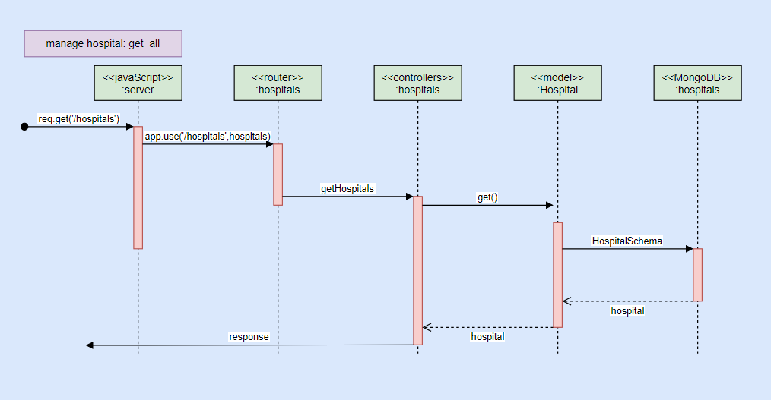

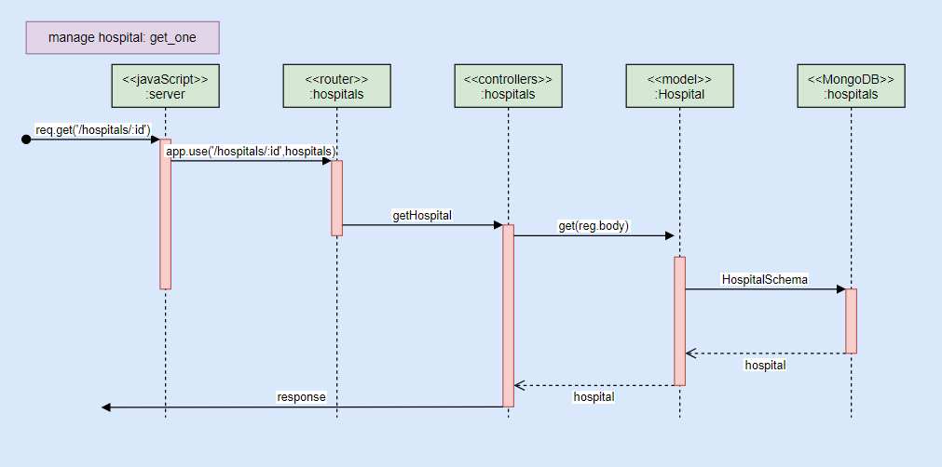

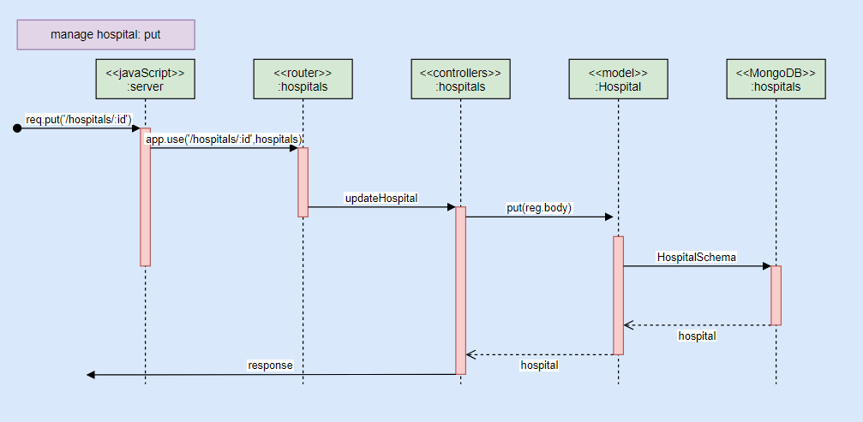

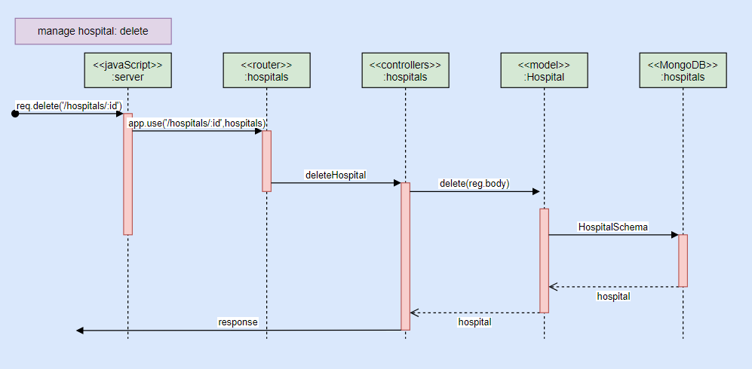

1. Please answer this question in your file:
   * how many minutes did you spend to finish this assignment, including watching videos, programming, drawing diagram, etc?

300 minutes