1 Capture your Postman & MongoDB Atlas Screens to show the register process. An example is in Slide#11. Please include your computer date/time in all captured pictures

2 Capture your Postman Screen after a register request with a token in the response. An example is in Slide#19.

1. A screenshot of a computer

   Description automatically generatedCapture your Postman Screen after a login request with token in the response. An example is in Slide#24.
2. Capture your Postman Screen after a login request with Cookie in the response. An example is in Slide#30.

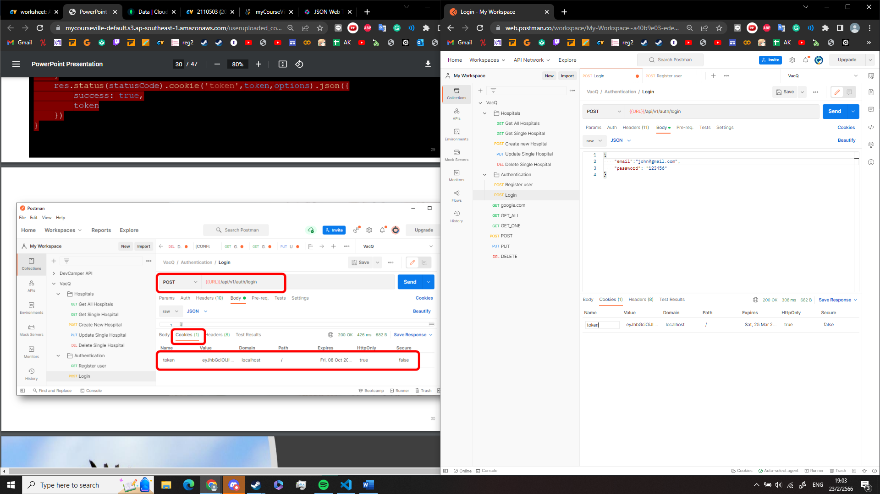

1. Capture your Postman Screen after an auth/me request with user data in the response. An example is in Slide#36.

6 Capture your Postman Screens after an auth/me request with and without a value in the token. An example is in Slide#41, but with a response.

with value in token

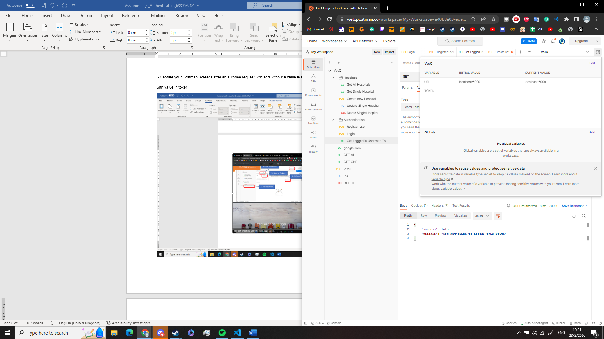

7 Capture your Postman Screen after ***Create New Hospital*** request with an admin token and another one with a user token. An example is in Slide#47.

with admin token

with user token

8 Your GitHub link to your code.